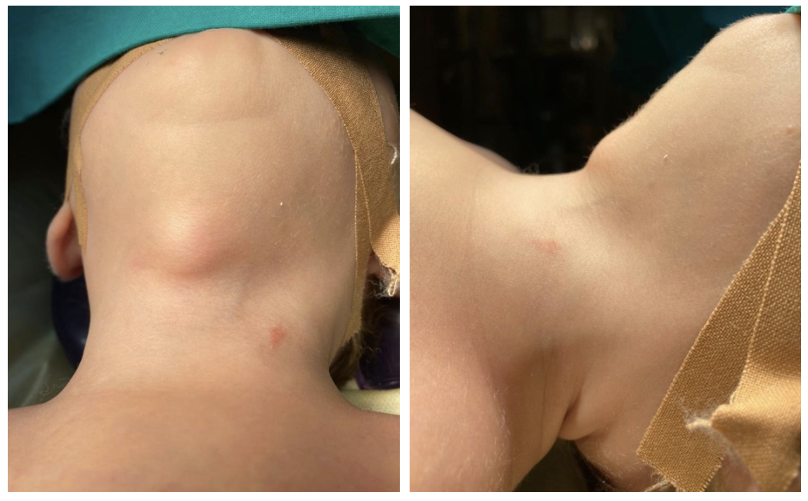
Thyroglossal Duct Cyst (TDC) is a common lesion of the midline neck, originating from an incomplete involution of the thyroglossal duct. It is typically observed in pre-scholar patients and surgery is the treatment of choice to prevent infections. No neonatal cases were ever described in a literature. Here reported a case of incidental diagnosis in a 3-weeks old male baby admitted for hypertrophic pyloric stenosis.

