Supplements

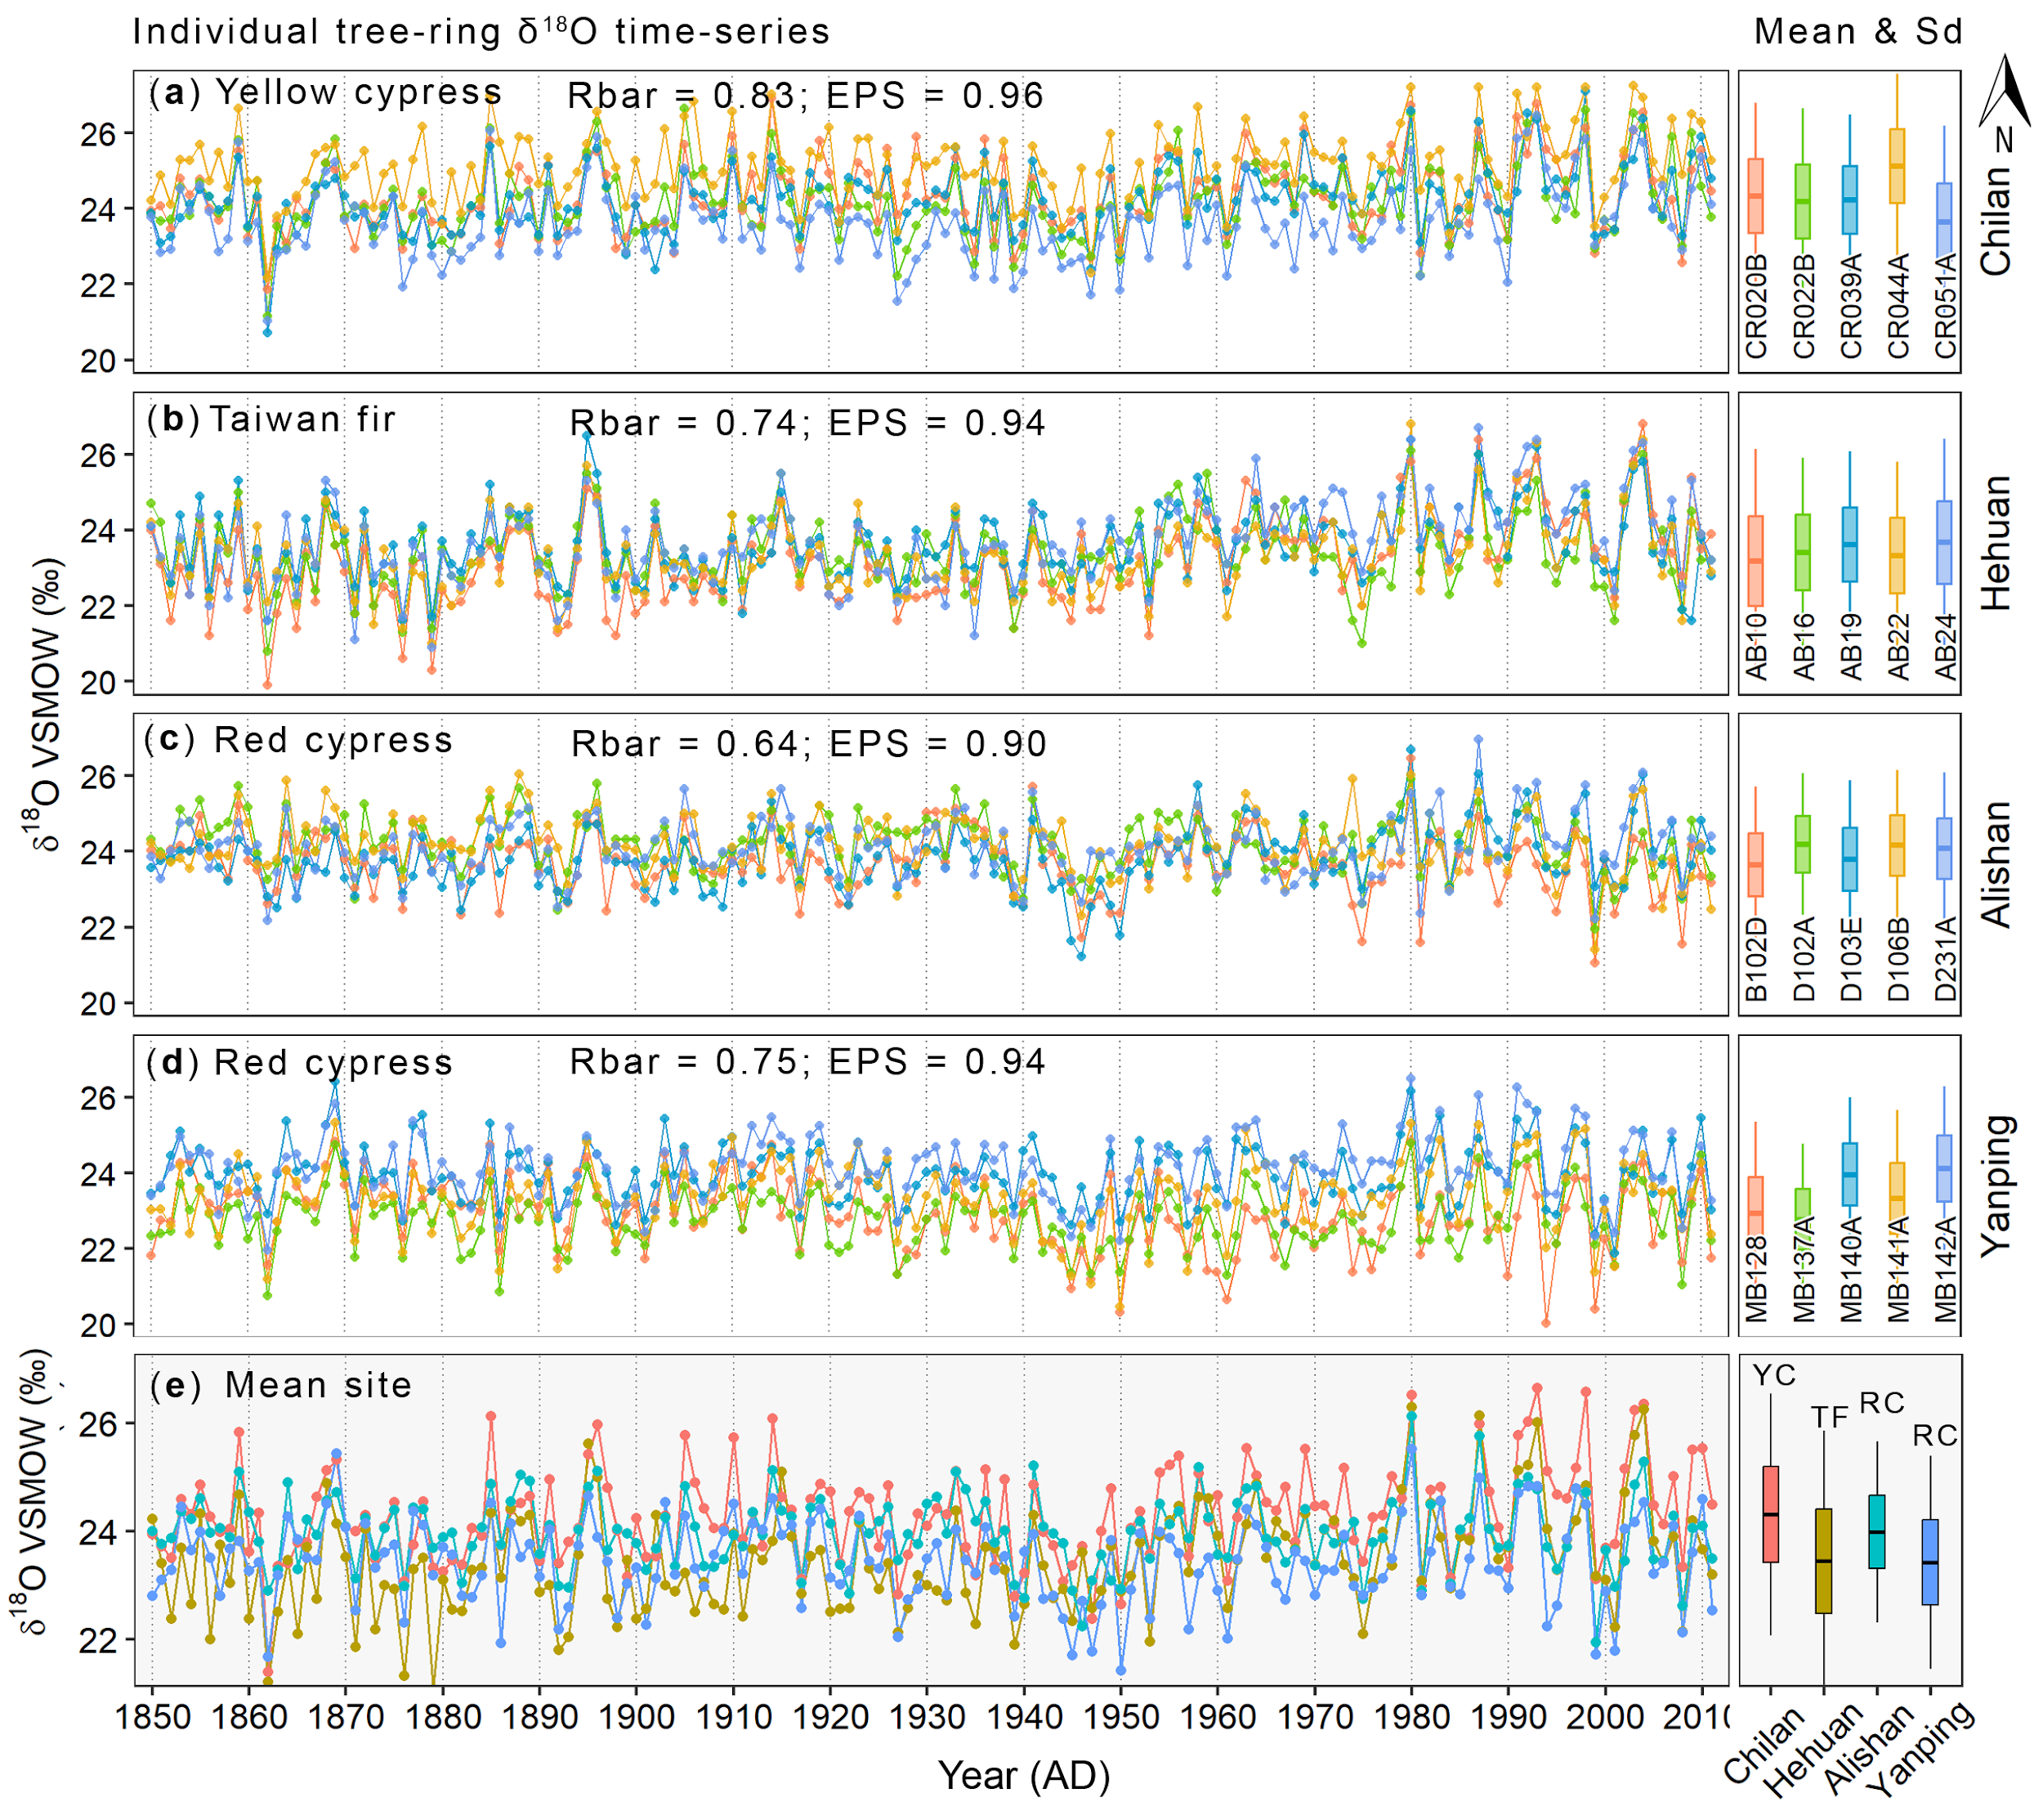
Fig.S1 | Instra-species and -sites variations of δ¹⁸O in tree-ring. (a-d) The individual tree-ring δ¹⁸O time-series (colored lines with dots) of Chilan (Yellow cypress), Hehuan (Taiwan fir), Alishan (Red cypress), and Yanping (Red cypress), attached by boxplot of the means and standard deviations (right panel). Rbar and EPS present the mean inter-series correlation and the expressed population signal. (e) The mean of individual δ¹⁸O time series at each site is attached by a boxplot of the means and standard deviations (right panel). YC, TF, and RC denote Yellow cypress, Taiwan fir, and Red cypress, respectively.

Fig.S2 | Local climate response of raw and residual δ¹⁸O_{tr} chronologies. (a-c) For raw δ¹⁸O_{tr}, (d-g) for residual δ¹⁸O_{tr} (i.e., excluding the effect of the upstream regional precipitation by subtracting their raw δ¹⁸O_{tr} values from their linear regressing on the upstream regional precipitation). Local climates (precipitation, humidity, and temperature) were obtained from the nearest meteorological station at each sampling site for the common period 1950–2011. The upstream regional precipitation was averaged from meteorological stations over southeast Taiwan (the northern part of upstream precipitation over the Luzon region). The lowercase and uppercase x-axis letters present the previous and current months

Fig.S3 | Spatial correlations between tree-ring δ¹⁸O network and ERA5 precipitation. Background color presents the spatial correlation between δ¹⁸O_{tr} and ERA5 precipitation from previous October to current August during the period 1950–2011. The dash contours present the correlation as significant at a 90% confidence level. The green circles denote the sampling sites of each tree-ring δ¹⁸O record.

Fig.S4 | Stability of upstream precipitation signal in tree-ring δ¹⁸O (PC1). Spatial correlations were calculated for separate periods (1950-1978; 1979-2011 and 1950-2011). This consistent correlation pattern despite the poor quality of data in the early time demonstrates the stability of δ¹⁸O_{tr} and upstream precipitation relationship. The precipitation data were obtained from various datasets; ERA5, CR20 and NCEP for the season from the previous October to the current August. The green circles denote the approximate location of the tree site network. Only correlations with significance at a 90% confidence level are shown.

Fig.S5 | Meteorological station-based precipitation response δ¹⁸O_{tr} chronologies. Monthly and seasonal correlation between tree-ring δ¹⁸O chronologies and precipitation at 21 meteorological stations along north-south Taiwan. The blue circles indicate the correlations are significant at a 95% confidence level. The lowercase and uppercase x-axis letters present previous and current months. The climate data were obtained from the DBAR during 1950–2011. The strongest correlations synchronously appeared with the southeast stations.
Fig.S6 | Regional and local precipitation response of δ¹⁸O_{tr} chronologies. Monthly and seasonal correlation between δ¹⁸O_{tr} chronologies with local and sub-regional precipitations. The correlation that is not statistically significant (p > 0.05) is faded. The red dashed line indicates the highest correlation. The light blue and pink shaded areas denote the incorporated seasonal precipitation and the highest seasonal correlation, respectively. The attached black thin line range in each bar presents the range of 95% confidence intervals. The lowercase and uppercase x-axis letters present previous and current months. Sub-climate regions by simply averaging data from meteorological stations located in different geographical directions of Taiwan Island during 1950–2011.

Fig.S7 | Comparison between PC1 and Luzon precipitation. Time-series comparison (a) and 21-year running correlation (b) between reverse PC1 and Luzon precipitation from different datasets. Precipitations were obtained from the CERA, RC20 and ERA5 reanalysis datasets for the OA season during the common period 1950–2011. The colored texts below the legend show the correlation coefficients between PC1 and Luzon precipitation for periods 1979–2011 and 1950–2011 from the different datasets, respectively. The attached asterisks “***” to the correlation coefficient indicate the significance at p ≤ 0.001. The red dashed think and thin lines present the 99% and 95% confidence levels, respectively. The dashed green lines present the year 1979 when the quality of climate observation data significantly improved thanks to advancements in satellite technology. All time series were standardized by the mean and deviation for better comparison and visualization. The reverse PC1 was used for better visualization.

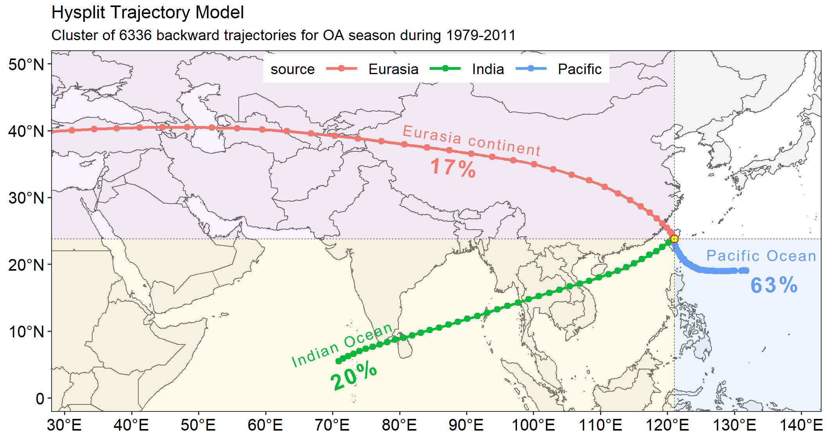
Fig.S8 | Water-vapor backward trajectory. Ten days (240 hours) of water-vapor backward trajectories arriving at the study site (yellow circle) during the OA season, i.e., every day from 01st May to 31 August and from 01st October to 31 December from 1979–2011. The thick colored lines present the cluster mean trajectories, calculated by cluster analysis for mean all daily trajectories, overlaid by the percent of water-vapor originating from different moisture sources, respectively. The trajectories outside the map view were moved out. The trajectories were created by the offline HYSPLIT5 model⁹⁹.

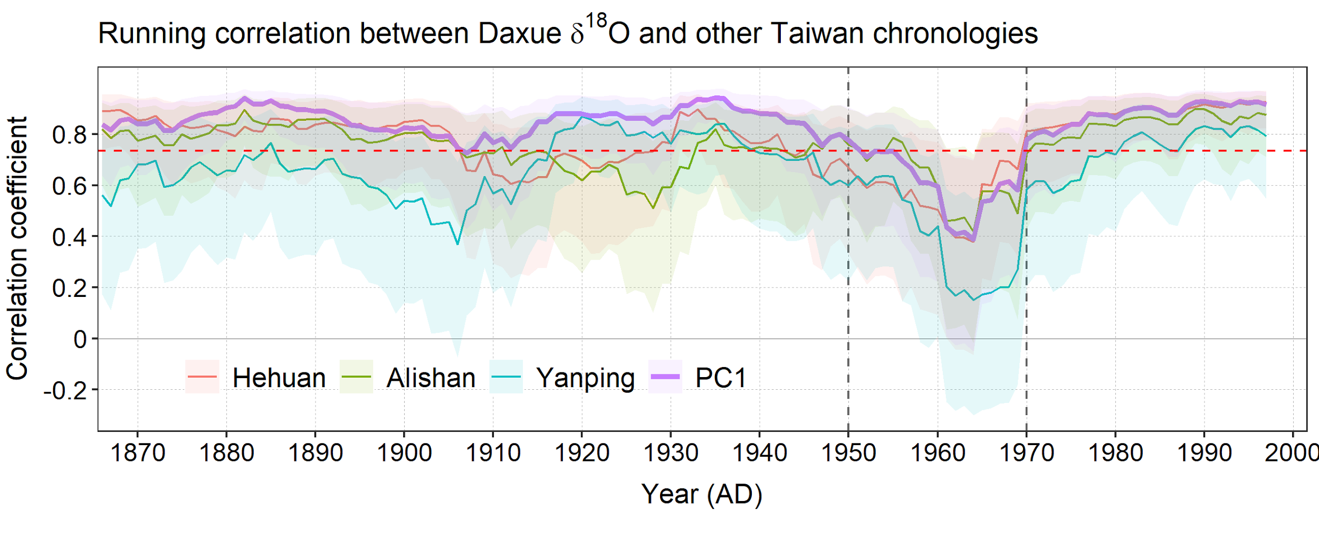
Fig.S8 | The discrepancy between tree-ring δ¹⁸O records from Daxue and other sites. Colored lines present the 21-year running correlation between tree-ring δ¹⁸O records from the Daxue site and other sites in Taiwan Island. Two black dashed lines present the mismatch of Daxue with others corresponding to periods of high correlation between Daxue and ENSO. The red dashed line indicates a 95% confidence level. All the correlations are fallen during the period 1950–1970.

Tab. S1 | Tree-ring δ¹⁸O chronologies along Taiwan Island

 | Site | Lon | Lat | Elevation  (m a.l.s) | Species | Period | Resource
1 | Chilan | 121.380 | 24.530 | 1,900–2,000 | Yellow cypress | 1850–2015 | This study
2 | Hehuan | 121.270 | 24.150 | ~ 3,790 | Taiwan fir | 1850–2011 | This study
3 | Daxue | 121.000 | 24.000 | 2,000–2,200 | Yellow cypress | 1850–2007 | ref⁶⁹
4 | Alishan | 120.810 | 23.450 | 1,635–2,261 | Red cypress | 1850–2015 | This study
5 | Yanping | 121.020 | 22.970 | 1,500–2,100 | Red cypress | 1850–2013 | ref¹

Tab. S2 | Main meteorological stations in Taiwan
Order |  | Station name | Sub-region | Elevation  (m a.l.s) | Lon | Lat | Start_year | Duration
1 |  | Pengjiayu | North | 101.7 | 122.080 | 25.628 | 1936 | 82
2 |  | Anbu | North | 837.6 | 121.530 | 25.183 | 1943 | 75
3 |  | Tamsui | North | 19.0 | 121.449 | 25.165 | 1942 | 76
4 |  | Zhuzihu | North | 607.1 | 121.545 | 25.162 | 1943 | 75
5 |  | Keelung | North | 26.7 | 121.740 | 25.133 | 1946 | 72
6 |  | Taipei | North | 5.3 | 121.515 | 25.038 | 1896 | 122
7 |  | Yilan | Northeast | 7.2 | 121.757 | 24.764 | 1935 | 83
8 |  | Hualien | Northeast | 16.1 | 121.613 | 23.975 | 1910 | 108
9 |  | Hsinchu | Northwest | 32.8 | 120.978 | 24.800 | 1938 | 80
10 |  | Taichung | Northwest | 84.0 | 120.684 | 24.146 | 1897 | 121
11 |  | SunMoonLake | Cloud forest | 1017.5 | 120.908 | 23.881 | 1941 | 77
12 |  | Alishan | Cloud forest | 2413.4 | 120.813 | 23.508 | 1933 | 85
13 |  | Yushan | Cloud forest | 3844.8 | 120.960 | 23.488 | 1943 | 75
14 |  | Penghu | Southwest | 10.7 | 119.563 | 23.566 | 1896 | 122
15 |  | Tainan | Southwest | 40.8 | 120.205 | 22.993 | 1897 | 121
16 |  | Kaohsiung | Southwest | 2.3 | 120.316 | 22.566 | 1931 | 87
17 |  | Chenggong | Southeast | 33.5 | 121.373 | 23.097 | 1940 | 78
18 |  | Taitung | Southeast | 9.0 | 121.155 | 22.752 | 1901 | 117
19 |  | Dawu | Southeast | 8.1 | 120.904 | 22.356 | 1940 | 78
20 |  | Lanyu | Southeast | 324 | 121.558 | 22.037 | 1941 | 77
21 |  | Hengchun | Southeast | 22.3 | 120.746 | 22.004 | 1896 | 122

