Supplementary material

Quantitative synthesis of microbe-driven acclimation and adaptation in wild vertebrates
Garazi Martin Bideguren¹, Orly Razgour², Antton Alberdi¹

¹Center for Evolutionary Hologenomics, Globe Institute, University of Copenhagen, 1353 Copenhagen, Denmark.
²Biosciences, University of Exeter, Streatham Campus, Exeter EX4 4PS, UK.

Table of contents
Supplementary tables 2
Table S1 2
Table S2 2
Table S3 2
Table S4 3
Relative weight of each criterion given by each of the experts and the average value used for the analyses. 3
Supplementary figures 4
Figure S1 4
Figure S2 5

Supplementary tables

Table S1
Linear model results of the temporal trends of performance scores
Performance metric | Parameter estimate | DF_{nom/den} | t-value | p-value
Total ~ Year | 0.009 | 1/107 | 2.196 | 0.030
Experimental design ~ Year | 0.012 | 1/107 | 1.641 | 0.104
Methodological resolution ~ Year | 0.008 | 1/107 | 1.495 | 0.138
Reproducibility ~ Year | 0.001 | 1/107 | 0.034 | 0.973

Table S2
Kruskal-Wallis test of the difference of performance scores across continents and taxa.
Comparison | chi-squared | DF | p-value
Total ~ Continent | 5.3242 | 5 | 0.3776
Total ~ Taxa | 2.8549 | 4 | 0.5824

Table S3
Description of the scoring criteria and the value assigned to each ordinal category.
Domain | Criterion | Description | Score
Experimental design | Experimental approach | No comparison | 0
Experimental design | Experimental approach | Observational without controlling the environment | 0.25
Experimental design | Experimental approach | Observational with controlling the environment | 0.5
Experimental design | Experimental approach | Manipulative (antibiotics) | 0.75
Experimental design | Experimental approach | Manipulative (FMT) | 1
Experimental design | Analysis approach | No statistics | 0
Experimental design | Analysis approach | Pure comparison | 0.5
Experimental design | Analysis approach | Mechanistic | 1
Experimental design | Adaptation means | Hypothesis not explicitly addressed the increased adaptability provided by microbiomes | 0
Experimental design | Adaptation means | Hypothesis explicitly addressed the increased adaptability provided by microbiomes | 1
Experimental design | Sample size | Below 10 | 0
Experimental design | Sample size | Between 10 and 30 | 0.33
Experimental design | Sample size | Between 30 and 100 | 0.66
Experimental design | Sample size | Over 100 | 1
Methodological resolution | Fitness measurement | Fitness not measured | 0
Methodological resolution | Fitness measurement | Proxy for fitness measured | 0.5
Methodological resolution | Fitness measurement | Fitness measured | 1
Methodological resolution | Association to host | No statistics | 0
Methodological resolution | Association to host | Experimental groups | 0.5
Methodological resolution | Association to host | Individual fitness (or proxy) | 1
Methodological resolution | Functional response | No functional analysis | 0
Methodological resolution | Functional response | Inferred from taxonomy | 0.2
Methodological resolution | Functional response | Inferred from 16S | 0.4
Methodological resolution | Functional response | Functional genes | 0.6
Methodological resolution | Functional response | Genome-resolved metagenomics | 0.8
Methodological resolution | Functional response | Metabolomics | 1
Methodological resolution | Molecular technique | No sequencing-based | 0
Methodological resolution | Molecular technique | Targeted sequencing | 0.33
Methodological resolution | Molecular technique | Shotgun metagenomics | 0.66
Methodological resolution | Molecular technique | Multi-omics | 1
Methodological resolution | Compositional variability resolution | No statistics | 0
Methodological resolution | Compositional variability resolution | Alpha diversity | 0.25
Methodological resolution | Compositional variability resolution | Neutral compositional analysis | 0.5
Methodological resolution | Compositional variability resolution | Phylogenetic compositional analysis | 0.75
Methodological resolution | Compositional variability resolution | Functional compositional analysis | 1
Reproducibility | Data availability | No data available | 0
Reproducibility | Data availability | Raw data available | 0.25
Reproducibility | Data availability | Detailed experimental protocols | 0.5
Reproducibility | Data availability | Origin of animals | 0.75
Reproducibility | Data availability | Bioinformatics/statistics code | 1

Table S4

Relative weight of each criterion given by each of the experts and the average value used for the analyses.
Criteria | Exp 1 | Exp 2 | Exp 3 | Exp 4 | Exp 5 | Exp 6 | Exp 7 | Exp 8 | Avg
Experimental approach | 0.130 | 0.083 | 0.067 | 0.048 | 0.143 | 0.063 | 0.176 | 0.091 | 0.1
Analysis approach | 0.087 | 0.083 | 0.067 | 0.095 | 0.095 | 0.125 | 0.059 | 0.091 | 0.09
Adaptation means | 0.087 | 0.042 | 0.067 | 0.048 | 0.095 | 0.063 | 0.059 | 0.091 | 0.07
Sample size | 0.130 | 0.125 | 0.133 | 0.143 | 0.095 | 0.063 | 0.118 | 0.136 | 0.12
Fitness measurement | 0.130 | 0.125 | 0.200 | 0.143 | 0.143 | 0.188 | 0.176 | 0.091 | 0.15
Association to host | 0.130 | 0.125 | 0.133 | 0.095 | 0.095 | 0.063 | 0.118 | 0.136 | 0.11
Functional response | 0.087 | 0.125 | 0.133 | 0.143 | 0.048 | 0.188 | 0.059 | 0.136 | 0.12
Molecular technique | 0.043 | 0.083 | 0.067 | 0.095 | 0.095 | 0.063 | 0.059 | 0.045 | 0.07
Compositional variability resolution | 0.130 | 0.083 | 0.067 | 0.095 | 0.095 | 0.125 | 0.059 | 0.136 | 0.1
Data availability | 0.043 | 0.125 | 0.067 | 0.095 | 0.095 | 0.063 | 0.118 | 0.045 | 0.08
Total | 1 | 1 | 1 | 1 | 1 | 1 | 1 | 1 | 1

Supplementary figures

Figure S1
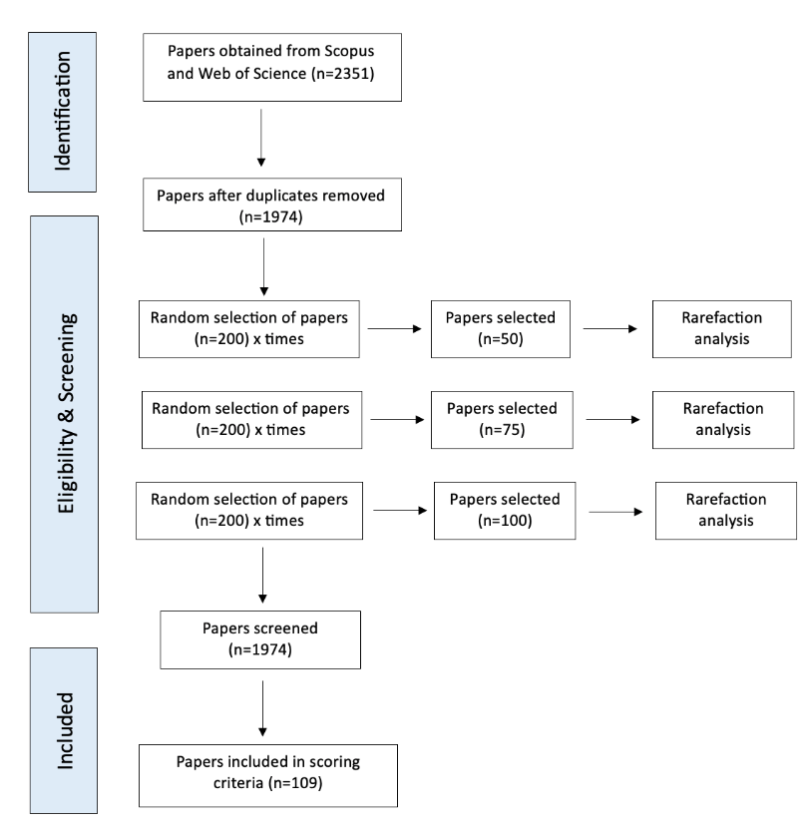
PRISMA chart of the filtering process.

Figure S2
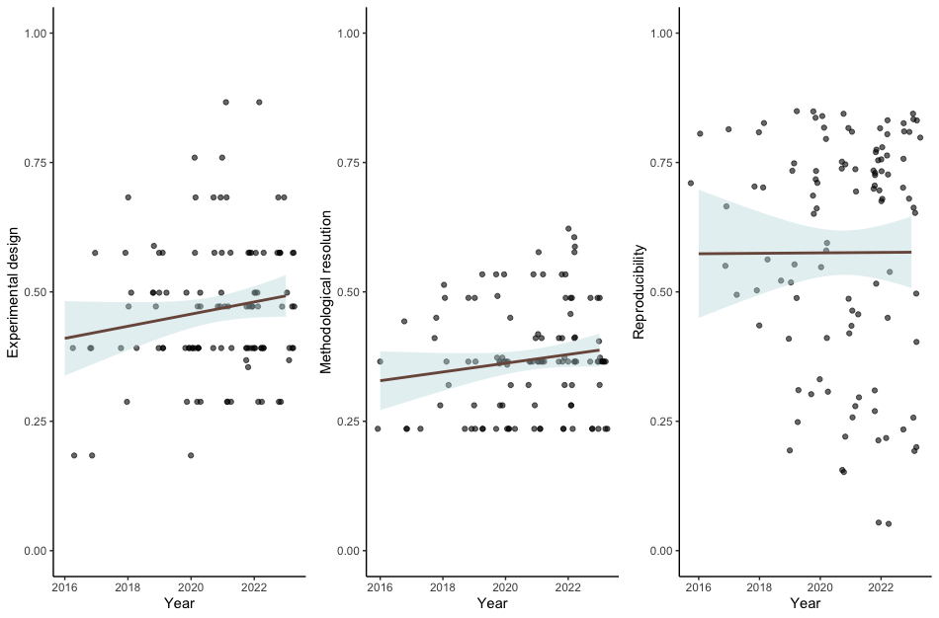
Temporal trends of performance scores in each of the domains.

