Supporting Information for

Far UV light in water treatment via producing reactive oxidative species
Kaiheng Guo†, Sining Wu†, Liping Wang†, Wenlei Qin†, Ruijie Xie†, Xuchun Li‽, Jingyun Fang*,†
† Guangdong Provincial Key Laboratory of Environmental Pollution Control and Remediation Technology, School of Environmental Science and Engineering, Sun Yat-Sen University, Guangzhou, 510275, P. R. China
‽ School of Environmental Science and Engineering, Zhejiang Gongshang University, Hangzhou, 310018, P. R. China
Corresponding author: email: fangjy3@mail.sysu.edu.cn, phone: +86 186 8058 1522

Number of pages (including this page): 12
Number of Tables: 1
Number of Figures: 6
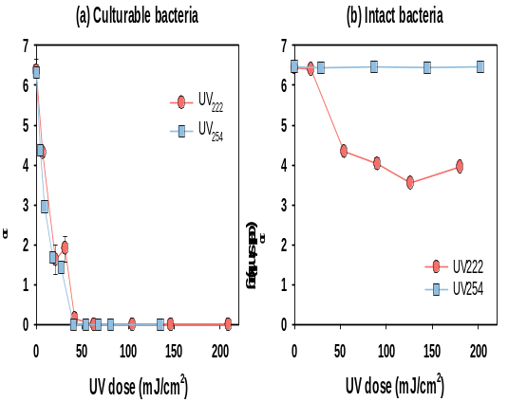
Figure S1. Inactivation of culturable cells of Pseudomonas aeruginosa in water by UV₂₂₂ and UV₂₅₄ irradiation. Conditions: I_{0, 222 nm} = 0.35 mW cm^{–2}, I_{0, 254 nm} = 0.45 mW cm^{–2}, and the initial concentration of Pseudomonas aeruginosa is ∼5 × 10⁶ CFU/mL.

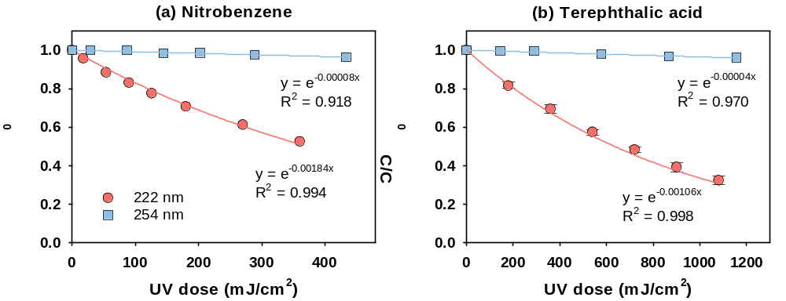
Figure S2. Degradation kinetics of (a) nitrobenzene and (b) terephthalic acid by UV₂₂₂ and UV₂₅₄ photolysis. Condition: pH = 7.0, (a & b) I_{0, 222 nm} = 0.35 mW cm⁻², I_{0, 254 nm} = 0.45 mW cm⁻², [nitrobenzene]₀ = 0.5 μM, [terephthalic acid]₀ = 2 μM.

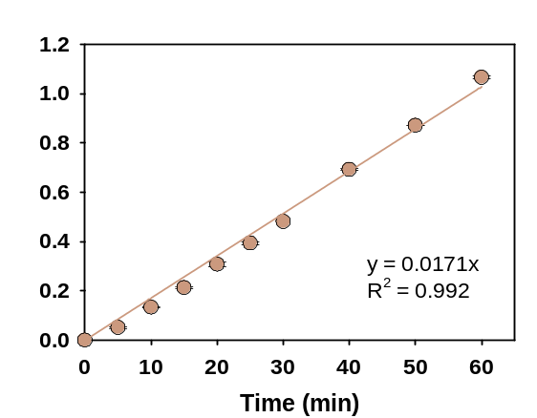
Figure S3. Increase of formaldehyde concentration (μM) over time (min) during UV₂₂₂ photolysis in the presence of TBA. Condition: pH = 7.0, I_{0, 222 nm} = 0.35 mW cm⁻², [TBA] = 5 mM.

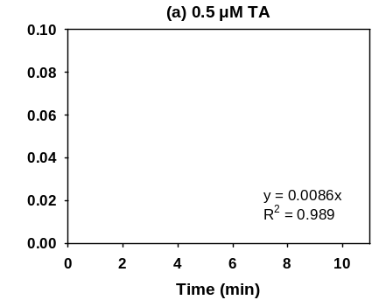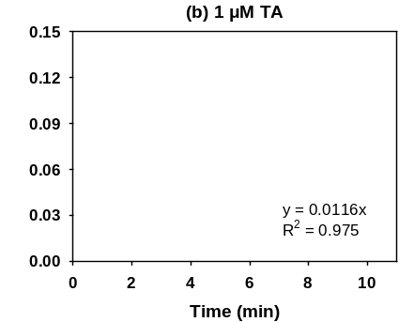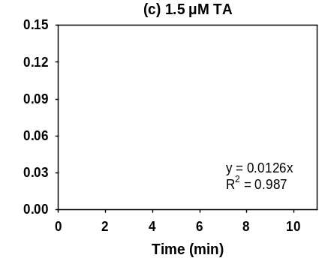
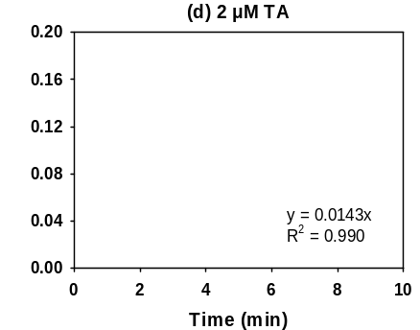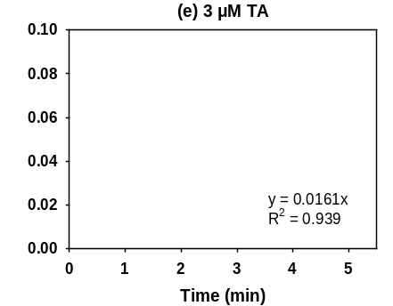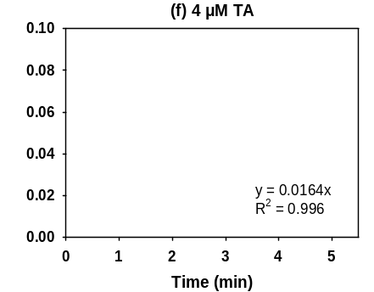
Figure S4. Increase of 2-hydroxyterephthalic acid (2HTA) concentration over time (min) during terephthalic acid (TA) transformation (μM) upon UV₂₂₂ photolysis in the presence of different dosages of TA.

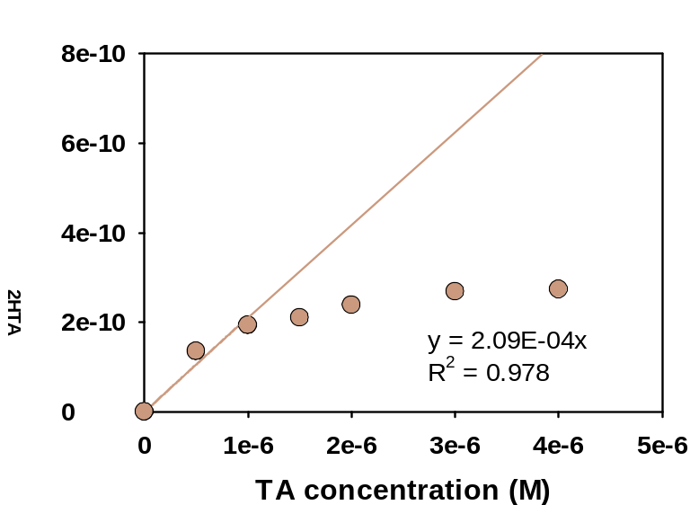
Figure S5. Formation rate of 2-hydroxyterephthalic acid (2HTA) (M s⁻¹) versus concentration of terephthalic acid (TA) (M). The growth of 2HTA was monitored over time.

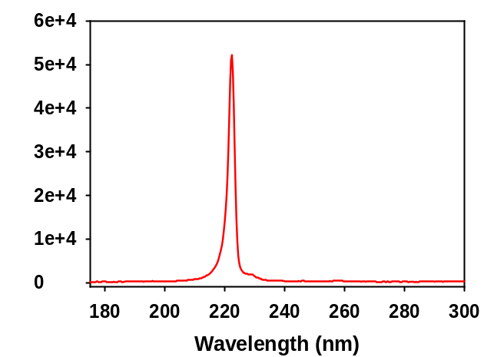
Figure S6. Emission spectrum of the KrCl* excimer lamp.

Table S1. Molar absorption coefficients (ε, M⁻¹ cm⁻¹) at 222 nm and 254 nm, and reactivities of chemicals toward ROS.
 | ε, _{222 nm}  (M⁻¹ cm⁻¹) | ε, _{254 nm}  (M⁻¹ cm⁻¹) | k_{HO}• (M⁻¹ s⁻¹) | k_{1O2} (M⁻¹ s⁻¹) | k_{O2}•₋ (M⁻¹ s⁻¹) | k_{O3} (M⁻¹ s⁻¹)
Naproxen | 61 917 | 5549 | 9.45×10⁹ ¹ |  |  | 2.0 × 10⁵ ²
Clofibric acid | 8414 | 318 | 6.98×10⁹ ³ | 3.22×10⁶ ⁴
Gemfibrozil | 6059 | 340 | 7.68×10⁹ ¹ |  |  | 4.6 × 10⁴ ²
Propranolol | 35 520 | 1410 | 9.65×10⁹ ¹ | 9.30×10³ ⁴
Metoprolol | 8938 | 412 | 8.20×10⁹ ¹ | 6.27×10³ ⁴
Primidone | 4169 | 327 | 6.63×10⁹ ¹
Carbamazepine | 22 155 | 5448 | 8.81×10⁹ ¹ | 6.4 × 10⁵ ⁵ |  | 3.0 × 10^{5 2,6}
Theophylline | 5475 | 5068 | 6.83×10⁹ ⁷
Caffeine | 6534 | 4360 | 6.14×10⁹ ¹ |  |  | 6.5 × 10² ⁸
Dimetridazole | 2566 | 1663 | 4.96×10⁹ ¹
Metronidazole | 2877 | 1917 | 5.00×10⁹ ⁹ | 1.5 × 10^{8 5,10}
Ornidazole | 3290 | 2223 | 4.39×10⁹ ¹
Tinidazole | 3259 | 2102 | 4.24×10⁹ ¹
Ronidazole | 3429 | 2148 | 4.03×10⁹ ⁷
Atrazine | 37 809 | 3309 | 2.54×10⁹ ¹¹ | < 4 × 10⁴ ¹⁰ | 4.1 × 10⁵ ¹⁰ | 6 – 7.9 ⁸
Aspirin | 6381 | 631 | 5.28×10⁹
Flumequine | 16 443 | 18 737 | 6.33×10⁹ ¹
DEET | 7159 | 1046 | 4.95×10⁹ ¹²
Nitrobenzene | 2286 | 5159
Terephthalic acid | 7827 | 7391 |  | 1.2 × 10⁷ ¹⁰ | 1.1 × 10⁴ ¹⁰
TBA | 0.097 | 0.051 |  | 1.8 × 10³ ¹⁰ | N.A.¹⁰ | 2.0 × 10⁻⁵ ¹⁰
O₂ | 21.2 | 4.0
N₂ | N.A. | N.A.

References

1. Guo, K. et al. Radical Chemistry and Structural Relationships of PPCP Degradation by UV/Chlorine Treatment in Simulated Drinking Water. Environ. Sci. Technol. 51, 10431-10439 (2017).
2. Lee, Y. & von Gunten, U. Quantitative structure–activity relationships (QSARs) for the transformation of organic micropollutants during oxidative water treatment. Water Res. 46, 6177-6195 (2012).
3. Tang, Y., Shi, X., Liu, Y., Feng, L. & Zhang, L. Degradation of clofibric acid in UV/chlorine disinfection process: kinetics, reactive species contribution and pathways. R. Soc. Open Sci. 5, 171372 (2018).
4. Du, R. et al. Quantitative structure-activity relationship models for the reaction rate coefficients between dissolved organic matter and PPCPs. J. Hazard. Mater. 458, 131845 (2023).
5. Zou, Y. et al. Interaction between graphene oxide and acetaminophen in water under simulated sunlight: Implications for environmental photochemistry of PPCPs. Water Res. 228, 119364 (2023).
6. Huber, M. M., Canonica, S., Park, G. & von Gunten, U. Oxidation of Pharmaceuticals during Ozonation and Advanced Oxidation Processes. Environ. Sci. Technol. 37, 1016-1024 (2003).
7. Chen, C. et al. Mechanistic and kinetic understanding of micropollutant degradation by the UV/NH2Cl process in simulated drinking water. Water Res. 204, 117569 (2021).
8. Broséus, R. et al. Ozone oxidation of pharmaceuticals, endocrine disruptors and pesticides during drinking water treatment. Water Res. 43, 4707-4717 (2009).
9. Wols, B. A., Hofman-Caris, C. H. M., Harmsen, D. J. H. & Beerendonk, E. F. Degradation of 40 selected pharmaceuticals by UV/H₂O₂. Water Res. 47, 5876-5888 (2013).
10. Guo, Y., Long, J., Huang, J., Yu, G. & Wang, Y. Can the commonly used quenching method really evaluate the role of reactive oxygen species in pollutant abatement during catalytic ozonation? Water Res. 215, 118275 (2022).
11. Kong, X. et al. Degradation of atrazine by UV/chlorine: Efficiency, influencing factors, and products. Water Res. 90, 15-23 (2016).
12. Song, W. et al. Free-radical-induced oxidative and reductive degradation of N,N′-diethyl-m-toluamide (DEET): Kinetic studies and degradation pathway. Water Res. 43, 635-642 (2009).

