Supplementary Material

Supplementary File 1. REDCap Questionnaire
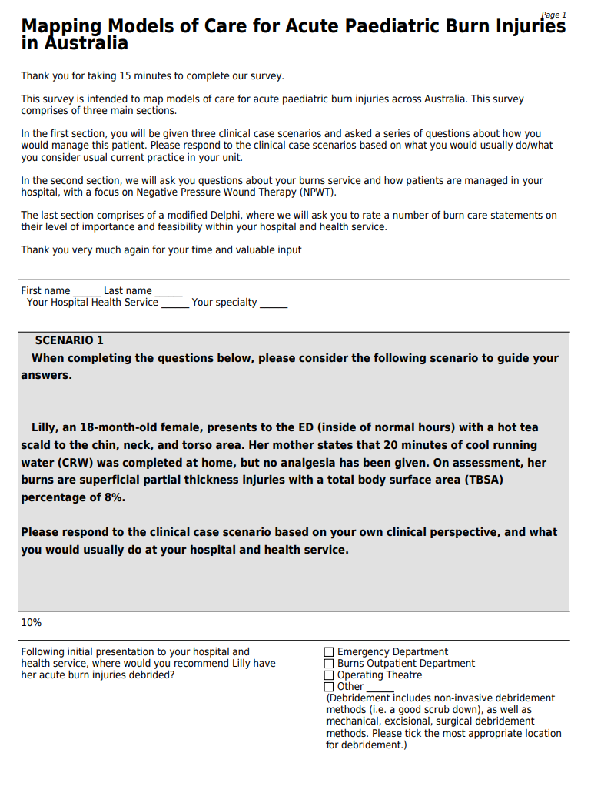

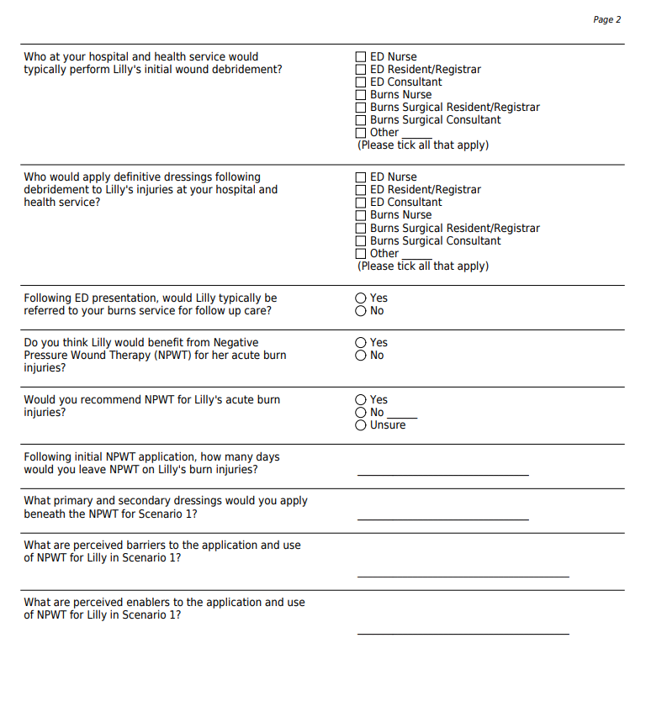

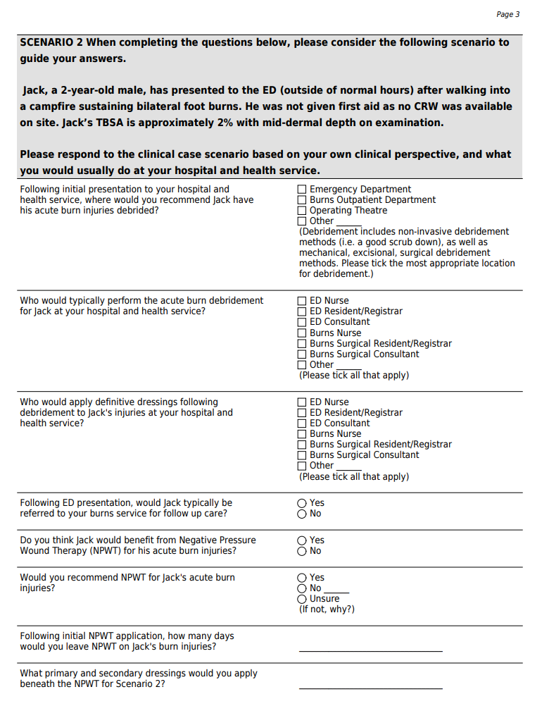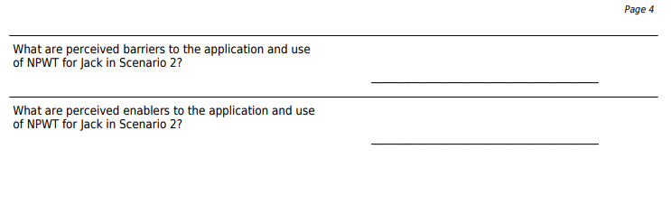
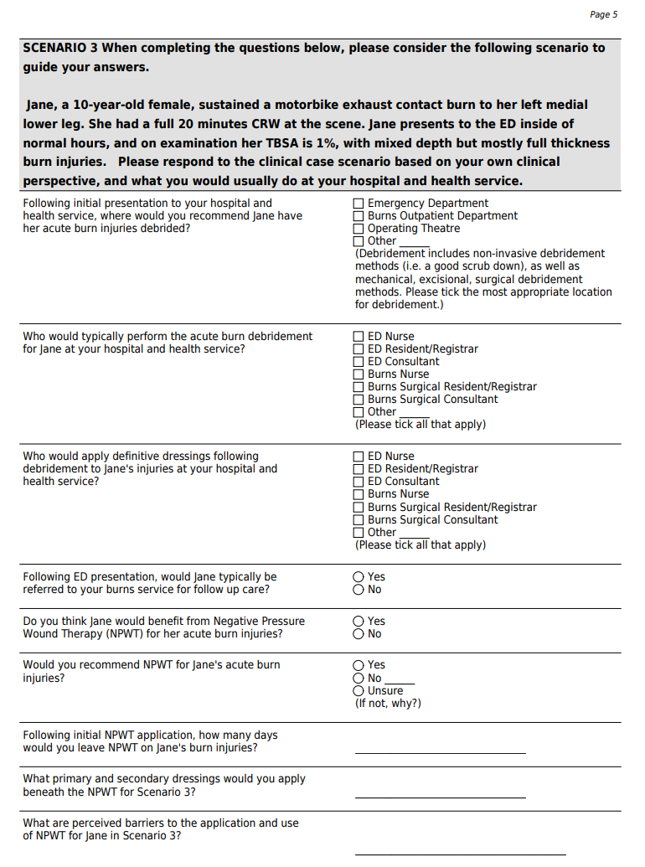
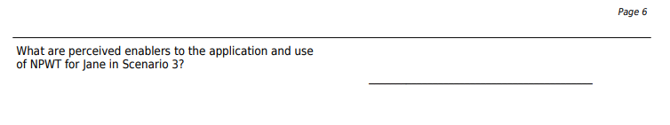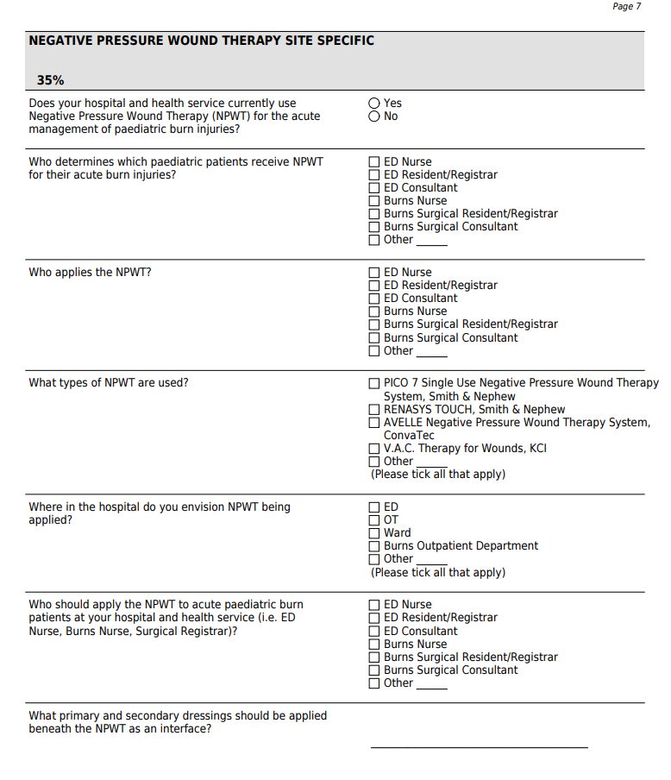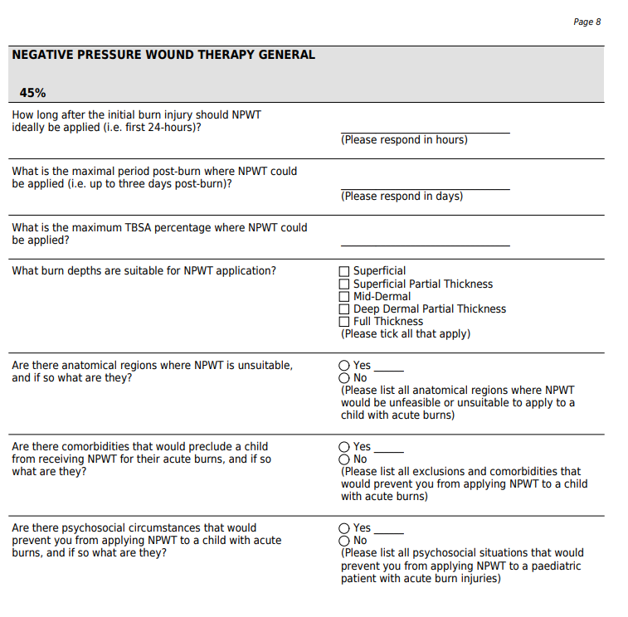

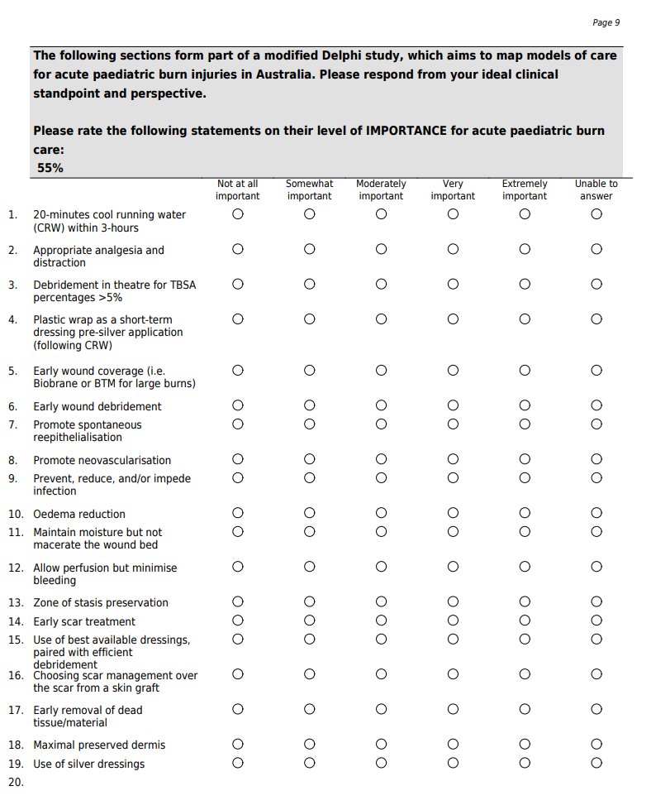

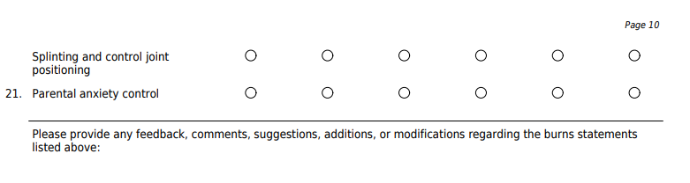

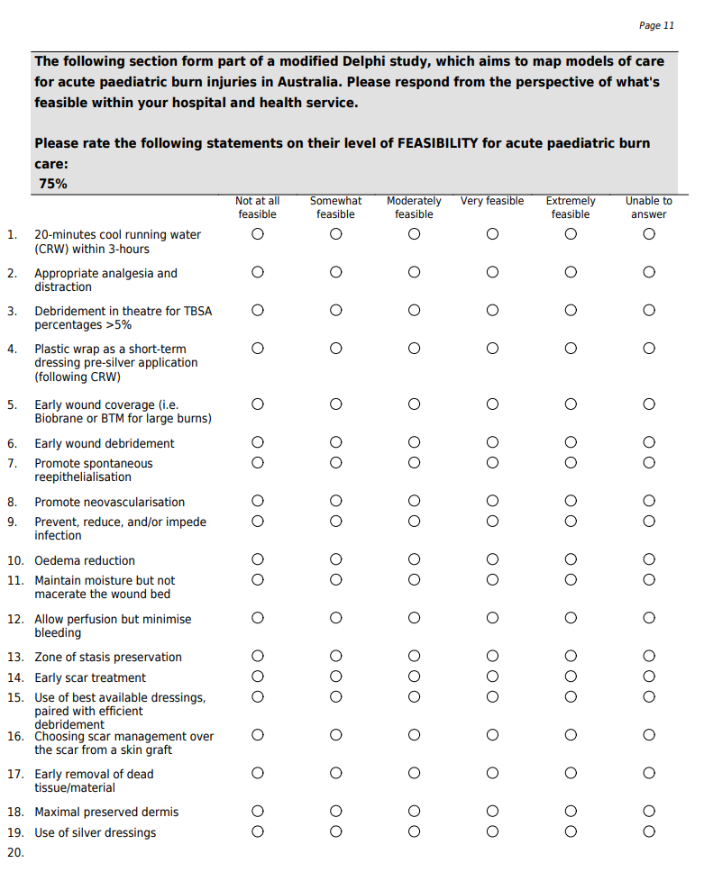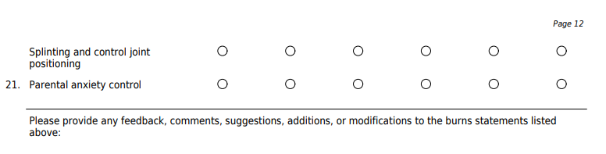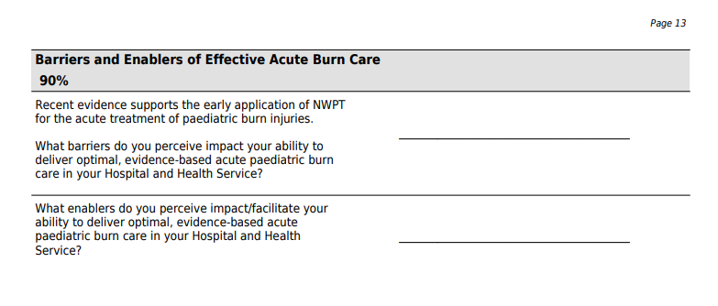

Supplementary File 2. Clinician Interview Guide
Introduction
Hi, my name is [name]. Thank you for taking the time to talk to me today. This conversation will last between 30 – 45 minutes. First, I am going to go over a few details about our conversation today before we start. If you have any questions at all, please ask them as they come up.

Purpose of the conversation
We want to learn about your opinions and experience with Negative Pressure Wound Therapy (NPWT) at your Hospital and Health Service (HHS). The information you share will help us better understand how to best implement NPWT into acute burn care across Australia.

Confidentiality
Everything you tell us today will be kept confidential. That means that we will not share anything you say with your name attached. While we might use quotes or ideas that you share, we will never use your name in reports or presentations about this research.

Recording the conversation
We would like to record this conversation so we can use the recording to transcribe notes. The recording will be kept safe and will not be used for any other purpose.

There are no right or wrong answers. We want to hear exactly what you think and feel about NPWT.
Do you have any questions before we begin?

- We are hoping to gain consensus on NPWT eligibility and how to best implement NPWT into acute burn care within your HHS:
  - Would it be acceptable, feasible and appropriate for Burns Surgical Resident/Registrar to decide which patients receive NPWT? If no, who should decide this?
  - Would it be acceptable, feasible and appropriate for NPWT to be applied to patients in the Emergency Department, Operating Theatre, Burns Ward, or Burns Outpatient Department? Is there anywhere you think is inappropriate to apply NPWT?
  - Would it be acceptable, feasible and appropriate for Burns Surgical Resident/Registrar to apply NPWT to acute burn patients presenting to your HHS? If no, who should be responsible for applying NPWT?
  - Would it be acceptable, feasible and appropriate for NPWT to be applied to patients within 24 – 48 hours of sustaining the initial injury (maximum 48 hours post-burn)?
  - Would it be acceptable, feasible and appropriate for NPWT to be applied continuously for minimum 3 days and maximum 7 days? If no, how long should NPWT be left on for? Would you be comfortable leaving NPWT on for 7 days for a 1st dressing for most patients?
  - Would it be acceptable, feasible and appropriate to use Mepitel and Acticoat beneath the NPWT? If no, what dressings should be applied beneath NPWT?
  - Would it be acceptable, feasible and appropriate to apply PICO, RENASYS TOUCH, and/or KCI NPWT devices to acute burn patients? If no, which specific device should be used?

- NPWT Eligibility:
  - Do you agree with the following medical exclusions for NPWT at [participating hospital]:
    - Infections; Deep burns with exposed tendons/structures/blood vessels; Vascular Conditions/Lymphoedema; Coagulopathy; Known allergy to adhesive fixation; Patient safety concerns
    - Potential exclusion – circumferential deep-dermal or full-thickness burns excluded at the discretion of treating clinician
  - Do you agree with the following psychosocial exclusions for NPWT at [participating hospital]:
    - Inability of parents/carers to manage the device and troubleshoot issues;
    - Behavioural, cognitive, or developmental issues/difficulties affecting compliance;
    - Complex social situation [single parent, addictions, mental health, chaotic family dynamic, unstable home environment];
    - Rural/remote families with limited local support;
    - State Residential Care;
    - Non-English-Speaking Background (without access to interpreter for informed consent)
  - Do you agree with the following anatomical regions being excluded from receiving NPWT:
    - Eyes; Face; Genitalia; Mucosal Surfaces [Anus/Lips/Stoma]

- How well does NPWT fit with existing acute burn care practices in your HHS?
  - What are likely issues or complications that may arise?
  - How will it interact or conflict with current standard practices?

- How does NPWT compare to other existing/alternative acute burn treatments in your HHS?
  - What advantages does NPWT have compared to existing adjunctive treatments (i.e., such as Plaster of Paris and Biobrane)?
  - What disadvantages does NPWT have compared to existing adjunctive treatments (i.e., such as Plaster of Paris and Biobrane)?

- Is there another intervention that people would rather use?
  - Can you describe that intervention?
  - Why would people prefer the alternative?

- What kinds of changes or alterations do you think you will need to make so that NPWT can be implemented effectively into acute burn care at your HHS?
  - Do you think you will be able to make these changes? Why or why not?
  - Consumables, educational resources, clinician support, family support?
  - Do you have any of these available?

- What current dressings do you use within your HHS for acute burn injuries?
  - If these dressings are not appropriate for use beneath NPWT, what dressings would you be happy to use?

- Are there components of acute burn care that should not be altered at your HHS?
  - Which ones should not be altered?
  - Standard acute burn dressings that you do not want to alter?

- How complicated is NPWT?
  - Please consider the following aspects of NPWT: duration, scope, intricacy, and number of steps involved and whether NPWT reflects a clear departure from previous practices.

- What additional costs do you believe will be incurred to implement NPWT at your HHS for acute burns?

Debunking the myth: In a recent prospective RCT examining the effectiveness of NPWT in acute paediatric burns injuries at a tertiary paediatric hospital – NPWT yielded both faster re-epithelialisation and lower overall costs. We found that mean costs per participant – including dressings, labour, medication, scar management, and theatre operations – were lower in the NPWT group (AUD $903.69) relative to the control group (AUD $1669.01).

- How do you think the patients and families receiving acute burn care at your HHS will respond to NPWT?

- Have you heard stories about the experiences of patients and families who have received NPWT for their burns?
  - Can you describe a specific story?
  - What are their perceptions of NPWT?

- What kinds of information and materials about NPWT have already been made available to you?
  - Copies of materials?
  - Personal contact?
  - Internal information sharing; e.g., staff meetings?
  - Has it been relevant? Sufficient?

- What resources do you require to successfully implement and administer NPWT to acute burn patients in your hospital?
  - What resources are you counting on?
  - What is the best method to distribute these resources? Paper, electronic, both?
  - Are there any other resources that you received, or would have liked to receive?

- What kind of training and education are required to successfully implement and administer NPWT
  - How would you prefer this education/training to be delivered?
  - What is missing?
  - What is the best way to provide continued training to staff at your hospital?

- We think a NPWT Champion would be helpful at your HHS, who would best fit that role in your team?
  - Who should the NPWT Champion should be? Surgical Champion? Nursing Champion?
  - How best to engage with them?
  - How available are these individuals?

- What kinds of information and materials about NPWT are needed for patients and families in your HHS?
  - Copies of materials? Paper or electronic copies?
  - Troubleshooting resources for parents and carers?
  - Personal contact?
  - Will it be timely? Relevant? Sufficient?

- What do you know about NPWT or its implementation in acute burn care?

- How do you feel about NPWT being used in your setting?
  - How do you feel about the plan to implement NPWT in your setting?
  - Do you have any feelings of anticipation? Stress? Enthusiasm? Why?

Are there any additional thoughts or comments you would like to share that I have not asked about?

Supplementary File 3. Parent-Caregiver Interview Guide
Introduction
Hi, my name is [name]. Thank you for taking the time to talk to me today. This conversation will last between 30 – 45 minutes. First, I am going to go over a few details about our conversation today before we start. If you have any questions at all, please ask them as they come up.

Purpose of the conversation
We want to learn about your experience with NPWT (NPWT) throughout your child’s treatment for their burn injuries. The information you share will help us better understand you and your child’s experience with NPWT, and the impact NPWT may or may not have had on your time with the Burns Service at the hospital.

Confidentiality
Everything you tell us today will be kept confidential. That means that we will not share anything you say with you (or your child’s name) attached. While we might use quotes or ideas that you share, we will never use your name in reports or presentations about this research.

Recording the conversation
We would like to record this conversation so we can use the recording to transcribe notes. The recording will be kept safe and will not be used for any other purpose.

There are no right or wrong answers. We want to hear exactly what you think and feel about NPWT, and your experience with it.
Do you have any questions before we begin?

- Would you mind sharing some details about your child’s burn injury?
- How long did your child have the NPWT on for?
- What NPWT device did your child receive (for example RENASYS or PICO)?
- How acceptable (suitable) did you find the NPWT for your child?
- How did you feel about the NPWT?
  - Did you like or dislike the NPWT?
- How much effort did it take to manage the NPWT?
  - Was the NPWT harder or easier than you anticipated/expected to manage?
- Did you feel you had to give up anything so your child could have/receive NPWT?
  - Did it interfere with other priorities in life?
- Did you experience any issues with NPWT during your child’s care?
- How confident did you feel about caring for a child with NPWT?
- How confident did you feel if things went wrong (troubleshooting)?
  - What tips would you give to parents caring for their child with NPWT?
- Were there aspects/things that you wanted more support in (for example managing leaks)?
- Did you have to access a service external to this hospital for NPWT management and how confident did you feel with the care you received?
- What is missing (in preparedness) from the care/support?
  - Is there anything you would add to the parent resources?
  - Could it have been made easier to understand? For example, additional education and resources?
  - Would you have preferred the resources to be emailed virtually or hardcopy?
- Do you believe that the NPWT helped your child’s burn recovery?
- Do you know how NPWT works?
  - Is it clear to you how NPWT helps to manage/heal the burn?
- Do you think the practice of using NPWT for acute burn injuries in children should be continued?
- If your child sustained another burn injury, would you consent to them receiving NPWT again?
- Did you or your child find the NPWT device burdensome or impractical?
- Did your child let you know if the NPWT bothered them?
- Did the NPWT impact on any of your child’s daily functioning?
- Could your child move, walk, and function normally with the NPWT device?
- Did your child find the NPWT device heavy or hard to carry around?
- How prepared were you to use the intervention (NPWT)?
  - What does prepared look like to you – and what advice would you give parents to deal with it well?

Are there any additional thoughts or comments you would like to share that I have not asked about?

