Supplementary figure 1
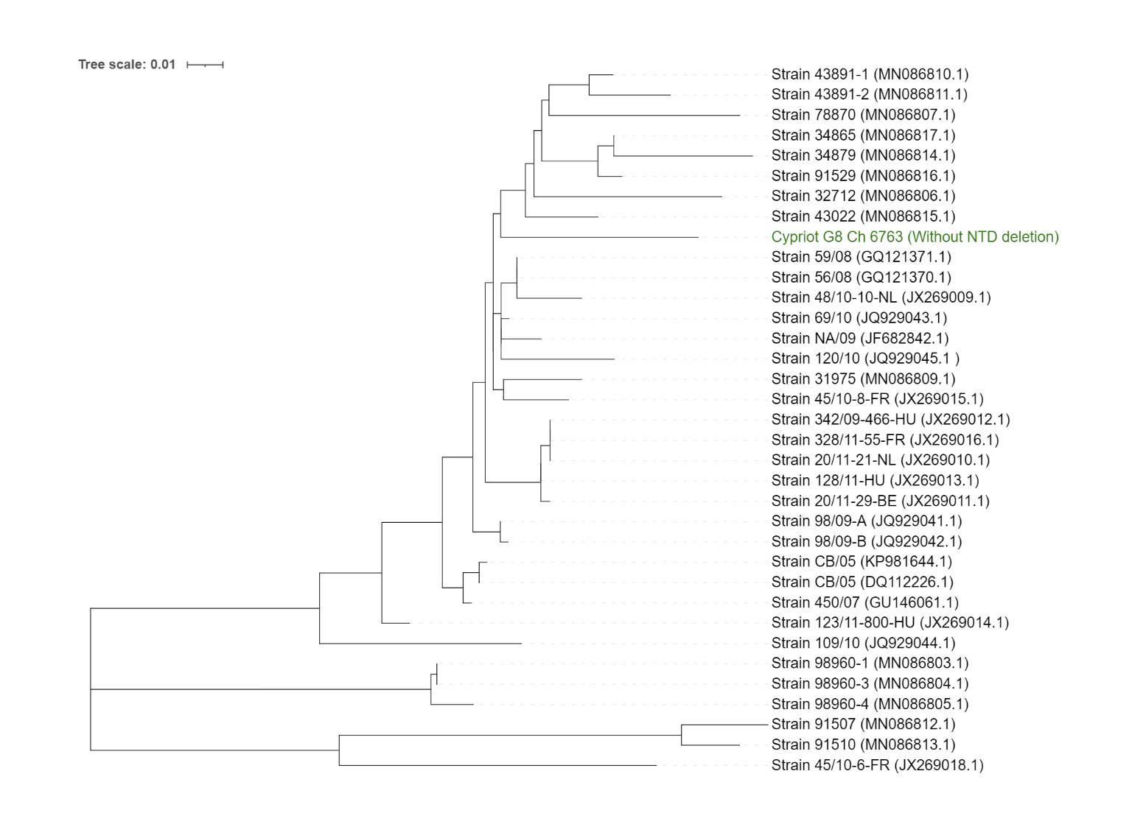
Supplementary Figure 1: Relationship to other pCCoV viruses. Maximum likelihood tree of pantropic CCoV spikes (~450bp region). Alignments were done with Muscle in MEGA7, and maximum likelihood tree was made in MEGA7 with default settings. Tree was visualized in iTOL.
Supplementary figure 1 shows a maximum likelihood tree generated from the alignment of known pCCoV spike amplicons with the non-deletion form of the FCoV-23 amplicon. The alignment was carried out with Muscle¹ in MEGA7² and the maximum likelihood tree was generated with MEGA7 on default settings. The tree was visualized with iTIOL³. The region targeted is ~450bp with longer sequences trimmed down. The FCoV-23 spike with the deletion could not be used as the deleted region heavily overlaps with the region in the alignment. The FCoV-23 amplicon clusters among the pCCoV sequences.

Supplementary figure 2
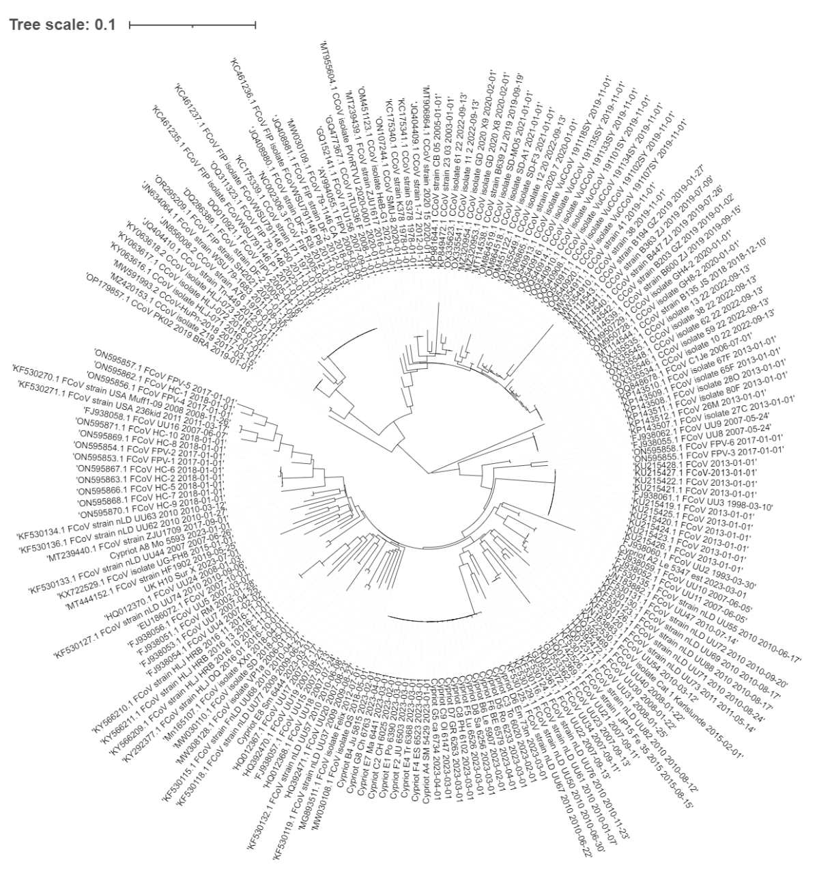
Supplementary Figure 2: POL1b ML tree from figure 2. Larger version of the maximum likelihood tree for a POL1b region. The amplicon for this region was amplified with the primers listed at the top of supplementary table 1. The methods are as described in the main methods section.

Supplementary figure 3
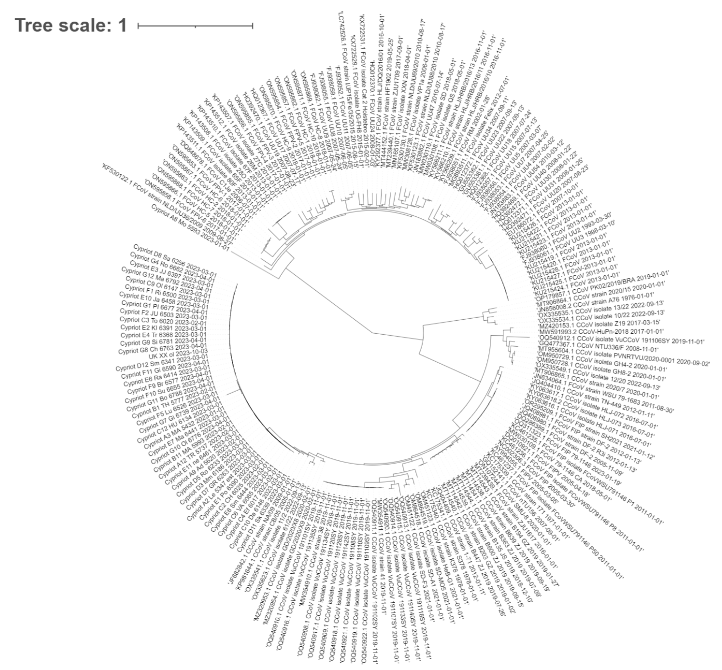
Supplementary Figure 3: Spike ML tree from figure 2. Larger version of the maximum likelihood tree for the spike gene. The amplicon for this region was amplified with the primers listed at the top of supplementary table 1. The methods are as described in the main methods section.

Supplementary figure 4
Supplementary Figure 4: ORFc/E/M ML tree from figure 2. Larger version of the maximum likelihood tree for a region spanning the NSP3c, E and M genes. The amplicons for this region were amplified with the primers listed at the top of supplementary table 1. The methods are as described in the main methods

Supplementary figure 5
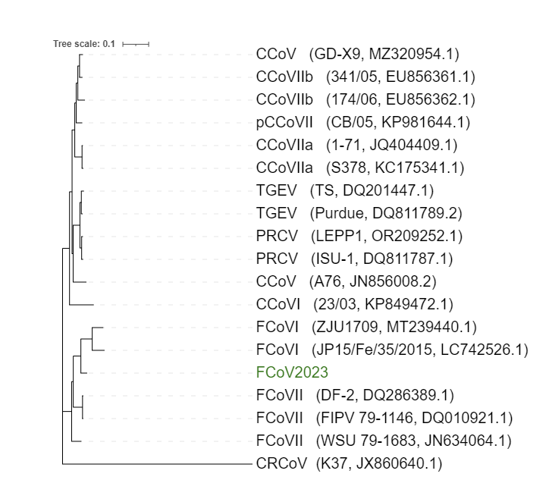
Supplementary figure 5: Maximum likelihood tree of FCoV-23 with other alphacoronavirus 1 full genome sequences.

Supplementary figure 6
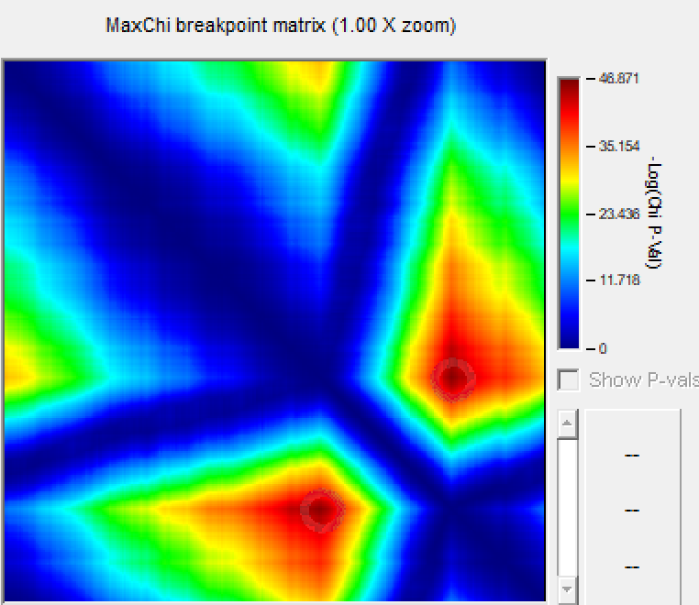
Supplementary Figure 6: MaxChi⁴ breakpoint matrix from RDP5⁵ analysis. MaxChi breakpoint matrix generated with default settings in RDP5. Supplementary figure 3 shows the MaxChi7 breakpoint matrix generated in RDP58. The dark red region highlights the likely recombination breakpoints, which align with the breakpoints described in the main text.

Supplementary figure 7
A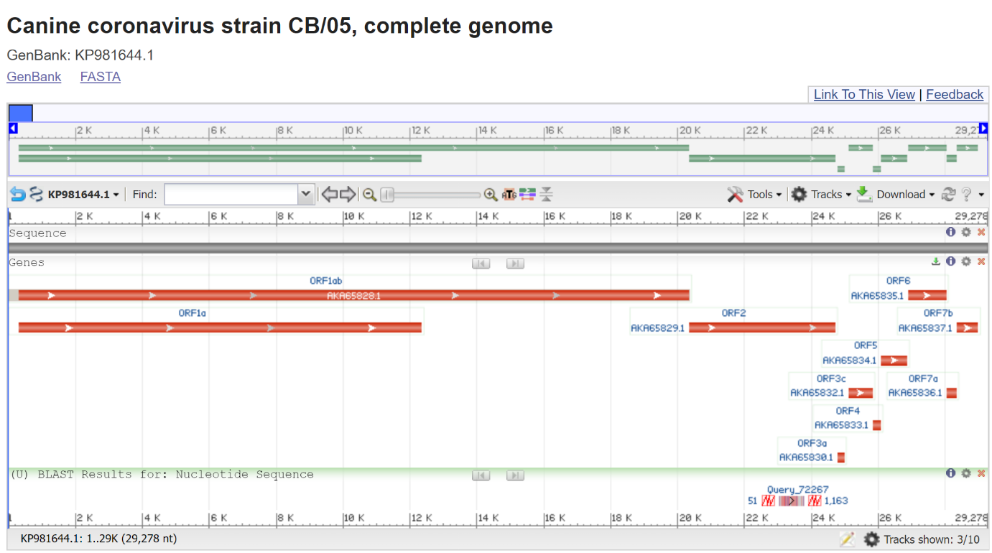
B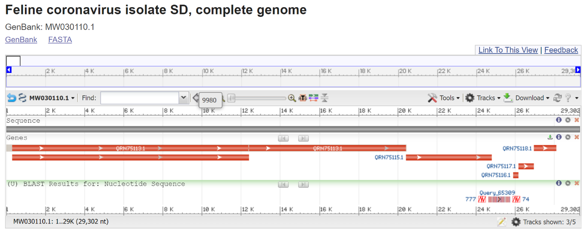
Supplementary Figure 7: BLAST visualizations from one example read that spans breakpoint in assembly gap. A) Alignment of read that spans second breakpoint against pCCoV CB/05. Read has not been adapter trimmed. B) Alignment of read that spans second breakpoint against FCoVI isolate SD. Read has not been adapter trimmed. Supplementary figures 4A and 4B show BLAST⁶ alignments of an FCoV-23 read that spans the gap in the assembled genome. While there was very low coverage over the region, there were several reads that when BLASTed against pCCoV (KP961644.1) and FCoVI (MW030110.1) demonstrated the location of the breakpoint for the recombination. The alignments showed that the likely second breakpoint is just within the spike gene. Supplementary figure 4a and 4b both show alignments of the same FCoV-23 read.

Supplementary figure 8

A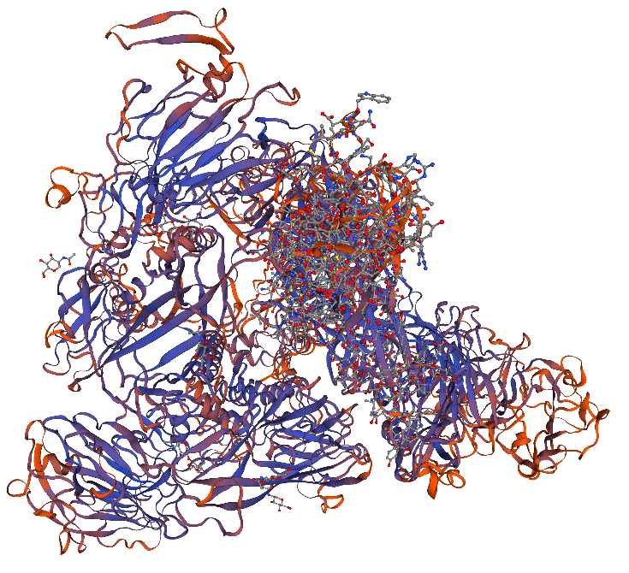 B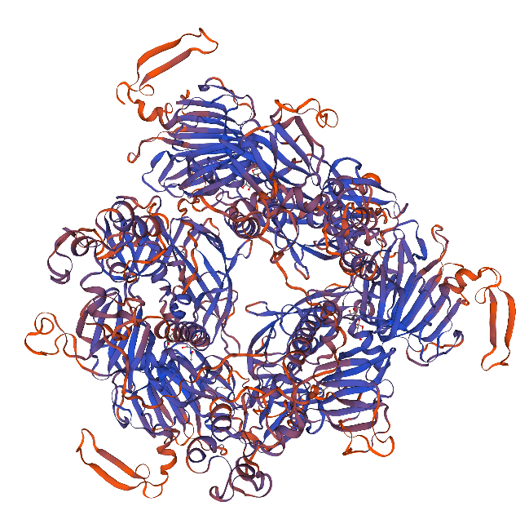
C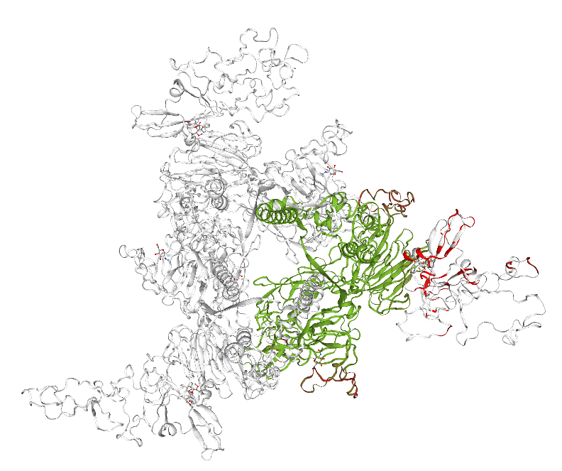D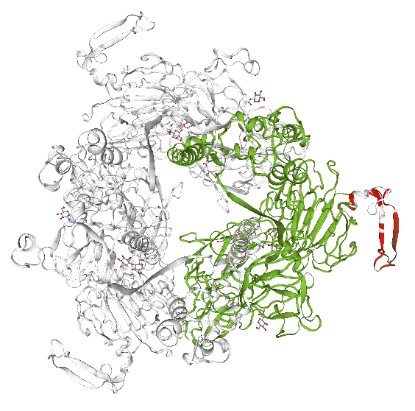
Supplementary figure 8: Protein structure modelling. Structural modelling of A) G8 full-length and B) C10 domain 0 deletion (short) spike using the 7us6.1.A proximal confirmation of CCoV-HuPN-2018 as a template. C&D) Comparison between the G8 full-length and the C10 domain 0 deletion (short) spike structure prediction. C) represents the swung out (modelled against the 7usa.1.A template) and D) the proximal confirmation (modelled against the 7us6.1.A template). Colors represent consistency with red being inconsistent and green consistent between the two structures.
RBD files can be found in the supplementary files 2-5 for G8 full-length 7usa.1.A (2), 7us6.1.A (3), C10 short 7usa.1.A (4), 7us6.1.A (5), and receptor binding domain (6), respectively.

References
1 Edgar, R. C. MUSCLE: multiple sequence alignment with high accuracy and high throughput. Nucleic Acids Res 32, 1792-1797, doi:10.1093/nar/gkh340 (2004).
2 Kumar, S., Stecher, G. & Tamura, K. MEGA7: Molecular Evolutionary Genetics Analysis Version 7.0 for Bigger Datasets. Mol Biol Evol 33, 1870-1874, doi:10.1093/molbev/msw054 (2016).
3 Letunic, I. & Bork, P. Interactive Tree Of Life (iTOL) v5: an online tool for phylogenetic tree display and annotation. Nucleic Acids Research 49, W293-W296, doi:10.1093/nar/gkab301 (2021).
4 Smith, J. M. Analyzing the mosaic structure of genes. J Mol Evol 34, 126-129, doi:10.1007/bf00182389 (1992).
5 Martin, D. P. et al. RDP5: a computer program for analyzing recombination in, and removing signals of recombination from, nucleotide sequence datasets. Virus Evolution 7, doi:10.1093/ve/veaa087 (2020).
6 Altschul, S. F., Gish, W., Miller, W., Myers, E. W. & Lipman, D. J. Basic local alignment search tool. J Mol Biol 215, 403-410, doi:10.1016/s0022-2836(05)80360-2 (1990).

