Supplementary Information
  - Multiple techniques confirm endogenous collagen in Edmontosaurus fossil bone
Lucien Tuinstra¹, Brian Thomas¹, Steven Robinson¹, Krzysztof Pawlak¹, Gazmend Elezi², Kym Francis Faull³, & Stephen Taylor¹*
¹ University of Liverpool, UK
² Pasarow Mass Spectrometry Laboratory, Jane and Terry Semel Institute for Neuroscience and Human Behaviour and Department of Psychiatry & Biobehavioral Sciences, David Geffen School of Medicine, University of California, Los Angeles, California, USA
³ Former Director²

Methods
The Edmontosaurus sp. fossil bone was found in Harding County, SD, USA (45°.56"N, -103°.46"W), and acquired by a licensed collector (Alan Stout).
Table S1. Links to 3D model of the Edmontosaurs sp. sacrem.
https://sketchfab.com/3d-models/large-fused-frag-scaled-1b3ec27799434e2cb82d04d0a98b720f
https://sketchfab.com/3d-models/long-frag-scaled-7072c0618f1e4e428fb058e5196b6b47
https://sketchfab.com/3d-models/small-frag-scaled-545a6dc5ef974aa295caf680c35f3542

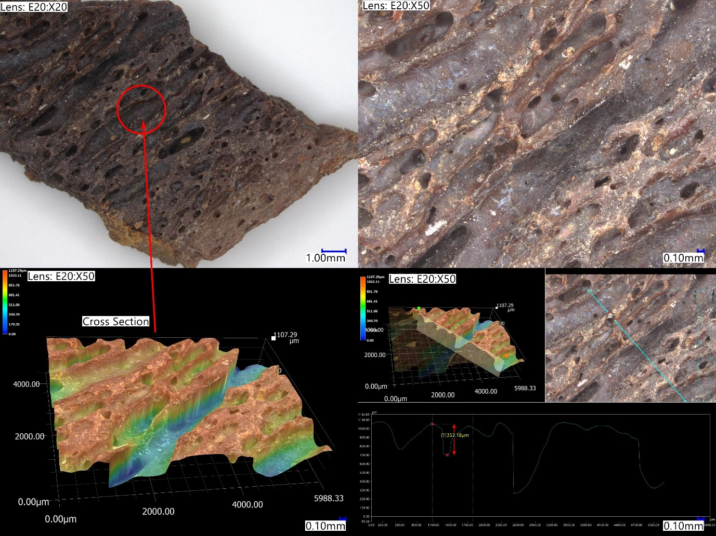
Figure S1. Small Edmontosaurus sections that were powderised to <50 μm particles. (Image: Keyence VHX-7000)
Table S2. Details of the various ranging runs performed in order to ascertain the appropriate volume of each sample to load onto the instrument.
Sample | Ranging Runs Performed (sample dilutions to check signal intensity) | Method Used | Injection Volume
Edmontosaurus | 1:1000, 1:10 | ‘Blank 30-min’ | 1 µL
Modern Turkey | 1:1000 | ‘Blank 30-min’ | 1 µL
Bovine Collagen | 1:1000 | ‘Blank 30-min’ | 1 µL

Results

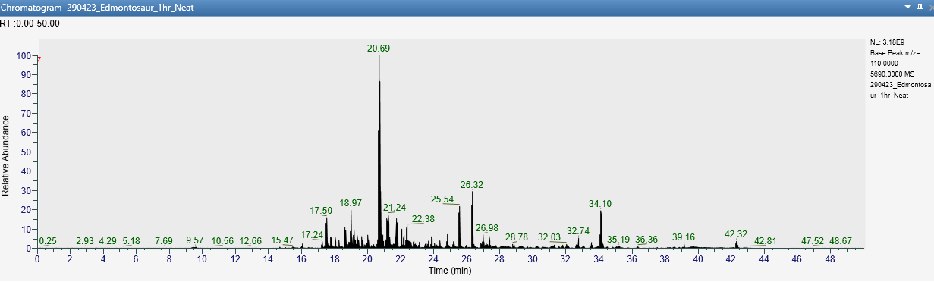
Sample 1: Edmontosaurus sp. (UOL GEO.1)
Figure S2. BPI (3.18e9) chromatogram for Edmontosaurus sp. (UOL GEO.1)

Table S3. Protein match summary for Edmontosaurus (UOL GEO.1). Database Searched: Swissprot (Entries: 564,638).
Accession | Score | Sequence Coverage (%) | No. of Pep-tides | No. of Unique Seq’s | Description | Assigned  sequence
P02467|CO1A2_CHICK | 361.9 | 32.43 | 27 | 24 | Collagen alpha-2(I) chain OS=Gallus gallus | GNVGLAGPR  VGPIGPAGNR  EGPVGFP(+15.99)GADGR  NGLP(+15.99)GPIGPAGVR  GEGGPAGPAGPAGAR  GLP(+15.99)GQP(+15.99)GSP(+15.99)GPAGK  GAP(+15.99)GLRGDTGATGR  GIP(+15.99)GPP(+15.99)GPAGPSGAR  GLHGEFGVP(+15.99)GPAGPR  GLP(+15.99)GAIGAP(+15.99)GPAGGAGDR  TGEQGIAGPP(+15.99)GFAGEK  GDAGPP(+15.99)GM(+15.99)TGFP(+15.99)GAAGR  GDP(+15.99)GPVGA(sub P)VGPAGAFGPR  GEIGPAGNVGPTGPAGPR  GLP(+15.99)GESGAVGPV(sub A)GPIGSR  GPSGPVGSP(+15.99)GPNGAP(+15.99)GEAGR  GEP(+15.99)GAAGPP(+15.99)GPP(+15.99)GPSGEEGK  VGP(+15.99)P(+15.99)GPAGITGPP(+15.99)GPP(+15.99)GPAGK  GEP(+15.99)GNVGPAGAP(+15.99)GPAGPGGIP(+15.99)GER  GLP(+15.99)GIAGATGEP(+15.99)GPLGVSGPP(+15.99)GAR  GAPGP(+15.99)EGNNGAQGPP(+15.99)GVTGNQGAK  GETGPTGAIGPIGASGPP(+15.99)GPVGAAGPAGPR  GLP(+15.99)GAIGAP(+15.99)GPAGGAGDRGEGGPAGPAGPAGAR  GLAGPQGPR
P02457|CO1A1_CHICK | 355.3 | 25.74 | 26 | 12 | Collagen alpha-1(I) chain OS=Gallus gallus | GRP(+15.99)GPSGPAGAR  GAP(+15.99)GPPGAVGAAGK  GAP(+15.99)GPP(+15.99)GAVGAAGK  GEAGPP(+15.99)GPAGPTGAR  GEP(+15.99)GPAGLP(+15.99)GPAGER  GAAGLPGAKGDR(+15.99)GDP(+15.99)GPK  DGEAGAQGPPGPTGPAGER  DGEAGAQGPP(+15.99)GPTGPAGER  NGDRGETGPAGPAGPP(+15.99)GPAGAR  GSP(+15.99)GADGPIGAP(+15.99)GTP(+15.99)GPQGIAGQR  GFSGLQGPP(+15.99)GPP(+15.99)GAP(+15.99)GEQGPSGASGPAGPR  GLTGPIGPP(+15.99)GPAGAP(+15.99)GDKGEAGPP(+15.99)GPAGPTGAR
P0C2W8|CO1A1_MAMAE | 306.7 | 21 | 15 | 2 | Collagen alpha-1(I) chain OS=Mammut americanum | GPAGPQGPSGAP(+15.99)GPK  GETGPAGPAGPAGPAGVR
P85154|CO1A2_MAMAE | 281.5 | 17.12 | 11 | 5 | Collagen alpha-2(I) chain OS=Mammut americanum | GEAGPAGSAGPAGPR  GPP(+15.99)GQSGAAGPTGPIGSR  GPSGDSGRP(+15.99)GEP(+15.99)GVM(+15.99)GPR  GIN(sub P)GPVGAAGATGAR  GEP(+15.99)GPAGSVGPVGAVGPR
P02454|CO1A1_RAT | 278.2 | 10.05 | 11 | 2 | Collagen alpha-1(I) chain OS=Rattus norvegicus | GEP(+15.99)GPAGVQGPP(+15.99)GPAGEEGK  GEPGP(+15.99)AGVQGPP(+15.99)GPAGEEGK  GEP(+15.99)GPAGVQGPP(+15.99)GPAGEEGKR
O46392|CO1A2_CANLF | 244.7 | 8.05 | 7 | 1 | Collagen alpha-2(I) chain OS=Canis lupus familiaris | GLP(+15.99)GEFGLP(+15.99)GPAGPR
P86289|CO1A1_BRACN | 230.9 | 86.73 | 6 | 1 | Collagen alpha-1(I) chain (Fragment) OS=Brachylophosaurus canadensis | N(sub G)ETGPAGPAGPP(+15.99)GPAGAR  GVQGPP(+15.99)GPQGPR  GETGPAGPAGPP(+15.99)GPAGAR  GETGPAGP(+15.99)AGPP(+15.99)GPAGAR  GATGAP(+15.99)GIAGAP(+15.99)GFP(+15.99)GAR  GSAGPP(+15.99)GATGFP(+15.99)GAAGR
C0HJP6|CO1A2_MACSX | 216.0 | 8.49 | 5 | 1 | Collagen alpha-2(I) chain (Fragment) OS=Macrauchenia | GEAGPAGPAGPAGPR
C0HJP8|CO1A2_TOXSP | 216.0 | 8.48 | 5 | 1 | Collagen alpha-2(I) chain (Fragment) OS=Toxodon | Further information can be found in the files spider.proteins.xlsx and spider.peptides.xlsx or in the (raw) data files made available via PRIDE (see manuscript for details).
P02465|CO1A2_BOVIN | 216.0 | 5.65 | 5 | 1 | Collagen alpha-2(I) chain OS=Bos taurus
C0HLH0|CO1A2_BRAVA | 215.9 | 8.38 | 5 | 2 | Collagen alpha-2(I) chain (Fragment) OS=Bradypus variegatus
C0HLJ4|CO1A2_NOTSH | 215.9 | 8.13 | 5 | 2 | Collagen alpha-2(I) chain (Fragment) OS=Nothrotheriops shastensis
C0HLI8|CO1A2_SCESW | 213.8 | 8.5 | 5 | 2 | Collagen alpha-2(I) chain (Fragment) OS=Scelidodon sp. (strain SLP-2019)
C0HJN6|CO1A2_HIPAM | 198.2 | 6.99 | 4 | 1 | Collagen alpha-2(I) chain (Fragment) OS=Hippopotamus amphibius
C0HJN8|CO1A2_TAPTE | 196.9 | 6.59 | 4 | 1 | Collagen alpha-2(I) chain (Fragment) OS=Tapirus terrestris
C0HLJ8|CO1A2_MEGJE | 196.3 | 7.44 | 4 | 2 | Collagen alpha-2(I) chain (Fragment) OS=Megalonyx jeffersonii
C0HLH4|CO1A2_ACRSX | 196.3 | 7.03 | 4 | 2 | Collagen alpha-2(I) chain (Fragment) OS=Acratocnus sp. (strain SLP-2019)
C0HLI4|CO1A2_GLORB | 196.3 | 6.49 | 4 | 2 | Collagen alpha-2(I) chain (Fragment) OS=Glossotherium robustum
C0HLG8|CO1A2_CHOHO | 196.3 | 6.46 | 4 | 2 | Collagen alpha-2(I) chain (Fragment) OS=Choloepus hoffmanni
C0HLJ0|CO1A2_NEOCO | 196.3 | 6.43 | 4 | 2 | Collagen alpha-2(I) chain (Fragment) OS=Neocnus comes
C0HJP4|CO1A2_MYLDA | 196.3 | 6.29 | 4 | 2 | Collagen alpha-2(I) chain (Fragment) OS=Mylodon darwinii
C0HLK0|CO1A2_PARHA | 196.3 | 6.24 | 4 | 2 | Collagen alpha-2(I) chain (Fragment) OS=Paramylodon harlani
C0HLJ6|CO1A2_MEGAE | 196.3 | 6.19 | 4 | 2 | Collagen alpha-2(I) chain (Fragment) OS=Megatherium americanum
C0HJN4|CO1A2_ORYAF | 196.3 | 6.44 | 4 | 1 | Collagen alpha-2(I) chain (Fragment) OS=Orycteropus afer
P08123|CO1A2_HUMAN | 195.4 | 4.61 | 4 | 1 | Collagen alpha-2(I) chain OS=Homo sapiens
C0HLH6|CO1A2_NEODO | 173.0 | 4.8 | 3 | 1 | Collagen alpha-2(I) chain (Fragment) OS=Neocnus dousman
P02466|CO1A2_RAT | 171.8 | 3.43 | 3 | 1 | Collagen alpha-2(I) chain OS=Rattus norvegicus
C0HLJ2|CO1A2_PARSU | 171.4 | 5.48 | 3 | 2 | Collagen alpha-2(I) chain (Fragment) OS=Parocnus serus
C0HLH2|CO1A2_ACRYE | 171.4 | 5.27 | 3 | 2 | Collagen alpha-2(I) chain (Fragment) OS=Acratocnus ye
C0HLI0|CO1A2_GLYSX | 167.2 | 5.79 | 3 | 1 | Collagen alpha-2(I) chain (Fragment) OS=Glyptodon sp. (strain SLP-2019)
C0HLI2|CO1A2_DOESX | 167.2 | 5.32 | 3 | 1 | Collagen alpha-2(I) chain (Fragment) OS=Doedicurus sp.
P05539|CO2A1_RAT | 161.3 | 2.82 | 3 | 1 | Collagen alpha-1(II) chain OS=Rattus norvegicus
P28481|CO2A1_MOUSE | 161.3 | 2.69 | 3 | 1 | Collagen alpha-1(II) chain OS=Mus musculus
Q01149|CO1A2_MOUSE | 152.0 | 3.72 | 3 | 1 | Collagen alpha-2(I) chain OS=Mus musculus
C0HLI6|CO1A2_SCESX | 140.3 | 7.75 | 2 | 1 | Collagen alpha-2(I) chain (Fragment) OS=Scelidotherium sp. (strain SLP-2019)
P02460|CO2A1_CHICK | 128.4 | 3.61 | 2 | 1 | Collagen alpha-1(II) chain (Fragment) OS=Gallus gallus
P02459|CO2A1_BOVIN | 128.4 | 2.08 | 2 | 1 | Collagen alpha-1(II) chain OS=Bos taurus OX=9913
P02458|CO2A1_HUMAN | 128.4 | 2.08 | 2 | 1 | Collagen alpha-1(II) chain OS=Homo sapiens
Q6P4Z2|CO2A1_XENTR | 128.4 | 2.08 | 2 | 1 | Collagen alpha-1(II) chain OS=Xenopus tropicalis
P86290|CO1A2_BRACN | 95.5 | 50 | 1 | 1 | Collagen alpha-2(I) chain (Fragment) OS=Brachylophosaurus canadensis | GSNGEP(+15.99)GSAGPP(+15.99)GPAGLR
C0HJP2|CO1A2_CYCDI | 92.7 | 2.15 | 1 | 1 | Collagen alpha-2(I) chain (Fragment) OS=Cyclopes didactylus

Sample 4. Modern Turkey (Meleagris gallopavo)
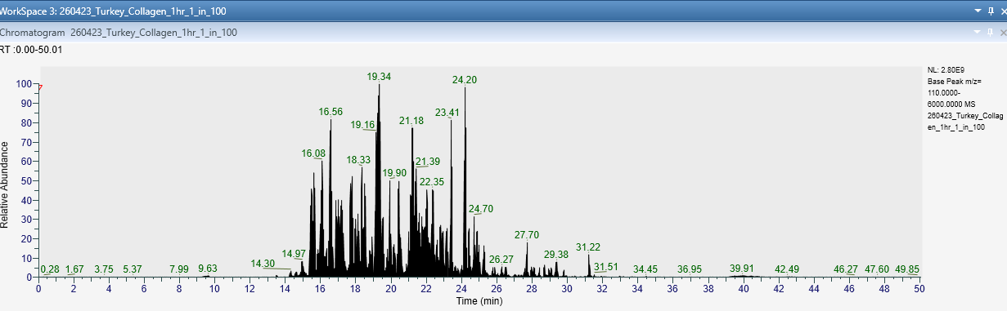
Figure S3. BPI (2.80e9) chromatogram for modern turkey (Meleagris gallopavo)

Table S4. Protein match summary for modern turkey (M. gallopavo). Database Searched: UniChick (Entries: 43,710).
Accession | Score | Sequence Coverage (%) | No. of Peptides | No. of Unique Sequences | Description
A0A1D5PYU1|A0A1D5PYU1_CHICK | 589.2 | 81.49 | 211 | 159 | Collagen type I alpha 1 chain OS=Gallus gallus
A0A5H1ZRJ7|A0A5H1ZRJ7_CHICK | 567.2 | 74.69 | 181 | 180 | Collagen type I alpha 2 chain OS=Gallus gallus
P02467|CO1A2_CHICK | 567.1 | 74.69 | 180 | 179 | Collagen alpha-2(I) chain OS=Gallus gallus
P02457|CO1A1_CHICK | 535.1 | 55.33 | 69 | 2 | Collagen alpha-1(I) chain OS=Gallus gallus
A0A1L1RPW4|A0A1L1RPW4_CHICK | 530.8 | 35.68 | 98 | 98 | Collagen type XII alpha 1 chain OS=Gallus gallus
P13944|COCA1_CHICK | 521.5 | 30.35 | 88 | 88 | Collagen alpha-1(XII) chain OS=Gallus gallus
A0A8V0YHJ1|A0A8V0YHJ1_CHICK | 451.2 | 18.94 | 56 | 56 | Collagen type VI alpha 3 chain OS=Gallus gallus
P15989|CO6A3_CHICK | 447.5 | 18.97 | 55 | 55 | Collagen alpha-3(VI) chain OS=Gallus gallus
A0A1D5PE57|A0A1D5PE57_CHICK | 441.3 | 39.45 | 43 | 15 | Collagen type III alpha 1 chain OS=Gallus gallus
P12105|CO3A1_CHICK | 378.8 | 28.53 | 28 | 1 | Collagen alpha-1(III) chain OS=Gallus gallus
P15988|CO6A2_CHICK | 357.7 | 23.29 | 22 | 22 | Collagen alpha-2(VI) chain OS=Gallus gallus
A0A8V1A8M8|A0A8V1A8M8_CHICK | 348.5 | 15.25 | 21 | 18 | Collagen type V alpha 1 chain OS=Gallus gallus
A0A8V0YIC4|A0A8V0YIC4_CHICK | 345.4 | 27.03 | 19 | 17 | Collagen type V alpha 2 chain OS=Gallus gallus
P20785|CO6A1_CHICK | 334.5 | 18.16 | 18 | 18 | Collagen alpha-1(VI) chain OS=Gallus gallus
A0A8V0YNN9|A0A8V0YNN9_CHICK | 334.5 | 16.07 | 18 | 18 | Collagen type VI alpha 1 chain OS=Gallus gallus
P02460|CO2A1_CHICK | 319.0 | 26.31 | 15 | 10 | Collagen alpha-1(II) chain (Fragment) OS=Gallus gallus
A0A8V0ZUR6|A0A8V0ZUR6_CHICK | 300.2 | 6.55 | 10 | 7 | Collagen type XI alpha 1 chain OS=Gallus gallus
Q90800|Q90800_CHICK | 52.5 | 3.7 | 2 | 2 | Collagen type IX alpha 3 chain OS=Gallus gallus
P32017|CO9A3_CHICK | 52.5 | 3.7 | 2 | 2 | Collagen alpha-3(IX) chain OS=Gallus gallus
A0A8V0YGK6|A0A8V0YGK6_CHICK | 32.3 | 1.32 | 1 | 1 | Collagen, type X, alpha 1 OS=Gallus gallus
A0A8V1ALZ8|A0A8V1ALZ8_CHICK | 30.2 | 0.63 | 1 | 1 | Fibrillar collagen NC1 domain-containing protein OS=Gallus gallus
A0A8V0Z1M4|A0A8V0Z1M4_CHICK | 27.6 | 0.73 | 1 | 1 | Collagen type XVI alpha 1 chain OS=Gallus gallus
Q7LZR2|CO8A1_CHICK | 26.3 | 0.94 | 1 | 1 | Collagen alpha-1(VIII) chain OS=Gallus gallus
P32018|COEA1_CHICK | 23.1 | 0.37 | 1 | 1 | Collagen alpha-1(XIV) chain OS=Gallus gallus
A0A8V0Y3S3|A0A8V0Y3S3_CHICK | 23.1 | 0.37 | 1 | 1 | Collagen type XIV alpha 1 chain OS=Gallus gallus
A0A8V0YLG2|A0A8V0YLG2_CHICK | 22.2 | 0.59 | 1 | 1 | Collagen type IV alpha 5 chain OS=Gallus gallus

Table S5. Protein match summary for modern turkey (M. gallopavo). Database Searched: UniTurkey (Entries: 28,236).
Accession | Score | Sequence Coverage (%) | No. of Peptides | No. of Unique Sequences | Description
G3USK9|G3USK9_MELGA | 479.3 | 18.61 | 55 | 55 | Collagen type VI alpha 3 chain OS=Meleagris gallopavo OX=9103 GN=COL6A3 PE=4 SV=2
A0A803YRZ8|A0A803YRZ8_MELGA | 406.1 | 33.39 | 30 | 30 | Collagen type XII alpha 1 chain OS=Meleagris gallopavo OX=9103 PE=4 SV=1
G3USK7|G3USK7_MELGA | 348.4 | 20.93 | 20 | 19 | Collagen type VI alpha 2 chain OS=Meleagris gallopavo OX=9103 GN=COL6A2 PE=4 SV=2
G3URW1|G3URW1_MELGA | 333.1 | 27.98 | 22 | 22 | Collagen type V alpha 2 chain OS=Meleagris gallopavo OX=9103 GN=COL5A2 PE=4 SV=2
G1N609|G1N609_MELGA | 186.8 | 11.16 | 3 | 3 | Fibrillar collagen NC1 domain-containing protein OS=Meleagris gallopavo OX=9103 PE=4 SV=3
A0A803Y1J6|A0A803Y1J6_MELGA | 175.6 | 11.26 | 3 | 3 | Collagen type XI alpha 1 chain OS=Meleagris gallopavo OX=9103 PE=4 SV=1
G1N4L1|G1N4L1_MELGA | 128.6 | 4.51 | 2 | 2 | Fibrillar collagen NC1 domain-containing protein OS=Meleagris gallopavo OX=9103 PE=4 SV=3
A0A803XL27|A0A803XL27_MELGA | 44.3 | 6.86 | 2 | 2 | Collagen IV NC1 domain-containing protein OS=Meleagris gallopavo OX=9103 PE=4 SV=1
G1N4R3|G1N4R3_MELGA | 39.4 | 0.74 | 3 | 3 | Collagen type IV alpha 6 chain OS=Meleagris gallopavo OX=9103 GN=COL4A6 PE=4 SV=3
G1NIW6|G1NIW6_MELGA | 31.6 | 1.14 | 2 | 1 | Collagen type XIV alpha 1 chain OS=Meleagris gallopavo OX=9103 GN=COL14A1 PE=4 SV=3

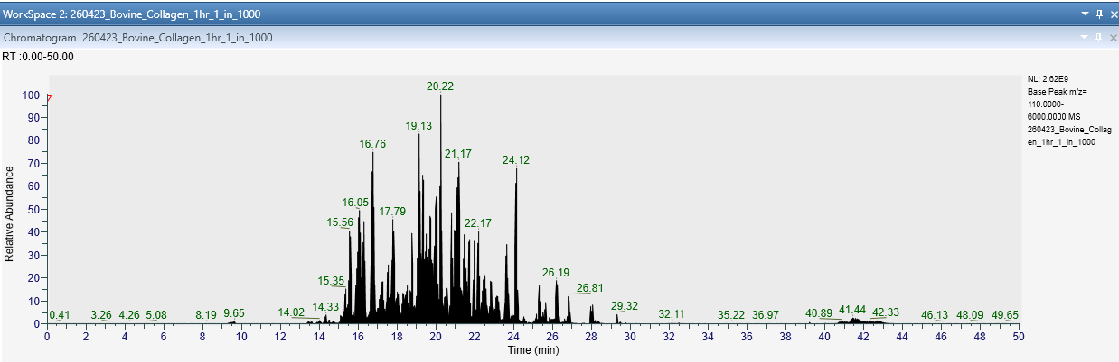
Sample 5. Bovine tendon collagen (Bos taurus, 96%)
Figure S4. BPI (2.62e9) chromatogram for bovine (Bos taurus) tendon collagen (96%)

Table S6. Protein match summary for bovine (B. taurus) tendon collagen (96%). Database Searched: UniCow (Entries: 42,151).
Accession | Score | Sequence Coverage (%) | No. of Peptides | No. of Unique Peptides | Description
P02453|CO1A1_BOVIN | 467.2 | 71.16 | 141 | 140 | Collagen alpha-1(I) chain OS=Bos taurus
P02465|CO1A2_BOVIN | 455.7 | 73.68 | 125 | 125 | Collagen alpha-2(I) chain OS=Bos taurus
E1BB91|E1BB91_BOVIN | 376.4 | 15.64 | 44 | 44 | Collagen type VI alpha 3 chain OS=Bos taurus
Q08E14|Q08E14_BOVIN | 365.1 | 44.41 | 42 | 41 | Collagen type III alpha 1 chain OS=Bos taurus
P04258|CO3A1_BOVIN | 356.7 | 54.81 | 37 | 36 | Collagen alpha-1(III) chain OS=Bos taurus
P02459|CO2A1_BOVIN | 329.7 | 29.39 | 28 | 26 | Collagen alpha-1(II) chain OS=Bos taurus
E1BI98|E1BI98_BOVIN | 270.0 | 16.65 | 14 | 14 | Collagen type VI alpha 1 chain OS=Bos taurus
F1MKG2|F1MKG2_BOVIN | 245.3 | 8.17 | 9 | 9 | Collagen type VI alpha 2 chain OS=Bos taurus
A0A3Q1MDT9|A0A3Q1MDT9_BOVIN | 237.3 | 9.66 | 9 | 9 | Collagen type V alpha 2 chain OS=Bos taurus
G3MZI7|G3MZI7_BOVIN | 198.0 | 3.19 | 6 | 5 | Collagen type V alpha 1 chain OS=Bos taurus
F1N401|F1N401_BOVIN | 192.6 | 1.86 | 5 | 5 | Collagen type XII alpha 1 chain OS=Bos taurus
F1N0K0|F1N0K0_BOVIN | 132.0 | 1.71 | 2 | 1 | Collagen type XI alpha 1 chain OS=Bos taurus
Q32S24|COBA2_BOVIN | 131.8 | 1.96 | 2 | 1 | Collagen alpha-2(XI) chain OS=Bos taurus
F1MRP6|F1MRP6_BOVIN | 131.8 | 1.96 | 2 | 1 | Collagen type XI alpha 2 chain OS=Bos taurus
A6QPB3|COHA1_BOVIN | 81.6 | 0.81 | 1 | 1 | Collagen alpha-1(XVII) chain OS=Bos taurus
W0SK50|W0SK50_BOVIN | 81.6 | 0.81 | 1 | 1 | Collagen type XVII alpha 1 chain OS=Bos taurus
A0A3Q1NK51|A0A3Q1NK51_BOVIN | 44.4 | 0.35 | 1 | 1 | Collagen type IV alpha 6 chain OS=Bos taurus
F1MJQ6|F1MJQ6_BOVIN | 37.5 | 0.86 | 1 | 1 | Collagen type V alpha 3 chain OS=Bos taurus
A0A3Q1LXW3|A0A3Q1LXW3_BOVIN | 37.4 | 0.28 | 1 | 1 | Collagen type VI alpha 5 chain OS=Bos taurus
F1N7K7|F1N7K7_BOVIN | 36.7 | 5.38 | 1 | 1 | Macrophage receptor with collagenous structure OS=Bos taurus

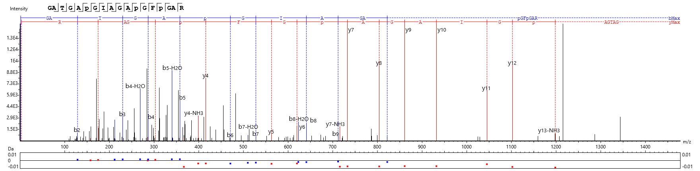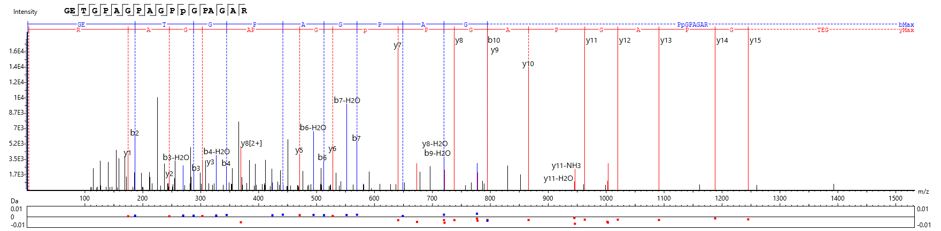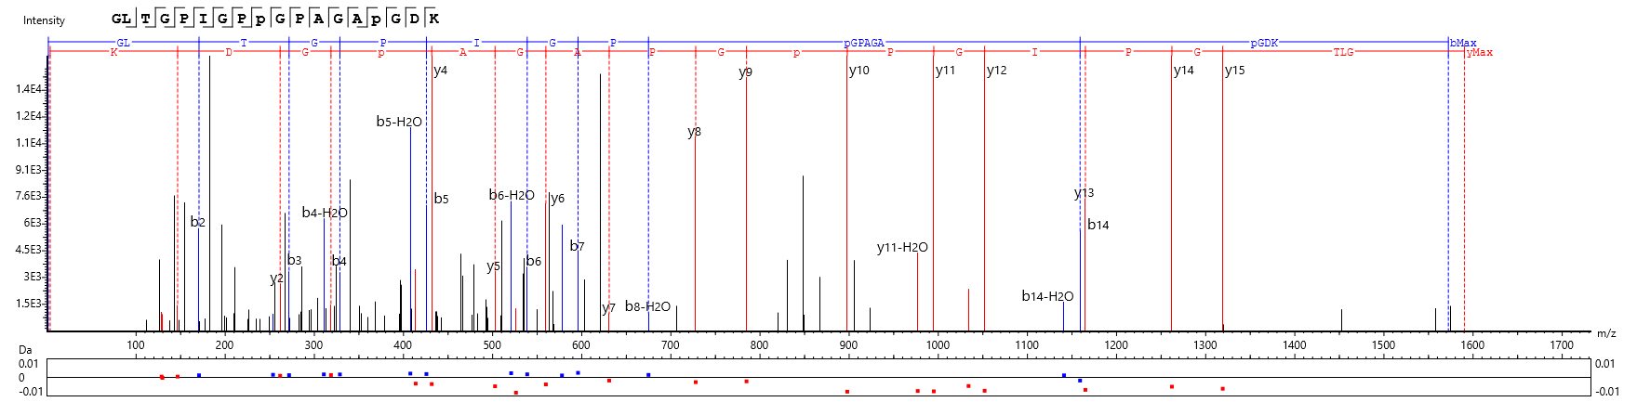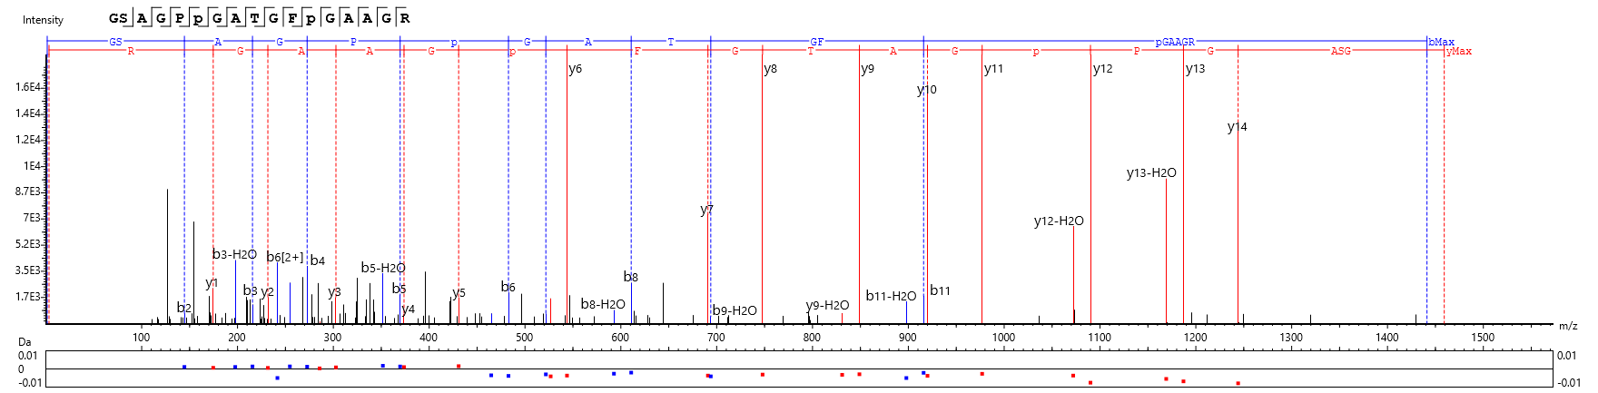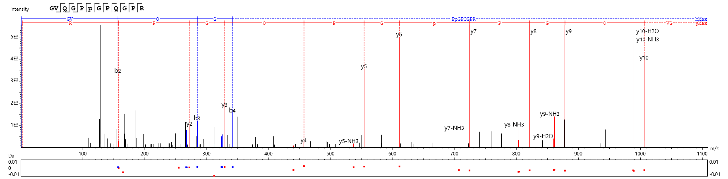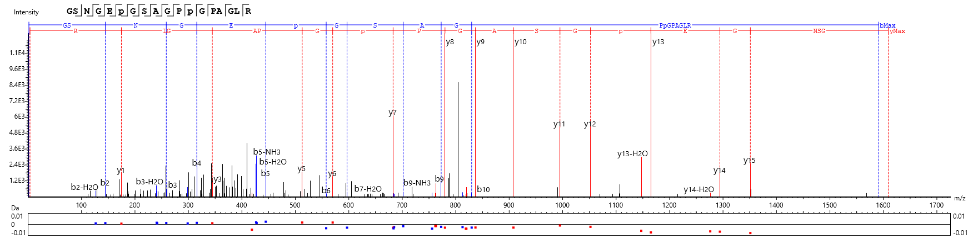
Figure S5 Annotated peptides corresponding to table 2 in the manuscript (and appear in the same order from top to bottom).

