Extended data figures
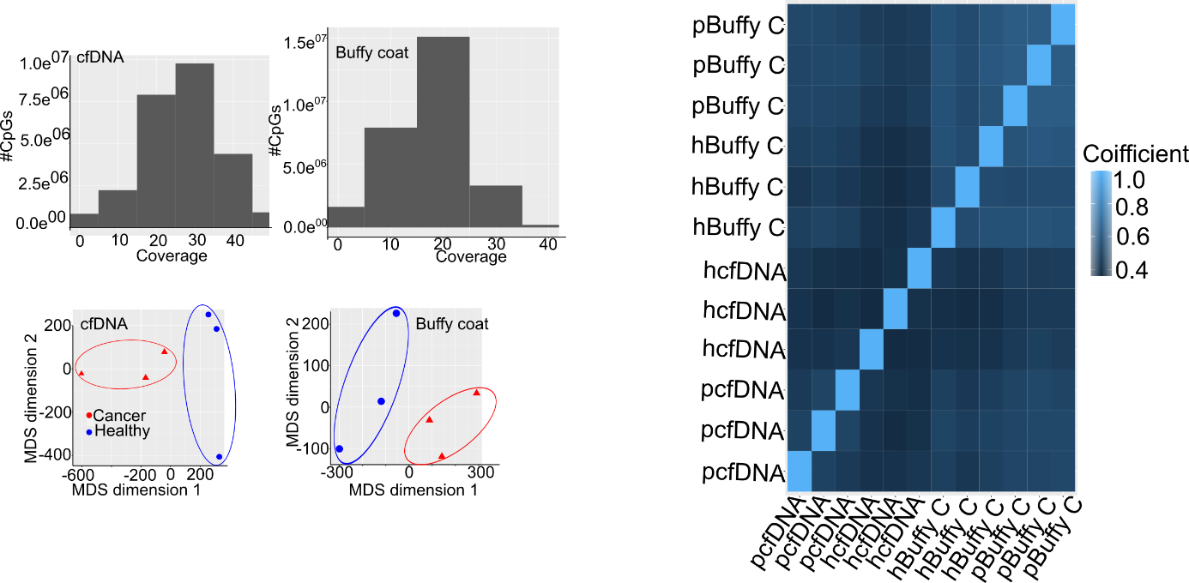
Extended data Fig. 1 | WGBS quality control and sample relationships. a, histogram showing the number of detected CpG sites in WGBS as a function of sequencing coverage in ccfDNA sample pools (left panel) and in buffy coat pools (right panel). b, multidimensional scaling plot presenting the unsupervised clustering of different sample types based on methylation tilling regions. c, A correlation heatmap showing the correlation between different samples groups and tissue types.

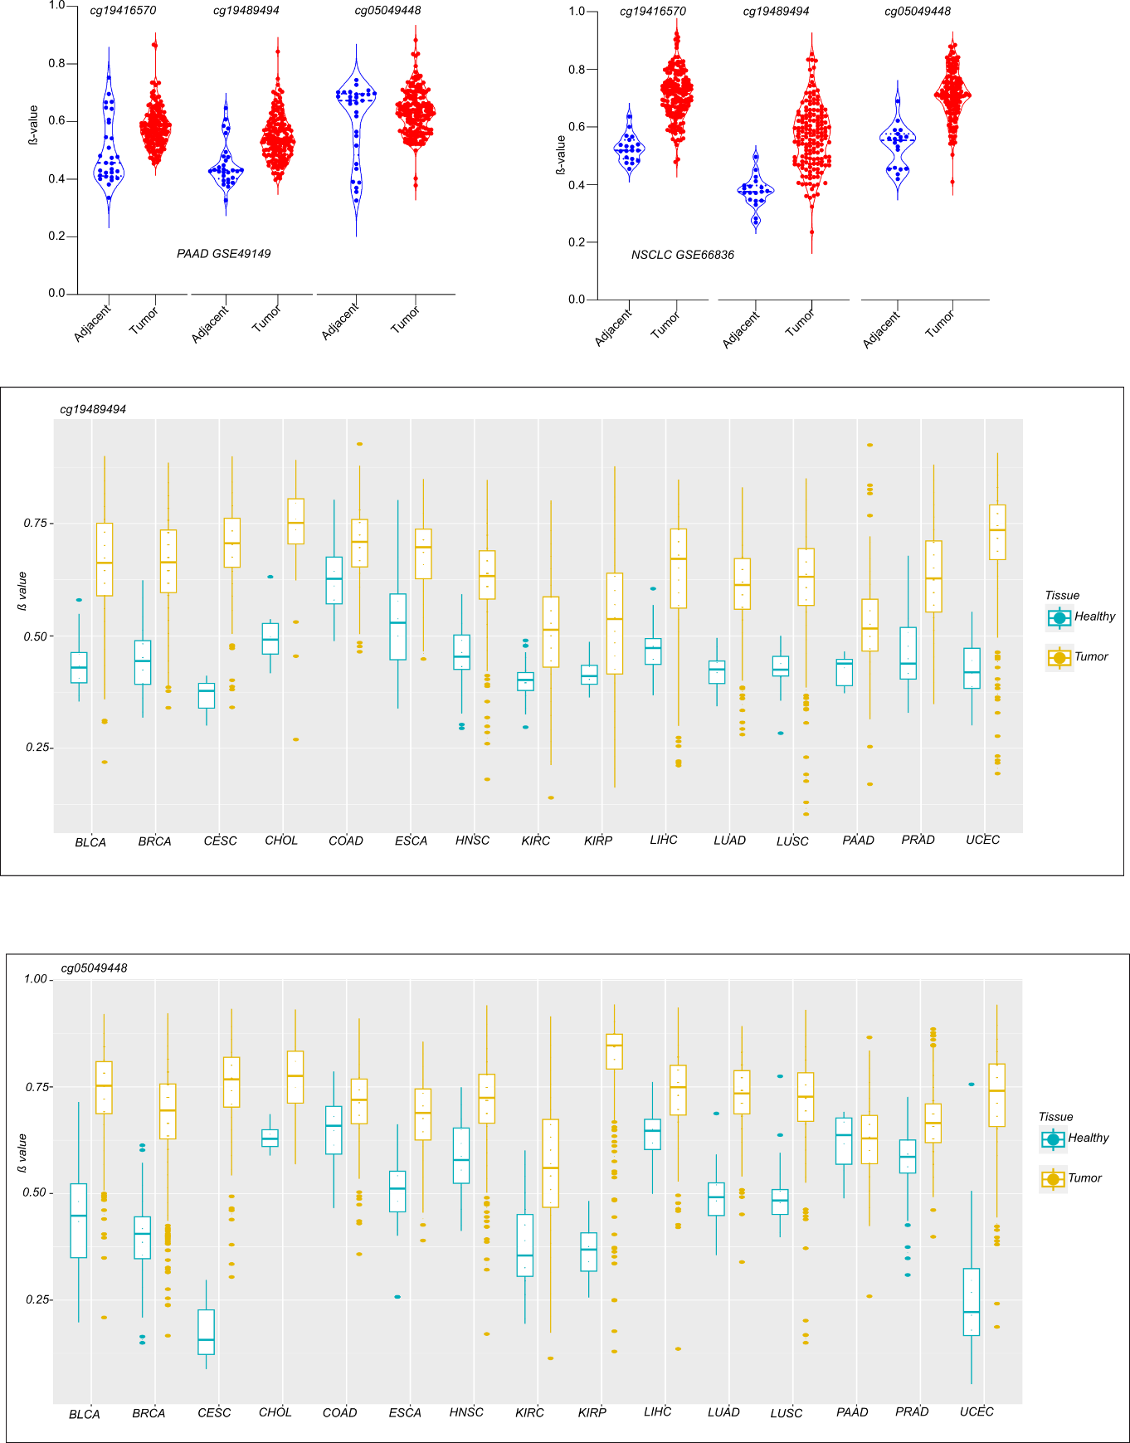
Extended data Fig. 2 | ccfDNA methylation patterns are reflected in independent patient cohorts from the gene expression omnibus (GEO). a, boxplot showing the methylation pattern of the pan-cancer hypermethylated site cg19489494 in tumor vs non-tumor tissue in fifteen cancer entities from the TCGA. b, boxplot showing the methylation pattern of the pan-cancer hypermethylated site cg05049448 in tumor vs non-tumor tissue in fifteen cancer entities from the TCGA. c, violin plots presenting the methylation patterns of the three best-performing CpGs (cg19489494, cg05049448 & cg19416570) in independent validation PAAD (left panel) and LUAD (right panel). The methylation data for PAAD was obtained from the study (ref 32, GSE49149), meanwhile the data for LUAD was obtained from the study (ref 31, GSE66836).

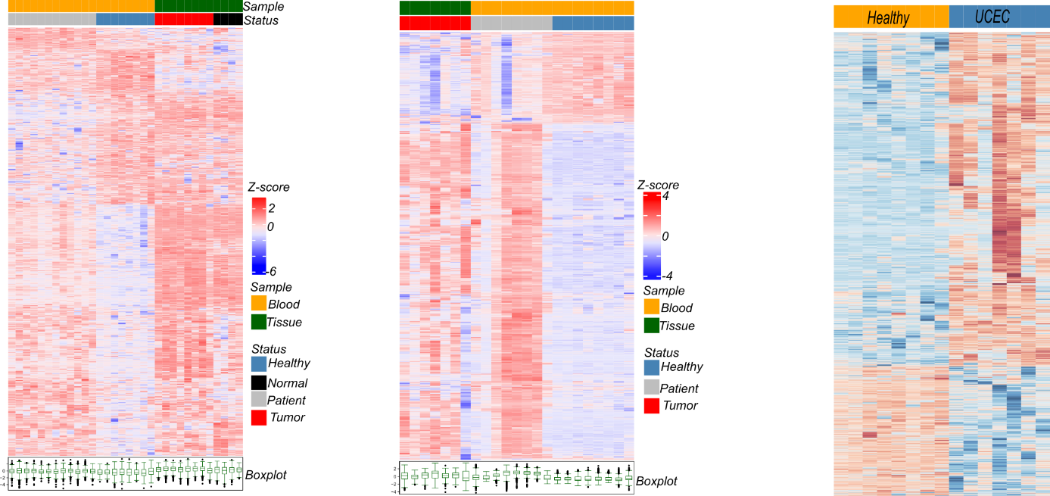
Extended data Fig. 3 | ccfDNA methylation patterns are similar in plasma and tumor tissue from the same entity. a, heatmap showing differentially methylated CpG sites (mean coverage ≥ 10, mean methylation difference ≥ 0.1, and p value < 0.05) in ccfDNA from BRCA patients vs healthy blood donors as well as BRCA tumor tissue vs non tumor samples(left panel) and differentially methylated CpG sites in ccfDNA from PRAD vs healthy blood donor and PRAD tumor tissue. For both BRCA and PRAD, differentially methylated sites were obtained by comparing ccfDNA from patients and healthy donors. The sites were then projected on data from tumor tissue without any further differential analysis. b, heatmaps showing differentially methylated ccfDNA sites in responders and non-responders to immune checkpoint blockage for COAD (left panel), NSCLC (middle panel) and SKCM (right panel).

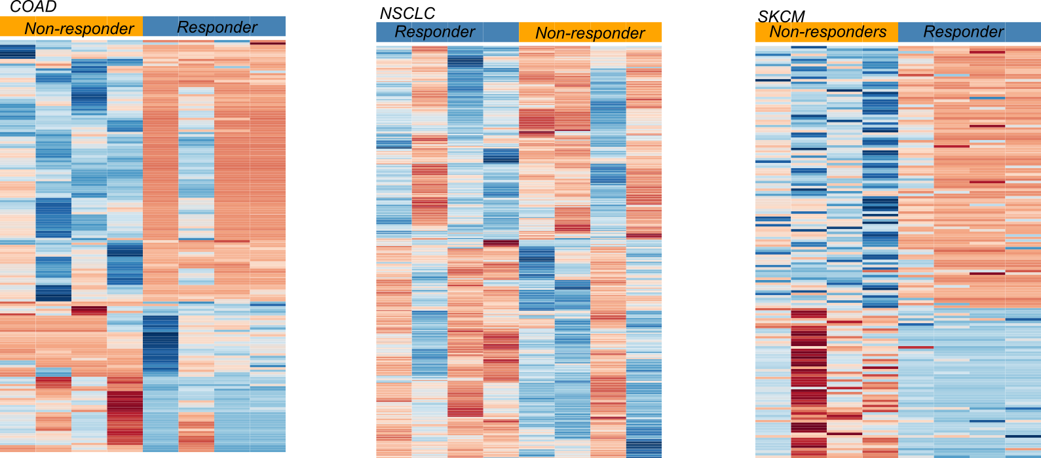
Extended data Fig. 4 | Genes associated with ccfDNA methylation show aberrant expression in tumor samples. a, boxplot presenting the expression of genes associated with cancer overarching hypermethylated sites in tumor vs normal samples across 15 TCGA cancer entities. b, boxplot showing the methylation profile between tumor and normal tissue across 15 cancer entities within the TCGA for the cancer overarching hypermethylated CpG sites (cg12018098) with mean methylation difference ≥ 0.3 and which is associated with the protein coding gene SPRED3. c, boxplot showing the gene expression profile between tumor and normal tissue across 15 cancer entities within the TCGA for the gene SPRED3, which is associated with the DMP cg12018098.

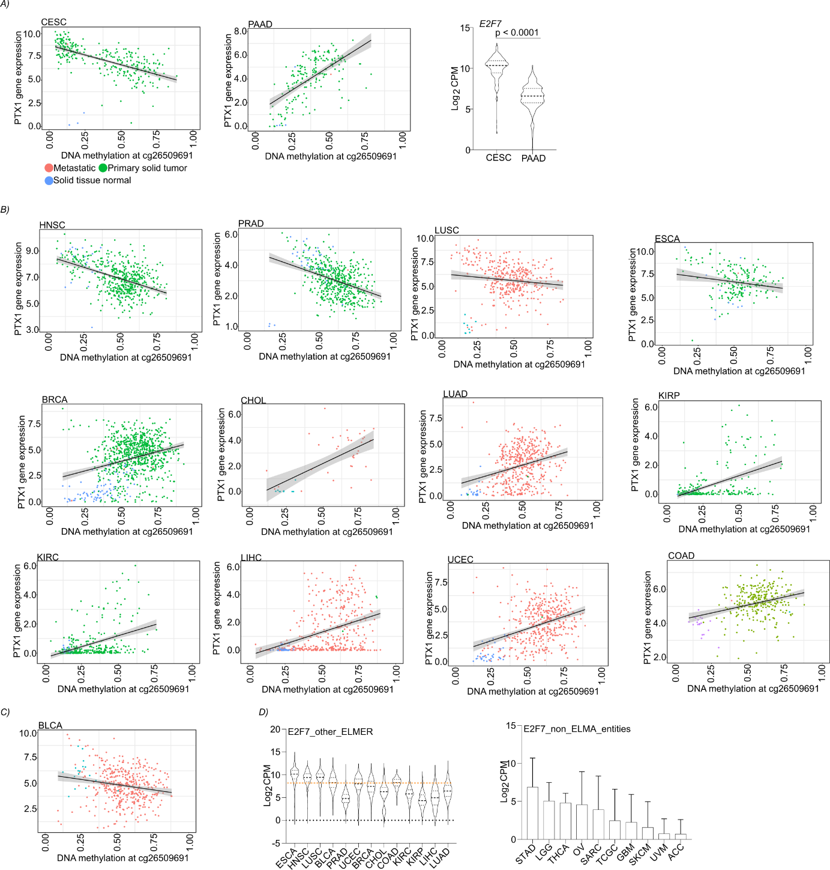
Extended data Fig. 5 | Tissue-specific expression patterns of repressor and activator transcription factors with methylated-CpG-binding activity might explain aberrant epigenetic gene expression control. a, scatter plot showing the correlation between DNA methylation at cg26509691 and the expression of its associated gene PITX1 in cervical cancer (left panel), in pancreatic ductal adenocarcinoma (middle panel) and a violin plot presenting the expression of the repressive E2F transcription factor family member E2F7, which has two DP1 sites for DNA binding (right panel). b, scatter plot showing the correlation between DNA methylation at cg26509691 and the expression of its associated gene PITX1 in thirteen independent cancer entities from within the TCGA. c, violin plot showing gene the expression of the repressive E2F transcription factor family member E2F7, which has two DP1 sites for DNA binding in the cancer entities presented in fig. b above. d, bar plot presenting the expression of the repressive E2F transcription factor family member E2F7, which has two DP1 sites for DNA binding in TCGA cancer entities not analyzed due in this study due to lack of paired tumor and normal samples with DNA methylation and gene expression data.
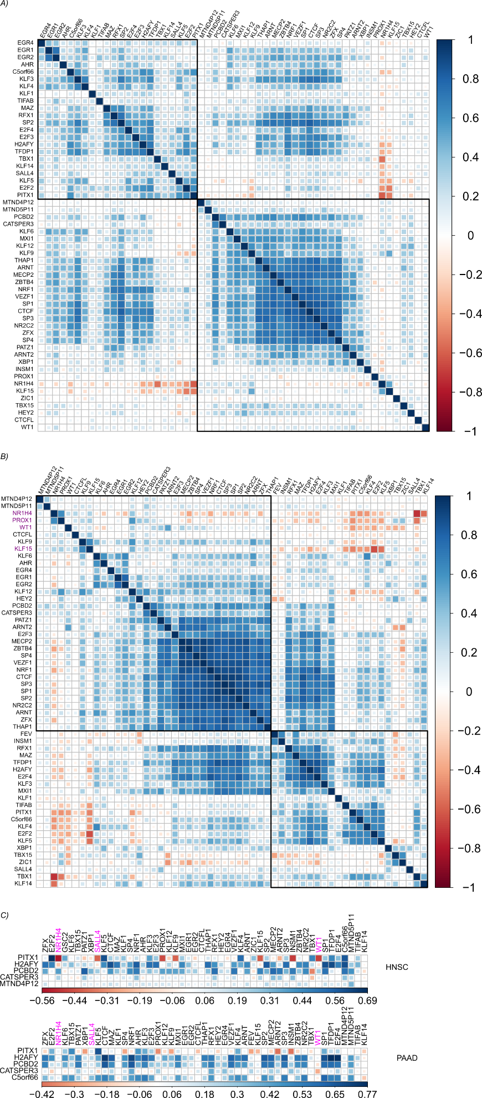
Extended data Fig. 6 | Methylated CpG-binding transcription factor modulate gene expression in a tissue- and context-dependent manner. a, correlation matrix showing the correlation coefficient between all cg26509691-nearby genes and all candidate transcription factors associated with probe-gene pairs in tumor samples. b, correlation matrix showing the correlation coefficient between all cg26509691-nearby genes and all candidate transcription factors associated with probe-gene pairs in non-tumor samples. Some transcription factors are unmatched between tumor and normal because of low or no expression. c, correlation matrix showing the correlation coefficient between selected cg26509691-nearby genes and all candidate transcription factors associated with probe-gene pairs in head and neck squamous cell carcinoma (HNSC), upper panel and in pancreatic ductal adenocarcinoma (PAAD), lower panel.

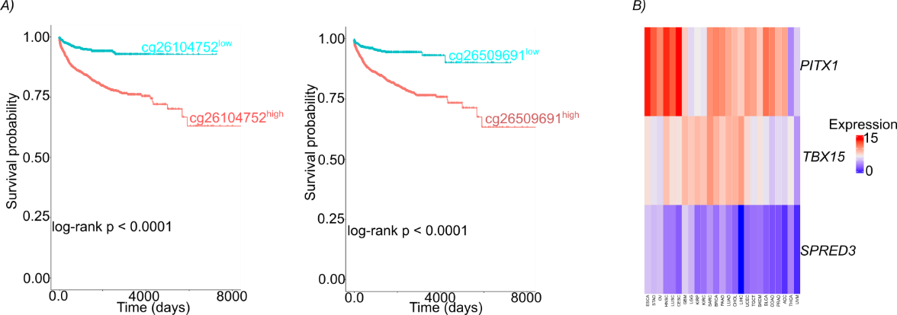
Extended data Fig. 7 | cancer overarching DNA methylation sites are prognostic. a, pan-cancer Kaplan-Meier overall survival curve showing the survival pattern of patients with high and low methylation profiles for the differentially methylated CpG cg26104752 (left panel) and cg26509691 (right panel). Patient dichotomization was achieved by means of the survminer package for each methylation event. b, heatmap showing the expression of protein-coding genes associated with the pan-cancer hypermethylated Cpg sites cg12018098, cg26104752 and cg26509691 in an independent pan-cancer gene expression cohort from GEPIA2 (http://gepia2.cancer-pku.cn/#index).

