Supporting information for ASAP: an automatic sequential assignment program for congested solid state multidimensional NMR spectra
Bo Chen
Department of Physics, University of Central Florida, Orlando, 32816 USA
Bo.chen@ucf.edu
ORCID: 0000-0001-5589-2075

Keywords Sequential assignment · NMR · multidimensional spectroscopy

Derivation of optimized annealing setup conditions.
The key challenge for correct sequential allocations is to remove type 1 local minima. Assignments trapped in such local minima need to be re-allocated by MCSA to achieve maximization of $n_{u}$, minimization of $n_{b}$ and $n_{e}$ and maximal continuous good connection $n_{g}$. When trapped in their local minima, they form either one or two good connections with their neighbors, just like the correctly allocated assignments. To remove such a misallocated coincidental “good assignment”, it will result $S_{k}^{i}\left(∆n_{gk},∆n_{bk},∆n_{ek},∆n_{uk}\right)<0$, unless they are replaced by a new assignment pair that also make the same or more good connections with neighbors, which is possible but its probability is very low. The most likely route to take out a pair of residue type assignments trapped in a local minimum with the least penalty, is to replace by a null assignment, whose probability is specified by $p_{0}$. However, not every attempt to replace with a null assignment will be accepted due to the penalty associated with the negative score function, unless sufficient trials are guaranteed. In the following, we will derive from basic statistics to specify the condition, which will guide the optimized setup for ASAP.
At the beginning of annealing step $i$, assume that a residue type assignment pair are forming two good connections with its neighbors. For the simplicity of our derivation, neglecting the non-uniform composition of different amino acids, the probability for an assignment pair of a specific residue type to be allocated to its correct position is:
 | $$p_{c}=\frac{20}{N_{res}}$$ | 1
Here $N_{res}$ is the total number of residues in the protein. We note that for those implicated with $n_{l}$ sets of assignments with overlapping ¹⁵N resonances, $n_{0}$ scales up accordingly, as they can more frequently be trapped with two good connections. Now, we are to replace this residue type assignment pair making two good connections with its neighbors by a null assignment. The incurred change of score function is:
 | $$S(-2,0,-2,-1)=-2\left(w_{1f}+w_{3f}\right)\frac{scalar}{n_{step}}i-w_{4f}\frac{scalar}{n_{step}}i$$ | 2
The probability for this step to be accepted is:
 | $$p_{s}=exp⁡(S(-2,0,-2,-1))$$ | 3
Hence, the probability of its rejection is:
 | $$p_{r}=1-p_{s}$$ | 4
If $n_{0}$ is the total number of attempts to replace the existing assignment by a null assignment, the number of guaranteed accepted moves is:
 | $$count=n_{0}\left[1-{\left(p_{r}\right)}^{n_{0}}\right]$$ | 5
The probability to make a null assignment attempt every time we visit a residue position is $p_{0}=0.4$. If we accept 95% probability to make a null assignment as an insurance, which is guaranteed in every six visits to each residue position, the number of null assignment attempts that takes place after this assignment pair trapped in a position with two good connection at the beginning of this annealing step is:
 | $$n_{0}≅\frac{n_{t}}{6}=\frac{N_{a}p_{c}}{6N_{res}}=\frac{10N_{a}}{3N_{res}^{2}}$$ | 6
Here $n_{t}$ is the total available Monte attempts. Therefore, combining Eqs. 5 and 6, the guaranteed number of accepted null assignment moves at each annealing step is:
 | $$count=\frac{n_{t}}{6}(1-{\left(p_{0}\right)}^{\frac{n_{t}}{6}})$$ | 7
To ensure its occurrence in operation, the threshold is determined by setting the expression in Eq. 5 to 1:
 | $$n_{0}\left[1-{\left(p_{r}\right)}^{n_{0}}\right]=1$$ | 8
Which can be further transformed into:
 | $$\ln{p_{r}}=\ln{{\left(1-\frac{1}{n_{0}}\right)}^{{\frac{1}{n}}_{0}}}$$ | 9
Plug in the expression for $p_{r}$ in Eq. 3:
 | $$\ln\left(1-e^{S(-2,0,-2,-1)}\right)=\ln{{\left(1-\frac{1}{n_{0}}\right)}^{{\frac{1}{n}}_{0}}}$$ | 10
Towards later stage of annealing, $n_{t}≫1$ and $S\left(-2,0,-2,-1\right)≪1$, so Taylor expansion is justified. Keep the first order approximation:
 | $$1-e^{S(-2,0,-2,-1)}\sim 1-{\left(\frac{1}{n_{0}}\right)}^{2}$$ | 11
Which gives us:
 | $$n_{0}=e^{-\frac{S(-2,0,-2,-1)}{2}}$$ | 12
Plug in the expression from Eq. 6, the number of Monte Carlo attempts required for one successful escape from a position making two good connections at the beginning of an annealing step is:
 | $$N_{a}(n_{g}=2)=\frac{3N_{res}^{2}}{10}e^{-\frac{S(-2,0,-2,-1)}{2}}$$ | 13
The same analysis can be applied for an assignment making a single good connection to either of its neighbors, with the other neighbor occupied by a null assignment. The threshold is described by:
 | $$N_{a}(n_{g}=1)=\frac{3N_{res}^{2}}{10}e^{-\frac{S(-1,0,0,-1)}{2}}$$ | 14
Therefore, given the annealing setup, Eqs. 13 and 14 are the analytical expressions to estimate the annealing steps for ASAP to execute effective annealing.

Figure S1. Snapshot of the summary report by ARTIST match pairing.

Figure S2. Histogram of the number of matched RTA pairs with overlapping ¹⁵N resonances and sufficiently different secondary chemical shifts implicated to incur type 2 local minima for RSV (A), SrtC (B) and MLKL (C). Red filled bars: results based on input with entirely non-ambiguous RTAs. Blue empty bars: results based on input with level 2 ambiguity for RSV, or level 1 ambiguity for SrtC and MLKL as described in text.

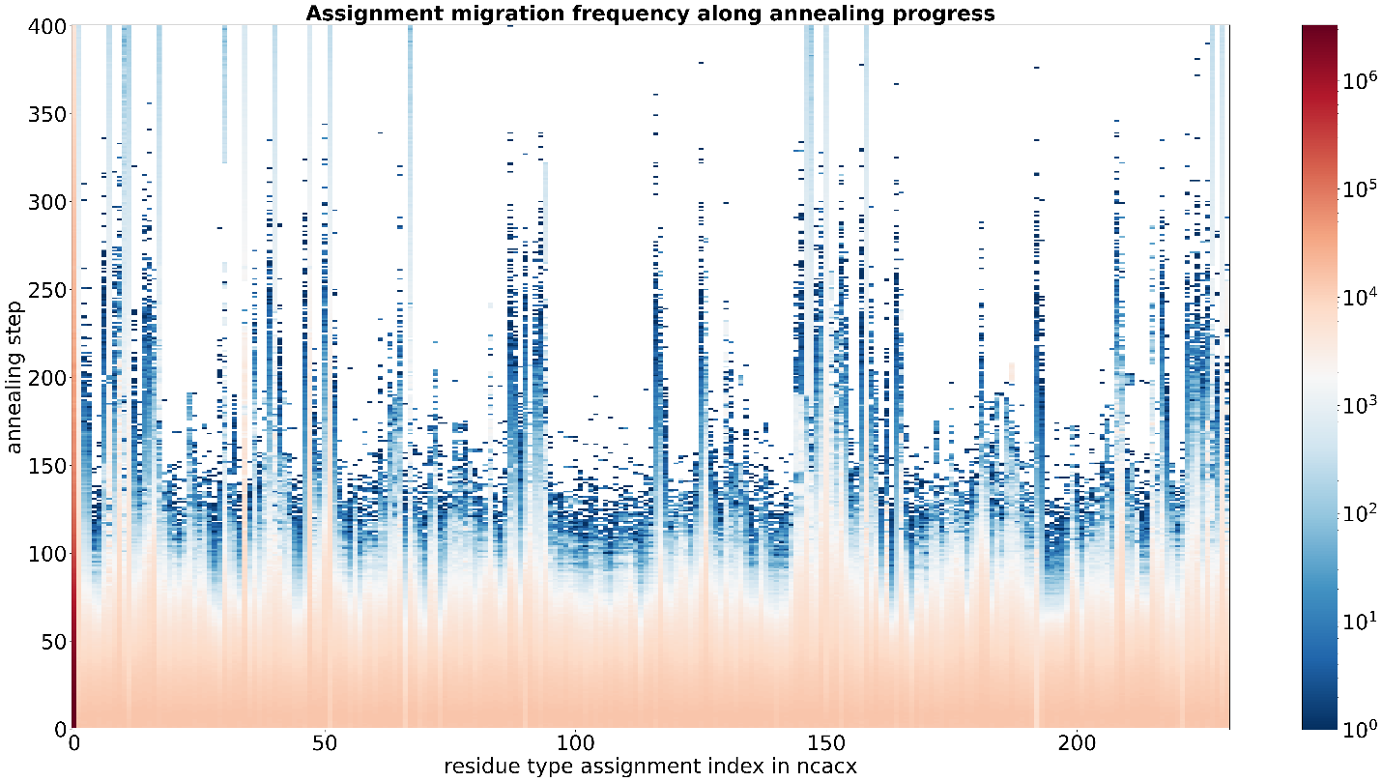
Figure S3. Re-allocation frequency of each RTA in input 1 as a function of annealing progress. The scale bar to the right denotes the re-allocation frequency.

Figure S4. Re-allocation frequency of each residue position at specified annealing step in A and B, and RTAs seated at neighboring positions at specified annealing step in C and D. The scale bars to the right denote the re-allocation frequency.

Figure S5. Re-allocation frequency of each residue position at specified annealing steps for run 10 in Table 1 (without ambiguity in input) in (A) and run 14 in Table 3 (with ambiguity in input) in (B).

Shifted assignments sets | ¹⁵N resonance | ¹³C-alpha resonance | ¹³C-beta resonance | Allocated positions | Ambiguity in input
 | 122.6 | 54.99 | 19.04 | A72 | No
 | 122.3 | 54.51 | 18.02 | A131 | Yes
 | 119.1 | 60.5 | 38.1 | I172 | Yes
 | 119 | 66.08 | 38.63 | I35 | No
 | 134.4 | 64.9 | NAN | P63 | Yes
 | 134.8 | 65.0 | NAN | P152 | No
 | 107.7 | 44.46 | NAN | G94 | Yes
 | 107.7 | 44.5 | NAN | G30 | No
Table S1. Shifted RTAs due to ambiguity in input that are not seated at the edge of a stretch of assignments with good connections.

