SUPPLEMENTARY MATERIAL
Supplementary material Table S1: Descriptions relating to OPCS-4 and ICD-10 codes used
OPCS-4 codes used to identify exclusions due to additional procedural complexity
C647 | Insertion of iris hooks
C776 | Insertion of capsule tension ring
C792 | Vitrectomy using pars plana approach
C793 | Injection of vitreous substitute into vitreous body
C795 | Internal tamponade of retina using gas
C796 | Internal tamponade of retina using liquid
C797 | Removal of internal tamponade agent from vitreous body
C801 | Peel of epiretinal fibroglial membrane
C802 | Peel of internal limiting membrane
C803 | Delamination of epiretinal fibrovascular membrane
C804 | Segmentation of epiretinal fibrovascular membrane
C805 | Removal of subretinal vascular membrane
C806 | Removal of subretinal membrane
C808 | Other specified operations on retinal membrane
C809 | Unspecified operations on retinal membrane
ICD-10 codes used to identify exclusions due to complex diagnoses
F00 | Dementia in Alzheimer's disease
F01 | Vascular dementia
F02 | Dementia in other diseases classified elsewhere
F03 | Unspecified dementia
G30 | Alzheimer's disease
F051 | Delirium superimposed on dementia
G310 | Circumscribed brain atrophy
G311 | Senile degeneration of brain, not elsewhere classified
F70 | Mild mental retardation
F71 | Moderate mental retardation
F72 | Severe mental retardation
F73 | Profound mental retardation
F78 | Other mental retardation
F79 | Unspecified mental retardation
H200 | Acute and subacute iridocyclitis
H201 | Chronic iridocyclitis
H202 | Lens-induced iridocyclitis
H208 | Other iridocyclitis
H209 | Iridocyclitis, unspecified
H220 | Iridocyclitis in infectious and parasitic diseases classified elsewhere
H221 | Iridocyclitis in other diseases classified elsewhere
H300 | Focal chorioretinal inflammation
H301 | Disseminated chorioretinal inflammation
H302 | Posterior cyclitis
H308 | Other chorioretinal inflammations
H309 | Chorioretinal inflammation, unspecified
H320 | Chorioretinal inflammation in infectious and parasitic diseases classified elsewhere
ICD-10 = International Statistical Classification of Diseases and Related Health Problems, tenth revision. OPCS-4 = Office of Populations Censuses and Surveys Classification of Interventions and Procedures version 4.

Supplementary material Table S2: Number of out-patient appointments (face-to-face and virtual) for patients with diabetes, glaucoma, both conditions and neither condition
Variable | Neither diabetes nor glaucoma (n = 364608) | Diabetes (n = 87212) | Glaucoma (n = 2772) | Diabetes and glaucoma (n = 758)
Pre-operative
0 | 66010 (18.1%) | 14201 (16.3%) | 605 (21.8%) | 164 (21.6%)
1 | 156623 (43%) | 32414 (37.2%) | 942 (34%) | 227 (29.9%)
2 | 86139 (23.6%) | 22026 (25.3%) | 628 (22.7%) | 177 (23.4%)
3 | 32373 (8.9%) | 9891 (11.3%) | 321 (11.6%) | 102 (13.5%)
≥ 4 | 23459 (6.4%) | 8680 (10%) | 276 (10%) | 88 (11.6%)
Post-operative
0 | 101646 (27.9%) | 20704 (23.7%) | 807 (29.1%) | 214 (28.2%)
1 | 154592 (42.4%) | 35196 (40.4%) | 1030 (37.2%) | 274 (36.1%)
2 | 60162 (16.5%) | 15868 (18.2%) | 474 (17.1%) | 133 (17.5%)
3 | 25813 (7.1%) | 7827 (9%) | 236 (8.5%) | 64 (8.4%)
≥ 4 | 22391 (6.1%) | 7617 (8.7%) | 225 (8.1%) | 73 (9.6%)

Supplementary material Figures S1: Scatterplot of the portion of patients with three or more pre-operative out-patient attendances and patient numbers for each integrated Care Board in England
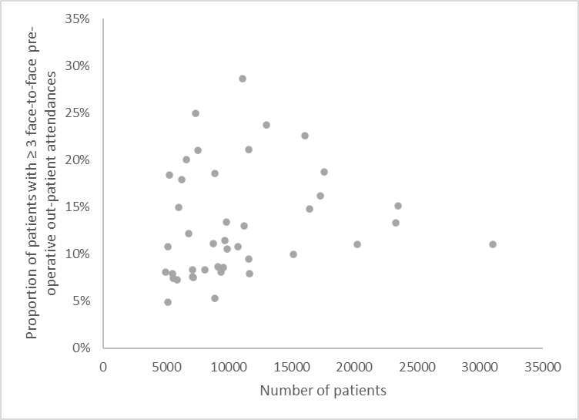

Supplementary material Figures S2: Scatterplot of the portion of patients with three or more post-operative out-patient attendances and patient numbers for each integrated Care Board in England
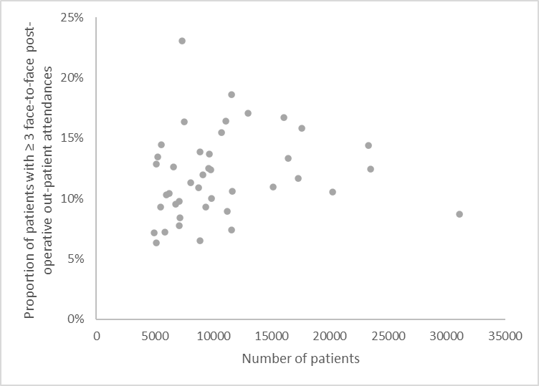

Supplementary material Figures S3: Scatterplot of the portion of patients with three or more pre-operative and post-operative out-patient attendances for each integrated Care Board in England
