Supplementary Table 1: Characteristics of clinical studies included in the meta-analysis
First author | Publication year | Drug | Clinical trial identifier (name) | Total Num with HF-T2DM | HF statues | Interventions (Num) | CVD/HHF |  | HHF |  | CVD |  | ACM
 |  |  |  |  |  |  | SGLT-2i group (events num, n/N) | Placebo group (events num, n/N) | SGLT-2i group (events num, n/N) | Placebo group (events num, n/N) | SGLT-2i group (events num, n/N) | Placebo group (events num, n/N) | SGLT-2i group (events num, n/N) | Placebo group (events num, n/N)
Fitchett | 2016 | Empagliflozin | NCT01131676  (EMPA-REG OUTCOME trial) | 706 | all HF | Empagliflozin 10mg or 25mg (462 pts)  Placobo (244 pts) | 75/462 | 49/244 | 48/462 | 30/244 | 38/462 | 27/244 | 56/462 | 35/244
Kato | 2019 | Dapagliflozin | NCT01730534 (DECLARE–TIMI 58 trial) | 1987 | HFrEF +  HFpEF | Dapagliflozin 10mg (980 pts)  Placobo (1007pts) | 151/980 | 194/1007 | 92/980 | 130/1007 | 79/980 | 85/1007 | 122/980 | 149/1007
Petrie | 2020 | Dapagliflozin | NCT03036124  (DAPA-HF trial) | 2139 | HFrEF | Dapagliflozin 10mg (1075pts)  Placobo (1064 pts) | 213/1075 | 268/1064 | 1381075 | 172/1064 | 121/1075 | 148/1064 | 143/1075 | 178/1064

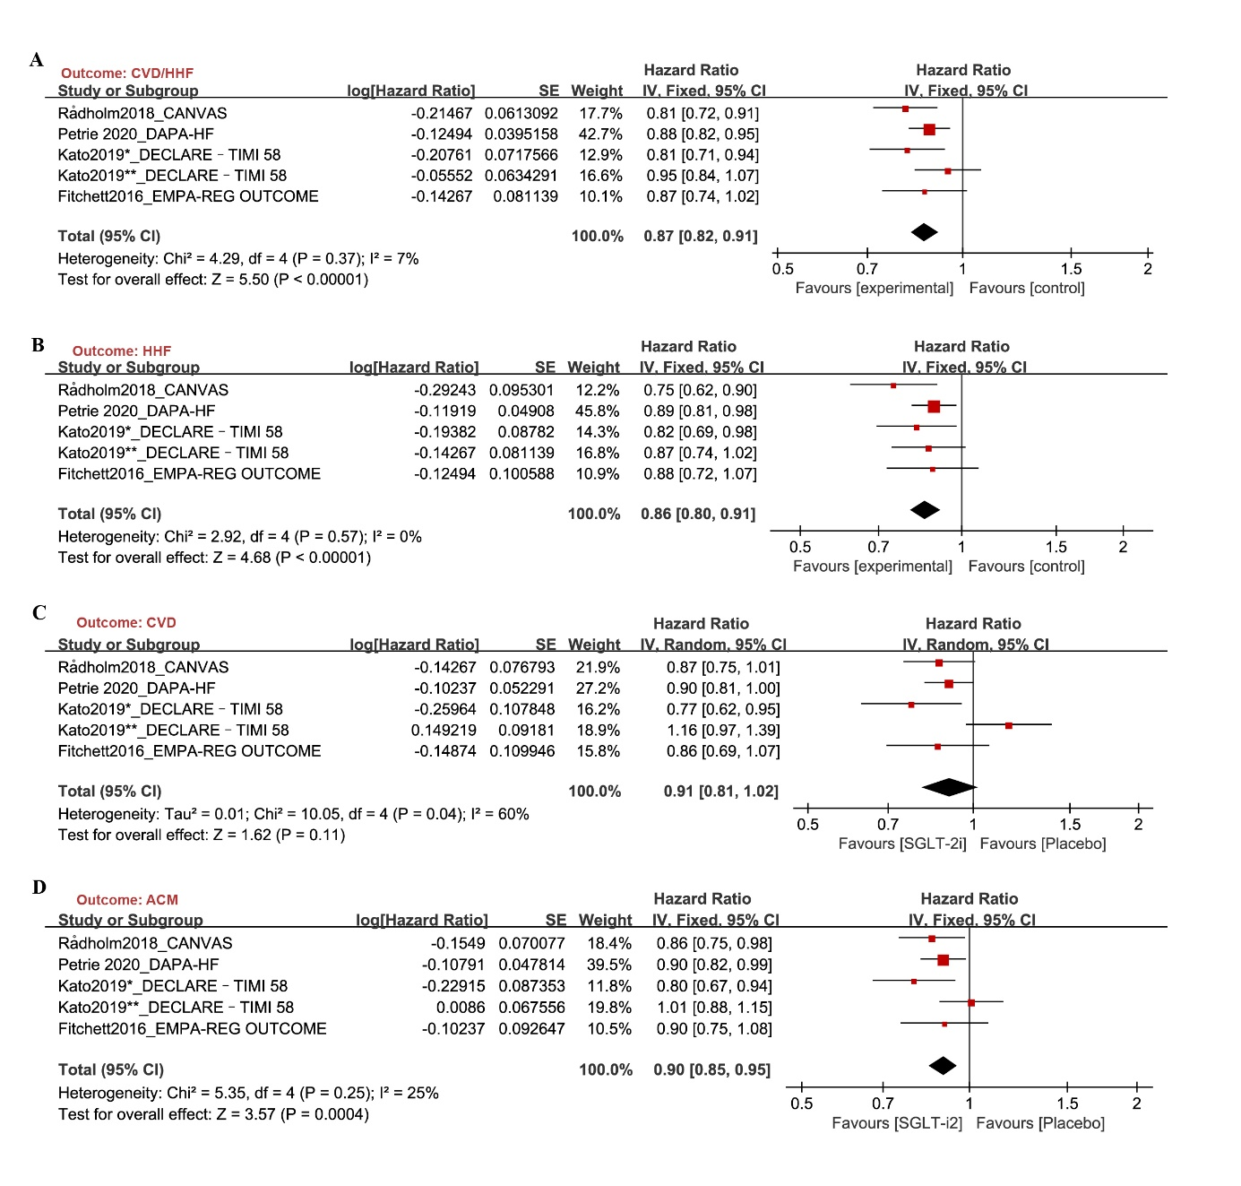
Supplementary Fig. 1 Sensitivity analysis: effect of SGLT-2i on the composite of CVD/HHF (A), HHF (B), CVD (C) and ACM (D) in patients of HF and T2DM by excluding CREDENCE trial. Abbreviation SGLT2i: sodium-glucose cotransporter-2 inhibitors; CVD: cardiovascular death; HHF: hospitalization for heart failure, ACM: all-cause mortality; CI: confidence interval.
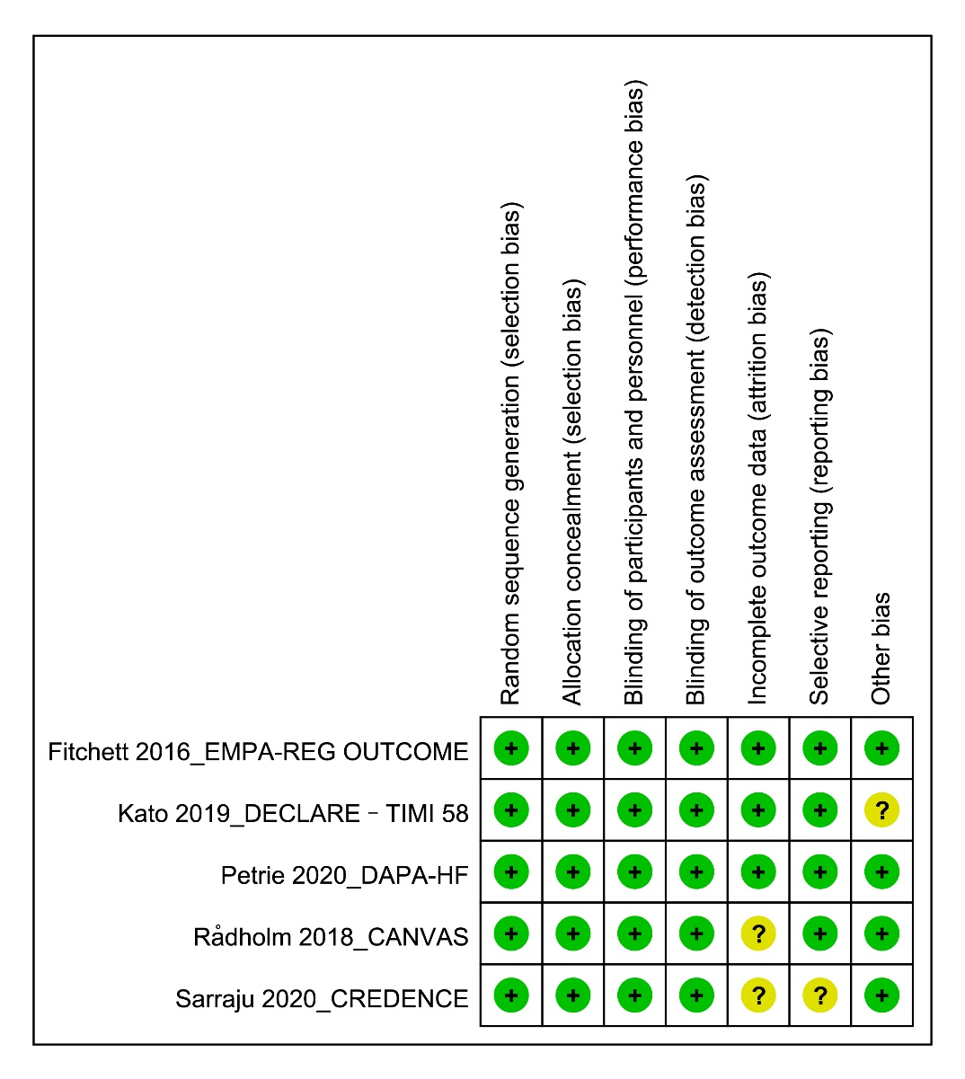
Supplementary Fig. 2 Risk of bias summary revealing the review of the authors' judgment about each risk of bias item for included RCTs.

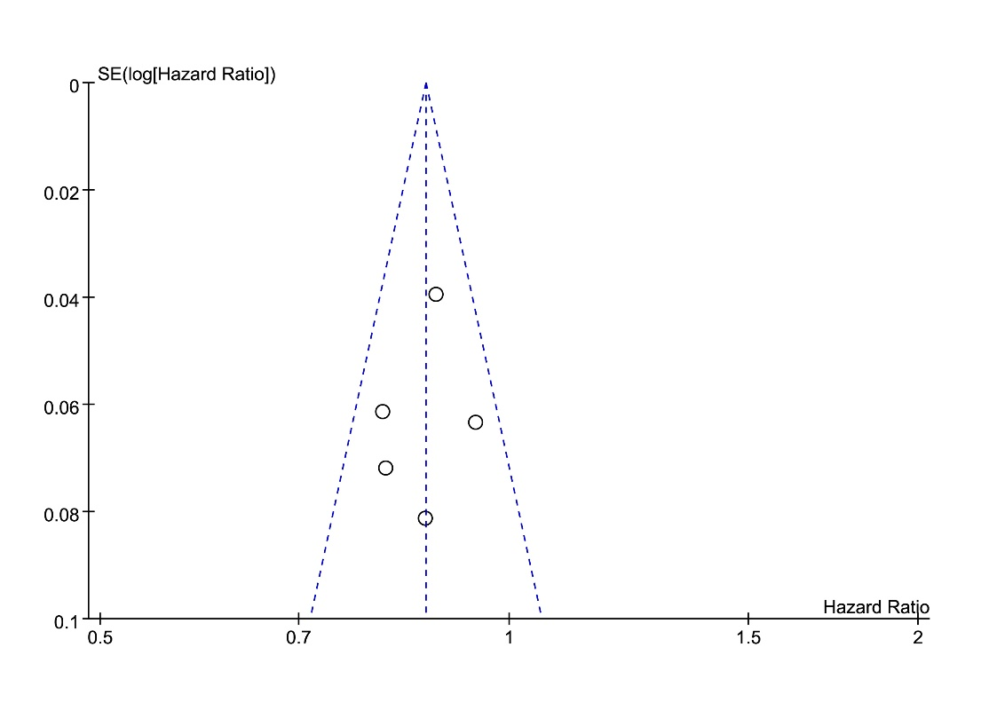
Supplementary Fig. 3 Funnel plot of hazard ratio for composite of CVD/HHF reported in the included studies.

