Supplementary
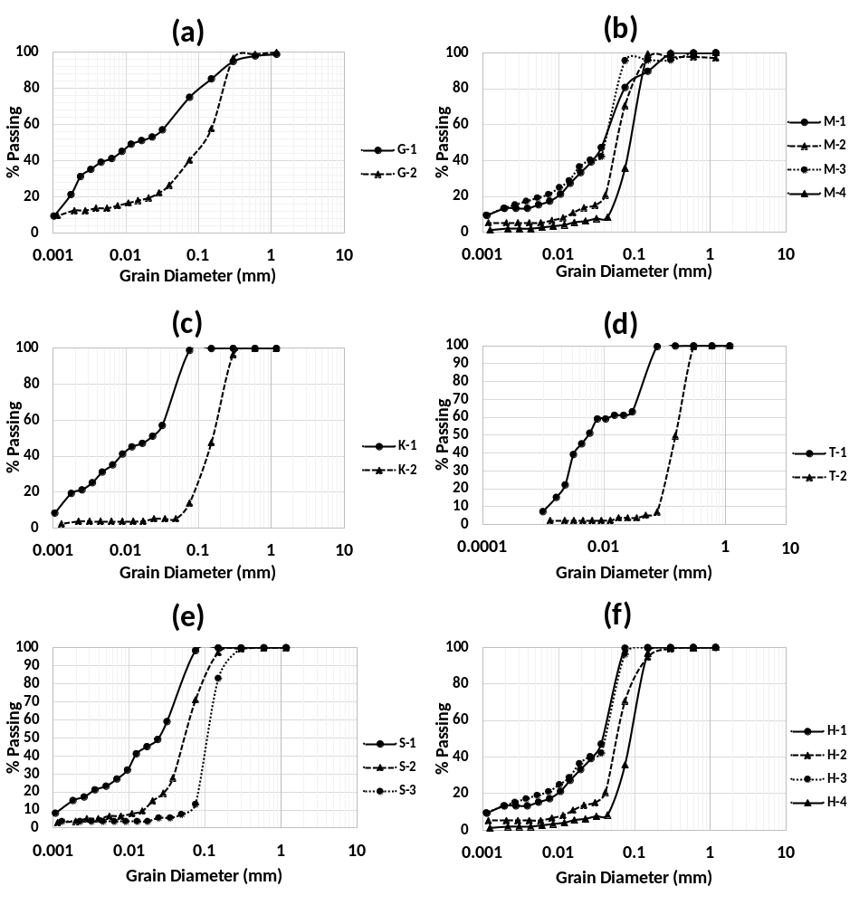
Supplementary. 1. Particle size distribution curve of the six locations (Samples name are given with the initial of the SPT locations and Borehole Sample numbers are given from top to bottom: close to the surface has been numbered as 1 and gradually increases towards the bottom of the borehole. The curves represent the grain size analysis of (a) Godagari (b) Mirganj (c) Koldiar (d) Talbaria (e) Satbaria (f) Habaspur.

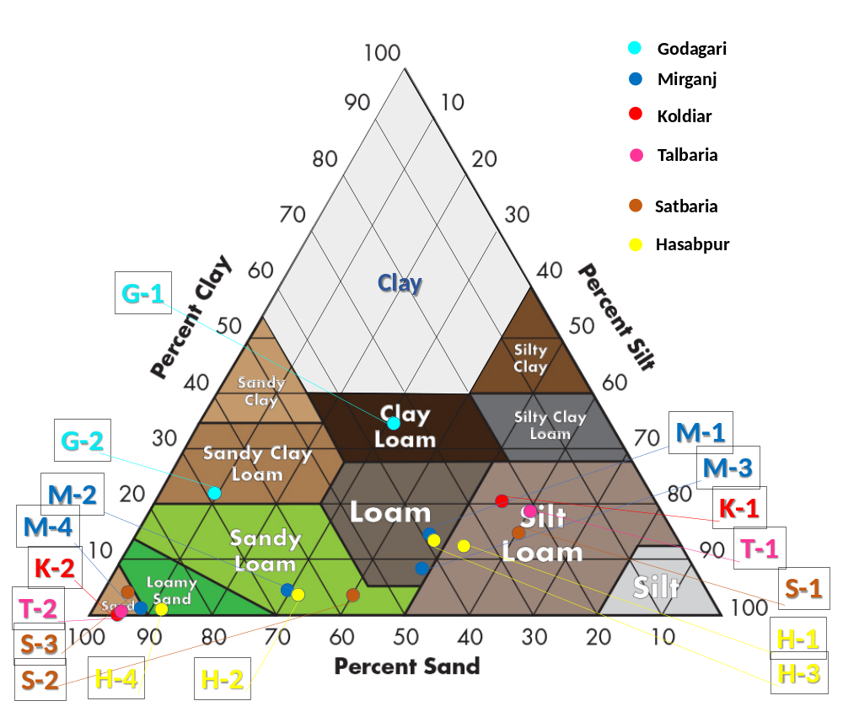
Supplementary. 2. Soil Sample texture plotting using Milton Whitney’s Soil Texture Chart (1911).

