Supplementary materials:
Reactivation of p53 as a radiosensitization strategy for mutant p53 cancers treated with high-LET radiotherapy
We display here 3 figures not included in the main text. The decay chain of 22Ra, tumor growth of groups of mice affiliated with Figure 4 of the main text, and a graphic representation of our findings.

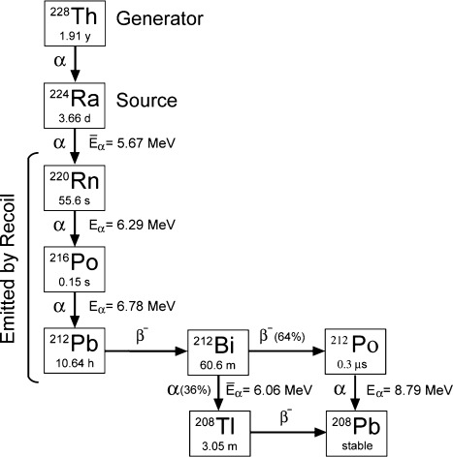

Supp. Figure 1. The decay chain of ²²⁴Ra.
Supp. Figure 2. Combination of high-LET ²²⁴Ra source with APR-246 in large CRC and PDAC xenografts (A) Mean tumor volume ± SEM of HCT116-bearing mice (~200 mm³ average volume) were treated with a 75-kBq ²²⁴Ra source or inert source on day 0, followed by 14 doses of 50 mg/kg APR-246 i.p. on days 1–7. (*** p < 0.005). (B) Mean tumor volume ± SEM of HCT116-bearing mice (~100 mm³ average volume) were treated with a 75-kBq ²²⁴Ra source or inert source on day 0, followed by 14 doses of 50 mg/kg APR-246 i.p. on days 1–7.

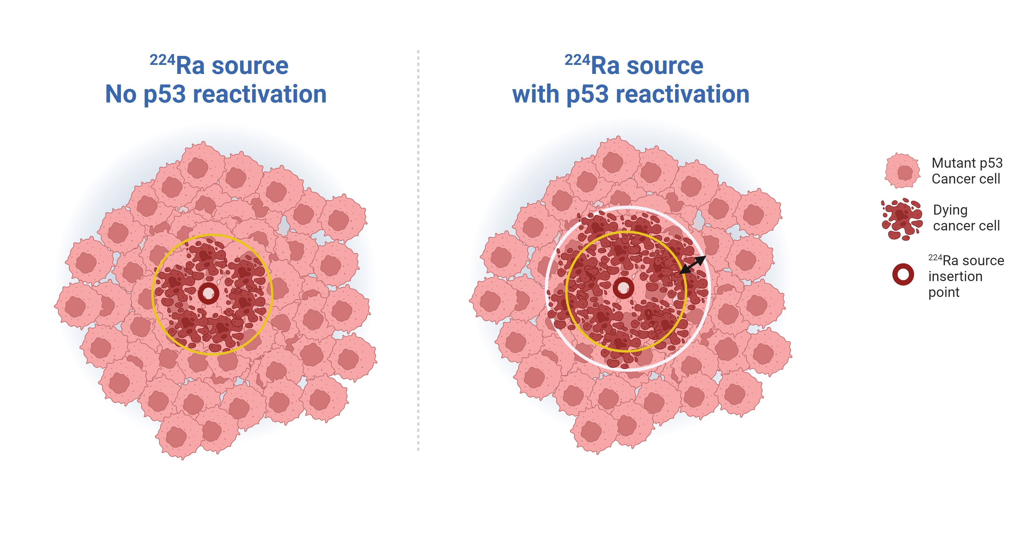
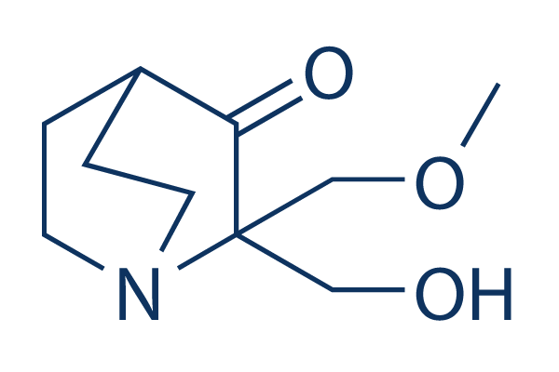
APR-246
Supp. Figure 3, Graphical representation. When combined with 224Ra source radiotherapy, the reactivation of the WT form of p53 in tumors harboring GOF mutant p53, will increase the region cell death. Such enlargement of affected perimeters will result in a more efficient tumor control and may be relevant and beneficial to CRC and PDAC patients in the future.

