Supplemental Material
Supplementary Table 1 | Evaluating the robustness of GNNs compared to benchmarks by adding 10 or 100 noisy features to the complete blood count datasets for sepsis classification (higher values represent better performance) and the required training time. We evaluated the classification performance on two datasets (internal and external dataset). Bold values represent the best values in each row. Note that the information of the original dataset (Table 1) was included in this table for a better comparison against the noisy datasets.
Dataset | Metric | Set | Tree-based Benchmarks |  |  |  | Non-tree-based algorithms |  | Graph learning algorithms
Dataset | Metric | Set | Decision Tree | Random Forest | RUSBoost | XGBoost | Logistic Regression | Neural network | Homogenous Similarity GNN | Heterogeneous Similarity GNN
Original dataset | AUROC | Internal | 0.8391 | 0.8700 | 0.8680 | 0.8642 | 0.8369 | 0.8806 | 0.8741 | 0.8747
Original dataset | AUROC | External | 0.7870 | 0.8178 | 0.8153 | 0.8121 | 0.7558 | 0.8145 | 0.8052 | 0.8176
Original dataset | F1- Macro | Internal | 0.4313 | 0.4770 | 0.4701 | 0.4373 | 0.4412 | 0.4479 | 0.4411 | 0.4422
Original dataset | F1- Macro | External | 0.4018 | 0.4609 | 0.4497 | 0.4184 | 0.3736 | 0.4502 | 0.3964 | 0.4020
Original dataset | MCC | Internal | 0.0432 | 0.0605 | 0.0576 | 0.0495 | 0.0442 | 0.0521 | 0.0499 | 0.0506
Original dataset | MCC | External | 0.0291 | 0.0385 | 0.0361 | 0.0327 | 0.0222 | 0.0383 | 0.0308 | 0.0326
Original dataset | Training Time [s] | Training | 2.00 | 17.36 | 212.88 | 0.54 | 5.97 | 19.97 | 394.69 | 981.10
With 10 noisy features | AUROC | Internal | 0.8378 | 0.8643 | 0.8605 | 0.8619 | 0.8350 | 0.8542 | 0.8617 | 0.8614
With 10 noisy features | AUROC | External | 0.7714 | 0.8155 | 0.8178 | 0.8045 | 0.7553 | 0.7917 | 0.8014 | 0.7923
With 10 noisy features | F1- Macro | Internal | 0.4297 | 0.4826 | 0.4723 | 0.5152 | 0.4413 | 0.4417 | 0.4463 | 0.4461
With 10 noisy features | F1- Macro | External | 0.4056 | 0.4661 | 0.4537 | 0.4973 | 0.3743 | 0.4449 | 0.4504 | 0.4031
With 10 noisy features | MCC | Internal | 0.0435 | 0.0636 | 0.0570 | 0.0733 | 0.0448 | 0.0484 | 0.0502 | 0.0494
With 10 noisy features | MCC | External | 0.0300 | 0.0362 | 0.0373 | 0.0358 | 0.0225 | 0.0330 | 0.0347 | 0.0300
With 10 noisy features | Training Time [s] | Training | 6.87 | 66.64 | 244.20 | 2.74 | 14.68 | 14.26 | 32.24 | 606.70
With 100 noisy features | AUROC | Internal | 0.6904 | 0.8541 | 0.8560 | 0.8469 | 0.8277 | 0.7652 | 0.8289 | 0.8134
With 100 noisy features | AUROC | External | 0.6581 | 0.8059 | 0.8096 | 0.7937 | 0.7522 | 0.7162 | 0.7674 | 0.7372
With 100 noisy features | F1- Macro | Internal | 0.4026 | 0.4951 | 0.4773 | 0.5153 | 0.4416 | 0.4387 | 0.4704 | 0.4635
With 100 noisy features | F1- Macro | External | 0.3842 | 0.4789 | 0.4608 | 0.5006 | 0.3769 | 0.4386 | 0.4696 | 0.4390
With 100 noisy features | MCC | Internal | 0.0220 | 0.0682 | 0.0596 | 0.0649 | 0.0439 | 0.0353 | 0.0508 | 0.0435
With 100 noisy features | MCC | External | 0.0126 | 0.0365 | 0.0368 | 0.0360 | 0.0224 | 0.0235 | 0.0323 | 0.0251
With 100 noisy features | Training Time [s] | Training | 15.24 | 223.51 | 809.45 | 12.82 | 102.85 | 6.38 | 19.72 | 297.97
Supplementary Table 2 | Attention weights of the last layer of the trained graph attention networks on each graph (directed graph, reverse directed graph and undirected graph). Each attention weight can vary between 0 (no influence) and 1 (high influence). We summarized all edges based on their source and target node label.
 | Directed graph |  |  |  | Reverse directed graph |  |  |  | Undirected graph
 | Control to Control | Sepsis to Control | Control to Sepsis | Sepsis to Sepsis | Control to Control | Sepsis to Control | Control to Sepsis | Sepsis to Sepsis | Control to Control | Sepsis to Control | Control to Sepsis | Sepsis to Sepsis
Number of edges | 7,245,987 | 0 | 10,691 | 2,533 | 7,245,987 | 10,691 | 0 | 2,533 | 12,675,003 | 10,691 | 10,691 | 2,602
Mean | 0.251 | 0.000 | 0.054 | 0.747 | 0.251 | 0.001 | 0.000 | 0.973 | 0.143 | 0.056 | 0.057 | 0.711
Standard deviation | 0.317 | 0.000 | 0.089 | 0.372 | 0.418 | 0.023 | 0.000 | 0.160 | 0.219 | 0.087 | 0.090 | 0.387
Minimum | 0.000 | 0.000 | 0.000 | 0.000 | 0.000 | 0.000 | 0.000 | 0.000 | 0.000 | 0.001 | 0.001 | 0.002
25% quantile | 0.035 | 0.000 | 0.008 | 0.381 | 0.000 | 0.000 | 0.000 | 1.000 | 0.025 | 0.009 | 0.010 | 0.320
50%- quantile | 0.110 | 0.000 | 0.020 | 1.000 | 0.000 | 0.000 | 0.000 | 1.000 | 0.063 | 0.023 | 0.023 | 1.000
75%- quantile | 0.318 | 0.000 | 0.058 | 1.000 | 0.417 | 0.000 | 0.000 | 1.000 | 0.154 | 0.062 | 0.062 | 1.000
Maximum | 1.000 | 0.000 | 0.987 | 1.000 | 1.000 | 1.000 | 0.000 | 1.000 | 1.000 | 0.959 | 0.846 | 1.000

Supplementary Table 3 | Reference values for blood parameters in complete blood count analysis. Note, that these values highly depend on various factors including the measurement device, sex, age, and genetics.
 | Red blood cells [Gpt/l] | Hemoglobin [mmol/l] | White blood cells [Gpt/l] | Mean corpuscular volume [fl] | Platelets [Gpt/l]
Lower bound | 4.1 | 7.14 | 3.7 | 80 | 137
Upper bound | 5.9 | 11.05 | 11.5 | 96 | 443
Reference | Gulati et al.⁴⁵ | Nebe et al.⁴⁴ | Nebe et al.⁴⁴ | Nebe et al.⁴⁴ | Gulati et al.⁴⁵

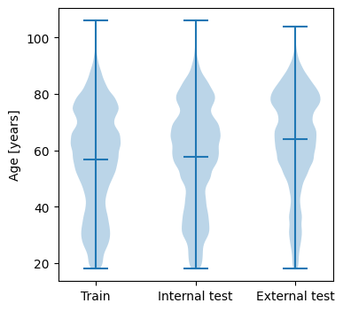 | 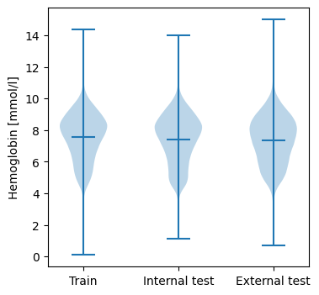
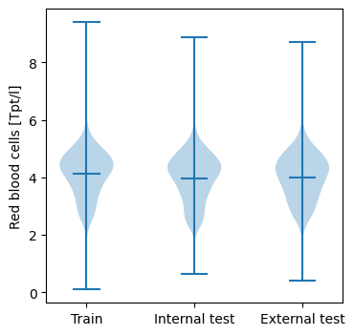 | 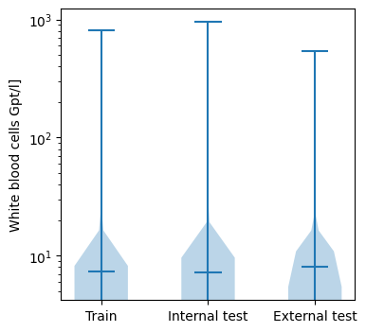
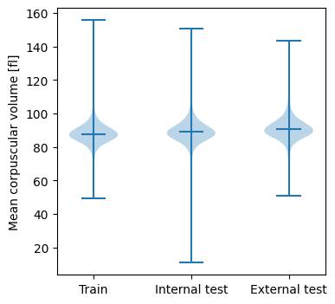 | 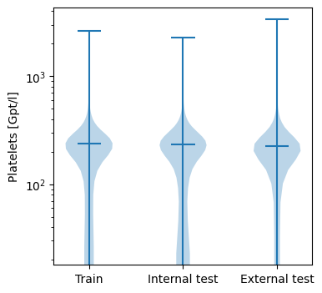
Supplemental Fig. 1 | Distribution of each continuous feature in the train, internal and external test datasets as violin plots.
We have plotted the violin plots (with minimum, mean, and maximum value) of the feature age (in years), hemoglobin (in millimole per liter), red blood cells (in terra-particles per liter), white blood cells (in giga-particles per liter), mean corpuscular volume (in femto-liter) and platelets (in giga-particles per liter) for the used train, internal test and external test dataset. White blood cells and platelets were semilogarithmic plotted for a better visualization of their distribution. The respective minimum values of white blood cells and platelets are in each case 0 Gpt/l. Note, that we have not visualized the feature “sex” since it is a categorical feature (i.e., either “male” and “female” were reported).

