Supplementary
Spatial variability in herbaceous plant phenology is mostly explained by variability in temperature but also by photoperiod and functional traits
International Journal of Biometeorology
Robert Rauschkolb^{1,2*}, Solveig Franziska Bucher, Isabell Hensen, Antje Ahrends, Eduardo Fernández-Pascual, Katja Heubach, Desiree Jakubka, Borja Jiménez-Alfaro, Andreas König, Tomáš Koubek, Alexandra Kehl, Anzar Khuroo, Anja Lindstädter, Faizan Shafee, Tereza Mašková, Elena Platonova, Patrizia Panico, Carolin Plos, Richard Primack, Christoph Rosche, Manzoor A. Shah, Maria Sporbert, Albert-Dieter Stevens, Flavio Tarquini, Katja Tielbörger, Sabrina Träger, Vibekke Vange, Patrick Weigelt, Aletta Bonn, Martin Freiberg, Barbara Knickmann, Birgit Nordt, Christian Wirth, Christine Römermann
*Corresponding author: Robert Rauschkolb, Robert.Rauschkolb@uni-jena.de
¹ German Centre for Integrative Biodiversity Research (iDiv) Halle-Jena-Leipzig, Leipzig, Germany
² Institute of Ecology and Evolution with Herbarium Haussknecht and Botanical Garden, Friedrich Schiller University Jena, Jena, Germany

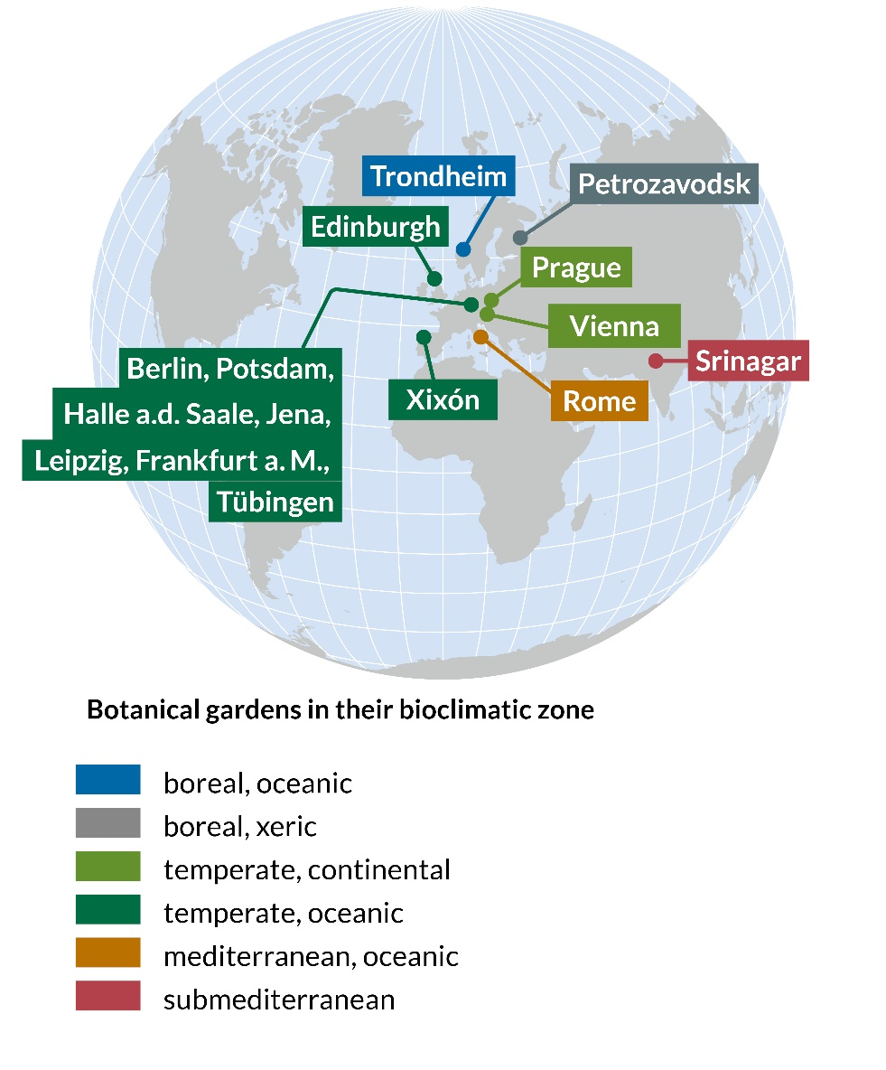

Fig. 5 Map of all botanical gardens in which phenology of herbaceous species was monitored and used in this study

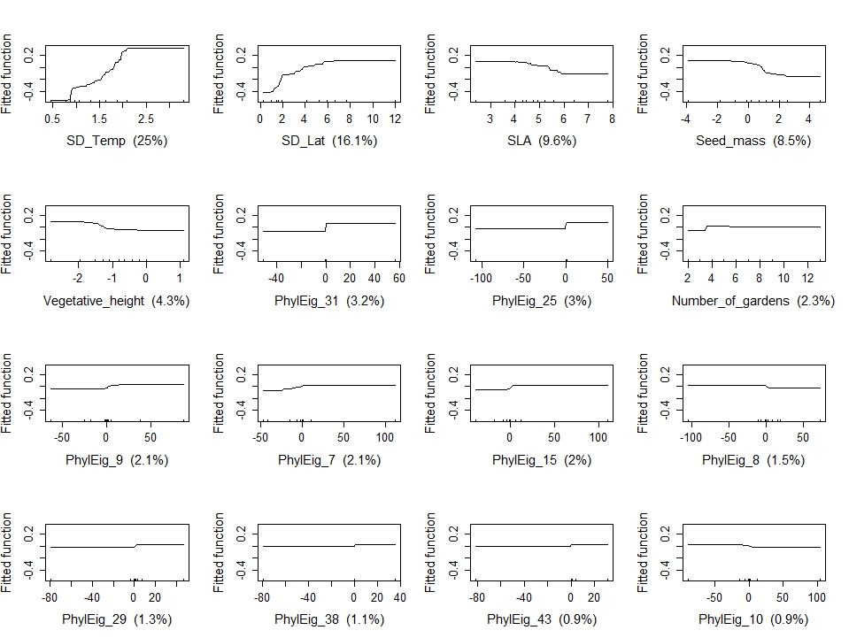
Fig. 6A Partial dependency plots of boosted regression trees for the relationship between ‘variability leaf unfolding’ and functional traits, variability in environmental conditions, phylogeny.

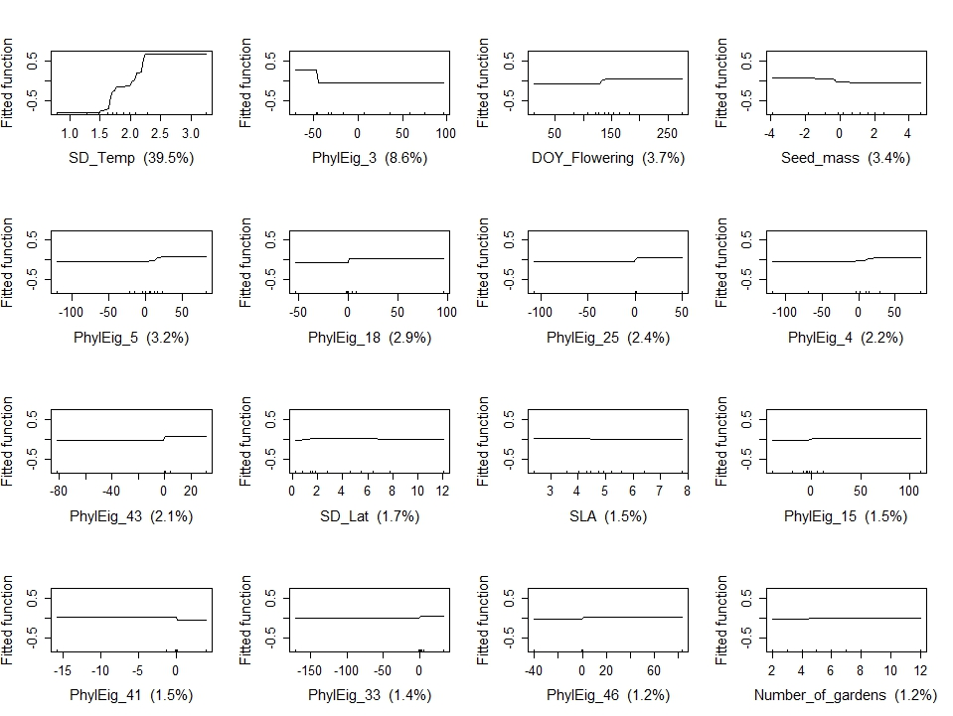
Fig. 6B Partial dependency plots of boosted regression trees for the relationship between ‘variability onset senescence’ and functional traits, variability in environmental conditions, phylogeny.

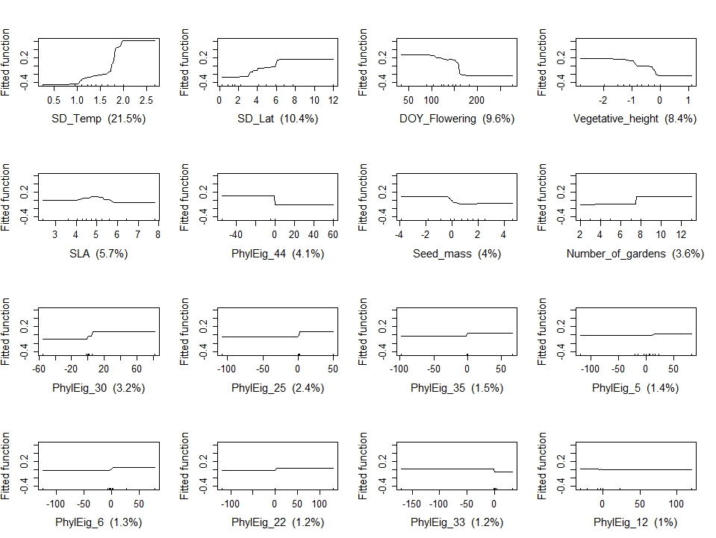
Fig. 6C Partial dependency plots of boosted regression trees for the relationship between ‘variability onset of flowering’ and functional traits, variability in environmental conditions, phylogeny.

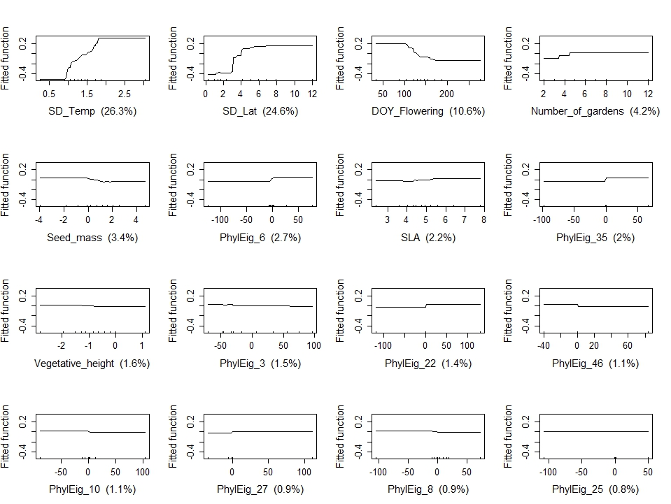
Fig. 6D Partial dependency plots of boosted regression trees for the relationship between ‘variability peak of flowering senescence’ and functional traits, variability in environmental conditions, phylogeny.

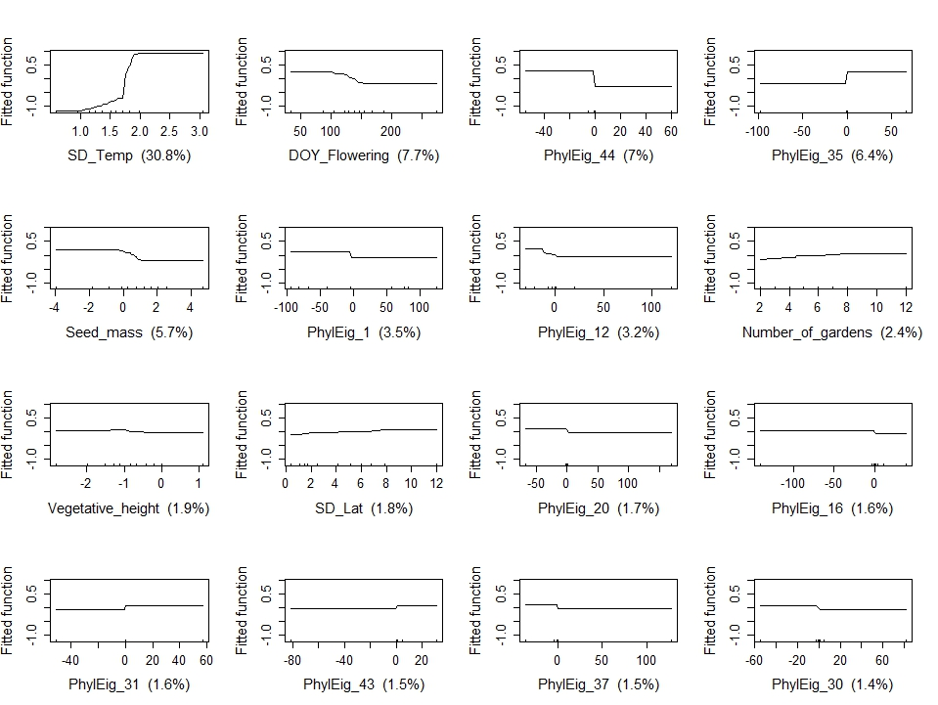
Fig. 6E Partial dependency plots of boosted regression trees for the relationship between ‘variability peak flowering duration’ and functional traits, variability in environmental conditions, phylogeny.

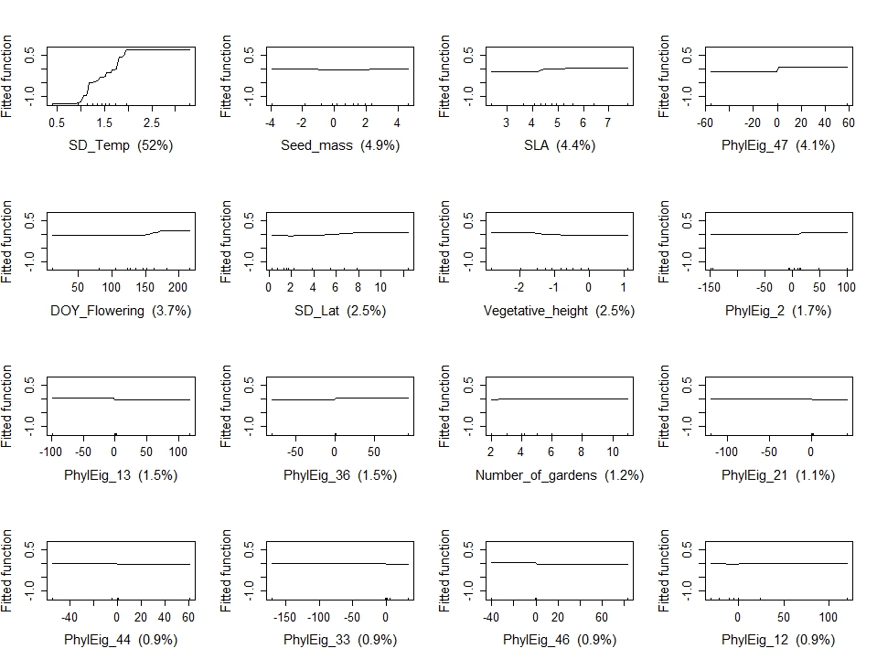
Fig. 6F Partial dependency plots of boosted regression trees for the relationship between ‘variability onset of fruiting’ and functional traits, variability in environmental conditions, phylogeny.

