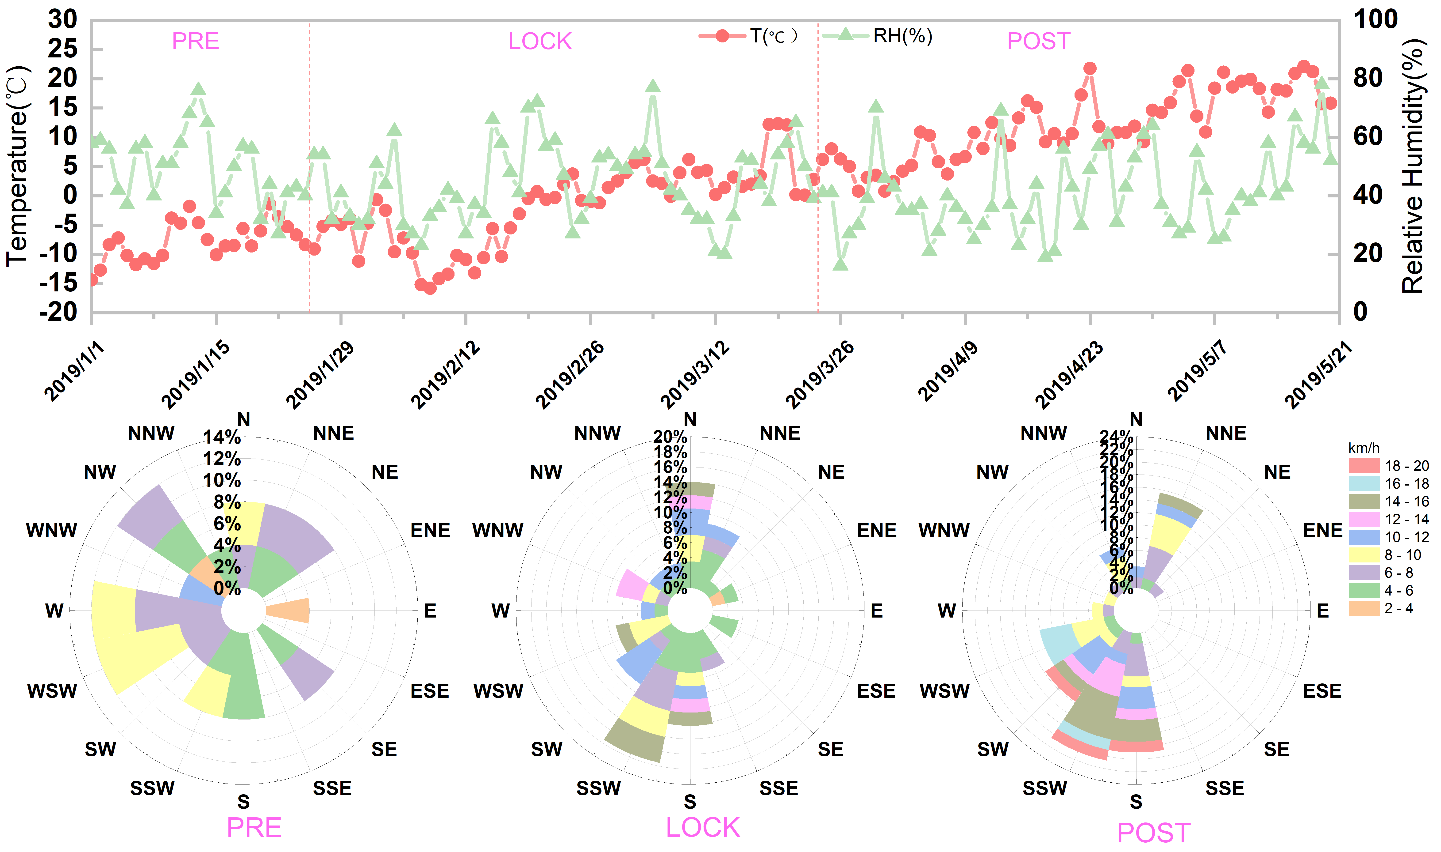
Fig. S1 Time series of daily average meteorological variables before, during and after the 2019 lockdown period in Shenyang and wind rose diagrams.

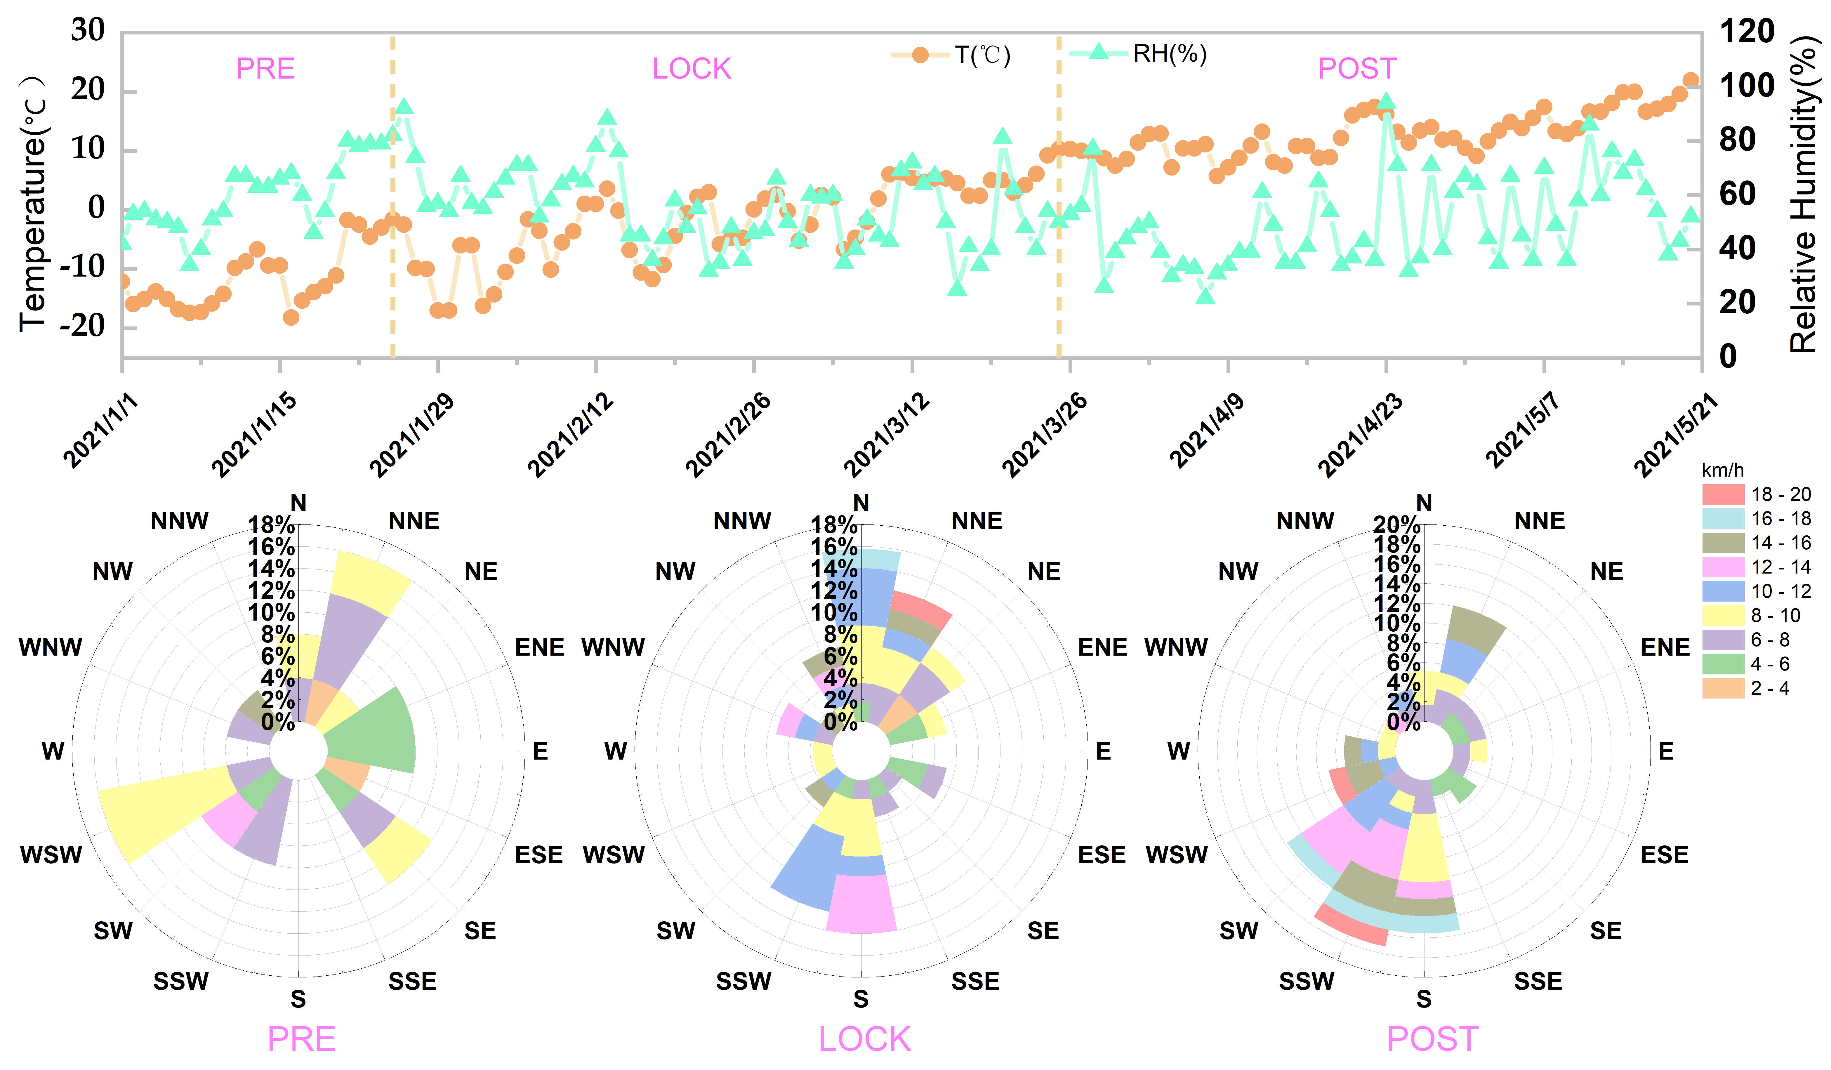
Fig. S2 Time series of daily average meteorological variables before, during and after the 2021 lockdown period in Shenyang and wind rose diagrams.

Fig. S3 Spatial distribution of air quality in (a)January, (b)February, (c)March and (d)April 2019 within the Shenyang urban area

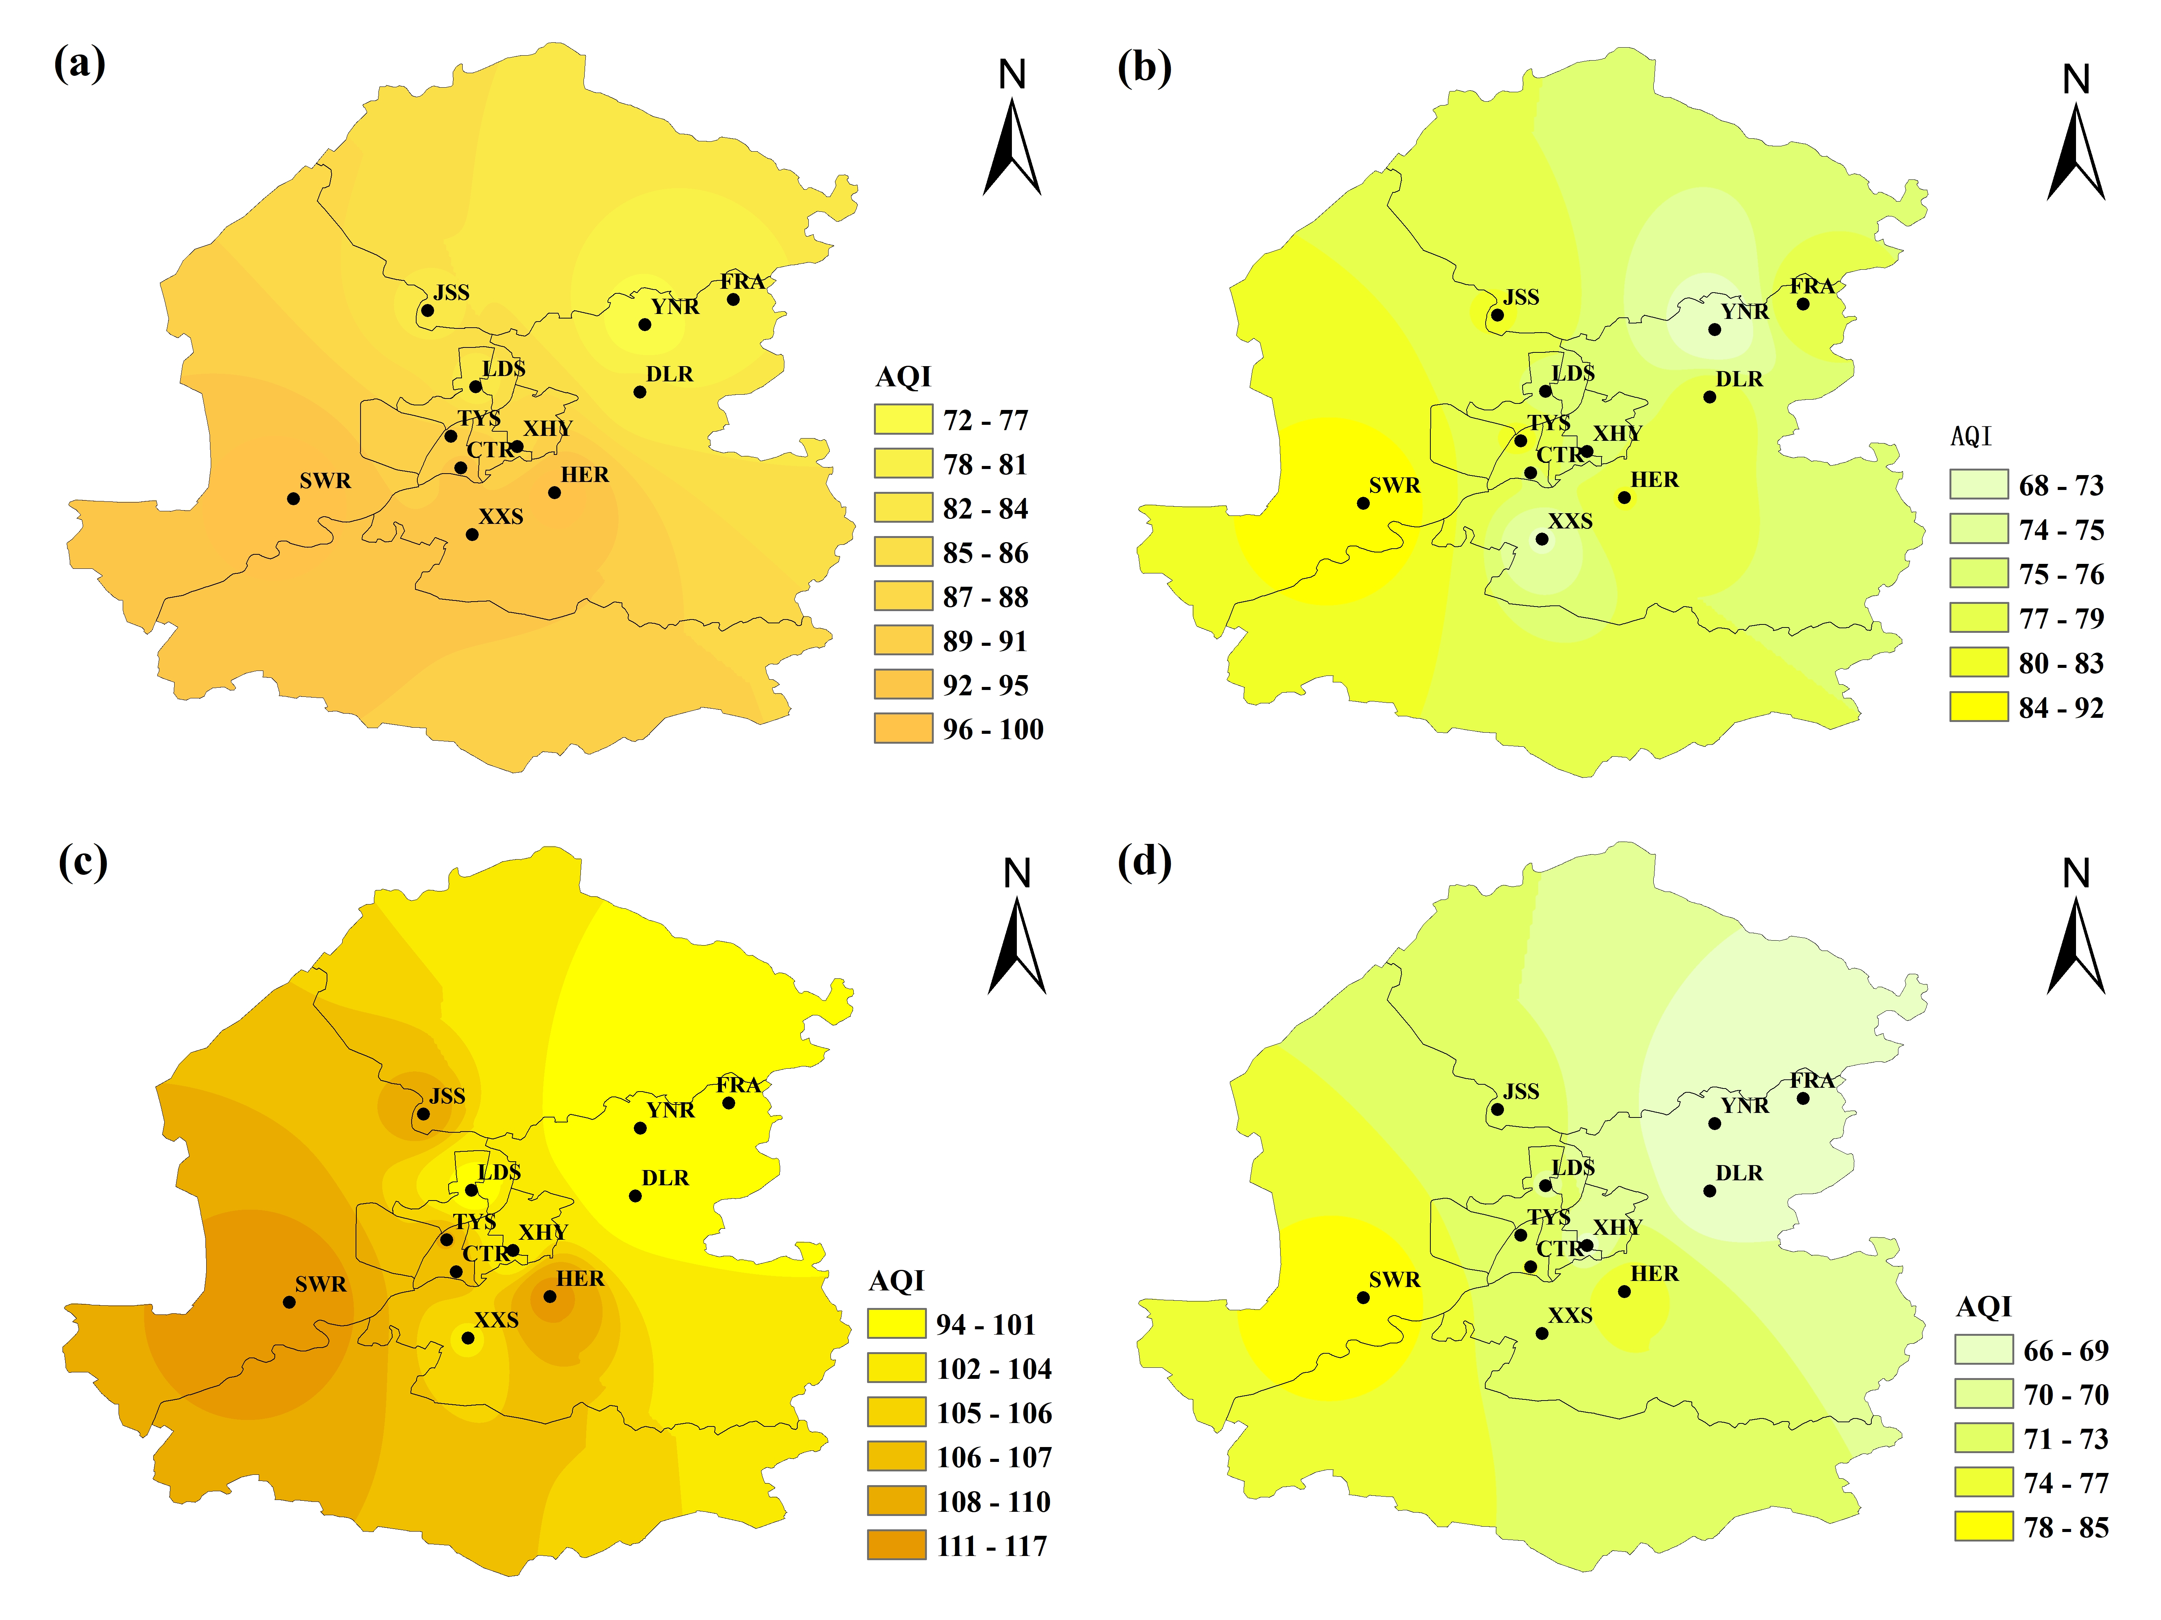
Fig. S4 Spatial distribution of air quality in (a)January, (b)February, (c)March and (d)April 2021 within the Shenyang urban area
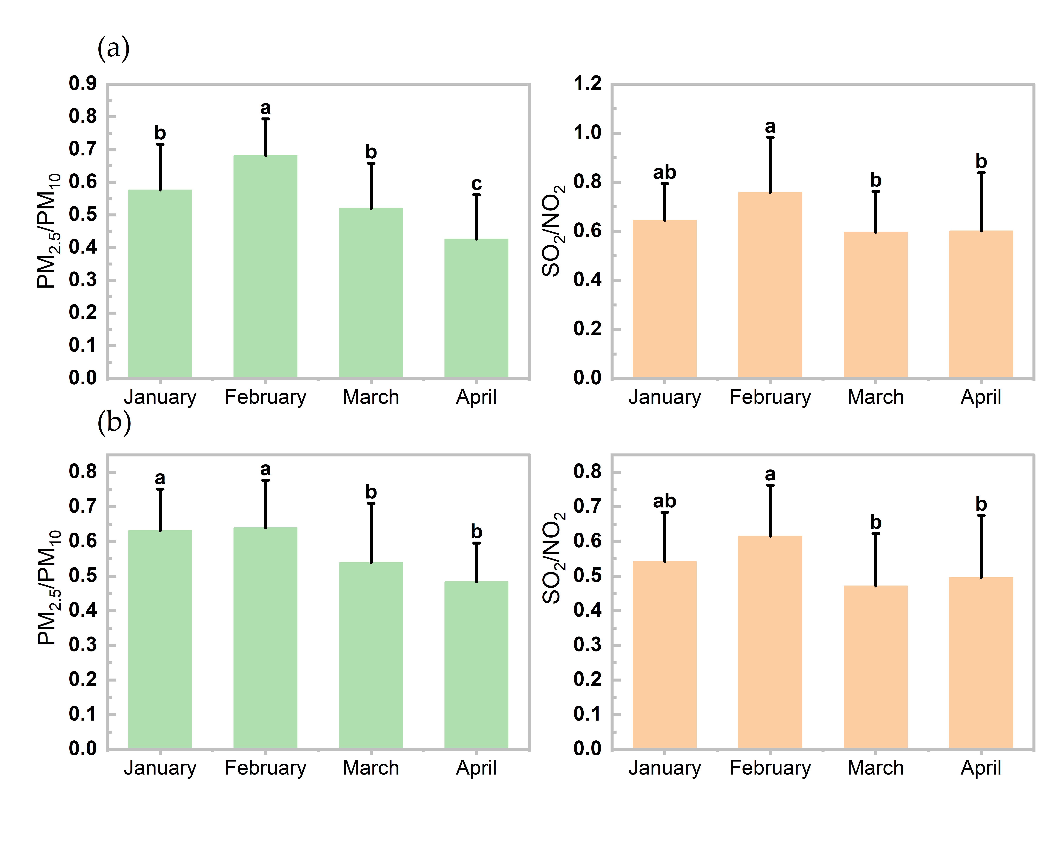
Fig. S5 Changes in the monthly average ratios of PM2.5/PM10 and SO2/NO2 in January, February, March and April 2019 (a)and 2021(b) in Shenyang.

Table S1 Monthly averages at monitoring sites in 2019
Monitoring station | Longitude | Latitude | January | February | March | April
Forest Avenue | 123.6836°Ｅ | 41.9339°Ｎ | 87 | 89 | 84 | 73
Hunnan East Road | 123.5050°Ｅ | 41.7406°Ｎ | 110 | 112 | 107 | 87
Xinxiu Street | 123.4231°Ｅ | 41.6989°Ｎ | 109 | 104 | 100 | 87
Dongling Road | 123.5903°Ｅ | 41.8411°Ｎ | 100 | 93 | 91 | 79
Lengdong Street | 123.4264°Ｅ | 41.8467°Ｎ | 95 | 88 | 87 | 83
Cultural Road | 123.4114°Ｅ | 41.7653°Ｎ | 105 | 101 | 95 | 88
Xiaoheyan | 123.4678°Ｅ | 41.7867°Ｎ | 102 | 99 | 95 | 82
Taiyuan Street | 123.4017°Ｅ | 41.7972°Ｎ | 95 | 97 | 94 | 83
Jingshen Street | 123.3783°Ｅ | 41.9228°Ｎ | 98 | 90 | 78 | 84
Shenliao West Road | 123.2444°Ｅ | 41.7347°Ｎ | 108 | 110 | 103 | 94
Yunong Road | 123.5953°Ｅ | 41.9086°Ｎ | 88 | 79 | 81 | 73

Table S2 Monthly averages at monitoring sites in 2020
Monitoring station | Longitude | Latitude | January | February | March | April
Forest Avenue | 123.6836°Ｅ | 41.9339°Ｎ | 115 | 63 | 61 | 81
Hunnan East Road | 123.5050°Ｅ | 41.7406°Ｎ | 164 | 84 | 67 | 118
Xinxiu Street | 123.4231°Ｅ | 41.6989°Ｎ | 143 | 79 | 67 | 101
Dongling Road | 123.5903°Ｅ | 41.8411°Ｎ | 132 | 71 | 63 | 86
Lengdong Street | 123.4264°Ｅ | 41.8467°Ｎ | 142 | 73 | 60 | 99
Cultural Road | 123.4114°Ｅ | 41.7653°Ｎ | 126 | 76 | 66 | 92
Xiaoheyan | 123.4678°Ｅ | 41.7867°Ｎ | 143 | 76 | 62 | 95
Taiyuan Street | 123.4017°Ｅ | 41.7972°Ｎ | 144 | 79 | 67 | 95
Jingshen Street | 123.3783°Ｅ | 41.9228°Ｎ | 132 | 63 | 63 | 90
Shenliao West Road | 123.2444°Ｅ | 41.7347°Ｎ | 160 | 87 | 74 | 115
Yunong Road | 123.5953°Ｅ | 41.9086°Ｎ | 121 | 68 | 63 | 87

Table S3 Monthly averages at monitoring sites in 2021
Monitoring station | Longitude | Latitude | January | February | March | April
Forest Avenue | 123.6836°Ｅ | 41.9339°Ｎ | 81 | 78 | 99 | 67
Hunnan East Road | 123.5050°Ｅ | 41.7406°Ｎ | 99 | 79 | 112 | 76
Xinxiu Street | 123.4231°Ｅ | 41.6989°Ｎ | 92 | 72 | 104 | 71
Dongling Road | 123.5903°Ｅ | 41.8411°Ｎ | 82 | 78 | 99 | 67
Lengdong Street | 123.4264°Ｅ | 41.8467°Ｎ | 82 | 75 | 99 | 70
Cultural Road | 123.4114°Ｅ | 41.7653°Ｎ | 92 | 76 | 106 | 73
Xiaoheyan | 123.4678°Ｅ | 41.7867°Ｎ | 87 | 75 | 102 | 68
Taiyuan Street | 123.4017°Ｅ | 41.7972°Ｎ | 88 | 80 | 107 | 71
Jingshen Street | 123.3783°Ｅ | 41.9228°Ｎ | 83 | 79 | 108 | 71
Shenliao West Road | 123.2444°Ｅ | 41.7347°Ｎ | 100 | 92 | 117 | 85
Yunong Road | 123.5953°Ｅ | 41.9086°Ｎ | 72 | 68 | 94 | 66

