The CRHR1→PN→PVI Pathway in Medial Prefrontal Cortex Mediates Early-life Stress-induced Cognitive Deficits in Adolescent Mice
Supplementary Material
Figure S1. The Effects of Early-life Stress on Body Weight, Adrenal Weight and Thymic Weight in Adolescent Male Mice. Related to Figure 1.
Figure S2. Additional Results of the Section “Early-life Stress Specifically Impaired Cognition in adolescent male mice”. Related to Figure 1.
Figure S3. Additional Results of the Section “Early-life Stress Reduced PVI (not SST-INs) activity in mPFC in Adolescent Male Mice”. Related to Figure 2.
Fig. S4. Ablation of mPFC PVIs Resulted in Cognitive Deficits in Adolescent Male Mice. Related to Figure 3.
Fig. S5. Additional Results of the Section “Prefrontal PVI Activity Mediates Early-Life Stress-Induced Cognitive Deficits in Adolescent Mice”. Related to Figure 3.
Fig. S6. Additional Results of the Section “Prefrontal PVI Activity Mediates Early-Life Stress-Induced Cognitive Deficits in Adolescent Mice”. Related to Figure 3.
Fig. S7. Additional Results of the Section “Prefrontal PVI Activity Mediates Early-Life Stress-Induced Cognitive Deficits in Adolescent Mice”. Related to Figure 3.
Fig. S8. The Effects of Early-life Stress on PNN and Soma Size of PVIs in the mPFC in Adolescent Male mice. Related to Figure 4.
Fig. S9. Chemogenetic Inhibition of mPFC PN Activity Impairs Cognition in Adolescent Mice. Related to Figure 4.
Fig. S10. Additional Results of the Section “Prefrontal PN Activity Mediates Early-Life Stress-Induced Cognitive Deficits by Enhancing PVI Activity in Adolescent Male Mice”. Related to Figure 4.
Fig. S11. Additional Results of the Section “CRHR1 Downregulation Reverses Early-Life Stress-Induced Cognitive Deficits in Adolescent Mice by Restoring PVI Activity in Medial Prefrontal Cortex”. Related to Figure 5.
Fig. S12. Additional Results of the Section “Environmental Enrichment Alleviates Early-life Stress-induced Cognitive Deficits through Activation of Prefrontal PNs and PVIs in Adolescent Mice”. Related to Figure 6.

Supplemental Table1. Sample size, Statistical Methods and Results for Main Figure.
Supplemental Table2. Sample size, Statistical Methods and Results for Supplemental Figure.

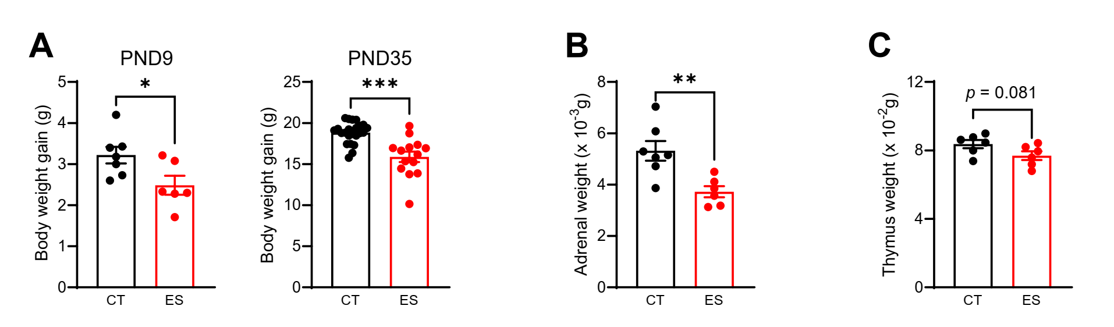
Fig. S1. The Effects of Early-life Stress on Body Weight, Adrenal Weight and Thymic Weight in Adolescent Male Mice. Related to Figure 1.
(A) Compared with control mice, ES significantly reduced the body weight of neonatal (PND9: t₁₁ = 2.415, p = 0.034, unpaired t test) and adolescent (PND35: t_{17.62} = 4.279, p < 0.001, unpaired t test with Welch's correction) male mice. (B-C) Mice exposed to ES also showed significant decrease in adrenal weight (B, t₁₁ = 3.458, p = 0.005, unpaired t test) and a tendency of decrease in thymic weight (C, t₁₀ = 1.938, p = 0.081, unpaired t test; Fig. S1C) in adolescence. Data are represented as mean ± SEM. *p < 0.05, **p < 0.01, ***p < 0.001, comparisons between CT and ES group. CT, control; ES, early-life stress; PND, postnatal day.

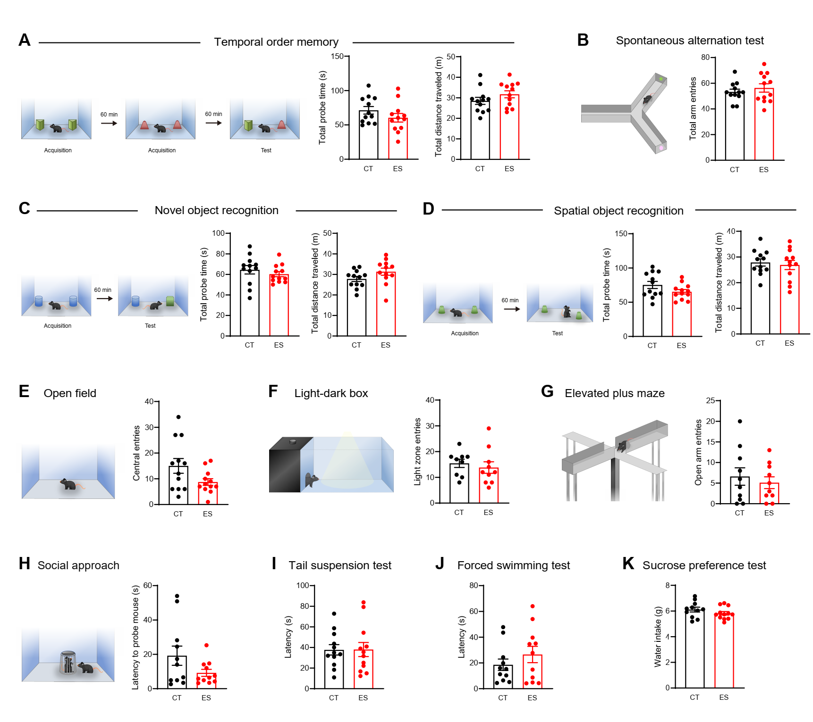
Figure S2. Additional Results of the Section “Early-life Stress Specifically Impaired Cognition in adolescent male mice”. Related to Figure 1.
(A) During the test phase, control and stressed mice spent similar time interacting with two objects (t₂₂ = 1.307, p = 0.205, unpaired t test) and traveled similar distances in 10 min (t₂₂ = 1.329, p = 0.198, unpaired t test) in the temporary order memory test. (B) ES did not affect the number of entries to the three arms in the Y-maze spontaneous alternations test (t₂₂ = 0.791, p = 0.437, unpaired t test). (C-D) During the test phases, control and stressed mice spent similar time interacting with two objects an and traveled similar distances in 10 min in the novel object recognition (C) and spatial object recognition tests (D). (E-G) For anxiety-like behaviors, ES did not affect the entries to the center zone in the open field test (E), the entries to the light box in the light-dark box test (F), or the entries to the open arms in the elevated plus maze test (G). (H) CT and ES mice showed similar latency to probe the “stranger” mouse in the social approach test. (I-K) For depressive-like behaviors, ES did not affect the latency to immobility in the tail suspension test (I) or the forced swimming test (J), or the total liquid intake in the sucrose preference test (K). Data are represented as mean ± SEM. CT, control; ES, early-life stress.

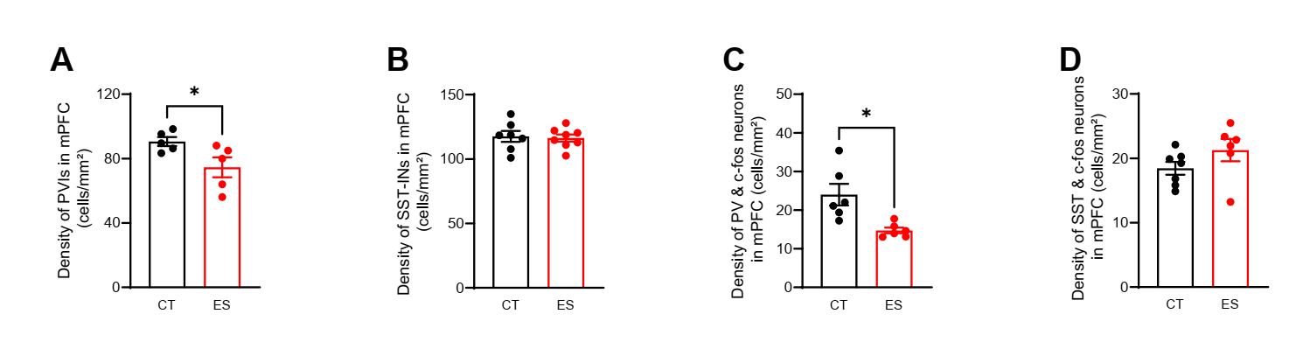
Figure S3. Additional Results of the Section “Early-life Stress Reduced PVI (not SST-INs) activity in mPFC in Adolescent Male Mice”. Related to Figure 2.
(A-B) Immunostaining revealed that ES significantly reduced the density of PVIs (A, t₈ = 2.438, p = 0.047, unpaired t test), not SST-INs (B, t₁₃ = 0.270, p = 0.791, unpaired t test), in the mPFC. (C-D) Immediate early gene c-fos immunostaining and colocalization analyses revealed that ES significantly reduced the density of activated PVIs (C, t_{5.695} = 3.219, p = 0.020, unpaired t test with Welch's correction), not SST-INs (D, t₁₁ = 1.475, p = 0.168, unpaired t test), in the mPFC. Data are represented as mean ± SEM. *p < 0.05, comparisons between CT and ES group. CT, control; ES, early-life stress; mPFC, medial prefrontal cortex; PVI, parvalbumin-expressing interneuron; SST-IN, somatostatin-expressing interneuron.

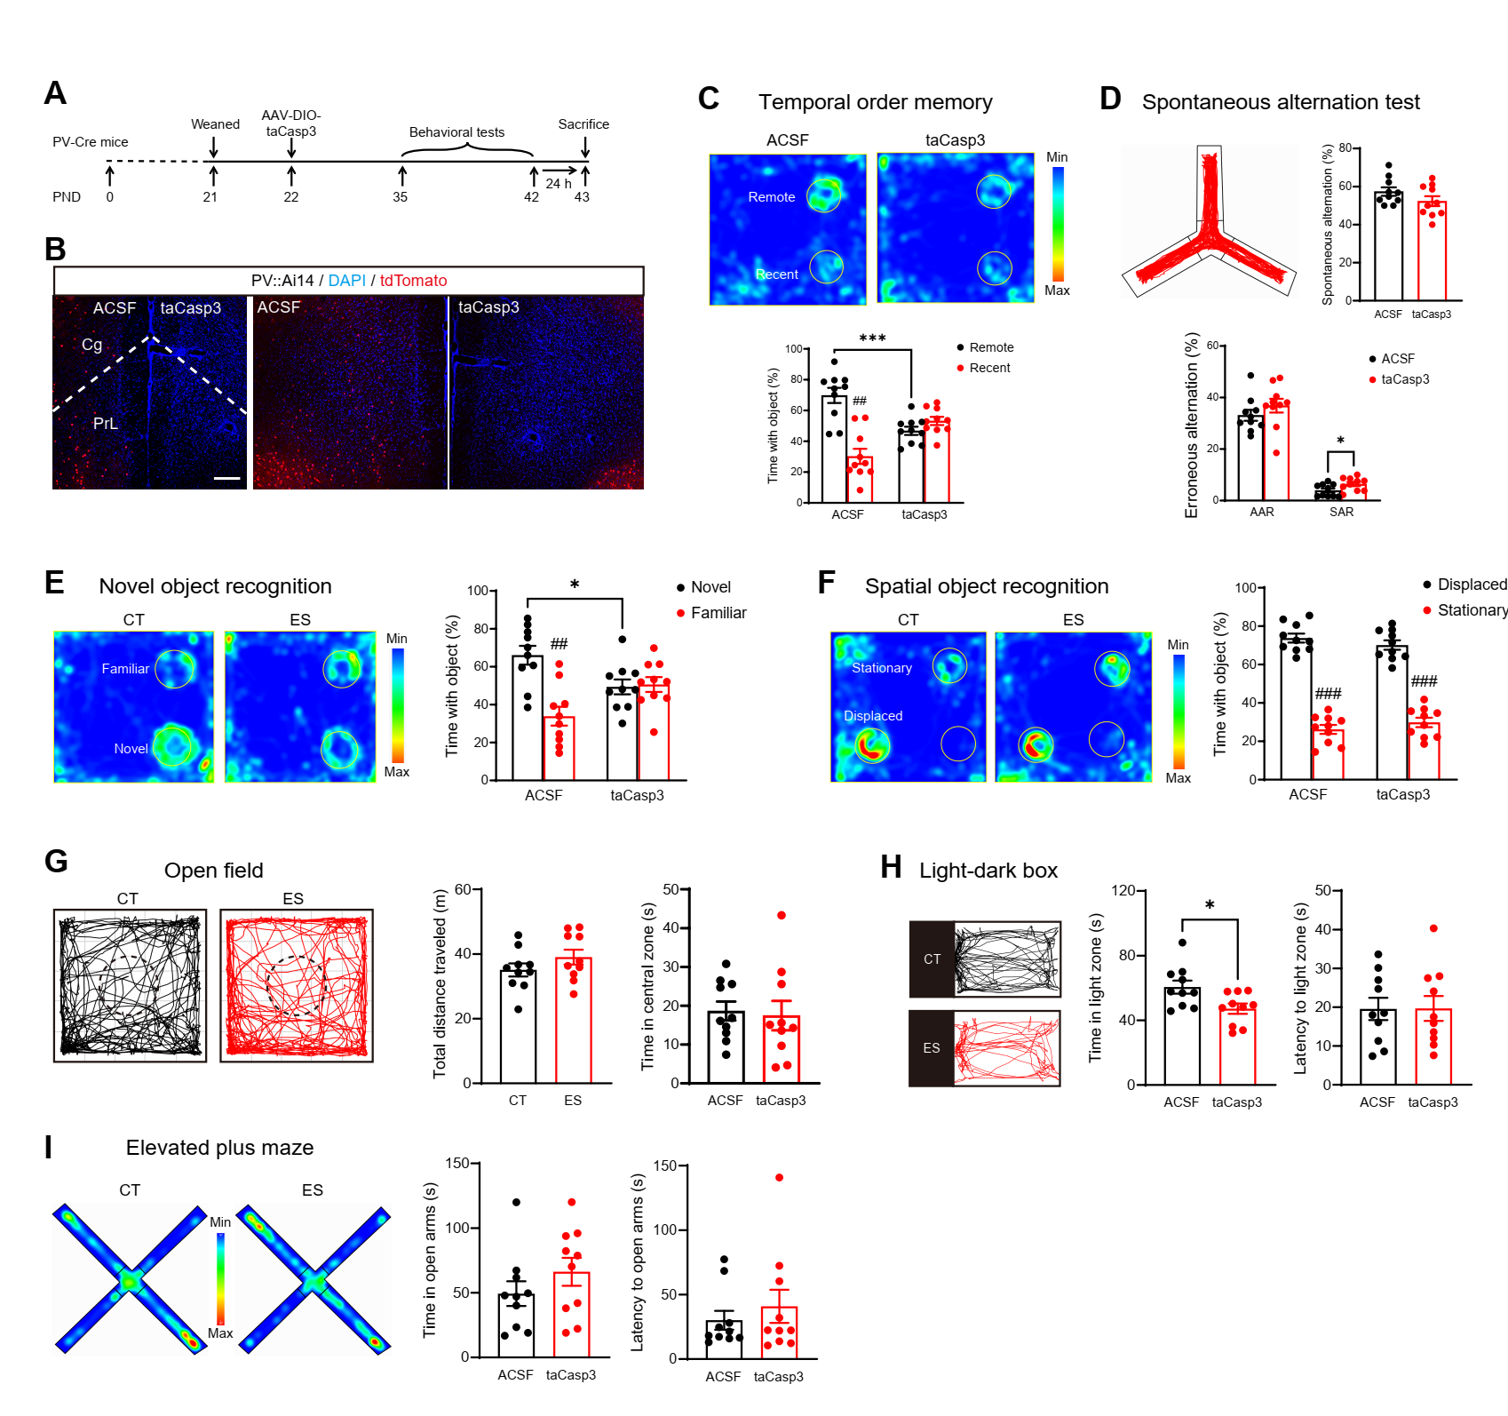
Fig. S4. Ablation of mPFC PVIs Resulted in Cognitive Deficits in Adolescent Male Mice. Related to Figure 3.
(A) The experimental timeline of the behavioral tests and brain tissue acquisition after DIO-taCasp3 viral injection in adolescent PV-Cre mice.
(B) Representative images showing that, compared with the ACSF group, the tdTomato-expressing neurons (representing PVIs) disappeared in the mPFC in taCasp3 mice. Scale bar, 100 μm.
(C-F) The effects of mPFC PVI ablation on cognitive behaviors. The heat maps in (C, E, F) show representative maps showing the time spent in each location for ACSF and taCasp3 mice; warm colors represent more time. (C) In the temporary order memory task, taCasp3 mice showed significantly lower discrimination index than the ACSF mice (t₁₈ = 4.118, p = 0.001, unpaired t test) and could not discriminate the “remote” object from the “recent” object (ACSF: t₉ = 4.030, p = 0.003; taCasp3: t₉ = 1.207, p= 0.258; paired t test). (D) In the Y-maze spontaneous alternation test, ablation of mPFC PVIs increased the erroneous alternations (SAR: t₁₈ = 2.250, p = 0.037, unpaired t test). Top-left, representative motion path in the test. (E) In the novel object recognition task, taCasp3 mice showed significantly lower discrimination index than ACSF mice (t₁₈ = 2.647, p = 0.016, unpaired t test) and could not discriminate the “novel” object from the “familiar” object (ACSF: t₉ = 3.259, p = 0.010; taCasp3: t₉ = 0.154, p = 0.881; paired t test). (F) In the spatial object recognition task, two groups showed similar performance.
(G-I) Anxiety-like behaviors. (G) In the open field test, ACSF and taCasp3 mice traveled similar distance (middle panel) and spent similar time in the center zone (right panel). Left panel, representative motion path for ACSF and taCasp3 mice in the test. (H) In the light-dark box test, taCasp3 mice spent less time in the light box (middle panel, t₁₈ = 2.589, p = 0.019, unpaired t test). The latency to the light zone (right panel) was not affected. Left, representative motion path for ACSF and taCasp3 mice in the light chamber. (I) In the elevated plus maze test, ACSF and taCasp3 mice showed similar time in the open arms (middle panel) and similar latency to the open arms (right panel). Left panel, representative map of the time spent in each location for ACSF and taCasp3 mice; warm colors represent more time.
Data are represented as mean ± SEM. *p < 0.05, ***p < 0.001, unpaired t test between ACSF and taCasp3 group; ##p < 0.01, ###p < 0.001, paired t test. ACSF: artificial cerebrospinal fluid; CT, control; ES, early-life stress; mPFC, medial prefrontal cortex; PND, postnatal day; PVI, parvalbumin-expressing interneuron; taCasp3: a genetically engineered caspase-3.

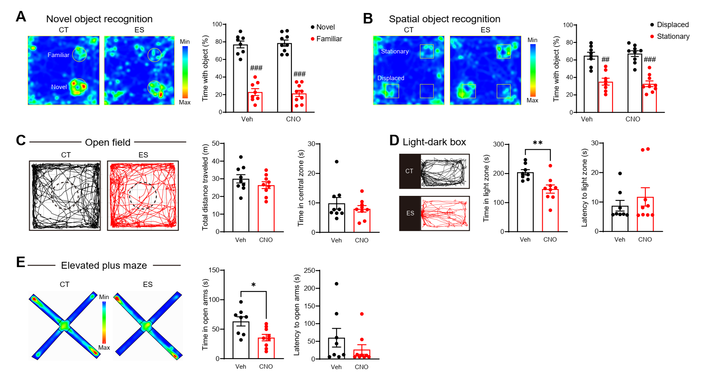
Fig. S5. Additional Results of the Section “Prefrontal PVI Activity Mediates Early-Life Stress-Induced Cognitive Deficits in Adolescent Mice”. Related to Figure 3.
(A-B) Chemogenetic inhibition of mPFC PVI activity did not affect the discrimination index in the novel object recognition (A) and spatial object recognition (B) tests. (C) No significant differences were found in the total distance traveled and time in the center zone in the open field test. (D) Inhibition of mPFC PVI activity reduced the time in the light zone (t₁₅ = 3.347, p = 0.004, unpaired t test), and did not affect the latency to the light zone in the light-dark box test. (E) Inhibition of mPFC PVI activity reduced the time in the open arms (t₁₅ = 2.921, p = 0.011, unpaired t test), and did not affect the latency to the open arms in the elevated plus maze test. Data are represented as mean ± SEM. *p < 0.05, **p < 0.05, unpaired t test between Veh and CNO group; ##p < 0.01, ###p < 0.001, paired t test. CNO, Clozapine-N-oxide; CT, control; ES, early-life stress; mPFC, medial prefrontal cortex; PVI, parvalbumin-expressing interneuron; Veh, vehicle.

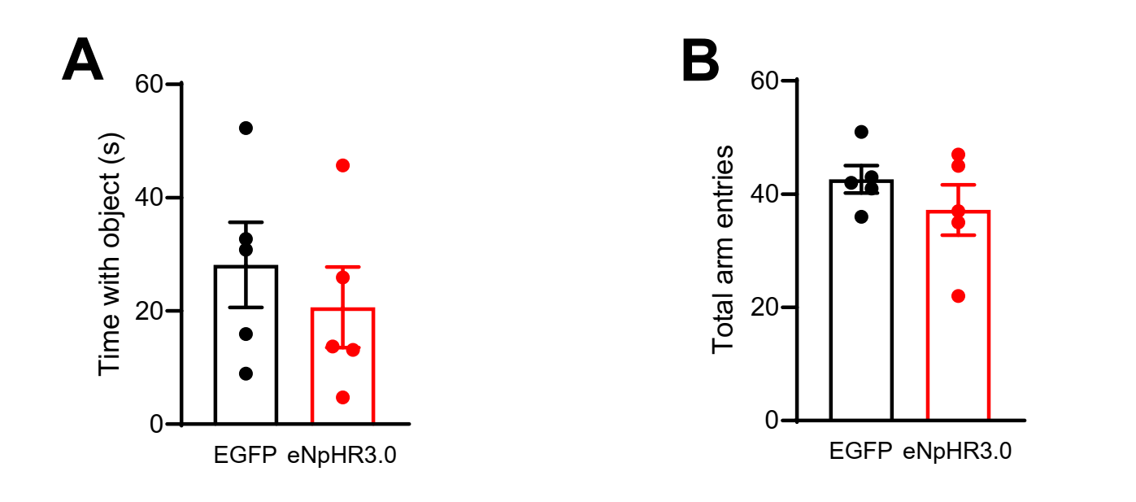
Fig. S6. Additional Results of the Section “Prefrontal PVI Activity Mediates Early-Life Stress-Induced Cognitive Deficits in Adolescent Mice”. Related to Figure 3.
(A) During the test phase, optogenetic inhibiton of mPFC PVI activity did not affect the total probe time with two objects in the temporary order memory test. (B) Optogenetic inhibiton of mPFC PVI activity did not affect the number of entries to the three arms in the Y-maze spontaneous alternation test. Data are represented as mean ± SEM. mPFC, medial prefrontal cortex; PVI, parvalbumin-expressing interneuron.

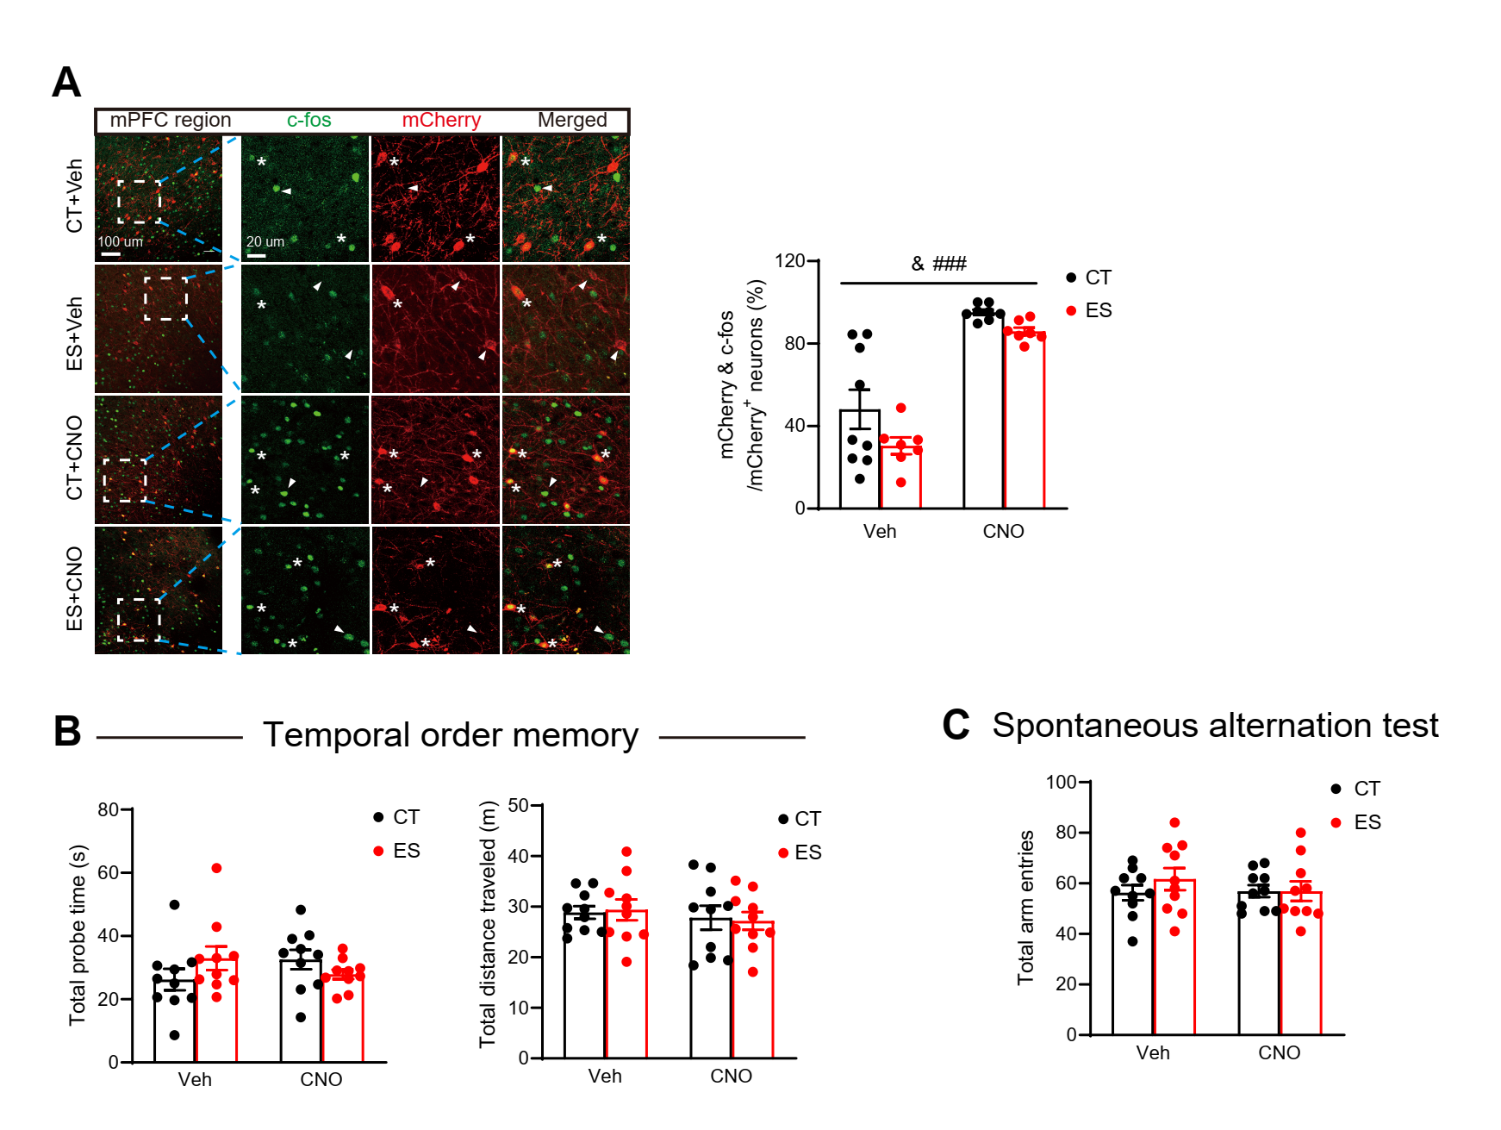
Fig. S7. Additional Results of the Section “Prefrontal PVI Activity Mediates Early-Life Stress-Induced Cognitive Deficits in Adolescent Mice”. Related to Figure 3. (A) Left panel, representative images showing the expression of c-fos and mCherry in the mPFC in the four groups of mice. Right panel, immunostaining analyses show that the percentage of activated mCherry-expressing neurons during the temporal order memory test was reduced by ES (stress effect: F _{1, 27} = 5.021, p = 0.034, two-way ANOVA) and increased by CNO (CNO effect: F _{1, 27} = 72.85, p < 0.001, two-way ANOVA). Asterisks indicate neurons that co-express mCherry and c-fos; arrowheads indicate mCherry-expressing cells without detectable c-fos expression. Scale bar, 100 µm or 20 µm. (B) Chemogenetic activation of mPFC PVI activity did not affect the total probe time and total distance traveled in the test phase of temporal order memory test and the total arm entries in the Y-maze spontaneous alternation test. Data are represented as mean ± SEM. &p < 0.05, stress effect of two-way ANOVA. $$$p < 0.001, drug effect of two-way ANOVA. CNO, Clozapine-N-oxide; CT, control; ES, early-life stress; mPFC, medial prefrontal cortex; PVI, parvalbumin-expressing interneuron; Veh, vehicle.

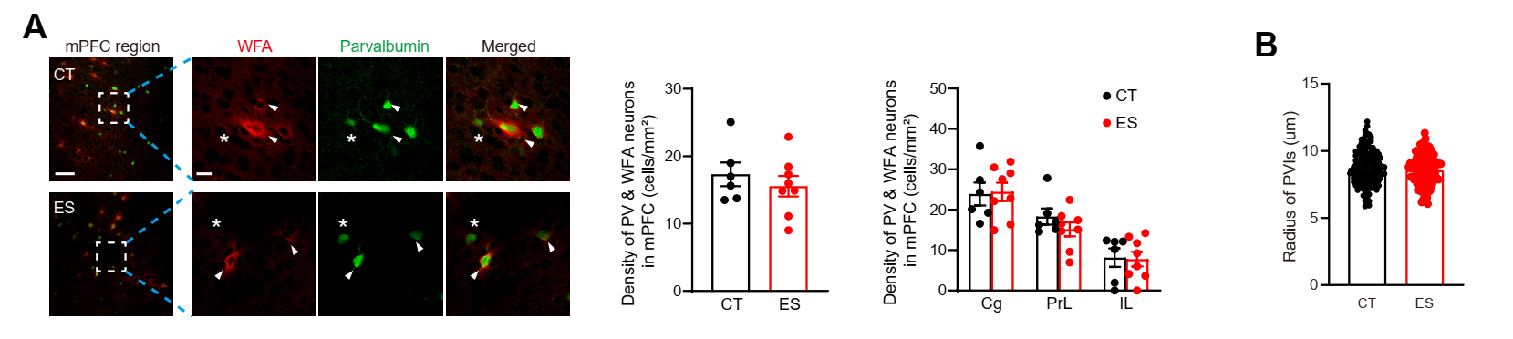
Fig. S8. The Effects of Early-life Stress on PNN and Soma Size of PVIs in the mPFC in Adolescent Male mice. Related to Figure 4.
(A) ES did not affect the density of WFA expression surrounding PVIs in the mPFC and the three mPFC subregions. Scale bar, 100 µm or 10 µm. (B) CT and ES mice showed similar soma radius of PVIs. Data are represented as mean ± SEM. CT, control; ES, early-life stress; mPFC, medial prefrontal cortex; PVI, parvalbumin-expressing interneuron; WFA, wisteria floribunda agglutinin.

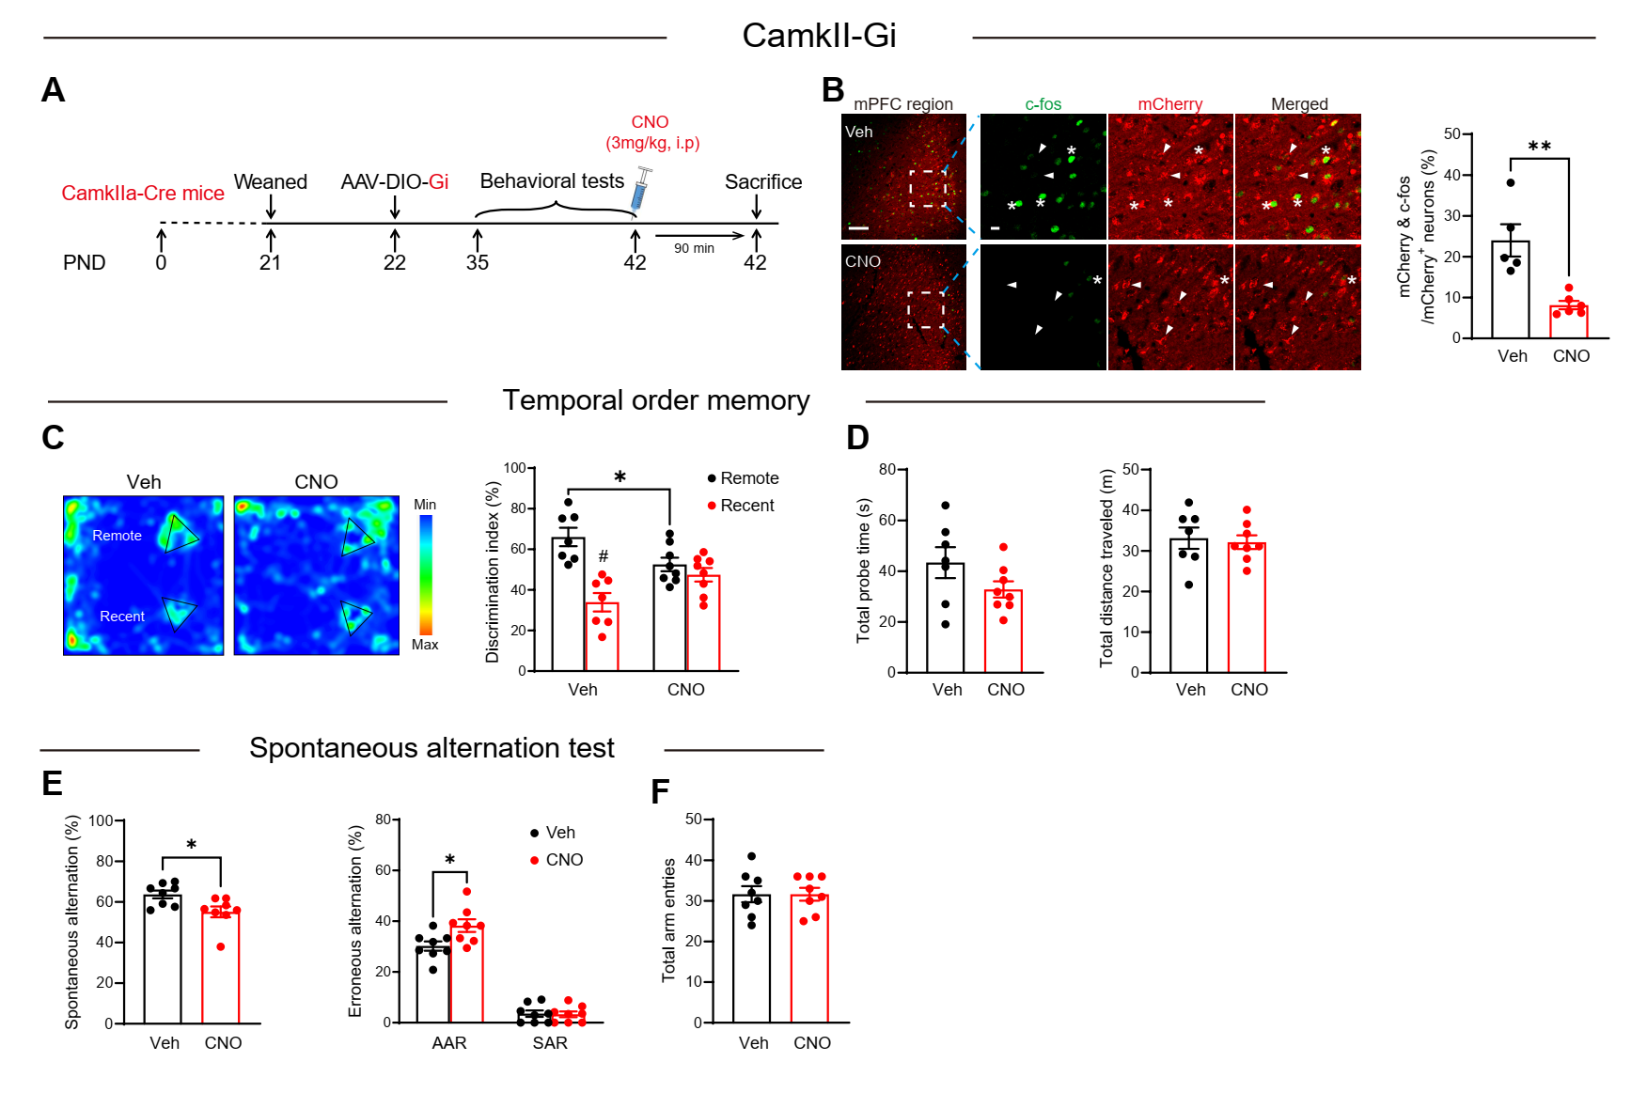
Fig. S9. Chemogenetic Inhibition of mPFC PN Activity Impairs Cognition in Adolescent Mice. Related to Figure 4.
(A) The experimental timeline of the behavioral tests, CNO injection, and brain tissue acquisition after hM4D(Gi) viral injection in adolescent CamkIIa-Cre mice. (B) Representative images show the expression of c-fos and mCherry in the mPFC of Veh and CNO mice. Immunostaining analyses conﬁrmed that Gi decreased the expression of c-fos in PNs in the mPFC (t₉ = 4.237, p = 0.002, unpaired t test). Asterisks indicate neurons that co-express mCherry and c-fos; arrowheads indicate mCherry-expressing cells without detectable c-fos expression. Scale bar, 100 µm or 20 µm. (C-D) Chemogenetic inhibition of mPFC PN activity impaired temporal order memory (Paired t test: Veh: t₆ = 3.549, p = 0.012; CNO: t₇ = 0.762, p = 0.471; unpaired t test: t₁₃ = 2.448, p = 0.029) and did not affect the total probe time and total distance traveled in the test phase of temporal order memory test in adolescent mice. (E-F) Chemogenetic inhibition of mPFC PN activity impaired spatial working memory (SA: t₁₄ = 2.613, p = 0.021, AAR: t₁₄₅ = 2.596, p = 0.021, unpaired t test) and did not affect the total arm entries in the Y-maze spontaneous alternation test in adolescent mice. Data are represented as mean ± SEM. *p < 0.05, **p < 0.01, unpaired t test; #p < 0.05, paired t test. AAR, alternative arm return; CNO, Clozapine-N-oxide; mPFC, medial prefrontal cortex; SAR, same arm return;Veh, vehicle.

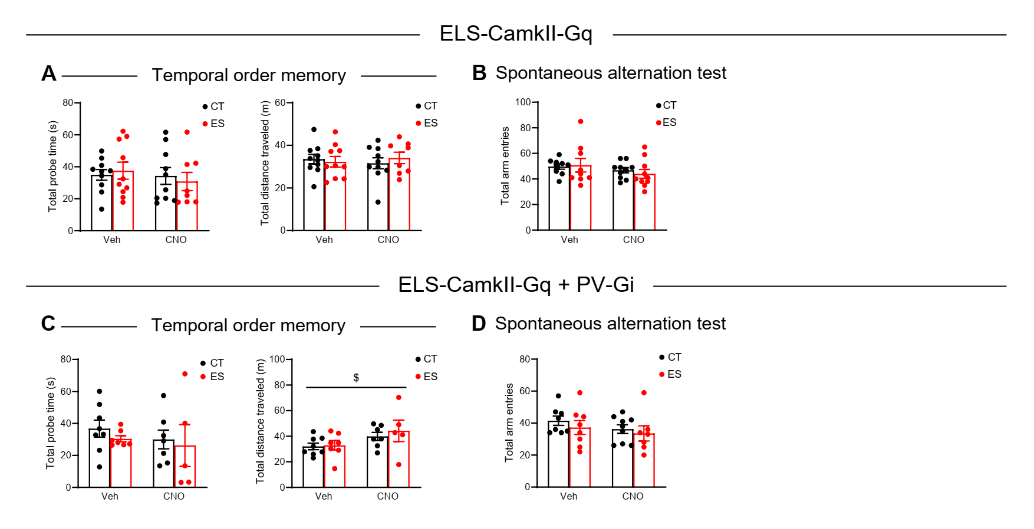
Fig. S10. Additional Results of the Section “Prefrontal PN Activity Mediates Early-Life Stress-Induced Cognitive Deficits by Enhancing PVI Activity in Adolescent Male Mice”. Related to Figure 4.
(A-B) Chemogenetic activation of mPFC PNs did not affect the total probe time and total distance traveled in the test phase of temporal order memory test (A) and the total arm entries in the Y-maze spontaneous alternation test (B). (C-D) Simultaneous chemocogenetic activation of PN and inhibition of PVI activity in the mPFC did not affect the total probe time and total distance traveled in the test phase of temporal order memory test (C) and the total arm entries in the Y-maze spontaneous alternation test (D). Data are represented as mean ± SEM. CNO, Clozapine-N-oxide; CT, control; ES, early-life stress; mPFC, medial prefrontal cortex; PN, pyramidal neuron; PVI, parvalbumin-expressing interneuron; Veh, vehicle.
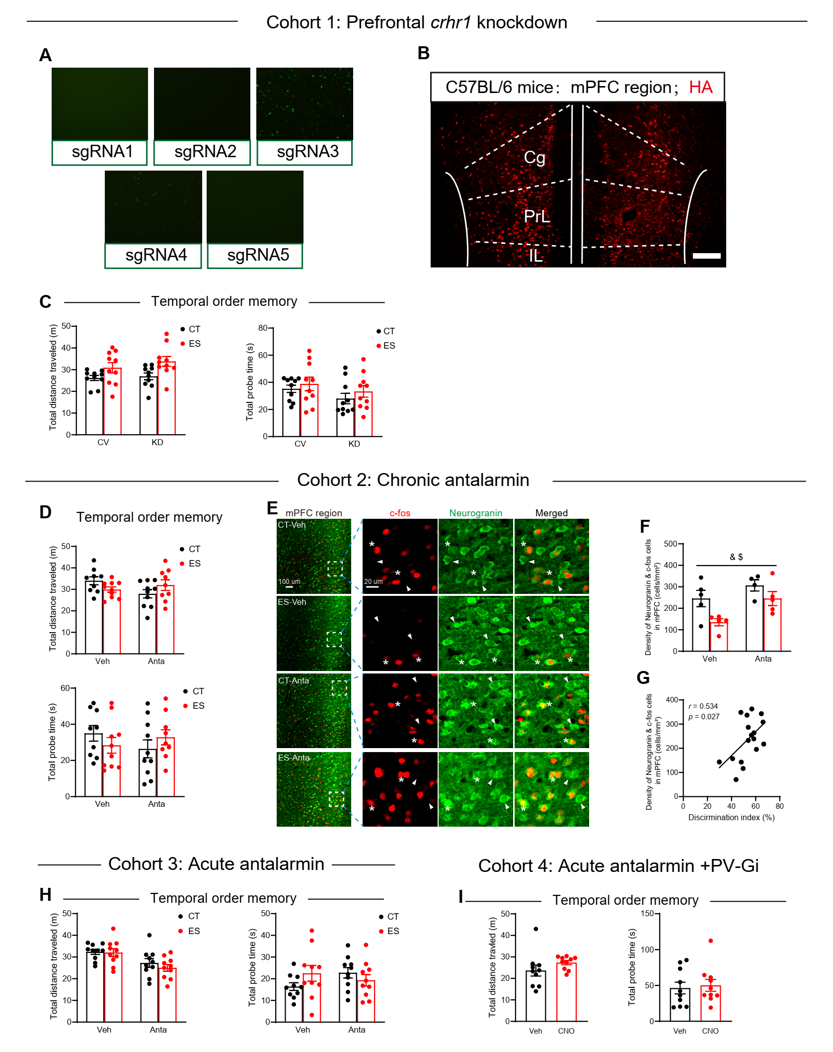
Fig. S11. Additional Results of the Section “CRHR1 Downregulation Reverses Early-Life Stress-Induced Cognitive Deficits in Adolescent Mice by Restoring PVI Activity in Medial Prefrontal Cortex”. Related to Figure 5.
(A) Five sgRNAs were screened using in vitro cellular assays, and sgRNA3 was chosen to package the CRHR1 knockout virus. (B) HA immunostaining to verify the range of viral infection in the mPFC. Scale bar, 100 μm. (C) CRHR1 knockout in the mPFC did not affect the total probe time and total distance traveled in the test phase of temporal order memory test. (D) Chronic antalarmin administration during ES did not affect the total probe time and total distance traveled in the test phase of temporal order memory test. (E) Representative images show the expression of c-fos and neurogranin in the mPFC of the four groups of mice. Asterisks indicate neurons that co-express c-fos and neurogranin; arrowheads indicate neurogranin-expressing cells without detectable c-fos expression. Scale bar, 100 µm or 20 µm. (F) The density of PNs co-labeled with c-fos during the temporal order memory task was significantly reduced by ES (F_{1, 15} = 8.115, p = 0.012, two-way ANOVA) and upregulated by chronic antalarmin administration during PND2-8 (F_{1, 15} = 8.114, p = 0.012, two-way ANOVA). (G) The correlation between the mPFC PN activity and discrimination index in the temporal order memory test across all animals. (H) Acute antalarmin treatment did not affect the total probe time and total distance traveled in the test phase of temporal order memory test. (I) Selective inhibition of PVI in mPFC did not affect the total probe time and total distance traveled in the test phase of temporal order memory test.
Data are represented as mean ± SEM. #p < 0.05, ##p < 0.01, ###p < 0.001, comparison between the remote and recent objects. &p < 0.05, &&p < 0.01, drug effect of two-way ANOVA; $p < 0.05, $$p < 0.05, drug effect of two-way ANOVA. Data are represented as mean ± SEM. Anta, antalarmin; crhr1, corticotropin-releasing hormone receptor 1; CT, control; ES, early-life stress; KO, knockout; mPFC, medial prefrontal cortex; PN, pyramidal neuron; PVI, parvalbumin-expressing interneuron; Veh, vehicle; CNO, Clozapine-N-oxide.

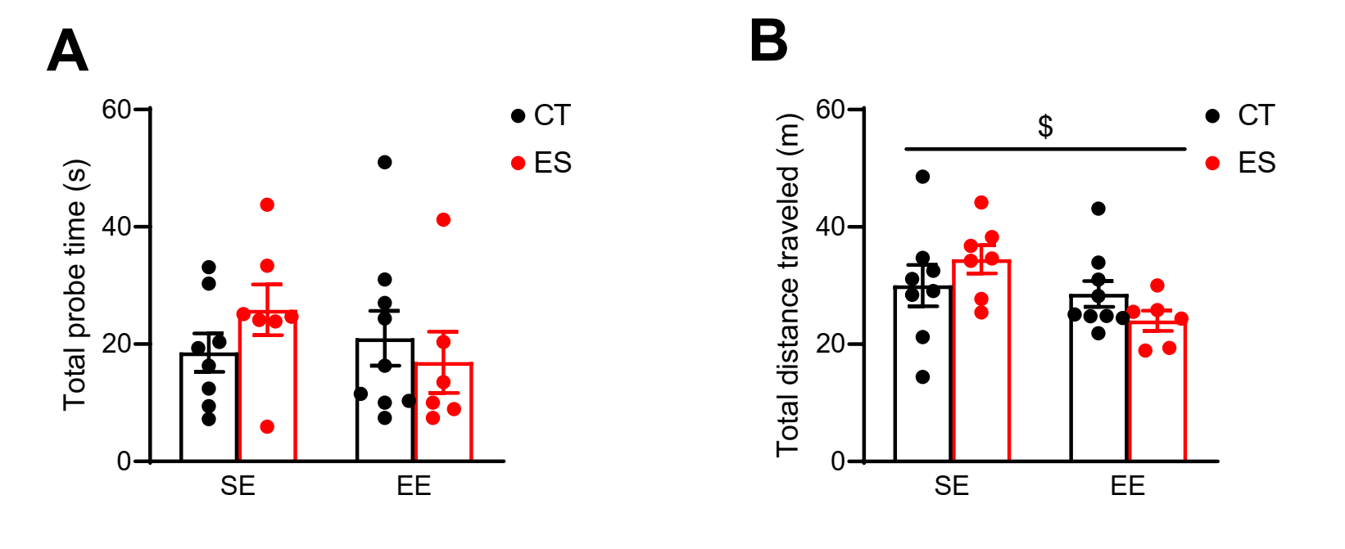
Fig. S12. Additional Results of the Section “Environmental Enrichment Alleviates Early-life Stress-induced Cognitive Deficits through Activation of Prefrontal PNs and PVIs in Adolescent Mice”. Related to Figure 6.
(A) EE did not affect the total probe time in the test phase of temporal order memory test. (B) EE decreased the total distance traveled in the test phase (treatment effect: F _{1, 26} = 4.879, p = 0.036, two-way ANOVA). Data are represented as mean ± SEM. $p < 0.05, treatment effect of two-way ANOVA. CT, control; EE, environmental enrichment; ES, early-life stress; SE, standard environment.

Table S1. Sample size, Statistical Methods and Results for Main Figure

Related figures | Sample size | Statistical methods and p values | t or F values
Fig.1C | 12 mice per group | Remote vs. Recent  CT: p = 0.001, paired t test  ES: p = 0.996, paired t test  CT vs. ES: p = 0.008,  unpaired t test | Remote vs. Recent  CT: t₁₁ = 4.475  ES: t₁₁ = 0.006  CT vs. ES: t₂₂ = 2.911
Fig.1D | 12 mice per group | Spontaneous alternation  p = 0.014, unpaired t test  AAR  p = 0.136, unpaired t test  SAR  p = 0.026, unpaired t test | Spontaneous alternation  t₂₂ = 2.676  AAR  t₂₂ = 1.549  SAR  t₂₂ = 2.381
Fig.1E | 12 mice per group | Novel vs. familiar  CT: p = 0.001, paired t test  ES: p = 0.070, paired t test  CT vs. ES: p = 0.429,  unpaired t test | Novel vs. familiar  CT: t₁₁ = 4.839  ES: t₁₁ = 2.003  CT vs. ES: t₂₂ = 0.806
Fig.1F | 12 mice per group | Displaced vs. stationary  CT: p = 0.006, paired t test  ES: p = 0.727, paired t test  CT vs. ES: p = 0.010,  unpaired t test | Displaced vs. stationary  CT: t₁₁ = 3.426  ES: t₁₁ = 0.358  CT vs. ES: t₂₂ = 2.819
Fig.1G | 12 mice per group | Total distance  p = 0.295, unpaired t test  Time in central zone  p = 0.057, unpaired t test with Welch's correction | Total distance  t₂₂ = 1.073  Time in central zone  t_{12.73} = 2.095
Fig.1H | CT: n = 9  ES: n = 10 | Time in light zone  p = 0.308, unpaired t test  Latency to light zone  p = 0.636, unpaired t test with Welch's correction | Time in light zone  t₁₇ = 1.051  Latency to light zone  t₁₇ = 0.482
Fig.1I | CT: n = 10  ES: n = 10 | Time in open arm  p = 0.263, unpaired t test with Welch's correction  Latency to open arm  p = 0.316, unpaired t test with Welch's correction | Time in open arm  t_{10.17} = 1.184  Latency to open arm  t_{10.52} = 1.053
Fig.1J | 12 mice per group | p = 0.201, unpaired t test | t₂₂ = 1.320
Fig.1K | 12 mice per group | p = 0.207, unpaired t test | t₂₂ = 1.299
Fig.1L | 11 mice per group | p = 0.035, unpaired t test | t₂₀ = 2.260
Fig.1M | 11 mice per group | Stress effect, p = 0.976,  Time effect, p = 0.613,  Interaction effect, p = 0.863,  two-way ANOVA | Stress effect, F _{(1, 63)} = 0.001  Time effect, F _{(2, 63)} = 0.493  Interaction effect, F _{(2, 63)} = 0.148
Fig.2A | 5 mice per group | Subregion  Stress effect, p = 0.004,  Region effect, p < 0.001,  Interaction effect, p = 0.763,  two-way ANOVA | Subregion  Stress effect, F _{(1, 24)} = 10.34  Region effect, F _{(2, 24)} = 24.36  Interaction effect, F _{(2, 24)} = 0.274
Fig.2B | CT: n = 7  ES: n = 8 | Subregion  Stress effect, p = 0.780,  Region effect, p = 0.823,  Interaction effect, p = 0.642,  two-way ANOVA | Subregion  Stress effect, F _{(1, 39)} = 0.079  Region effect, F _{(2, 39)} = 0.196  Interaction effect, F _{(2, 39)} = 0.448
Fig.2D | 6 mice per group | Stress effect, p < 0.001,  Region effect, p = 0.025,  Interaction effect, p = 0.466,  two-way ANOVA | Stress effect, F _{(1, 30)} = 17.78  Region effect, F _{(2, 30)} = 4.183  Interaction effect, F _{(2, 30)} = 0.784
Fig.2E | 6 mice per group | Stress effect, p = 0.170,  Region effect, p = 0.090,  Interaction effect, p = 0.477,  two-way ANOVA | Stress effect, F _{(1, 33)} = 1.969  Region effect, F _{(2, 33)} = 2.589  Interaction effect, F _{(2, 33)} = 0.757
Fig.2G | CT: n = 11 cells  ES: n = 18 cells | Stress effect, p = 0.034,  Injection current effect, p < 0.001,  Interaction effect, p = 0.006,  two-way Repeated ANOVA  Current > 200 pA, CT vs. ES: p < 0.044, unpaired t test | Stress effect, F _{(1, 27)} = 4.990  Injection current effect, F _{(10, 270)} = 205.9  Interaction effect, F _{(10, 270)} = 2.533
Fig.2H | CT: n = 14 cells  ES: n = 11 cells | Frequency  p = 0.678, unpaired t test  Amplitude  p = 0.135, unpaired t test with Welch's correction | Frequency  t₂₃ = 0.421  Amplitude  t_{13.34} = 1.593
Fig. 3C | 6 mice per group | p = 0.021, unpaired t test | t₁₀ = 2.748
Fig. 3D | 10 mice per group | Remote vs. Recent  Veh: p = 0.028, paired t test  CNO: p = 0.169, paired t test  Veh vs. CNO: p = 0.008,  unpaired t test | Remote vs. Recent  Veh: t₉ = 2.617  CNO: t₉ = 1.495  Veh vs. CNO: t₁₈ = 3.010
Fig. 3E | Veh: n = 8  CNO: n = 9 | Spontaneous alternation  p = 0.421, unpaired t test  AAR  p = 0.549, unpaired t test  SAR  p = 0.050, unpaired t test | Spontaneous alternation  t₁₅ = 0.828  AAR  t₁₅ = 0.613  SAR  t₁₅ = 2.135
Fig. 3H | 5 mice per group | Remote vs. Recent  EGFP: p = 0.013, paired t test  eNpHR3.0: p = 0.198, paired t test  EGFP vs. eNpHR3.0: p = 0.009, unpaired t test | Remote vs. Recent  EGFP: t₄ = 4.301  eNpHR3.0: t₄ = 1.542  CT vs. ES: t₈ = 3.414
Fig. 3I | 5 mice per group | Spontaneous alternation  p = 0.726, unpaired t test  AAR  p = 0.027, unpaired t test  SAR  p = 0.410, unpaired t test | Spontaneous alternation  t₈ = 0.363  AAR  t₈ = 2.709  SAR  t₈ = 0.870
Fig.3L | CT-Veh: n = 8  ES-Veh: n = 8  CT-CNO: n = 8  ES-CNO: n = 7 | Interaction effect, p = 0.022,  two-way ANOVA  CT-Veh vs. ES-Veh: p = 0.040,  ES-Veh vs. ES-CNO: p < 0.001,  Bonferroni’s post hoc test | F _{(1, 27)} = 5.885
Fig.3M | 10 mice per group | Interaction effect, p < 0.001,  two-way ANOVA  CT-Veh vs. ES-Veh: p < 0.001, ES-Veh vs. ES-CNO: p < 0.001, Bonferroni’s post hoc test | F _{(1, 36)} = 16.33
Fig.3N | CT-Veh: n = 10  ES-Veh: n = 9  CT-CNO: n = 10  ES-CNO: n = 9 | Spontaneous alternation  Interaction effect, p = 0.048,  two-way ANOVA  CT-Veh vs. ES-Veh: p < 0.001, Bonferroni’s post hoc test  ES-Veh vs. ES-CNO: p = 0.001, unpaired t test  AAR  Stress effect, p = 0.171,  Drug effect, p = 0.804,  Interaction effect, p = 0.744,  two-way ANOVA  SAR  Interaction effect, p = 0.005,  two-way ANOVA  CT-Veh vs. ES-Veh: p < 0.001, ES-Veh vs. ES-CNO: p = 0.002, Bonferroni’s post hoc test | Spontaneous alternation  F _{(1, 34)} = 4.203  ES-Veh vs. ES-CNO: t₁₆ = 3.880  AAR  Stress effect, F _{(1, 34)} = 1.953  Drug effect, F _{(1, 34)} = 0.062  Interaction effect, F _{(1, 34)} = 0.108  SAR  F _{(1, 34)} = 8.948
Fig.4C | CT: n = 5  ES: n = 4 | Stress effect, p = 0.028,  Distances effect, p < 0.001,  Interaction effect, p < 0.001,  two-way Repeated ANOVA  Distance > 8.784 um, CT vs. ES: p < 0.028, Bonferroni’s post hoc test | Stress effect, F _{(1, 7)} = 7.628  Distances effect, F _{(21, 147)} = 377.8  Interaction effect, F _{(21, 147)} = 8.021
Fig.4D | 5 mice per group | p < 0.001, unpaired t test | t₈ = 6.682
Fig.4E | CT: n = 5  ES: n = 6 | p = 0.043, unpaired t test | t₉ = 2.352
Fig.4I | 6 mice per group | Stress effect, p = 0.479,  Drug effect, p < 0.001,  Interaction effect, p = 0.212,  two-way ANOVA | Stress effect, F _{(1, 20)} = 0.520  Drug effect, F _{(1, 20)} = 23.03  Interaction effect, F _{(1, 20)} = 1.665
Fig.4J | CT-Veh: n = 10  ES-Veh: n = 10  CT-CNO: n = 10  ES-CNO: n = 8 | Interaction effect, p = 0.015,  two-way ANOVA  CT-Veh vs. ES-Veh: p = 0.003, Bonferroni’s post hoc test  ES-Veh vs. ES-CNO: p = 0.038, Bonferroni’s post hoc test | F _{(1, 34)} = 6.590
Fig.4K | CT-Veh: n = 9  ES-Veh: n = 9  CT-CNO: n = 10  ES-CNO: n = 10 | Spontaneous alternation  Interaction effect, p = 0.005,  two-way ANOVA  CT-Veh vs. ES-Veh: p = 0.002,  ES-Veh vs. ES-CNO: p = 0.008,  Bonferroni’s post hoc test  AAR  Stress effect, p = 0.797,  Drug effect, p = 0.779,  Interaction effect, p = 0.166,  two-way ANOVA  SAR  Interaction effect, p = 0.036,  two-way ANOVA  CT-Veh vs. ES-Veh: p = 0.003,  ES-Veh vs. ES-CNO: p = 0.007,  Bonferroni’s post hoc test | Spontaneous alternation  F _{(1, 34)} = 9.104  AAR  Stress effect, F _{(1, 34)} = 0.067  Drug effect, F _{(1, 34)} = 0.080  Interaction effect, F _{(1, 34)} = 2.003  SAR  F _{(1, 34)} = 4.758
Fig.4M | 4 mice per group | mCherry (non-PV) & c-fos  Interaction effect, p = 0.012,  Drug effect, p < 0.001,  two-way ANOVA  CT-Veh vs. CT-CNO: p = 0.032,  ES-Veh vs. ES-CNO: p < 0.001,  Bonferroni’s post hoc test | mCherry & c-fos  Interaction effect, F _{(1, 12)} = 8.681,  Drug effect, F _{(1, 12)} = 59.85
Fig.4N | 4 mice per group | PV (mCherry⁺) & c-fos  Interaction effect, p < 0.001,  Drug effect, p < 0.001,  two-way ANOVA  CT-Veh vs. ES-Veh: p < 0.001,  CT-Veh vs. CT-CNO: p < 0.001,  Bonferroni’s post hoc test | PV (mCherry⁺) & c-fos  Interaction effect, F _{(1, 12)} = 63.79  Drug effect, F _{(1, 12)} = 37.78
Fig.4O | CT-Veh: n = 8  ES-Veh: n = 7  CT-CNO: n = 7  ES-CNO: n =5 | Stress effect, p = 0.009,  Drug effect, p = 0.073,  Interaction effect, p = 0.061,  two-way ANOVA  CT-Veh vs. ES-Veh: p < 0.001,  CT-Veh vs. CT-CNO: p = 0.003, ES-Veh vs. ES-CNO: p = 0.963, unpaired t test | Stress effect, F _{(1, 23)} = 8.204  Drug effect, F _{(1, 23)} = 3.540  Interaction effect, F _{(1, 23)} = 3.874  CT-Veh vs. ES-Veh:  t₁₃ = 4.556  CT-Veh vs. CT-CNO:  t₁₃ = 3.581  ES-Veh vs. ES-CNO:  t₁₀ = 0.048
Fig.4P | CT-Veh: n = 8  ES-Veh: n = 8  CT-CNO: n = 9  ES-CNO: n = 6 | Spontaneous alternation  Stress effect, p = 0.036,  Drug effect, p = 0.263,  Interaction effect, p = 0.686,  two-way ANOVA  AAR  Stress effect, p = 0.267,  Drug effect, p = 0.002,  Interaction effect, p = 0.267,  two-way ANOVA  SAR  Stress effect, p = 0.146,  Drug effect, p = 0.007,  Interaction effect, p = 0.152,  two-way ANOVA | Spontaneous alternation  Stress effect, F _{(1, 27)} = 4.859  Drug effect, F _{(1, 27)} = 1.306  Interaction effect, F _{(1, 27)} = 0.167  AAR  Stress effect, F _{(1, 27)} = 1.283  Drug effect, F _{(1, 27)} = 11.72  Interaction effect, F _{(1, 27)} = 1.283  SAR  Stress effect, F _{(1, 27)} = 2.239  Drug effect, F _{(1, 27)} = 8.421  Interaction effect, F _{(1, 27)} = 2.177
Fig.5C | 10 mice per group | Interaction effect, p < 0.001,  two-way ANOVA  CT-CV vs. ES-CV: p = 0.002,  ES-CV vs. ES-KD: p < 0.001, Bonferroni’s post hoc test | F _{(1, 36)} = 14.31
Fig.5E | CT-CV: n = 4  ES-CV: n = 4  CT-KD: n = 5  ES-KD: n = 5 | Interaction effect, p = 0.031,  two-way ANOVA  CT-CV vs. ES-CV: p = 0.047,  ES-CV vs. ES-KD: p = 0.041, Bonferroni’s post hoc test | F _{(1, 15)} = 5.706
Fig.5F | n = 18 | p = 0.013  Pearson’s correlation test | r = 0.573
Fig.5H | CT-Veh: n = 9  ES-Veh: n = 10  CT-Anta: n = 10  ES-Anta: n = 9 | Interaction effect, p = 0.021,  two-way ANOVA  CT-Veh vs. ES-Veh: p = 0.003, Bonferroni’s post hoc test  ES-Veh vs. ES-Anta: p = 0.042, Bonferroni’s post hoc test | F _{(1, 34)} = 5.898
Fig.5J | CT-Veh: n = 5  ES-Veh: n = 5  CT-Anta: n = 5  ES-Anta: n = 5 | Stress effect, p = 0.003,  Drug effect, p < 0.001,  Interaction effect, p = 0.680,  two-way ANOVA | Stress effect, F _{(1, 16)} = 12.67  Drug effect, F _{(1, 16)} = 16.97  Interaction effect, F _{(1, 16)} = 0.177
Fig.5K | n = 19 | p = 0.015  Pearson’s correlation test | r = 0.550
Fig.5M | 10 mice per group | Interaction effect, p = 0.014,  two-way ANOVA  CT-Veh vs. ES-Veh: p = 0.002, ES-Veh vs. ES-Anta: p = 0.002, Bonferroni’s post hoc test | F _{(1, 36)} = 6.719
Fig.5O | CT-Veh: n = 5  ES-Veh: n = 5  CT-Anta: n = 4  ES-Anta: n = 5 | Interaction effect, p = 0.022,  two-way ANOVA  CT-Veh vs. ES-Veh: p = 0.001,  ES-Veh vs. ES-Anta: p = 0.007, Bonferroni’s post hoc test | F _{(1, 15)} = 6.589
Fig.5P | n = 18 | p = 0.019  Pearson’s correlation test | r = 0.545
Fig.5S | Veh: n = 6  CNO: n = 5 | p < 0.001, unpaired t test | t₉ = 4.898
Fig.5T | Veh: n = 7  CNO: n = 8 | Remote vs. Recent  Veh: p = 0.012, paired t test  CNO: p = 0.815, paired t test  Veh vs. CNO: p = 0.024,  unpaired t test | Remote vs. Recent  Veh: t₉ = 3.122  CNO: t₉ = 0.242  Veh vs. CNO: t₁₈ = 2.464
Fig.6C | CT-SE: n = 8  ES-SE: n = 7  CT-EE: n = 9  ES-EE: n = 6 | Remote vs. Recent  CT-SE: p = 0.002, paired t test  ES-SE: p = 0.706, paired t test  CT-EE: p = 0.011, paired t test  ES-EE: p = 0.015, paired t test | Remote vs. Recent  CT-SE: t₇ = 4.818  ES-SE: t₆ = 0.396  CT-EE: t₈ = 3.316  ES-EE: t₅ = 3.609
Fig.6E | 5 mice per group | Interaction effect, p = 0.002,  two-way ANOVA  CT-SE vs. ES-SE: p = 0.013,  Bonferroni’s post hoc test  ES-SE vs. ES-EE: p = 0.024, unpaired t test | F _{(1, 16)} = 13.240  ES-SE vs. ES-EE:  t₈ = 2.774
Fig.6F | n = 17 | p = 0.049  Pearson’s correlation test | r = 0.484
Fig.6H | 5 mice per group | Interaction effect, p < 0.001  two-way ANOVA  CT-SE vs. ES-SE: p < 0.001,  ES-SE vs. ES-EE: p = 0.017,  Bonferroni’s post hoc test | F _{(1, 16)} = 29.14
Fig.6I | n = 17 | p = 0.025  Pearson’s correlation test | r = 0.527

Table S2. Sample size, Statistical Methods and Results for Supplemental Figure

Related figures | Sample size | Statistical methods and p values | t or F values
Fig.S1A left | CT: n = 7  ES: n = 6 | p = 0.0343, unpaired t test | t₁₁ = 2.415
Fig.S1A right | CT: n = 23  ES: n = 14 | p < 0.001, unpaired t test with Welch's correction | t_{17.62} = 4.279
Fig.S1B | CT: n = 7  ES: n = 6 | p = 0.005, unpaired t test | t₁₁ = 3.458
Fig.S1C | 6 mice per group | p = 0.0813, unpaired t test | t₁₀ = 1.938
Fig.S2A | 12 mice per group | Total probe time  CT vs. ES: p = 0.205,  unpaired t test  Total distance  CT vs. ES: p = 0.198,  unpaired t test | Total probe time  CT vs. ES: t₂₂ = 1.307  Total distance  CT vs. ES: t₂₂ = 1.329
Fig.S2B | 12 mice per group | Total entries  CT vs. ES: p = 0.437,  unpaired t test | Total entries  CT vs. ES: t₂₂ = 0.791
Fig.S2C | 12 mice per group | Total probe time  CT vs. ES: p = 0.388,  unpaired t test  Total distance  CT vs. ES: p = 0.109,  unpaired t test | Total probe time  CT vs. ES: t₂₂ = 0.880  Total distance  CT vs. ES: t₂₂ = 1.671
Fig.S2D | 12 mice per group | Total probe time  CT vs. ES: p = 0.123,  unpaired t test  Total distance  CT vs. ES: p = 0.671,  unpaired t test | Total probe time  CT vs. ES: t₂₂ = 1.606  Total distance  CT vs. ES: t₂₂ = 0.430
Fig.S2E | 12 mice per group | p = 0.065, unpaired t test with Welch's correction | t_{15.39} = 1.991
Fig.S2F | CT: n = 9  ES: n = 10 | p = 0.564, unpaired t test | t₁₇ = 0.588
Fig.S2G | CT: n = 10  ES: n = 10 | p = 0.563, unpaired t test | t₁₈ = 0.589
Fig.S2H | 12 mice per group | p = 0.119, unpaired t test with Welch's correction | t_{12.60} = 1.675
Fig.S2I | 12 mice per group | p = 0.971, unpaired t test | t₂₂ = 0.037
Fig.S2J | 11 mice per group | p = 0.314, unpaired t test | t₂₀ = 1.032
Fig.S2K | CT: n = 11  ES: n = 12 | p = 0.223, unpaired t test | t₂₁ = 1.255
Fig.S3A | 5 mice per group | mPFC: p = 0.047, unpaired t test | mPFC: t₈ = 2.438
Fig.S3B | CT: n = 7  ES: n = 8 | mPFC: p = 0.791, unpaired t test | mPFC: t₁₃ = 0.270
Fig.S3C | 6 mice per group | p = 0.020, unpaired t test with Welch's correction | t_{5.695} = 3.219
Fig.S3D | CT: n = 7  ES: n = 6 | p = 0.168, unpaired t test | t₁₁ = 1.475
Fig.S4C | 10 mice per group | Remote vs. Recent  ACSF: p = 0.003, paired t test  taCasp3: p = 0.258, paired t test  ACSF vs. taCasp3: p = 0.001, unpaired t test | Remote vs. Recent  ACSF: t₉ = 4.030  taCasp3: t₉ = 1.207  ACSF vs. taCasp3: t₁₈ = 4.118
Fig.S4D | 10 mice per group | Spontaneous alternation  p = 0.155, unpaired t test  AAR  p = 0.287, unpaired t test  SAR  p = 0.037, unpaired t test | Spontaneous alternation  t₁₈ = 1.483  AAR  t₁₈ = 1.098  SAR  t₁₈ = 2.250
Fig.S4E | 10 mice per group | Novel vs. familiar  ACSF: p = 0.010, paired t test  taCasp3: p = 0.881, paired t test  ACSF vs. taCasp3: p = 0.016, unpaired t test | Novel vs. familiar  ACSF: t₉ = 3.259  taCasp3: t₉ = 0.154  ACSF vs. taCasp3: t₁₈ = 2.647
Fig.S4F | 10 mice per group | Displaced vs. stationary  ACSF: p < 0.001, paired t test  taCasp3: p < 0.001, paired t test  ACSF vs. taCasp3: p = 0.293, unpaired t test | Displaced vs. stationary  ACSF: t₉ = 10.25  taCasp3: t₉ = 8.278  ACSF vs. taCasp3: t₁₈ = 1.083
Fig.S4G | 10 mice per group | Total distance  p = 0.213, unpaired t test  Time in central zone  p = 0.797, unpaired t test | Total distance  t₁₈ = 1.292  Time in central zone  t₁₈ = 0.261
Fig.S4H | 10 mice per group | Time in light zone  p = 0.019, unpaired t test  Latency to light zone  p = 0.973, unpaired t test | Time in light zone  t₁₈ = 2.589  Latency to light zone  t₁₈ = 0.035
Fig.S4I | 10 mice per group | Time in open arm  p = 0.256, unpaired t test  Latency to open arm  p = 0.475, unpaired t test | Time in open arm  t₁₈ = 1.174  Latency to open arm  t₁₈ = 0.730
Fig.S5A | Veh: n = 8  CNO: n = 9 | Novel vs. familiar  Veh: p < 0.001, paired t test  CNO: p < 0.001, paired t test  Veh vs. CNO: p = 0.774,  unpaired t test | Novel vs. familiar  Veh: t₇ = 6.977  CNO: t₈ = 8.196  Veh vs. CNO: t₁₅ = 0.293
Fig.S5B | Veh: n = 8  CNO: n = 9 | Displaced vs. stationary  Veh: p < 0.001, paired t test  CNO: p < 0.001, paired t test  Veh vs. CNO: p = 0.010,  unpaired t test | Displaced vs. stationary  Veh: t₇ = 3.747  CNO: t₈ = 5.216  Veh vs. CNO: t₁₅ = 0.471
Fig.S5C | 9 mice per group | Total distance  p = 0.254, unpaired t test  Time in central zone  p = 0.421, unpaired t test | Total distance  t₁₆ = 1.184  Time in central zone  t₁₆ = 0.826
Fig.S5D | Veh: n = 8  CNO: n = 9 | Time in light zone  p = 0.004, unpaired t test  Latency to light zone  p = 0.431, unpaired t test | Time in light zone  t₁₅ = 3.347  Latency to light zone  t₁₅ = 0.809
Fig.S5E | Veh: n = 8  CNO: n = 9 | Time in open arm  p = 0.011, unpaired t test  Latency to open arm  p = 0.261, unpaired t test | Time in open arm  t₁₅ = 2.921  Latency to open arm  t₁₅ = 1.167
Fig.S6A | 5 mice per group | Total probe time  p = 0.490, unpaired t test | Total probe time  t₈ = 0.724
Fig. S6B | 5 mice per group | Total arm entries  p = 0.316, unpaired t test | Total arm entries  t₈ = 1.069
Fig.S7A | CT-Veh: n = 9  ES-Veh: n = 7  CT-CNO: n = 8  ES-CNO: n = 7 | Stress effect, p = 0.034,  Drug effect, p < 0.001,  Interaction effect, p = 0.488,  two-way ANOVA | Stress effect, F _{(1, 27)} = 5.021  Drug effect, F _{(1, 27)} = 72.850  Interaction effect, F _{(1, 27)} = 0.494
Fig.S7B | 10 mice per group | Total probe time  Stress effect, p = 0.744,  Drug effect, p = 0.836,  Interaction effect, p = 0.070,  two-way ANOVA  Total distance  Stress effect, p = 0.981,  Drug effect, p = 0.402,  Interaction effect, p = 0.765,  two-way ANOVA | Total probe time  Stress effect, F _{(1, 36)} = 0.109  Drug effect, F _{(1, 36)} = 0.043  Interaction effect, F _{(1, 36)} = 3.500  Total distance  Stress effect, F _{(1, 36)} = 0.001  Drug effect, F _{(1, 36)} = 0.720  Interaction effect, F _{(1, 36)} = 0.091
Fig.S7C | 10 mice per group | Stress effect, p = 0.445,  Drug effect, p = 0.551,  Interaction effect, p = 0.445,  two-way ANOVA | Stress effect, F _{(1, 36)} = 0.598  Drug effect, F _{(1, 36)} = 0.362  Interaction effect, F _{(1, 36)} = 0.598
Fig.S8A | CT: n = 6  ES: n = 8 | mPFC:  p = 0.462, unpaired t test  Subregion:  Stress effect, p = 0.579,  Region effect, p < 0.001,  Interaction effect, p = 0.679,  two-way ANOVA | mPFC:  t₁₂ = 0.759  Subregion:  Stress effect, F _{(1, 36)} = 0.314  Region effect, F _{(2, 36)} = 27.94  Interaction effect, F _{(2, 36)} = 0.391
Fig.S8B | CT: n = 144 cells  ES: n = 121 cells | p = 0.307, unpaired t test | t₂₆₃ = 1.023
Fig.S9B | Veh: n = 5  CNO: n = 6 | p = 0.002, unpaired t test | t₉ = 4.237
Fig.S9C | Veh: n = 7  CNO: n = 8 | Remote vs. Recent  Veh: p = 0.012, paired t test  CNO: p = 0.471, paired t test  Veh vs. CNO: p = 0.029,  unpaired t test | Remote vs. Recent  Veh: t₆ = 3.549  CNO: t₇ = 0.762  Veh vs. CNO: t₁₃ = 2.448
Fig.S9D | Veh: n = 7  CNO: n = 8 | Total probe time  Veh vs. CNO: p = 0.135,  unpaired t test  Total distance  Veh vs. CNO: p = 0.751,  unpaired t test | Total probe time  Veh vs. CNO: t₁₃ = 1.593  Total distance  Veh vs. CNO: t₁₃ = 0.324
Fig. S9E | 8 mice per group | Spontaneous alternation  p = 0.021, unpaired t test  AAR  p = 0.021, unpaired t test  SAR  p = 0.886, unpaired t test | Spontaneous alternation  t₁₄ = 2.613  AAR  t₁₄ = 2.596  SAR  t₁₄ = 0.146
Fig.S9F | 8 mice per group | p > 0.999, unpaired t test | t₁₄ = 0.000
Fig.S10A | CT-Veh: n = 10  ES-Veh: n = 10  CT-CNO: n = 10  ES-CNO: n = 8 | Total probe time  Stress effect, p = 0.928,  Drug effect, p = 0.455,  Interaction effect, p = 0.546,  two-way ANOVA  Total distance  Stress effect, p = 0.804,  Drug effect, p = 0.976,  Interaction effect, p = 0.461,  two-way ANOVA | Total probe time  Stress effect, F _{(1, 34)} = 0.008  Drug effect, F _{(1, 34)} = 0.570  Interaction effect, F _{(1, 34)} = 0.372  Total distance  Stress effect, F _{(1, 34)} = 0.062  Drug effect, F _{(1, 34)} = 0.000  Interaction effect, F _{(1, 34)} = 0.557
Fig.S10B | CT-Veh: n = 9  ES-Veh: n = 9  CT-CNO: n = 10  ES-CNO: n = 10 | Stress effect, p = 0.808,  Drug effect, p = 0.170,  Interaction effect, p = 0.573,  two-way ANOVA | Stress effect, F _{(1, 34)} = 0.060  Drug effect, F _{(1, 34)} = 1.967  Interaction effect, F _{(1, 34)} = 0.323
Fig.S10C | CT-Veh: n = 8  ES-Veh: n = 7  CT-CNO: n = 7  ES-CNO: n =5 | Total probe time  Stress effect, p = 0.452,  Drug effect, p = 0.416,  Interaction effect, p = 0.846,  two-way ANOVA  Total distance  Stress effect, p = 0.547,  Drug effect, p = 0.036,  Interaction effect, p = 0.678,  two-way ANOVA | Total probe time  Stress effect, F _{(1, 23)} = 0.586  Drug effect, F _{(1, 23)} = 0.686  Interaction effect, F _{(1, 23)} = 0.039  Total distance  Stress effect, F _{(1, 23)} = 0.374  Drug effect, F _{(1, 23)} = 4.970  Interaction effect, F _{(1, 23)} = 0.177
Fig.S10D | CT-Veh: n = 8  ES-Veh: n = 8  CT-CNO: n = 9  ES-CNO: n = 6 | Stress effect, p = 0.354,  Drug effect, p = 0.232,  Interaction effect, p = 0.829,  two-way ANOVA | Stress effect, F _{(1, 28)} = 0.888  Drug effect, F _{(1, 28)} = 1.496  Interaction effect, F _{(1, 28)} = 0.048
Fig.S11C | 10 mice per group | Total distance  Stress effect, p = 0.004,  KD effect, p = 0.343,  Interaction effect, p = 0.572,  two-way ANOVA  Total probe time  Stress effect, p = 0.280,  KD effect, p = 0.120,  Interaction effect, p = 0.840,  two-way ANOVA | Total distance  Stress effect, F _{(1, 36)} = 9.218  KD effect, F _{(1, 36)} = 0.923  Interaction effect, F _{(1, 36)} = 0.326  Total probe time  Stress effect, F _{(1, 36)} = 1.204  KD effect, F _{(1, 36)} = 2.537  Interaction effect, F _{(1, 36)} = 0.042
Fig.S11D | CT-Veh: n = 9  ES-Veh: n = 10  CT-Anta: n = 10  ES-Anta: n = 9 | Total distance  Interaction effect, p = 0.038,  two-way ANOVA  CT-Veh vs. ES-Veh: p = 0.813, Bonferroni’s post hoc test  ES-Veh vs. ES-Anta: p > 0.999, Bonferroni’s post hoc test  Total probe time  Stress effect, p = 0.983,  Drug effect, p = 0.648,  Interaction effect, p = 0.156,  two-way ANOVA | Total distance  F _{(1, 34)} = 4.671  Total probe time  Stress effect, F _{(1, 34)} = 0.001  Drug effect, F _{(1, 34)} = 0.211  Interaction effect, F _{(1, 34)} = 2.109
Fig.S11F | CT-Veh: n = 5  ES-Veh: n = 4  CT-Anta: n = 5  ES-Anta: n = 5 | Stress effect, p = 0.012,  Drug effect, p = 0.012,  Interaction effect, p = 0.426,  two-way ANOVA | Stress effect, F _{(1, 15)} = 8.115  Drug effect, F _{(1, 15)} = 8.114  Interaction effect, F _{(1, 15)} = 0.671
Fig.S11H | 10 mice per group | Total distance  Stress effect, p = 0.452,  Drug effect, p < 0.001,  Interaction effect, p = 0.556,  two-way ANOVA  Total probe time  Stress effect, p = 0.622,  Drug effect, p = 0.559,  Interaction effect, p = 0.085,  two-way ANOVA | Total distance  Stress effect, F _{(1, 36)} = 0.579  Drug effect, F _{(1, 36)} = 13.19  Interaction effect, F _{(1, 36)} = 0.353  Total probe time  Stress effect, F _{(1, 36)} = 0.247  Drug effect, F _{(1, 36)} = 0.348  Interaction effect, F _{(1, 36)} = 3.135
Fig.S11I | Veh: n = 7  CNO: n = 8 | Total distance  Veh vs. CNO: p = 0.199,  unpaired t test  Total probe time  Veh vs. CNO: p = 0.749,  unpaired t test | Total distance  Veh vs. CNO: t₁₈ = 1.333  Total probe time  Veh vs. CNO: t₁₈ = 0.325
Fig.S12A | CT-SE: n = 8  ES-SE: n = 7  CT-EE: n = 9  ES-EE: n = 6 | Total probe time  Stress effect, p = 0.722,  Treatment effect, p = 0.472,  Interaction effect, p = 0.213,  two-way ANOVA | Total probe time  Stress effect, F _{(1, 26)} = 0.129  Treatment effect, F _{(1, 26)} = 0.532  Interaction effect, F _{(1, 26)} = 1.628
Fig.S12B | CT-SE: n = 8  ES-SE: n = 7  CT-EE: n = 9  ES-EE: n = 6 | Total distance  Stress effect, p = 0.979,  Treatment effect, p = 0.036,  Interaction effect, p = 0.104,  two-way ANOVA | Total distance  Stress effect, F _{(1, 26)} = 0.001  Treatment effect, F _{(1, 26)} = 4.879  Interaction effect, F _{(1, 26)} = 2.836

