Supplementary Material

Supplementary Figures and Tables

Supplementary Figures
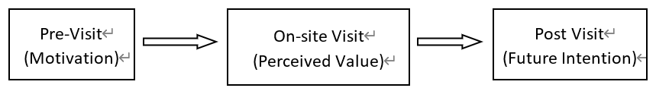
Figure 1. The proposed conceptual model

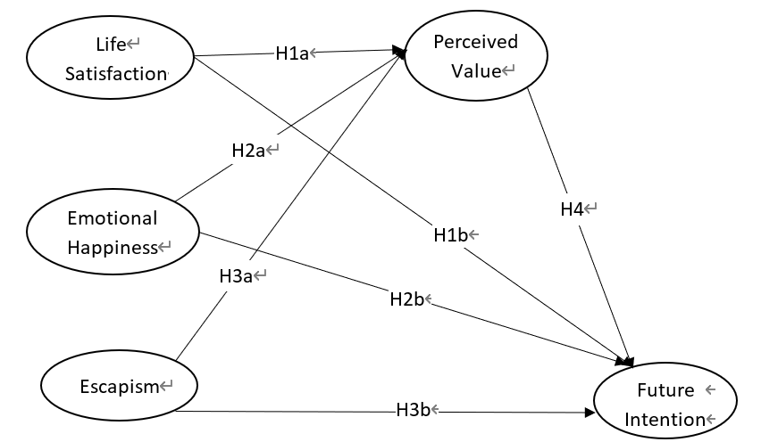
Figure 2. Conceptual Framework with Hypotheses
*H4 – Mediator Measurement by Perceived Value

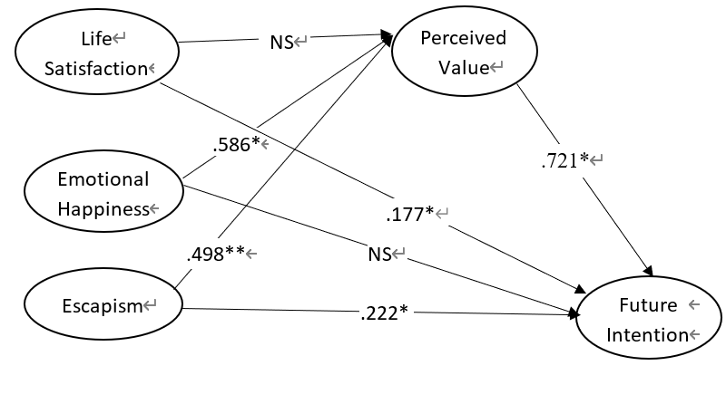
Figure 3. SEM Overview (Direct Effects)

Supplementary Tables
Table 1. Summary of Survey Items
Constructs | Item | Source
Life  Satisfaction  (4) | Participating in sport events is relaxed. | Armstrong, 2002; Park et al., 2016; Rode et al., 2018; Trail & James, 2001; Wann, 1995; Wild & Cant, 2015
Life  Satisfaction  (4) | Participating in sport events is for a healthy leisure life.
Life  Satisfaction  (4) | Participating in sport events is for freedom.
Life  Satisfaction  (4) | Participating in sport events is for pleasure.
Emotional  Happiness  (5) | Participating in sport event is always fun. | Armstrong, 2002; Park et al., 2016; Rode et al., 2018; Trail & James, 2001; Wann, 1995; Wild & Cant, 2015
Emotional  Happiness  (5) | Participating in sport events allows you to have a happy time with your family.
Emotional  Happiness  (5) | Participating in sport events is for my happiness.
Emotional  Happiness  (5) | Participating in sport events is for psychological happiness.
Emotional  Happiness  (5) | Participating in sport events is for my life vitality.
Escapism  (4) | Participation in sport events provides opportunities for a sense of freedom. | Armstrong, 2002; Park et al., 2016; Rode et al., 2018; Trail & James, 2001; Wann, 1995; Wild & Cant, 2015
Escapism  (4) | Participating in sport events is to escape from everyday life.
Escapism  (4) | Participation in sport events gives a sense of freedom.
Escapism  (4) | Participation in sport events helps escape from daily life.
Perceived  Value  (6) | Participating in sport events is superior to any other form of tourism. | Armstrong, 2002; Park et al., 2016; Rode et al., 2018; Trail & James, 2001; Wann, 1995; Wild & Cant, 2015
Perceived  Value  (6) | Participating in sport events does not waste my time.
Perceived  Value  (6) | Participating in sport events gives me pleasure.
Perceived  Value  (6) | Participating in sport events has positively changed my life.
Perceived  Value  (6) | I perceive that participating in sport events has recharged my life.
Perceived  Value  (6) | I perceive that my life is enriched by participating in sport events.
Future  Intention  (5) | I will participate in those sport events again that I am currently doing now. | Armstrong, 2002; Park et al., 2016; Rode et al., 2018; Trail & James, 2001; Wann, 1995; Wild & Cant, 2015
Future  Intention  (5) | I will participate in sport events that I am doing now with people around me.
Future  Intention  (5) | If there is another sport events program, I will participate in it.
Future  Intention  (5) | I will recommend the sport events program that I am currently participating into people around me.
Future  Intention  (5) | I will tell other people around me about the sport events program I have participated in.

Table 2. Summary of Demographics
Items | Frequency | Percent (%)
Gender (n=96)
Male | 77 | 71.3
Female | 31 | 28.7
Age (n=96)
20-29 | 26 | 24.1
30-39 | 33 | 30.6
40-49 | 29 | 26.9
50-59 | 19 | 17.6
Over 60 | 1 | 0.9
What is your final educational level? (n=96)
Less than high school | 51 | 47.2
University enrolment/graduation | 52 | 48.1
Postgraduate or above | 4 | 3.7
Others | 1 | 0.9
What is your job? (n=96)
Student | 16 | 14.8
Office/Administrative position | 2 | 1.9
Agriculture/Fishery | 1 | 0.9
Production/Technical positions | 2 | 1.9
Sales/Service | 30 | 27.8
Specialized(professions)/Free positions | 2 | 1.9
Self-employment/Management | 54 | 50.0
Others | 1 | 0.9
Marital Status (n=96)
Single | 56 | 51.9
Married | 52 | 48.1
Monthly Income (n=96)
Less than $2,000 | 39 | 36.1
$2,000-3,000 | 50 | 46.3
$3,000-4,000 | 14 | 13.0
$4,000-5,000 | 1 | 0.9
$5,000-6,000 | 3 | 2.8
Over $6,000 | 1 | 0.9
How many children do you have? (n=96)
0 | 67 | 62.0
1 | 14 | 13.0
2 | 22 | 20.4
3 or more | 5 | 4.6
How many times a year are you involved in sports tourism? (n=96)
1-2 | 65 | 60.2
3-4 | 18 | 16.7
5-6 | 15 | 13.9
Over 7 | 10 | 9.3

Table 3. Factor Loadings, Reliabilities, and Fit Indices
Constructs | Factor  Loadings  (Std  Estimates) | Cronbach  alpha | Average  variance  extracted  (AVE) | Composite  Reliability  (CR)
Life  Satisfaction | .953 | .915 | .737 | .917
Life  Satisfaction | .953 | .915 | .737 | .917
Life  Satisfaction | .826 | .915 | .737 | .917
Life  Satisfaction | .671 | .915 | .737 | .917
Emotional Happiness | .911 | .921 | .720 | .927
Emotional Happiness | .930 | .921 | .720 | .927
Emotional Happiness | .870 | .921 | .720 | .927
Emotional Happiness | .670 | .921 | .720 | .927
Emotional Happiness | .835 | .921 | .720 | .927
Escapism | .915 | .941 | .802 | .942
Escapism | .839 | .941 | .802 | .942
Escapism | .922 | .941 | .802 | .942
Escapism | .904 | .941 | .802 | .942
Perceived Value | .871 | .966 | .828 | .967
Perceived Value | .924 | .966 | .828 | .967
Perceived Value | .909 | .966 | .828 | .967
Perceived Value | .913 | .966 | .828 | .967
Perceived Value | .929 | .966 | .828 | .967
Perceived Value | .913 | .966 | .828 | .967
Future  Intention | .855 | .930 | .729 | .931
Future  Intention | .831 | .930 | .729 | .931
Future  Intention | .816 | .930 | .729 | .931
Future  Intention | .874 | .930 | .729 | .931
Future  Intention | .890 | .930 | .729 | .931
Table 4. Regression Weights
Constructs | Dependent | Hypotheses | Unstandardized  Estimates | Standardized  Estimates | S.E. | Significance
Independent
Life Satisfaction | Perceived  Value | H1a | -.102 | -.132 | .044 | *
Emotional Happiness | Perceived  Value | H2a | .586 | .651 | .066 | ***
Escapism | Perceived  Value | H3a | .498 | .552 | .062 | ***
Life Satisfaction | Future  Intention | H1b | .177 | .258 | .034 | ***
Emotional Happiness | Future  Intention | H2b | -.029 | -.036 | .065 | NS
Escapism | Future  Intention | H3b | .222 | .276 | .061 | ***
Perceived Value | Future  Intention | H4 | .721 | .810 | .110 | ***
† Significance level .10; * Significance level .05; ** Significance level .01; ***Significance level .001, NS: Non-Significant

Independent | Dependent | Direct | Indirect | Total | Hypotheses
Life  Satisfaction | Perceived Value | -.102 |  | -.102
Life  Satisfaction | Future Intention | .177* | -.074 | .104 | H4a
Emotional Happiness | Perceived Value | .586* |  | .586*
Emotional Happiness | Future Intention | -.029 | .423* | .394* | H4b
Escapism | Perceived Value | .498** |  | .498**
Escapism | Future Intention | .222** | .359** | .581** | H4c
Perceived Value | Future Intention | .721* |  | .721*
† Significance level .10; * Significance level .05; ** Significance level .01; ***Significance level .001.
Table 5. Direct, Indirect, and Total Effects

