Supplementary Information:

Absorption Spectra of p-Nitroaniline Derivatives: Charge Transfer Effects and the Role of Substituents

Matheus Máximo-Canadas¹, Itamar Borges Jr^{1*}

¹Departamento de Química, Instituto Militar de Engenharia (IME), Rio de Janeiro, RJ 22290-270, Brasil

* Corresponding author: itamar@ime.eb.br
Summary
S1. The choice of the substitution site S7
S2. The choice of the substituent groups S8
S2.1 – EDG -NH₂, –OCH₃, and –OH S8
S2.2 – EDGs –C₆H₅, –CH₃, and –CCH S9
S2.3 – EWGs –F, –Cl, and –Br S9
S3. Vertical gas phase spectra of the substituted pNA S10
S4. Excited State Decomposition and Natural Transition Orbitals (NTOs) S32
S5. Hammett correlation S41
S6. Geometries S45
References S59

List of figures
Fig. S 1: The absorption spectra of the electron-donor group (EDG) a) OCH₃, and b) OH substituents. S11
Fig. S 2: The absorption spectra of the electron-donor group (EDG) a) C₆H₅, b) CH₃, and c) CCH substituents. S12
Fig. S 3: The absorption spectra of the electron-withdrawing group (EWG) a) F, b) Cl, and c) Br substituents. S13
Fig. S 4: The absorption spectra of the electron-withdrawing group (EWG) a) COOH, b) CN, and c) SO₂H substituents. S14
Fig. S 5: The absorption spectra of the electron-withdrawing group (EWG) a) CF₃, and b) CCl₃ substituents. S15
Fig. S 6: ADC(2)//def2-TZVPD excited state decomposition of the substituted by halogens a) pNA–Br, b) pNA–Cl, c) pNA–F. CT from the remaining three regions of Scheme 1 on the main article toward: the nitro group (NCT), the benzene ring (RCT), and the substituent (SCT). Local excitation on the nitro group (NLE), the benzene ring (RLE), and the substituent (SLE). The states indicated in red (S₂ and S₇) are the brighter states of the first and second bands, respectively. S32
Fig. S 7: ADC(2)//def2-TZVPD excited state decomposition of the substituted EDG a) pNA–NH₂, b) pNA–OCH₃, c) pNA–OH, d) pNA–C₆H₅, e) pNA–CCH, and f) pNA–CH₃. CT from the remaining three regions of Scheme 1 on the main article toward: the nitro group (NCT), the benzene ring (RCT), and the substituent (SCT). Local excitation on the nitro group (NLE), the benzene ring (RLE), and the substituent (SLE). The states indicated in red (S₂ and S₇) are the brighter states of the first and second bands, respectively. S33
Fig. S 8: ADC(2)//def2-TZVPD excited state decomposition of the EWG substituted a) pNA–COOH, b) pNA–CN, c) pNA–NO₂, d) pNA–SO₂H, e) pNA–CCl₃, and f) pNA–CF₃. CT from the remaining three regions of Scheme 1 on the main article toward: the nitro group (NCT), the benzene ring (RCT), and the substituent (SCT). Local excitation on the nitro group (NLE), the benzene ring (RLE), and the substituent (SLE). The states indicated in red (S₂ and S₇) are the brighter states of the first and second bands, respectively. S34
Fig. S 9: The brightest states of each band of the absorption’s spectrum with its oscillator strength, and the NTOs with their amplitudes to the transitions from the hole (occupied NTO, on the left) to the particle (virtual NTO, on the right) to the EDG a) pNA–NH₂, b) pNA–OCH₃, and c) pNA–OH. S35
Fig. S 10: The brightest states of each band of the absorption’s spectrum with its oscillator strength, and the NTOs with their amplitudes to the transitions from the hole (occupied NTO, on the left) to the particle (virtual NTO, on the right) to the EDG a) pNA–C₆H₅, b) pNA–CCH, and c) pNA–CH₃. S36
Fig. S 11: The brightest states of each band of the absorption’s spectrum with its oscillator strength, and the NTOs with their amplitudes to the transitions from the hole (occupied NTO, on the left) to the particle (virtual NTO, on the right) to the EWG a) pNA–Br, b) pNA–Cl., and c) pNA–F. S37
Fig. S 12: The brightest states of each band of the absorption’s spectrum with its oscillator strength, and the NTOs with their amplitudes to the transitions from the hole (occupied NTO, on the left) to the particle (virtual NTO, on the right) to the EWG a) pNA–COOH, b) pNA–CN, and c) pNA–SO₂H. S38
Fig. S 13: The brightest states of each band of the absorption’s spectrum with its oscillator strength, and the NTOs with their amplitudes to the transitions from the hole (occupied NTO, on the left) to the particle (virtual NTO, on the right) to the EWG a) pNA–NO₂ and b) pNA–CCl₃. S39
Fig. S 14: Relation between σ_{m}⁰ and the molecular properties a) HOMO-LUMO gap, b) HOMO energy, c) LUMO energy, d) first band maximum energy, e) second band maximum energy. The red substituents caused a redshift in the spectrum, while the blue ones caused a blueshift. S41
Fig. S 15: Relation between σ_{m} and the molecular properties a) HOMO-LUMO gap, b) HOMO energy, c) LUMO energy, d) first band maximum energy, e) second band maximum energy. The red substituents caused a redshift in the spectrum, while the blue ones caused a blueshift. S42
Fig. S 16: Relation between σ_{R} and the molecular properties a) HOMO-LUMO gap, b) HOMO energy, c) LUMO energy, d) first band maximum energy, e) second band maximum energy. The red substituents caused a redshift in the spectrum, while the blue ones caused a blueshift. S43
Fig. S 17: Relation between σ_{I} and the molecular properties a) HOMO-LUMO gap, b) HOMO energy, c) LUMO energy, d) first band maximum energy, e) second band maximum energy. The red substituents caused a redshift in the spectrum, while the blue ones caused a blueshift. S44
Fig. S 18: The pNA theoretical and experimental (a) bond lengths and (b) bond angles. Numbers from top to bottom: MP2//def2-TZVPD (red), CAM-B3LYP//def2-TZVPD (orange), and three sets of experimental crystal data: Trueblood [6] (pink), Colapietro [7] (green), and Nieger [8] (in black). S45
Fig. S 19: The calculated RI-MP2//def2-TZVPD and CAM-B3LYP//def2-TZVPD bond lengths of a) pNA–OH with experimental [5] and b) pNA–OCH₃ with experimental [6]. S46
Fig. S 20: The calculated RI-MP2//def2-TZVPD and CAM-B3LYP//def2-TZVPD bond lengths of a) pNA–NO₂ with experimental [7] and b) pNA–NH₂ with experimental [8]. S47
Fig. S 21: The calculated RI-MP2//def2-TZVPD and CAM-B3LYP//def2-TZVPD bond lengths of a) pNA–F and b) pNA–CN with experimental [9]. S48
Fig. S 22: The calculated RI-MP2//def2-TZVPD and CAM-B3LYP//def2-TZVPD bond lengths of a) pNA– CH₃ with experimental [10] and b) pNA–CCH. S49
Fig. S 23: The calculated RI-MP2//def2-TZVPD and CAM-B3LYP//def2-TZVPD and experimental bond lengths of a) pNA–C₆H₅ and b) pNA–SO₂H. S50
Fig. S 24: The calculated RI-MP2//def2-TZVPD and CAM-B3LYP//def2-TZVPD and experimental bond lengths of a) pNA–COOH and b) pNA–CCl₃. S51
Fig. S 25: The calculated RI-MP2//def2-TZVPD and CAM-B3LYP//def2-TZVPD and experimental bond lengths of a) pNA–CF₃ with experimental [11] and b) pNA–Cl with experimental [12] S52
Fig. S 26: The calculated RI-MP2//def2-TZVPD and CAM-B3LYP//def2-TZVPD and experimental bond lengths of pNA–Br with experimental [13]. S53

List of Tables
Table S 1: RI-ADC(2)//def2-TZVPD transition energies ($∆E$), optical oscillator strengths ($f$), and dominant contribution to the character of the singlet states to the pNA–NH₂. S16
Table S 2: RI-ADC(2)//def2-TZVPD transition energies ($∆E$), optical oscillator strengths ($f$), and dominant contribution to the character of the singlet states to the pNA–OCH₃. S16
Table S 3: RI-ADC(2)//def2-TZVPD transition energies ($∆E$), optical oscillator strengths ($f$), and dominant contribution to the character of the singlet states to the pNA–OH. S17
Table S 4: RI-ADC(2)//def2-TZVPD transition energies ($∆E$), optical oscillator strengths ($f$), and dominant contribution to the character of the singlet states to the pNA–C₆H₅. S18
Table S 5: RI-ADC(2)//def2-TZVPD transition energies ($∆E$), optical oscillator strengths ($f$), and dominant contribution to the character of the singlet states to the pNA–CCH. S19
Table S 6: RI-ADC(2)//def2-TZVPD transition energies ($∆E$), optical oscillator strengths ($f$), and dominant contribution to the character of the singlet states to the pNA–CH₃. S20
Table S 7: RI-ADC(2)//def2-TZVPD transition energies ($∆E$), optical oscillator strengths ($f$), and dominant contribution to the character of the singlet states to the pNA–Br. S21
Table S 8: RI-ADC(2)//def2-TZVPD transition energies ($∆E$), optical oscillator strengths ($f$), and dominant contribution to the character of the singlet states to the pNA–Cl. S22
Table S 9: RI-ADC(2)//def2-TZVPD transition energies ($∆E$), optical oscillator strengths ($f$), and dominant contribution to the character of the singlet states to the pNA–F. S23
Table S 10: RI-ADC(2)//def2-TZVPD transition energies ($∆E$), optical oscillator strengths ($f$), and dominant contribution to the character of the singlet states to the pNA–COOH. S24
Table S 11: RI-ADC(2)//def2-TZVPD transition energies ($∆E$), optical oscillator strengths ($f$), and dominant contribution to the character of the singlet states to the pNA–CN. S26
Table S 12: RI-ADC(2)//def2-TZVPD transition energies ($∆E$), optical oscillator strengths ($f$), and dominant contribution to the character of the singlet states to the pNA–SO₂H. S27
Table S 13: RI-ADC(2)//def2-TZVPD transition energies ($∆E$), optical oscillator strengths ($f$), and dominant contribution to the character of the singlet states to the pNA–NO₂. S28
Table S 14: RI-ADC(2)//def2-TZVPD transition energies ($∆E$), optical oscillator strengths ($f$), and dominant contribution to the character of the singlet states to the pNA–CCl₃. S30
Table S 15: RI-ADC(2)//def2-TZVPD transition energies ($∆E$), optical oscillator strengths ($f$), and dominant contribution to the character of the singlet states to the pNA–CF₃. S31
Table S 16: The RI-ADC(2)//def2-TZVPD molecular properties for each substituent (R). S40
Table S 17: Unsubstituted and substituted pNA CAM-B3LYP//def2-TZVPD xyz coordinates. S53

S1. The choice of the substitution site

In an electrophilic aromatic substitution reaction, the donor (amine, NH₂) and acceptor (nitro, NO₂) groups already present in the original pNA affect the rate and the specific substitution site. Specifically, the regioselectivity is influenced by the so-called director groups, a substituent that influences the position at which a new substituent will be added to a molecule during a chemical reaction. The ortho,para (o,p-) directors promote substitution at the ortho and para positions, and meta (m-) directors promote substitution at the meta position [1]. Electron donor groups (EDGs), such as amines, usually act as an o,p-director mostly due to resonance effects, whereas electron-withdrawing groups (EWGs), such as nitro groups, typically are a m-director type, also due to resonance effects, except for halogens, an EWG and o,p-director [1].
The amino group is ortho,para-directing toward electrophiles. The nitrogen’s lone pair can interact with the ring, leading to resonance forms where the lone pair is delocalized into the ring – see Scheme S1 (a). This results in increased electron density at the ortho and para positions compared to the meta position. Therefore, for an electrophilic aromatic substitution (EAS) on the aniline – Scheme S1(b), the product is a mixture of ortho- and para-compounds. Conversely, the nitro group is meta-directing. The curved arrow mechanism in Scheme S1 (c) indicates that the nitro group withdraws electron density from the π system specifically from the ortho and para positions. Since more electron density is removed from these positions, the least electron-deficient position is the meta position and, therefore, on the EAS on the nitrobenzene in Scheme S1 (d), the product is a meta compound.
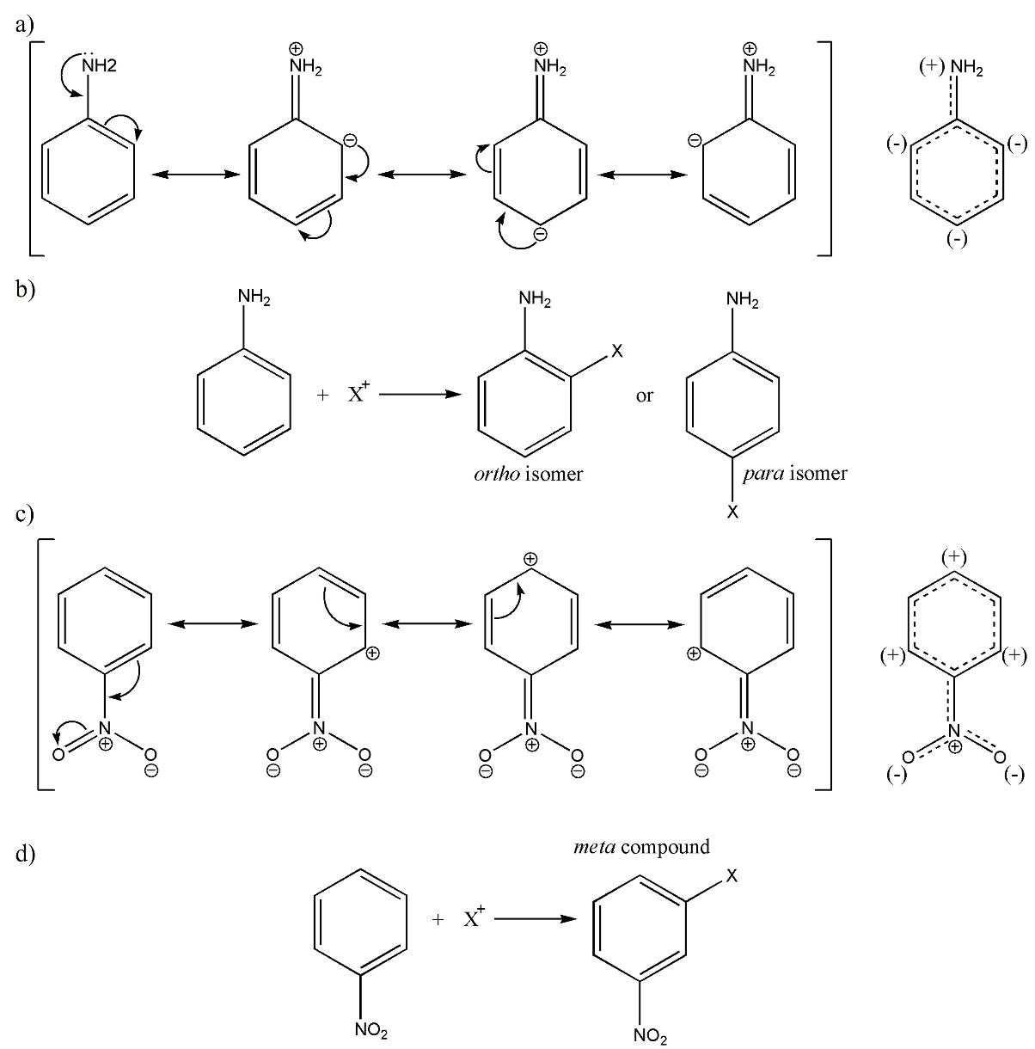
Scheme S1: The curved arrow mechanism to the a) aniline and c) nitrobenzene with the resonance structures between the bracket on the left and the resonance hybrid on the right. And the electrophilic aromatic substitution on the b) aniline and d) nitrobenzene.

S2. The choice of the substituent groups

S2.1 – EDG –NH₂, –OCH₃, and –OH

Oxygen substituents (–OH, –OR, and –O¯) have a nonbonding lone pair, which is a doubly occupied n_{π}-orbitals, acting as a mesomeric electron and typically broadens a band and shifts both the absorption and fluorescence spectra [2], an effect more pronounced in the –O¯ than –OR, and less in –OH [3]. This is reflected in the wider pNA–OCH₃ bands compared with pNA–OH. Furthermore, an EDG amine substituent, –NH₂, also has a mesomeric lone pair, and given that the nitrogen atom is less electronegative than oxygen, its lone pair has a higher energy. Consequently, the amine’s lone pair is even more prone to interact with the π system of the molecule than phenols, phenyl ethers, or phenoxide ions [3].
Substituents such as amines, phenols, and ethers can lead to the formation of extended conjugated systems in molecules, which creates a series of molecular orbitals in the conjugated system, enhancing the probability of electronic transitions. The broader absorption spectrum observed in molecules with extended conjugated systems results from the increased number of allowed transitions determined by the selection rules.

S2.2 – EDGs –C₆H₅, –CH₃, and –CCH

The methyl is an EDG by induction due to the differences in electronegativity between atoms. Moreover, it neither has a lone pair nor π electrons available for conjugation with the π system (π conjugation). Despite that, one of the three σ C–H bonds can interact with the π system by hyperconjugation (also known as σ conjugation), which typically involves the interaction between an adjacent σ bond and an empty or partially filled p orbital [4,5], and is believed to be the cause of a small redshift on the absorption spectra of saturated alkyl chains [3]. The phenyl and ethynyl are EDGs by resonance because they have π electrons that can be conjugated with the benzene ring π system (π conjugation). The phenomenon of σ conjugation and inductive effect have a much smaller effect compared to a π conjugation in conjugated hydrocarbons [3,4] due to their extensive electron delocalization. In systems having π conjugation, the π electrons are spread over a larger conjugated structure, producing a wider range of energy levels. The increase in the extent of the π-electron system is a well-known factor leading to a redshift in the absorption spectra [110].

S2.3 – EWGs –F, –Cl, and –Br

The halogens substituents –F, –Cl, and –Br can act both as electron donors by conjugation and as electron withdrawers by induction. However, the latter effect plays a much more significant role, leading to these halogens being classified as weak electron-withdrawing groups. They have three lone pairs, one of which may conjugate with the ring, but this stabilization is limited since the carbon’s 2p orbitals poorly overlap with the chlorine’s 3p orbitals and bromine’s 4p orbitals. Even though fluorine does not have this mismatch, its orbitals have much lower energy compared with carbon's 2p since fluorine is the most electronegative element. Therefore, the weak lone pair conjugation of the halogens should be overcome by their inductive electron withdrawal.

S3. Vertical gas phase spectra of the substituted pNA

The ADC(2) and CAM-B3LYP vertical gas phase spectra of the substituted pNA employing the def2-TZVPD basis set are depicted in Fig. S1 to Fig. S5. Thirteen substituents are shown, namely pNA–OCH₃, pNA–OH, pNA–C₆H₅, pNA–CCH, pNA–CH₃, pNA–Br, pNA–Cl, pNA–F, pNA–COOH, pNA–CN, pNA–SO₂H, pNA–CF₃, and pNA–CCl₃. The pNA, pNA–NO₂, and pNA–NH₂ are shown in the main paper The CAM-B3LYP//def2-TZVPD S₀ geometry was used for these vertical calculations. The y-axis was normalized to 1.0 at the energy of the bigger absorption peak to better compare the results. The spectra of the pNA–NH₂, pNA–NO₂, and unsubstituted pNA are shown in the main paper.

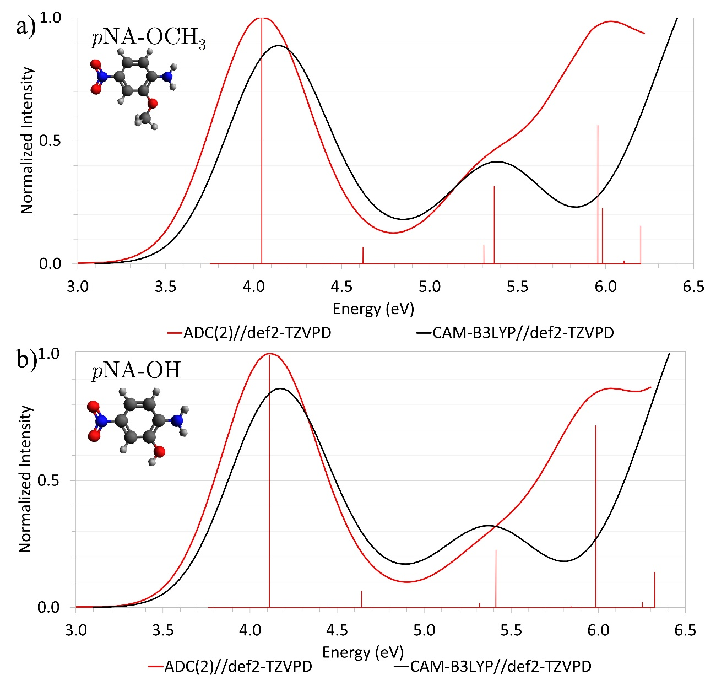
Fig. S 1: The absorption spectra of the electron-donor group (EDG) a) OCH₃, and b) OH substituents.
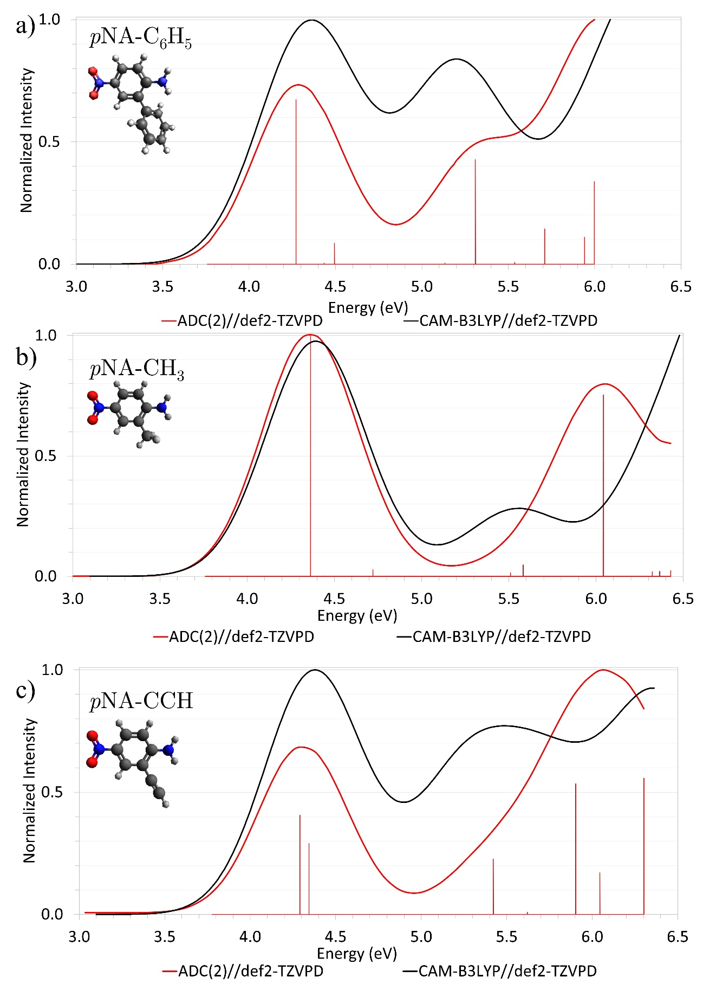
Fig. S 2: The absorption spectra of the electron-donor group (EDG) a) C₆H₅, b) CH₃, and c) CCH substituents.

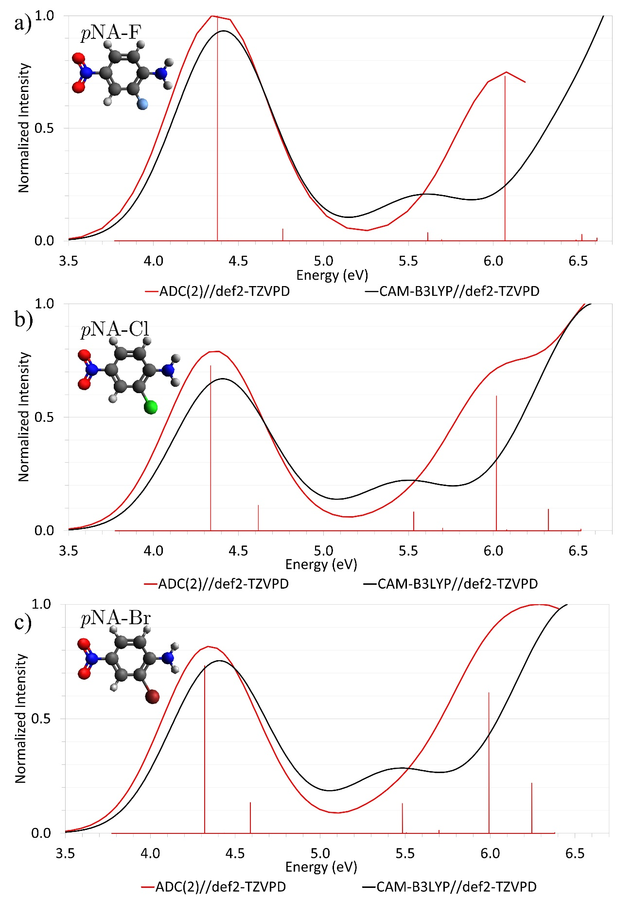
Fig. S 3: The absorption spectra of the electron-withdrawing group (EWG) a) F, b) Cl, and c) Br substituents.

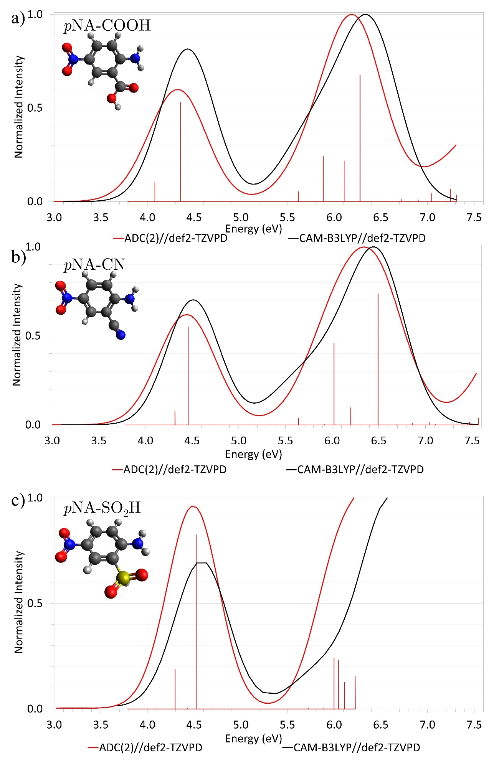
Fig. S 4: The absorption spectra of the electron-withdrawing group (EWG) a) COOH, b) CN, and c) SO₂H substituents.
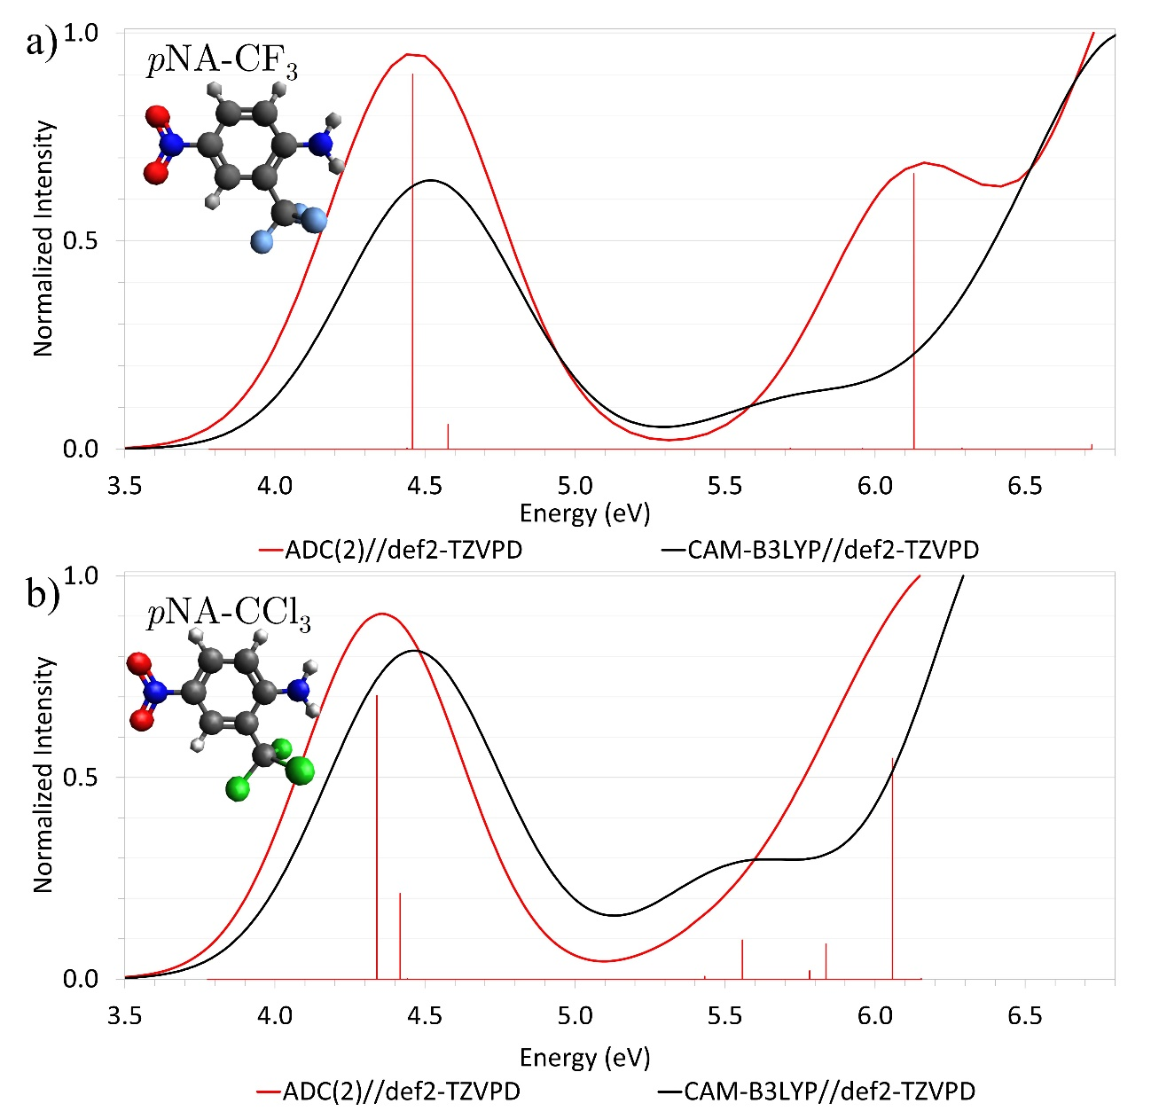
Fig. S 5: The absorption spectra of the electron-withdrawing group (EWG) a) CF₃, and b) CCl₃ substituents.

The RI-ADC(2)//def2-TZVPD transition energies ($∆E$), optical oscillator strengths ($f$), and dominant contribution to the character of the singlet states to the substituents (assignment), the percentage of these contributors ($\%$) and the charge transfer (CT) character are shown from Table S1 to Table S15. For each state, if the primary assignment has a percentage below 60%, we identify other transition possibilities that contribute and their corresponding weights when they are above 10%.

Table S 1: RI-ADC(2)//def2-TZVPD transition energies ($∆E$), optical oscillator strengths ($f$), and dominant contribution to the character of the singlet states to the pNA–NH₂.
pNA–NH₂
State | $∆E$ª | $f$^{b} | Assignment^{c} | %^{d} | CT^{e}
S₁ | 3.755 | 0.000 | HOMO-4$→$LUMO | 76.1 | 0.242
S₂ | 4.112 | 0.235 | HOMO$→$LUMO | 88.8 | 0.651
S₃ | 4.440 | 0.004 | HOMO-5$→$LUMO | 63.1 | 0.265
S₄ | 4.634 | 0.063 | HOMO$-1→$LUMO  HOMO$→$LUMO+7 | 49.5  28.2 | 0.497
S₅ | 5.264 | 0.016 | HOMO$→$LUMO+1 | 77.8 | 0.587
S₆ | 5.358 | 0.194 | HOMO-1$→$LUMO  HOMO$→$LUMO+7 | 37.4  29.7 | 0.571
S₇ | 5.902 | 0.005 | HOMO$→$LUMO+2  HOMO-1$→$LUMO+1 | 59.6  14.7 | 0.530
S₈ | 5.973 | 0.285 | HOMO-2$→$LUMO | 74.6 | 0.341
S₉ | 6.163 | 0.103 | HOMO-1$→$LUMO+7  HOMO$→$LUMO+15 | 28.4  13.5 | 0.481
S₁₀ | 6.228 | 0.017 | HOMO$→$LUMO+3 | 64.0 | 0.524
ª The transition energies ($∆E$) in eV.
^{b} The optical oscillator strengths ($f$).
^{c} The dominant contribution to the character of the singlet states to the substituents (assignment).
^{d} the percentage of these contributors ($\%$).
^{e} The charge transfer character in $e$.

Table S 2: RI-ADC(2)//def2-TZVPD transition energies ($∆E$), optical oscillator strengths ($f$), and dominant contribution to the character of the singlet states to the pNA–OCH₃.
pNA–OCH₃
State | $∆E$ª | $f$^{b} | Assignment^{c} | %^{d} | CT^{e}
S₁ | 3.754 | 0.000 | HOMO-4$→$LUMO+1 | 60.3 | 0.249
S₂ | 4.046 | 0.342 | HOMO$→$LUMO+1 | 71.3 | 0.670
S₃ | 4.446 | 0.000 | HOMO-5$→$LUMO+1 | 60.0 | 0.267
S₄ | 4.621 | 0.023 | HOMO$→$LUMO+8  HOMO-1$→$LUMO+1 | 36.8  34.6 | 0.464
S₅ | 5.308 | 0.026 | HOMO$→$LUMO  HOMO$→$LUMO+2 | 38.9  20.4 | 0.580
S₆ | 5.366 | 0.108 | HOMO$→$LUMO+8  HOMO-1$→$LUMO+1 | 26.1  25.6 | 0.561
S₇ | 5.956 | 0.193 | HOMO-2$→$LUMO+1  HOMO-2$→$LUMO | 48.4  12.9 | 0.396
S₈ | 5.982 | 0.077 | HOMO$→$LUMO+2  HOMO$→$LUMO+5  HOMO-2$→$LUMO+1 | 34.4  12.7  12.1 | 0.540
S₉ | 6.105 | 0.004 | HOMO$→$LUMO+3 | 79.3 | 0.551
S₁₀ | 6.199 | 0.052 | HOMO$→$LUMO+16  HOMO$→$LUMO+11  HOMO$→$LUMO+5  HOMO-1$→$LUMO+8 | 23.1  16.3  14.5  12.8 | 0.560
ª The transition energies ($∆E$) in eV.
^{b} The optical oscillator strengths ($f$).
^{c} The dominant contribution to the character of the singlet states to the substituents (assignment).
^{d} the percentage of these contributors ($\%$).
^{e} The charge transfer character in $e$.

Table S 3: RI-ADC(2)//def2-TZVPD transition energies ($∆E$), optical oscillator strengths ($f$), and dominant contribution to the character of the singlet states to the pNA–OH.
pNA–OH
State | $∆E$ª | $f$^{b} | Assignment^{c} | %^{d} | CT^{e}
S₁ | 3.760 | 0.000 | HOMO-4$→$LUMO+1 | 78.3 | 0.247
S₂ | 4.111 | 0.358 | HOMO$→$LUMO+1 | 90.4 | 0.653
S₃ | 4.445 | 0.000 | HOMO-5$→$LUMO+1 | 77.5 | 0.267
S₄ | 4.640 | 0.023 | HOMO-1$→$LUMO+1  HOMO$→$LUMO+6  HOMO$→$LUMO+8 | 40.0  26.1  17.6 | 0.452
S₅ | 5.317 | 0.006 | HOMO$→$LUMO | 67.7 | 0.574
S₆ | 5.412 | 0.081 | HOMO-1$→$LUMO+1  HOMO$→$LUMO+6  HOMO$→$LUMO+8  HOMO-2$→$LUMO+1 | 42.5  18.7  11.4  10.2 | 0.552
S₇ | 5.843 | 0.001 | HOMO$→$LUMO+2 | 63.9 | 0.586
S₈ | 5.986 | 0.257 | HOMO-2$→$LUMO+1 | 73.1 | 0.360
S₉ | 6.253 | 0.007 | HOMO$→$LUMO+3 | 68.2 | 0.537
S₁₀ | 6.324 | 0.050 | HOMO$→$LUMO+17  HOMO$→$LUMO+11  HOMO-1$→$LUMO+6  HOMO$→$LUMO+14 | 23.1  17.5  12.8  12.6 | 0.518
ª The transition energies ($∆E$) in eV.
^{b} The optical oscillator strengths ($f$).
^{c} The dominant contribution to the character of the singlet states to the substituents (assignment).
^{d} the percentage of these contributors ($\%$).
^{e} The charge transfer character in $e$.

Table S 4: RI-ADC(2)//def2-TZVPD transition energies ($∆E$), optical oscillator strengths ($f$), and dominant contribution to the character of the singlet states to the pNA–C₆H₅.
pNA–C₆H₅
State | $∆E$ª | $f$^{b} | Assignment^{c} | %^{d} | CT^{e}
S₁ | 3.758 | 0.000 | HOMO-6$→$LUMO | 73.9 | 0.249
S₂ | 4.271 | 0.365 | HOMO$→$LUMO | 80.2 | 0.655
S₃ | 4.434 | 0.002 | HOMO-7$→$LUMO | 71.3 | 0.271
S₄ | 4.494 | 0.046 | HOMO$→$LUMO+4  HOMO$→$LUMO+6  HOMO-1$→$LUMO | 35.0  16.3  13.0 | 0.466
S₅ | 5.133 | 0.002 | HOMO-2$→$LUMO+5  HOMO$→$LUMO+8  HOMO$→$LUMO+12 | 18.3  15.8  10.2 | 0.215
S₆ | 5.309 | 0.232 | HOMO-1$→$LUMO  HOMO$→$LUMO+4  HOMO-3$→$LUMO | 43.9  16.3  10.9 | 0.618
S₇ | 5.537 | 0.004 | HOMO$→$LUMO+1 | 62.3 | 0.580
S₈ | 5.711 | 0.078 | HOMO$→$LUMO+12  HOMO-4$→$LUMO  HOMO$→$LUMO+11 | 21.0  14.5  11.0 | 0.562
S₉ | 5.942 | 0.060 | HOMO-4$→$LUMO  HOMO$→$LUMO+7 | 31.8  19.1 | 0.576
S₁₀ | 5.998 | 0.183 | HOMO-4$→$LUMO  HOMO$→$LUMO+7 | 29.4  13.2 | 0.588
ª The transition energies ($∆E$) in eV.
^{b} The optical oscillator strengths ($f$).
^{c} The dominant contribution to the character of the singlet states to the substituents (assignment).
^{d} the percentage of these contributors ($\%$).
^{e} The charge transfer character in $e$.

Table S 5: RI-ADC(2)//def2-TZVPD transition energies ($∆E$), optical oscillator strengths ($f$), and dominant contribution to the character of the singlet states to the pNA–CCH.
pNA–CCH
State | $∆E$ª | $f$^{b} | Assignment^{c} | %^{d} | CT^{e}
S₁ | 3.777 | 0.000 | HOMO-5$→$LUMO | 78.0 | 0.248
S₂ | 4.291 | 0.260 | HOMO$→$LUMO  HOMO$→$LUMO+3 | 53.1  32.3 | 0.585
S₃ | 4.343 | 0.186 | HOMO$→$LUMO+3  HOMO$→$LUMO  HOMO-1$→$LUMO | 43.5  33.4  14.1 | 0.537
S₄ | 4.448 | 0.000 | HOMO-7$→$LUMO | 76.3 | 0.267
S₅ | 5.422 | 0.145 | HOMO-1$→$LUMO | 66.2 | 0.577
S₆ | 5.621 | 0.005 | HOMO$→$LUMO+1 | 77.0 | 0.578
S₇ | 5.903 | 0.342 | HOMO-3$→$LUMO  HOMO-1$→$LUMO+3 | 38.1  20.3 | 0.410
S₈ | 6.045 | 0.109 | HOMO-3$→$LUMO  HOMO-1$→$LUMO+3 | 32.7  23.1 | 0.443
S₉ | 6.207 | 0.000 | HOMO-5$→$LUMO+3 | 87.1 | 0.901
S₁₀ | 6.302 | 0.357 | HOMO-1$→$LUMO+3  HOMO$→$LUMO+9  HOMO$→$LUMO+10  HOMO$→$LUMO+12 | 41.5  11.5  11.1  11.0 | 0.549
ª The transition energies ($∆E$) in eV.
^{b} The optical oscillator strengths ($f$).
^{c} The dominant contribution to the character of the singlet states to the substituents (assignment).
^{d} the percentage of these contributors ($\%$).
^{e} The charge transfer character in $e$.

Table S 6: RI-ADC(2)//def2-TZVPD transition energies ($∆E$), optical oscillator strengths ($f$), and dominant contribution to the character of the singlet states to the pNA–CH₃.
pNA–CH₃
State | $∆E$ª | $f$^{b} | Assignment^{c} | %^{d} | CT^{e}
S₁ | 3.759 | 0.000 | HOMO-3$→$LUMO+1 | 78.7 | 0.247
S₂ | 4.364 | 0.411 | HOMO$→$LUMO+1 | 89.9 | 0.646
S₃ | 4.440 | 0.001 | HOMO-5$→$LUMO+1 | 74.6 | 0.267
S₄ | 4.721 | 0.011 | HOMO$→$LUMO+6  HOMO-1$→$LUMO+1 | 55.1  30.8 | 0.399
S₅ | 5.510 | 0.006 | HOMO$→$LUMO | 70.7 | 0.586
S₆ | 5.582 | 0.020 | HOMO-1$→$LUMO+1  HOMO-2$→$LUMO+1  HOMO$→$LUMO+6 | 41.7  23.3  20.2 | 0.490
S₇ | 6.042 | 0.311 | HOMO-2$→$LUMO+1 | 60.6 | 0.402
S₈ | 6.322 | 0.008 | HOMO$→$LUMO+2 | 63.8 | 0.597
S₉ | 6.364 | 0.009 | HOMO$→$LUMO+3  HOMO$→$LUMO+14 | 42.9  9.8 | 0.516
S₁₀ | 6.428 | 0.010 | HOMO$→$LUMO+3  HOMO$→$LUMO+14 | 27.4  16.7 | 0.536
ª The transition energies ($∆E$) in eV.
^{b} The optical oscillator strengths ($f$).
^{c} The dominant contribution to the character of the singlet states to the substituents (assignment).
^{d} the percentage of these contributors ($\%$).
^{e} The charge transfer character in $e$.

Table S 7: RI-ADC(2)//def2-TZVPD transition energies ($∆E$), optical oscillator strengths ($f$), and dominant contribution to the character of the singlet states to the pNA–Br.
pNA–Br
State | $∆E$ª | $f$^{b} | Assignment^{c} | %^{d} | CT^{e}
S₁ | 3.773 | 0.000 | HOMO-5$→$LUMO+1 | 76.4 | 0.250
S₂ | 4.320 | 0.351 | HOMO$→$LUMO+1 | 84.6 | 0.620
S₃ | 4.436 | 0.000 | HOMO-6$→$LUMO+1 | 70.9 | 0.270
S₄ | 4.590 | 0.064 | HOMO$→$LUMO+7  HOMO-1$→$LUMO+1  HOMO$→$LUMO+4 | 41.8  22.0  21.3 | 0.431
S₅ | 5.484 | 0.063 | HOMO-1$→$LUMO+1  HOMO-3$→$LUMO+1  HOMO$→$LUMO+7 | 57.2  13.1  11.8 | 0.547
S₆ | 5.507 | 0.001 | HOMO$→$LUMO  HOMO$→$LUMO+13  HOMO$→$LUMO+9 | 20.5  20.3  10.3 | 0.633
S₇ | 5.699 | 0.006 | HOMO$→$LUMO+2  HOMO$→$LUMO | 54.6  19.6 | 0.561
S₈ | 5.993 | 0.295 | HOMO-3$→$LUMO+1 | 68.8 | 0.375
S₉ | 6.245 | 0.105 | HOMO-1$→$LUMO+7  HOMO$→$LUMO+11  HOMO-1$→$LUMO+4  HOMO$→$LUMO+14 | 24.4  20.2  13.0  12.8 | 0.505
S₁₀ | 6.380 | 0.001 | HOMO-1$→$LUMO+13  HOMO-1$→$LUMO | 16.6  10.1 | 0.551
ª The transition energies ($∆E$) in eV.
^{b} The optical oscillator strengths ($f$).
^{c} The dominant contribution to the character of the singlet states to the substituents (assignment).
^{d} the percentage of these contributors ($\%$).
^{e} The charge transfer character in $e$.

Table S 8: RI-ADC(2)//def2-TZVPD transition energies ($∆E$), optical oscillator strengths ($f$), and dominant contribution to the character of the singlet states to the pNA–Cl.
pNA–Cl
State | $∆E$ª | $f$^{b} | Assignment^{c} | %^{d} | CT^{e}
S₁ | 3.774 | 0.000 | HOMO-4$→$LUMO  HOMO-5$→$LUMO | 46.2  27.5 | 0.249
S₂ | 4.336 | 0.366 | HOMO$→$LUMO | 85.8 | 0.621
S₃ | 4.439 | 0.000 | HOMO-6$→$LUMO | 61.5 | 0.269
S₄ | 4.617 | 0.057 | HOMO$→$LUMO+4  HOMO$→$LUMO+7  HOMO-1$→$LUMO | 34.7  27.1  22.6 | 0.425
S₅ | 5.531 | 0.042 | HOMO-1$→$LUMO  HOMO-2$→$LUMO | 54.9  16.7 | 0.522
S₆ | 5.702 | 0.006 | HOMO$→$LUMO+2  HOMO$→$LUMO+2 | 57.7  19.6 | 0.557
S₇ | 6.018 | 0.299 | HOMO-2$→$LUMO | 66.7 | 0.383
S₈ | 6.078 | 0.003 | HOMO$→$LUMO+2  HOMO$→$LUMO+8 | 36.5  27.2 | 0.624
S₉ | 6.324 | 0.048 | HOMO$→$LUMO+11  HOMO$→$LUMO+14  HOMO-1$→$LUMO+4 | 25.5  22.7  12.3 | 0.529
S₁₀ | 6.515 | 0.004 | HOMO$→$LUMO+3  HOMO-4$→$LUMO+4  HOMO-4$→$LUMO+7 | 25.1  13.1  11.3 | 0.695
ª The transition energies ($∆E$) in eV.
^{b} The optical oscillator strengths ($f$).
^{c} The dominant contribution to the character of the singlet states to the substituents (assignment).
^{d} the percentage of these contributors ($\%$).
^{e} The charge transfer character in $e$.

Table S 9: RI-ADC(2)//def2-TZVPD transition energies ($∆E$), optical oscillator strengths ($f$), and dominant contribution to the character of the singlet states to the pNA–F.
pNA–F
State | $∆E$ª | $f$^{b} | Assignment^{c} | %^{d} | CT^{e}
S₁ | 3.770 | 0.000 | HOMO-3$→$LUMO | 79.9 | 0.247
S₂ | 4.377 | 0.408 | HOMO$→$LUMO | 89.9 | 0.630
S₃ | 4.440 | 0.000 | HOMO-5$→$LUMO | 72.3 | 0.267
S₄ | 4.761 | 0.022 | HOMO$→$LUMO+4  HOMO-1$→$LUMO | 54.8  31.7 | 0.408
S₅ | 5.614 | 0.015 | HOMO-1$→$LUMO  HOMO-2$→$LUMO  HOMO$→$LUMO+4 | 41.4  23.9  19.7 | 0.480
S₆ | 5.695 | 0.002 | HOMO$→$LUMO+1 | 75.2 | 0.525
S₇ | 6.068 | 0.299 | HOMO-2$→$LUMO | 60.1 | 0.411
S₈ | 6.487 | 0.002 | HOMO$→$LUMO+2 | 70.7 | 0.496
S₉ | 6.521 | 0.012 | HOMO$→$LUMO+9  HOMO$→$LUMO+16  HOMO-1$→$LUMO+13  HOMO$→$LUMO+4  HOMO$→$LUMO+3 | 18.8  16.6  14.2  10.7  10.4 | 0.537
S₁₀ | 6.610 | 0.005 | HOMO$→$LUMO+3  HOMO$→$LUMO+6 | 57.8  9.1 | 0.486
ª The transition energies ($∆E$) in eV.
^{b} The optical oscillator strengths ($f$).
^{c} The dominant contribution to the character of the singlet states to the substituents (assignment).
^{d} the percentage of these contributors ($\%$).
^{e} The charge transfer character in $e$.

Table S 10: RI-ADC(2)//def2-TZVPD transition energies ($∆E$), optical oscillator strengths ($f$), and dominant contribution to the character of the singlet states to the pNA–COOH.
pNA–COOH
State | $∆E$ª | $f$^{b} | Assignment^{c} | %^{d} | CT^{e}
S₁ ($A’’$) | 3.788 | 0.000 | HOMO-4$→$LUMO+1 | 77.9 | 0.249
S₁ ($A’$) | 4.079 | 0.079 | HOMO$→$LUMO+3 | 86.4 | 0.497
S₂ ($A’$) | 4.354 | 0.405 | HOMO$→$LUMO+1 | 89.1 | 0.633
S₂ ($A’’$) | 4.453 | 0.000 | HOMO-6$→$LUMO+1 | 68.2 | 0.269
S₃ ($A’’$) | 5.081 | 0.000 | HOMO-3$→$LUMO+3 | 72.7 | 0.476
S₃ ($A’$) | 5.615 | 0.041 | HOMO-1$→$LUMO+1  HOMO-2$→$LUMO+1 | 59.6  15.2 | 0.505
S₄ ($A’’$) | 5.831 | 0.000 | HOMO$→$LUMO  HOMO$→$LUMO+2 | 46.5  37.4 | 0.540
S₄ ($A’$) | 5.883 | 0.184 | HOMO-2$→$LUMO+1  HOMO$→$LUMO+10  HOMO-1$→$LUMO+3 | 36.1  17.4  11.9 | 0.444
S₅ ($A’’$) | 5.899 | 0.000 | HOMO-4$→$LUMO+3 | 93.1 | 0.924
S₅ ($A’$) | 6.108 | 0.165 | HOMO-2$→$LUMO+1  HOMO-1$→$LUMO+1  HOMO$→$LUMO+10 | 31.4  23.7  10.0 | 0.456
S₆ ($A’$) | 6.278 | 0.515 | HOMO-1$→$LUMO+3 | 66.5 | 0.467
S₆ ($A’’$) | 6.340 | 0.000 | HOMO-6$→$LUMO+3  HOMO-3$→$LUMO+1 | 58.6  17.8 | 0.883
S₇ ($A’’$) | 6.370 | 0.000 | HOMO-3$→$LUMO+1 | 60.3 | 0.896
S₈ ($A’’$) | 6.491 | 0.000 | HOMO$→$LUMO+5  HOMO$→$LUMO+2  HOMO$→$LUMO  HOMO$→$LUMO+4 | 28.2  23.8  14.5  11.0 | 0.588
S₉ ($A’’$) | 6.719 | 0.009 | HOMO$→$LUMO+4 | 61.9 | 0.556
S₇ ($A’$) | 6.902 | 0.007 | HOMO-2$→$LUMO+3 | 88.2 | 0.945
S₁₀ ($A’’$) | 7.026 | 0.000 | HOMO$→$LUMO+5  HOMO$→$LUMO  HOMO$→$LUMO+2 | 38.6  23.3  11.2 | 0.702
S₈ ($A’$) | 7.042 | 0.032 | HOMO-7$→$LUMO+3  HOMO-3$→$LUMO  HOMO-5$→$LUMO+3 | 31.6  31.5  12.4 | 0.416
S₉ ($A’$) | 7.245 | 0.051 | HOMO-3$→$LUMO  HOMO-5$→$LUMO+3  HOMO-7$→$LUMO+3 | 35.0  16.0  12.6 | 0.511
S₁₀ ($A’$) | 7.311 | 0.027 | HOMO-5$→$LUMO+1  HOMO-5$→$LUMO+3 | 57.6  8.8 | 0.617
ª The transition energies ($∆E$) in eV.
^{b} The optical oscillator strengths ($f$).
^{c} The dominant contribution to the character of the singlet states to the substituents (assignment).
^{d} the percentage of these contributors ($\%$).
^{e} The charge transfer character in $e$.

Table S 11: RI-ADC(2)//def2-TZVPD transition energies ($∆E$), optical oscillator strengths ($f$), and dominant contribution to the character of the singlet states to the pNA–CN.
pNA–CN
State | $∆E$ª | $f$^{b} | Assignment^{c} | %^{d} | CT^{e}
S₁ ($A’’$) | 3.791 | 0.000 | HOMO-4$→$LUMO | 72.5 | 0.250
S₁ ($A’$) | 4.317 | 0.058 | HOMO$→$LUMO+2 | 83.5 | 0.448
S₂ ($A’’$) | 4.442 | 0.000 | HOMO-6$→$LUMO | 61.6 | 0.270
S₂ ($A’$) | 4.459 | 0.410 | HOMO$→$LUMO | 91.4 | 0.630
S₃ ($A’$) | 5.641 | 0.027 | HOMO-1$→$LUMO  HOMO-2$→$LUMO | 59.8  24.2 | 0.488
S₃ ($A’’$) | 5.916 | 0.002 | HOMO$→$LUMO+1 | 83.2 | 0.549
S₄ ($A’$) | 6.021 | 0.342 | HOMO-2$→$LUMO  HOMO-1$→$LUMO | 53.5  13.7 | 0.422
S₄ ($A’’$) | 6.036 | 0.000 | HOMO-4$→$LUMO+2 | 85.8 | 0.919
S₅ ($A’$) | 6.200 | 0.072 | HOMO$→$LUMO+8  HOMO-1$→$LUMO+2  HOMO$→$LUMO+11 | 30.9  22.0  17.6 | 0.508
S₅ ($A’’$) | 6.449 | 0.000 | HOMO-6$→$LUMO+2 | 66.9 | 0.880
S₆ ($A’$) | 6.492 | 0.548 | HOMO-1$→$LUMO+2 | 64.8 | 0.446
S₆ ($A’’$) | 6.685 | 0.002 | HOMO$→$LUMO+4  HOMO$→$LUMO+3  HOMO$→$LUMO+5 | 50.4  21.9  11.5 | 0.526
S₇ ($A’’$) | 6.861 | 0.007 | HOMO$→$LUMO+3  HOMO$→$LUMO+4 | 53.4  21.0 | 0.519
S₇ ($A’$) | 7.045 | 0.011 | HOMO-2$→$LUMO+2 | 90.1 | 0.933
S₈ ($A’’$) | 7.110 | 0.001 | HOMO$→$LUMO+14  HOMO$→$LUMO+7  HOMO$→$LUMO+17 | 19.5  17.4  14.1 | 0.605
S₉ ($A’’$) | 7.199 | 0.000 | HOMO-4$→$LUMO+8  HOMO-4$→$LUMO+11  HOMO-4$→$LUMO  HOMO-4$→$LUMO+18 | 44.4  14.5  11.4  10.5 | 0.803
S₈ ($A’$) | 7.448 | 0.004 | HOMO-4$→$LUMO+1  HOMO-4$→$LUMO+4 | 31.6  27.7 | 0.668
S₉ ($A’$) | 7.472 | 0.012 | HOMO-5$→$LUMO | 70.1 | 0.604
S₁₀ ($A’’$) | 7.486 | 0.002 | HOMO$→$LUMO+5  HOMO$→$LUMO+7 | 20.1  14.9 | 0.554
S₁₀ ($A’$) | 7.568 | 0.028 | HOMO-1$→$LUMO+8  HOMO-5$→$LUMO+2  HOMO-1$→$LUMO+11 | 30.6  24.8  17.2 | 0.601
ª The transition energies ($∆E$) in eV.
^{b} The optical oscillator strengths ($f$).
^{c} The dominant contribution to the character of the singlet states to the substituents (assignment).
^{d} the percentage of these contributors ($\%$).
^{e} The charge transfer character in $e$.

Table S 12: RI-ADC(2)//def2-TZVPD transition energies ($∆E$), optical oscillator strengths ($f$), and dominant contribution to the character of the singlet states to the pNA–SO₂H.
pNA–SO₂H
State | $∆E$ª | $f$^{b} | Assignment^{c} | %^{d} | CT^{e}
S₁ | 3.785 | 0.000 | HOMO-4$→$LUMO  HOMO-4$→$LUMO+1 | 57.8  10.1 | 0.253
S₂ | 4.296 | 0.086 | HOMO$→$LUMO+1  HOMO$→$LUMO+4  HOMO$→$LUMO+3 | 32.4  25.7  11.4 | 0.441
S₃ | 4.428 | 0.001 | HOMO-5$→$LUMO  HOMO-5$→$LUMO+1 | 48.4  8.6 | 0.275
S₄ | 4.523 | 0.380 | HOMO$→$LUMO | 70.0 | 0.601
S₅ | 5.723 | 0.002 | HOMO-1$→$LUMO  HOMO-2$→$LUMO  HOMO-1$→$LUMO+1 | 35.9  28.2  11.5 | 0.431
S₆ | 5.890 | 0.002 | HOMO-4$→$LUMO+4  HOMO-4$→$LUMO+1  HOMO-4$→$LUMO+3 | 30.4  24.7  11.9 | 0.898
S₇ | 5.999 | 0.112 | HOMO$→$LUMO+2  HOMO$→$LUMO+1  HOMO-2$→$LUMO | 22.2  15.1  13.4 | 0.538
S₈ | 6.048 | 0.107 | HOMO$→$LUMO+2  HOMO-2$→$LUMO | 25.5  10.6 | 0.549
S₉ | 6.113 | 0.058 | HOMO-3$→$LUMO+1  HOMO-3$→$LUMO+4 | 19.5  16.1 | 0.618
S₁₀ | 6.227 | 0.072 | HOMO$→$LUMO+10  HOMO-1$→$LUMO  HOMO$→$LUMO+9 | 13.0  11.8  11.4 | 0.548
ª The transition energies ($∆E$) in eV.
^{b} The optical oscillator strengths ($f$).
^{c} The dominant contribution to the character of the singlet states to the substituents (assignment).
^{d} the percentage of these contributors ($\%$).
^{e} The charge transfer character in $e$.

Table S 13: RI-ADC(2)//def2-TZVPD transition energies ($∆E$), optical oscillator strengths ($f$), and dominant contribution to the character of the singlet states to the pNA–NO₂.
pNA–NO₂
State | $∆E$ª | $f$^{b} | Assignment^{c} | %^{d} | CT^{e}
S₁ ($A’’$) | 3.791 | 0.000 | HOMO-4→LUMO+1 | 71.1 | 0.254
S₂ ($A’’$) | 3.796 | 0.000 | HOMO-7→LUMO | 61.8 | 0.270
S₁ ($A’$) | 3.876 | 0.103 | HOMO→LUMO | 90.0 | 0.603
S₃ ($A’’$) | 4.435 | 0.000 | HOMO-5→LUMO+1 | 61.8 | 0.274
S₄ ($A’’$) | 4.467 | 0.001 | HOMO-8→LUMO | 62.0 | 0.287
S₂ ($A’$) | 4.499 | 0.374 | HOMO→LUMO+1 | 90.3 | 0.618
S₃ ($A’$) | 5.420 | 0.155 | HOMO→LUMO+8  HOMO-1$→$LUMO  HOMO-1$→$LUMO+1 | 30.4  26.6  20.3 | 0.545
S₅ ($A’’$) | 5.639 | 0.000 | HOMO-4$→$LUMO | 88.5 | 0.934
S₄ ($A’$) | 5.718 | 0.089 | HOMO-1→LUMO  HOMO-3$→$LUMO  HOMO-1$→$LUMO+1 | 37.8  20.3  19.6 | 0.488
S₅ ($A’$) | 5.825 | 0.026 | HOMO-2→LUMO+1  HOMO$→$LUMO+8  HOMO-3$→$LUMO | 46.2  14.4  13.3 | 0.401
S₆ ($A’$) | 5.955 | 0.342 | HOMO-3→LUMO  HOMO-1$→$LUMO | 51.0  23.1 | 0.450
S₆ ($A’’$) | 6.051 | 0.000 | HOMO$→$LUMO | 69.8 | 0.901
S₇ ($A’’$) | 6.076 | 0.001 | HOMO$→$LUMO | 82.6 | 0.514
S₇ ($A’$) | 6.169 | 0.212 | HOMO-1$→$LUMO+1  HOMO-2$→$LUMO+1  HOMO$→$LUMO+8 | 32.6  25.7  17.4 | 0.489
S₈ ($A’’$) | 6.222 | 0.000 | HOMO$→$LUMO | 77.4 | 0.946
S₈ ($A’$) | 6.606 | 0.020 | HOMO-2$→$LUMO | 77.9 | 0.928
S₉ ($A’’$) | 6.665 | 0.000 | HOMO-8$→$LUMO | 79.0 | 0.907
S₉ ($A’$) | 6.754 | 0.022 | HOMO$→$LUMO+9  HOMO$→$LUMO+17  HOMO$→$LUMO+19  HOMO-2$→$LUMO | 27.9  20.7  10.7  10.2 | 0.704
S₁₀ ($A’’$) | 6.786 | 0.001 | HOMO$→$LUMO+4  HOMO$→$LUMO+6  HOMO$→$LUMO+3 | 58.8  13.6  10.4 | 0.497
S₁₀ ($A’$) | 7.143 | 0.009 | HOMO-3$→$LUMO+1 | 81.1 | 0.898
ª The transition energies ($∆E$) in eV.
^{b} The optical oscillator strengths ($f$).
^{c} The dominant contribution to the character of the singlet states to the substituents (assignment).
^{d} the percentage of these contributors ($\%$).
^{e} The charge transfer character in $e$.

Table S 14: RI-ADC(2)//def2-TZVPD transition energies ($∆E$), optical oscillator strengths ($f$), and dominant contribution to the character of the singlet states to the pNA–CCl₃.
pNA–CCl₃
State | $∆E$ª | $f$^{b} | Assignment^{c} | %^{d} | CT^{e}
S₁ | 3.776 | 0.000 | HOMO-7$→$LUMO+1  HOMO-7$→$LUMO+3 | 57.6  9.7 | 0.253
S₂ | 4.340 | 0.334 | HOMO$→$LUMO+1 | 77.6 | 0.608
S₃ | 4.417 | 0.101 | HOMO$→$LUMO+5  HOMO$→$LUMO+13 | 49.2  16.7 | 0.489
S₄ | 4.441 | 0.001 | HOMO-9$→$LUMO+1  HOMO-6$→$LUMO+1 | 50.6  8.7 | 0.272
S₅ | 5.432 | 0.003 | HOMO$→$LUMO+9  HOMO$→$LUMO+14 | 44.7  10.5 | 0.861
S₆ | 5.558 | 0.046 | HOMO-1$→$LUMO+1  HOMO-2$→$LUMO+1 | 52.6  12.2 | 0.549
S₇ | 5.782 | 0.010 | HOMO$→$LUMO  HOMO$→$LUMO+2 | 32.8  19.1 | 0.581
S₈ | 5.837 | 0.041 | HOMO-2$→$LUMO+1  HOMO$→$LUMO  HOMO$→$LUMO+20 | 15.3  14.9  11.1 | 0.563
S₉ | 6.057 | 0.260 | HOMO-2$→$LUMO+1  HOMO-1$→$LUMO+1 | 39.6  18.2 | 0.449
S₁₀ | 6.154 | 0.001 | HOMO$→$LUMO+23  HOMO$→$LUMO+21 | 20.5  17.8 | 0.856
ª The transition energies ($∆E$) in eV.
^{b} The optical oscillator strengths ($f$).
^{c} The dominant contribution to the character of the singlet states to the substituents (assignment).
^{d} the percentage of these contributors ($\%$).
^{e} The charge transfer character in $e$.

Table S 15: RI-ADC(2)//def2-TZVPD transition energies ($∆E$), optical oscillator strengths ($f$), and dominant contribution to the character of the singlet states to the pNA–CF₃.
pNA–CF₃
State | $∆E$ª | $f$^{b} | Assignment^{c} | %^{d} | CT^{e}
S₁ | 3.781 | 0.000 | HOMO-3$→$LUMO | 79.1 | 0.251
S₂ | 4.440 | 0.001 | HOMO-3$→$LUMO | 77.8 | 0.271
S₃ | 4.459 | 0.441 | HOMO$→$LUMO | 91.5 | 0.620
S₄ | 4.577 | 0.029 | HOMO$→$LUMO+4 | 77.0 | 0.395
S₅ | 5.717 | 0.001 | HOMO-1$→$LUMO  HOMO-2$→$LUMO | 42.5  42.0 | 0.415
S₆ | 5.958 | 0.001 | HOMO$→$LUMO+1 | 81.6 | 0.534
S₇ | 6.129 | 0.324 | HOMO-2$→$LUMO  HOMO-1$→$LUMO | 43.7  35.1 | 0.451
S₈ | 6.290 | 0.001 | HOMO$→$LUMO+9  HOMO$→$LUMO+14  HOMO$→$LUMO+13 | 31.8  20.8  10.7 | 0.586
S₉ | 6.305 | 0.000 | HOMO-3$→$LUMO+4 | 95.0 | 0.914
S₁₀ | 6.722 | 0.005 | HOMO$→$LUMO+3 | 66.7 | 0.504
ª The transition energies ($∆E$) in eV.
^{b} The optical oscillator strengths ($f$).
^{c} The dominant contribution to the character of the singlet states to the substituents (assignment).
^{d} The percentage of these contributors ($\%$).
^{e} The charge transfer character in $e$.

S4. Excited State Decomposition and Natural Transition Orbitals (NTOs)

Fig S6 shows the excited state decomposition for the substituted halogens pNA–Br, pNA–Cl, and pNA–F. Fig S7 shows to EDG pNA–NH₂, pNA–OCH₃, pNA–OH, pNA–C₆H₅, pNA–CCH, and pNA–CH₃. Fig S8 shows to EWG substituted a) pNA–COOH, b) pNA–CN, c) pNA–NO₂, d) pNA–SO₂H, e) pNA–CCl₃, and f) pNA–CF₃. The unsubstituted pNA is presented in the main article.

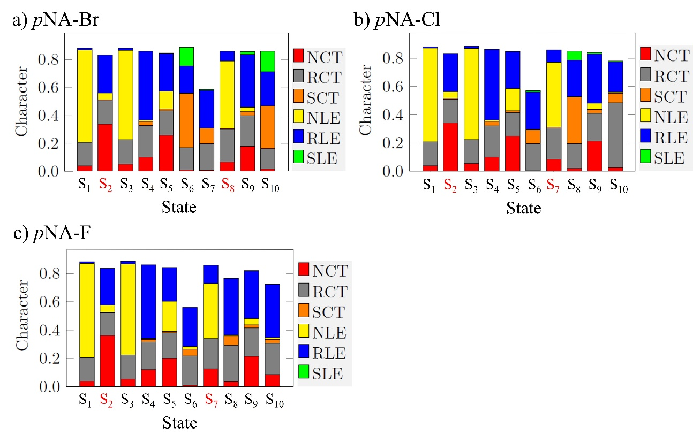
Fig. S 6: ADC(2)//def2-TZVPD excited state decomposition of the substituted by halogens a) pNA–Br, b) pNA–Cl, c) pNA–F. CT from the remaining three regions of Scheme 1 on the main article toward: the nitro group (NCT), the benzene ring (RCT), and the substituent (SCT). Local excitation on the nitro group (NLE), the benzene ring (RLE), and the substituent (SLE). The states indicated in red (S₂ and S₇) are the brighter states of the first and second bands, respectively.

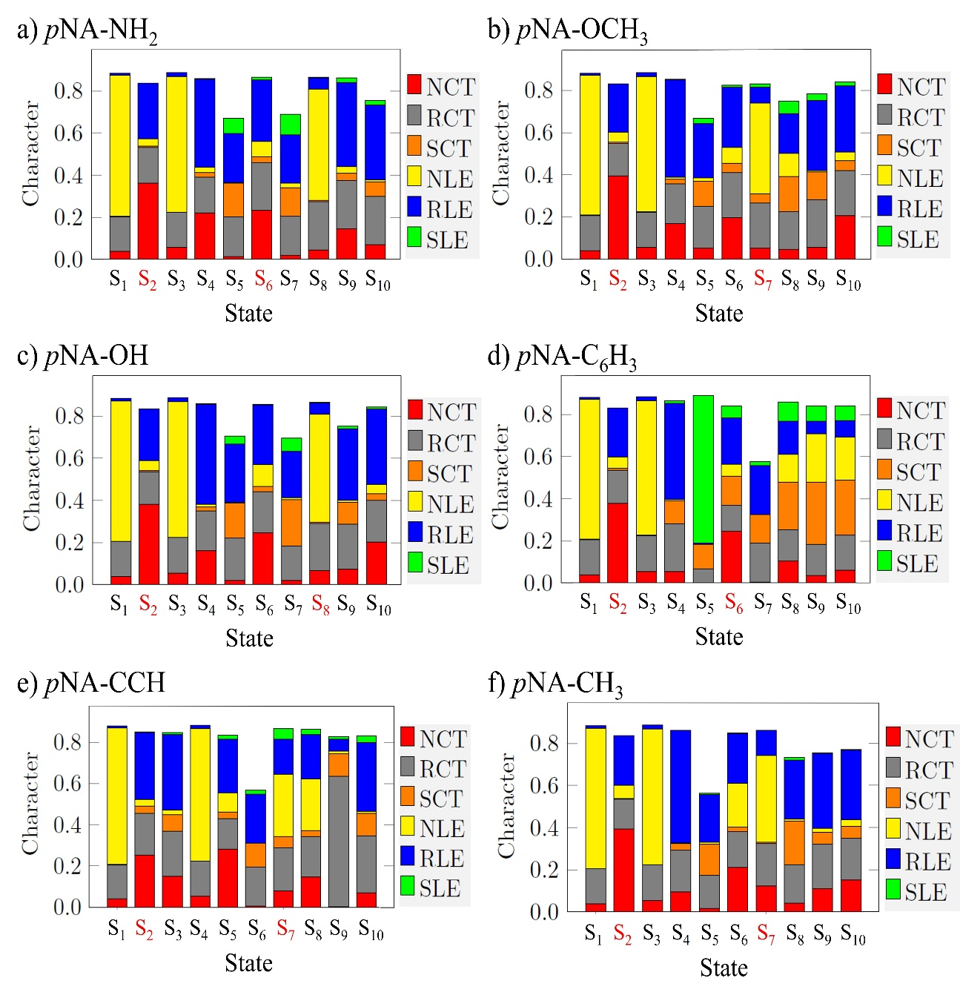
Fig. S 7: ADC(2)//def2-TZVPD excited state decomposition of the substituted EDG a) pNA–NH₂, b) pNA–OCH₃, c) pNA–OH, d) pNA–C₆H₅, e) pNA–CCH, and f) pNA–CH₃. CT from the remaining three regions of Scheme 1 on the main article toward: the nitro group (NCT), the benzene ring (RCT), and the substituent (SCT). Local excitation on the nitro group (NLE), the benzene ring (RLE), and the substituent (SLE). The states indicated in red (S₂ and S₇) are the brighter states of the first and second bands, respectively.
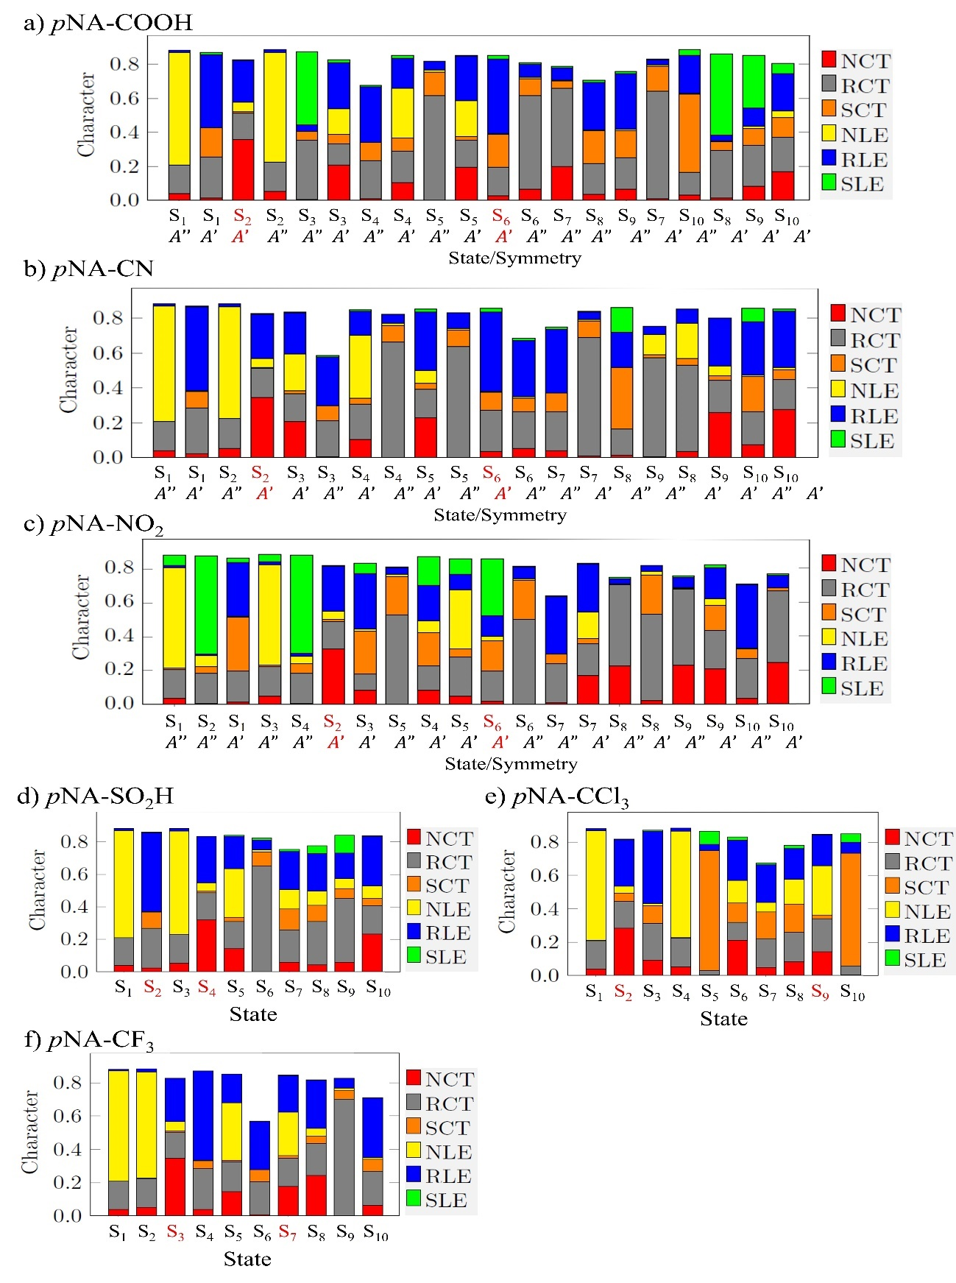
Fig. S 8: ADC(2)//def2-TZVPD excited state decomposition of the EWG substituted a) pNA–COOH, b) pNA–CN, c) pNA–NO₂, d) pNA–SO₂H, e) pNA–CCl₃, and f) pNA–CF₃. CT from the remaining three regions of Scheme 1 on the main article toward: the nitro group (NCT), the benzene ring (RCT), and the substituent (SCT). Local excitation on the nitro group (NLE), the benzene ring (RLE), and the substituent (SLE). The states indicated in red (S₂ and S₇) are the brighter states of the first and second bands, respectively.
The brightest states of each band in the substituent’s spectrum with its oscillator strength and the NTOs to the transitions from the hole to the particle are illustrated from Fig. S9 to Fig. S13. The unsubstituted pNA is presented in the main article.

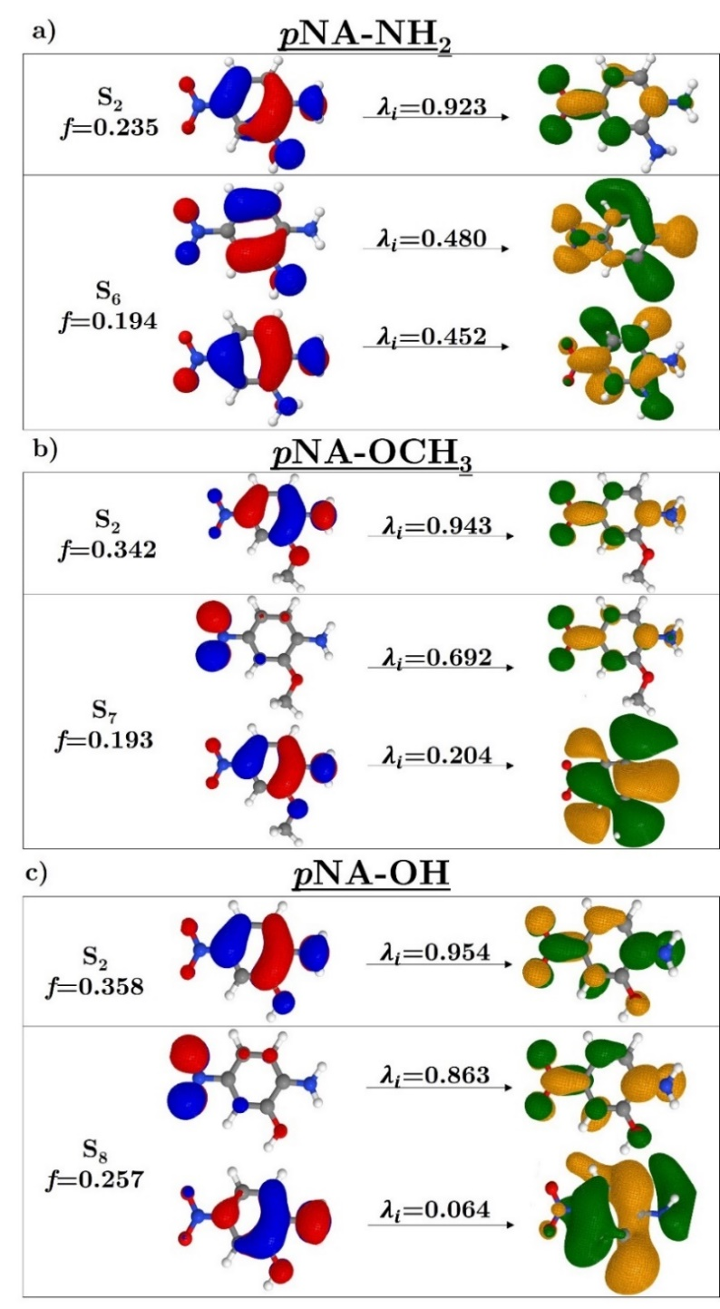
Fig. S 9: The brightest states of each band of the absorption’s spectrum with its oscillator strength, and the NTOs with their amplitudes to the transitions from the hole (occupied NTO, on the left) to the particle (virtual NTO, on the right) to the EDG a) pNA–NH₂, b) pNA–OCH₃, and c) pNA–OH.

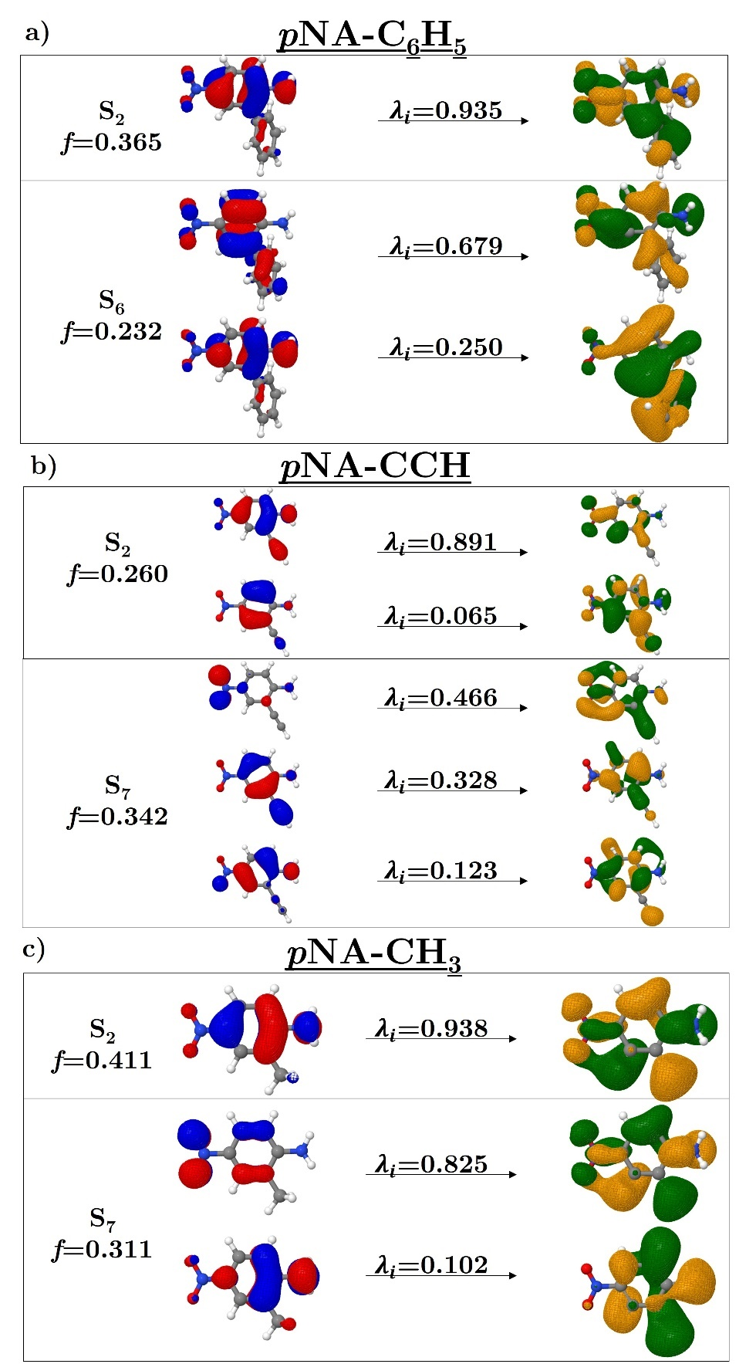
Fig. S 10: The brightest states of each band of the absorption’s spectrum with its oscillator strength, and the NTOs with their amplitudes to the transitions from the hole (occupied NTO, on the left) to the particle (virtual NTO, on the right) to the EDG a) pNA–C₆H₅, b) pNA–CCH, and c) pNA–CH₃.

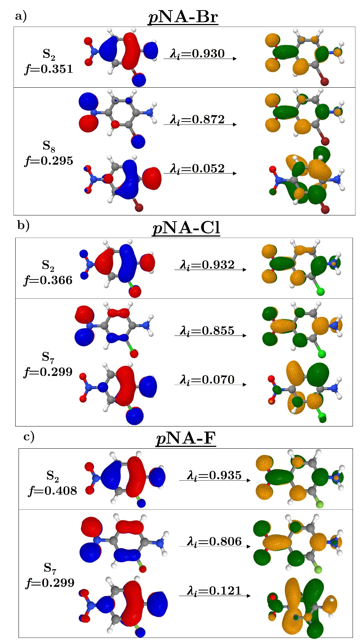
Fig. S 11: The brightest states of each band of the absorption’s spectrum with its oscillator strength, and the NTOs with their amplitudes to the transitions from the hole (occupied NTO, on the left) to the particle (virtual NTO, on the right) to the EWG a) pNA–Br, b) pNA–Cl., and c) pNA–F.

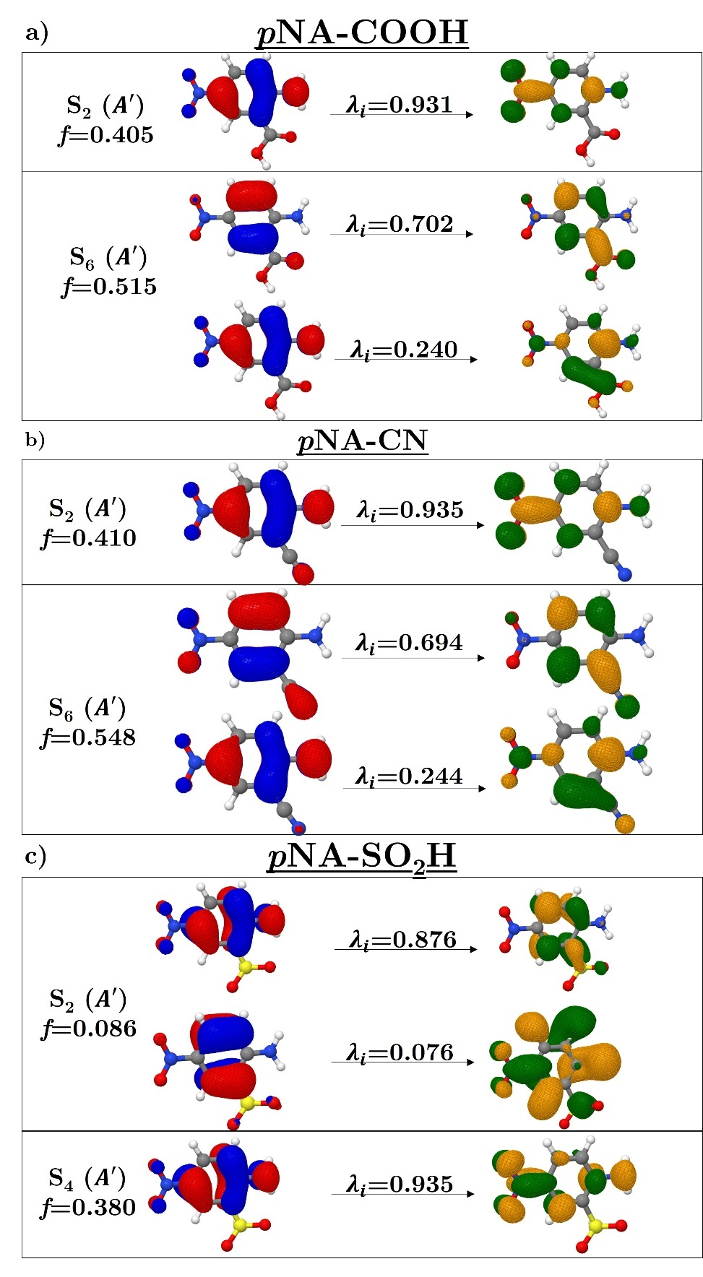
Fig. S 12: The brightest states of each band of the absorption’s spectrum with its oscillator strength, and the NTOs with their amplitudes to the transitions from the hole (occupied NTO, on the left) to the particle (virtual NTO, on the right) to the EWG a) pNA–COOH, b) pNA–CN, and c) pNA–SO₂H.

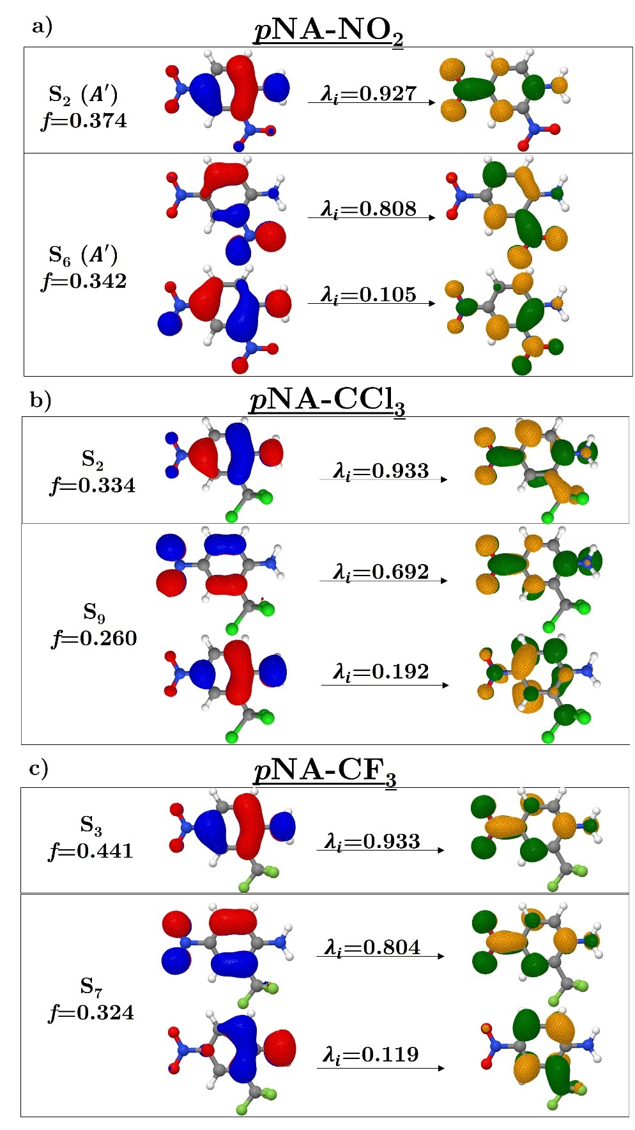
Fig. S 13: The brightest states of each band of the absorption’s spectrum with its oscillator strength, and the NTOs with their amplitudes to the transitions from the hole (occupied NTO, on the left) to the particle (virtual NTO, on the right) to the EWG a) pNA–NO₂ and b) pNA–CCl₃.

S5. Hammett correlation
The Table S16 contains the Hammet parameters and some molecular properties. These molecular data are plotted with σ_{m}⁰ (Figure S14), σ_{m} (Figure S15), σ_{R} (Figure S16), and σ_{I} (Figure S14). The R² is the Adjusted R².

Table S 16: The RI-ADC(2)//def2-TZVPD molecular properties for each substituent (R).
R | $E_{gap}$ª | $E_{HOMO}$^{b} | $E_{LUMO}$^{c} | $E_{B1}$^{d} | $E_{B2}$^{e}
H | 10.416 | -8.9072 | 1.5089 | 4.415 | 6.086
NH₂ | 9.988 | -8.5050 | 1.4835 | 4.112 | 5.358
OCH₃ | 9.949 | -8.4872 | 1.4615 | 4.046 | 5.956
OH | 9.919 | -8.6192 | 1.3002 | 4.111 | 5.986
C₆H₅ | 10.1 | -8.5866 | 1.5135 | 4.271 | 5.309
CCH | 10.201 | -8.7481 | 1.4525 | 4.291 | 5.903
CH₃ | 10.224 | -8.7489 | 1.4750 | 4.364 | 6.042
Br | 10.254 | -9.0394 | 1.2146 | 4.320 | 5.993
Cl | 10.334 | -9.0396 | 1.2943 | 4.336 | 6.018
F | 10.373 | -9.1016 | 1.2716 | 4.377 | 6.068
COOH | 10.381 | -9.0587 | 1.3218 | 4.354 | 6.278
CN | 10.509 | -9.4120 | 1.0976 | 4.459 | 6.492
SO₂H | 10.594 | -9.5754 | 1.0187 | 4.523 | 6.541
NO₂ | 10.305 | -9.5652 | 0.7397 | 4.499 | 5.955
CF₃ | 10.533 | -9.3276 | 1.2052 | 4.459 | 6.129
CCl₃ | 10.285 | -9.1389 | 1.1464 | 4.340 | 6.424
ª The HOMO-LUMO gap energy in eV.
^{b} The HOMO energy in eV.
^{c} The LUMO energy in eV.
^{d} The maximum energy of the first band in eV
^{e} The maximum energy of the second band in eV.

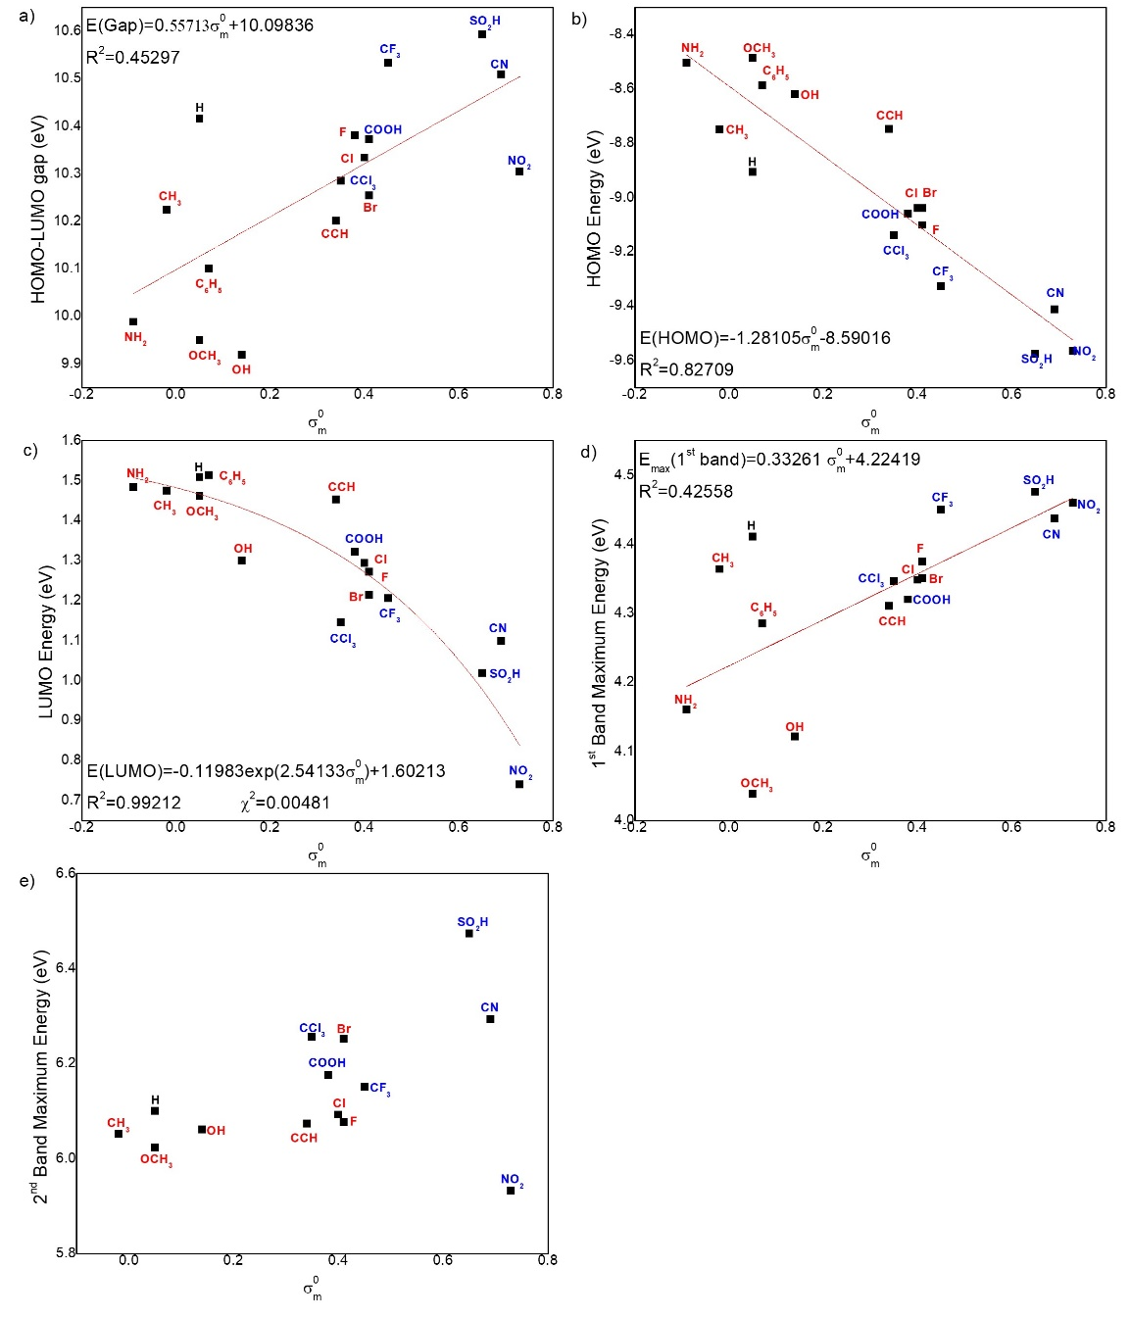
Fig. S 14: Relation between σ_{m}⁰ and the molecular properties a) HOMO-LUMO gap, b) HOMO energy, c) LUMO energy, d) first band maximum energy, e) second band maximum energy. The red substituents caused a redshift in the spectrum, while the blue ones caused a blueshift.

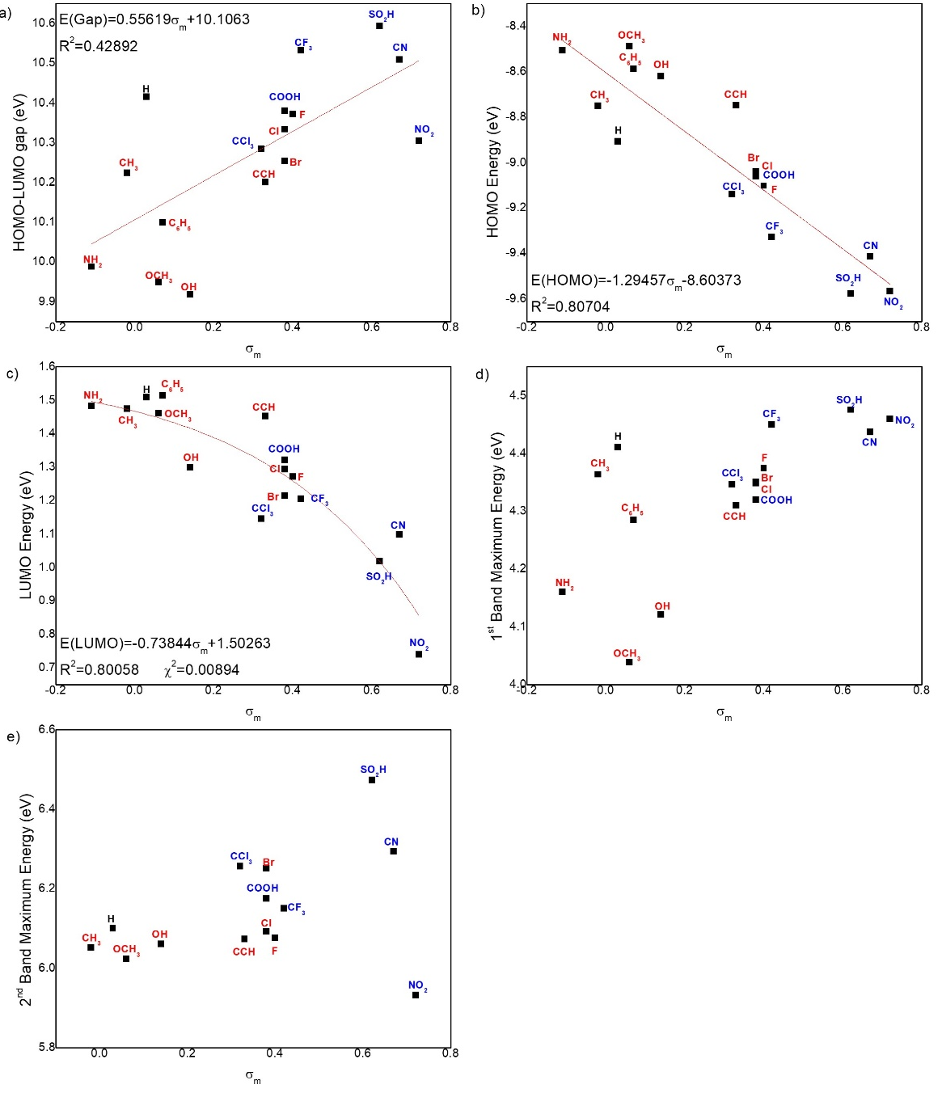
Fig. S 15: Relation between σ_{m} and the molecular properties a) HOMO-LUMO gap, b) HOMO energy, c) LUMO energy, d) first band maximum energy, e) second band maximum energy. The red substituents caused a redshift in the spectrum, while the blue ones caused a blueshift.

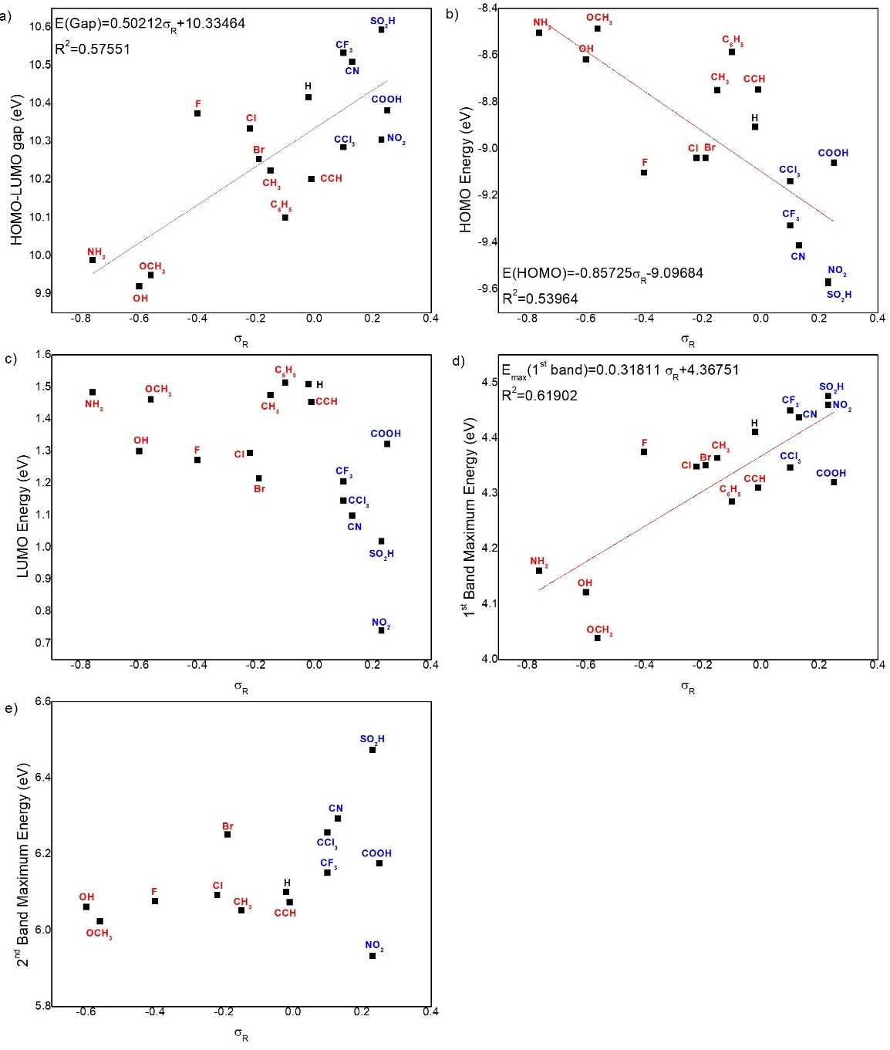
Fig. S 16: Relation between σ_{R} and the molecular properties a) HOMO-LUMO gap, b) HOMO energy, c) LUMO energy, d) first band maximum energy, e) second band maximum energy. The red substituents caused a redshift in the spectrum, while the blue ones caused a blueshift.

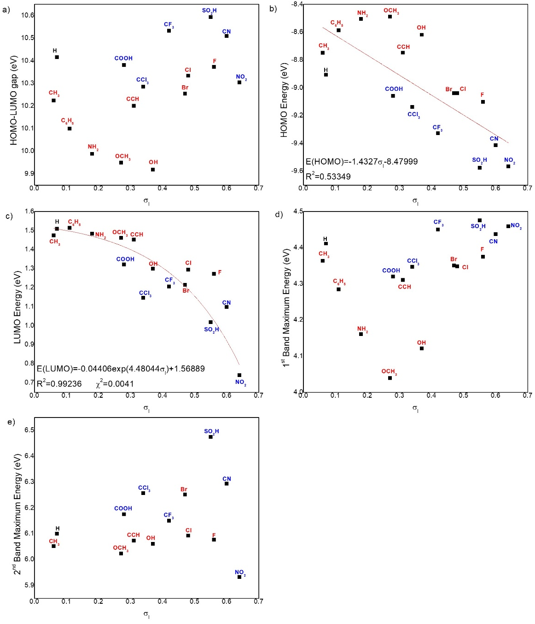
Fig. S 17: Relation between σ_{I} and the molecular properties a) HOMO-LUMO gap, b) HOMO energy, c) LUMO energy, d) first band maximum energy, e) second band maximum energy. The red substituents caused a redshift in the spectrum, while the blue ones caused a blueshift.

S6. Geometries
Fig. S18 to Fig. S25 contains the calculated RI-MP2//def2-TZVPD and CAM-B3LYP//def2-TZVPD and experimental unsubstituted and substituted pNA bond lengths, and Table S17 the unsubstituted and substituted pNA CAM-B3LYP//def2-TZVPD in xyz coordinates. Table S17 contains the xyz coordinates of the molecules studied in the present work.
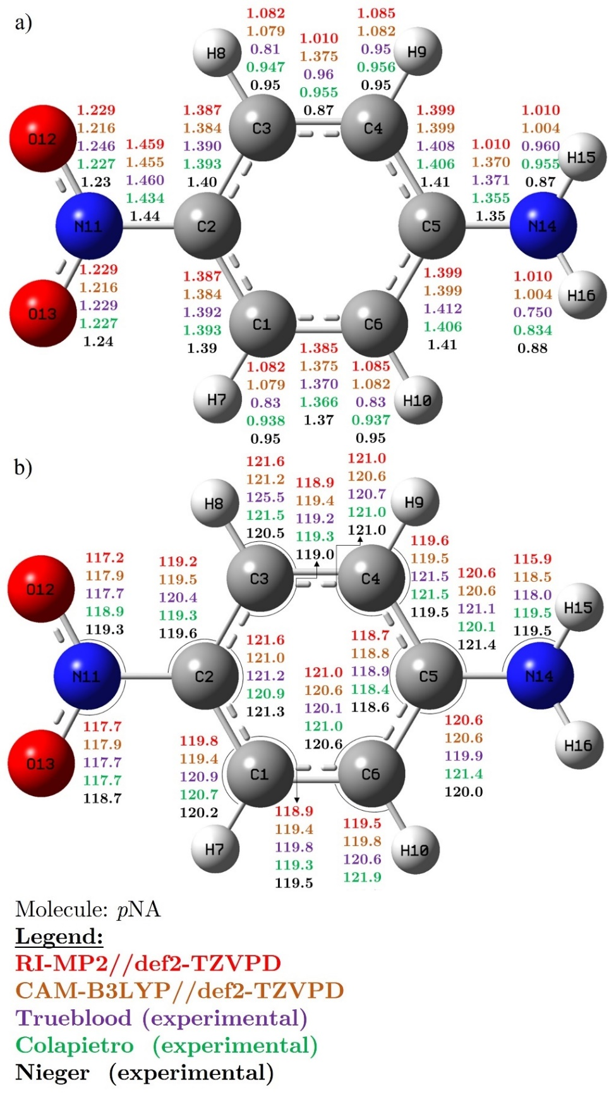
Fig. S 18: The pNA theoretical and experimental (a) bond lengths and (b) bond angles. Numbers from top to bottom: MP2//def2-TZVPD (red), CAM-B3LYP//def2-TZVPD (orange), and three sets of experimental crystal data: Trueblood [6] (pink), Colapietro [7] (green), and Nieger [8] (in black).

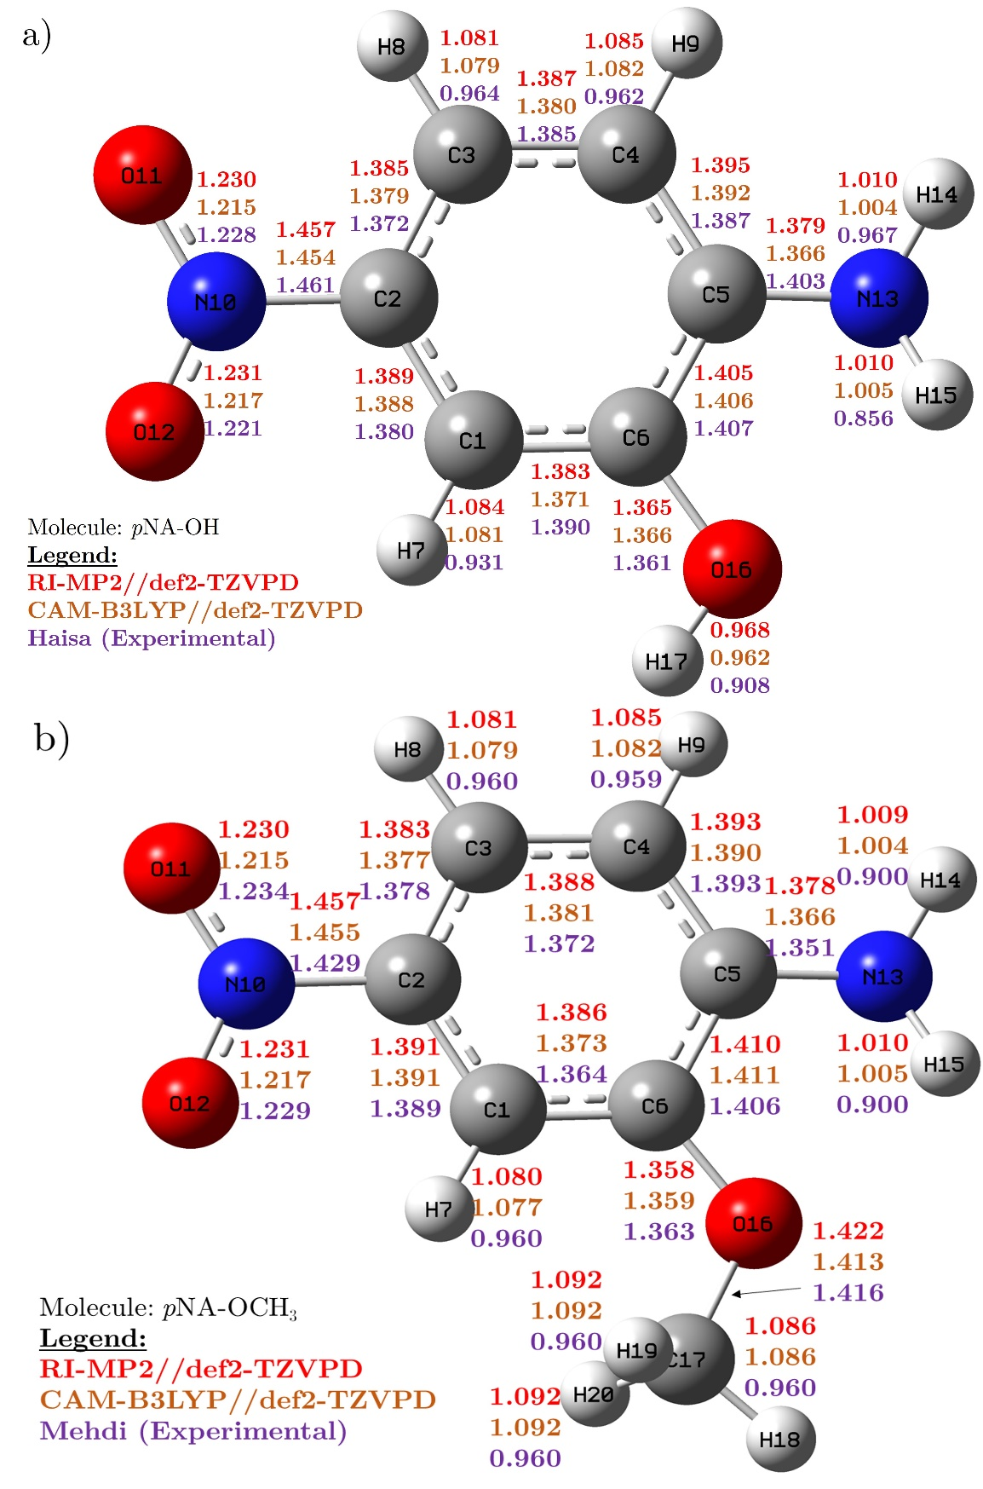
Fig. S 19: The calculated RI-MP2//def2-TZVPD and CAM-B3LYP//def2-TZVPD bond lengths of a) pNA–OH with experimental [5] and b) pNA–OCH₃ with experimental [6].

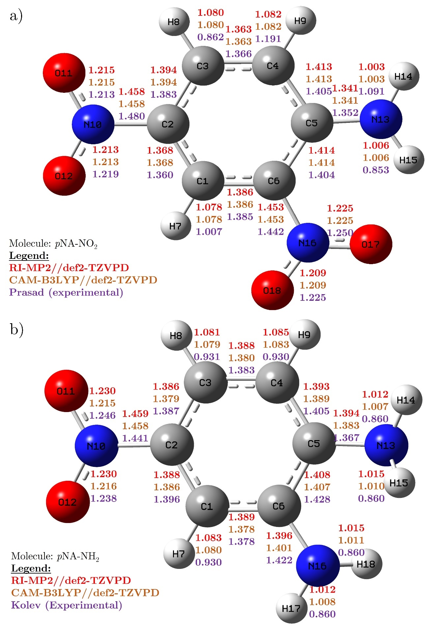
Fig. S 20: The calculated RI-MP2//def2-TZVPD and CAM-B3LYP//def2-TZVPD bond lengths of a) pNA–NO₂ with experimental [7] and b) pNA–NH₂ with experimental [8].

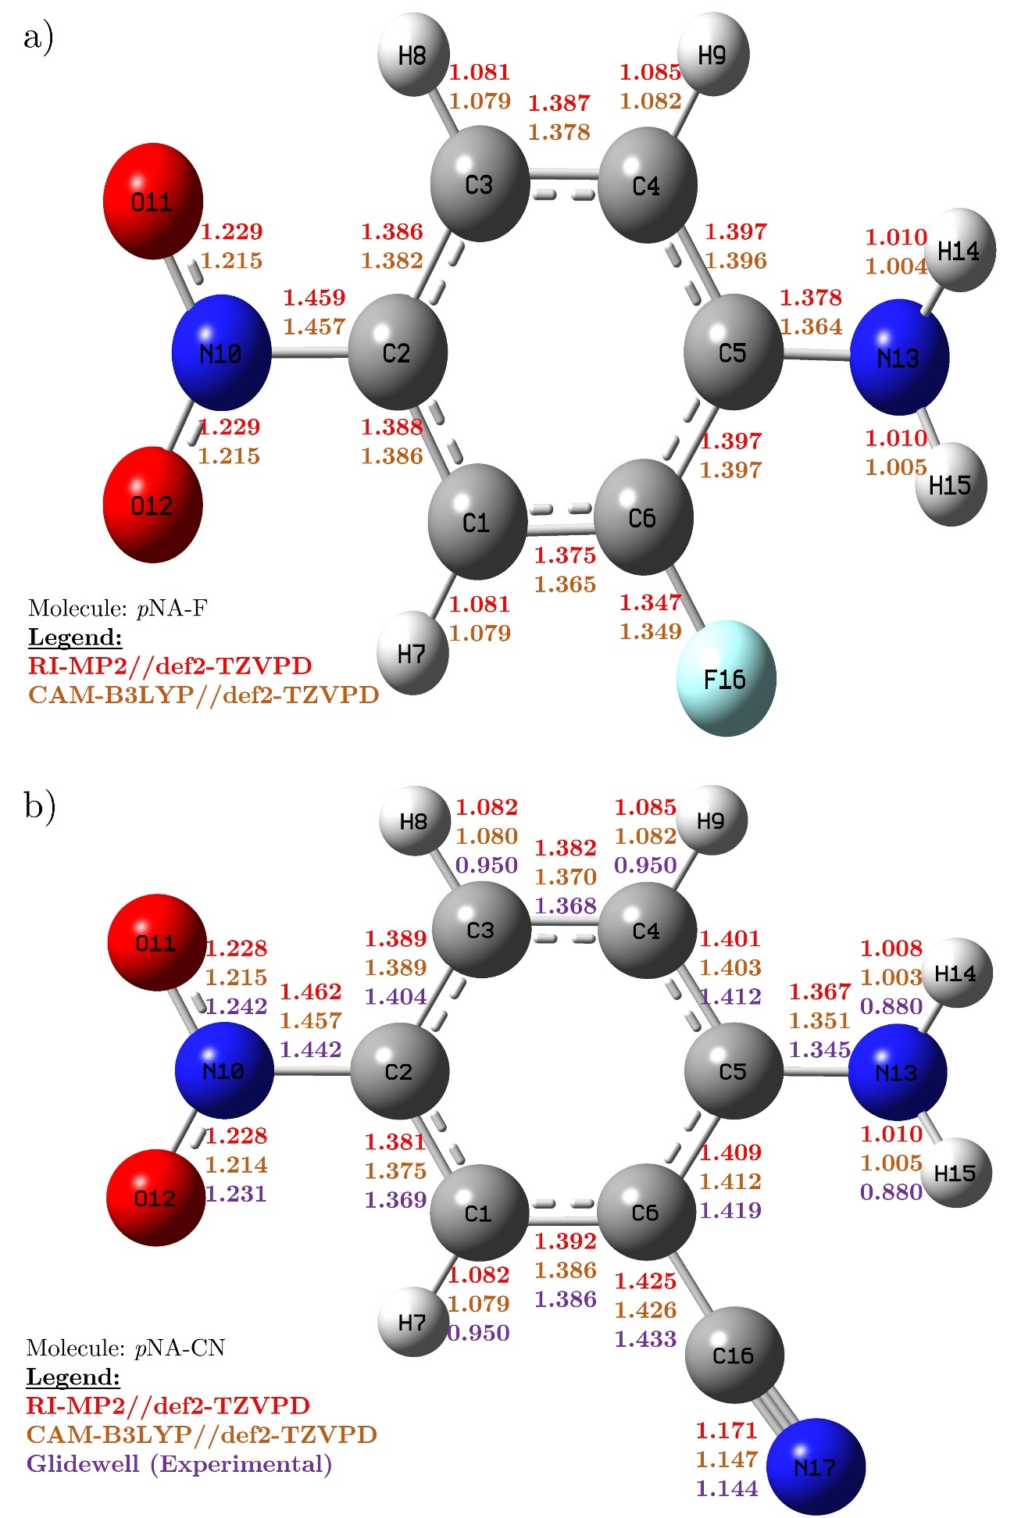
Fig. S 21: The calculated RI-MP2//def2-TZVPD and CAM-B3LYP//def2-TZVPD bond lengths of a) pNA–F and b) pNA–CN with experimental [9].

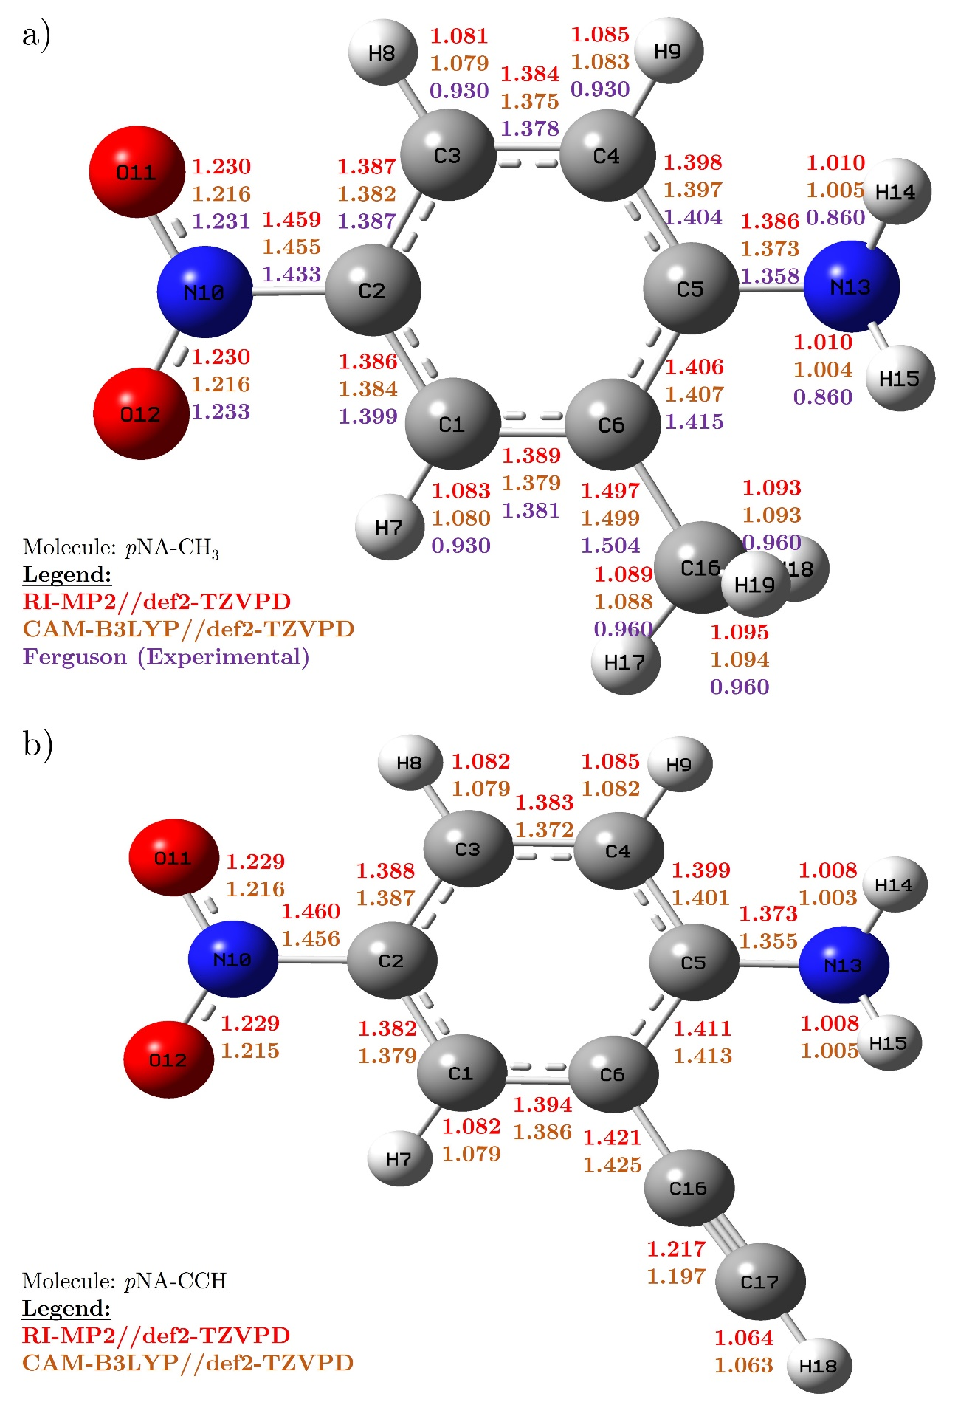
Fig. S 22: The calculated RI-MP2//def2-TZVPD and CAM-B3LYP//def2-TZVPD bond lengths of a) pNA–CH₃ with experimental [10] and b) pNA–CCH.

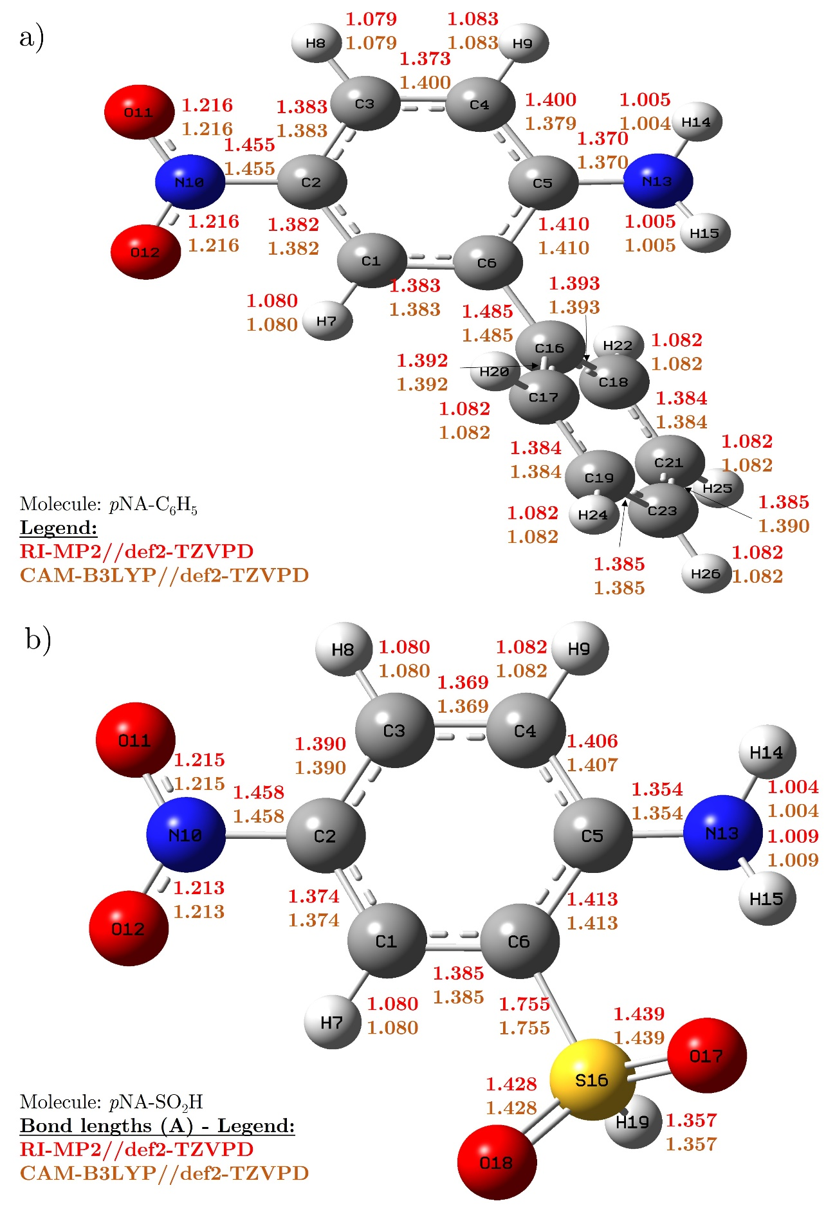
Fig. S 23: The calculated RI-MP2//def2-TZVPD and CAM-B3LYP//def2-TZVPD and experimental bond lengths of a) pNA–C₆H₅ and b) pNA–SO₂H.

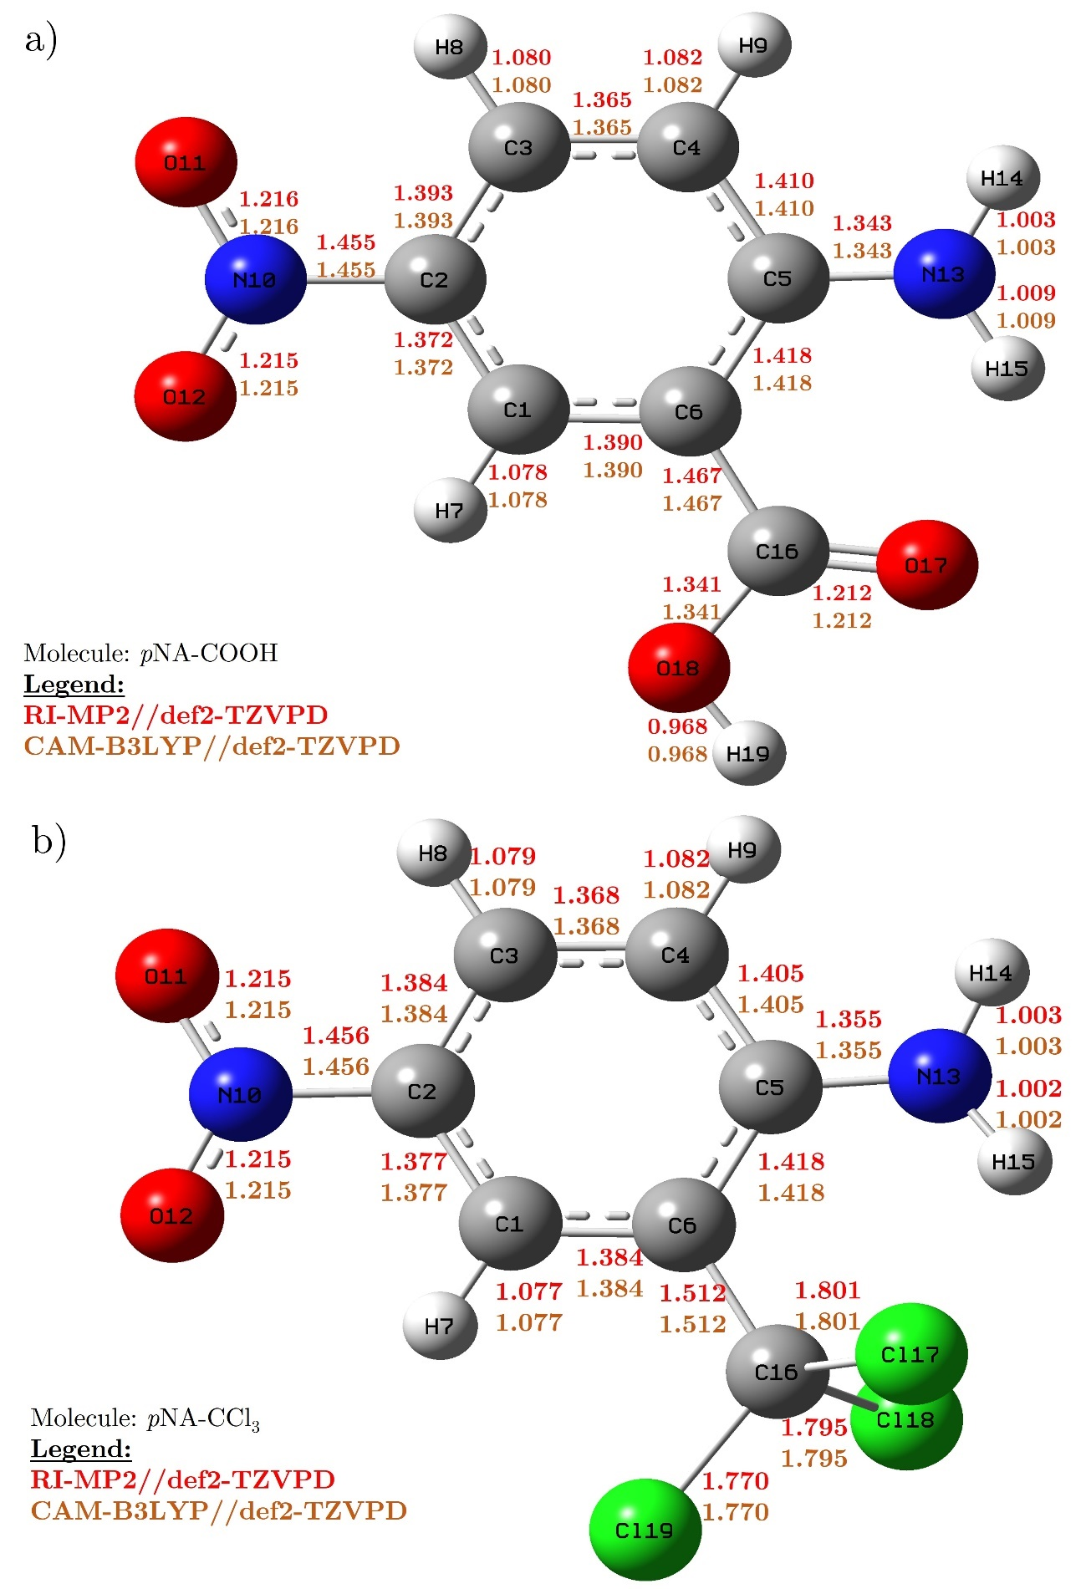
Fig. S 24: The calculated RI-MP2//def2-TZVPD and CAM-B3LYP//def2-TZVPD and experimental bond lengths of a) pNA–COOH and b) pNA–CCl₃.

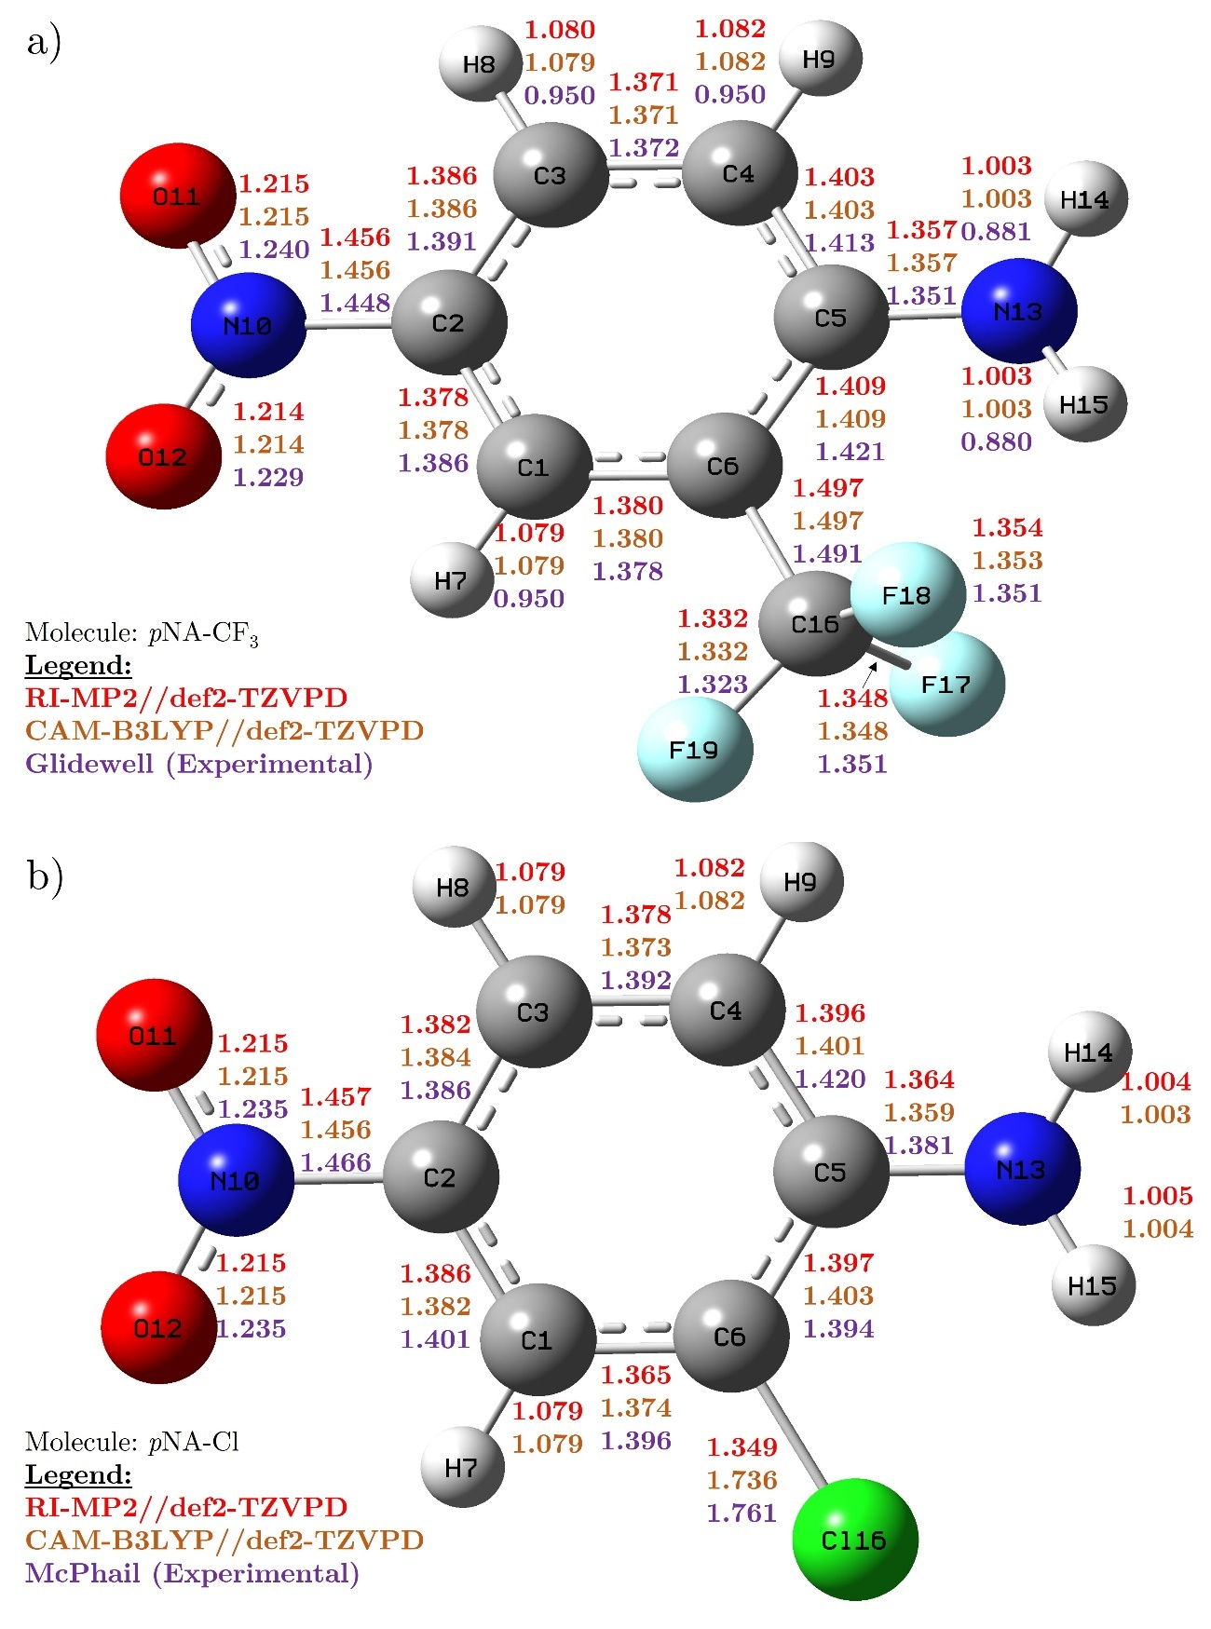
Fig. S 25: The calculated RI-MP2//def2-TZVPD and CAM-B3LYP//def2-TZVPD and experimental bond lengths of a) pNA–CF₃ with experimental [11] and b) pNA–Cl with experimental [12]

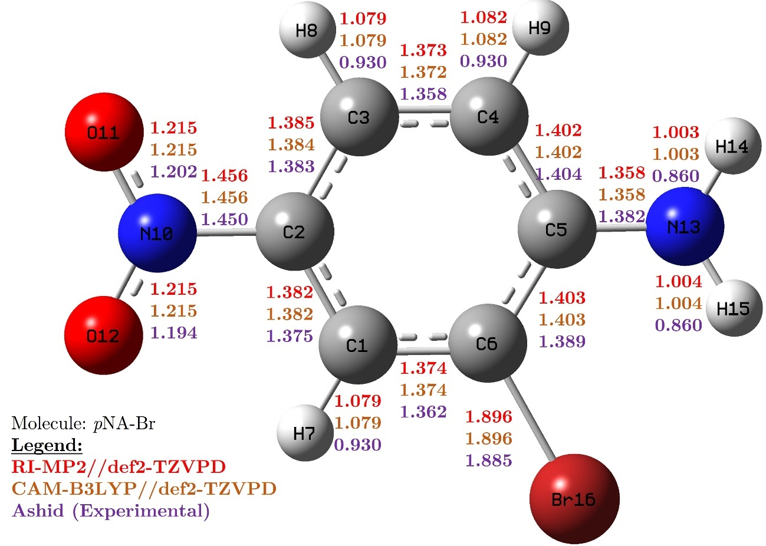
Fig. S 26: The calculated RI-MP2//def2-TZVPD and CAM-B3LYP//def2-TZVPD and experimental bond lengths of pNA–Br with experimental [13].

Table S 17: Unsubstituted and substituted pNA CAM-B3LYP//def2-TZVPD xyz coordinates.
pNA  C -0.02068 -1.20510 -0.00271  C -0.70203 -0.00000 -0.00150  C -0.02068 1.20510 -0.00272  C 1.35458 1.20435 -0.00475  C 2.06648 0.00000 -0.00497  C 1.35459 -1.20435 -0.00474  H -0.57896 -2.12895 -0.00132  H -0.57896 2.12895 -0.00133  H 1.89350 2.14312 -0.00934  H 1.89350 -2.14311 -0.00932  N -2.15719 -0.00000 0.00260  O -2.72638 1.07438 0.00435  O -2.72638 -1.07438 0.00432  N 3.43637 -0.00000 -0.04400  H 3.92258 0.84853 0.18512  H 3.92257 -0.84853 0.18512 | pNA–OCH₃  C 0.09824 0.71817 -0.00300  C 1.15382 -0.18751 -0.00123  C 0.94189 -1.54843 0.00141  C -0.35593 -2.02099 -0.00100  C -1.43856 -1.14875 -0.00630  C -1.18849 0.24018 -0.00466  H 0.31962 1.77258 -0.00053  H 1.78500 -2.22138 0.00443  H -0.54057 -3.08747 -0.00425  N 2.51407 0.32781 0.00106  O 3.42865 -0.47283 0.00596  O 2.66580 1.53569 -0.00177  N -2.73222 -1.58435 -0.04703  H -2.92845 -2.53985 0.18931  H -3.45501 -0.91173 0.13911  O -2.30566 1.01402 0.00176  C -2.14435 2.41797 0.00377  H -3.14540 2.83937 0.00726  H -1.60612 2.75164 0.89380  H -1.61204 2.75376 -0.88885
pNA–NO₂  C -0.30859 -0.69498 -0.00000  C -1.37977 0.15619 0.00000  C -1.19742 1.53801 -0.00000  C 0.06706 2.04802 -0.00000  C 1.21098 1.21767 -0.00000  C 0.97660 -0.17633 -0.00000  H -0.45292 -1.76353 -0.00000  H -2.06154 2.18517 -0.00000  H 0.21592 3.11975 -0.00001  N -2.73097 -0.39141 0.00000  O -3.65359 0.39910 0.00001  O -2.85488 -1.59780 -0.00000  N 2.42751 1.78294 -0.00001  H 2.51053 2.78268 0.00001  H 3.24548 1.19729 0.00002  N 2.06537 -1.13809 0.00000  O 3.21463 -0.71309 0.00001  O 1.79334 -2.31659 -0.00001 | pNA–NH₂  C -0.08094 0.96984 -0.00009  C -0.94149 -0.11618 0.00146  C -0.47387 -1.41351 0.02752  C 0.89085 -1.62140 0.02587  C 1.77944 -0.55374 -0.00165  C 1.28154 0.76260 0.00878  H -0.49205 1.96893 0.00271  H -1.17110 -2.23640 0.03704  H 1.28012 -2.63169 0.02780  N -2.37956 0.12667 -0.00925  O -3.12009 -0.83625 0.01292  O -2.76140 1.28092 -0.03954  N 3.15073 -0.73691 0.00785  H 3.46578 -1.67486 -0.17874  H 3.67429 -0.03977 -0.50125  N 2.20420 1.81568 -0.03037  H 1.78172 2.72907 0.03250  H 2.95238 1.72369 0.64389
pNA–F  C 0.09205 0.99282 -0.00173  C 0.93189 -0.11011 -0.00117  C 0.42992 -1.39765 -0.00026  C -0.93442 -1.59346 -0.00235  C -1.81650 -0.51163 -0.00509  C -1.25419 0.76730 -0.00330  H 0.48884 1.99641 0.00140  H 1.11365 -2.23237 0.00148  H -1.33507 -2.59866 -0.00636  N 2.37292 0.10216 0.00138  O 3.09049 -0.87807 0.00455  O 2.77635 1.24841 0.00046  N -3.17234 -0.65912 -0.04471  H -3.56885 -1.55306 0.18157  H -3.74467 0.14541 0.14109  F -2.10946 1.81052 0.00307 | pNA–CN  C -0.13372 -0.85729 -0.00000  C -1.13724 0.08339 -0.00000  C -0.84827 1.44229 -0.00000  C 0.45649 1.86133 -0.00000  C 1.51053 0.93536 -0.00000  C 1.18749 -0.43917 -0.00000  H -0.38009 -1.90822 -0.00000  H -1.66161 2.15226 -0.00000  H 0.68438 2.91893 -0.00001  N -2.52690 -0.35532 0.00000  O -3.38756 0.50171 0.00002  O -2.74359 -1.54980 -0.00002  N 2.79831 1.34266 -0.00001  H 3.02656 2.31892 0.00000  H 3.55278 0.67827 0.00001  C 2.25598 -1.38297 0.00000  N 3.16853 -2.07778 0.00001
pNA–CH₃  C 0.07323 0.95599 0.00080  C 0.95492 -0.11126 -0.00045  C 0.49846 -1.41610 -0.00422  C -0.85754 -1.64410 -0.00468  C -1.76450 -0.58116 -0.00246  C -1.28908 0.74316 -0.00141  H 0.47068 1.96038 0.00222  H 1.20650 -2.23051 -0.00521  H -1.23210 -2.65991 -0.00967  N 2.38726 0.14672 0.00259  O 3.13793 -0.80982 0.00099  O 2.75863 1.30481 0.00685  N -3.11386 -0.82974 -0.04322  H -3.42845 -1.76064 0.16598  H -3.74915 -0.09745 0.21750  C -2.25356 1.89067 -0.00800  H -1.72478 2.84087 -0.03215  H -2.91344 1.85271 -0.87827  H -2.88716 1.89257 0.88393 | pNA–CCH  C -0.11696 -0.83979 -0.00273  C -1.14942 0.07375 -0.00073  C -0.90113 1.43860 0.00153  C 0.39509 1.88794 0.00005  C 1.46931 0.98869 -0.00357  C 1.19631 -0.39783 -0.00344  H -0.33705 -1.89619 -0.00218  H -1.73215 2.12741 0.00405  H 0.59736 2.95106 -0.00117  N -2.52440 -0.40386 0.00076  O -3.41233 0.42654 0.00442  O -2.71022 -1.60471 -0.00165  N 2.74994 1.43222 -0.02470  H 2.95122 2.40738 0.09245  H 3.50561 0.77623 0.06702  C 2.28130 -1.32160 0.00008  C 3.22158 -2.06276 0.00513  H 4.04008 -2.74120 0.00746
pNA–C₆H₅  C 0.86142 -0.54090 0.07332  C 2.17902 -0.12489 0.04049  C 2.50186 1.21316 -0.09869  C 1.48706 2.13147 -0.21225  C 0.14426 1.73754 -0.18571  C -0.17151 0.37221 -0.03052  H 0.64686 -1.59237 0.19316  H 3.53811 1.51397 -0.11943  H 1.72387 3.18138 -0.32912  N 3.24299 -1.11110 0.15695  O 4.39159 -0.71249 0.13703  O 2.92808 -2.28036 0.26629  N -0.83843 2.68634 -0.29520  H -0.58033 3.58798 -0.65515  H -1.77295 2.38421 -0.50978  C -1.57772 -0.10455 -0.00112  C -2.00383 -1.08526 -0.89224  C -2.48883 0.38770 0.93073  C -3.30310 -1.56130 -0.85438  H -1.30813 -1.47415 -1.62460  C -3.78819 -0.08848 0.96896  H -2.16980 1.13624 1.64448  C -4.19997 -1.06331 0.07547  H -3.61557 -2.32341 -1.55600  H -4.47896 0.29764 1.70700  H -5.21525 -1.43564 0.10621 | pNA–OH  C 0.08229 0.97619 -0.00218  C 0.93481 -0.11973 -0.00136  C 0.44835 -1.41035 -0.00009  C -0.91728 -1.60948 -0.00235  C -1.80297 -0.53508 -0.00582  C -1.27233 0.76678 -0.00392  H 0.49927 1.97364 0.00111  H 1.13719 -2.24056 0.00194  H -1.31395 -2.61648 -0.00625  N 2.37106 0.11022 0.00142  O 3.10430 -0.85867 0.00497  O 2.76198 1.26284 0.00035  N -3.15909 -0.69741 -0.04625  H -3.54545 -1.59279 0.19152  H -3.73183 0.10598 0.14458  O -2.19266 1.77561 0.00276  H -1.75525 2.63236 0.01055
pNA–SO₂H  C 0.49809 -0.59264 0.04151  C 1.66923 0.12476 -0.00133  C 1.65566 1.51435 -0.00948  C 0.46118 2.18208 0.01389  C -0.76468 1.49304 0.04386  C -0.71148 0.08146 0.07062  H 0.51813 -1.67243 0.04795  H 2.59288 2.04965 -0.04053  H 0.44837 3.26407 -0.00159  N 2.94410 -0.58198 -0.03271  O 3.95613 0.08907 -0.07166  O 2.92004 -1.79462 -0.01649  N -1.92812 2.18417 0.07558  H -1.89377 3.17794 -0.06522  H -2.78347 1.70801 -0.16900  S -2.16726 -0.89289 0.18497  O -3.24002 -0.22069 -0.49824  O -1.84994 -2.25591 -0.10039  H -2.45574 -0.81758 1.50857 | pNA–COOH  C -0.29878 -0.67140 -0.00000  C -1.40328 0.14272 0.00000  C -1.27098 1.52949 0.00001  C -0.02446 2.08603 0.00001  C 1.13709 1.28595 0.00000  C 0.97854 -0.12294 -0.00000  H -0.42811 -1.74193 -0.00001  H -2.15843 2.14437 0.00001  H 0.08673 3.16251 0.00001  N -2.73197 -0.44997 0.00000  O -3.68554 0.30456 0.00000  O -2.81676 -1.66171 0.00000  N 2.34803 1.86866 -0.00001  H 2.42616 2.86840 0.00001  H 3.17206 1.28642 -0.00001  C 2.15381 -1.00128 -0.00000  O 3.30732 -0.62816 0.00000  O 1.85321 -2.30839 -0.00002  H 2.69168 -2.79242 -0.00002
pNA–CCl₃  C 0.97284 -0.47450 -0.00378  C 2.20453 0.14085 -0.00112  C 2.31572 1.52085 0.00230  C 1.17161 2.27049 0.00150  C -0.10414 1.68181 -0.00191  C -0.19516 0.26715 -0.00330  H 0.94413 -1.55070 -0.00553  H 3.29192 1.98124 0.00423  H 1.23747 3.35082 0.00473  N 3.40768 -0.67927 -0.00235  O 4.47922 -0.10580 0.00050  O 3.27579 -1.88684 -0.00624  N -1.18053 2.50481 0.01871  H -1.03564 3.49241 -0.08305  H -2.11318 2.16592 -0.12058  C -1.53836 -0.42687 0.00370  Cl -2.50282 0.04218 -1.44318  Cl -2.47744 0.02471 1.46491  Cl -1.42662 -2.19373 -0.01307 | pNA–CF₃  C -0.50846 -0.61766 0.00765  C -1.66414 0.13337 0.00080  C -1.61508 1.51833 -0.00738  C -0.39764 2.14827 -0.00601  C 0.80087 1.41893 0.00312  C 0.71898 0.01210 0.00758  H -0.57584 -1.69427 0.01254  H -2.53613 2.08139 -0.01272  H -0.35076 3.22941 -0.01203  N -2.95461 -0.54147 0.00237  O -3.95284 0.15126 -0.00506  O -2.96056 -1.75586 0.01109  N 1.98671 2.07909 -0.01668  H 1.99217 3.07658 0.09057  H 2.85396 1.60145 0.14528  C 1.96846 -0.81169 -0.00480  F 2.69669 -0.60713 -1.12011  F 2.78637 -0.49953 1.02748  F 1.72596 -2.11900 0.07291
pNA–Cl  C -0.19188 -0.80505 -0.00176  C -1.20775 0.13195 -0.00098  C -0.93304 1.48869 -0.00008  C 0.37456 1.90877 -0.00150  C 1.43469 0.99296 -0.00401  C 1.11219 -0.37274 -0.00315  H -0.42801 -1.85786 0.00017  H -1.74833 2.19572 0.00156  H 0.60024 2.96721 -0.00436  N -2.59106 -0.32331 0.00113  O -3.46425 0.52164 0.00396  O -2.79506 -1.52105 0.00011  N 2.72593 1.41494 -0.03426  H 2.93204 2.38231 0.13307  H 3.46509 0.75123 0.11290  Cl 2.39864 -1.53837 0.00147 | pNA–Br  C -0.52189 -0.62065 -0.00200  C -1.70380 0.09534 -0.00097  C -1.70356 1.47986 0.00007  C -0.50567 2.14991 -0.00125  C 0.71724 1.46338 -0.00391  C 0.67155 0.06102 -0.00342  H -0.55017 -1.69916 -0.00038  H -2.64268 2.01156 0.00184  H -0.49431 3.23216 -0.00380  N -2.96916 -0.62539 0.00111  O -3.99248 0.02983 0.00399  O -2.93181 -1.83978 -0.00001  N 1.89204 2.14436 -0.03278  H 1.89136 3.13492 0.12548  H 2.75590 1.65183 0.10862  Br 2.29288 -0.92165 0.00077

This Supplementary Information presented additional figures, data, and other information supporting the main text’s findings. It includes detail to support the conclusions drawn in the main paper and may be of interest to readers who wish to delve deeper into this research.

References
1. J. Clayden, N. Greeves, S. Warren, Organic Chemistry, 2nd ed., Oxford University Press, New York, 2012.
2. B. Valeur, M.N. Berberan-Santos, Molecular Fluorescence: Principles and Applications, Second Edition, Molecular Fluorescence: Principles and Applications, Second Edition. (2012). https://doi.org/10.1002/9783527650002.
3. P. Klán, J. Wirz, Photochemistry of organic compounds : from concepts to practice, Wiley, Chichester, UK, 2009.
4. J. Clayden, N. Greeves, S. Warren, Organic Chemistry, 2nd ed., Oxford University Press, New York, 2012.
5. P.Yurkanis. Bruice, Organic Chemistry, 8th ed., Pearson Education, New Jersey, 2016.
6. K.N. Trueblood, E. Goldish, J. Donohue, IUCr, A three-dimensional refinement of the crystal structure of 4-nitroaniline, Urn:Issn:0365-110X. 14 (1961) 1009–1017. https://doi.org/10.1107/S0365110X61002965.
7. M. Colapietro, A. Domenicano, C. Marciante, G. Portalone, Effects of Through-Conjugation on the Molecular Structure of p-Nitroaniline [1], Zeitschrift Fur Naturforschung - Section B Journal of Chemical Sciences. 37 (1982) 1309–1311. https://doi.org/10.1515/znb-1982-1016.
8. Nieger. M.;, CCDC, 659427: Experimental Crystal Structure Determination, (2008). https://doi.org/10.5517/ccq45vv.

