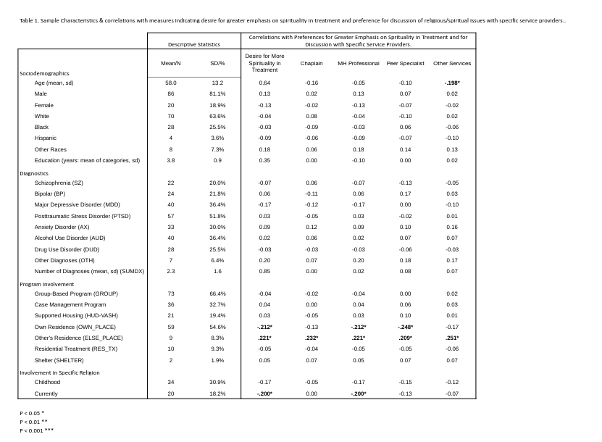

Table 2. Comparison of differences in preference ratings for discussing R/S issues between paired groups among four provider categories using paired t-tests of ratings scored 1-5.#
 | Mental health professionals | Chaplains | Peer counsellors | Other service types
Mental health professionals | - | 0.42* | 0.34* | 0.71*
sd |  | 1.37 | 1.00 | 1.38
Chaplains |  | - | -0.04 | 0.32*
sd |  |  | 1.54 | 1.11
Peer counsellors |  |  | - | 0.39*
sd |  |  |  | 1.41
#Scale = 1-Not at all, 2-A little bit, 3-Somewhat, 4-Very, and 5-Extremely
* = p<.01

