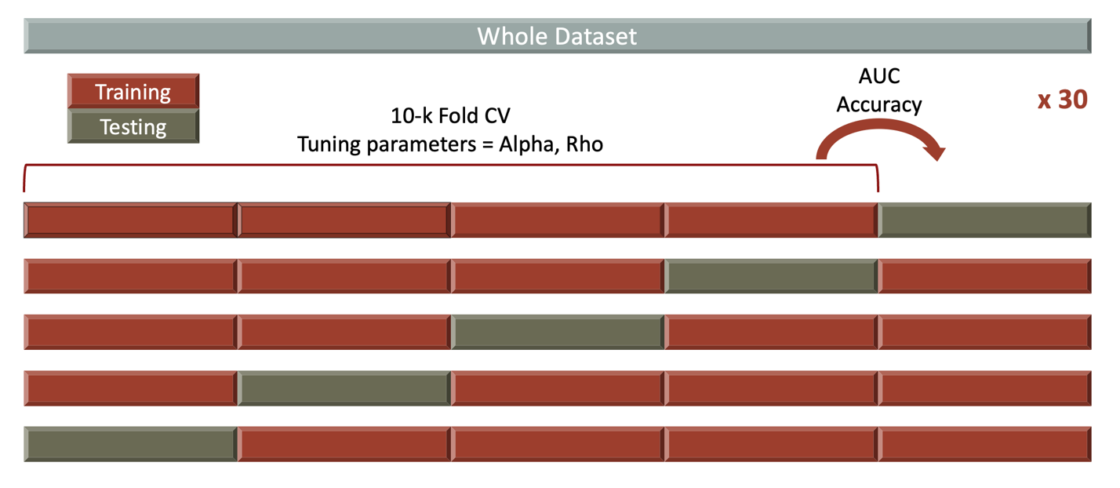
Supplementary Figure 1: Repeated stratified nested cross-validation. 10-fold cross-validation (CV) was performed, with the loss function as “deviance” for tuning the elastic-net mixing parameter and the weight of the agreement penalty in the inner loop. The outer loop assessed the performance of models trained in the inner loop. AUC and accuracy metrics were calculated. The final performance scores were averaged after a 5-fold CV. We conducted each experiment 30 times.

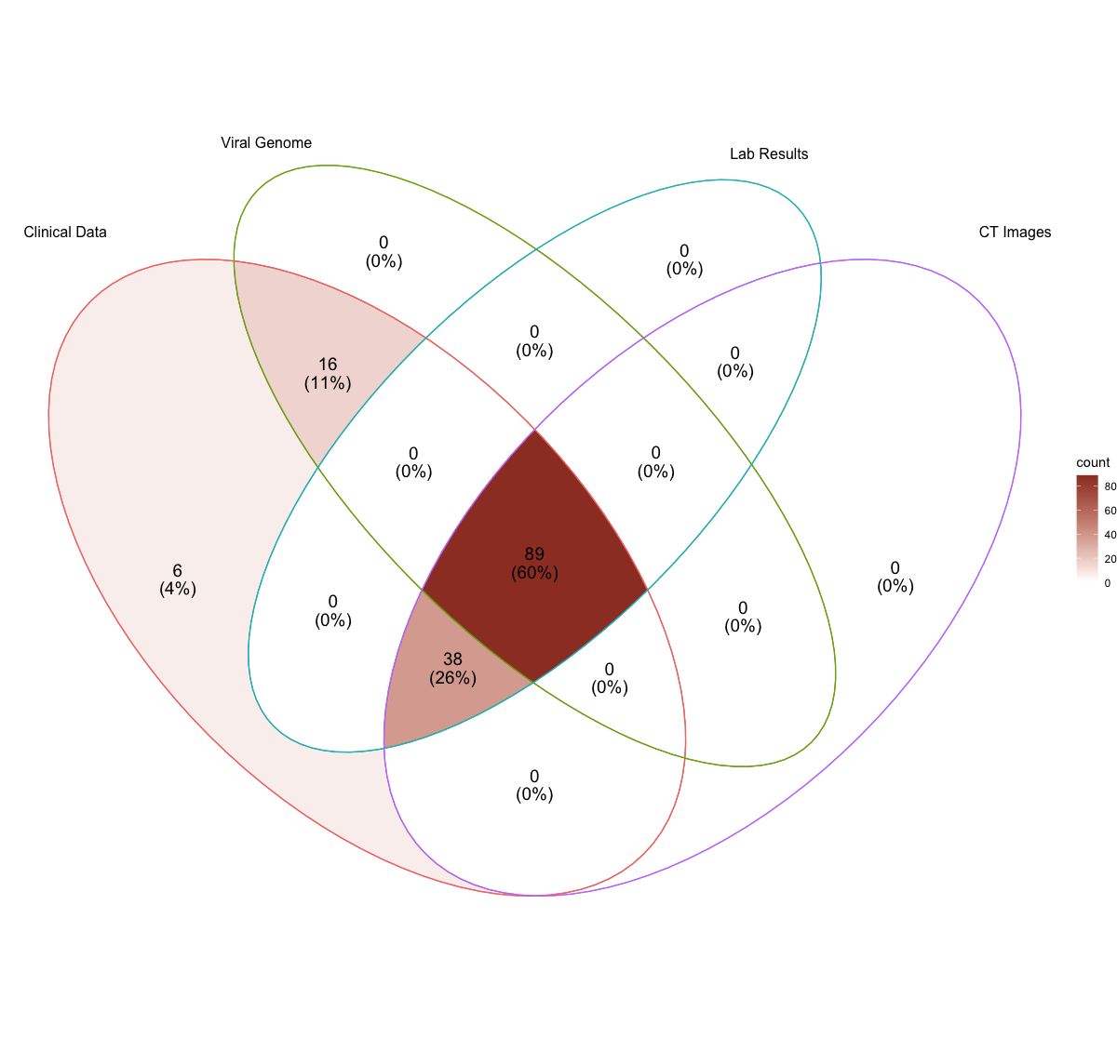
Supplementary Figure 2: The number of patients in the cohort with different data modalities

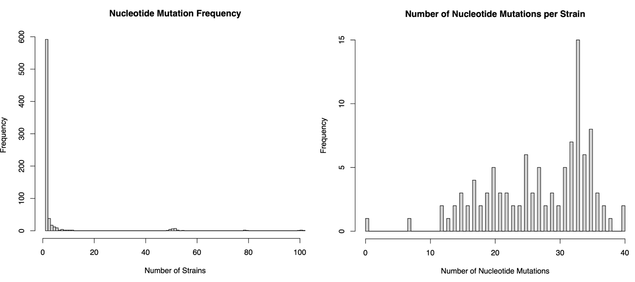
Supplementary Figure 3: Nucleotide mutation frequency and number of nucleotide mutations per strain histograms. The histogram on the left side shows the nucleotide mutation frequency. 592 nucleotide mutations were observed at once. The histogram on the right side shows the number of nucleotide mutations per strain.

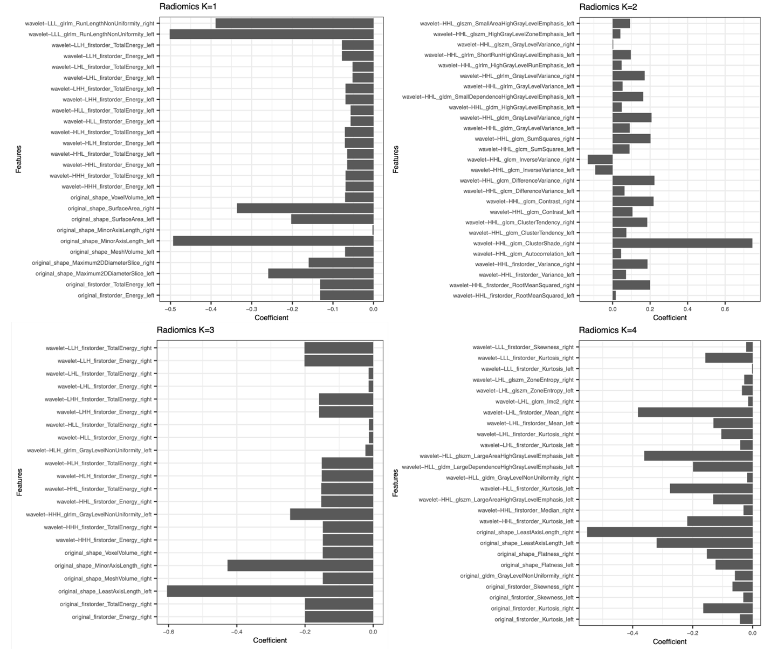

Supplementary Figure 4: Sparce CCA analysis of imaging and clinical data. The first four canonical variates are provided. The first and third canonical vectors are found to be associated with sex, and the second and fourth ones were with lymphoma and CCI, respectively.

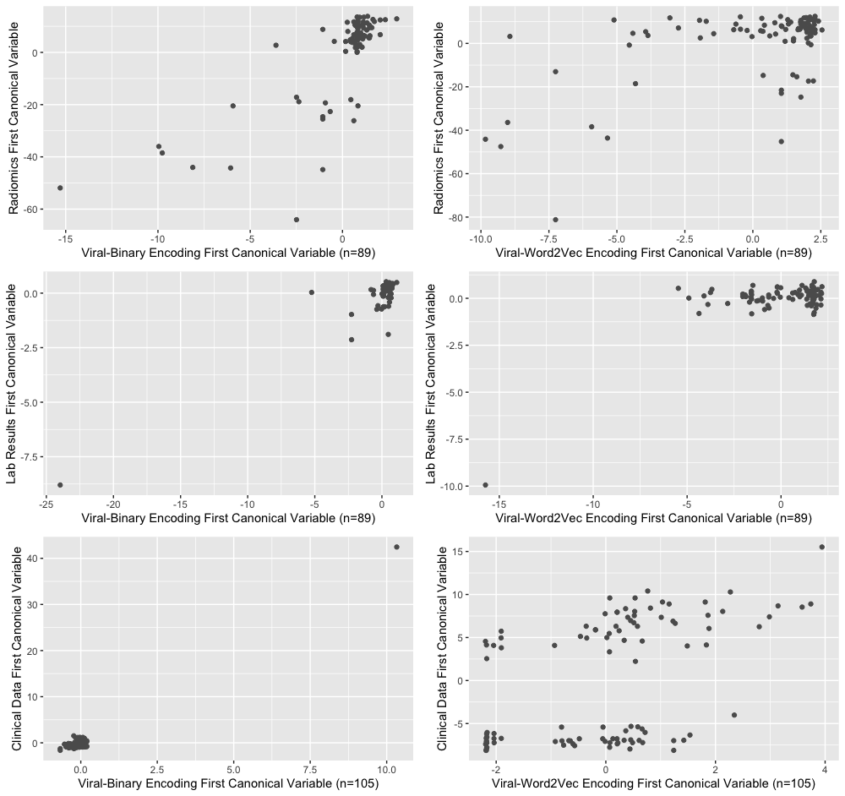
Supplementary Figure 5: Sparce CCA analysis of viral genome sequencing data with different data modalities. The left side shows the first canonical variables of Viral-Binary encoding, and the right side shows Viral-Word2Vec encoding. As it is seen, different encoding techniques for the viral genome change the correlation plots, yielding a better separation with Viral-Word2Vec encoding. Only the correlation plot at the bottom left was found to be significant (p<0.01).

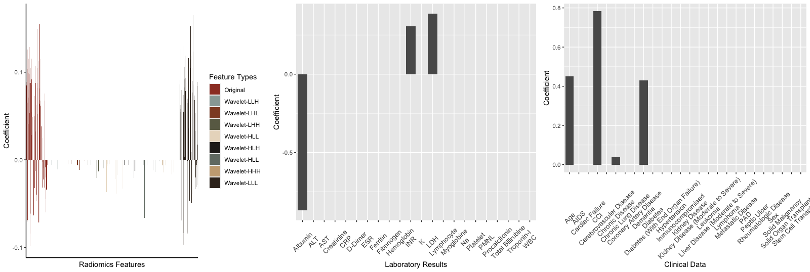
Supplementary Figure 6: The first canonical vectors of multi-CCA. While the dominance of histogram-based first-order radiomics features and the importance of albumin and LDH among the laboratory results persist in the analysis of these 89 patients, as seen in the example of sparse CCA analysis of radiomics features and laboratory results, clinical data’s first canonical vectors slightly reveal a different clinical phenotype of an elderly multimorbid patient with dementia.

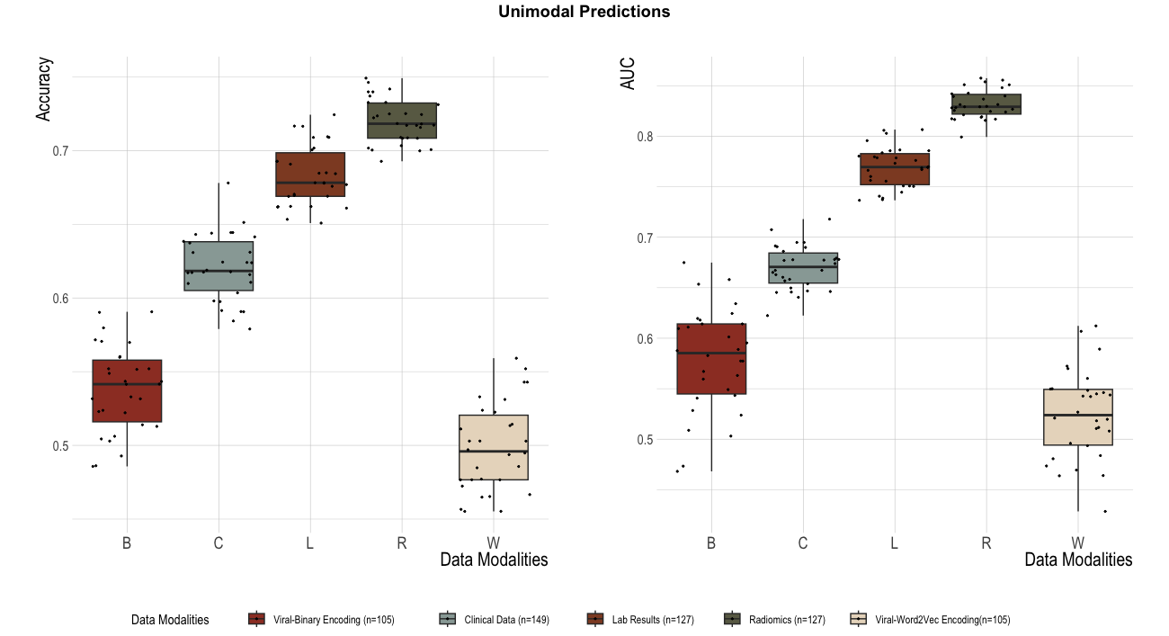

Supplementary Figure 7: Unimodal prediction models for all data modalities in all available patients. Radiomics features have the highest score (AUC=0.83 ± 0.01), followed by laboratory results and clinical data (AUC=0.77 ± 0.02 vs. 0.67 ± 0.02), respectively

Supplementary Table 2: Unimodal Prediction Models Evaluated in All Available Patients
Model | n |  | Accuracy | AUC
 | ICU (+) | ICU (-)
Clinical Data | 63 (42%) | 86 (58%) | 0.62 ± 0.02 | 0.67 ± 0.02
Radiomics Features | 57 (45%) | 70 (55%) | 0.72 ± 0.02 | 0.83 ± 0.01
Laboratory Results | 57 (45%) | 70 (55%) | 0.68 ± 0.02 | 0.77 ± 0.02
Viral-Binary Encoding | 49 (47%) | 56 (53%) | 0.54 ± 0.03 | 0.58 ± 0.05
Viral-Word2Vec Encoding | 49 (47%) | 56 (53%) | 0.50 ± 0.03 | 0.52 ± 0.04
Abbreviations: ICU, Intensive care unit: AUC, Area under the curve

Supplementary Table 3: Unimodal and Multimodal Prediction Models Evaluated in 89 Patients with Post-hoc Analysis Results (n=89)
Model | Accuracy | Adjusted p-values
 |  | C | L | R | D | W | CL | CR | LR | CD | CW | LD | LW | RD | RW | CLRD | CLRW
C | 0.63 ± 0.04 | - | .000 | .000 | .000 | .000 | .000 | .000 | .000 | .138 | .167 | .000 | .000 | .000 | .000 | .000 | .000
L | 0.74 ± 0.03 | .000 | - | .874 | .000 | .000 | .366 | .03 | .958 | .000 | .000 | .85 | .824 | .999 | .774 | 1 | .005
R | 0.72 ± 0.03 | .000 | .874 | - | .000 | .000 | .003 | .731 | .082 | .000 | .000 | 1 | 1 | 1 | .019 | .693 | .000
B | 0.55 ± 0.03 | .000 | .000 | .000 | - | 1 | .000 | .000 | .000 | .036 | .000 | .000 | .000 | .000 | .000 | .000 | .000
W | 0.55 ± 0.04 | .000 | .000 | .000 | 1 | - | .000 | .000 | .000 | .148 | .003 | .000 | .000 | .000 |  | .000 | .000
CL | 0.76 ± 0.03 | .000 | .366 | .003 | .000 | .000 | - | .000 | 1 | .000 | .000 | .003 | .004 | .03 | 1 | .431 | .936
CR | 0.71 ± 0.04 | .000 | .03 | .731 | .000 | .000 | .000 | - | .000 | .000 | .000 | .775 | .906 | .311 | .000 | .013 | .000
LR | 0.75 ± 0.03 | .000 | .958 | .082 | .000 | .000 | 1 | .000 | - | .000 | .000 | .074 | .08 | .361 | 1 | .981 | .383
CB | 0.59 ± 0.05 | .138 | .000 | .000 | .036 | .148 | .000 | .000 | .000 | - | 1 | .000 | .000 | .000 | .000 | .000 | .000
CW | 0.60 ± 0.04 | .167 | .000 | .000 | .000 | .003 | .000 | .000 | .000 | 1 | - | .000 | .000 | .000 | .000 | .000 | .000
LB | 0.72 ± 0.03 | .000 | .85 | 1 | .000 | .000 | .003 | .775 | .074 | .000 | .000 | - | 1 | 1 | .017 | .658 | .000
LW | 0.72 ± 0.03 | .000 | .824 | 1 | .000 | .000 | .004 | .906 | .08 | .000 | .000 | 1 | - | 1 | .021 | .642 | .000
RB | 0.73 ± 0.03 | .000 | .999 | 1 | .000 | .000 | .03 | .311 | .361 | .000 | .000 | 1 | 1 | - | .132 | .987 | .000
RW | 0.75 ± 0.03 | .000 | .774 | .019 | .000 | .000 | 1 | .000 | 1 | .000 | .000 | .017 | .021 | .132 | - | .844 | .567
CLRB | 0.74 ± 0.03 | .000 | 1 | .693 | .000 | .000 | .431 | .013 | .981 | .000 | .000 | .658 | .642 | .987 | .844 | - | .006
CLRW | 0.77 ± 0.03 | .000 | .005 | .000 | .000 | .000 | .936 | .000 | .383 | .000 | .000 | .000 | .000 | .000 | .567 | .006 | -

Model | AUC |  |  | Adjusted p-values
 |  |  | C |  |  | L |  |  | R |  |  | D |  |  | W |  |  | CL |  |  |  | CR |  |  | LR |  |  | CD |  |  | CW |  |  | LD |  |  | LW |  |  | RD |  |  | RW |  |  | CLRD |  |  | CLRW
C | 0.66 ± 0.03 |  |  | - |  |  | .000 |  |  | .000 |  |  | .000 |  |  | .000 |  |  | .000 |  |  |  | .000 |  |  | .000 |  |  | .083 |  |  | .03 |  |  | .000 |  |  | .000 |  |  | .000 |  |  | .000 |  |  | .000 |  |  | .000
L | 0.83 ± 0.03 |  |  | .000 |  |  | - |  |  | 1 |  |  | .000 |  |  | .000 |  |  | .849 |  |  |  | .134 |  |  | 1 |  |  | .000 |  |  | .000 |  |  | .019 |  |  | .329 |  |  | 1 |  |  | .001 |  |  | 1 |  |  | .000
R | 0.83 ± 0.03 |  | .000 |  |  | 1 |  |  | - |  |  | .000 |  |  | .000 |  |  | .593 |  |  |  | .354 |  |  | .993 |  |  | .000 |  |  | .000 |  |  | .064 |  |  | .592 |  |  | 1 |  |  | .002 |  |  | 1 |  |  | .000
B | 0.59 ± 0.05 |  | .000 |  |  | .000 |  |  | .000 |  |  | - |  |  | .24 |  |  | .000 |  |  |  | .000 |  |  | .000 |  |  | .17 |  |  | .375 |  |  | .000 |  |  | .000 |  |  | .000 |  |  | .000 |  |  | .000 |  |  | .000
W | 0.55 ± 0.05 |  | .000 |  |  | .000 |  |  | .000 |  |  | .24 |  |  | - |  |  | .000 |  |  |  | .000 |  |  | .000 |  |  | .000 |  |  | .000 |  |  | .000 |  |  | .000 |  |  | .000 |  |  | .000 |  |  | .000 |  |  | .000
CL | 0.85 ± 0.03 |  | .000 |  |  | .849 |  |  | .593 |  |  | .000 |  |  | .000 |  |  | - |  |  |  | .000 |  |  | .015 |  |  | .000 |  |  | .000 |  |  | .000 |  |  | .006 |  |  | .862 |  |  | .972 |  |  | .665 |  |  | .462
CR | 0.81 ± 0.02 |  | .000 |  |  | .134 |  |  | .354 |  |  | .000 |  |  | .000 |  |  | .000 |  |  |  | - |  |  | .999 |  |  | .000 |  |  | .000 |  |  | .999 |  |  | 1 |  |  | .008 |  |  | 000 |  |  | .304 |  |  | .000
LR | 0.84 ± 0.03 |  | .000 |  |  | 1 |  |  | .993 |  |  | .000 |  |  | .000 |  |  | .015 |  |  |  | .999 |  |  | - |  |  | .000 |  |  | .000 |  |  | .002 |  |  | .069 |  |  | 1 |  |  | .219 |  |  | .997 |  |  | .03
CB | 0.62 ± 0.04 |  | .083 |  |  | .000 |  |  | .000 |  |  | .17 |  |  | .000 |  |  | .000 |  |  |  | .000 |  |  | .000 |  |  | - |  |  | 1 |  |  | .000 |  |  | .000 |  |  | .000 |  |  | .000 |  |  | .000 |  |  | .000
CW | 0.62 ± 0.05 |  | .03 |  |  | .000 |  |  | .000 |  |  | .375 |  |  | .000 |  |  | .000 |  |  |  | .000 |  |  | .000 |  |  | 1 |  |  | - |  |  | .000 |  |  | .000 |  |  | .000 |  |  | .000 |  |  | .000 |  |  | .000
LB | 0.80 ± 0.03 |  | .000 |  |  | .019 |  |  | .064 |  |  | .000 |  |  | .000 |  |  | .000 |  |  |  | .999 |  |  | .002 |  |  | .000 |  |  | .000 |  |  | - |  |  | 1 |  |  | .001 |  |  | .000 |  |  | .052 |  |  | .000
LW | 0.81 ± 0.03 |  | .000 |  |  | .329 |  |  | .592 |  |  | .000 |  |  | .000 |  |  | .006 |  |  |  | 1 |  |  | .069 |  |  | .000 |  |  | .000 |  |  | 1 |  |  | - |  |  | .085 |  |  | .000 |  |  | .539 |  |  | .000
RB | 0.83 ± 0.02 |  | .000 |  |  | 1 |  |  | 1 |  |  | .000 |  |  | .000 |  |  | .862 |  |  |  | .008 |  |  | 1 |  |  | .000 |  |  | .000 |  |  | .001 |  |  | .085 |  |  | - |  |  | .000 |  |  | 1 |  |  | .000
RW | 0.86 ± 0.02 |  | .000 |  |  | .001 |  |  | .002 |  |  | .000 |  |  | .000 |  |  | .972 |  |  |  | 000 |  |  | .219 |  |  | .000 |  |  | .000 |  |  | .000 |  |  | .000 |  |  | .000 |  |  | - |  |  | .003 |  |  | .956
CLRB | 0.83 ± 0.02 |  | .000 |  |  | 1 |  |  | 1 |  |  | .000 |  |  | .000 |  |  | .665 |  |  |  | .304 |  |  | .997 |  |  | .000 |  |  | .000 |  |  | .052 |  |  | .539 |  |  | 1 |  |  | .003 |  |  | - |  |  | .000
CLRW | 0.87 ± 0.03 |  | .000 |  |  | .000 |  |  | .000 |  |  | .000 |  |  | .000 |  |  | .462 |  |  |  | .000 |  |  | .03 |  |  | .000 |  |  | .000 |  |  | .000 |  |  | .000 |  |  | .000 |  |  | .956 |  |  | .000 |  |  | -
Abbreviations: ICU, Intensive care unit; AUC, Area under the curve; C, Clinical data; L, Laboratory results; R, Radiomics; B, Viral-Binary encoding; W, Viral-Word2Vec encoding

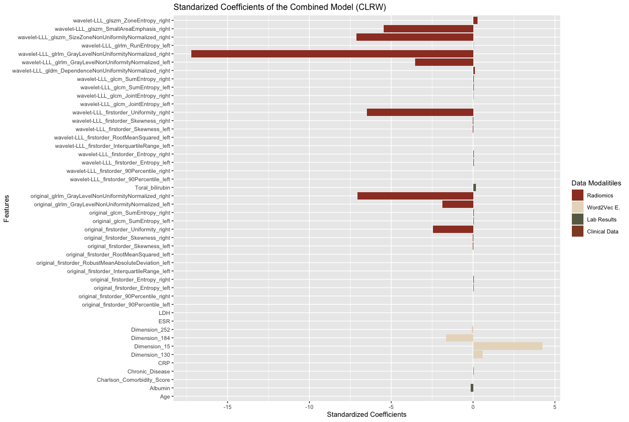
Supplementary Figure 8: Standardized coefficients of the quadruple model (CLRW). Model standardized coefficients were extracted at λ = 0.1. The original and wavelet features in the LLL frequency channel have the highest absolute values for the standardized coefficients. Word2Vec embedding also contributes to the supervised task with its four dimensions.

