Supplementary Information
Aberration-Corrected STEM to Determine the Surface Coverage and Distribution of Immobilized Molecular Complexes

Sungho Jeon¹, Hannah S. Nedzbala², Brittany L. Huffman³, Adam J. Pearce², Carrie L. Donley³, Xiaofan Jia², Gabriella P. Bein³, Jihoon Choi¹, Nicolas Durand⁴, Hala Atallah⁴, Felix N. Castellano⁴, Jillian L. Dempsey³, James M. Mayer², Nilay Hazari^{2*}, and Eric A. Stach^{1*}

¹Department of Materials Science and Engineering, University of Pennsylvania, Philadelphia, PA 19104.
²Department of Chemistry, Yale University, New Haven, CT 06520.
³Department of Chemistry, University of North Carolina at Chapel Hill, Chapel Hill, NC 27599.
⁴Department of Chemistry, North Carolina State University, Raleigh, NC 27695-8204.
Corresponding authors: Eric A. Stach (stach@seas.upenn.edu), Nilay Hazari (nilay.hazari@yale.edu)

Table of Contents
Supplementary Information 1
Supplementary Notes 2
Supplementary Note 1 - Machine learning algorithm for analysis of images 2
Supplementary Note 2 - Electron beam damage 2
Supplementary Figures 4
Supplementary Tables 24
Captions for Supplementary Movies 28
References 29

Supplementary Notes

Supplementary Note 1 - Machine learning algorithm for analysis of images
We segmented the STEM images using a CNN trained using images of Re-Bubpy or Pt-porph. A previously reported framework¹ was used for the training, which generated small crops (21 pixel × 21 pixel) of the original image for the positive and negative training set. The positive training set comprises images with tags of individual atoms, while the negative training set consists of images without such tags. The tags on the training set were manually marked on the original image.
The number of cropped images used for the training was 3722 for Re-^{Bu}bpy and 9722 for Pt-porph. We trained the CNN independently using Re-^{Bu}bpy and Pt-porph because the model trained by Re-^{Bu}bpy could segment Re atoms from the background in Re-Phen and other Re-^{R}bpy complexes, but falsely segmented Ti atoms as metal atoms in images of Pt-porph. The images of Pt-porph were segmented using another model trained by the images of Pt-porph (Supplementary Fig. 3a-c).
We opted to train the CNN with our own dataset for atom detection, as two alternative approaches proved ineffective (Supplementary Fig. 3d-f). The first method, involving image processing techniques utilizing top-hat filtering, failed to detect atoms within the clusters. Likewise, the second method, which used a CNN model provided in the paper¹ that was trained using images of Pt atoms on nitrogen-doped amorphous carbon, also proved unsuccessful in atom detection within the clusters. To prepare the training set using our images, we tagged the atoms on the images using top-hat filtering and reviewed manually to find and add missing atoms in the images.

Supplementary Note 2 - Electron beam damage
The consecutive STEM images acquired in the same area show the process of atomic clustering due to the electron beam (Supplementary Fig. 10 – 17 and Movie 1 – 8). We captured every image with 8 µs pixel time and 1024 × 1024 resolution, taking 8.4 seconds in total for a capture. We adjusted the viewing area (Supplementary Fig. 17) before every capture, which required an additional time of ~1 second for the observation at cryogenic temperature because the sample drifted severely. Many of the gaps between metal atoms in the clusters in the last images in the image set (Supplementary Fig. 10 – 17 and Movie 1 – 8) measured less than 3 Å. This is close to the Re-Re distance in well-defined Re clusters, which is 2.76 Å at room temperature². This proximity implies the dissociation (or at least partial destruction in the molecule) and clustering of the metal atoms. However, we conclude that the clusters shown in the first image are likely not related to beam damage because (i) a similar number of clusters are found in the TEM observation at cryogenic temperature (< −150 °C) where the beam-induced clustering is substantially decreased (image: Supplementary Fig. 17, K_{dev}: Fig. 3i), (ii) signals consistent with Re(0) complexes were detected by XPS for both Re-^{Bu}bpy and Re-Phen (Fig. 1d,e) suggesting some clustering prior to the microscopy experiment, and (iii) the diffusion of metal atoms we observed was too slow to generate clusters during one image capture.
Given the slow rate of diffusion of metal atoms, we posit that the first image represents the intact sample. Most atoms and all clusters are trackable from the consecutive images (Fig. 3a, Supplementary Fig. 10 – 17, and Movie 1-8). We marked detected Re atoms in the consecutive images of Re-^{Bu}bpy on the same image to visualize the diffusion of the metal atoms after drift correcting the images using cross-correlation (Supplementary Fig. 18). The hopping distance of most Re atoms in the Re-^{Bu}bpy measures less than 5 Å for one image capture, although a few atoms were missed during the observation probably because of the clustering. The clusters moved less than 1 nm throughout the 7 image captures, but they tended to be tightly packed during the image capture sequence. Also, the round shape of atoms observed from the images of the samples, except for Re-^{Et}bpy observed at room temperature (Supplementary Fig 16), indicates that their movement is not fast. Finally, in another report³, most copper (Cu) atoms on graphene oxide (GO) hopped less than 5 Å during sequential image captures. The experiment used a different substrate and lower beam energy (80 kV). However, theoretically, the Cu atoms at 80 kV are expected to diffuse faster than Re or Pt atoms at 200 kV because Cu is lighter than Re or Pt atoms. Additionally, we showed that the diffusion of Re atoms could be resisted by the molecules attached to the surface, using the experiment with and without “backfill” as shown in Fig. 3b – 3e. Finally, we minimized the sample's exposure to the beam before imaging. We conclude that the first images in this paper should show the position of the molecules as deposited.

Supplementary Figures

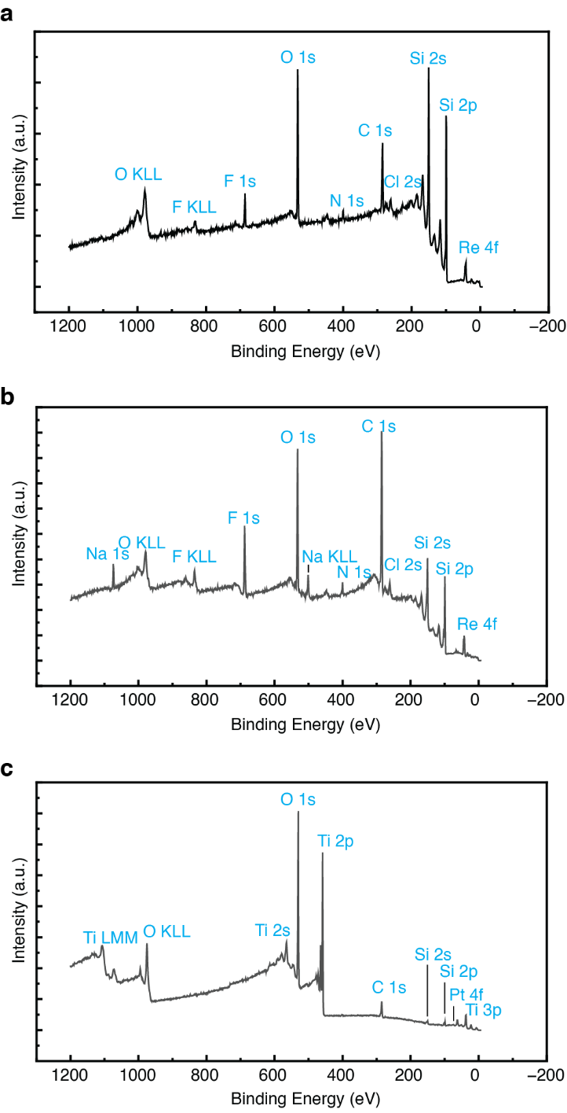
Supplementary Figure 1. The XPS survey spectra of (a) Re-Bubpy, (b) Re-Phen, and (c) Pt-porph.

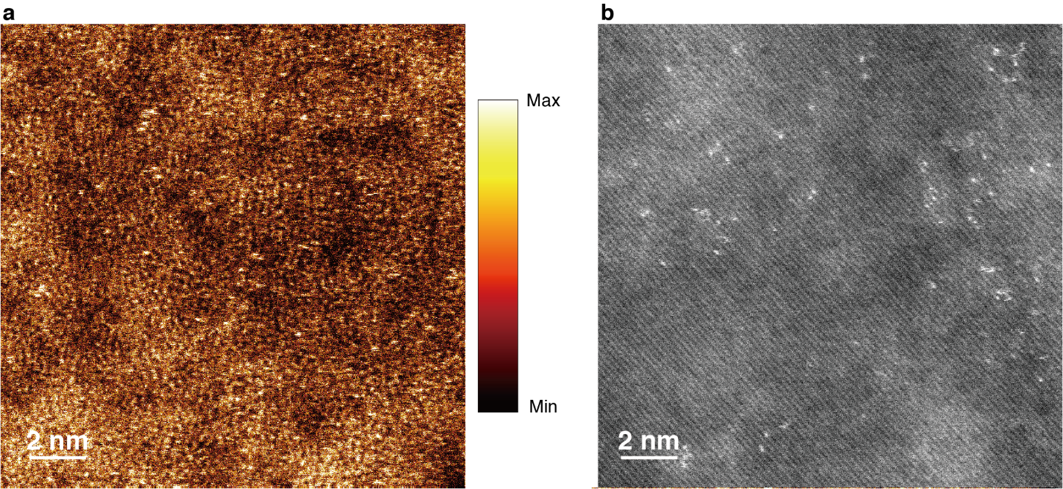
Supplementary Figure 2. STEM images for Pt-porph. (a) The colored STEM image of Pt-porph after bright and contrast adjustment. Ti atoms are highlighted by yellow spots in this image. (b) STEM image displaying the backside of the Si thin film. Unlike in (a) or Fig. 1f, Ti atoms are not visible in this image, and Pt atoms are observed on specific areas of the surface. The Pt-porph molecules can also be attached to SiO₂, and we assume that Pt-porph is attached to the surface of irregularly grown native SiO₂ in this image.

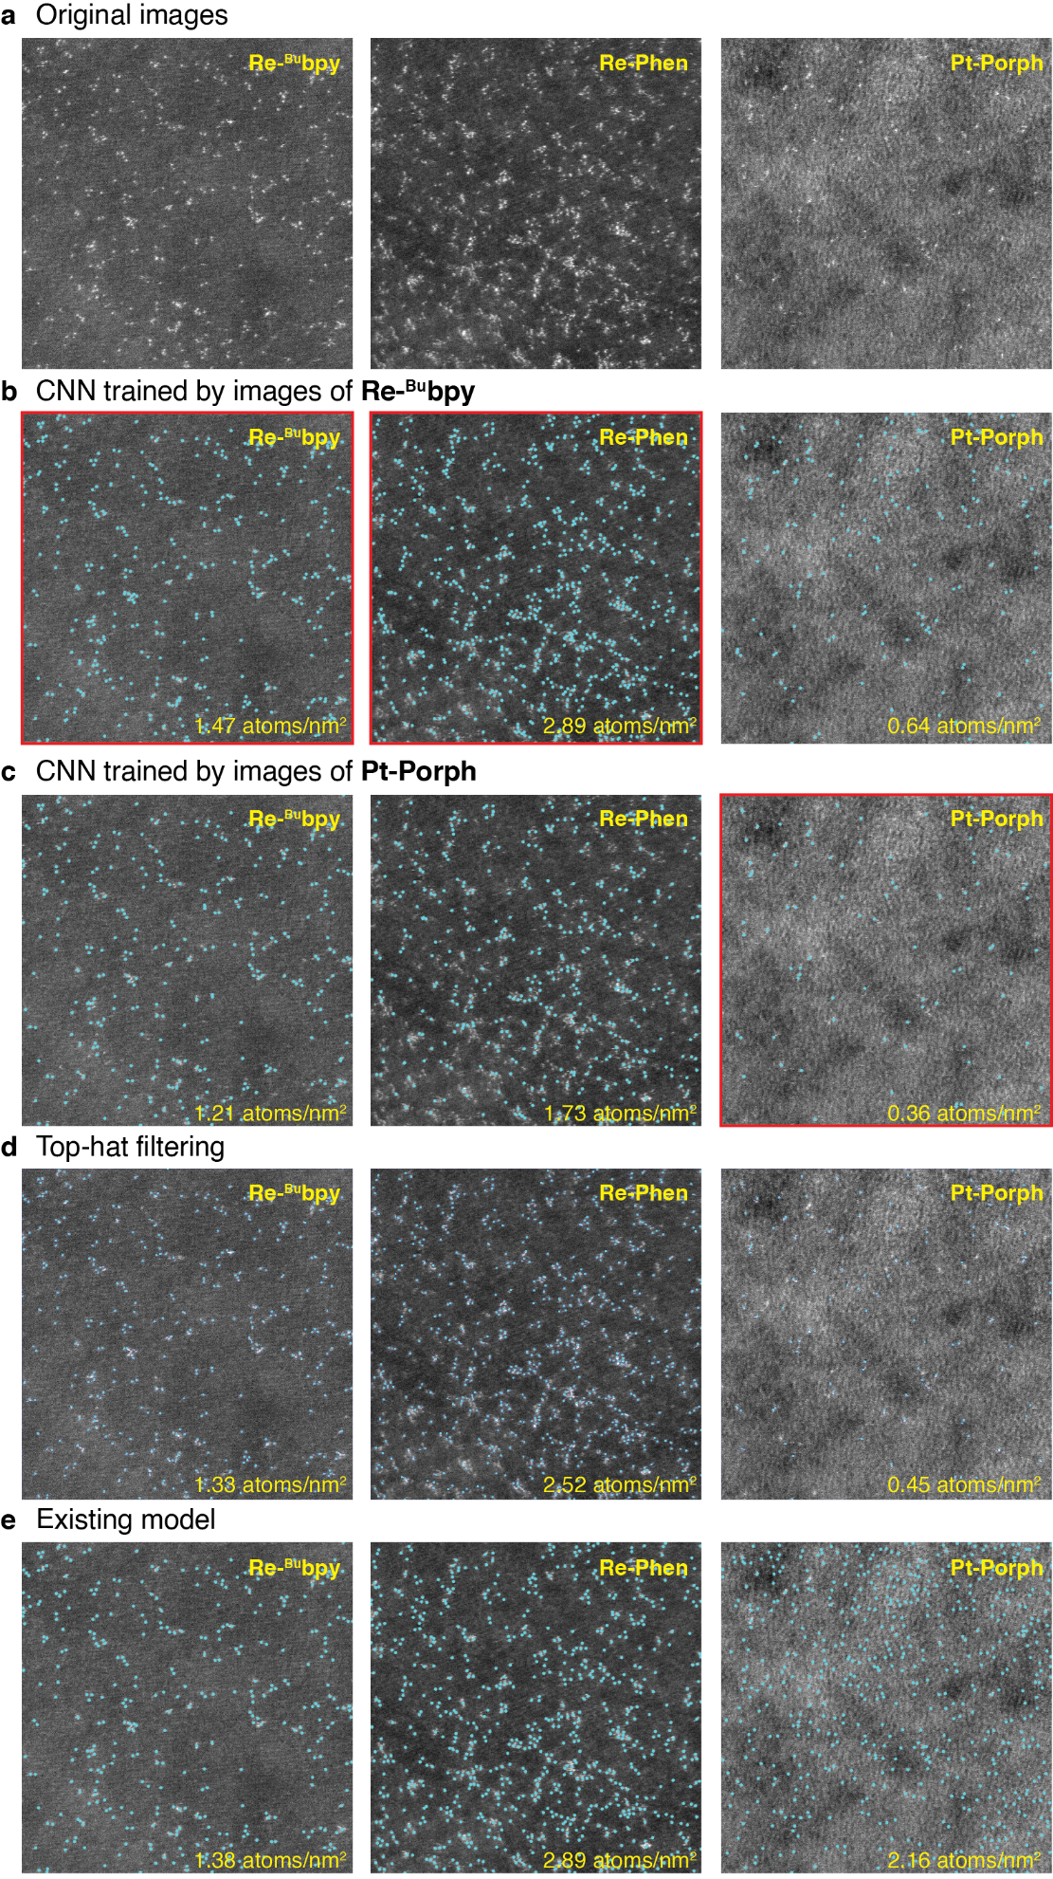
Supplementary Figure 3. Atomic detection outcomes marked by cyan dots. Metal atoms within the original image (a) were identified through methods, including the CNN model trained on Re-^{Bu}bpy images (b), and the CNN model trained on Pt-porph images (c). For further analysis, the CNN model trained on Re-^{Bu}bpy were used to detect the images of Re-^{Bu}bpy and Re-Phen and that trained on Pt-porph was used to detect the images of Pt-porph. The exemplary images of those cases are highlighted by red borders. Metal atoms were also identified through top-hat filtering (d), the CNN model presented previously in the literature¹ (e), for comparison.

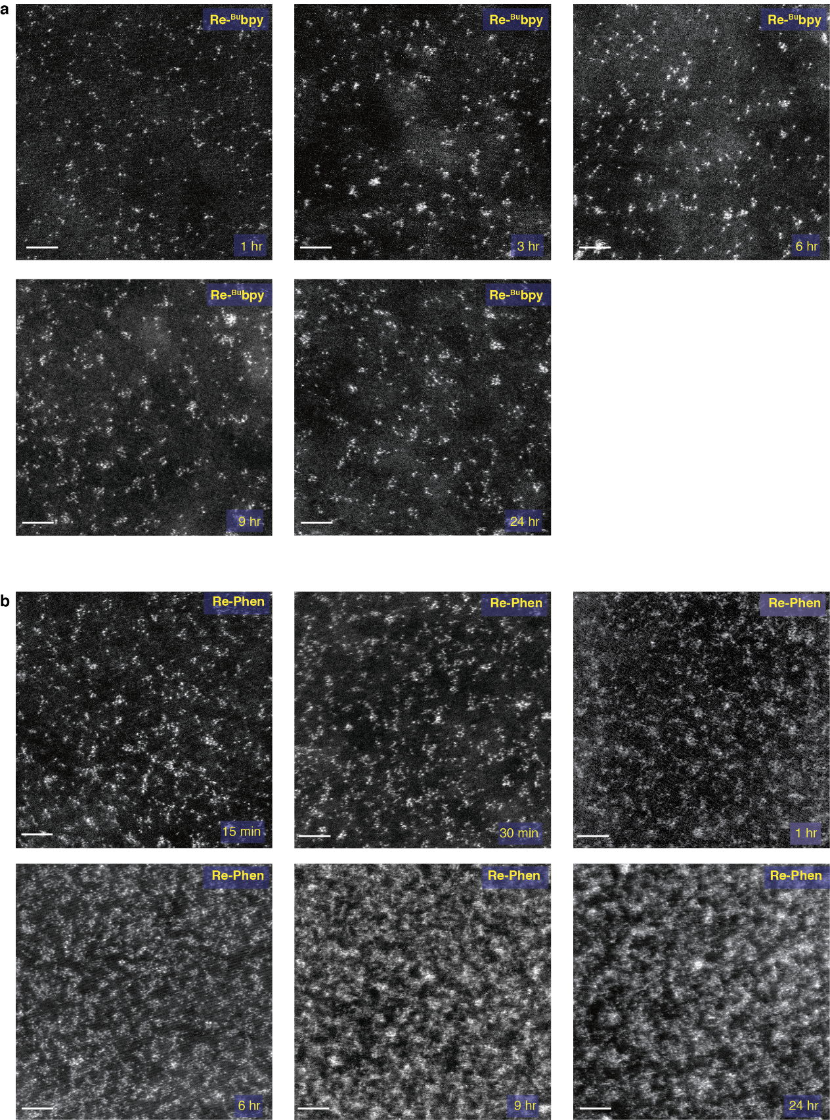
Supplementary Figure 4. Selected images of Re-^{Bu}bpy (a), Re-Phen (b) with different reaction times for the hydrosilylation reaction. Both sets of functionalization were performed at 2 mM [Re].

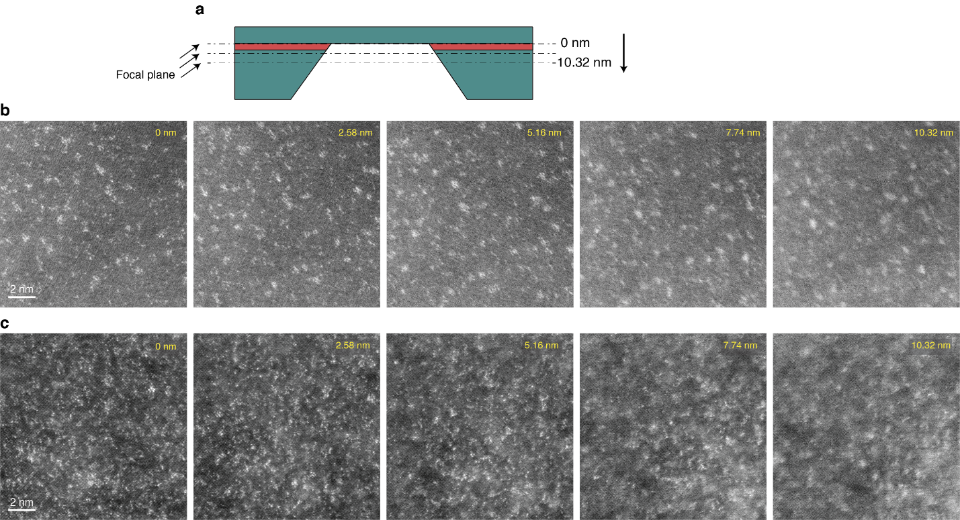
Supplementary Figure 5. The HAADF-STEM observations obtained by changing the relative focal length by up to 10.32 nm. (a) Schematic showing the focal plane's movement during the observation from 0 nm to 10.32 nm. Both series of images of (b) Re-^{Bu}bpy (2mM, 24h) and (c) Re-Phen (2mM, 24h) show blurring in the imaging of Re atoms as the focal length shifts away from the surface, but the blurring process was different. In the case of Re-^{Bu}bpy, all atoms were blurred similarly as focal length shifts away. However, in the case of Re-Phen, some Re atoms were clearly shown even at 7.74 nm or 10.32 nm, while some atoms are blurred from 2.58 nm. This shows that the Re atoms are positioned at different heights from the surface in the Re-Phen sample.
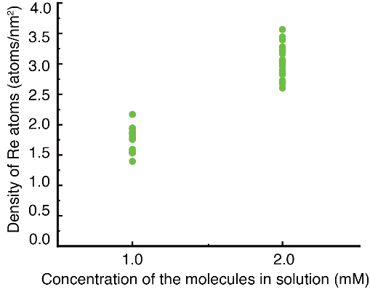
Supplementary Figure 6. Surface coverage of Re-^{Bu}bpy as a function of the concentration of the molecules in solution during the hydrosilylation reaction. The reaction time was held constant at 24h.

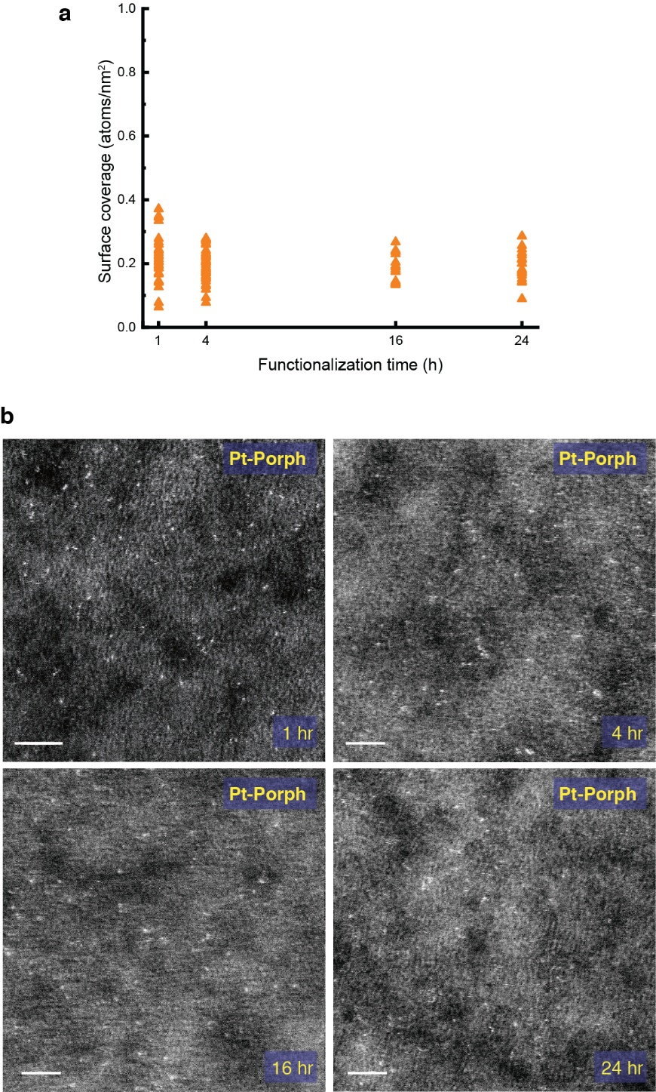
Supplementary Figure 7. Surface coverage of Pt-porph determined by HAADF-STEM images. (a) Surface coverage as a function of the time for the hydrolysis reaction used for surface attachment. The Si grids were functionalized in the 10:1 chlorobenzene:benzonitrile solution with 0.5 mM Pt-porph at 90 °C for 1h, 4h, 16h, & 24 h. (b) the representative images of Pt-porph used for the measurement of surface coverage. Scale bars: 2 nm.

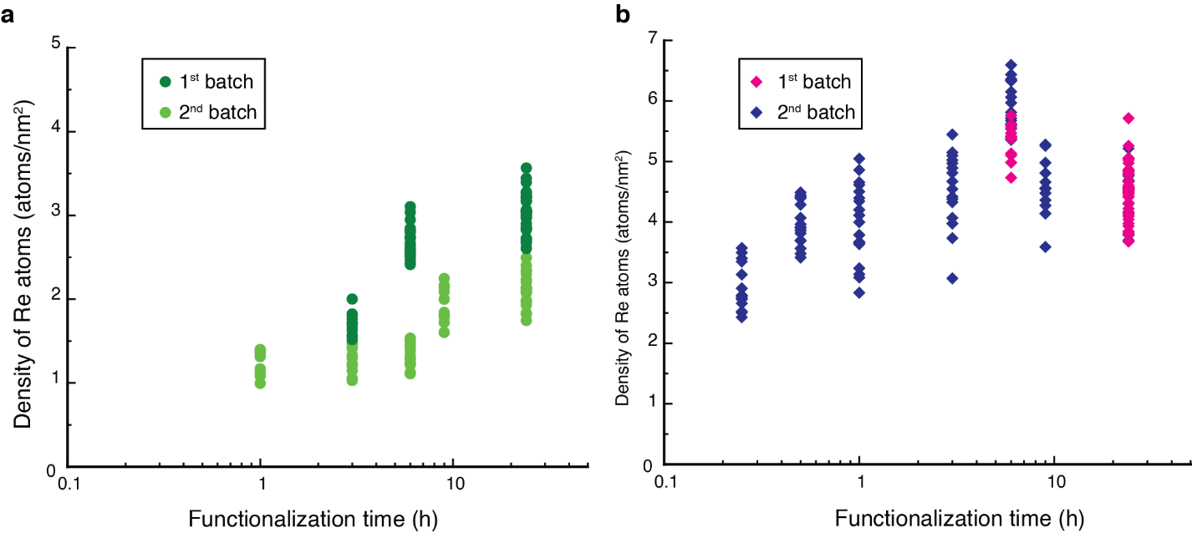
Supplementary Figure 8. Surface coverages of Re-^{Bu}bpy (aa) and Re-Phen (b) calculated from different batches as a function of the time for the hydrosilylation reaction used for surface attachment. The Si grids were functionalized in 2 mM solutions of Re-^{Bu}bpy and Re-Phen. Here we use the term “batch” to refer the set of samples that were processed in the same day using the same solution. It is unsurprising that there is some small variation in the surface coverage between immobilization reactions performed on different days.

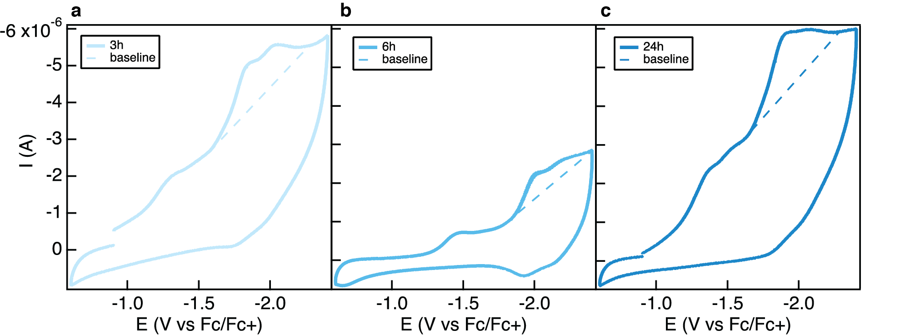
Supplementary Figure 9. cyclic voltammograms used to calculate the surface coverage of Re-^{Bu}bpy after hydrosilylation reactions (at 2 mM Re) for 3h (a), 6h (b), and 24h (c). Cyclic voltammograms were collected at a scan rate of 100 mV/s in 0.25M ^{n}Bu₄NPF₆ in acetonitrile with a Pt counter electrode and an Ag wire pseudo-reference electrode. The features selected for integration were selected based on their overlap with electrochemical features corresponding to the molecular solution species, Re-^{Bu}bpy. The number of electrons transferred from the Si to each attached Re was assumed to be 2. Similar analysis was performed in a recent study of immobilized complexes⁴.
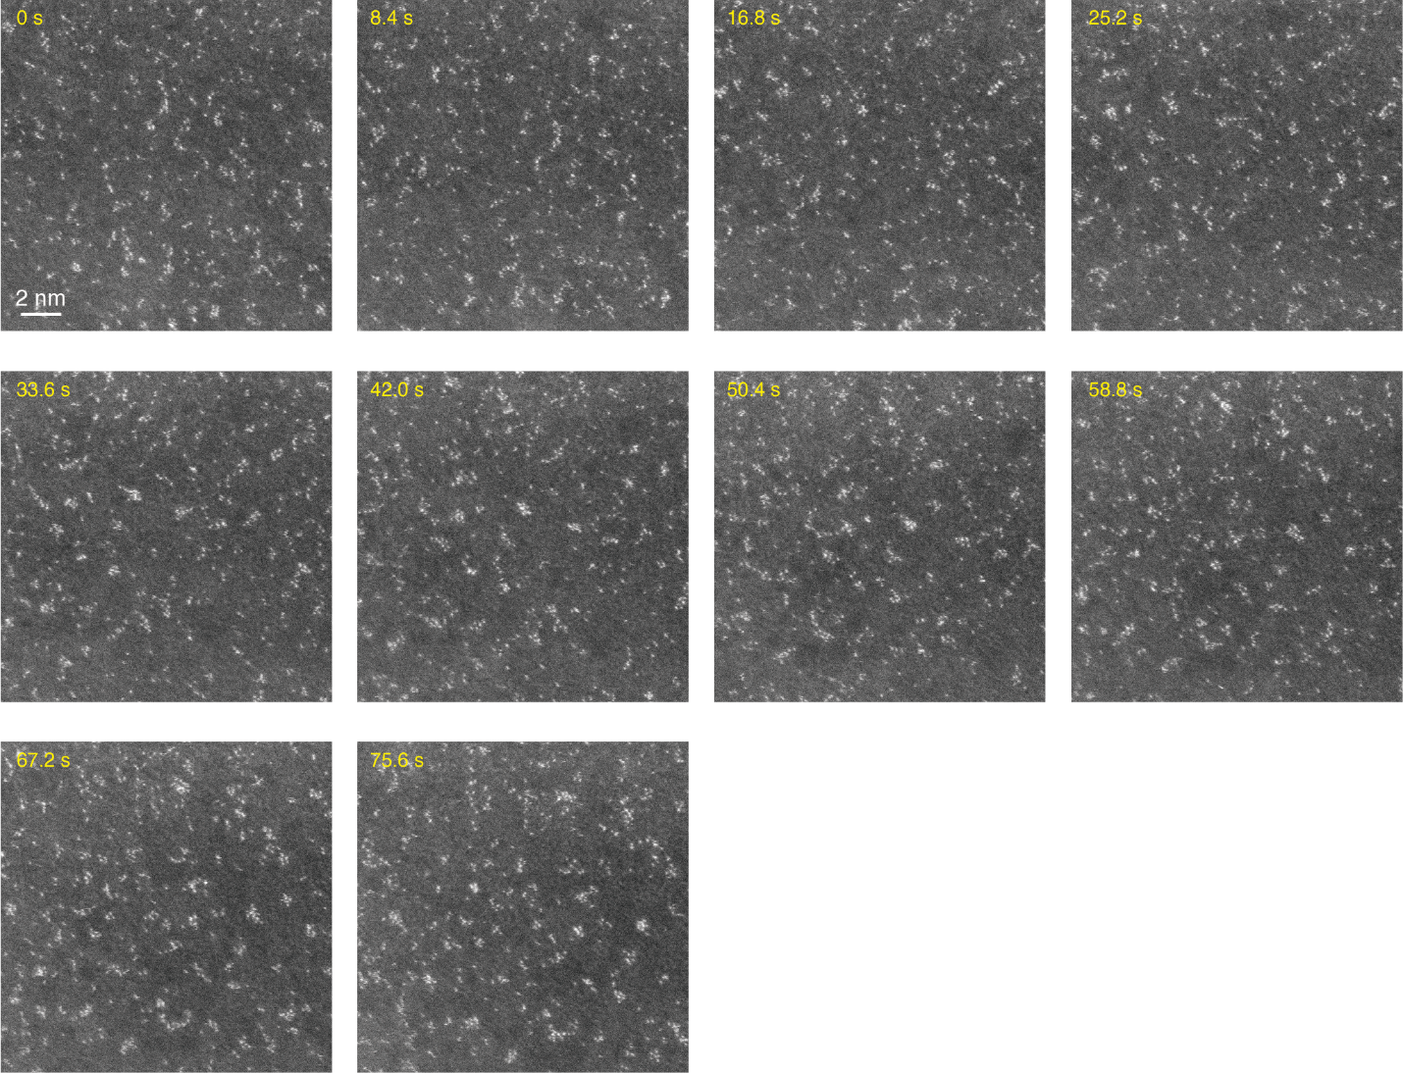
Supplementary Figure 10. 10 consecutive images of Re-^{Bu}bpy (2mM, 24h) captured with 8 µs per pixel dwell time. The 8 µs dwell time and 1024 × 1024 resolution allows 8.4 s capture time. The Si grids were functionalized by 2mM Re-^{Bu}bpy in mesitylene solution for 24h. In the last frame (75.6 s), We observe multiple clusters with a radius of approximately 5 Å.

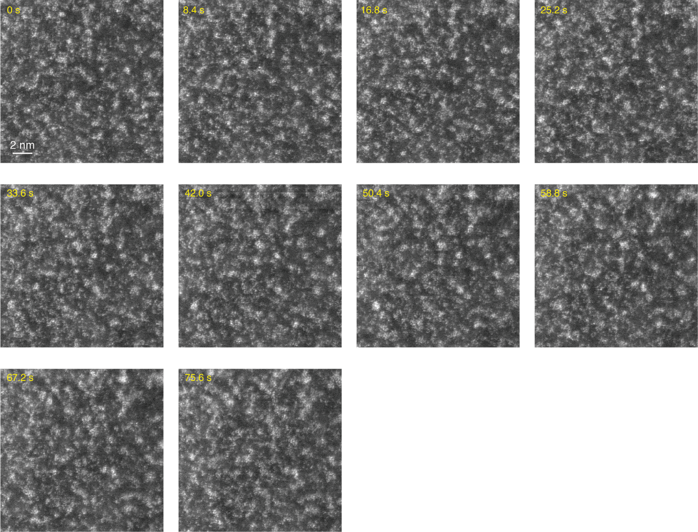
Supplementary Figure 11. 10 consecutive images of Re-Phen (2mM, 24h) captured with 8 µs per pixel dwell time. The 8 µs dwell time and 1024 × 1024 resolution allows 8.4 s capture time. The Si grids were functionalized by 2mM Re-Phen in mesitylene solution for 24h In the last frame (75.6 s), We observe the increased size of clusters in the last frame compared to the first frame.

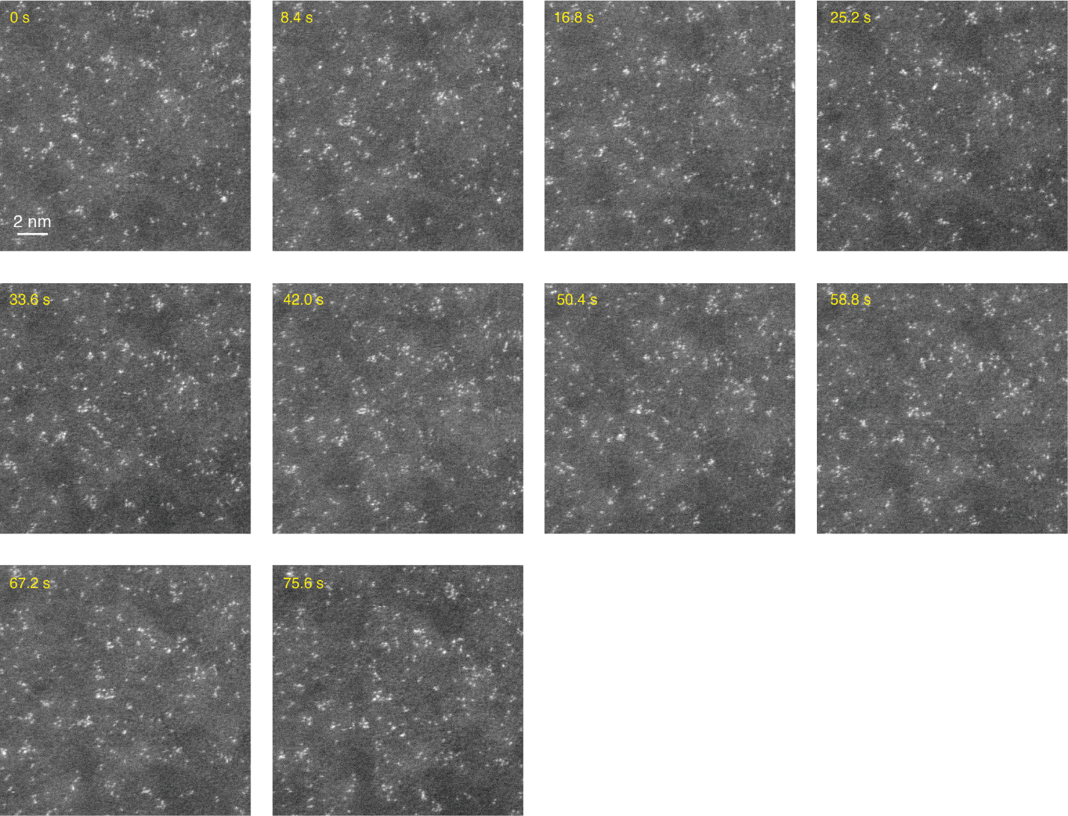
Supplementary Figure 12. 10 consecutive images of Re-^{Bu}bpy with the surface backfilled with 1-hexene captured with 8 µs per pixel dwell time. The Si grids were functionalized by 2mM Re-^{Bu}bpy in mesitylene solution for 24h, and then functionalized again by 10% 1-hexene in mesitylene for 24h. The 8 µs dwell time and 1024 × 1024 resolution allows 8.4 s capture time. The growth of clusters was not observed from the consecutive images of backfilled Re-^{Bu}bpy.

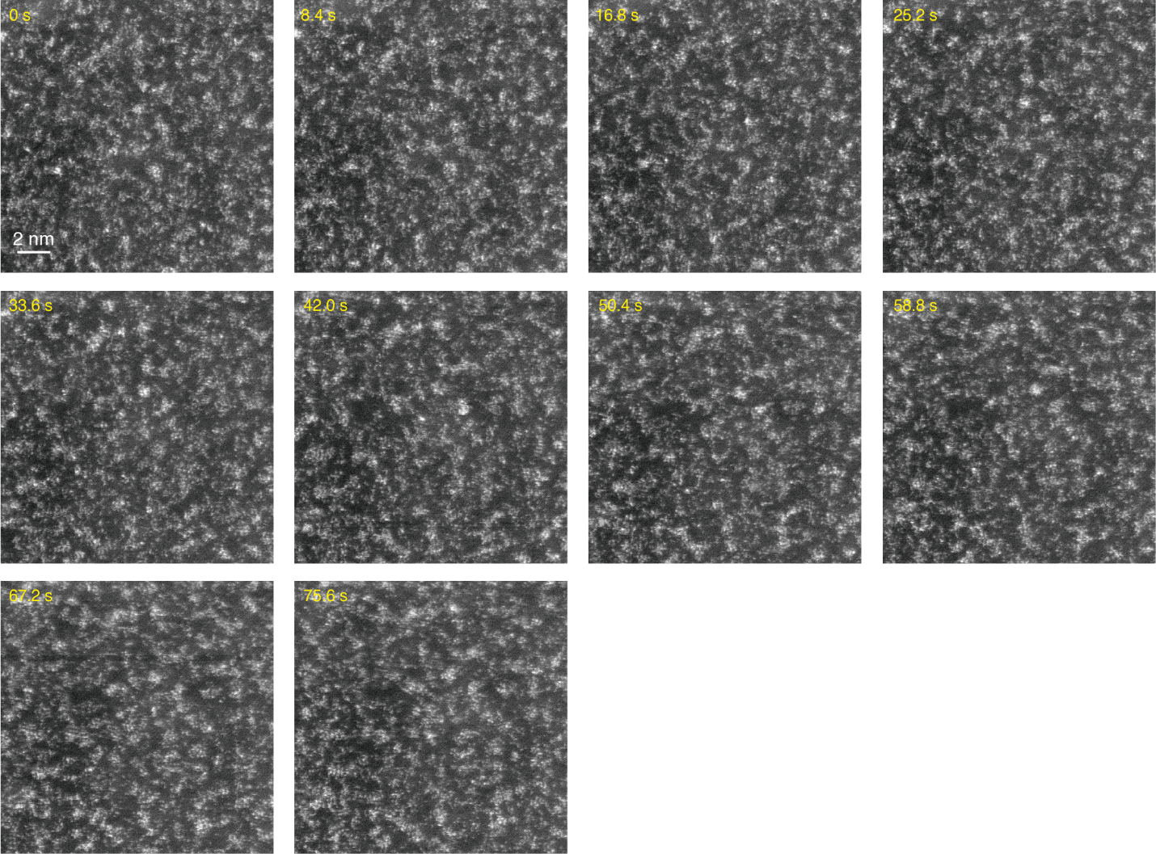
Supplementary Figure 13. 10 consecutive images of Re-Phen with the surface backfilled with 1-hexene captured with 8 µs per pixel dwell time. The Si grids were functionalized by 2mM Re-Phen in mesitylene solution for 24h, and then functionalized again by 10% 1-hexene in mesitylene for 24h. The 8 µs dwell time and 1024 × 1024 resolution allows 8.4 s capture time. The growth of clusters was not observed from the consecutive images of backfilled Re-Phen.

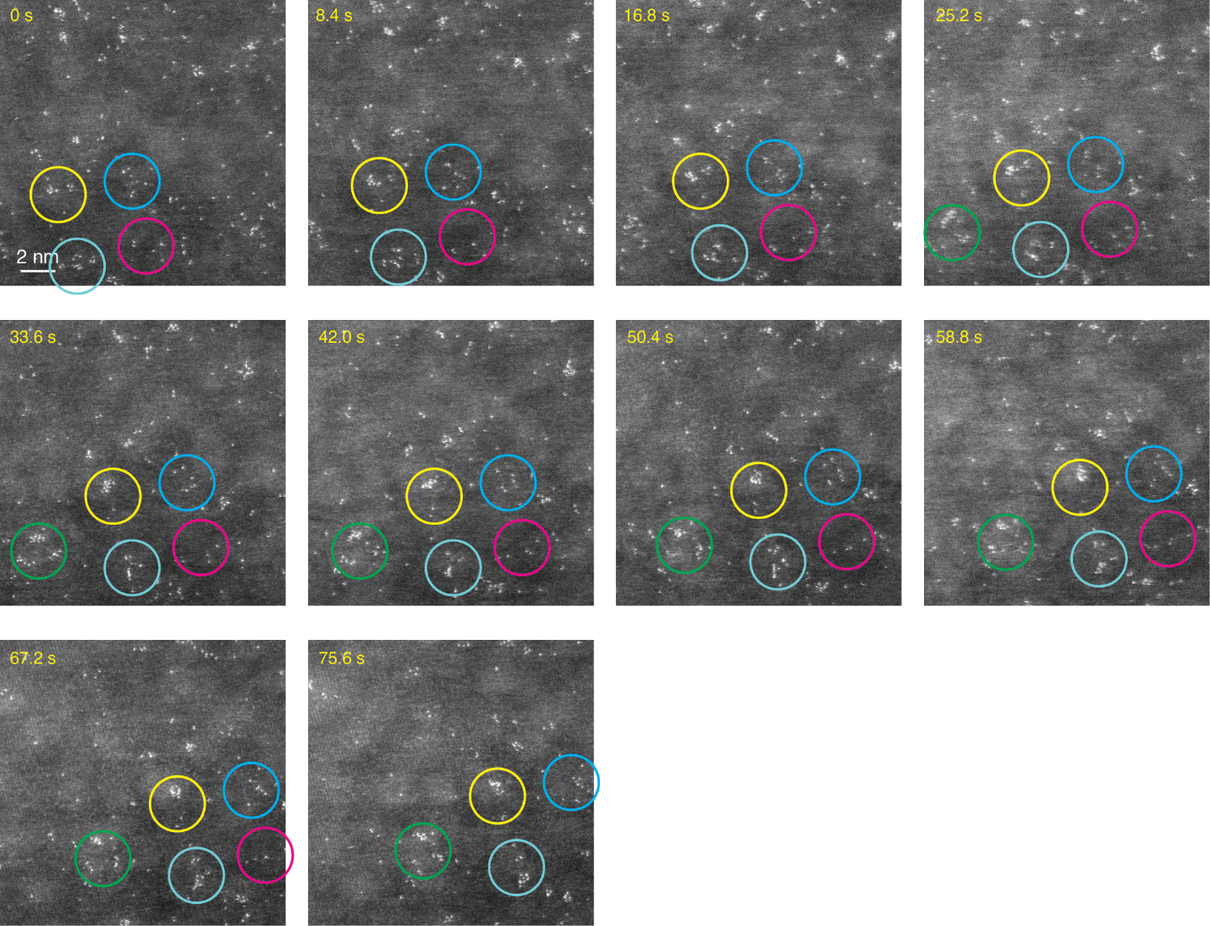
Supplementary Figure 14. 10 consecutive images of Re-^{Bu2}bpy captured with 8 µs per pixel dwell time. The 8 µs dwell time and 1024 × 1024 resolution allows 8.4 s capture time. The Si grids were functionalized by 2mM Re-^{Bu2}bpy in mesitylene solution for 1h Although there is clustering as shown in the area with yellow circle, many metal atoms (probably in the molecules) did not cluster even though they were located closely to one another (marked with blue, cyan, green, and magenta circles).

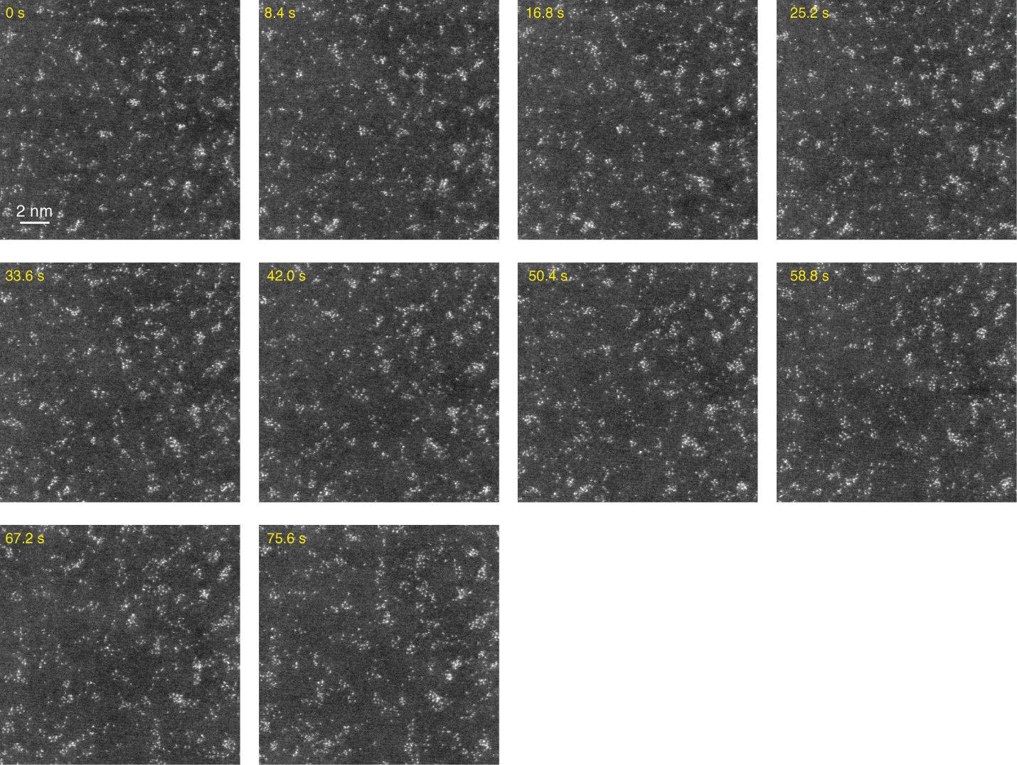
Supplementary Figure 15. 10 consecutive images of Re-^{Non}bpy captured with 8 µs per pixel dwell time. The 8 µs dwell time and 1024 × 1024 resolution allows 8.4 s capture time. The Si grids were functionalized by 2mM Re-^{Non}bpy in mesitylene solution for 1h. More clusters are shown in the last image than the first image. However, the clusters look more loosely packed than Re-^{Bu}bpy.

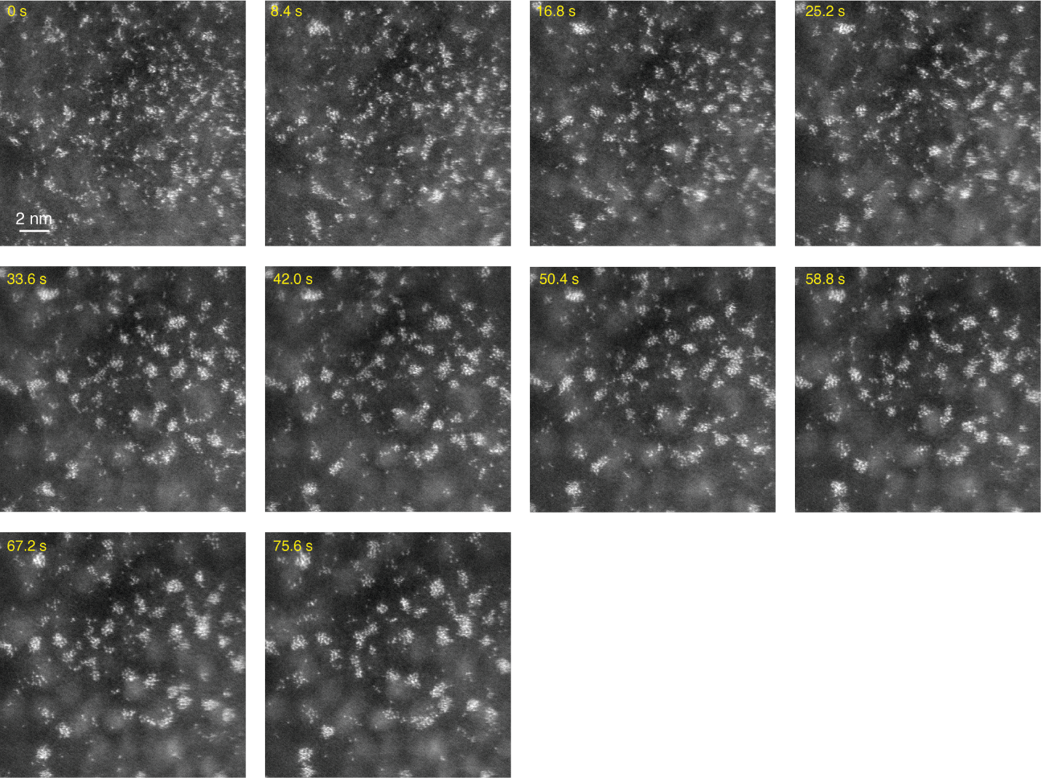
Supplementary Figure 16. 10 consecutive images of Re-^{Et}bpy captured with 8 µs per pixel dwell time. The 8 µs dwell time and 1024 × 1024 resolution allows 8.4 s capture time. The Si grids were functionalized by 2mM Re-^{Et}bpy in mesitylene solution for 1h. The clustering process was fastest in the sample of Re-^{Et}bpy compared to all other systems studied.
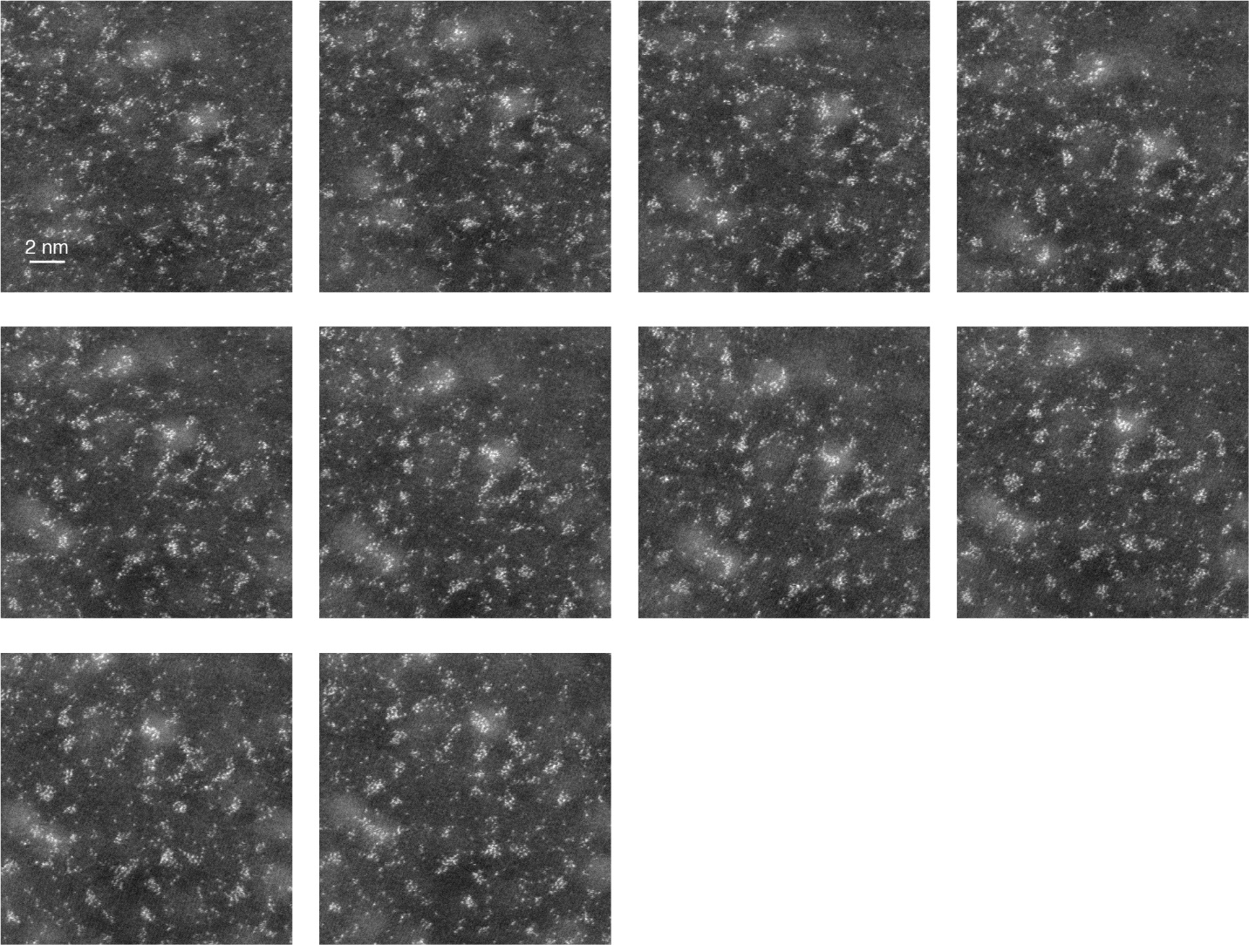
Supplementary Figure 17. 10 consecutive images of Re-^{Et}bpy at cryogenic temperature captured with 8 µs per pixel dwell time. The 8 µs dwell time and 1024 × 1024 resolution allows 8.4 s capture time but we adjusted the imaging area before every image capture because the drift was severe at the cryogenic temperature (< 150 °C), which took additional time of about 1 second. The clustering is substantially decreased compared to the case of Re-^{Et}bpy at room temperature.

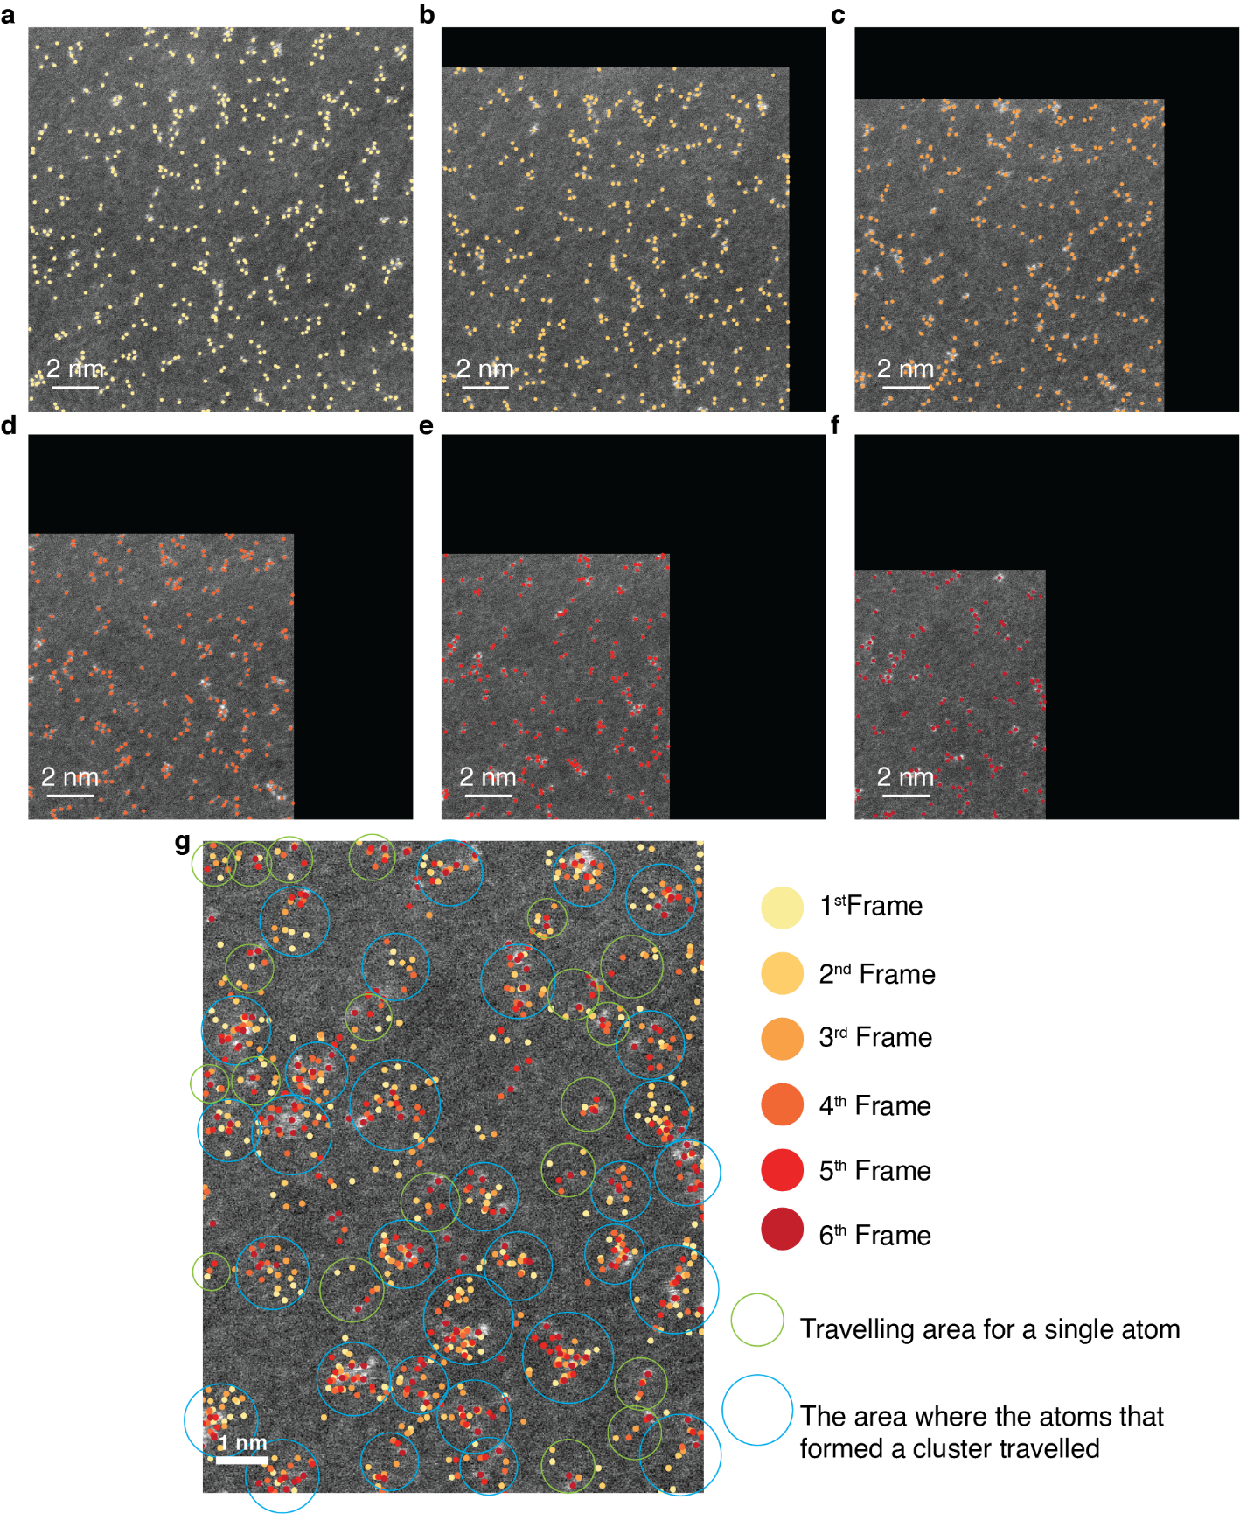
Supplementary Figure 18. The diffusion distance for Re atoms visualized from the consecutive images of Re-^{Bu}bpy (Supplementary Figure 10). We used the CNN-based atomic detection and the drift correction of the image for the visualization.

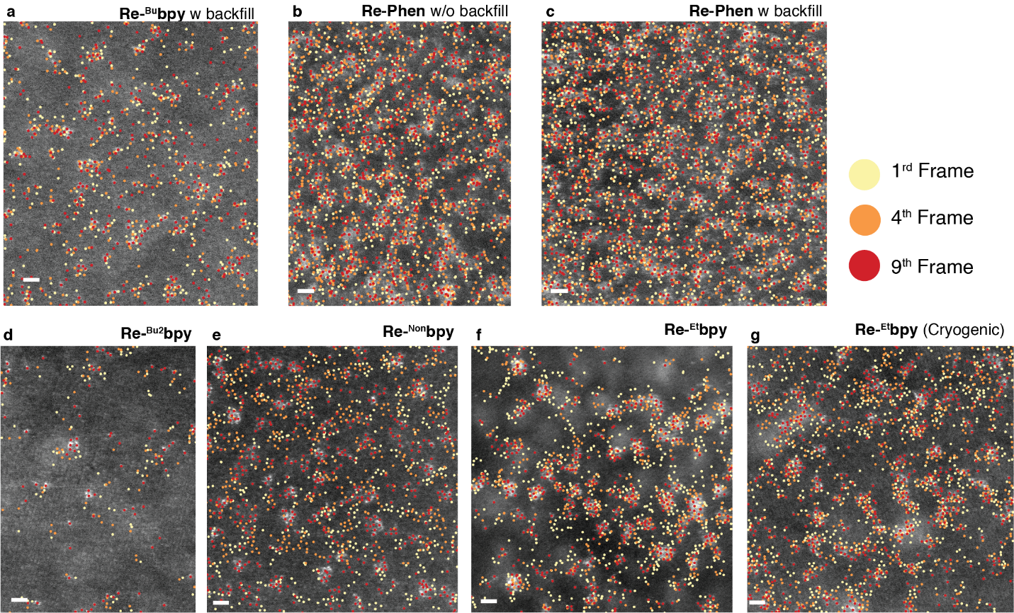
Supplementary Figure 19. The atomic positions of atoms in 1st, 4th, and 9th images in the consecutive image set shown above. (a) Re-^{Bu}bpy backfilled with 1-hexene, (b) Re-Phen, (c) Re-Phen backfilled with 1-hexene, (d) Re-^{Bu2}bpy, (e) Re-^{Non}bpy, and (f) Re-^{Et}bpy observed at room temperature and (g) Re-^{Et}bpy observed at cryogenic temperature (The images are shown in Supplementary Figure 11 - 17). The method for marking atoms in an image is shown in Supplementary Figure. 18. Scale bars: 1 nm.

Supplementary Tables
Supplementary Table 1. XPS quantification data for the Re-^{Bu}bpy
 | Binding energy [eV] | FWHM [eV] | Relative sensitivity factor | Atomic conc. [%]
Si 2p Si | 98.68 | 0.00 | 0.33 | 53.89
Re 4f Re(0) | 40.00 | 1.11 | 3.96 | 0.15
Re 4f Re(I) | 41.58 | 1.30 | 3.96 | 0.73
Re 4f ReO₃ | 43.27 | 1.52 | 3.96 | 0.09
O 1s | 531.99 | 0.00 | 0.78 | 17.72
N 1s | 399.89 | 0.00 | 0.48 | 2.02
C 1s | 284.59 | 0.00 | 0.28 | 25.40
The Si grids were functionalized in the 2mM Re-^{Bu}bpy in mesitylene solution under a N₂ atmosphere at 160 ℃ for 1h.

Supplementary Table 2. XPS quantification data for the Re-Phen
 | Binding energy [eV] | FWHM [eV] | Relative sensitivity factor | Atomic conc. [%]
Si 2p | 98.93 | 0.00 | 0.33 | 24.39
Re 4f Re(0) | 40.01 | 1.10 | 3.96 | 0.05
Re 4f Re(I) | 41.87 | 1.16 | 3.96 | 0.82
O 1s | 532.33 | 0.00 | 0.78 | 16.94
N 1s | 400.23 | 0.00 | 0.48 | 2.45
Cl 2p | 197.93 | 0.00 | 0.89 | 0.74
C 1s | 284.73 | 0.00 | 0.28 | 54.61
The Si grids were functionalized in the 2mM Re-Phen in mesitylene solution under a N₂ atmosphere at 160 ℃ for 1h.

Supplementary Table 3. XPS quantification data for the Pt-porph
 |  | Binding energy [eV] | FWHM [eV] | Relative sensitivity factor | Atomic conc. [%]
Ti 2p |  | 458.41 | 0.00 | 2.00 | 23.36
Si 2p Si |  | 98.59 | 0.00 | 0.33 | 4.89
Pt 4f |  | 73.01 | 0.00 | 5.58 | 0.07
O 1s |  | 529.91 | 0.00 | 0.78 | 53.65
N 1s |  | 399.91 | 0.00 | 0.48 | 1.16
C 1s |  | 284.71 | 0.00 | 0.28 | 16.87
The Si grids were functionalized in the 0.5mM Pt-porph in 10:1 chlorobenzene:benzonitrile under an ambient atmosphere at 90 ℃ for 1h.

Supplementary Table 4. ICPMS data
Sample | Surface Loading (Atoms/nm²)
Re-^{Bu}bpy¹, 3h | 1.331
Re-^{Bu}bpy¹, 6h | 1.744
Re-^{Bu}bpy¹, 24h | 1.382
Re-Phen², 15min | 0.859
Re-Phen², 30min | 0.967
Re-Phen², 1h | 1.350
Re-Phen², 3h | 2.359
Re-Phen², 6h | 5.221
Re-Phen², 24h | 1.332
Re-Phen², 24h + 1-hexene backfill | 3.896
Pt-porph³, 1h | 0.181
¹ The Si grids were functionalized in the 2mM Re-^{Bu}bpy in mesitylene solution under a N₂ atmosphere at 160 ℃ for the time noted above.
² The Si grids were functionalized in the 2mM Re-Phen in mesitylene solution under a N₂ atmosphere at 160 ℃ for the time noted above.
³ The Si grids were functionalized in the 0.5mM Pt-porph in 10:1 chlorobenzene:benzonitrile solution at 90 ºC for the time noted above.
For all samples, the Si grids were in the solution for 1 hour after the functionalization process for cool-down.

Captions for Supplementary Movies

Supplementary Movie 1. Drift corrected image sequence of 6 consecutive images of the Re-^{Bu}bpy captured by HAADF-STEM. The original images of this movie are presented in Supplementary Figure 10, and the K-functions calculated from the original images are shown in Fig. 3b and Scale bar: 2 nm.

Supplementary Movie 2. Drift corrected image sequence of 10 consecutive images of the Re-Phen captured by HAADF-STEM. The original images of this movie are presented in Supplementary Figure 11, and the K-functions calculated from the original images are shown in Fig. 3c and Scale bar: 2 nm.

Supplementary Movie 3. Drift corrected image sequence of 10 consecutive images of the backfilled Re-^{Bu}bpy captured by HAADF-STEM. The original images of this movie are presented in Supplementary Figure 12, and the K-functions calculated from the original images are shown in Fig. 3d and Scale bar: 2 nm.

Supplementary Movie 4. Drift corrected image sequence of 10 consecutive images of the backfilled Re-Phen captured by HAADF-STEM. The original images of this movie are presented in Supplementary Figure 13, and the K-functions calculated from the original images are shown in Fig. 3e and Scale bar: 2 nm.

Supplementary Movie 5. Drift corrected image sequence of 10 consecutive images of the Re-^{Bu2}bpy captured by HAADF-STEM. The original images of this movie are presented in Supplementary Figure 14, and the K-functions calculated from the original images are shown in Fig. 3f and Scale bar: 2 nm.

Supplementary Movie 6. Drift corrected image sequence of 10 consecutive images of the Re-^{Non}bpy captured by HAADF-STEM. The original images of this movie are presented in Supplementary Figure 15, and the K-functions calculated from the original images are shown in Fig. 3g and Scale bar: 2 nm.

Supplementary Movie 7. Drift corrected image sequence of 10 consecutive images of the Re-^{Et}bpy captured by HAADF-STEM. The original images of this movie are presented in Supplementary Figure 16, and the K-functions calculated from the original images are shown in Fig. 3h and Scale bar: 2 nm.

Supplementary Movie 8. Drift corrected image sequence of 10 consecutive images of the Re-^{Et}bpy captured by HAADF-STEM at cryogenic temperature. The original images of this movie are presented in Supplementary Figure 17, and the K-functions calculated from the original images are shown in Fig. 3i and Scale bar: 2 nm.

Supplementary Movie 9. Explanation for the K function calculated from three different point patterns in the case of dispersed, random, and clustered points. The function counts the number of points closer than a distance r (The points in the blue circle in the movie) from each atom and sums them to estimate K.

References
1 Mitchell, S. et al. Automated image analysis for single-atom detection in catalytic materials by transmission electron microscopy. Journal of the American Chemical Society 144, 8018-8029 (2022).
2 Liu, L.-G., Takahashi, T. & Bassett, W. A. Effect of pressure and temperature on the lattice parameters of rhenium. Journal of Physics and Chemistry of Solids 31, 1345-1351 (1970).
3 Furnival, T. et al. Anomalous diffusion of single metal atoms on a graphene oxide support. Chemical Physics Letters 683, 370-374 (2017).
4 Jia, X. et al. Synthesis and Surface Attachment of Molecular Re (I) Complexes Supported by Functionalized Bipyridyl Ligands. Inorganic Chemistry 62, 2359-2375 (2023).

