Table 3. MIRD calculations results for oral ingestion through the stomach with isotopes Lu-177 (3a), Mg-28 (3b), Y-90 (3c), and I-131 (3d) on the same phantom subject and at the same activity level of 19.7 MBq, with retention over 21 hours.
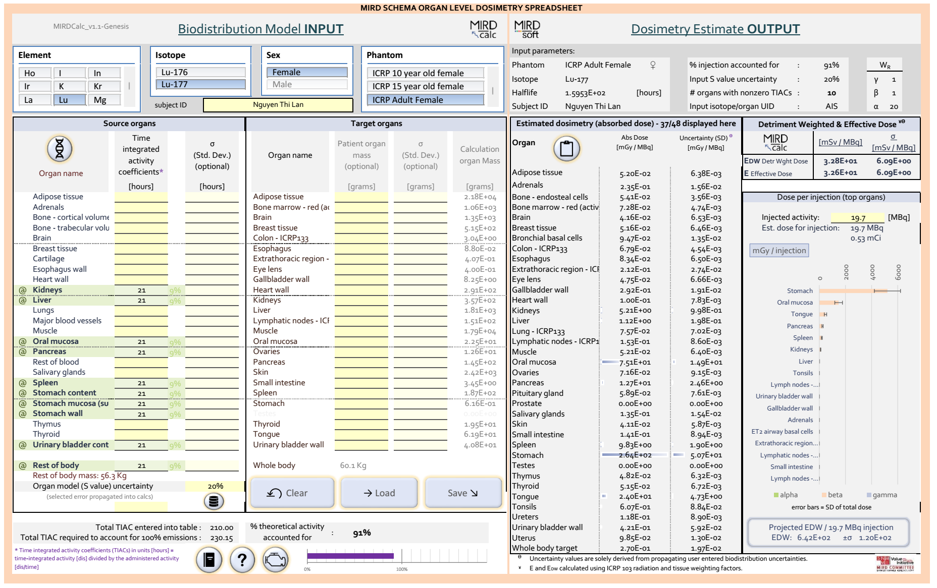  3a). Lu-177 | 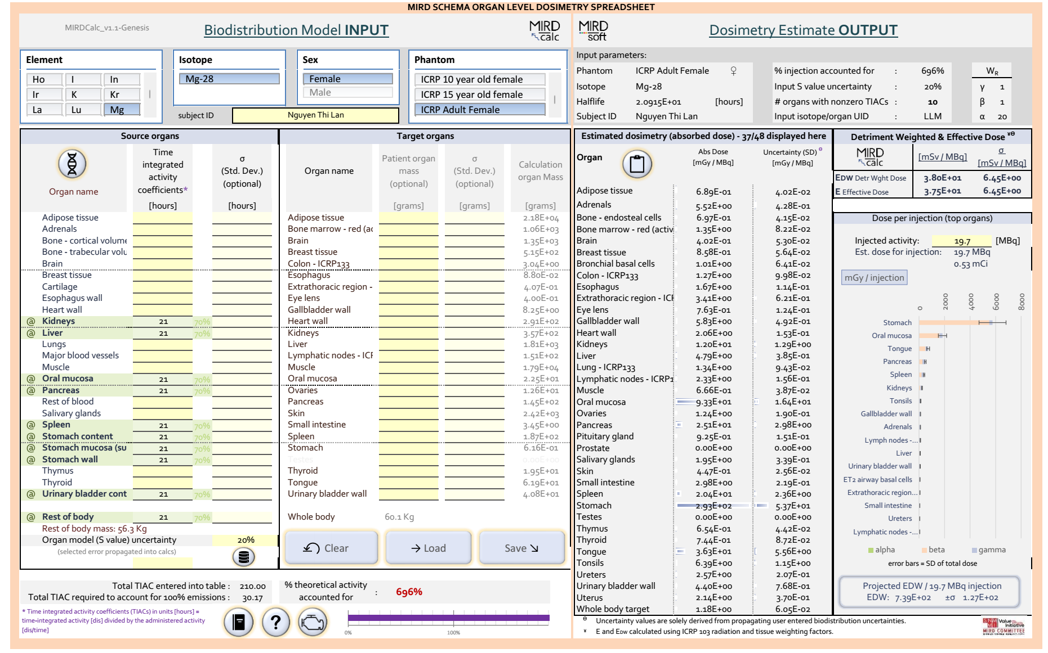  3b). Mg-28
Table 3 (continue)
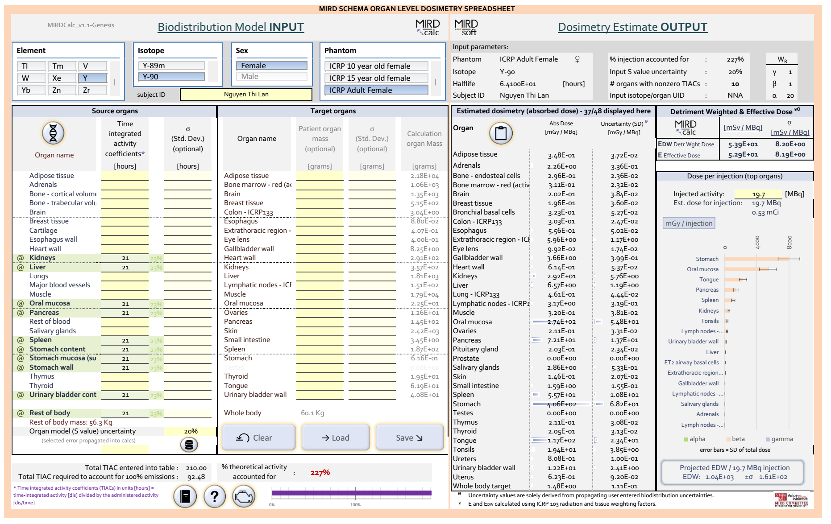  3c). Y-90 | 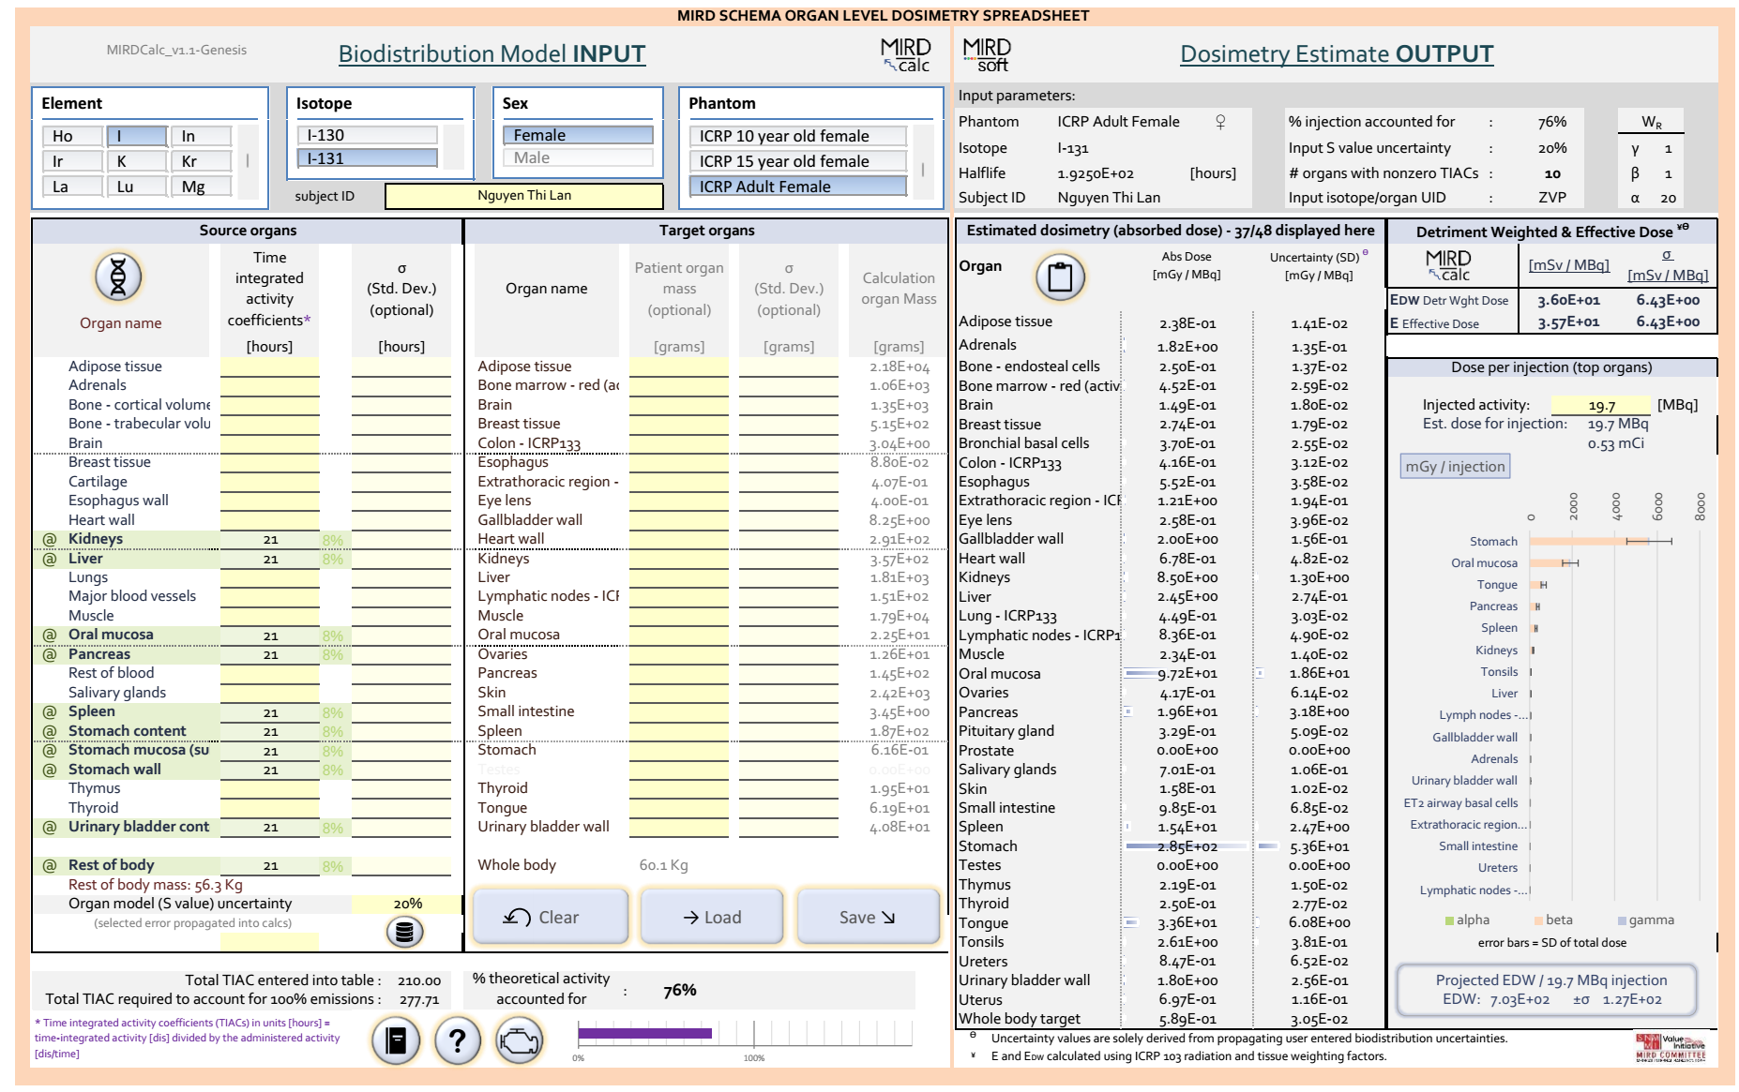  3d). I-131

Table 5. Pathways of administering 19.7 MBq of Mg-28 into the body with a retention time of one half-life (21 hours).
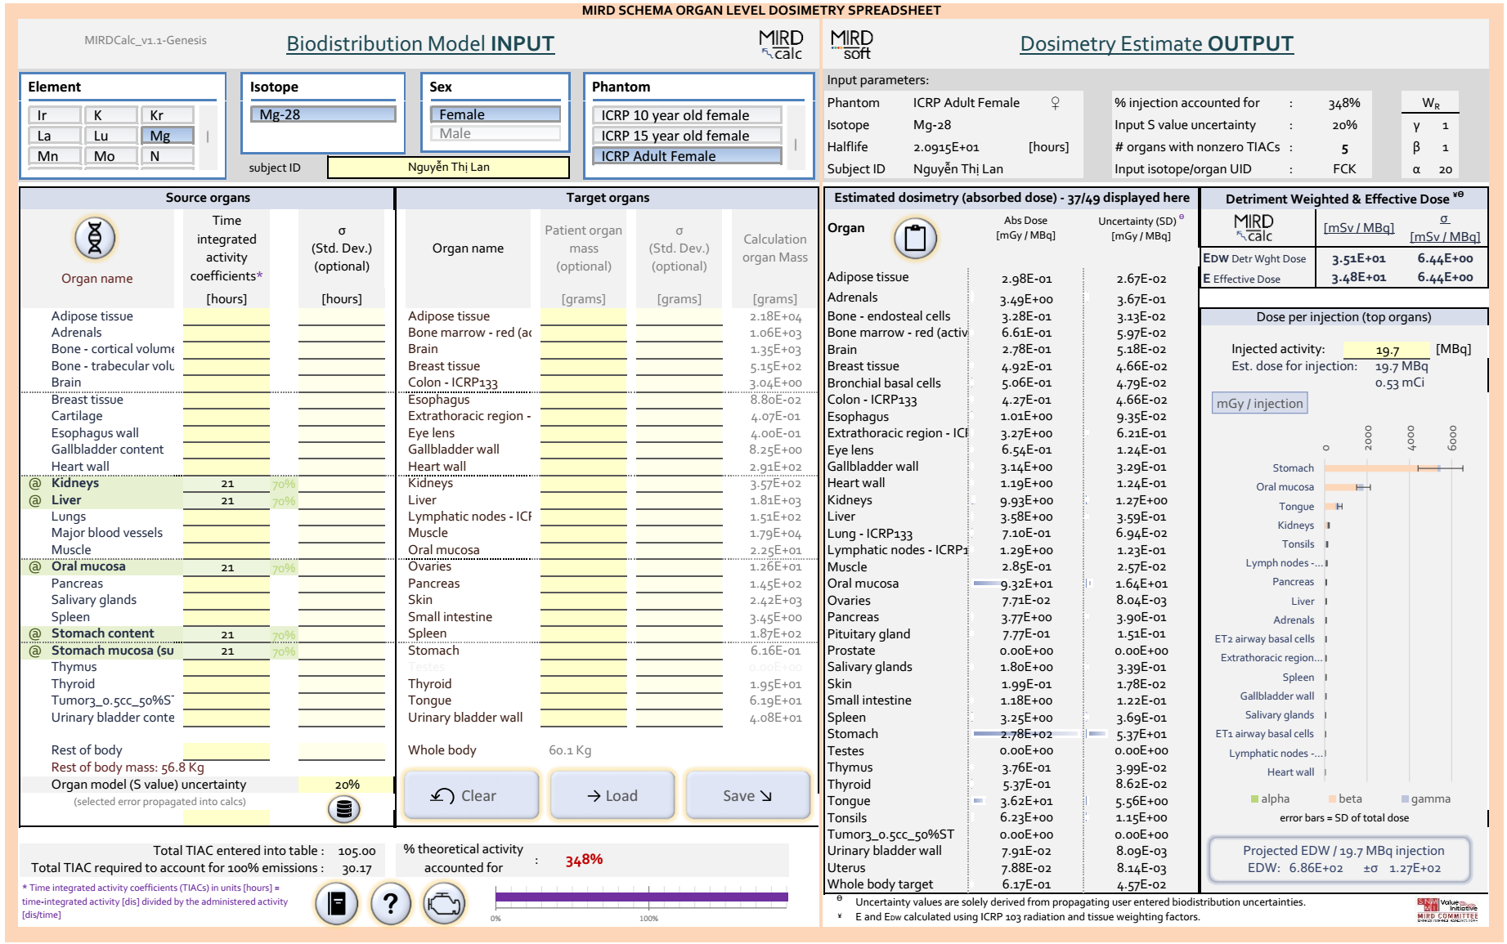  5a). Administering Mg-28 via the gastrointestinal route | 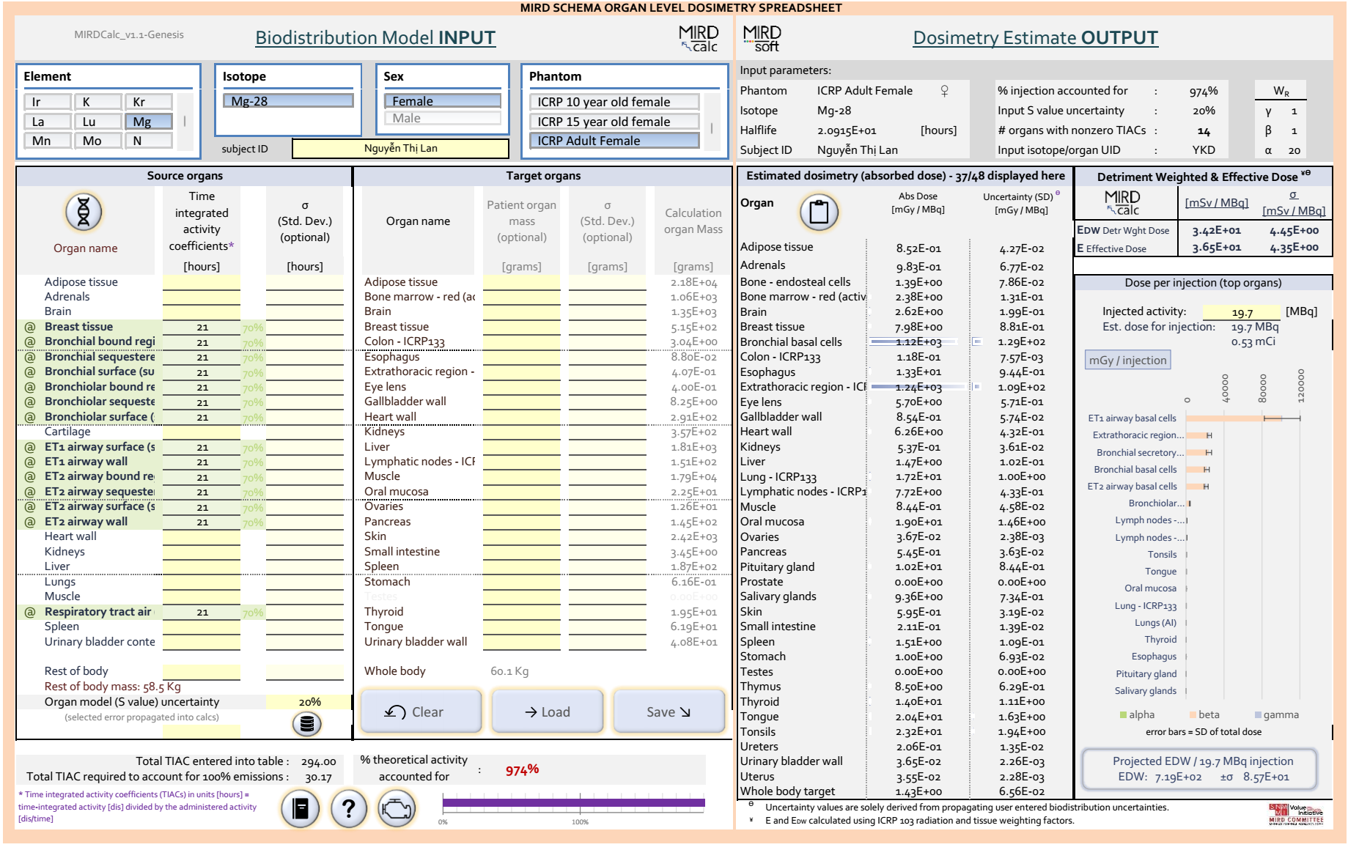  5b). Administering Mg-28 via inhalation
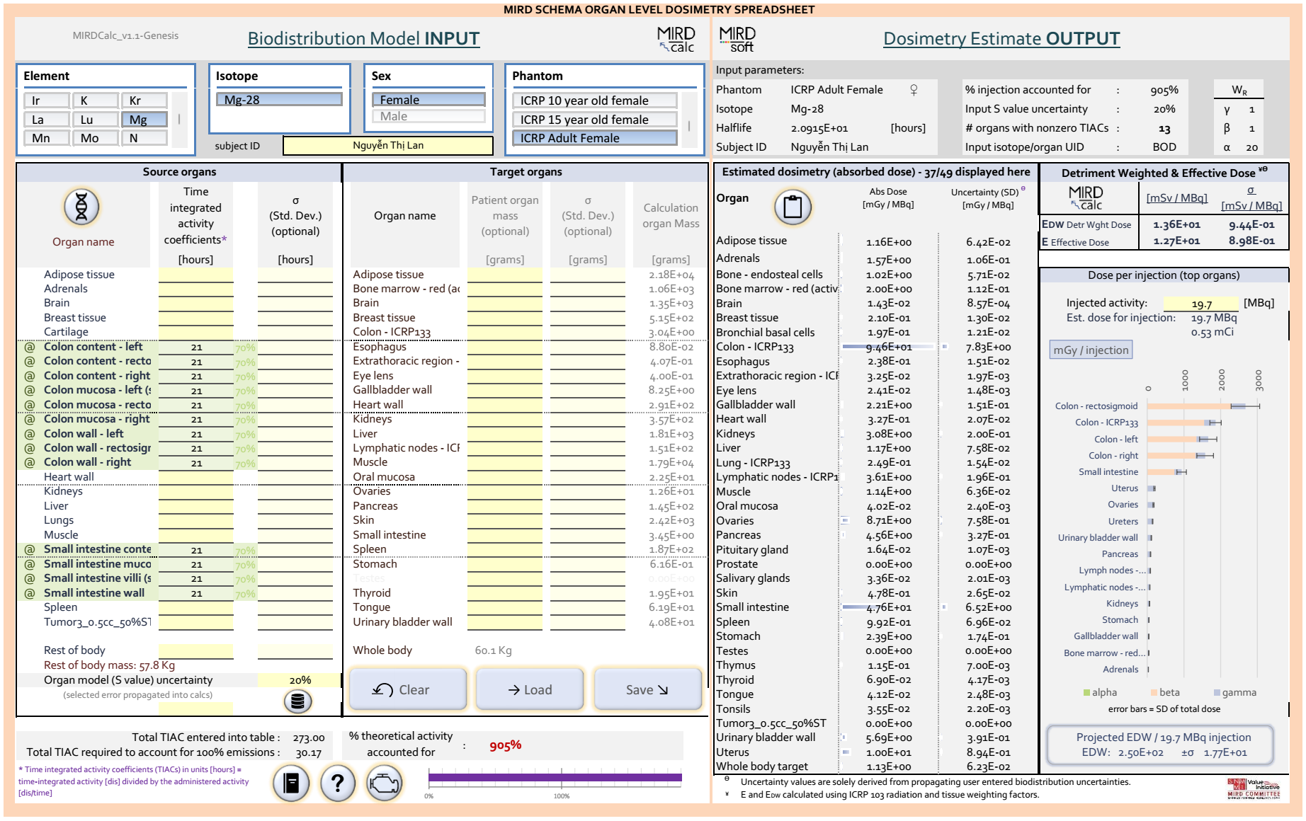  5c). Administering Mg-28 via the samll intestine route | 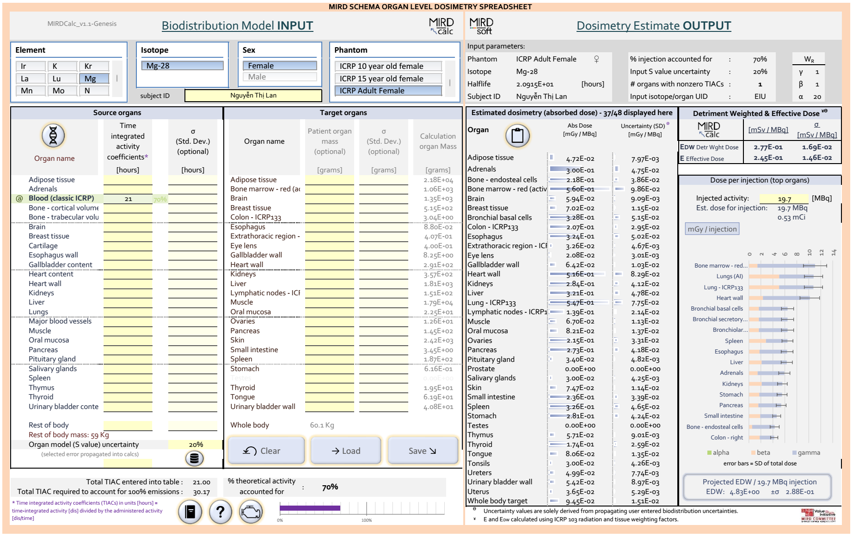  5d). Administering Mg-28 via intravenous injection
Table 6. Absorbed dose of Mg-28 via intravenous injection in different tissues and U masses after 21 hours.
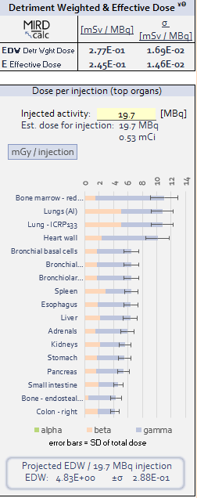 | 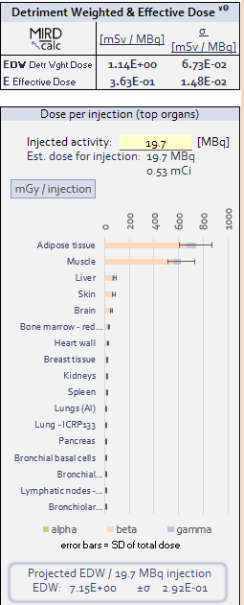
6a) Absorbed dose of Mg-28 in the circulatory system: 3.76 E+1 (mGy/MBq) | 6b) Absorbed dose in adipose tissue: 3.76 E+1 (mGy/MBq), in muscle tissue: 3.16 E+1 (mGy/MBq)
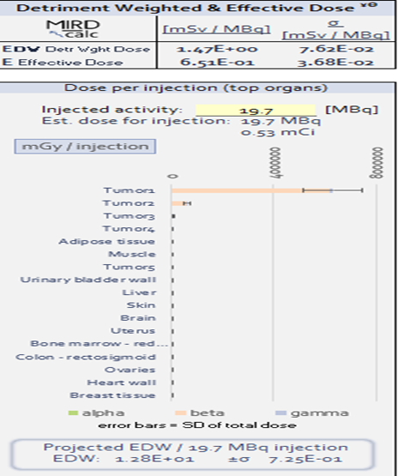 | 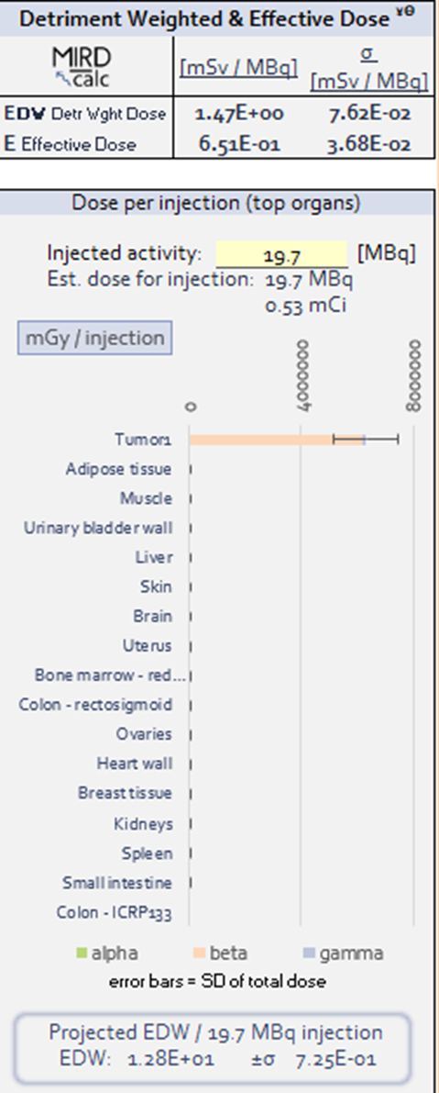
6c) Absorbed dose in different tumor masses after 21 hours: T1: 3.21 E+5 (mGy/MBq), T2: 3.2 E+4 (mGy/MBq), T3: 3.02E+3 (mGy/MBq), T4: 3.18E+2 (mGy/MBq), T5: 5.34 (mGy/MBq) | 6d) Absorbed dose of Mg-28 in tumor T1 after 21 hours: 3.21 E+05 (mGy/MBq)
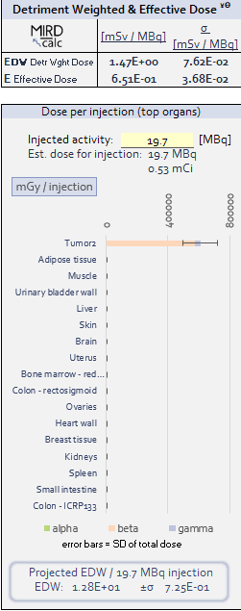 | 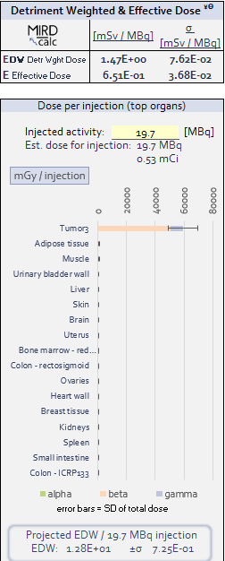
6e) Absorbed dose of Mg-28 in tumor T2: 3.1 E+04 (mGy/MBq) | 6f) Absorbed dose of Mg-28 in tumor T3: 3.02 E+03 (mGy/MBq)
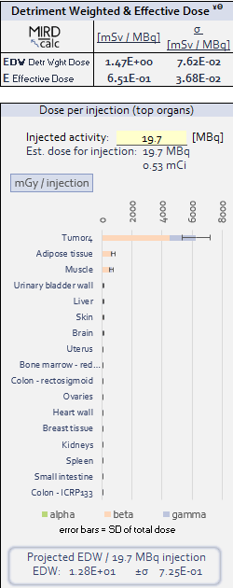 | 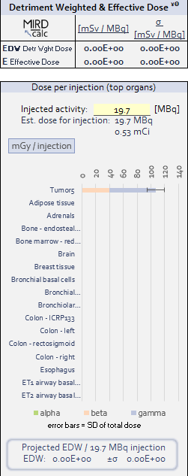
6g). Absorbed dose of Mg-28 in tumor T4: 3,18 E+02 (mGy/MBq) | 6h) Absorbed dose in tumor T5 when directly administering Mg-28 into the tumor: 5.34 (mGy/MBq)
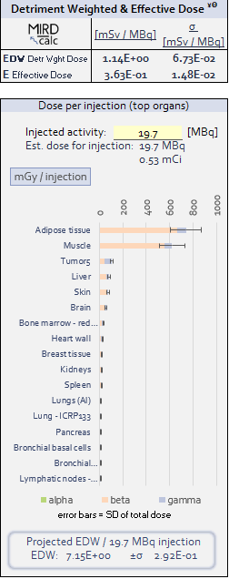 | 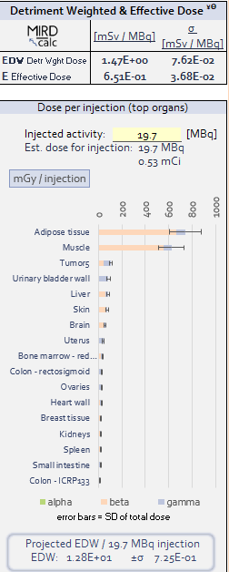
6i) Absorbed dose in tumor T5 when intravenously injecting Mg-28: 5.34 (mGy/MBq) | 6k) Absorbed dose in tumor T5 when intravenously injecting Mg-28 with additional bladder dose: 5.34 (mGy/MBq)

