Table:- 3.1 Truth table of 4221 RPU
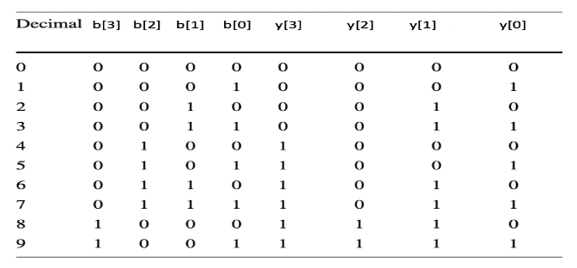

Table:-4.1 Quantum parameters of the HS-RBCDM Block
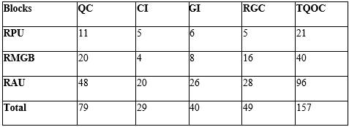
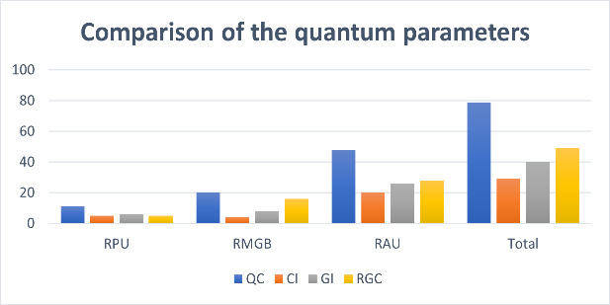
Table:- 4.2 Quantum parameters of HS- RBCDM_{(PE)} block
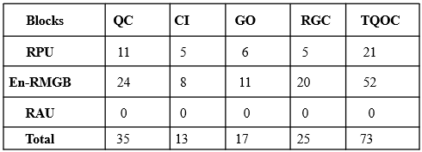
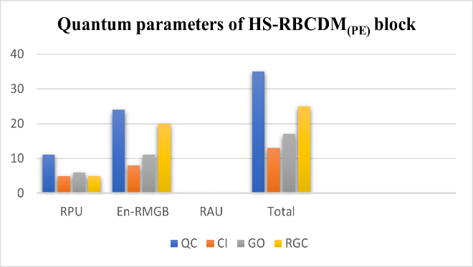
Table:-4.3 Comparison of the quantum parameters
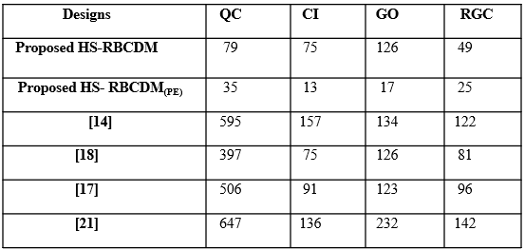
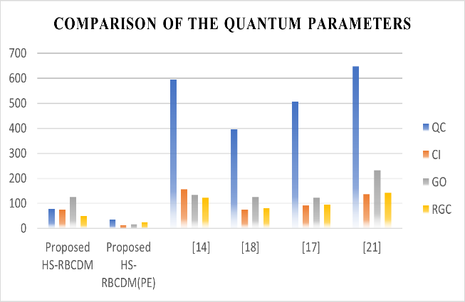

Table:-4.4 Power, area, and delay comparison of the proposed in 90-nm ASIC Technology
