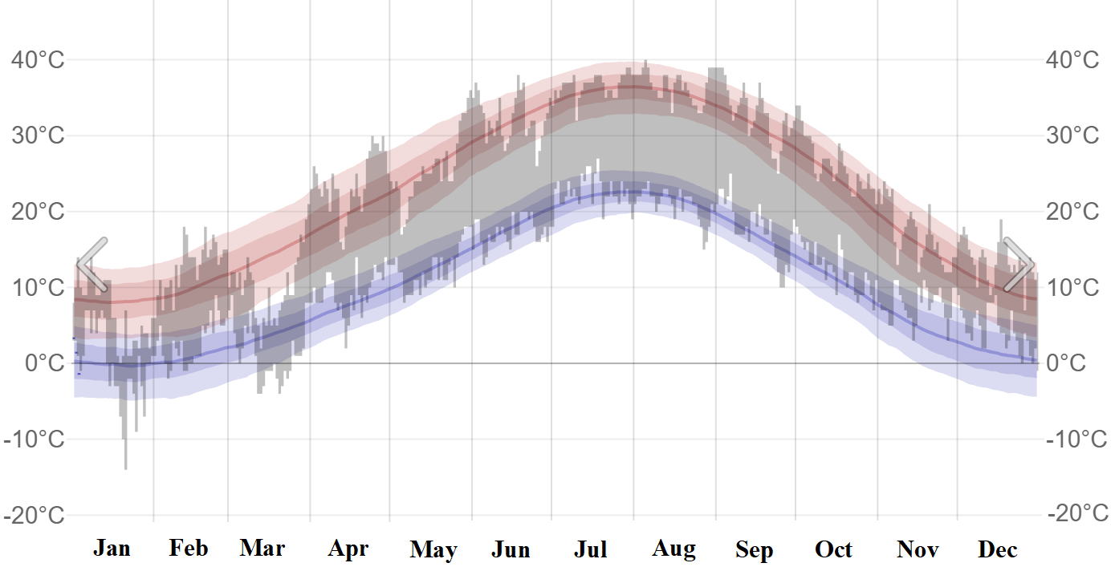
Figure S1 The weather data for the growing area of plant materials in 2022 (https://tr.weatherspark.com)
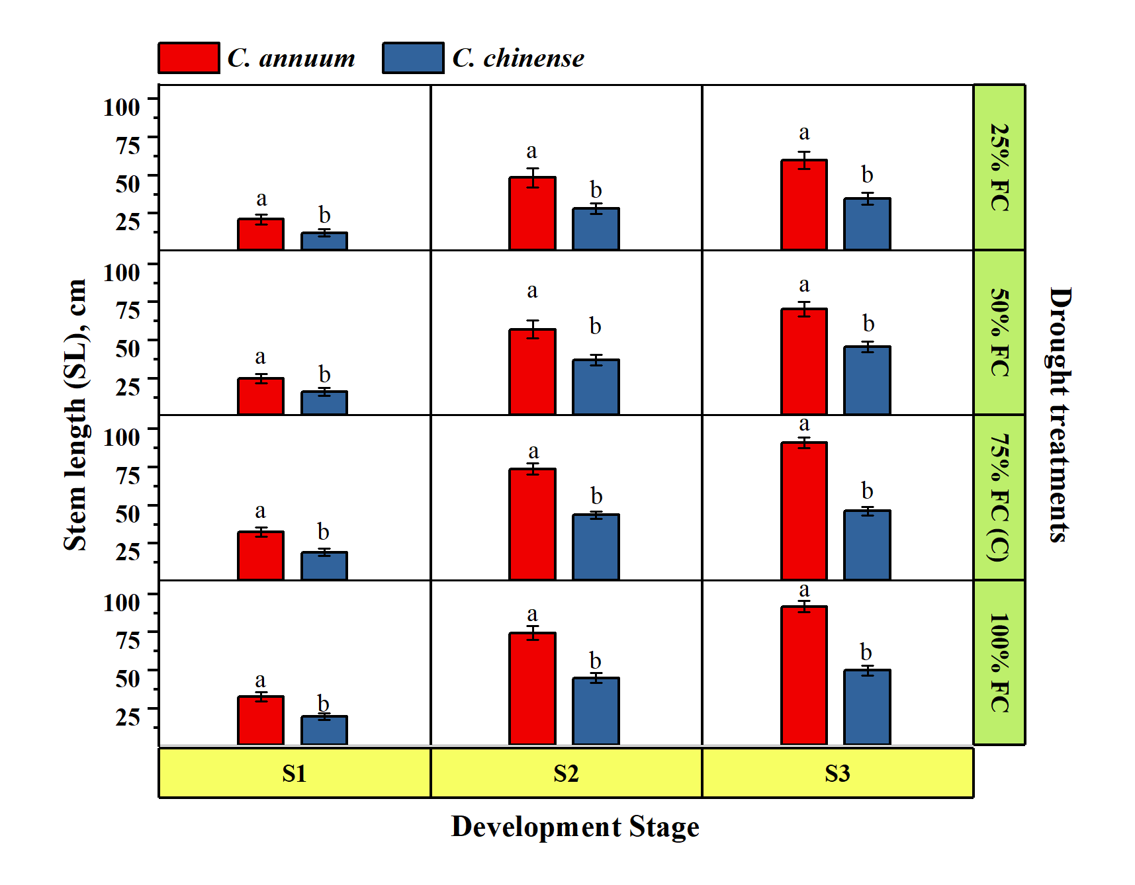
Figure S2 Effect of drought stress on stem length of Capsicum species (C. annuum and C. chinense). Different letters in drought treatments or development periods are different at least at the p < 0.05 level in Tukey’s multiple comparison test
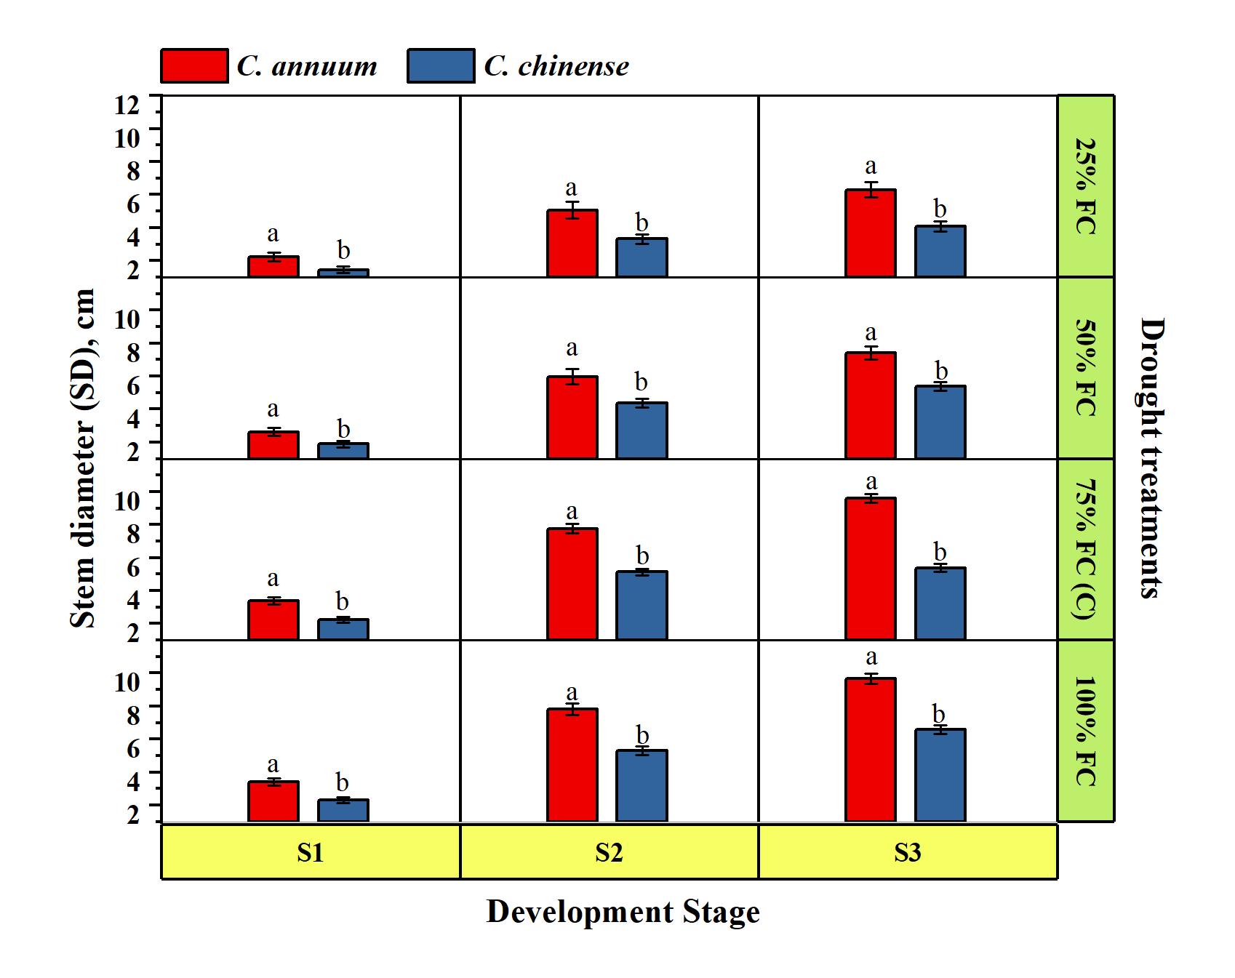
Figure S3 Effect of drought stress on stem diameter of Capsicum species (C. annuum and C. chinense). Different letters in drought treatments or development periods are different at least at the p < 0.05 level in Tukey’s multiple comparison test
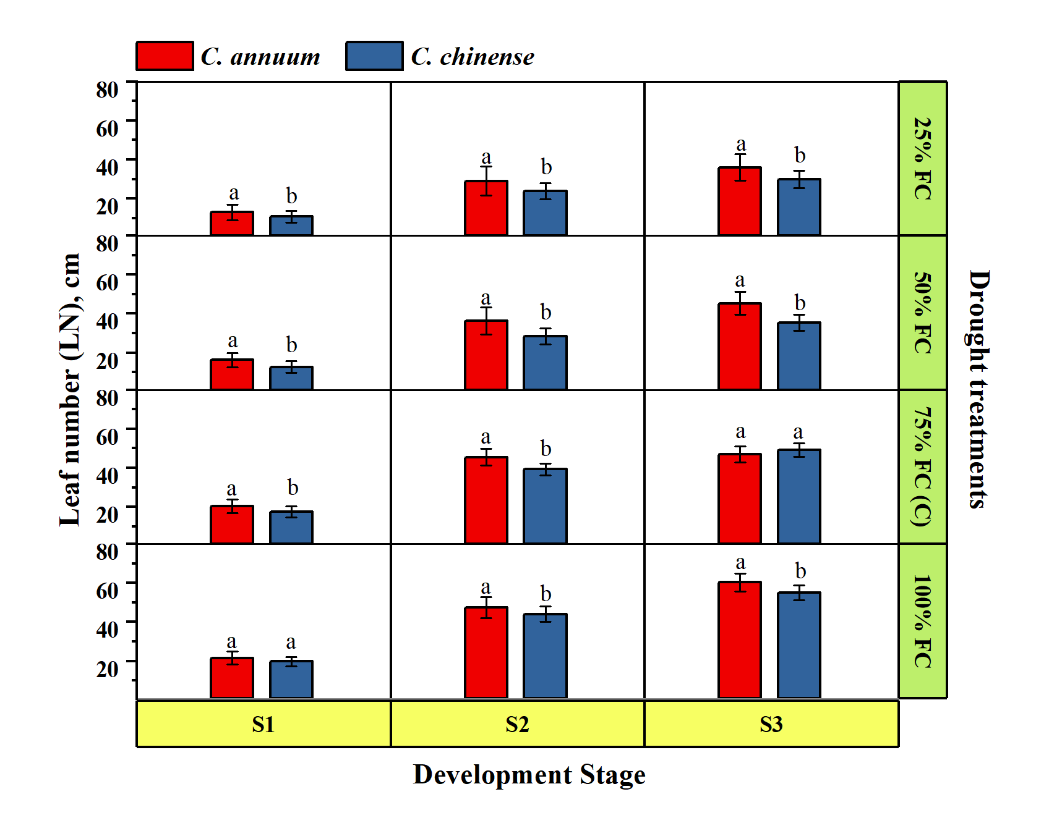
Figure S4 Effect of drought stress on leaf number of Capsicum species (C. annuum and C. chinense). Different letters in drought treatments or development periodss are different at least at the p < 0.05 level in Tukey’s multiple comparison test
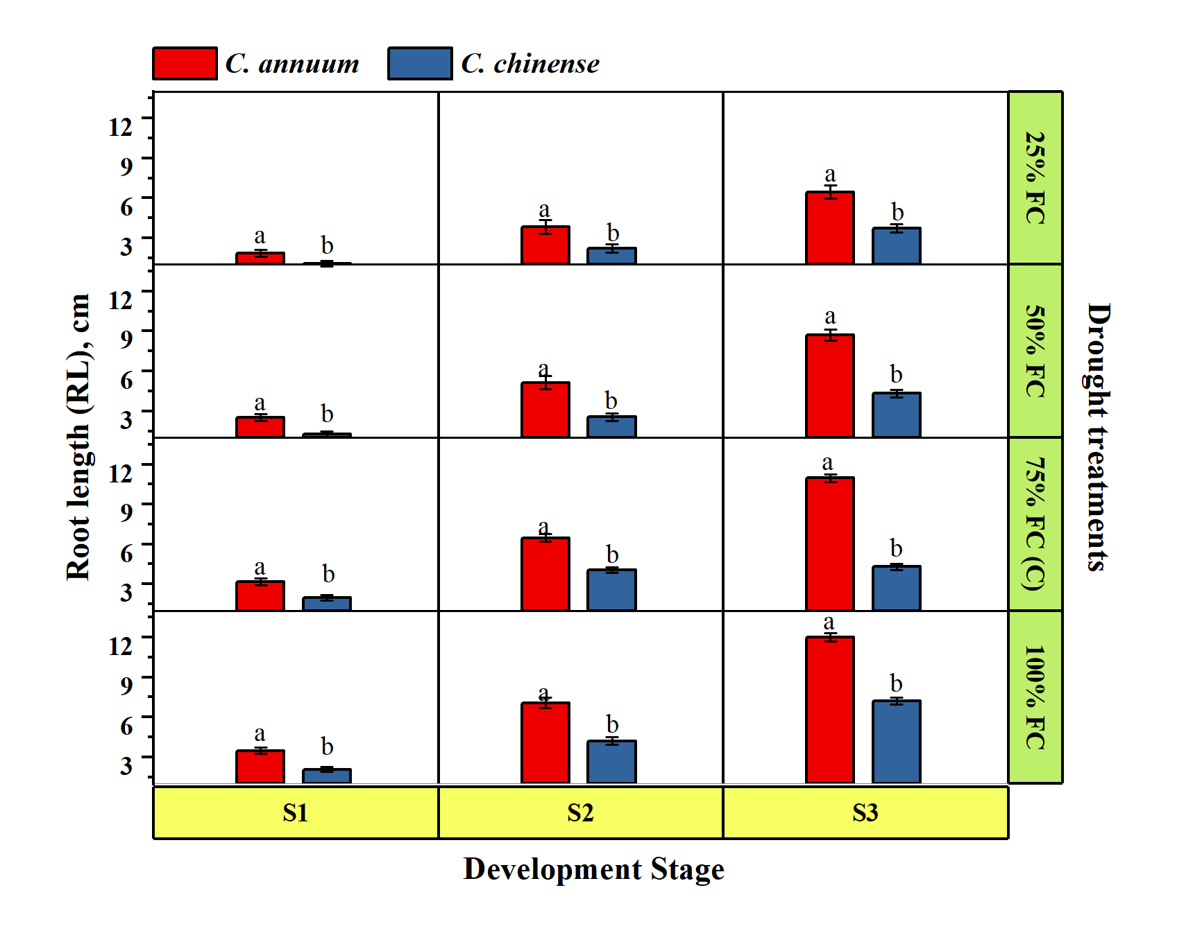
Figure S5 Effect of drought stress on root length of Capsicum species (C. annuum and C. chinense). Different letters in drought treatments or development periods are different at least at the p < 0.05 level in Tukey’s multiple comparison test
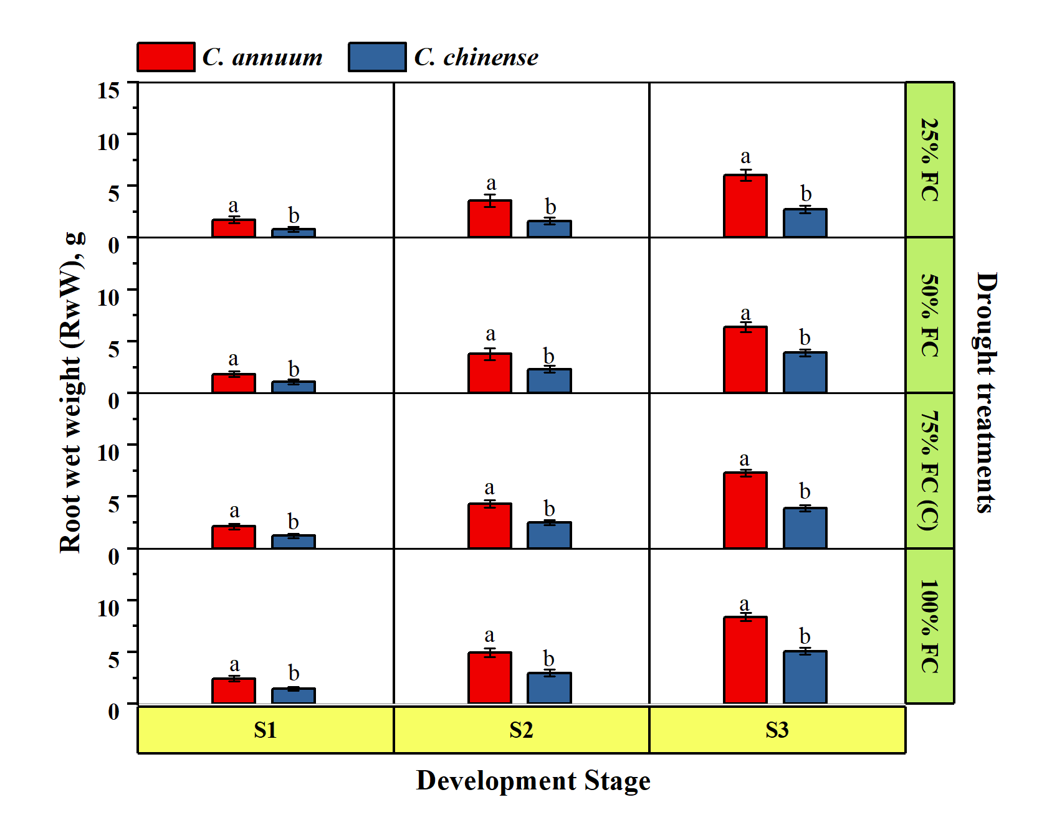
Figure S6 Effect of drought stress on root wet weight of Capsicum species (C. annuum and C. chinense). Different letters in drought treatments or development periods are different at least at the p < 0.05 level in Tukey’s multiple comparison test
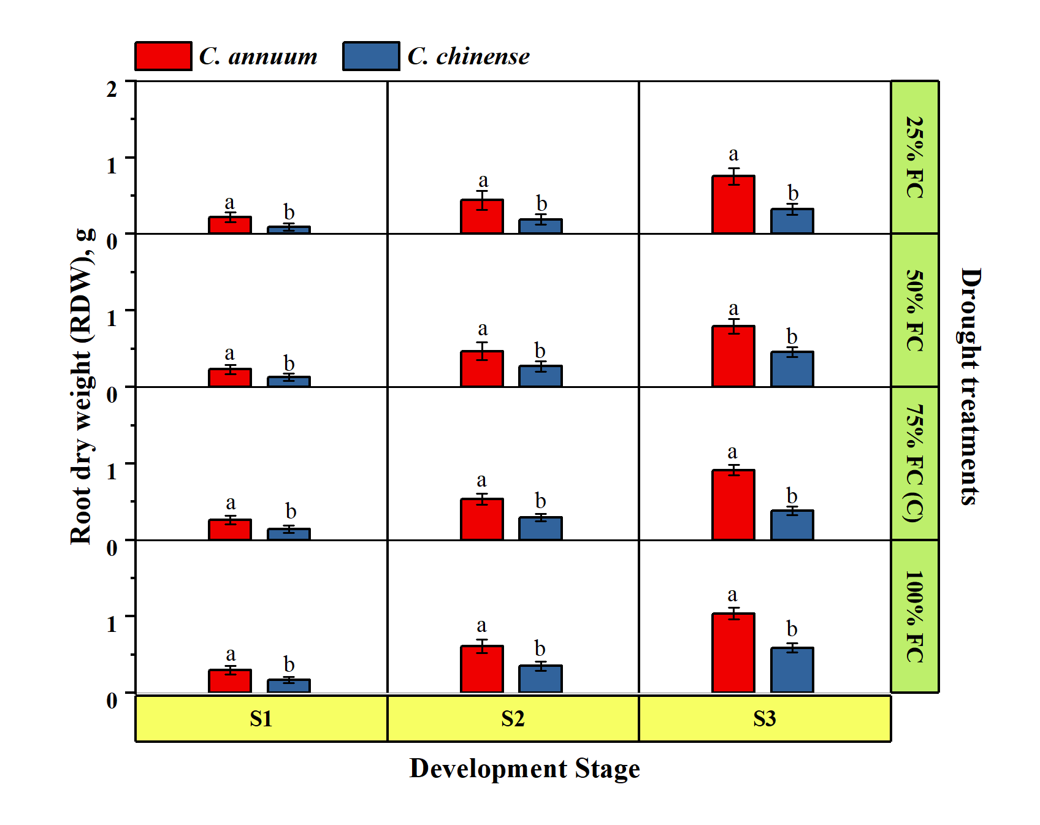
Figure S7 Effect of drought stress on root dry weight of Capsicum species (C. annuum and C. chinense). Different letters in drought treatments or development periods are different at least at the p < 0.05 level in Tukey’s multiple comparison test
Table S1 The interactive impacts of drought treatments (25% FC, 50% FC, 75% FC, and 100% FC) on the leaf photosynthetic pigment contents in C. annuum and C. chinense species during the post-flowering 20th, 40th, and 60th days (S1, S2, and S3 developmental stages)
Species | Development Stage | Drought Treatments | Chlorophyll a  (mg g⁻¹ FW) | Chlorophyll b  (mg g⁻¹ FW) | Total  Chlorophyll (mg g⁻¹ FW) | Total  Carotenoids  (mg g⁻¹ FW)
C.  annuum | S1 | 25% FC | 0.63 ^{d} | 0.32 ^{cdef} | 0.96 ^{cde} | 1.18 ^{f}
C.  annuum | S1 | 50% FC | 0.72 ^{c} | 0.36 ^{abc} | 1.08 ^{abc} | 1.34 ^{d}
C.  annuum | S1 | 75% FC (C) | 0.76 ^{b} | 0.38 ^{ab} | 1.14 ^{ab} | 1.71 ª
C.  annuum | S1 | 100% FC | 0.81 ª | 0.41 ª | 1.21 ª | 1.50 ^{b}
C  chinense | S1 | 25% FC | 0.57 ^{e} | 0.29 ^{efg} | 0.85 ^{ef} | 0.82 ^{l}
C  chinense | S1 | 50% FC | 0.64 ^{d} | 0.32 ^{cde} | 0.96 ^{cde} | 0.93 ^{j}
C  chinense | S1 | 75% FC (C) | 0.65 ^{d} | 0.37 ^{ab} | 1.10 ^{ab} | 1.01 ^{hi}
C  chinense | S1 | 100% FC | 0.71 ^{c} | 0.36 ^{abc} | 1.08 ^{abc} | 1.04 ^{h}
C.  annuum | S2 | 25% FC | 0.54 ^{e} | 0.28 ^{efg} | 0.82 ^{ef} | 0.99 ^{i}
C.  annuum | S2 | 50% FC | 0.62 ^{d} | 0.31 ^{def} | 0.92 ^{de} | 1.11 ^{g}
C.  annuum | S2 | 75% FC (C) | 0.64 ^{d} | 0.32 ^{cdef} | 0.96 ^{cde} | 1.44 ^{c}
C.  annuum | S2 | 100% FC | 0.69 ^{c} | 0.35 ^{bcd} | 1.04 ^{bcd} | 1.25 e
C  chinense | S2 | 25% FC | 0.48 ^{f} | 0.24 ^{g} | 0.72 ^{f} | 0.68 ^{no}
C  chinense | S2 | 50% FC | 0.55 ^{e} | 0.27 ^{fg} | 0.82 ^{ef} | 0.78 ^{m}
C  chinense | S2 | 75% FC (C) | 0.57 e | 0.29 ^{efg} | 0.85 ^{ef} | 1.00 ^{hi}
C  chinense | S2 | 100% FC | 0.62 ^{d} | 0.31 ^{def} | 0.92 ^{de} | 0.87 ^{k}
C.  annuum | S3 | 25% FC | 0.17 ^{hi} | 0.09 ^{h} | 0.26 ^{g} | 0.61 ^{p}
C.  annuum | S3 | 50% FC | 0.20 ^{gh} | 0.10 ^{h} | 0.29 ^{g} | 0.70 ^{n}
C.  annuum | S3 | 75% FC (C) | 0.21 ^{g} | 0.11 ^{h} | 0.31 ^{g} | 0.91 ^{jk}
C.  annuum | S3 | 100% FC | 0.22 ^{g} | 0.11 ^{h} | 0.33 ^{g} | 0.78 ^{lm}
C  chinense | S3 | 25% FC | 0.16 ^{i} | 0.08 ^{h} | 0.23 ^{g} | 0.43 ^{s}
C  chinense | S3 | 50% FC | 0.17 ^{hi} | 0.09 ^{h} | 0.26 ^{g} | 0.49 ^{r}
C  chinense | S3 | 75% FC (C) | 0.20 ^{gh} | 0.09 ^{h} | 0.30 ^{g} | 0.65 ^{op}
C  chinense | S3 | 100% FC | 0.21 ^{gh} | 0.10 ^{h} | 0.29 ^{g} | 0.55 ^{q}
Significance
Species (S) |  |  | *** | *** | *** | ***
Development Stage (DS) |  |  | *** | *** | *** | ***
Drought Treatments (DT) |  |  | *** | *** | *** | ***
S x DS |  |  | * | ** | ** | ***
S x DT |  |  | ns | ns | ns | ***
DS x DT |  |  | *** | *** | *** | **
S x DS x DT |  |  | ns | ns | ns | **
Values for each parameter indicate the results of Tukey’s HSD test between species and drought stress for each development stage (S1, S2, and S3); ^{ns} non-significant. * p ≤ 0.05** p ≤ 0.01. ***p ≤ 0.001.

Table S2 The interactive impacts of drought treatments (25% FC, 50% FC, 75% FC, and 100% FC) on the leaf phytochemical contents in C. annuum and C. chinense species during the post-flowering 20th, 40th, and 60th days (S1, S2, and S3 developmental stages)
Species | Development Stage | Drought Treatments | Total phenolics  (mg GAE g⁻¹ FW) | Total flavonoids  (mg QE g⁻¹ FW) | Total antioxidants  (μmol TEAC g⁻¹ FW)
C.  annuum | S1 | 25% FC | 6.02 ª | 8.27 ª | 9.33 ^{i}
C.  annuum | S1 | 50% FC | 5.33 ^{b} | 7.18 ^{c} | 6.32 ^{n}
C.  annuum | S1 | 75% FC (C) | 4.44 e | 4.2 ^{m} | 5.76 º
C.  annuum | S1 | 100% FC | 4.24 ^{g} | 3.96 º | 5.73 º
C  chinense | S1 | 25% FC | 3.62 ^{j} | 8.22 ^{b} | 8.19 ^{k}
C  chinense | S1 | 50% FC | 3.16 ^{m} | 7.14 ^{d} | 5.63 º
C  chinense | S1 | 75% FC (C) | 2.67 ^{p} | 4.17 ^{n} | 5.06 ^{p}
C  chinense | S1 | 100% FC | 2.51 ^{r} | 3.94 ^{p} | 5.04 ^{p}
C.  annuum | S2 | 25% FC | 3.79 ^{i} | 6.17 ^{e} | 26.86 ª
C.  annuum | S2 | 50% FC | 3.36 ^{l} | 5.36 ^{g} | 8.57 ^{jk}
C.  annuum | S2 | 75% FC (C) | 3.61 ^{j} | 3.13 ^{q} | 16.60 ^{c}
C.  annuum | S2 | 100% FC | 3.44 ^{k} | 2.96 ^{u} | 7.76 ^{l}
C  chinense | S2 | 25% FC | 2.28 ^{t} | 6.13 ^{f} | 23.59 ^{b}
C  chinense | S2 | 50% FC | 1.99 ^{w} | 5.33 ^{h} | 7.63 ^{l}
C  chinense | S2 | 75% FC (C) | 2.17 ^{u} | 3.11 ^{r} | 14.58 ^{d}
C  chinense | S2 | 100% FC | 2.04 ^{v} | 2.94 ^{v} | 6.82 ^{m}
C.  annuum | S3 | 25% FC | 4.74 ^{c} | 4.79 ^{I} | 12.86 ^{e}
C.  annuum | S3 | 50% FC | 4.20 ^{h} | 4.26 ^{k} | 12.2 ^{f}
C.  annuum | S3 | 75% FC (C) | 4.51 ^{d} | 3.09 ^{s} | 8.89 ^{j}
C.  annuum | S3 | 100% FC | 4.30 ^{f} | 2.90 ^{w} | 10.95 ^{gh}
C  chinense | S3 | 25% FC | 2.85 ^{n} | 4.76 ^{j} | 11.29 ^{g}
C  chinense | S3 | 50% FC | 2.49 ^{s} | 4.23 ^{l} | 10.72 ^{h}
C  chinense | S3 | 75% FC (C) | 2.71 º | 3.07 ^{t} | 7.55 ^{l}
C  chinense | S3 | 100% FC | 2.55 ^{q} | 2.88 ^{x} | 9.62 ^{i}
Significance
Species (S) |  |  | *** | *** | ***
Development Stage (DS) |  |  | *** | *** | ***
Drought Treatments (DT) |  |  | *** | *** | ***
S x DS |  |  | *** | *** | ***
S x DT |  |  | *** | *** | ***
DS x DT |  |  | *** | *** | ***
S x DS x DT |  |  | ** | ** | **
Values for each parameter indicate the results of Tukey’s HSD test between species and drought stress for each development stage (S1, S2, and S3); ** p ≤ 0.01. ***p ≤ 0.001.

Table S3 The interactive impacts of drought treatments (25% FC, 50% FC, 75% FC, and 100% FC) on the leaf biochemical contents in C. annuum and C. chinense species during the post-flowering 20th, 40th, and 60th days (S1, S2, and S3 developmental stages)
Species | Development Stage | Drought Treatments | Prolin  (μg g⁻¹ FW) | MDA  (μg g⁻¹ FW) | Protein  (mg g⁻¹ FW)
C.  annuum | S1 | 25% FC | 35.78 ^{f} | 1.48 ^{h} | 21.38 ^{d}
C.  annuum | S1 | 50% FC | 28.25 ^{i} | 1.40 ^{k} | 18.82 ^{f}
C.  annuum | S1 | 75% FC (C) | 19.97 ^{p} | 1.31 ^{m} | 14.38 ^{ij}
C.  annuum | S1 | 100% FC | 17.65 ^{q} | 1.31 ^{n} | 13.74 ^{jk}
C  chinense | S1 | 25% FC | 23.64 ^{k} | 0.98 ^{s} | 12.82 ^{kl}
C  chinense | S1 | 50% FC | 19.65 º | 0.97 ^{u} | 11.28 ^{mn}
C  chinense | S1 | 75% FC (C) | 14.14 ^{u} | 0.93 ^{w} | 9.47 ^{op}
C  chinense | S1 | 100% FC | 12.64 ^{v} | 0.94 ^{v} | 8.23 ^{p}
C.  annuum | S2 | 25% FC | 58.19 ª | 2.41 ª | 27.01 ^{b}
C.  annuum | S2 | 50% FC | 45.94 ^{c} | 2.27 ^{b} | 20.27 ^{de}
C.  annuum | S2 | 75% FC (C) | 20.99 ^{op} | 1.38 ^{l} | 16.97 ^{g}
C.  annuum | S2 | 100% FC | 23.45 ^{l} | 1.74 ^{e} | 15.32 ^{hi}
C  chinense | S2 | 25% FC | 38.45 ^{d} | 1.59 ^{i} | 16.19 ^{gh}
C  chinense | S2 | 50% FC | 31.96 ^{h} | 1.58 ^{j} | 12.15 ^{lm}
C  chinense | S2 | 75% FC (C) | 14.86 ^{t} | 0.98 ^{t} | 10.16 ^{no}
C  chinense | S2 | 100% FC | 16.8 ^{s} | 1.25 ^{p} | 9.17 ^{op}
C.  annuum | S3 | 25% FC | 53.21 ^{b} | 2.21 ^{c} | 32.68 ª
C.  annuum | S3 | 50% FC | 38.14 ^{e} | 1.89 ^{d} | 24.53 ^{c}
C.  annuum | S3 | 75% FC (C) | 24.04 ^{n} | 1.58 ^{g} | 20.53 ^{de}
C.  annuum | S3 | 100% FC | 23.42 ^{lm} | 1.74 ^{f} | 18.54 ^{f}
C  chinense | S3 | 25% FC | 35.16 ^{g} | 1.46 ^{m} | 19.59 ^{ef}
C  chinense | S3 | 50% FC | 26.53 ^{j} | 1.31 º | 14.7 ^{ij}
C  chinense | S3 | 75% FC (C) | 17.03 ^{r} | 1.12 ^{r} | 12.29 ^{lm}
C  chinense | S3 | 100% FC | 16.77 ^{s} | 1.25 ^{q} | 11.09 ^{mn}
Significance
Species (S) |  |  | *** | *** | ***
Development Stage (DS) |  |  | *** | *** | ***
Drought Treatments (DT) |  |  | *** | *** | ***
S x DS |  |  | *** | *** | ***
S x DT |  |  | *** | *** | ***
DS x DT |  |  | ** | *** | ***
S x DS x DT |  |  | ** | ** | **
Values for each parameter indicate the results of Tukey’s HSD test between species and drought stress for each development stage (S1, S2, and S3); ** p ≤ 0.01. ***p ≤ 0.001.

Table S4 The interactive impacts of drought treatments (25% FC, 50% FC, 75% FC, and 100% FC) on the leaf antioxidative enzyme activities in C. annuum and C. chinense species during the post-flowering 20th, 40th, and 60th days (S1, S2, and S3 developmental stages)
Species | Development Stage | Drought Treatments | SOD  (U g⁻¹  Protein FW) | POD  (nmol min⁻¹ g⁻¹ Protein FW) | CAT  (nmol min⁻¹ g⁻¹ Protein FW)
C.  annuum | S1 | 25% FC | 687.47 ^{f} | 465.40 ^{f} | 59.21 ^{f}
C.  annuum | S1 | 50% FC | 541.74 ^{i} | 366.74 ^{h} | 45.14 ^{i}
C.  annuum | S1 | 75% FC (C) | 288.85 ^{p} | 293.32 ^{m} | 38.36 ^{m}
C.  annuum | S1 | 100% FC | 269.52 ^{r} | 243.28 ^{s} | 28.94 ^{q}
C  chinense | S1 | 25% FC | 548.38 ^{h} | 358.27 ^{j} | 45.70 ^{i}
C  chinense | S1 | 50% FC | 431.66 ^{l} | 282.02 º | 35.97 ^{no}
C  chinense | S1 | 75% FC (C) | 239.79 ^{v} | 228.87 ^{t} | 32.06 ^{r}
C  chinense | S1 | 100% FC | 216.92 ^{x} | 195.31 ^{v} | 24.10 ^{s}
C.  annuum | S2 | 25% FC | 893.72 ^{b} | 648.93 ^{b} | 81.25 ^{b}
C.  annuum | S2 | 50% FC | 545.83 ^{g} | 436.08 ^{f} | 54.58 ^{g}
C.  annuum | S2 | 75% FC (C) | 313.05 º | 353.20 ^{i} | 43.48 ^{j}
C.  annuum | S2 | 100% FC | 291.08 ^{q} | 305.51 ^{n} | 36.38 ^{n}
C  chinense | S2 | 25% FC | 712.89 ^{d} | 508.10 ^{e} | 23.79 ^{t}
C  chinense | S2 | 50% FC | 470.51 ^{k} | 335.35 ^{k} | 62.63 ^{d}
C  chinense | S2 | 75% FC (C) | 238.21 ^{u} | 266.33 ^{q} | 42.77 ^{k}
C  chinense | S2 | 100% FC | 234.27 ^{w} | 229.58 ^{u} | 35.15 º
C.  annuum | S3 | 25% FC | 1098.37 ª | 825.02 ª | 101.56 ª
C.  annuum | S3 | 50% FC | 702.69 ^{e} | 518.94 ^{d} | 60.12 ^{e}
C.  annuum | S3 | 75% FC (C) | 334.96 ^{m} | 346.00 ^{j} | 44.07 ^{ij}
C.  annuum | S3 | 100% FC | 336.97 ^{n} | 335.24 ^{l} | 40.57 ^{l}
C  chinense | S3 | 25% FC | 870.57 ^{c} | 620.48 ^{c} | 28.84 ^{qr}
C  chinense | S3 | 50% FC | 526.97 ^{j} | 375.59 ^{g} | 77.83 ^{c}
C  chinense | S3 | 75% FC (C) | 270.81 ^{s} | 279.37 ^{p} | 47.91 ^{h}
C  chinense | S3 | 100% FC | 262.38 ^{t} | 260.39 ^{r} | 35.63 ^{p}
Significance
Species (S) |  |  | *** | *** | ***
Development Stage (DS) |  |  | *** | *** | ***
Drought Treatments (DT) |  |  | *** | *** | ***
S x DS |  |  | *** | *** | ***
S x DT |  |  | *** | *** | ***
DS x DT |  |  | ** | *** | **
S x DS x DT |  |  | ** | ** | **
Values for each parameter indicate the results of Tukey’s HSD test between species and drought stress for each development stage (S1, S2, and S3); ** p ≤ 0.01. ***p ≤ 0.001.

