Table 3 Summary of the morphological differences between Sporendonema species.

Species | Microscopy | Spore/Hyphae shape
Sporendonema aurantiacum | Hyphae and asci can be seen on slides from MEA while slides from PDA shows chlamydospore-like structures on the hyphae. Ascospores orange-yellow, globose and smooth. |   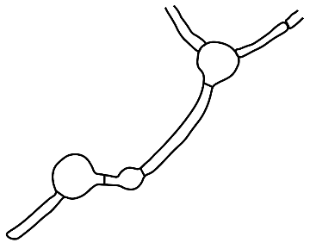  
S. casei | Slides from MEA shows the typical enteroarthric conidiogenesis while spherical orange spores and irregular hyphae can be seen only on the slides from PDA. | 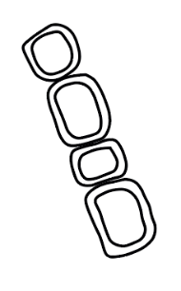  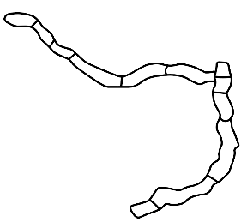
S. confluens | Ascospores are yellow but compared to S. ruber and S. aurantiacum they have lighter color. Ascospores have slightly thick walls. Racquet hyphae is common on slides from MEA. |   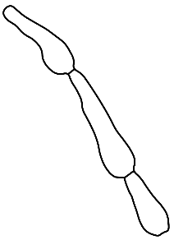
S. equinum | Holoblastic conidiogenesis with smooth and spherical conidia. Longer conidia chains compare to S. isthmoides. | 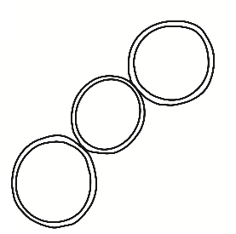
S. isthmoides | Thallic-enteroarthric conidiogenesis with mostly lemon-shaped and warted conidia. Reveals remnants of hyphae between the conidia. Hyphae with warts are also common. | 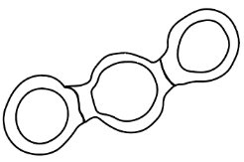  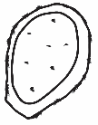
S. rubrum | Asci can be seen on slides from MEA while rocket hyphae is common slides from PDA. Ascospores are orange-yellow, oblate with two equatorial thickenings. | 