Supplementary Materials

200 years of taxonomic confusion: Sporendonema and allies

Hazal Kandemir^{1,2}, Cony Decock³, Margarita Hernández-Restrepo², Roman Labuda^{4,5},
Jos Houbraken², Macit Ilkit⁶, G. Sybren de Hoog^{1*}

¹ Center of Expertise in Mycology, Radboud University Medical Center/Canisius Wilhelmina Hospital, Nijmegen, The Netherlands.
² Westerdijk Fungal Biodiversity Institute, Utrecht, The Netherlands.
³ Mycothéque de l'Université Catholique de Louvain, Louvain-la-Neuve, Belgium.
⁴ Research Platform Bioactive Microbial Metabolites, Tulln/Donau, Austria.
⁵ Institute of Food Safety, Food Technology and Veterinary Public Health, University of Veterinary Medicine Vienna, Veterinaerplatz 1, 1210, Vienna, Austria.
⁶ Division of Medical Mycology, Faculty of Medicine, University of Çukurova, Adana, Turkey

*Author for correspondence:
G. Sybren de Hoog
Email: Sybren.deHoog@radboudumc.nl

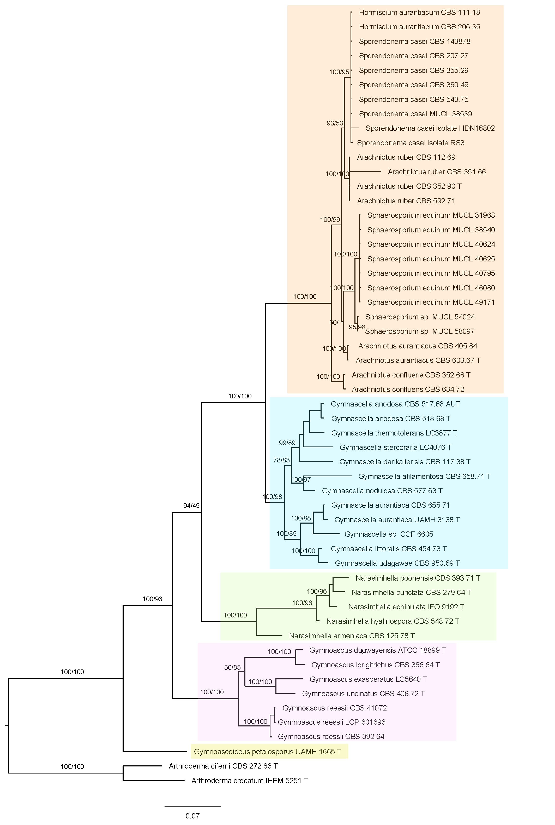
Fig. S1

Fig. S2
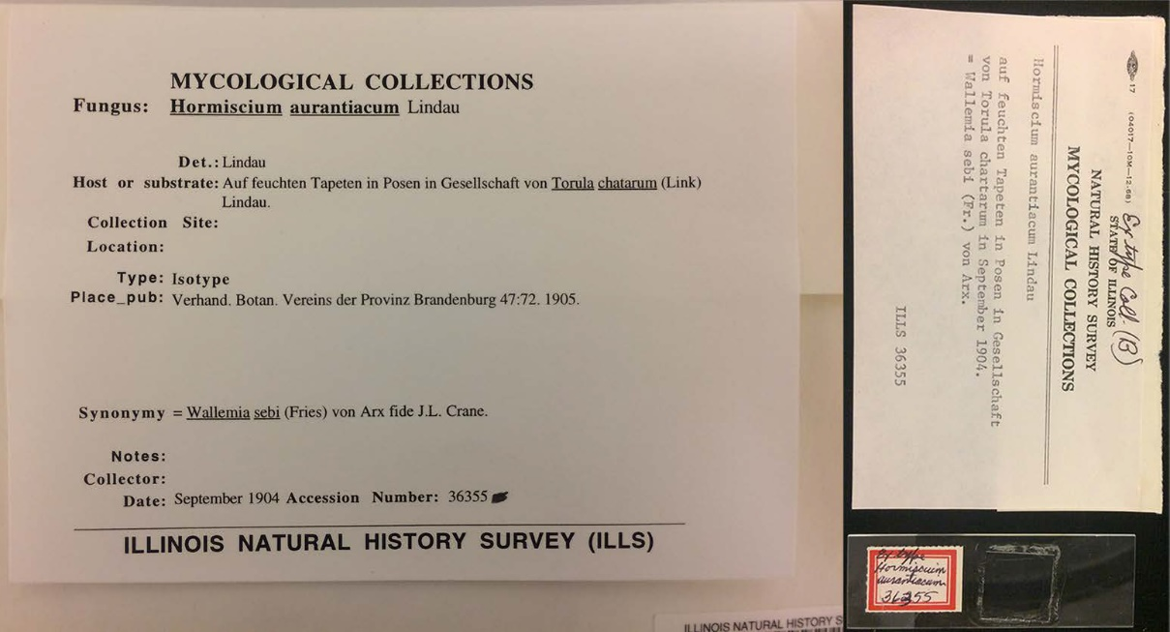

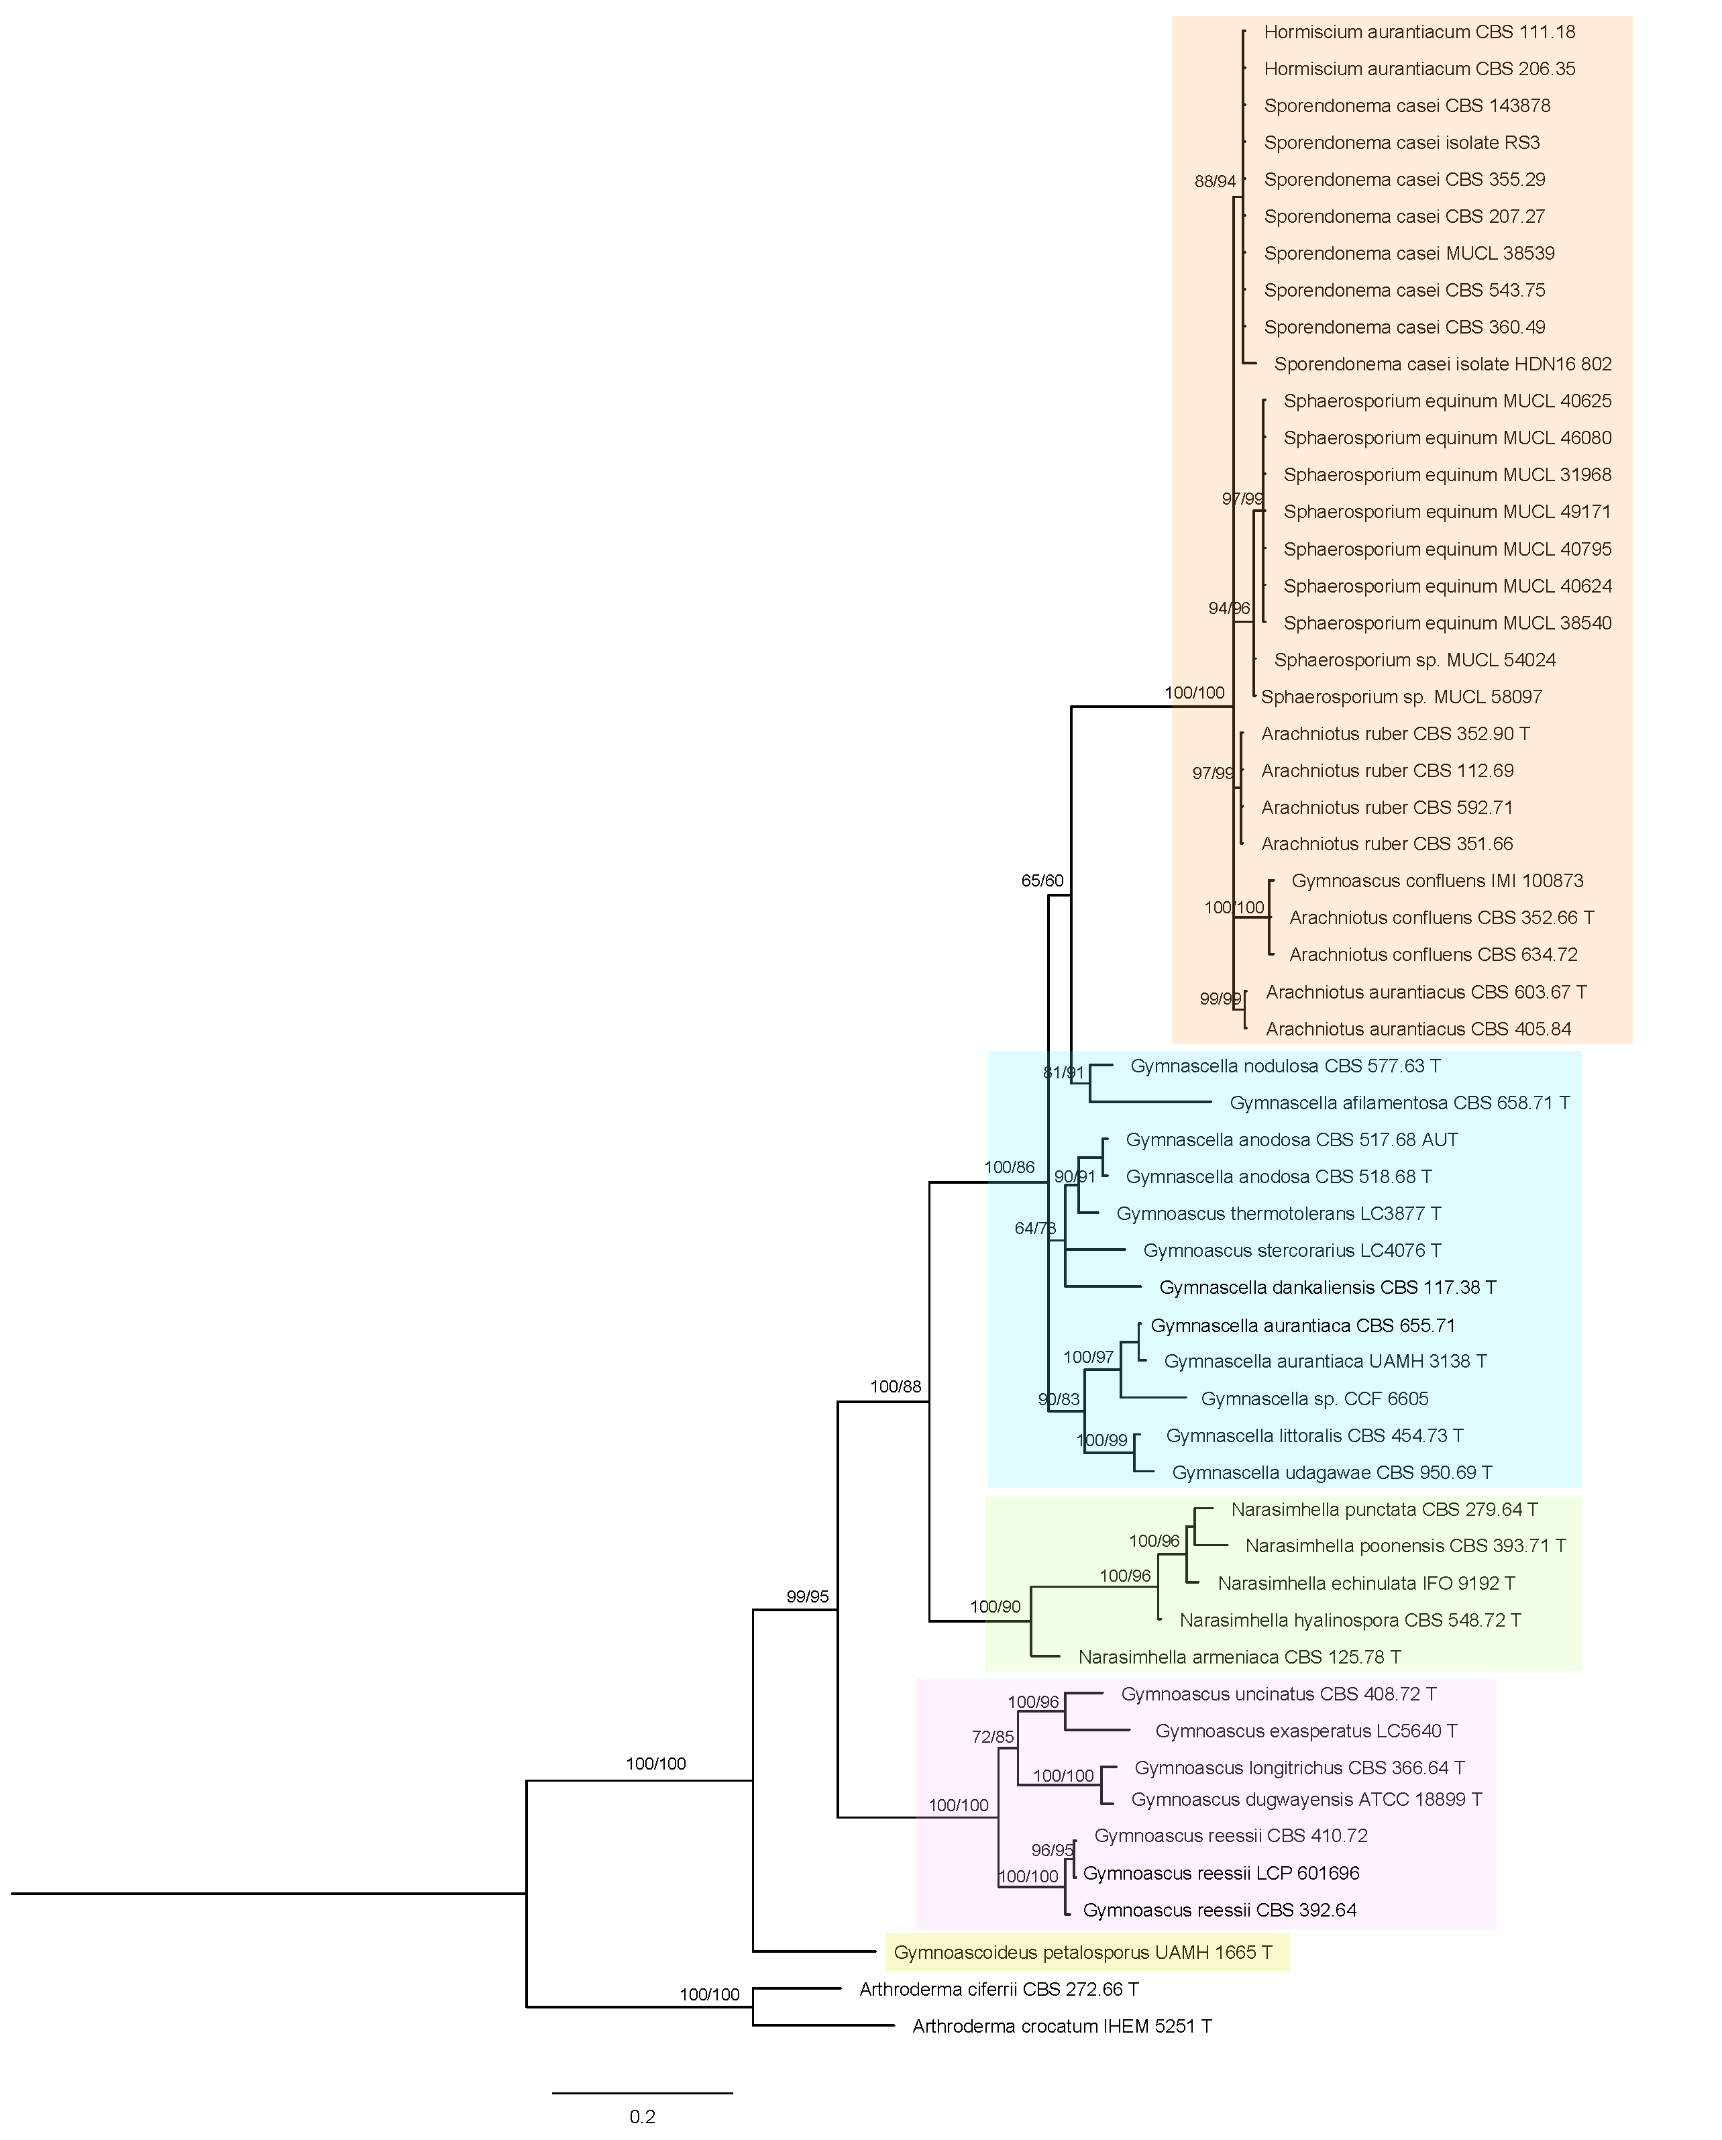
Fig. S3

Fig. S1 Multilocus (ITS, LSU and TUB) phylogeny of the species based on Bayesian and maximum likelihood analysis.
Fig. S2 Isotype of Hormiscium aurantiacum ILLS 36355
Fig. S3 ITS phylogeny of the species based on Bayesian and maximum likelihood analysis

