Supplementary figures
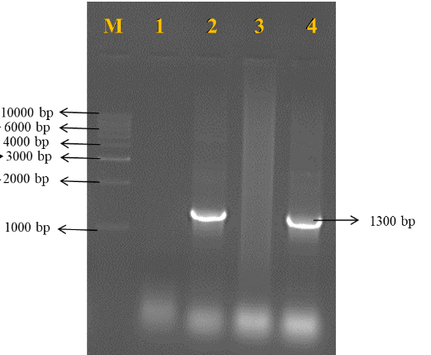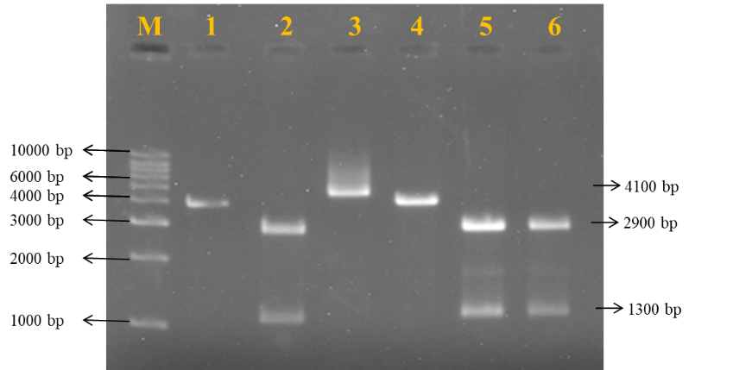
Supplementary Figure 1: Cloning of HC-Pro gene into pTZ57R/T. (A) Colony PCR of transformed colonies using gene-specific primers, Lane M: 1kb DNA ladder, Lane 1-4: Transformed colonies; (B) Restriction profile of recombinant pTZ57R/T:: HCPro plasmid, Lane M : 1 kb ladder, Lane 1: Undigested pTZ57R/T::HCPro plasmid, Lane 2, 5 and 6: Double digested recombinant pTZ57R/T vector, Lane 3-4: Single digested recombinant pTZ57R/T vector

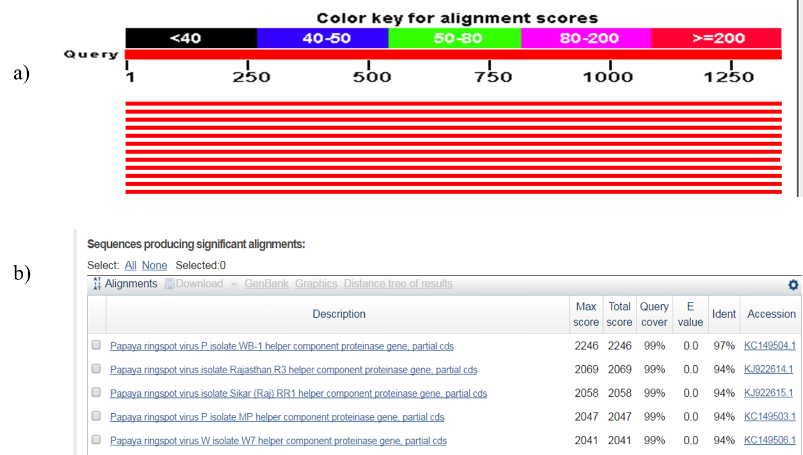
(A)
(B)
Supplementary Figure 2: BLAST homology search based on HC-Pro gene sequences of PRSV strain utilizing NCBI database.
A) Graphical summary,
B) Significant alignments

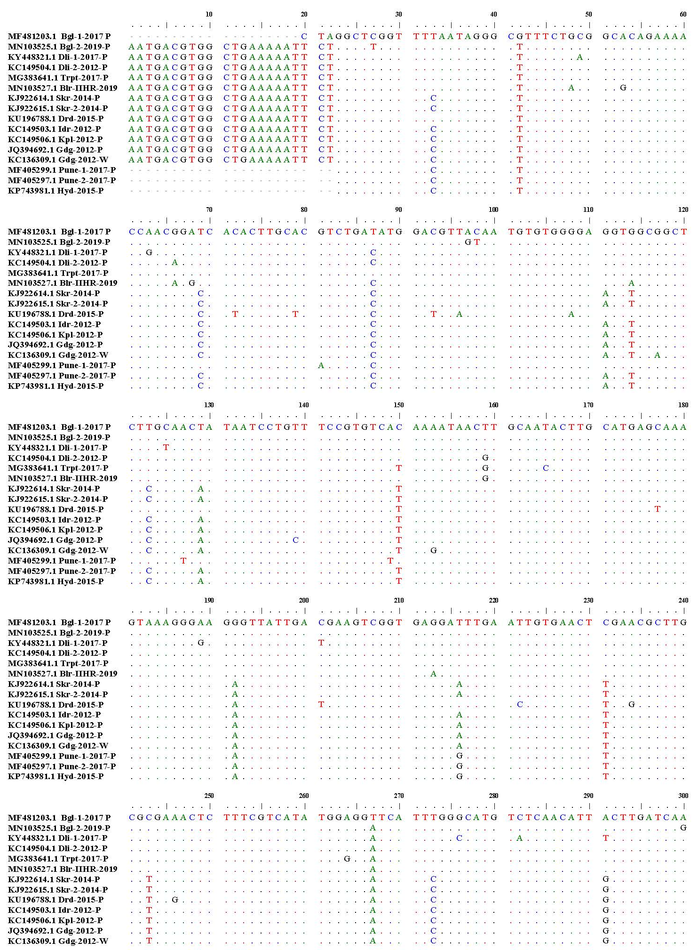
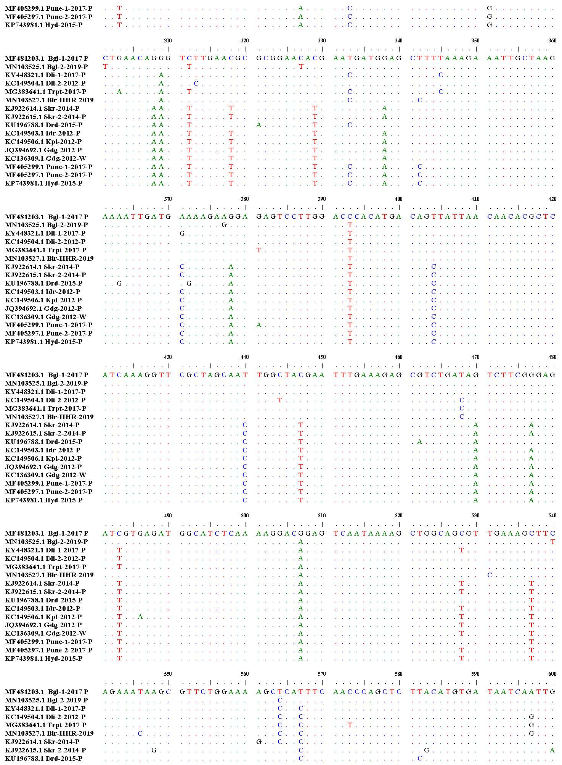
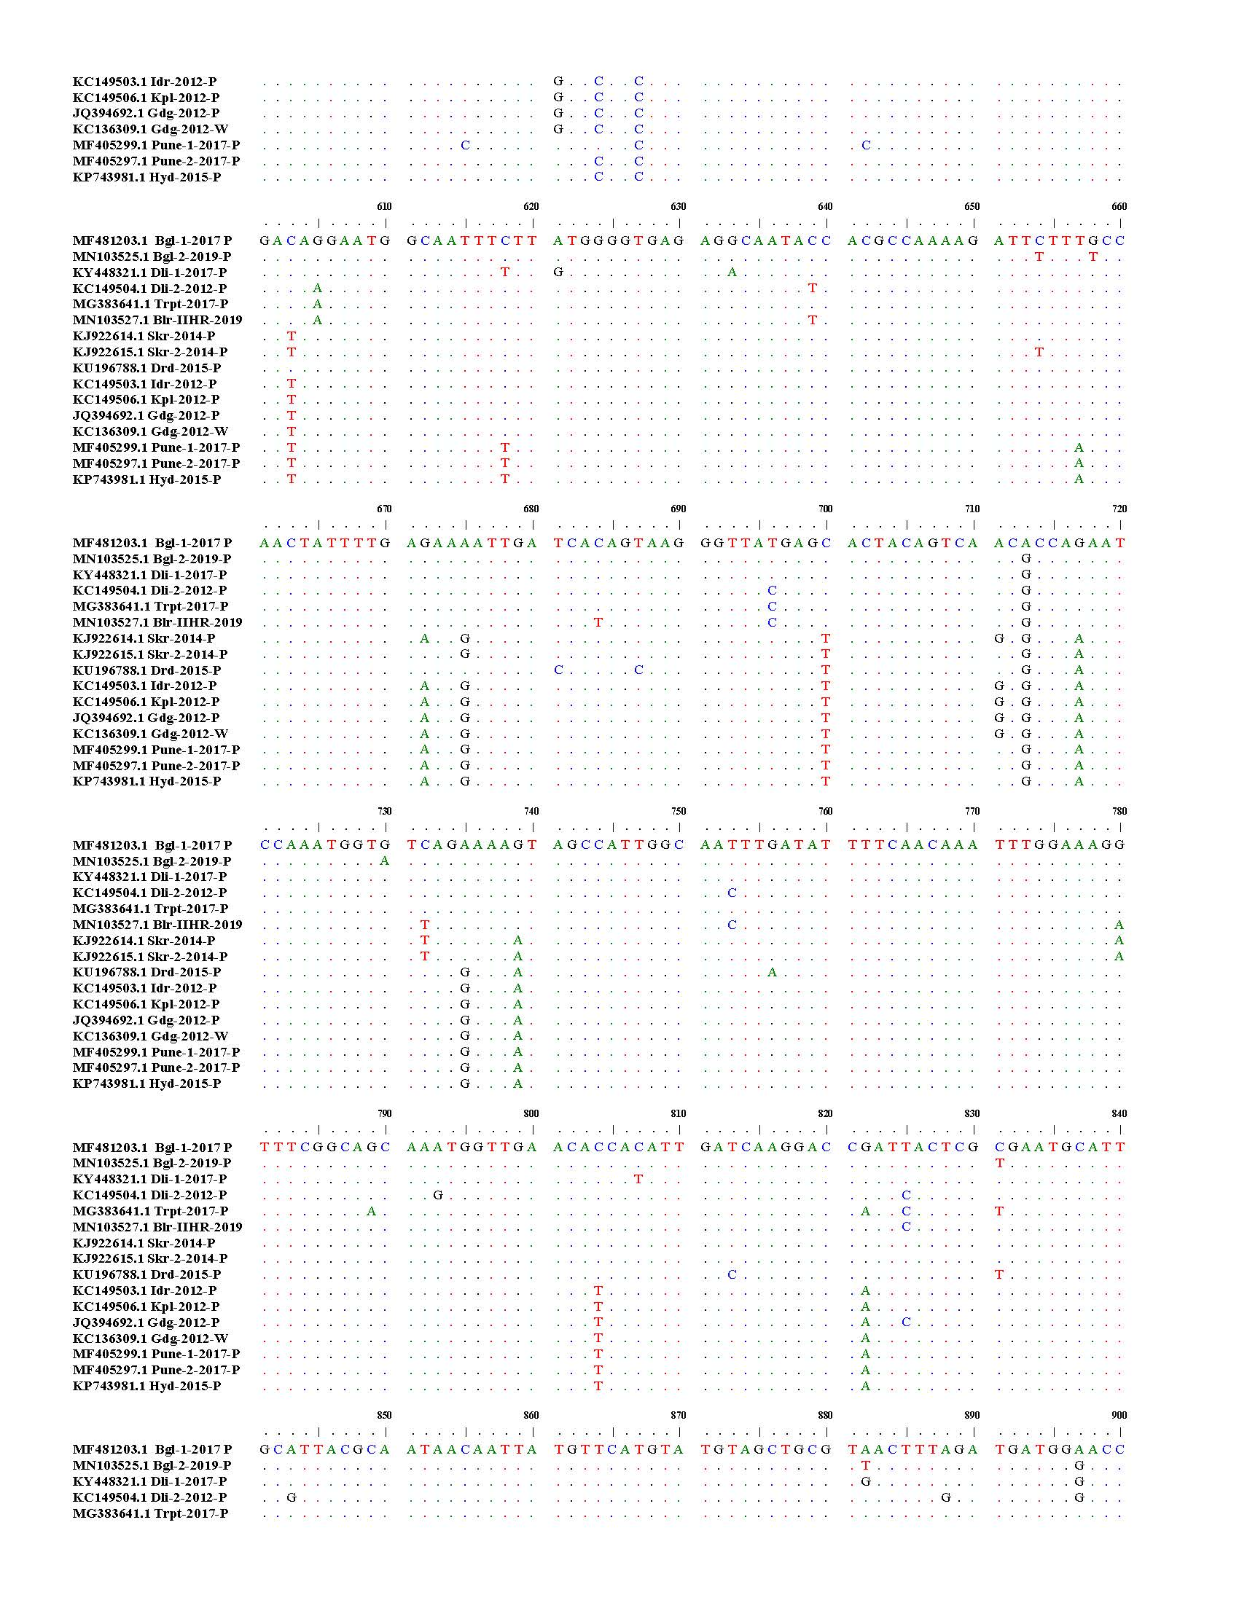
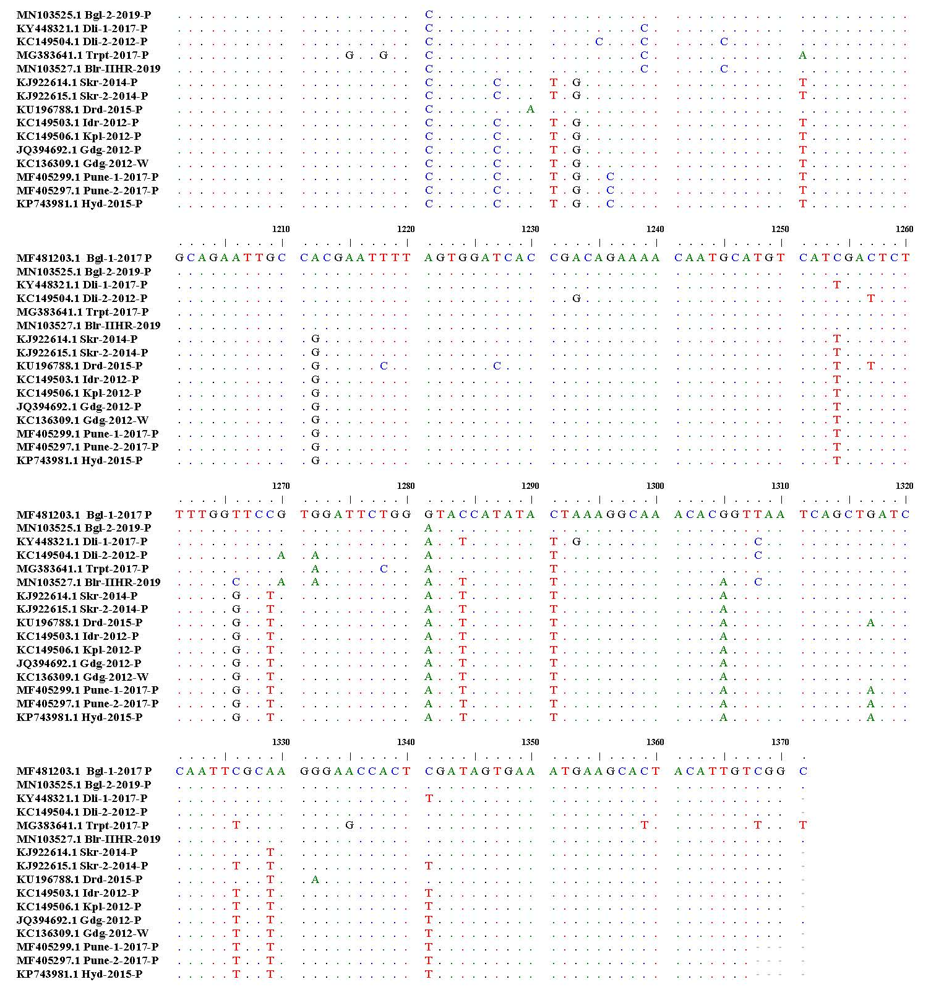
Supplementary Figure 3: Nucleotide sequence alignment of PRSV-P Helper-component proteinase of the Bangalore-1 isolate and fifteen similar isolates from Gene bank.
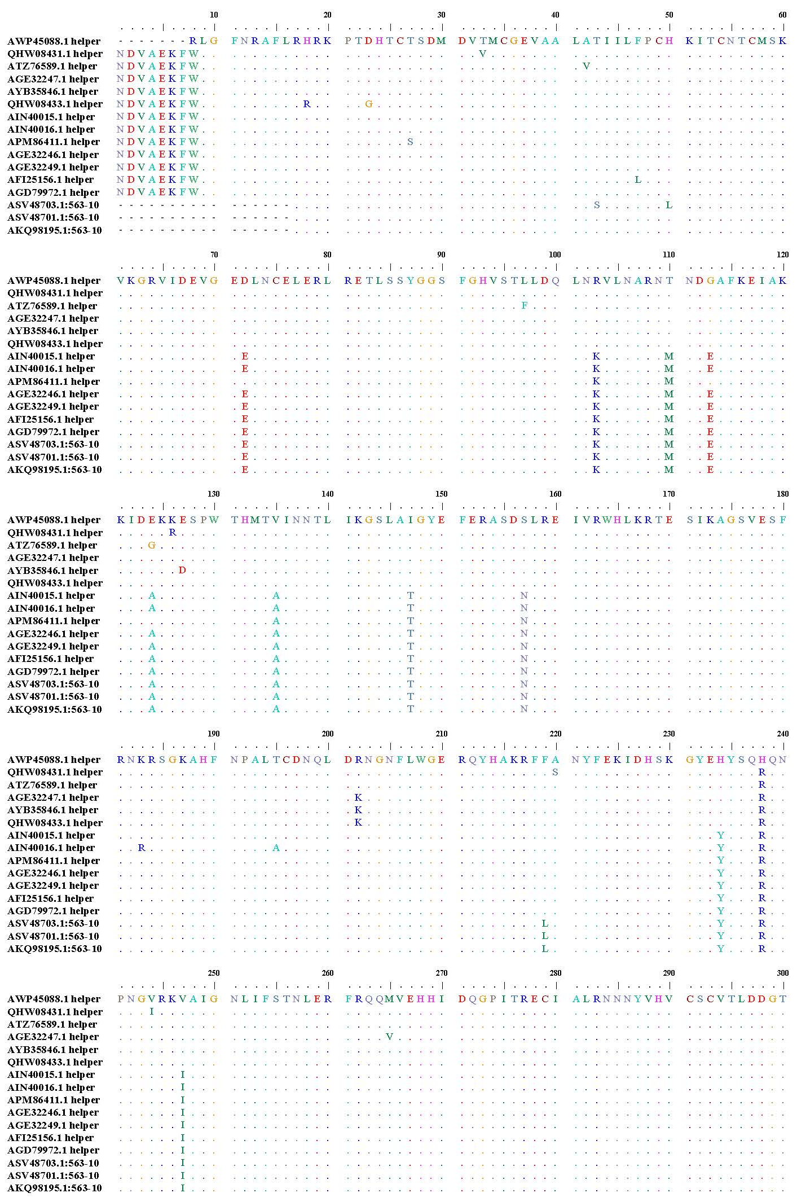
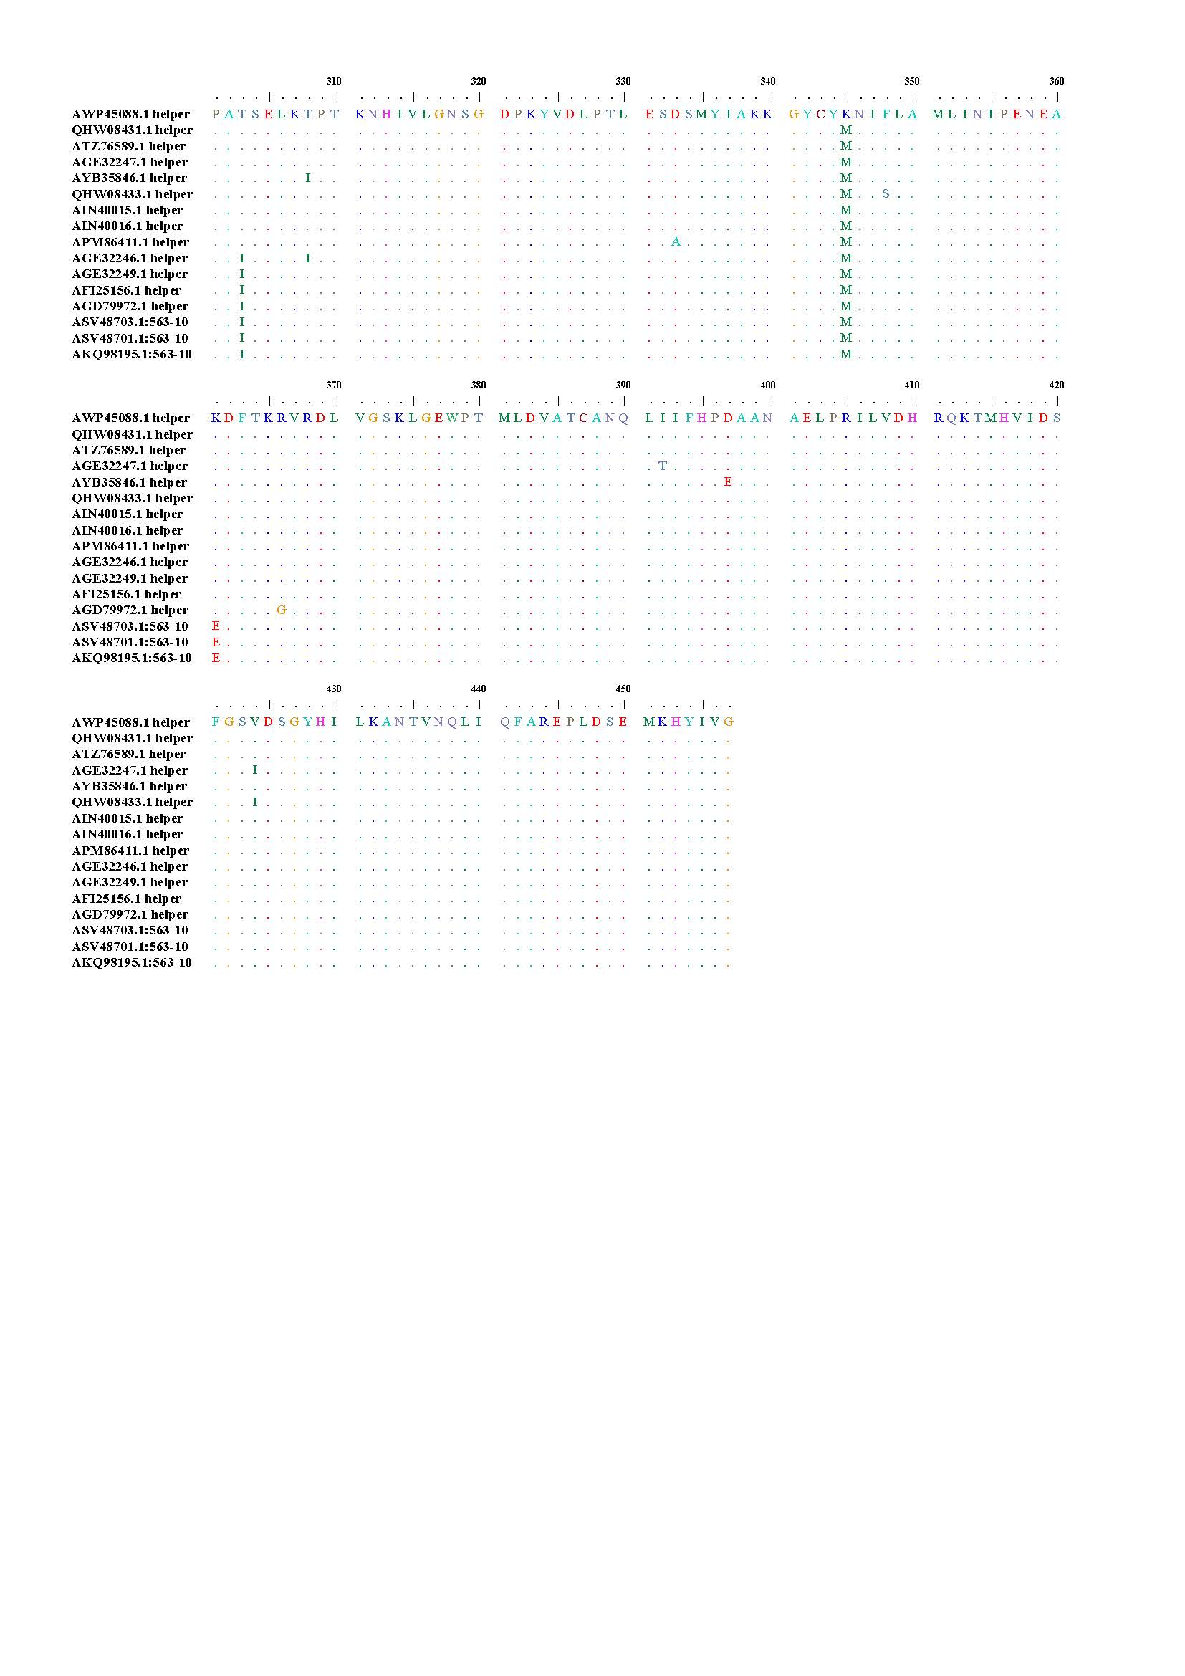
Supplementary Figure 4: Amino acid alignment of PRSV-P Helper-component proteinase with the Bangalore-1 isolate and fifteen similar isolates from Gene Bank.

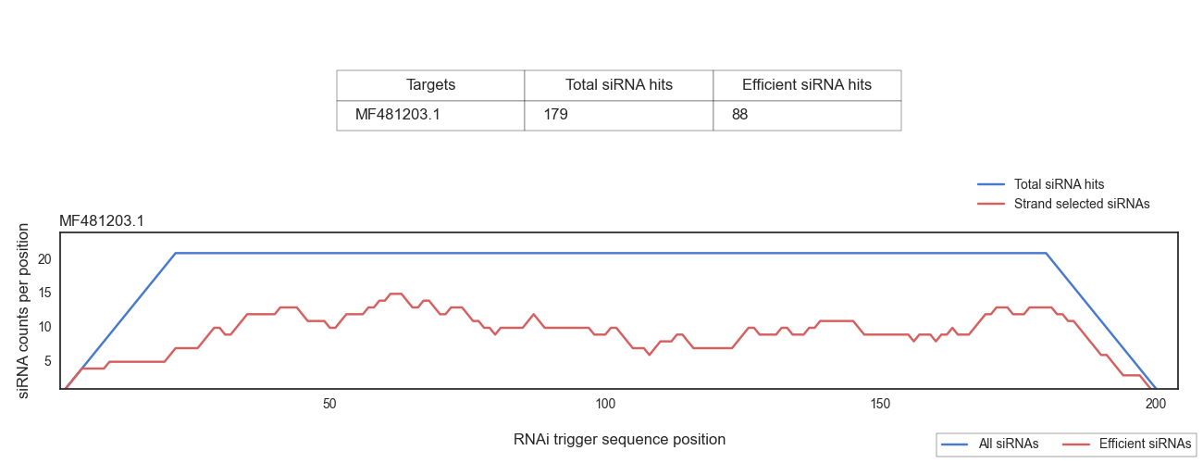
Supplementary figure 5: Off-target prediction analysis of the 201 bp HC-Pro gene construct sequence submitted against N. benthamiana express sequence tag (EST) library with siFi21 software.

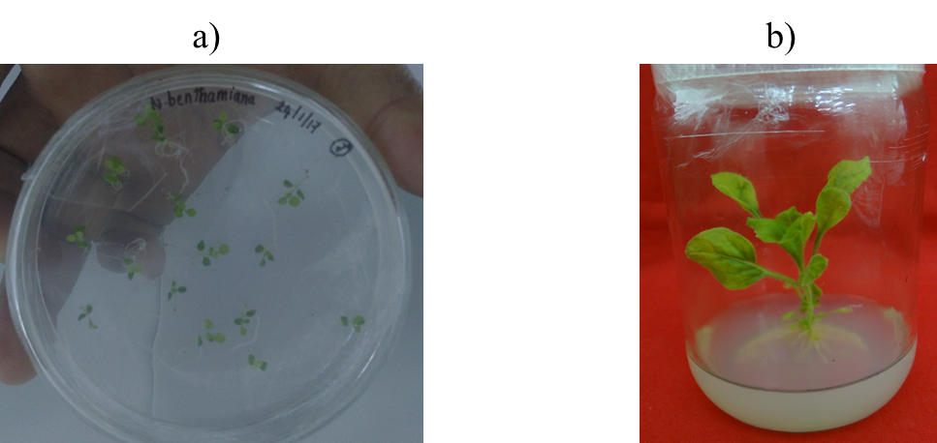
(A)
(B)
Supplementary figure 6: The in vitro germinated N. benthamiana, as the source of sterile explants for the transformation. (A) Germinating seedlings (20 days after sowing); (B) Source of leaf explant (45 days after sowing)

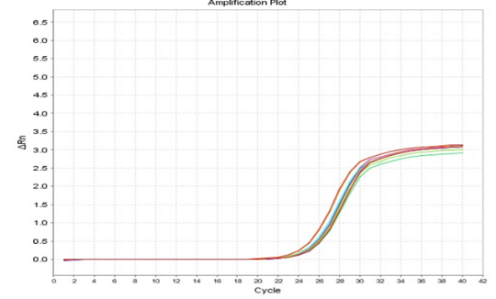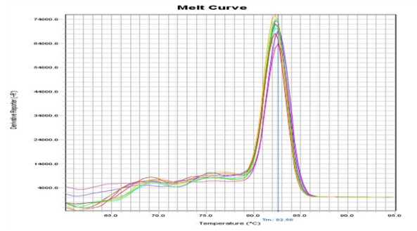
(G)
(A)
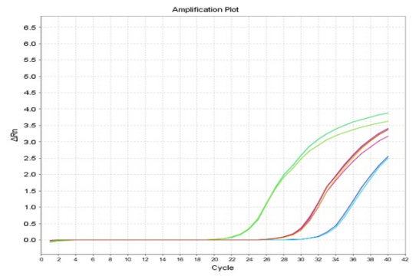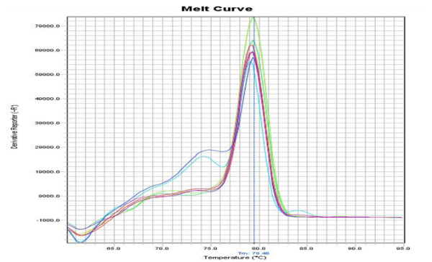
(H)
(B)
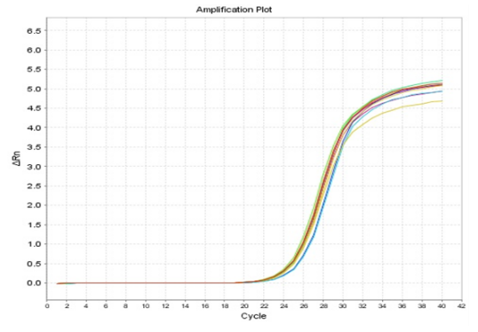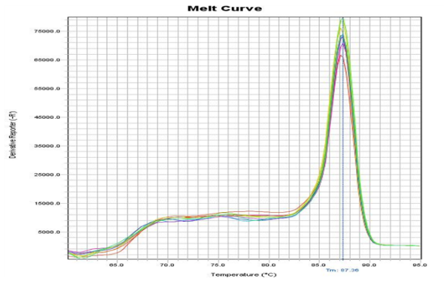
(I)

)
(C)
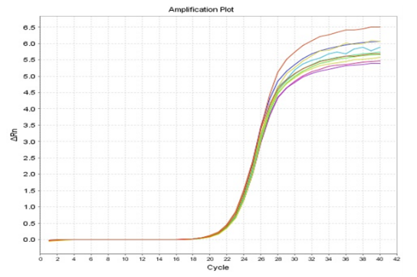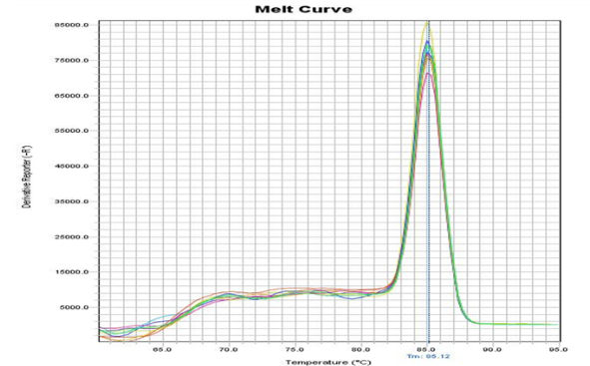
(J)

)
(D)

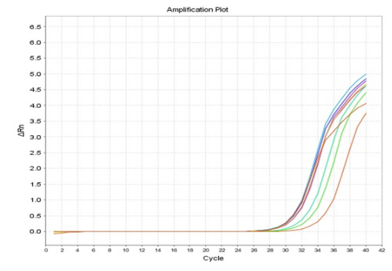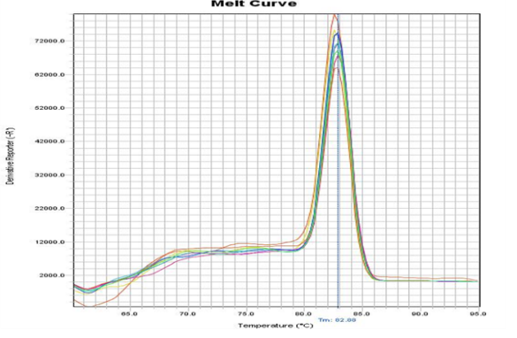
(K)

)
(E)
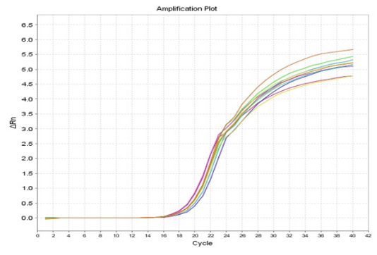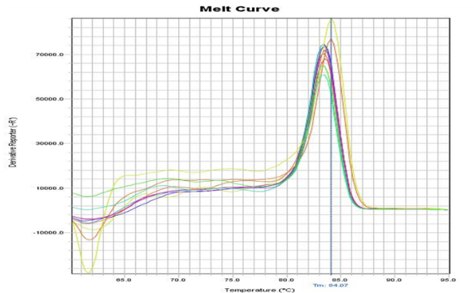
(L)

)
(F)
Supplementary figure 7: Amplification plots and the dissociation curves of 6 genes in cDNA samples, the green horizontal line represents the threshold fluorescence at which the C T value was determined. (A)- (F): Amplification plots of Tubulin, HC-Pro, SOD, APX, POD and CAT genes respectively, (G)-(L): Dissociation curves of Tubulin, HC-Pro, SOD APX, POD and CAT genes respectively

Supplementary tables

Supplementary Table 1: List of effective siRNAs targeting to PRSV HC-Pro gene

Sr no | Target  position | Target sequence  21nt target + 2nt overhang | RNA oligo sequences  21nt guide (5′→3′)  21nt passenger (5′→3′) | Functional  siRNA  selection:  Ui-Tei | Seed-duplex  stabilty (Tm);
 |  |  |  |  |  | Guide | Passenger
 | 62-84 | GTCTGATATGGACGTTACAATGT | AUUGUAACGUCCAUAUCAGAC  CUGAUAUGGACGUUACAAUGU | U |  | 14.7 °C | 14.9 °C
 | 64-86 | CTGATATGGACGTTACAATGTGT | ACAUUGUAACGUCCAUAUCAG  GAUAUGGACGUUACAAUGUGU | U |  | 13.5 °C | 21.2 °C
 | 127-149 | GTCACAAAATAACTTGCAATACT | UAUUGCAAGUUAUUUUGUGAC  CACAAAAUAACUUGCAAUACU | U |  | 20.0 °C | 5.3 °C
 | 234-256 | TCGTCATATGGAGGTTCATTTGG | AAAUGAACCUCCAUAUGACGA  GUCAUAUGGAGGUUCAUUUGG | U |  | 14.8 °C | 14.9 °C
 | 308-330 | CACGAATGATGGAGCTTTTAAAG | UUAAAAGCUCCAUCAUUCGUG  CGAAUGAUGGAGCUUUUAAAG | U |  | 13.7 °C | 16.2 °C
 | 309-331 | ACGAATGATGGAGCTTTTAAAGA | UUUAAAAGCUCCAUCAUUCGU  GAAUGAUGGAGCUUUUAAAGA | U |  | -3.8 °C | 13.6 °C
 | 319-341 | GAGCTTTTAAAGAAATTGCTAAG | UAGCAAUUUCUUUAAAAGCUC  GCUUUUAAAGAAAUUGCUAAG | U |  | 18.5 °C | -3.8 °C
 | 320-342 | AGCTTTTAAAGAAATTGCTAAGA | UUAGCAAUUUCUUUAAAAGCU  CUUUUAAAGAAAUUGCUAAGA | U |  | 19.7 °C | -9.1 °C
 | 335-357 | TGCTAAGAAAATTGATGAAAAGA | UUUUCAUCAAUUUUCUUAGCA  CUAAGAAAAUUGAUGAAAAGA | U |  | 16.3 °C | 7.1 °C
 | 402-424 | ATCAAAGGTTCGCTAGCAATTGG | AAUUGCUAGCGAACCUUUGAU  CAAAGGUUCGCUAGCAAUUGG | U |  | 19.7 °C | 17.3 °C
 | 412-434 | CGCTAGCAATTGGCTACGAATTT | AUUCGUAGCCAAUUGCUAGCG  CUAGCAAUUGGCUACGAAUUU | U |  | 20.9 °C | 19.7 °C
 | 477-499 | CTCAAAAGGACGGAGTCAATAAA | UAUUGACUCCGUCCUUUUGAG  CAAAAGGACGGAGUCAAUAAA | U |  | 19.2 °C | 18.7 °C
 | 506-528 | CAGCGTTGAAAGCTTCAGAAATA | UUUCUGAAGCUUUCAACGCUG  GCGUUGAAAGCUUCAGAAAUA | U |  | 20.4 °C | 21.1 °C
 | 507-529 | AGCGTTGAAAGCTTCAGAAATAA | AUUUCUGAAGCUUUCAACGCU  CGUUGAAAGCUUCAGAAAUAA | U |  | 20.4 °C | 14.9 °C
 | 508-530 | GCGTTGAAAGCTTCAGAAATAAG | UAUUUCUGAAGCUUUCAACGC  GUUGAAAGCUUCAGAAAUAAG | U |  | 12.0 °C | 12.2 °C
 | 533-555 | TTCTGGAAAAGCTCATTTCAACC | UUGAAAUGAGCUUUUCCAGAA  CUGGAAAAGCUCAUUUCAACC | U |  | 13.8 °C | 20.1 °C
 | 557-579 | AGCTCTTACATGTGATAATCAAT | UGAUUAUCACAUGUAAGAGCU  CUCUUACAUGUGAUAAUCAAU | U |  | 11.6 °C | 20.3 °C
 | 559-581 | CTCTTACATGTGATAATCAATTG | AUUGAUUAUCACAUGUAAGAG  CUUACAUGUGAUAAUCAAUUG | U |  | 8.9 °C | 13.5 °C
 | 563-585 | TACATGTGATAATCAATTGGACA | UCCAAUUGAUUAUCACAUGUA  CAUGUGAUAAUCAAUUGGACA | U |  | 17.7 °C | 20.5 °C
 | 612-634 | AGGCAATACCACGCCAAAAGATT | UCUUUUGGCGUGGUAUUGCCU  GCAAUACCACGCCAAAAGAUU | U |  | 16.1 °C | 20.0 °C
 | 613-635 | GGCAATACCACGCCAAAAGATTC | AUCUUUUGGCGUGGUAUUGCC  CAAUACCACGCCAAAAGAUUC | U |  | 12.2 °C | 20.0 °C
 | 629-651 | AAGATTCTTTGCCAACTATTTTG | AAAUAGUUGGCAAAGAAUCUU  GAUUCUUUGCCAACUAUUUUG | U |  | 4.6 °C | 5.3 °C
 | 638-660 | TGCCAACTATTTTGAGAAAATTG | AUUUUCUCAAAAUAGUUGGCA  CCAACUAUUUUGAGAAAAUUG | U |  | 14.8 °C | 11.6 °C
 | 639-661 | GCCAACTATTTTGAGAAAATTGA | AAUUUUCUCAAAAUAGUUGGC  CAACUAUUUUGAGAAAAUUGA | U |  | 5.3 °C | 4.6 °C
 | 642-664 | AACTATTTTGAGAAAATTGATCA | AUCAAUUUUCUCAAAAUAGUU  CUAUUUUGAGAAAAUUGAUCA | U |  | 7.4 °C | -1.4 °C
 | 701-723 | TCCAAATGGTGTCAGAAAAGTAG | ACUUUUCUGACACCAUUUGGA  CAAAUGGUGUCAGAAAAGUAG | U |  | 10.3 °C | 18.8 °C
 | 727-749 | TTGGCAATTTGATATTTTCAACA | UUGAAAAUAUCAAAUUGCCAA  GGCAAUUUGAUAUUUUCAACA | U |  | 7.4 °C | 14.0 °C
 | 729-751 | GGCAATTTGATATTTTCAACAAA | UGUUGAAAAUAUCAAAUUGCC  CAAUUUGAUAUUUUCAACAAA | U |  | 14.9 °C | 7.4 °C
 | 801-823 | CCGATTACTCGCGAATGCATTGC | AAUGCAUUCGCGAGUAAUCGG  GAUUACUCGCGAAUGCAUUGC | U |  | 19.9 °C | 14.5 °C
 | 820-842 | TTGCATTACGCAATAACAATTAT | AAUUGUUAUUGCGUAAUGCAA  GCAUUACGCAAUAACAAUUAU | U |  | 6.9 °C | 13.7 °C
 | 827-849 | ACGCAATAACAATTATGTTCATG | UGAACAUAAUUGUUAUUGCGU  GCAAUAACAAUUAUGUUCAUG | U |  | 16.1 °C | 6.9 °C
 | 828-850 | CGCAATAACAATTATGTTCATGT | AUGAACAUAAUUGUUAUUGCG  CAAUAACAAUUAUGUUCAUGU | U |  | 20.5 °C | 6.9 °C
 | 834-856 | AACAATTATGTTCATGTATGTAG | ACAUACAUGAACAUAAUUGUU  CAAUUAUGUUCAUGUAUGUAG | U |  | 13.3 °C | -1.8 °C
 | 847-869 | ATGTATGTAGCTGCGTAACTTTA | AAGUUACGCAGCUACAUACAU  GUAUGUAGCUGCGUAACUUUA | U |  | 19.6 °C | 13.1 °C
 | 883-905 | CTGCAACAAGTGAGTTGAAGACT | UCUUCAACUCACUUGUUGCAG  GCAACAAGUGAGUUGAAGACU | U |  | 19.2 °C | 16.7 °C
 | 905-927 | TCCTACTAAGAACCATATCGTTC | ACGAUAUGGUUCUUAGUAGGA  CUACUAAGAACCAUAUCGUUC | U |  | 15.3 °C | 11.3 °C
 | 915-937 | AACCATATCGTTCTTGGTAATTC | AUUACCAAGAACGAUAUGGUU  CCAUAUCGUUCUUGGUAAUUC | U |  | 20.0 °C | 15.3 °C
 | 916-938 | ACCATATCGTTCTTGGTAATTCT | AAUUACCAAGAACGAUAUGGU  CAUAUCGUUCUUGGUAAUUCU | U |  | 20.0 °C | 16.4 °C
 | 1000-1022 | AAGGTTACTGCTACAAGAACATC | UGUUCUUGUAGCAGUAACCUU  GGUUACUGCUACAAGAACAUC | U |  | 19.2 °C | 19.0 °C
 | 1007-1029 | CTGCTACAAGAACATCTTTTTAG | AAAAAGAUGUUCUUGUAGCAG  GCUACAAGAACAUCUUUUUAG | U |  | 5.3 °C | 16.4 °C
 | 1008-1030 | TGCTACAAGAACATCTTTTTAGC | UAAAAAGAUGUUCUUGUAGCA  CUACAAGAACAUCUUUUUAGC | U |  | 5.5 °C | 20.3 °C
 | 1105-1127 | TCGGAGAATGGCCAACGATGTTA | ACAUCGUUGGCCAUUCUCCGA  GGAGAAUGGCCAACGAUGUUA | U |  | 21.1 °C | 20.4 °C
 | 1122-1144 | ATGTTAGATGTCGCAACATGTGC | ACAUGUUGCGACAUCUAACAU  GUUAGAUGUCGCAACAUGUGC | U |  | 18.1 °C | 13.4 °C
 | 1139-1161 | ATGTGCAAATCAGCTAATAATTT | AUUAUUAGCUGAUUUGCACAU  GUGCAAAUCAGCUAAUAAUUU | U |  | -2.3 °C | 20.0 °C
 | 1141-1163 | GTGCAAATCAGCTAATAATTTTT | AAAUUAUUAGCUGAUUUGCAC  GCAAAUCAGCUAAUAAUUUUU | U |  | -10.3 °C | 13.8 °C
 | 1142-1164 | TGCAAATCAGCTAATAATTTTTC | AAAAUUAUUAGCUGAUUUGCA  CAAAUCAGCUAAUAAUUUUUC | U |  | -10.3 °C | 12.0 °C
 | 1180-1202 | ATGCAGAATTGCCACGAATTTTA | AAAUUCGUGGCAAUUCUGCAU  GCAGAAUUGCCACGAAUUUUA | U |  | 15.2 °C | 12.0 °C
 | 1181-1203 | TGCAGAATTGCCACGAATTTTAG | AAAAUUCGUGGCAAUUCUGCA  CAGAAUUGCCACGAAUUUUAG | U |  | 7.4 °C | 12.0 °C
 | 1251-1273 | GTGGATTCTGGGTACCATATACT | UAUAUGGUACCCAGAAUCCAC  GGAUUCUGGGUACCAUAUACU | U |  | 20.0 °C | 20.4 °C

Supplementary Table 2: List of VIGS candidates targeting the PRSV-P HC-Pro gene based on potential siRNA sequence

Sl. No. | Range on target sequence | Length | Number of siRNAs | Number of off-target | Significant off-targets / Number of hits
 | 557-757 | 201 | 14 | 184 | 4
 | 1068-1267 | 200 | 14 | 216 | 10
 | 1081-1280 | 200 | 14 | 218 | 10
 | 188-387 | 200 | 13 | 199 | 2
 | 214-413 | 200 | 13 | 207 | 6
 | 27-226 | 200 | 13 | 223 | 4
 | 308-507 | 200 | 10 | 145 | 10
 | 370-569 | 200 | 12 | 160 | 9
 | 37-236 | 200 | 13 | 217 | 4
 | 411-610 | 200 | 11 | 158 | 5
 | 515-714 | 200 | 11 | 185 | 4
 | 696-895 | 200 | 14 | 207 | 8
 | 720-919 | 200 | 14 | 211 | 12
 | 763-962 | 200 | 15 | 226 | 8
 | 847-1046 | 200 | 12 | 204 | 6
 | 913-1112 | 200 | 12 | 197 | 8
 | 946-1145 | 200 | 13 | 208 | 10
 | 95-294 | 200 | 14 | 237 | 2
 | 997-1196 | 200 | 11 | 184 | 10
 | 1092-1290 | 199 | 14 | 226 | 10
 | 1102-1300 | 199 | 14 | 227 | 12
 | 264-462 | 199 | 11 | 160 | 8
 | 451-649 | 199 | 12 | 181 | 5
 | 53-251 | 199 | 12 | 205 | 2
 | 665-863 | 199 | 14 | 212 | 8
 | 814-1012 | 199 | 13 | 206 | 2
 | 827-1025 | 199 | 13 | 212 | 4
 | 1026-1223 | 198 | 12 | 201 | 10
 | 1113-1310 | 198 | 14 | 228 | 12
 | 179-376 | 198 | 13 | 196 | 2
 | 278-475 | 198 | 10 | 142 | 8
 | 293-490 | 198 | 10 | 144 | 10
 | 904-1101 | 198 | 12 | 199 | 6
 | 1125-1321 | 197 | 14 | 234 | 12
 | 530-726 | 197 | 11 | 189 | 4
 | 597-793 | 197 | 11 | 183 | 6
 | 607-803 | 197 | 11 | 184 | 6
 | 629-825 | 197 | 12 | 191 | 10
 | 678-874 | 197 | 14 | 210 | 8
 | 783-979 | 197 | 14 | 203 | 4
 | 794-990 | 197 | 14 | 207 | 4
 | 875-1071 | 197 | 12 | 211 | 4
 | 111-306 | 196 | 14 | 226 | 2
 | 121-316 | 196 | 14 | 217 | 2
 | 231-426 | 196 | 13 | 198 | 8
 | 487-682 | 196 | 11 | 177 | 7
 | 888-1083 | 196 | 12 | 214 | 4
 | 16-210 | 195 | 13 | 215 | 4
 | 356-550 | 195 | 12 | 173 | 13
 | 992-1186 | 195 | 11 | 187 | 12
 | 1051-1244 | 194 | 13 | 214 | 2
 | 206-399 | 194 | 13 | 200 | 4
 | 6-199 | 194 | 13 | 206 | 4
 | 621-814 | 194 | 11 | 181 | 10
 | 91-284 | 194 | 14 | 233 | 2
 | 940-1133 | 194 | 12 | 194 | 10
 | 1063-1255 | 193 | 13 | 210 | 10
 | 590-782 | 193 | 11 | 186 | 6
 | 393-583 | 191 | 11 | 153 | 9
 | 442-632 | 191 | 12 | 176 | 5
 | 718-908 | 191 | 13 | 190 | 8
 | 762-952 | 191 | 14 | 209 | 8
 | 932-1122 | 191 | 12 | 197 | 8
 | 139-328 | 190 | 14 | 217 | 2
 | 505-694 | 190 | 11 | 179 | 7
 | 549-738 | 190 | 11 | 184 | 6
 | 745-932 | 188 | 14 | 212 | 8
 | 662-845 | 184 | 13 | 204 | 10
 | 1166-1341 | 176 | 15 | 251 | 10

