Appendix 1

We recall the growth path of technology and human capital growth:
and

Then, divide them by z and h, respectively:
and

Take log and take the first order condition wrt time:
where and are growth rate of human capital and technology respectively:

and

where we assume .

With the constant growth rate of technology and human capital, we could potentially ascertain a balanced-growth equilibrium as steady state.

As we can affirm that in a steady state there is no agent movement, we can thus take the first order condition wrt for agent and then apply envelop theorem wrt k:
………(1)

We also know that ………(2)
Combine (1) and (2):
………(3)

The budget constraint:
multiply by :
………(4)

As the proportion of each person’s human capital relative to the island’s human capital is constant in equilibrium, and from (2), we know that capital in each island should grow at the same rate, therefore, should also grow at a constant rate. If balanced growth holds, the proportion of each person’s capital and the proportion of each island’s capital relative to the total capital in the economy should be constant.
Therefore, if , from (4), is a function of :
………(5)

It is now possible now to draw the path of the dynamic combining (5) and (3) in Figure A1:

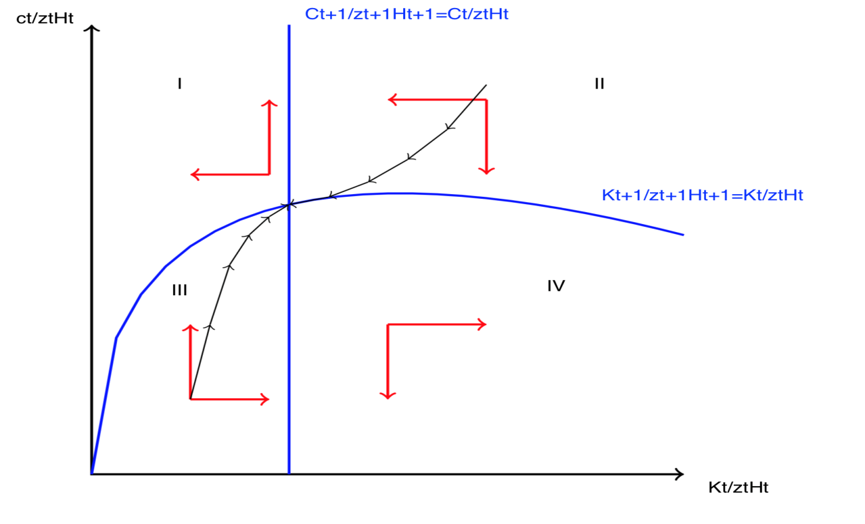
Figure A1. Path towards steady state for each agent

Only in zone II and III can agent attain the steady state. However, we should notice that each agent should also follow different path to reach its own steady state, and in steady state, is constant; yet is different as per the agents and islands, which depends on the share of agent’s capital to the total capital.

The study can now turn to solve the steady state distributionand, which can be utilised to solve the issues related to share of capital and human capital.

First, we notice that in steady state, every agent’s consumption and every island’s quality increases at the same constant rate. Accordingly, we can remove the part 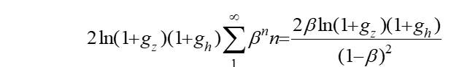from each agent’s value function, which does not affect the result of the steady state. Now we can focus entirely on the initial value of at the time when the economy reaches its steady state, and thus ignore the growth.

Then, as it is known that is constant in steady state, as with and , agents only care about each island’s technology and quality. Moreover, we recall that and , and that they are constant in their steady states. When givenfor the island, we can solve corresponding total human capital and capital on that island. Human capitalof agents with speed of learning on that island is also pinned down.

Appendix 2
The first order conditions of the agent is:
=>…......(8)

We also have:
………(9)

The budget constraint is:
Then multiply by :
………(10)

As previously discussed, from (8), for balanced growth, is constant. Then from (6)(7), given ZAt, we are able to solve and PBt, which are found to be constant in a steady state. PBt is positive correlated with while is negatively correlated with it.

Proof:

Recall that:
is negatively correlated with , because if increases, decreases while increases. The increase of will thus lead to lower to ensure the equation holds. With (7), any decrease of will increase PBt.

These findings suggest that in islands with higher levels of technology, non-tradable goods exhibit a higher price, even though these goods are the same for all islands. Our intuition is that higher technology islands offer higher wages for tradable goods. To ensure that people are willing to work for the non-tradable sector, the two sectors must have the same wage. To cover the additional costs from the necessary wage, the non-tradable sectors are compelled to increase the price. This is essentially the Balassa-Samuelson effect (see Samuelson, 1964 and Kravis and Lipsey, 1983), which is found to be statistically significant by Samuelson (1994). Vaona (2011) and Nenna (2001) also found evidence to support this from an intra-country level in Italy, whereas Songtao (2009) tested it for real estate price between cities in China, validating the rationale of applying the Balassa-Samuelson effect on the city-level.

We can know that from (6) , the wage-price level is negatively correlated with and therefore positively correlated with ZA. As capital income is irrelevant with the island, the agent stays, whereas income-price ratio also increases as technology increases. This can suggest that among the islands with higher technology levels, non-tradable goods are more affordable. As we know from Part I, on the frontier, higher quality islands have lower technology, which therefore have a low income-to-price rate. This answers the question of why some cities with beautiful natural views exhibit high prices but offer low wages.

We also find that non-tradable goods exhibit a higher capital-to-human-capital ratio in more productive cities. This because the price of human capital is higher in these cities, so that the producer in the non-tradable sector cannot afford hiring too many workers. Accordingly, they tend to replace workers with machines, which are relatively cheaper and also works to increase the ratio. This is consistent with the research of Kakkar (2002; 2011), which tested the Balassa-Samuelson effect on the capital-to-human capital ratio of the OCED and Asian countries, respectively.

We then substitute PBt as a function of and with (9) and (10), we can now utilise two forms of budget constraints:
………(11)

and

………(12)
where is increasing function of solved by (6)(7)

We can now solve steady state levels of and by (8)(11) and (8)(12), respectively, as presented in the Method section (Part I), given the proportion of capital and human capital of the agent to the total level. As we know that and in steady state
, we can find the corresponding HA for level z at the time of steady state. From constant , we can determine KA.
We can also determine for each agent located on the island. Determining this enables us to ascertain the proportion of human capital, which in light of the set we described above, we can then determine the ratio of capital to the total capital on the island (notice that it does not need to sum to one, as capital owned by the agent can be rented in other islands). Like Part I, we then only need to define k, which is owned by each agent, on each island at any time of the balanced-growth equilibrium.

Following this, we can find CA and CB by the budget constraint and first order conditions. We now have all the requisite individual information on the steady state, given their speed of learning, capital and location.

For each island, if we know its capital K, we can know KB and by (6)(7) we can determine.

