Images

Serosal surface
Mucosal surface
Full thickness of bowel ( ischemic infarction suggestive of thromboembolism)

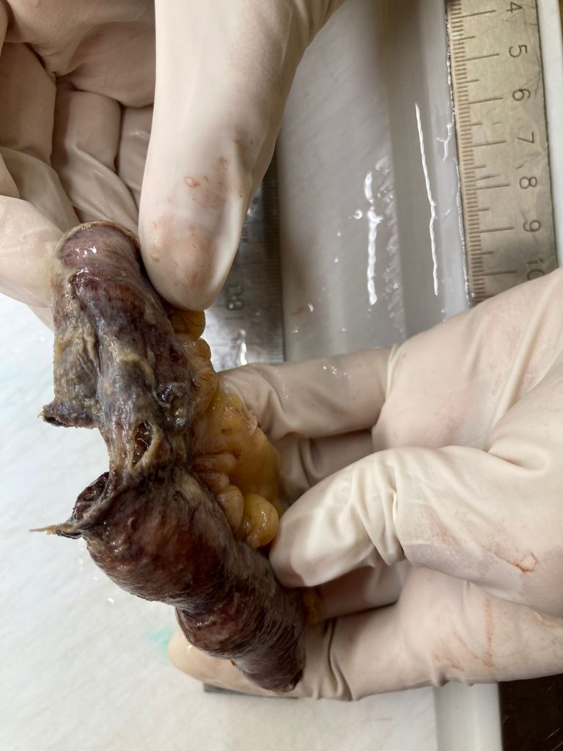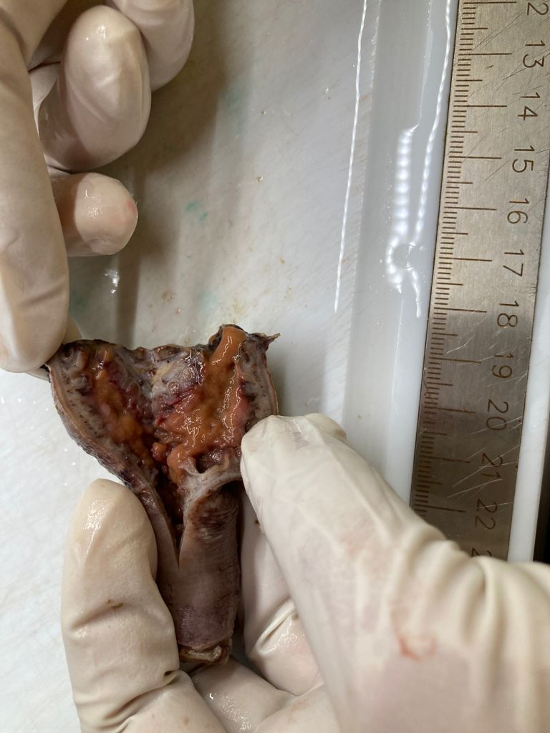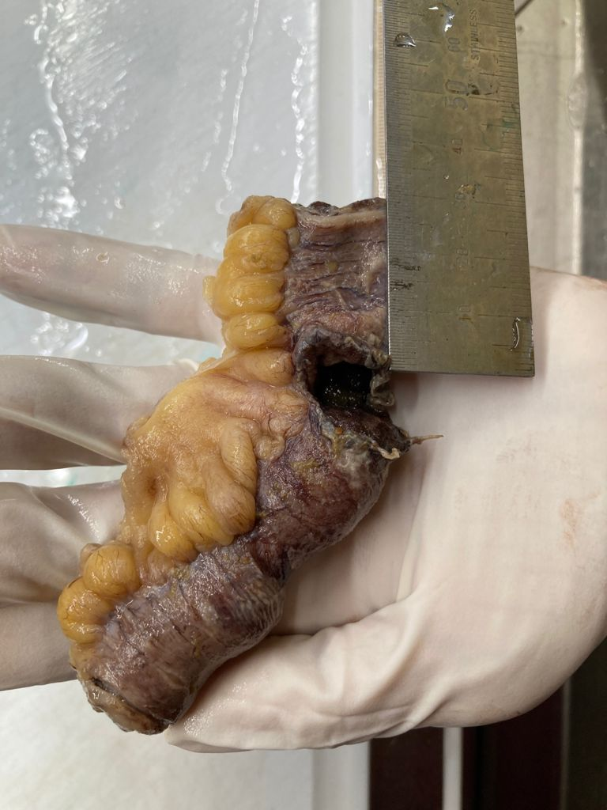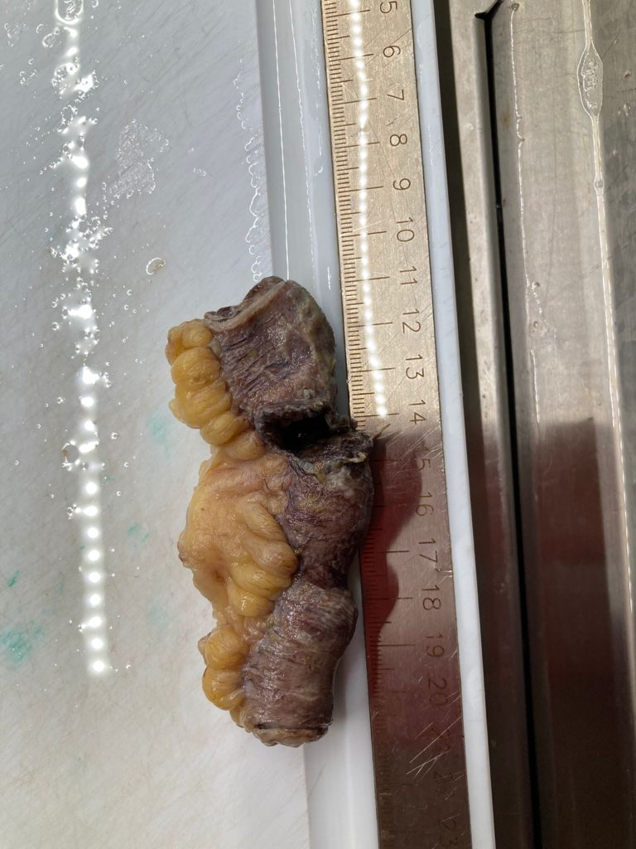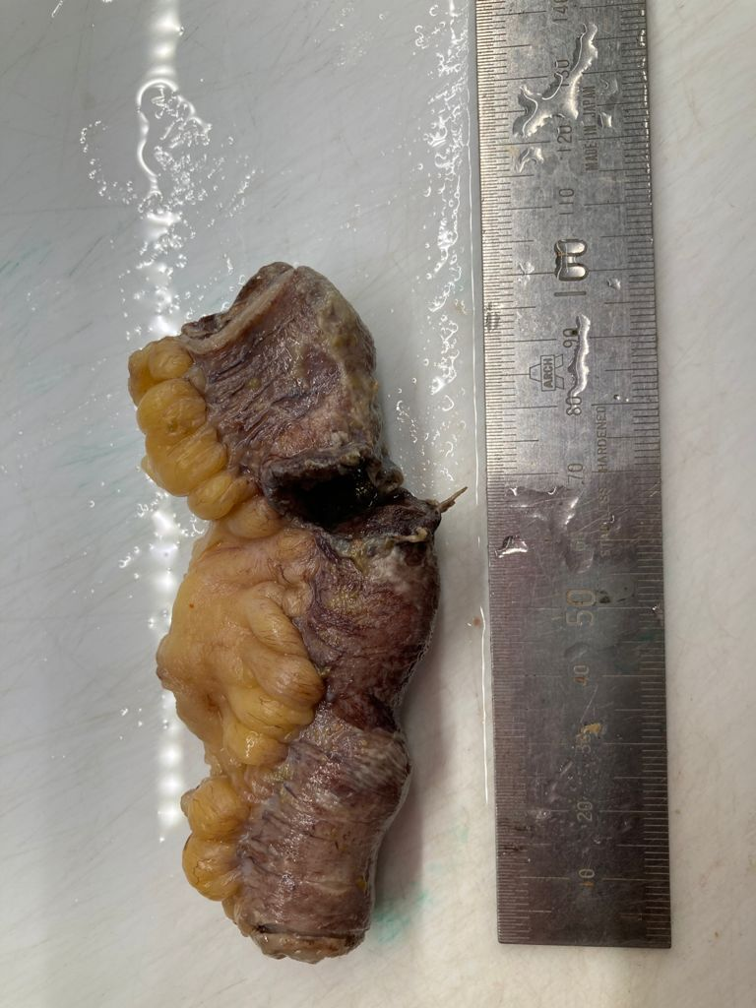
Necrotic discolored ileal segment of bowel with perforation showing full thickness perforation

