Table 2: AutoDock Vina screening of various top candidate proteins
Candidate Protein PDB IDs | Binding Energy kcal/ mol | Docking Plot | Interaction Diagram
6NWL | -10.75 | 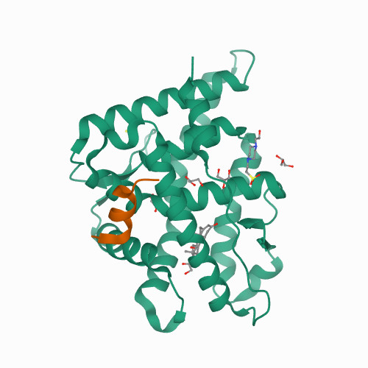 | 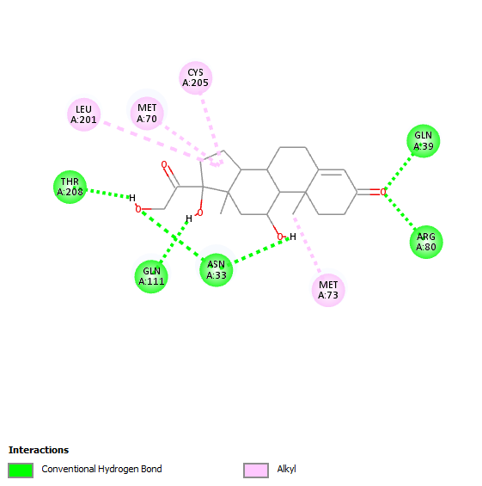
2V95 | -9.67 | 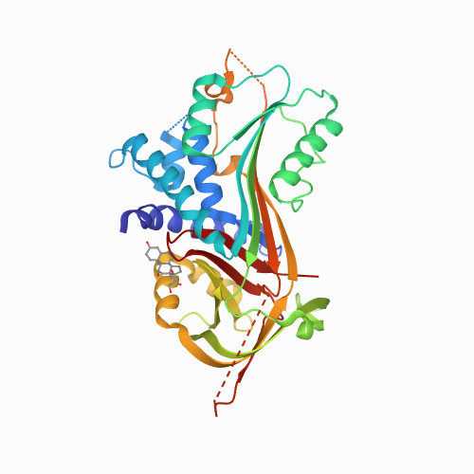 | 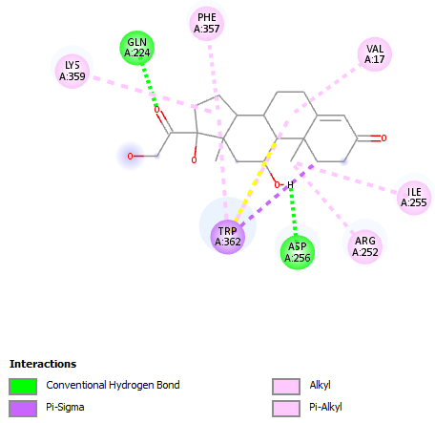
2VDY | -9.28 | 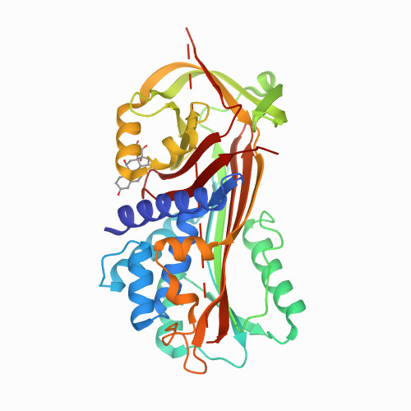 | 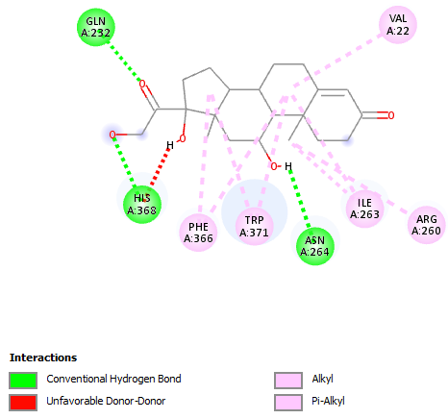

Table 3: Interaction diagrams of baseline peptide compared with glucose and progesterone
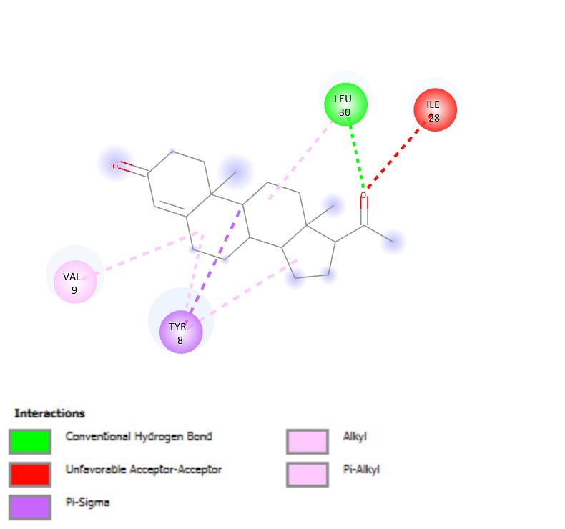 | 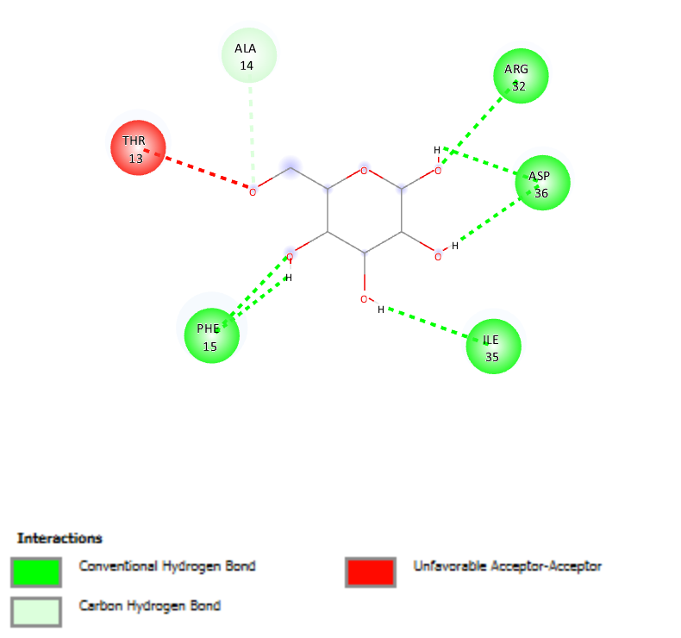
Progesterone – BE: -5.38 kcal/mol | Glucose – BE: -3.34 kcal/mol

