Supplementary Information
An insilico design of a peptide bioreceptor for cortisol using molecular modelling techniques
Parijat Deshpande^{1,2} Debankita De¹ Yogesh Badhe¹ Siddharth Tallur³ Debjani Paul⁴ and Beena Rai¹
¹ TCS Research, Tata Research Development & Design Centre (TRDDC), Pune 411013, India
²Centre for Research in Nanotechnology & Science (CRNTS), IIT Bombay, Mumbai 400076, India.
³Department of Electrical Engineering, IIT Bombay, Mumbai 400076, India.
⁴Department of Biosciences and Bioengineering, IIT Bombay, Mumbai 400076, India.

E-mail: parijat.deshpande@tcs.com

This supplementary information provides interaction diagrams and conformation renderings for various candidate proteins from protein database¹ for design of baseline peptide bioreceptor.
- High throughput screening using molecular docking
Table SI 1: AutoDock Vina screening of various top candidate protein

Candidate Protein PDB IDs | Binding Energy kcal/ mol | Docking Plot | Interaction Diagram
6NWL | -12.36 | 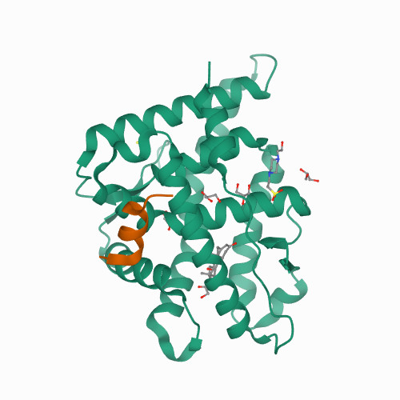 | 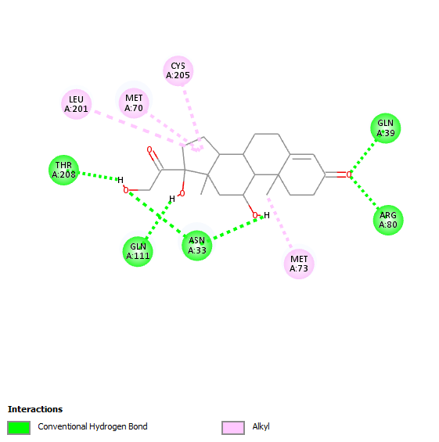
2V95 | -9.67 | 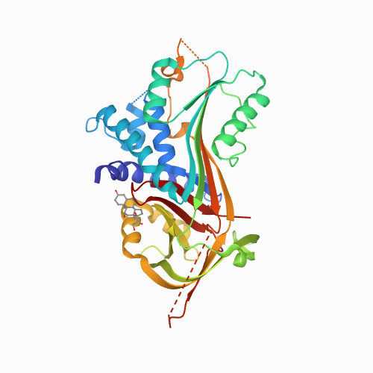 | 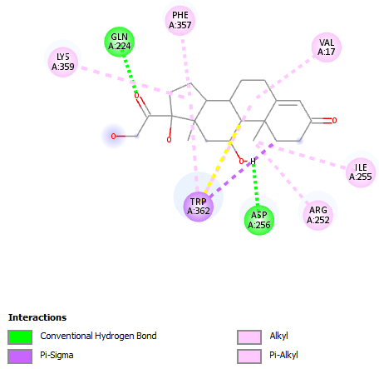
2VDY | -9.28 | 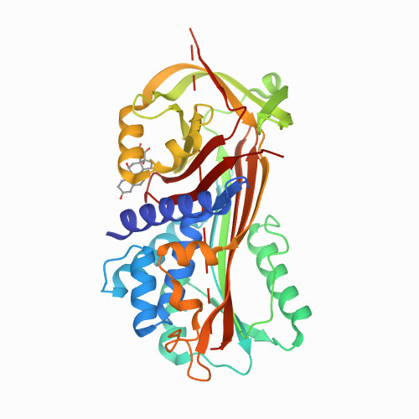 | 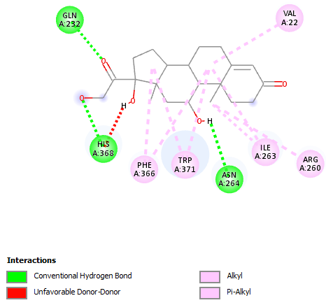
NewBG – III  (Alpha1-antichymotrypsin variant) | -7.72 | 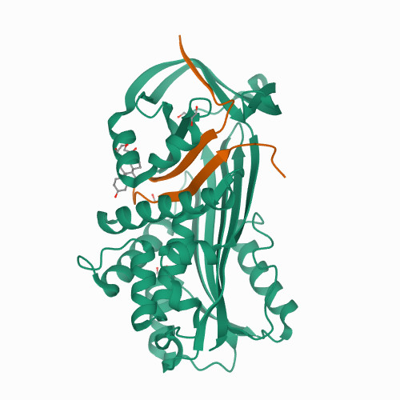 | 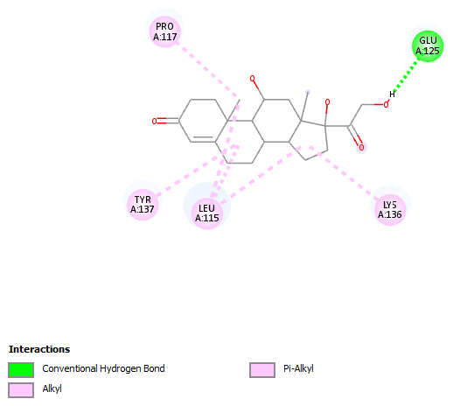
6HGG | -7.7 |  | 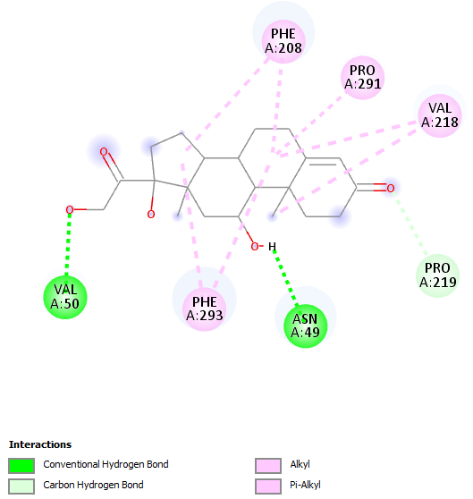
6HGC  Serpin | -9.11 | 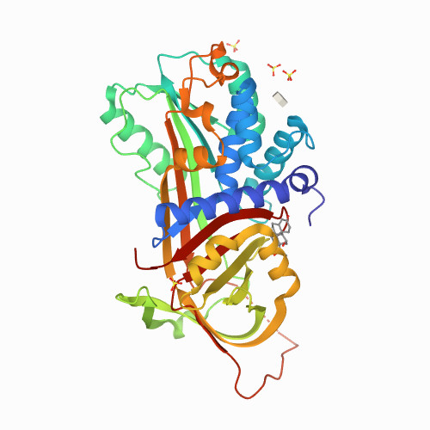 | 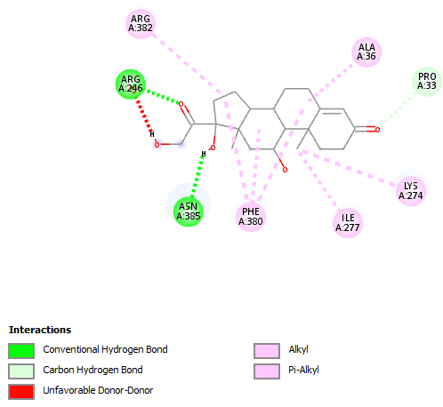
6ITP  VHH Antibody | -8.32 | 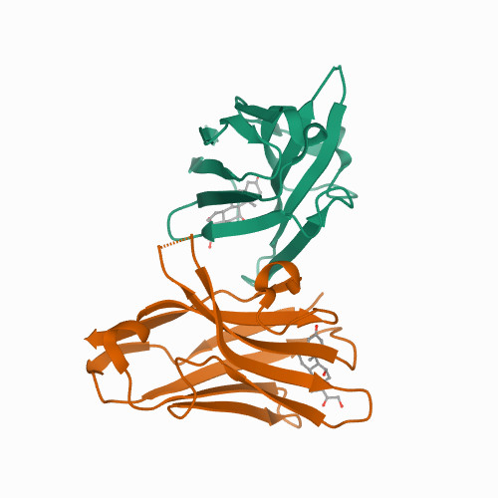 | 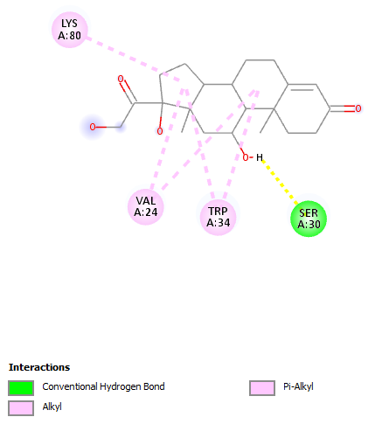

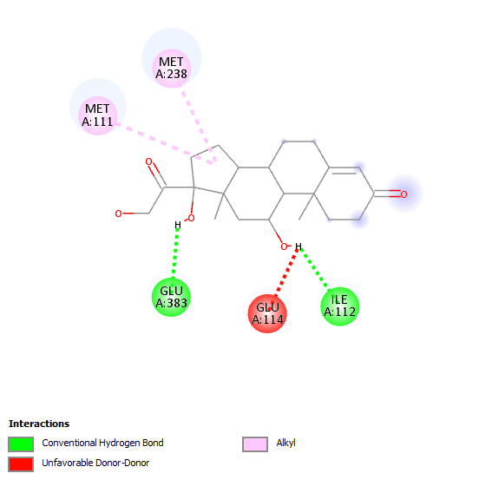 | 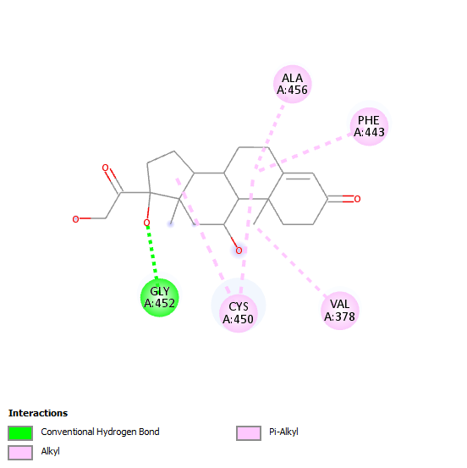
PDB: 6XZ8 BE: -6.51 kcal/mol | PDB: 6XZ9 BE: -5.93 kcal/mol
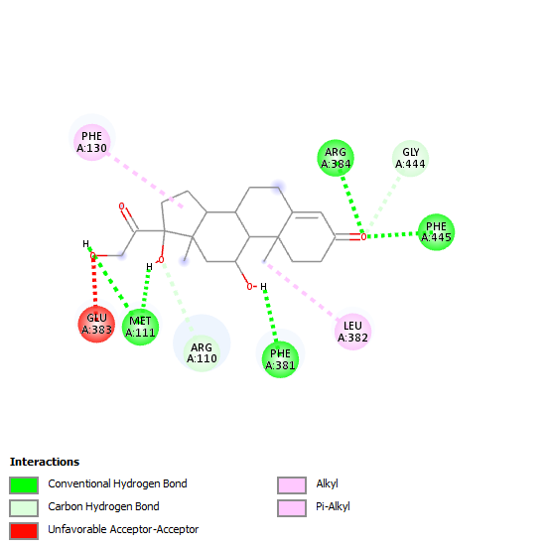 | 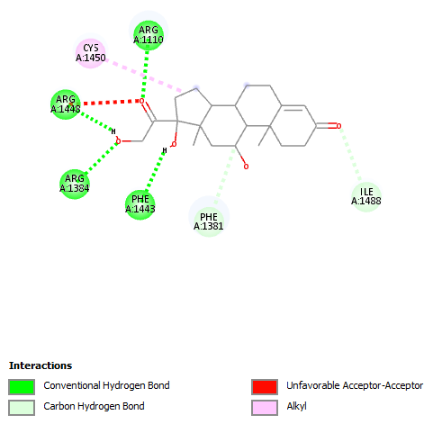
PDB: 7E7F BE: – 9.56 kcal/mol | PDB: 7M8I BE: -8.12 kcal/mol
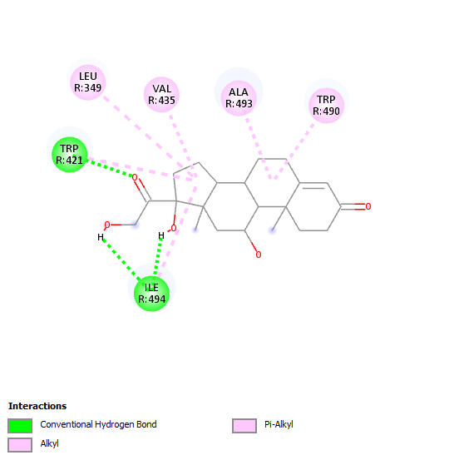 | 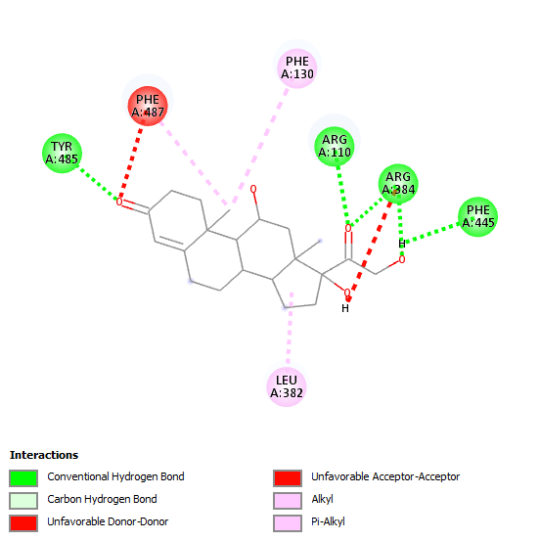
PDB: 7D77 BE – 8.44 kcal/mol | PDB: 7M8V BE -10.5 kcal/mol
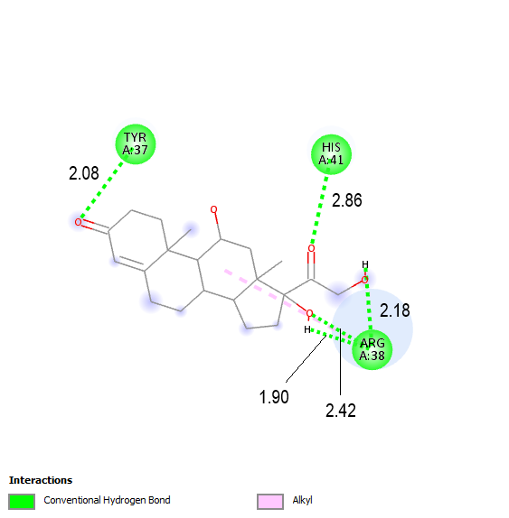 | 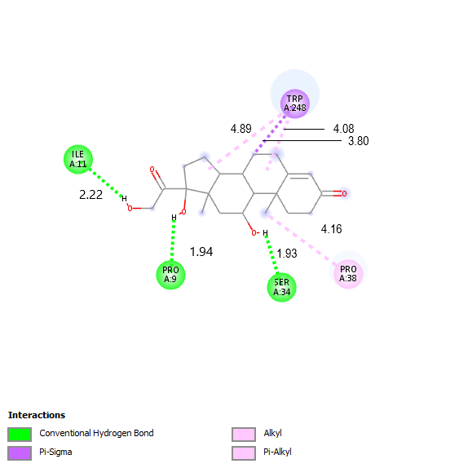
PDB: 6P9X BE: -6.12 kcal/mol | PDB: 5BK8 BE: – 4.87 kcal/mol
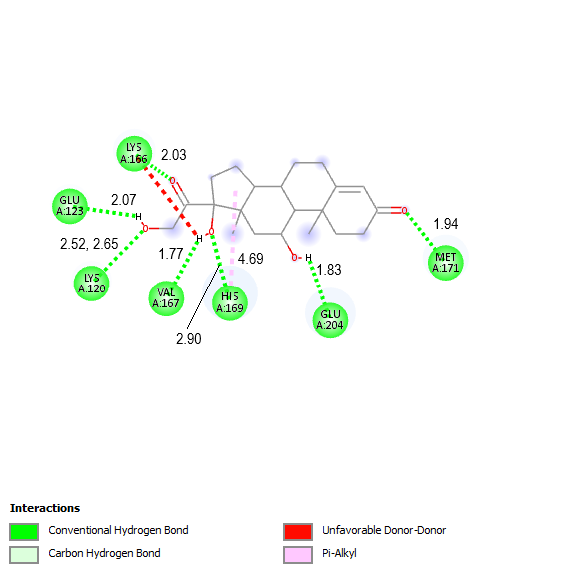 | 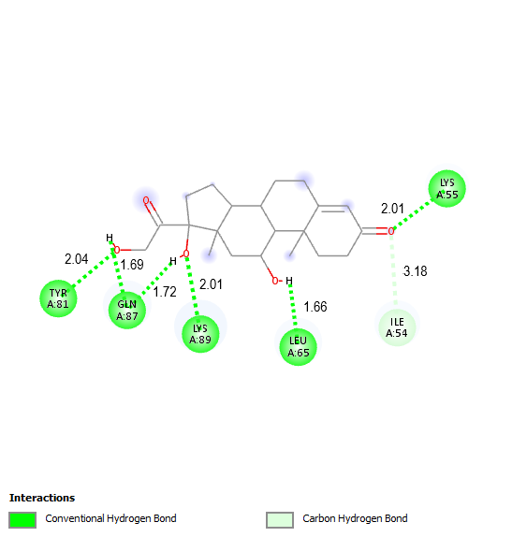
PDB: 6R5G BE: -5.38 kcal/mol | PDB: 6ROY BE: -7.92 kcal/mol
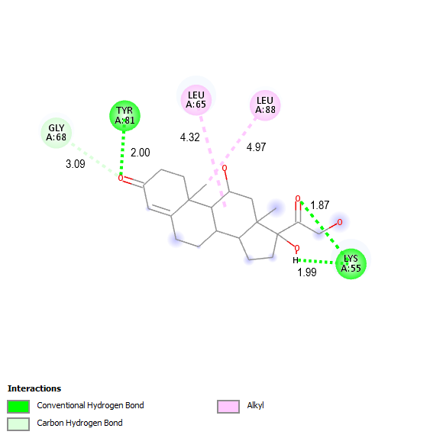 | 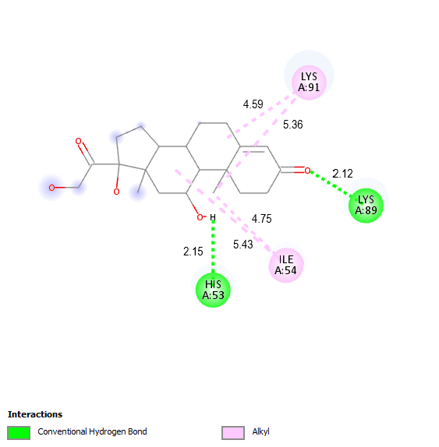
PDB: 6ROZ BE: -8.00 kcal/mol | PDB: 6WU8 BE: -6.13 kcal/mol
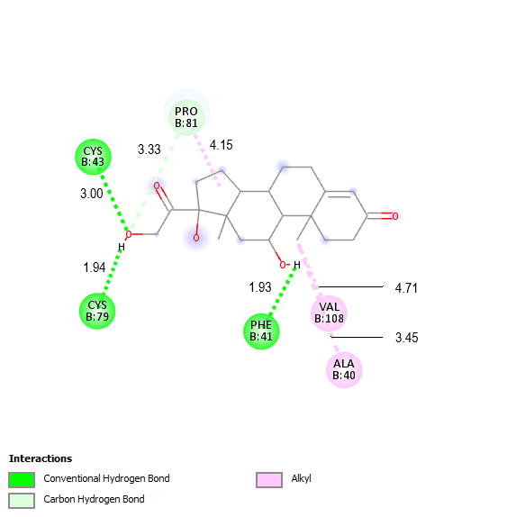 | 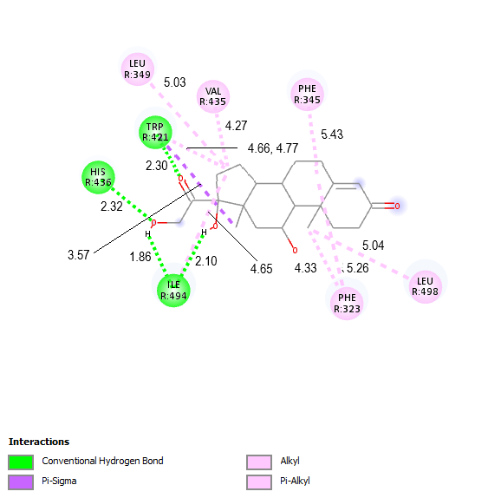
PDB: 7AGO BE: -6.33 kcal/mol | PDB: 7D76 BE: -6.86 kcal/mol
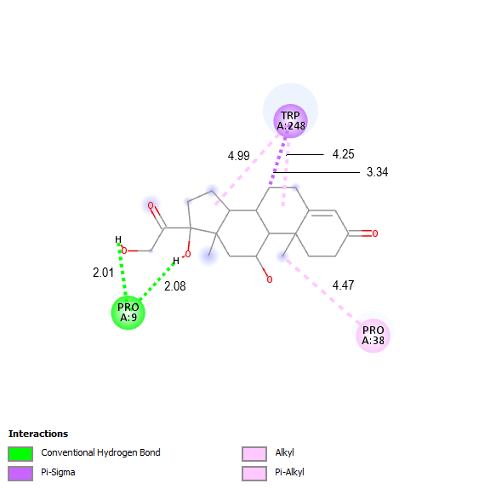 | 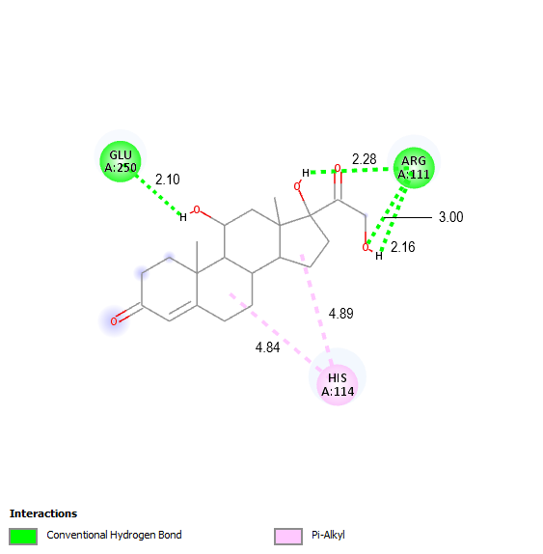
PDB: 7EMN BE: -5.19 kcal/mol | PDB: 7JVM BE: – 7.18 kcal/mol
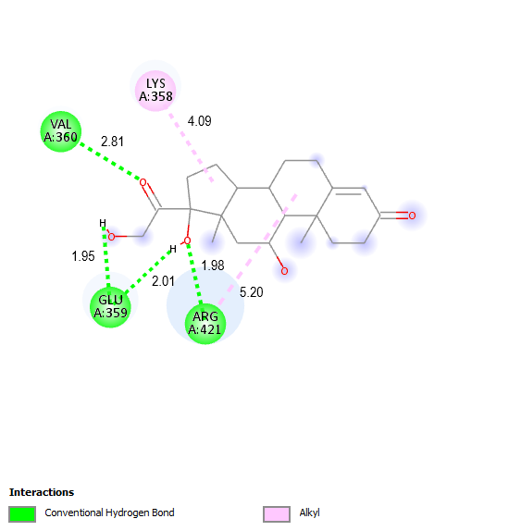 | 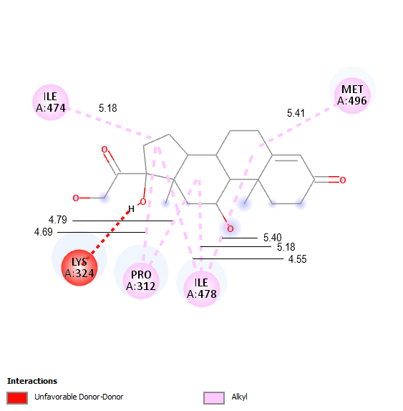
PDB: 7JVN BE: -4.91 kcal/mol | PDB: 7R7D BE: -4.7 kcal/mol
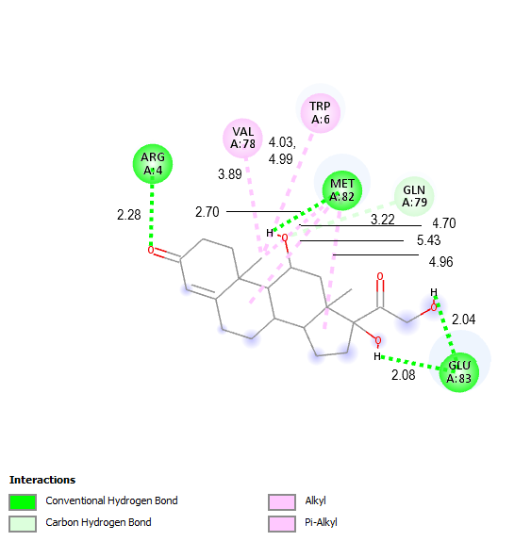 | 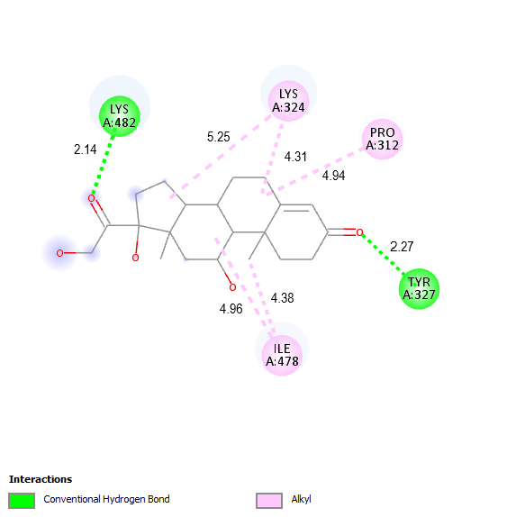
PDB: 7R7I BE: -4.35 kcal/mol | PDB: 7R7L BE: -4.92 kcal/mol
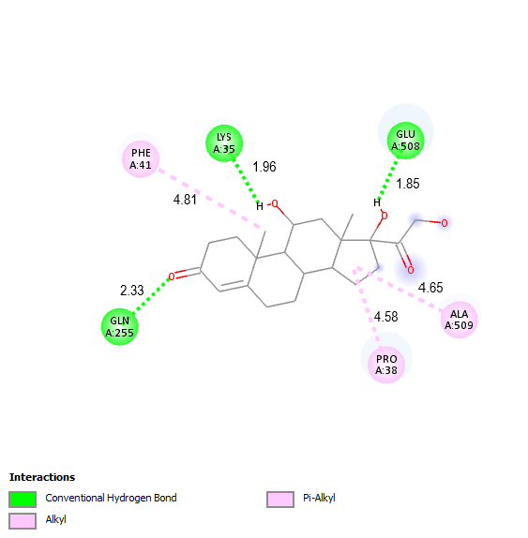 | 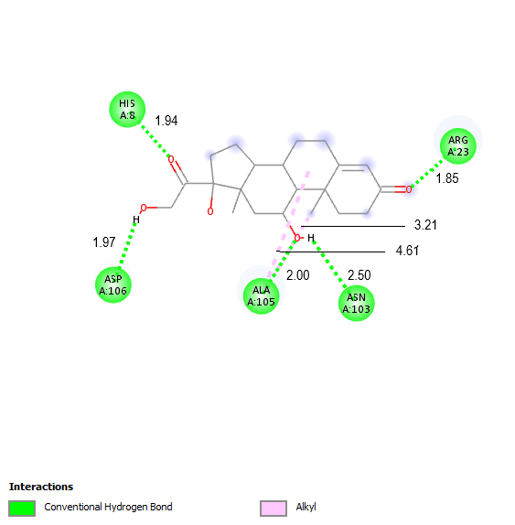
PDB: 7R75 BE: -8.05 kcal/mol | PDB: 7RCT BE: -6.68 kcal/mol
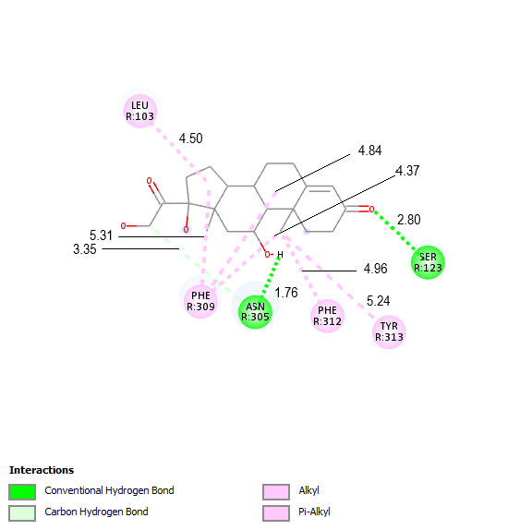 | 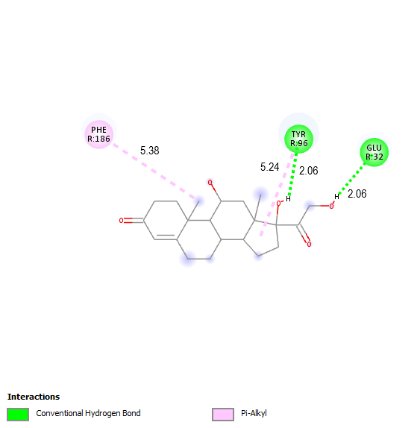
PDB: 7W2Z BE: -7.81 kcal/mol | PDB: 7WQ3 BE: -5.01 kcal/mol
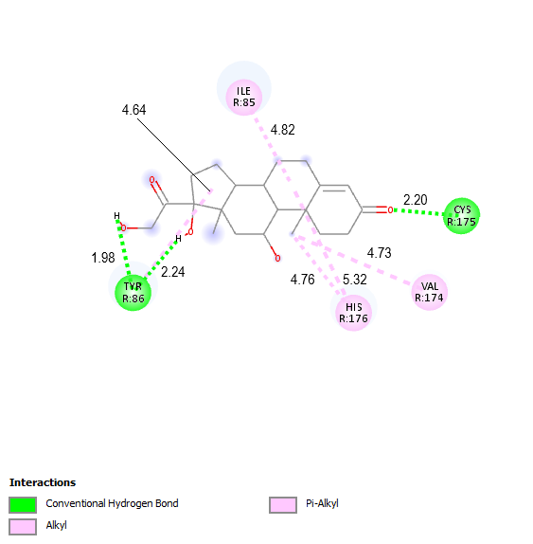 | 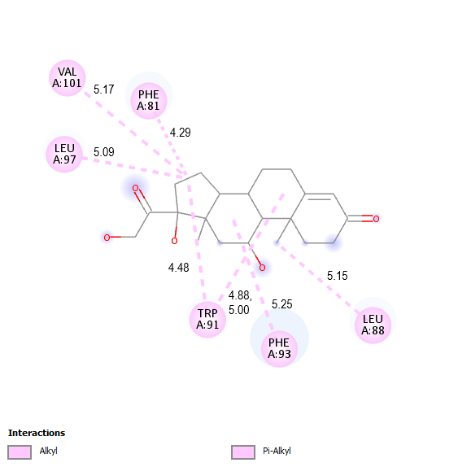
PDB: 7WQ4 BE: -5.66 kcal/mol | PDB: 7XBD BE: -5.22 kcal/mol

- Similarity assessment using Basic Local Alignment Search Tool (BLAST)²
These proteins were further compared for their similarities via the NCBI (National Library of Medicine) online server Basic Local Alignment Search Tool (BLAST)² method and found to have > 75% similarity altogether especially in their active binding sites for the intended target ligand cortisol.
FASTA format – input sequence
>2V95_1|Chain A|Peptide
CQLIQMDYVGNGTAFFILPDQGQMDTVIAALSRDTIDR
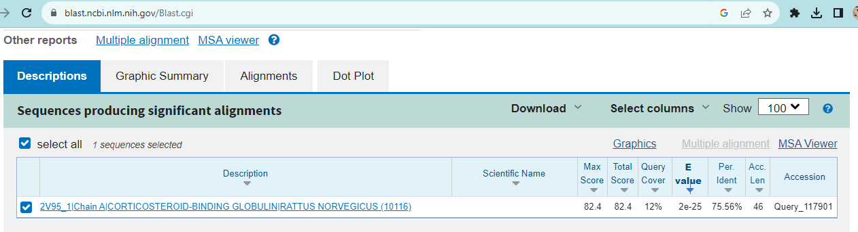
Figure S1 Sequence comparison between Corticosteroid-Binding Globulin PDB ID 2V95 and peptide demonstrating similarity

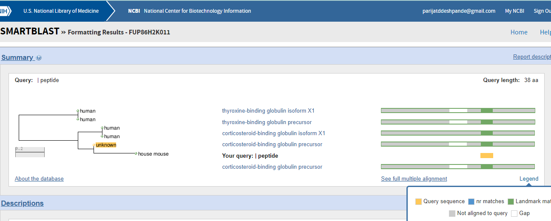
Figure S2 Baseline peptide compared with other proteins from database using smart BLAST

- Hydrophobicity of the baseline peptide as computed using Pep-Calc⁵.
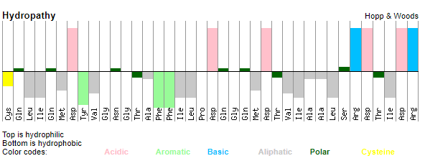

Figure S3: Hydrophobicity and hydrophilicity of the baseline peptide bioreceptor using Pep-Calc⁵

- Molecular modelling of native protein 2V95 using GROMACS
A
B
C
D

Figure S4: Intermediate molecular modelling plots for assessing (A) RMSD, (B) Radius of gyration, and (C) Compute WHAM⁴ (D) Binding affinity of cortisol with 2V95 in eccrine sweat solution using umbrella sampling³ and PMF
- Iterative development protocol of baseline peptide and comparison with Corticosteroid-Binding Globulins
Table SI 2: Interaction diagrams of candidate peptides compared with RAT, PIG, HUMAN CBGs

Candidate Peptides – Single letter representation of AAs | Docked structure with lowest binding energy | Interaction Diagram
Peptide # 1 QMDYVGNGTAFFILPDQGQMDTVIALSRDTIDILE | 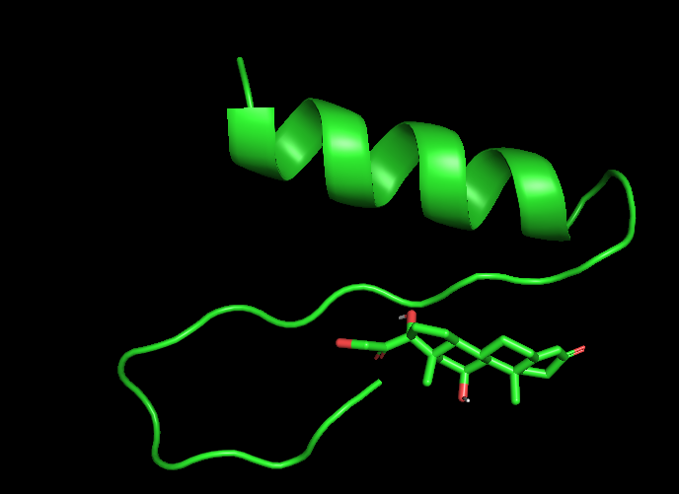 | 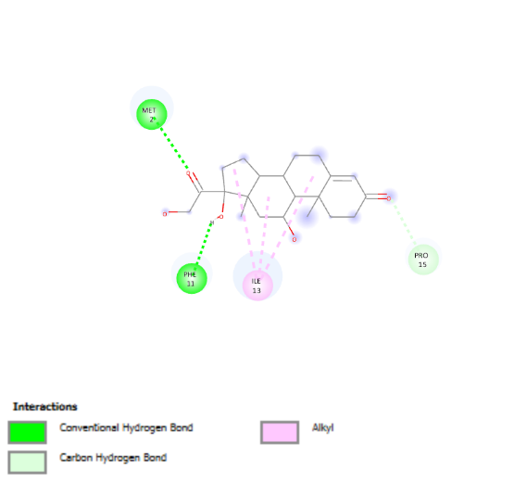
Peptide - #1 – 34AA sequence
Number of conformations = 50
Number of distinct conformational clusters found = 18
Cluster with lowest BE = -5.48 kcal/ mol has 7 conformations with a mean BE of -4.89 kcal/ mol
Cluster with highest number of conformations (=9) has lowest BE = -3.98 kcal/mol with a mean BE = -3.81 kcal/ mol
Peptide #2  LIQMDYVGNGTAFFILPDQGQMDTVIALSRDTIDRW | 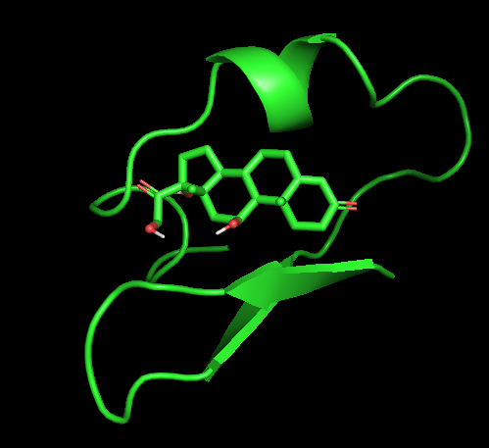 | 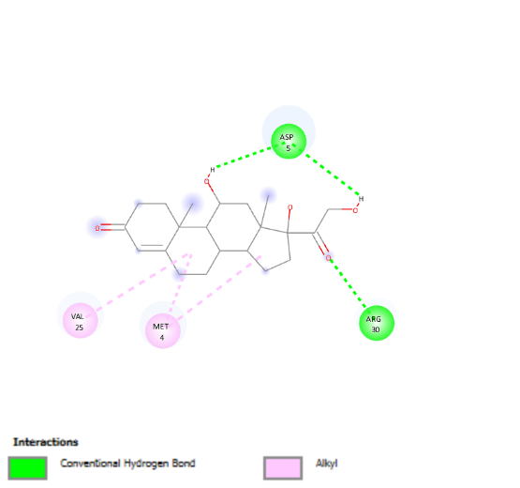
Peptide - #2 – 35AA sequence
Number of conformations = 10
Number of distinct conformational clusters found = 4
Cluster with lowest BE = -6.38 kcal/ mol has 7 conformations with a mean BE of -4.89 kcal/ mol has largest population
The residues GLN224 and ASP256 from the original 2V95 protein do not participate in the interaction with Cortisol, although the lowest BE increases. The peptide structure also changes, it now contains beta sheet in addition to alpha helixes.
Peptide #3  PCQLIQMDYVGNGTAFFILPDQGQMDTVIALSRDTIDRWGKL | 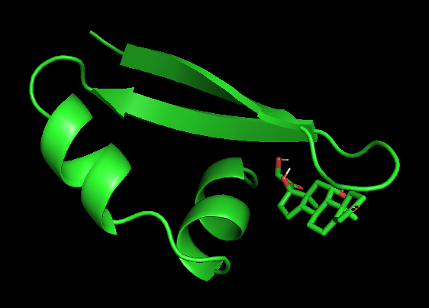 | 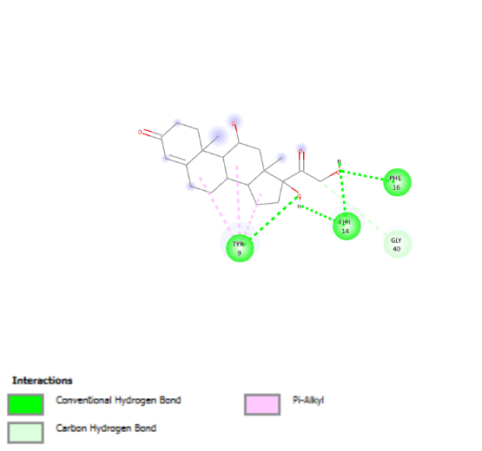
Peptide - #3 – 41AA sequence
Number of conformations = 10
Number of distinct conformational clusters found = 2
Cluster with lowest BE = -6.69 kcal/mol has a population of 8 and a mean BE of -6.47 kcal/mol
No significant improvement at the cost of longer AA sequence
RAT CBG -PCQLIQMDYVGNGTAFFILPDQGQMDTVIAALSRDTIDRWGKLMTP | 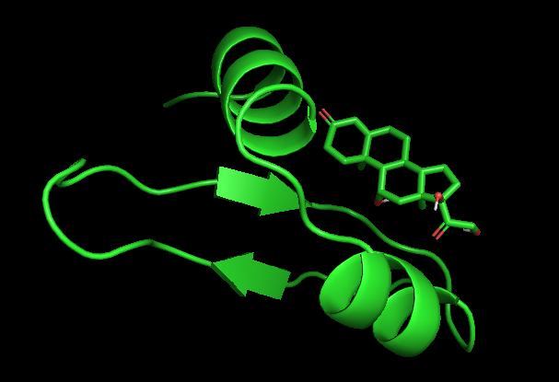 | 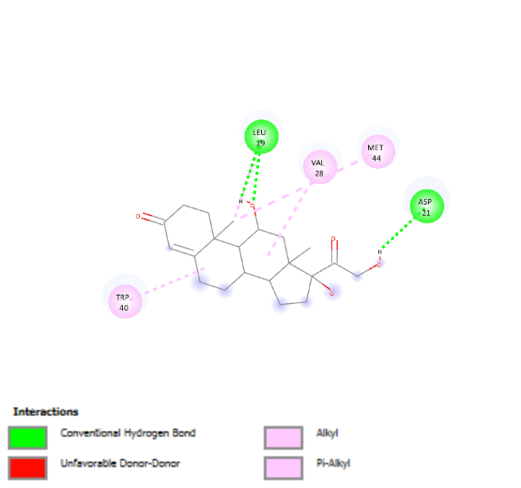
Number of conformations = 10
Number of distinct conformational clusters found = 2
Cluster with lowest BE = -6.34 kcal/mol has a population of 3 and a mean BE of -5.80 kcal/mol

PIG CBG - PCQLVQLEYTGNETAFFILPVKGEMDTVIAGLSRDTIQRWSKSLIP |  | 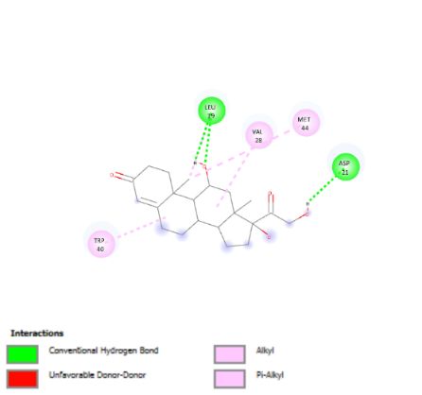
Number of conformations = 10
Number of distinct conformational clusters found = 2
Cluster with lowest BE = -4.61 kcal/mol has a population of 6 and a mean BE of -4.61 kcal/mol

HUMAN CBG - PCQLVQMNYVGNGTVFFILPDKGKMNTVIAALSRDTINRWSAGLTS | 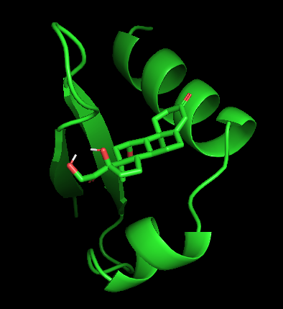 | 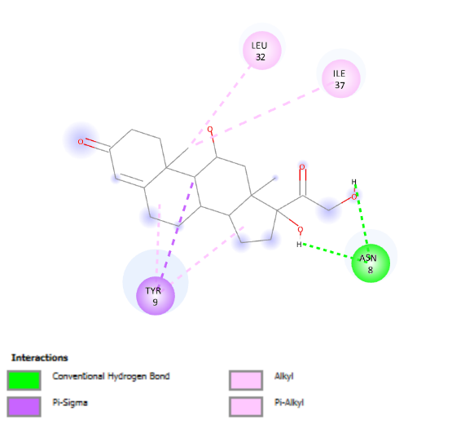
Number of conformations = 10
Number of distinct conformational clusters found = 4
Cluster with lowest BE = -6.42 kcal/mol has a population of 6 and a mean BE of -5.82 kcal/mol
Peptide with CYS at N-terminus  CQLIQMDYVGNGTAFFILPDQGQMDTVIALSRDTIDR | 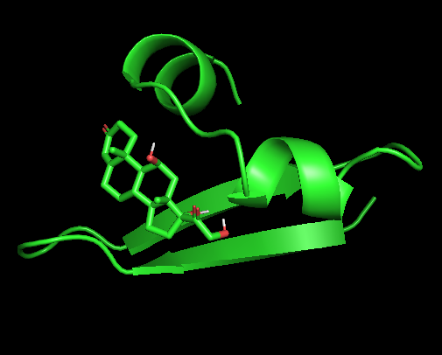 | 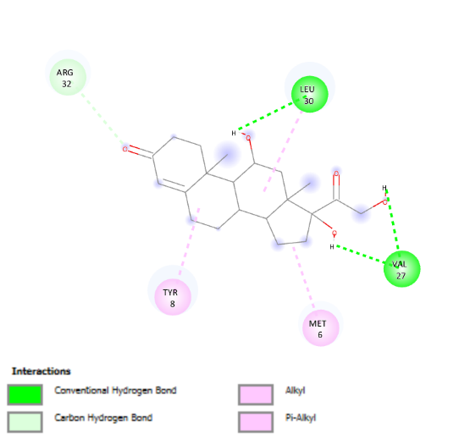
Peptide – Candidate baseline bioreceptor for cortisol – 37AA sequence
Number of conformations = 10
Number of distinct conformational clusters found = 4
Cluster with lowest BE = -6.45 kcal/mol has a population of 6 and a mean BE of -5.82 kcal/mol

References:
1. RCSB PDB: Homepage. https://www.rcsb.org/.
2. Boratyn, G. M. et al. Domain enhanced lookup time accelerated BLAST. (2012).
3. Badhe, Y., Gupta, R. & Rai, B. In silico design of peptides with binding to the receptor binding domain (RBD) of the SARS-CoV-2 and their utility in bio-sensor development for SARS-CoV-2 detection. RSC Adv 11, 3816–3826 (2021).
4. Rosenberg, J. M. et al. The weighted histogram analysis method for free-energy calculations on biomolecules The Weighted Histogram Analysis Method for Free-Energy Calculations on Biomolecules. I. The Method. https://www.researchgate.net/publication/200147620 (1992).
5. Lear, S. & Cobb, S. L. Pep-Calc.com: A set of web utilities for the calculation of peptide and peptoid properties and automatic mass spectral peak assignment. J Comput Aided Mol Des 30, 271–277 (2016).

