SUPPLEMENTARY FIGURES AND TABLES
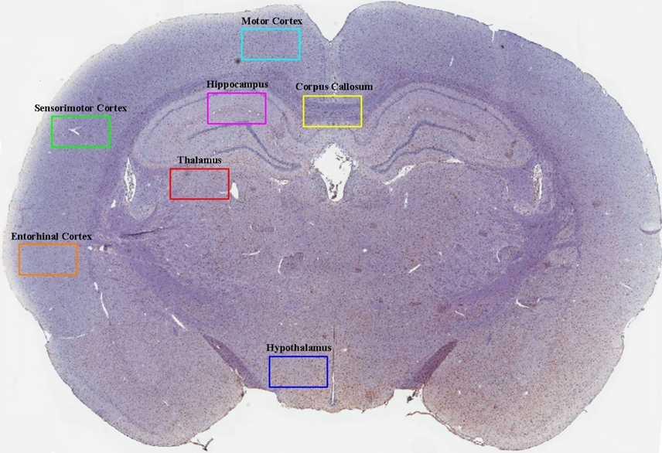
Supplementary Figure 1: Representative image of regions of interest included for microglia quantification. To isolate regions of interest for microglia cell number analyses, 1mm × 0.05mm boxes were placed over the motor cortex (teal), sensorimotor cortex (green), entorhinal cortex (orange), hippocampus (pink), corpus callosum (yellow), thalamus (red), and hypothalamus (dark blue) of brain slices stained for IBA-1.

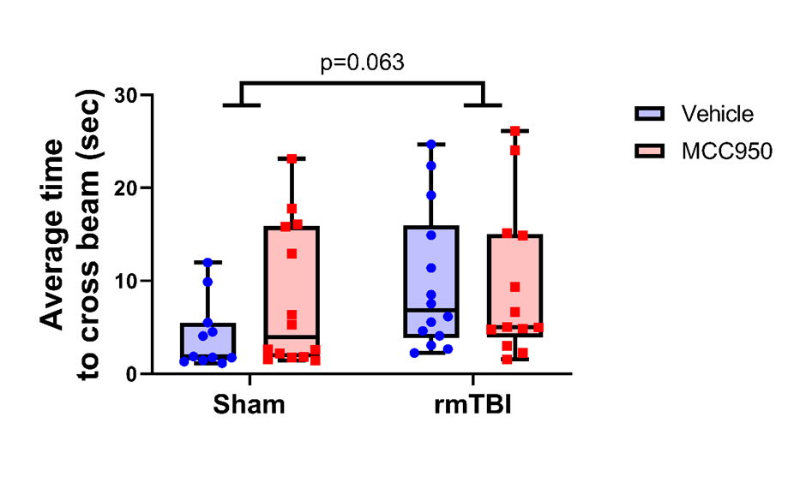
Supplementary Figure 2: Time to cross on the beam walk. There was no significant effect of rmTBI on the time to cross the beam at 4-hours post-rmTBI. Data are presented as min-max box-plots.

Supplementary Figure 3: There was no change to microglial reactivity in the contralateral hemisphere after rmTBI compared to shams. Microglial morphology was assessed as an indicator of reactivity. (A-C) Mean number of microglial branchpoints was similar between groups in the primary somatosensory cortex barrel field (S1BF), hippocampus, and perirhinal cortex. (D-F) Mean number of microglial endpoints was similar between groups in the S1BF, hippocampus, and perirhinal cortex. (G) Mean microglial branch length was decreased following rmTBI compared to uninjured shams in the S1BF, regardless of MCC950 treatment. (H-I) Mean microglial branch length was similar between groups in the hippocampus and perirhinal cortex. Data are presented as min-max box-plots. * denotes p-value < 0.05.
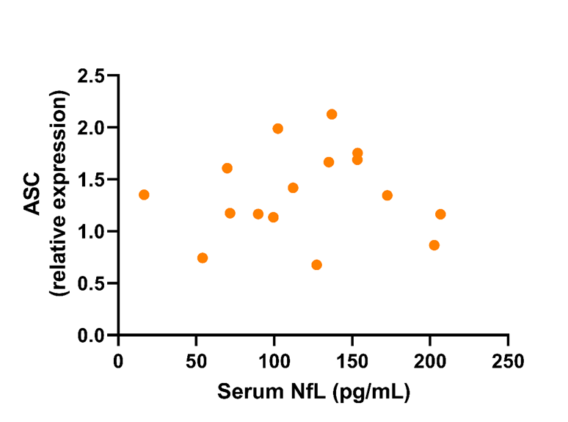
Supplementary Figure 4: Serum NfL levels were not significantly correlated with ASC mRNA levels in the hippocampus. A scatterplot represents the correlation analysis performed between serum NfL levels and mRNA levels of ASC in the hippocampus at 72-hours following rmTBI. No significant correlation was found.

 | Sham+Vehicle | Sham+MCC950 | rmTBI+Vehicle | rmTBI+MCC950
Sham+Vehicle |  | 95% CI (-20.47 to 27.13), p=0.972 | 95% CI (-30.77 to 20.11), p=0.916 | 95% CI (-50.47 to -2.87), p=0.028
Sham+MCC950 |  |  | 95% CI (-32.47 to 15.13), p=0.690 | 95% CI (-52.03 to -7.97), p=0.009
rmTBI+Vehicle |  |  |  | 95% CI (-45.13 to 2.47), p=0.083
rmTBI+MCC950

Supplementary Table 1: Post-hoc results for statistical analyses assessing group differences for microglia cell number in the hippocampus. 95% confidence intervals (CI) and p-values are provided for the Tukey’s multiple comparisons test for the microglial cell number in the hippocampus at 72-hours post the final injury. Significant group differences are in bold text.

