Supplementary Information

Supplementary Text 1. Conversion from annual Fe precipitation to BIF depositional rate
Supplementary Text 2. Greenalite saturation index and precipitation rate calculation
Supplementary Text 3. Archean carbonate ion concentration, model siderite saturation index, and siderite precipitation rate calculation
Supplementary Table 1. List of biogeochemical reactions included in the model
Supplementary Table 2. List of kinetics for the reactions included in the model
Supplementary Table 3. Default parameter values and their uncertainties used for sensitivity analyses
Supplementary Figure 1. Morris screening results of 14 model outputs
Supplementary Figure 2. Sobol’ indices of the remaining 13 model outputs
Supplementary Figure 3. Frequency histogram of the uncertainty of the Fe(II) oxidation fraction by photoferrotrophs
Supplementary Figure 4. Uncertainty propagation of net annual Fe precipitation
Supplementary Figure 5. Oxygenic phototroph productivity difference between the scenarios when microaerophilic IOB is present and absent.

Supplementary Texts

Supplementary Text 1. Conversion from annual Fe precipitation to BIF depositional rate

To estimate the banded iron formation (BIF) depositional rate with a net annual iron (Fe) precipitation, average density and Fe weight percentage of BIF are required. At the same time, the average density of BIF can be estimated with the weight percentage and redox state of Fe in BIFs.
We first assume that BIFs are composed of FeO, Fe₂O₃, and SiO₂ only. The average weight percentage and redox state of Fe in BIFs are estimated to be 38.1% and 2.4, respectively [1], which implies that average BIFs consist of 29.39% FeO, 21.77% Fe₂O₃, and 48.84% SiO₂. With the known densities of FeO (5.74E3 kg/m³), Fe₂O₃ (5.24E3 kg/m³), and SiO₂ (2.65E3 kg/m³), we arrive at an average BIF density of 4.12E3 kg/m³. The annual BIF depositional rate can then be calculated:
$$\begin{aligned}annual BIF depositional rate=\frac{net annual Fe precipitation*Fe molar weight}{BIF Fe weight percentage*BIF density}\#\left(1\right)\end{aligned}$$
Following this formula, a net annual Fe precipitation of 9.1 mol on a unit area converts to a BIF depositional rate of 325 m per million years (Myrs).

Supplementary Text 2. Greenalite saturation index and precipitation rate calculation

Idealized greenalite precipitation follows the stoichiometric equation:
$${3Fe}^{2+}+{2SiO}_{2(aq)}+5H_{2}O→4{Fe}_{3}{Si}_{2}O_{5}{(OH)}_{4}+6H^{+}$$
with a solubility product K_{sp}^{greenalite} of 3.98E-27 M⁻¹ [2]. The greenalite saturation index SI_{greenalite} can then be calculated:
$${SI}_{greenalite}=\log_{10}(\frac{{IAP}_{greenalite}}{K_{sp}^{greenalite}})$$
where IAP_{greenalite} is the greenalite ion activity product of the solution:
$${IAP}_{greenalite}=\frac{{(γ_{Fe(II)}*[Fe(II)])}^{3}*{(γ_{SiO_{2}}*[SiO_{2}])}^{3}}{{(γ_{H^{+}}*[H^{+}])}^{6}}$$
Where the seawater activity coefficient of Fe(II) ($γ_{Fe(II)}$) is 0.23, $γ_{SiO_{2}}$ is 1.13, and $γ_{H^{+}}$ is 0.73. The empirical greenalite precipitation rate is an exponential function of SI_{greenalite}:
$$r_{greenalite}=k_{greenalite}* exp(b_{greenalite}*{SI}_{greenalite})$$
where k_{greenalite} equals 6.996E-13 Mh⁻¹, b_{greenalite} equals 1.856 [3].

With a well constrained Archean silica concentration of 1.5 μM [4] and simulated Archean ocean pH of 7 [5, 6], our default Fe(II) concentration (50 μM) corresponds to a greenalite SI of -4. To achieve a theoretical maximum greenalite SI, we adopt a silica concentration saturated with respect to amorphous silica (2.2 μM), an upper bound of simulated pH of 7.7 [6], and a high Archean Fe(II) concentration of 150 μM, which lead to a greenalite Si of 0.8. This theoretical maximum greenalite SI gives rise to an annual greenalite precipitation rate of 0.014 mol/m².

Supplementary Text 3. Archean carbonate ion concentration, model siderite saturation index, and siderite precipitation rate calculation

The carbonate ion concentration in Archean oceans can be derived either from estimated pH and atmospheric pCO2, or from calcite solubility, estimated calcium ion concentration, and calcite supersaturation state. Carbon cycle modelling gives an estimated 2.5 Ga ocean pH of 7 and atmospheric pCO2 of 0.06 atm [6], which corresponds to an carbonate ion concentration of 1.28E-4 M. Assuming that the Archean ocean calcite supersaturation state is same as the preindustrial one (2.6), an Archean ocean calcium concentration of 0.03 M [4] corresponds to an carbonate ion concentration of 4.18E-5 M. We thus adopt a conservative Archean carbonate ion concentration of 1E-4 M.

The siderite SI is
$${SI}_{siderite}=\log_{10}(\frac{γ_{Fe(II)}*[Fe(II)]*γ_{{CO}_{3}^{2-}}*[{CO}_{3}^{2-}]}{K_{sp}^{siderite}})$$
Where $γ_{{CO}_{3}^{2-}}$ equals 1.17 and $K_{sp}^{siderite}$ equals 5.8E-11 [7]. In ferruginous seawater, siderite precipitation is initiated by the precipitation of amorphous Fe carbonate (AFC). The empirical precipitation rate of AFC is
$$r_{siderite}=3.271*{10}^{-10}* exp(9.042*\log_{10}({IAP}_{AFC}))$$
Where the AFC ion activity product IAP_{AFC} can be calculated as
$${IAP}_{AFC}=γ_{Fe(II)}*[Fe(II)]*γ_{{CO}_{3}^{2-}}*[{CO}_{3}^{2-}]*{(γ_{{OH}^{-}}*[{OH}^{-}])}^{0.5}$$
Our default Fe(II) concentration of 50 μM corresponds to a siderite SI of 1.4, which leads to an annual AFC precipitation rate of 1.2e-53 mol/m².

Supplementary Tables

Supplementary Table 1. List of biogeochemical reactions included in the model

 | Process | Stoichiometry
R1 | oxygenic phototroph growth | $${HCO}_{3}^{-}+(1+3a)H_{2}O+a{PO}_{4}^{3-}\underset{→}{light}CH_{2}O{(H_{3}{PO}_{4})}_{a}+O_{2}+(1+3a){OH}^{-}$$
R2 | photoferrotroph growth | $${HCO}_{3}^{-}+{4Fe}^{2+}+a{PO}_{4}^{3-}+10H_{2}O\underset{→}{light}CH_{2}O{(H_{3}{PO}_{4})}_{a}+4Fe{(OH)}_{3(c)}+(7-3a)H^{+}$$
R3 | microaerophilic iron oxidizing bacteria (IOB) growth | $${HCO}_{3}^{-}+b{Fe}^{2+}+{(\frac{b-4}{4})O}_{2}+a{PO}_{4}^{3-}+(2.5b)H_{2}O$$  $$→CH_{2}O{(H_{3}{PO}_{4})}_{a}+bFe{(OH)}_{3(c)}+(2b-3a-1)H^{+}$$
R4 | Iron reducing bacteria (IRB) growth on iron oxyhydroxide colloid | $$1.2CH_{2}O{(H_{3}{PO}_{4})}_{a}+4Fe{(OH)}_{3(c)}+(7-3a)H^{+}$$  $$→0.2CH_{2}O{(H_{3}{PO}_{4})}_{a(IRB)}+{HCO}_{3}^{-}+{4Fe}^{2+}+a{PO}_{4}^{3-}+10H_{2}O$$
R5 | IRB growth on iron oxyhydroxide particulate | $$1.2CH_{2}O{(H_{3}{PO}_{4})}_{a}+4Fe{(OH)}_{3(p)}+(7-3a)H^{+}$$  $$→0.2CH_{2}O{(H_{3}{PO}_{4})}_{a(IRB)}+{HCO}_{3}^{-}+{4Fe}^{2+}+a{PO}_{4}^{3-}+10H_{2}O$$
R6 | abiotic homogeneous Fe(II) oxidation by oxygen | $${4Fe}^{2+}+O_{2}+10H_{2}O→4Fe{(OH)}_{3(c)}+8H^{+}$$
R7 | abiotic heterogeneous Fe(II) oxidation by oxygen | $${4Fe}^{2+}+O_{2}+10H_{2}O\underset{→}{Fe{(OH)}_{3(p)}}4Fe{(OH)}_{3(c)}+8H^{+}$$
R8 | iron oxyhydroxide colloid aggregation | $$Fe{(OH)}_{3(c)}→ Fe{(OH)}_{3(p)}$$

Supplementary Table 2. List of kinetics for the reactions included in the model

process | kinetics formulation
oxygenic phototroph growth | $$R1=Vmax_opt*\frac{light}{Km_I_opt+light}*\frac{[{PO}_{4}^{3-}]}{Km_P_opt+[{PO}_{4}^{3-}]}$$
photoferrotroph growth | $$R2=Vmax_pft*\frac{light}{Km_I_pft+light}*\frac{[{PO}_{4}^{3-}]}{Km_P_pft+[{PO}_{4}^{3-}]}*\frac{[{Fe}^{2+}]}{Km_Fe_pft+{[Fe}^{2+}]}$$
microaerophilic IOB growth | $$R3=Vmax_IOB*\frac{[{PO}_{4}^{3-}]}{Km_P_IOB+[{PO}_{4}^{3-}]}*\frac{[{Fe}^{2+}]}{Km_Fe_IOB+{[Fe}^{2+}]}*\frac{[O_{2}]}{Km_O2_IOB+[O_{2}]}$$
IRB growth on iron oxyhydroxide colloid | $$R4=4*(R1+R2+R3)*\frac{[Fe{(OH)}_{3(c)}]}{Km_FeIIIc_IRB+[Fe{(OH)}_{3(c)}]}$$
IRB growth on iron oxyhydroxide particulate | $$R5=4*(R1+R2+R3)/3*\frac{[Fe{(OH)}_{3(p)}]}{Km_FeIIIp_IRB+[Fe{(OH)}_{3(p)}]}$$
abiotic homogeneous Fe(II) oxidation by oxygen | $$R6={10}^{\left[\left(21.56-\frac{1545}{T}\right)-3.29*\sqrt{I}+1.52*I\right]}*[{Fe}^{2+}]*[O_{2}]*{[{OH}^{-}]}^{2}$$
abiotic heterogeneous Fe(II) oxidation by oxygen | $$R7=\frac{ks*Kads*[O_{2}]}{[H^{+}]}*[Fe{(OH)}_{3(p)}]* [{Fe}^{2+}]$$
iron oxyhydroxide colloid aggregation | $$R8={10}^{\left[\log\left(\left[Fe{(OH)}_{3(c)}\right]*1e9\right)-25.1\right]}*1e9*{[Fe{(OH)}_{3(c)}]}^{2}$$

Supplementary Table 3. Default parameter values and their uncertainties used for sensitivity analyses

 | model parameter | description | min | default value | max | unit | min /default | max /default | source
1 | PO4_bottom | bottom water phosphate concentration | 50 | 150 | 450 | µmol/m³ | 0.333 | 3 | [4]
2 | Fe_bottom | bottom water ferrous iron concentration | 16666.7 | 50000 | 150000 | µmol/m³ | 0.333 | 3 | [8]
3 | O2_top | atmosphere oxygen concentration | 0.5 | 1.5 | 4.5 | µmol/m³ | 0.333 | 3 | [9]
4 | Kv | seawater vertical turbulent diffusivity | 3.3E-05 | 0.0001 | 0.0003 | m²/s | 0.333 | 3 | [10]
5 | w | seawater upwelling speed | -1.93E-06 | -5.79E-06 | -1.74E-05 | m/s | 0.333 | 3 | [11]
6 | Sc | iron oxyhydroxide colloid settling speed | 4E-09 | 1.2E-08 | 4E-08 | m/s | 0.333 | 3 | N/A
7 | Sp | iron oxyhydroxide particulate settling speed | 0.00004 | 0.00012 | 0.0004 | m/s | 0.333 | 3 | N/A
8 | I0 | incident light intensity at the ocean surface | 700 | 1000 | 1500 | µEinst/m²/s | 0.7 | 1.5 | [12]
9 | k_I | seawater light attenuation length scale | 5 | 15 | 20 | m | 0.333 | 1.3 | [13]
10 | Vmax_opt | maximum growth rate of oxygenic phototrophs | 0.66667 | 2 | 6 | µmolC/m³/s | 0.333 | 3 | [14]
11 | Vmax_pft | maximum growth rate of photoferrotrophs | 0.33333 | 1 | 3 | µmolC/m³/s | 0.333 | 3 | [15]
12 | Vmax_IOB | maximum growth rate of microaerophilic IOB | 0.66667 | 2 | 6 | µmolC/m³/s | 0.333 | 3 | [16]
13 | Km_P_opt | phosphate half saturation constant of oxygenic phototrophs | 5 | 15 | 45 | µmol/m³ | 0.333 | 3 | [14]
14 | Km_P_pft | phosphate half saturation constant of photoferrotrophs | 3.33333 | 10 | 30 | µmol/m³ | 0.333 | 3 | [15]
15 | Km_P_IOB | phosphate half saturation constant of microaerophilic IOB | 3.33333 | 10 | 30 | µmol/m³ | 0.333 | 3 | N/A
16 | Km_I_opt | light half saturation constant of oxygenic phototrophs | 32.6667 | 98 | 294 | µEinst/m²/s | 0.333 | 3 | [14]
17 | Km_I_pft | light half saturation constant of photoferrotrophs | 0.33333 | 1 | 3 | µEinst/m²/s | 0.333 | 3 | [17]
18 | Km_Fe_pft | Fe(II) half saturation constant of photoferrotrophs | 3666.67 | 11000 | 33000 | µmol/m³ | 0.333 | 3 | [15]
19 | Km_Fe_IOB | Fe(II) half saturation constant of microaerophilic IOB | 15533.3 | 46600 | 139800 | µmol/m³ | 0.333 | 3 | [18]
20 | Km_O2_IOB | oxygen half saturation constant of microaerophilic IOB | 625 | 1875 | 5625 | µmol/m³ | 0.333 | 3 | [18]
21 | Km_FeIIIc_IRB | iron oxyhydroxide colloid half saturation constant of IRB | 333333 | 1E+06 | 3E+06 | µmol/m³ | 0.333 | 3 | [19]
22 | Km_FeIIIp_IRB | iron oxyhydroxide particulate half saturation constant of IRB | 333333 | 1E+06 | 3E+06 | µmol/m³ | 0.333 | 3 | [19]
23 | rFeC_IOB | Fe(II) oxidation to carbon fixation ratio of microaerophilic IOB | 14.6667 | 44 | 132 | N/A | 0.333 | 3 | [20]
24 | I | seawater ionic strength | 0.23333 | 0.7 | 2.1 | mol/L | 0.333 | 3 | N/A
25 | pH | seawater pH | 6.5 | 7 | 8.1 | N/A | 0.929 | 1.2 | [6]
26 | ks | surface rate change of heterogeneous iron oxidation | 2.4E-08 | 7.3E-08 | 2.2E-07 | m³/µmol/s | 0.333 | 3 | [21]
27 | Kads | adsorption constant of Fe(II) on particulate iron oxyhydroxides | 4.7E-06 | 1.4E-05 | 4.2E-05 | N/A | 0.333 | 3 | [21]
28 | t | seawater temperature | 8.33333 | 25 | 75 | °C | 0.333 | 3 | N/A
29 | kO2 | piston velocity for oxygen gas exchange | 1.5E-05 | 4.5E-05 | 1.4E-04 | m/s | 0.333 | 3 | N/A

Supplementary Figures
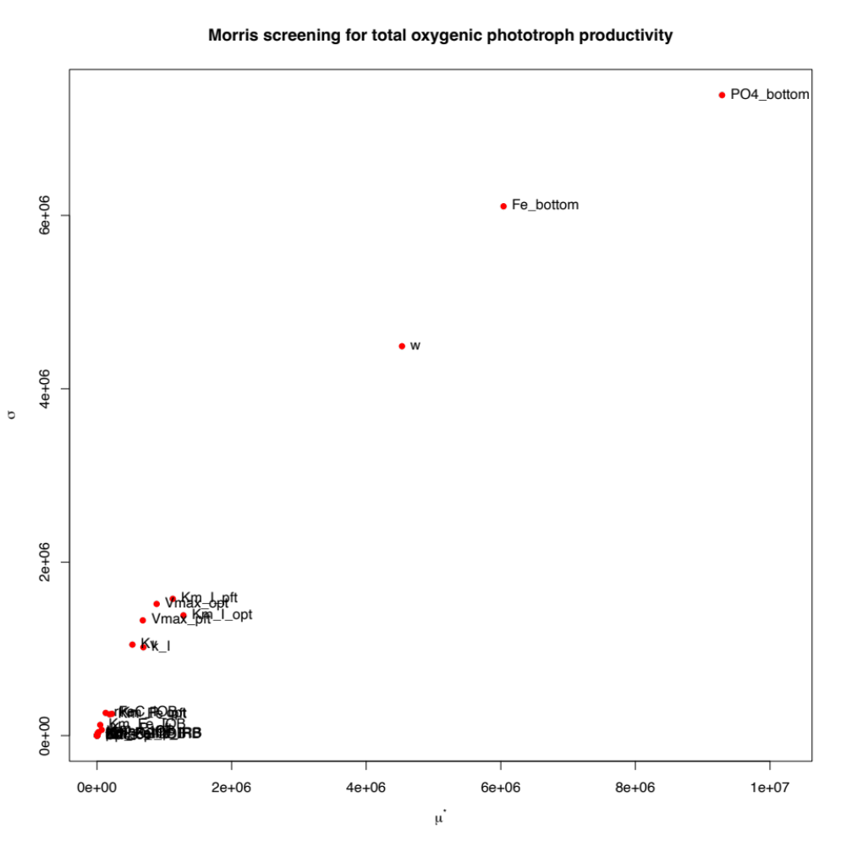
Supplementary Figure 1(a). Total oxygenic phototroph productivity
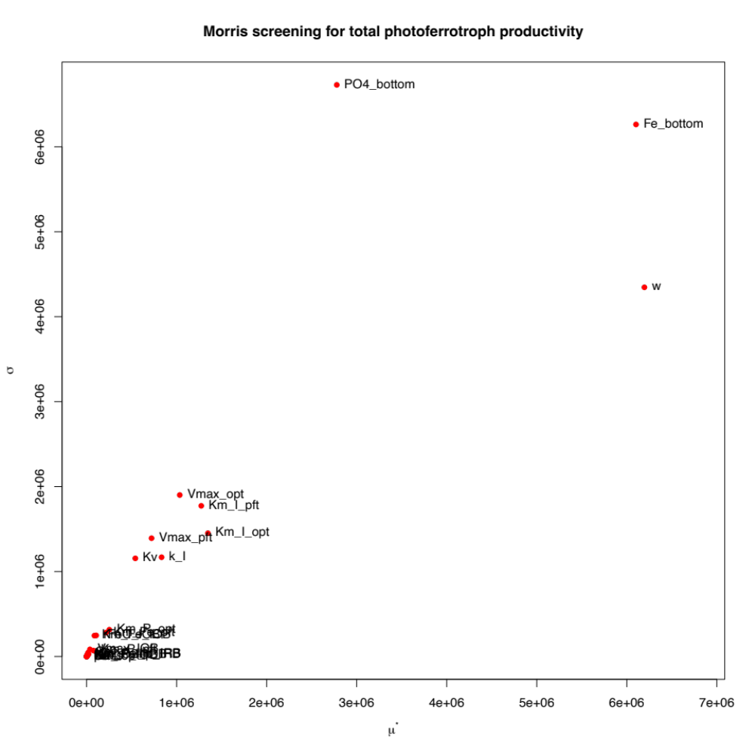
Supplementary Figure 1(b). Total photoferrotroph productivity
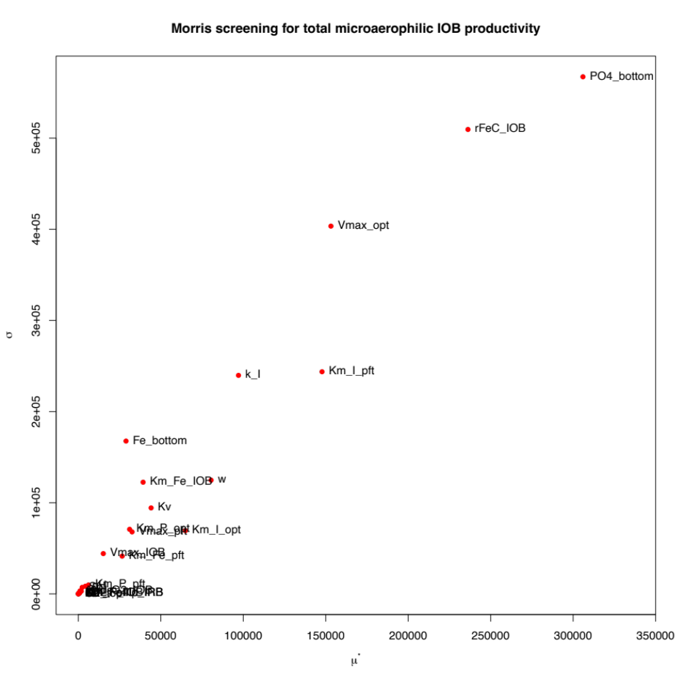
Supplementary Figure 1(c). Total microaerophilic IOB productivity
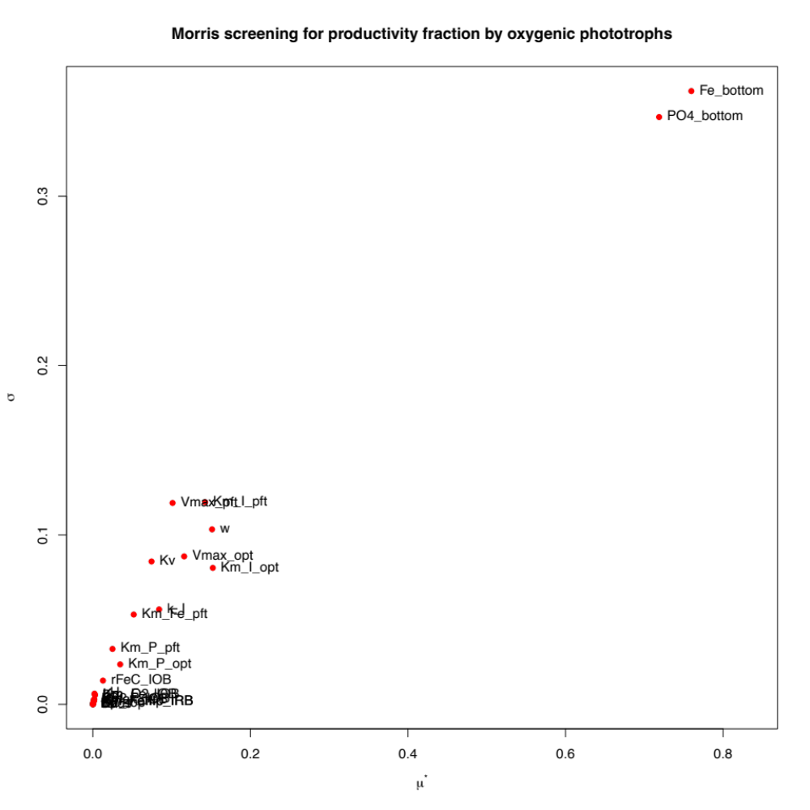
Supplementary Figure 1(d). Productivity fraction by oxygenic phototrophs
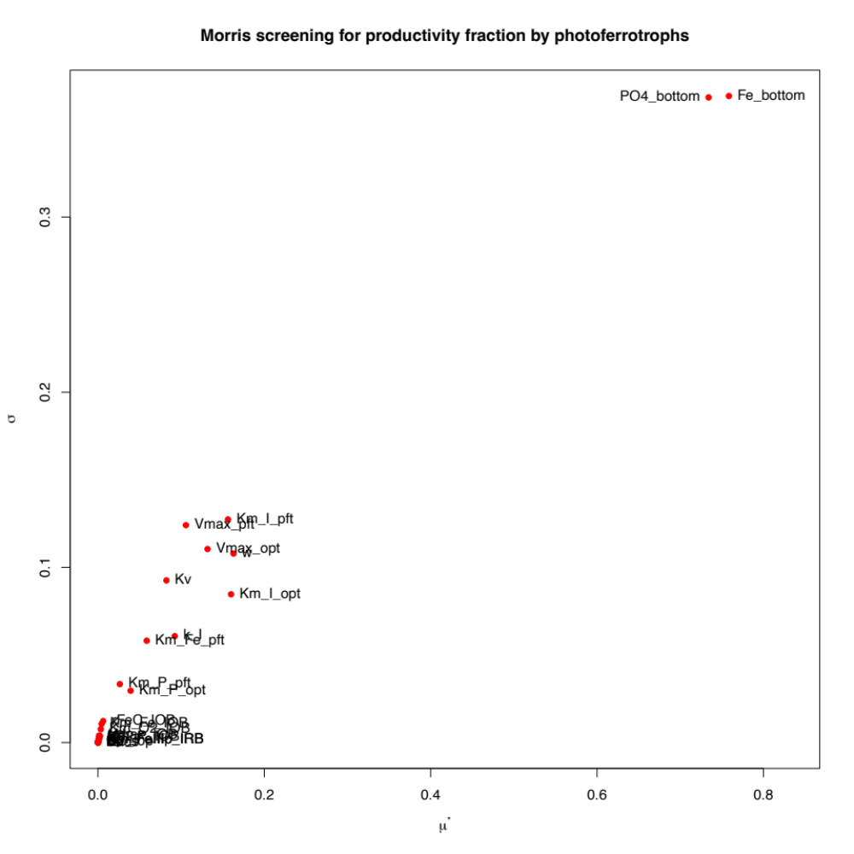
Supplementary Figure 1(e). Productivity fraction by photoferrotrophs
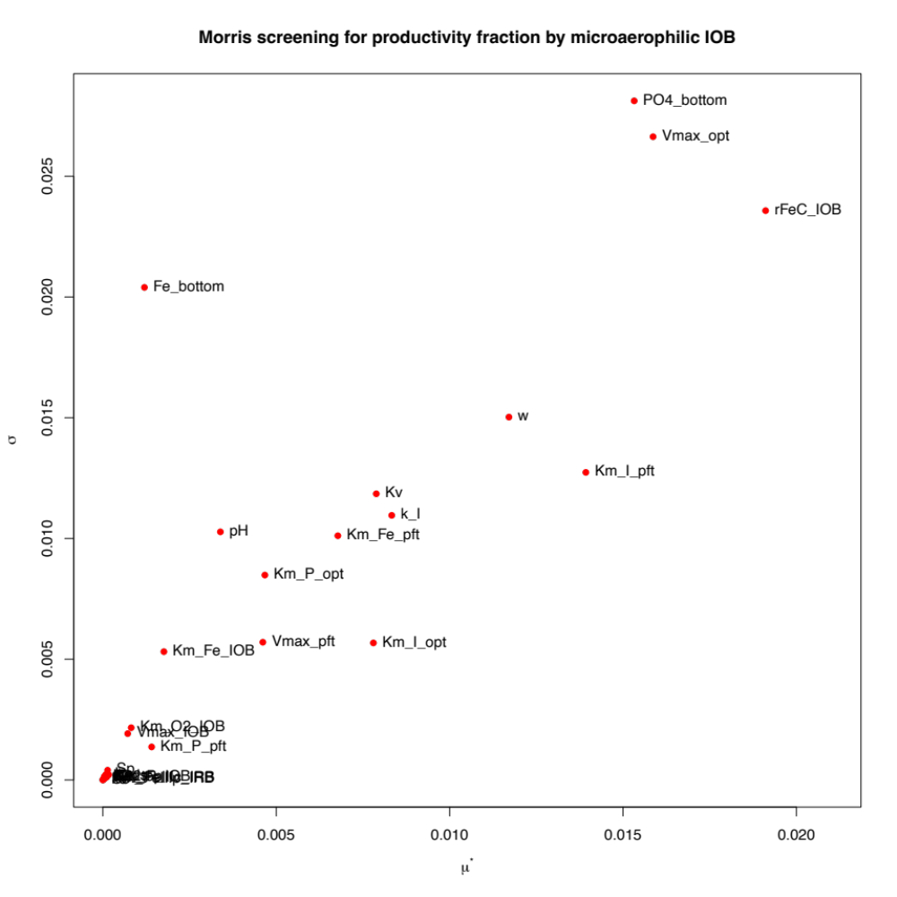
Supplementary Figure 1(f). Productivity fraction by microaerophilic IOB
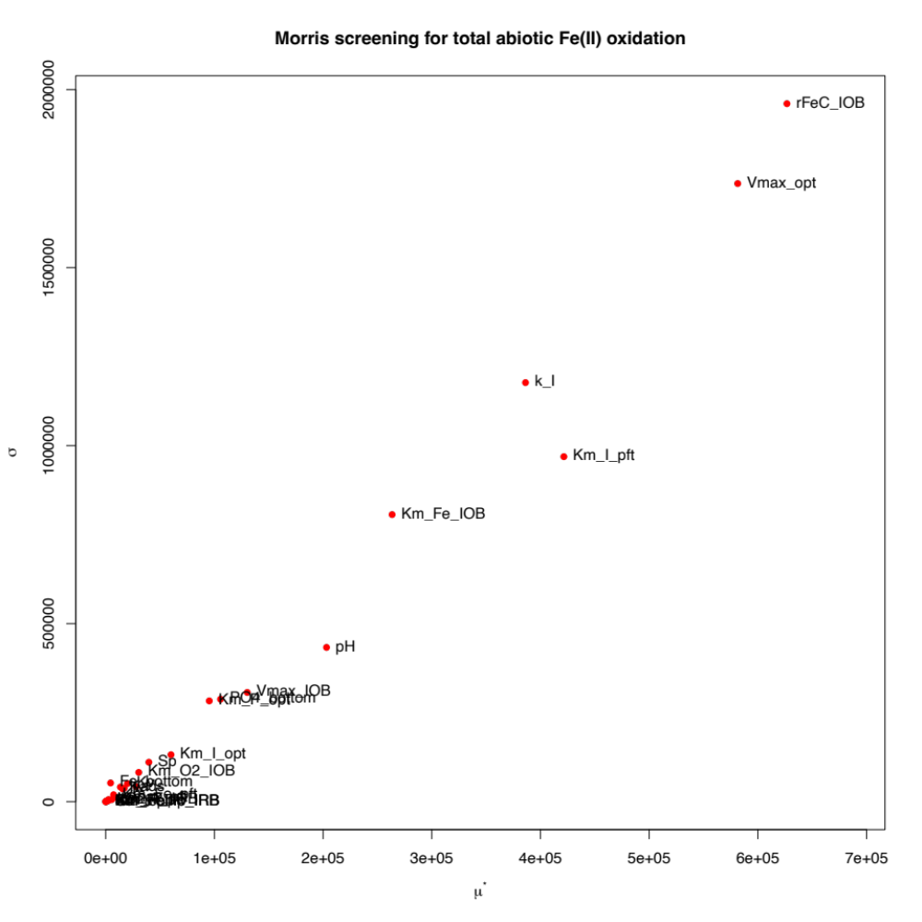
Supplementary Figure 1(g). Total Fe(II) oxidation via abiotic reactions with oxygen
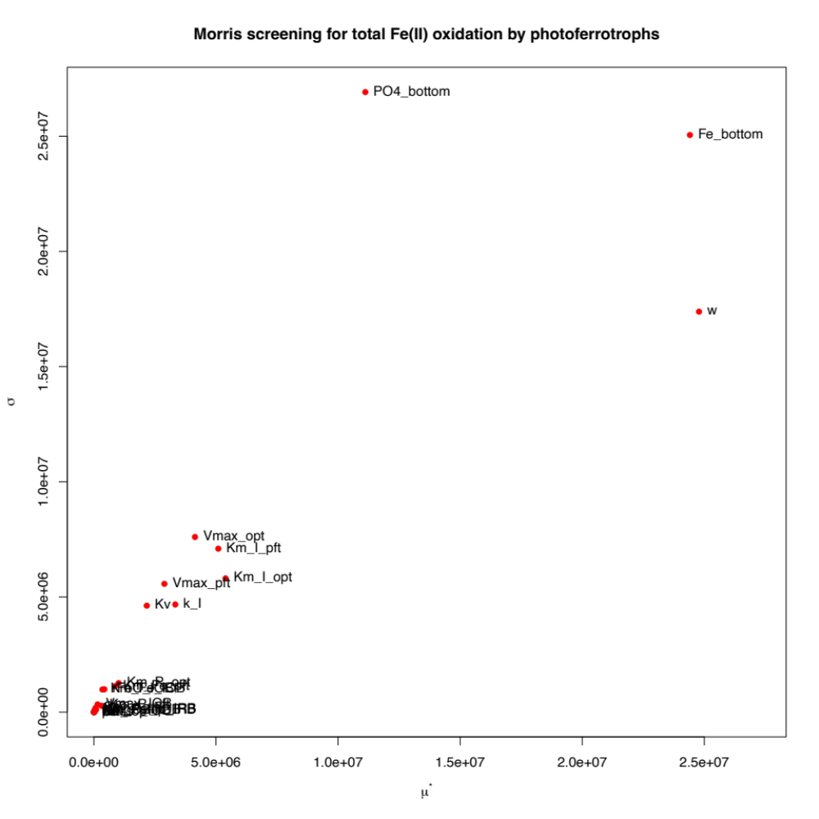
Supplementary Figure 1(h). Total Fe(II) oxidation by photoferrotrophs
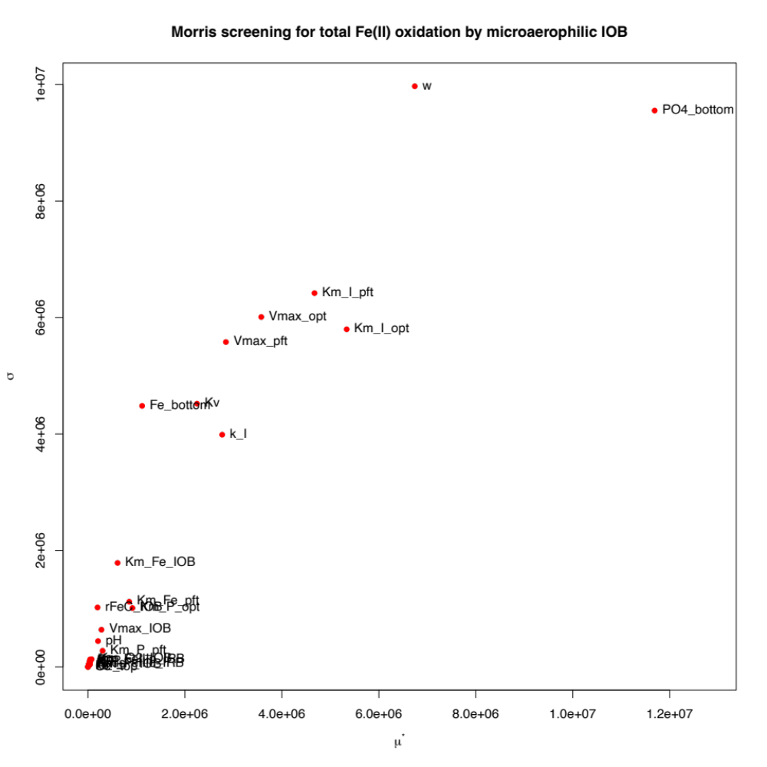
Supplementary Figure 1(i). Total Fe(II) oxidation by microaerophilic IOB
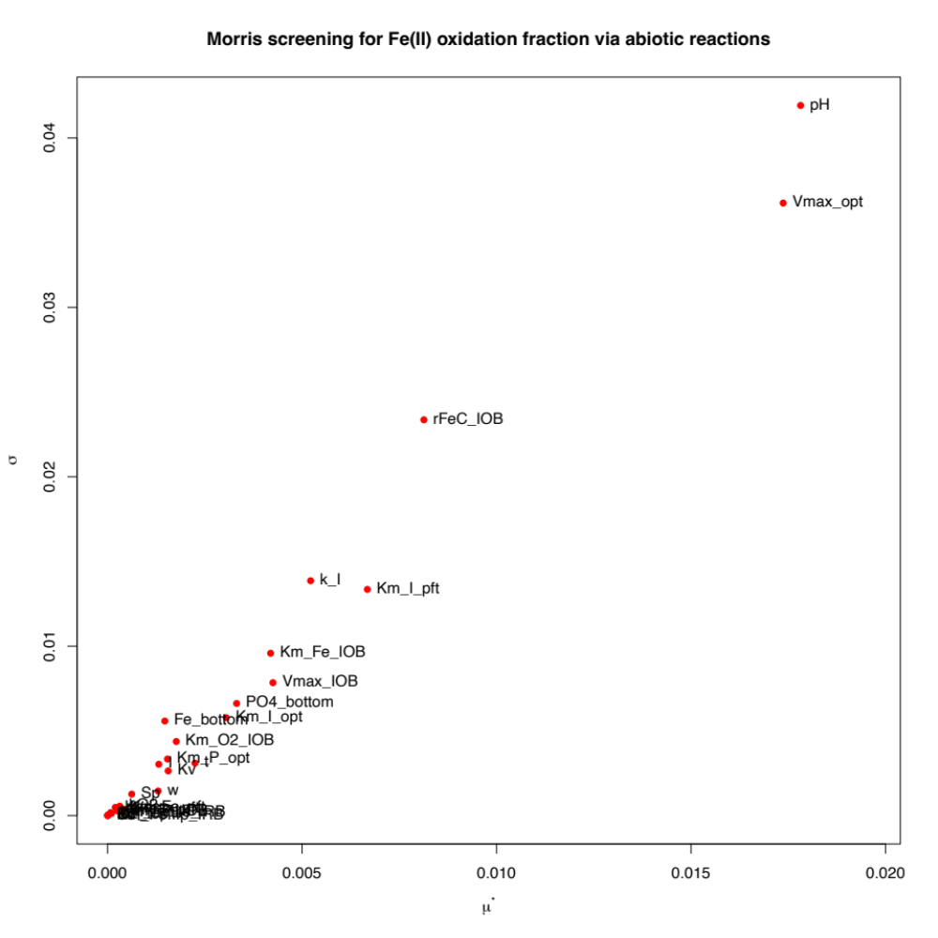
Supplementary Figure 1(j). Fe(II) oxidation fraction via abiotic reactions with oxygen
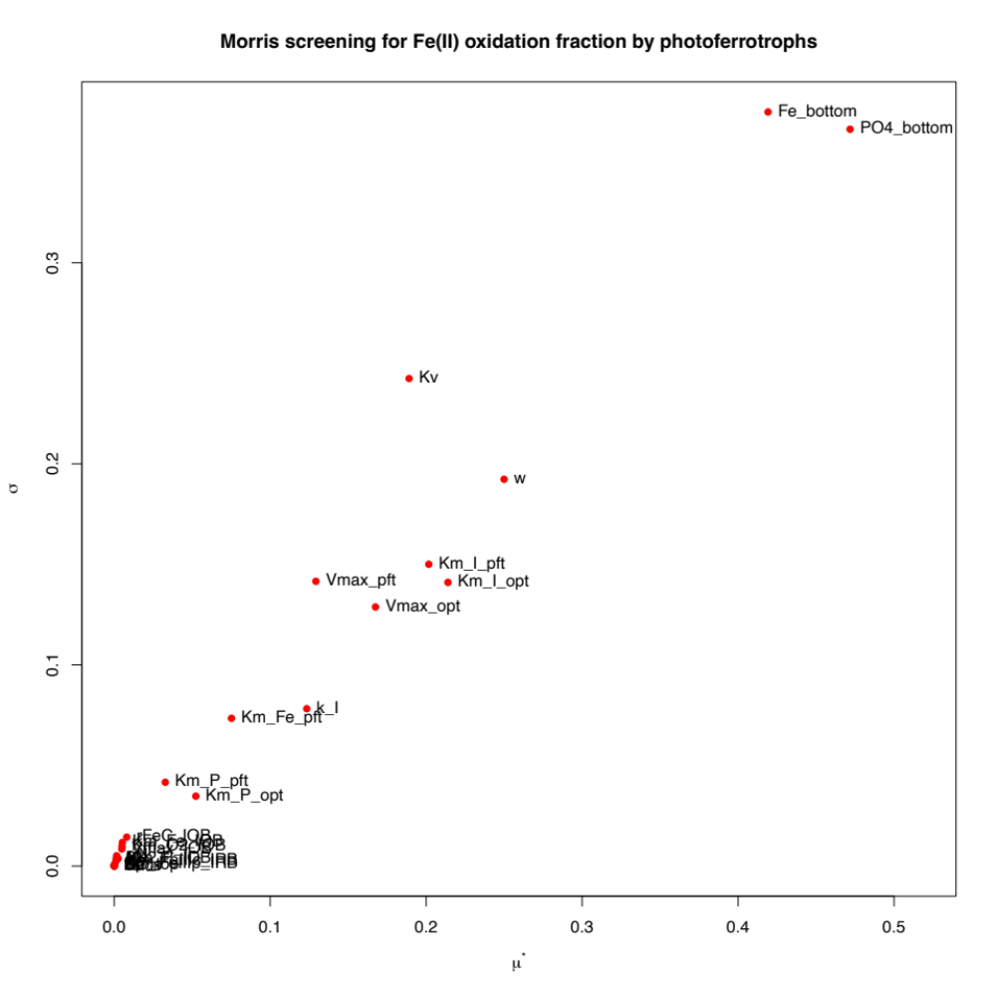
Supplementary Figure 1(k). Fe(II) oxidation fraction by photoferrotrophs
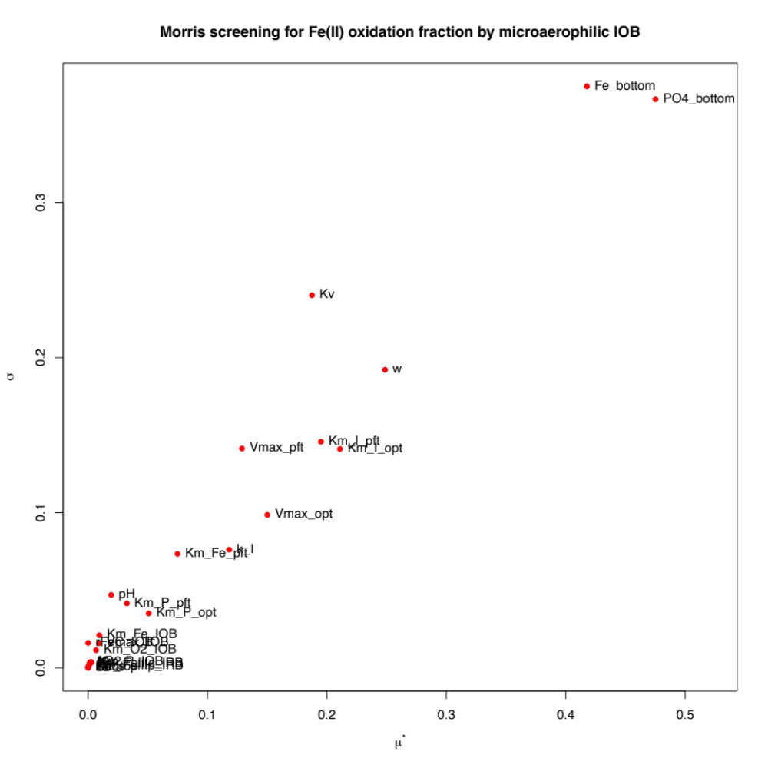
Supplementary Figure 1(l). Fe(II) oxidation fraction by microaerophilic IOB
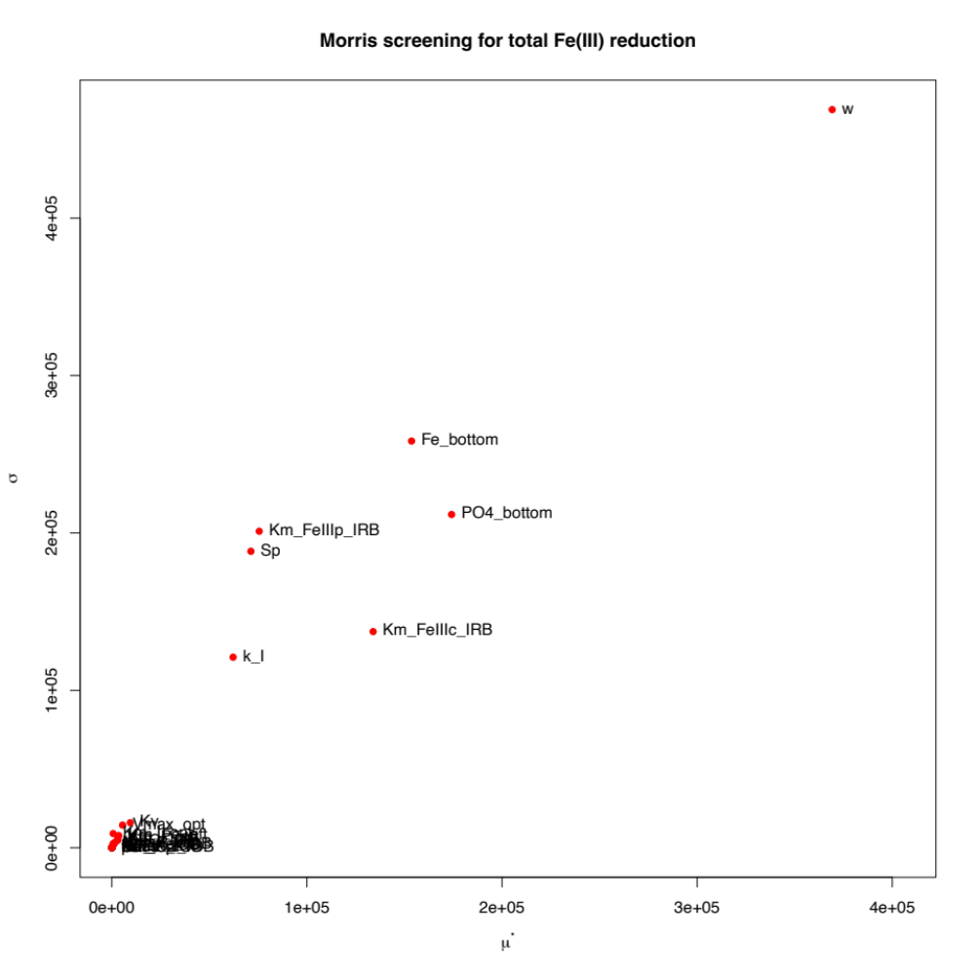
Supplementary Figure 1(m). Total iron reduction
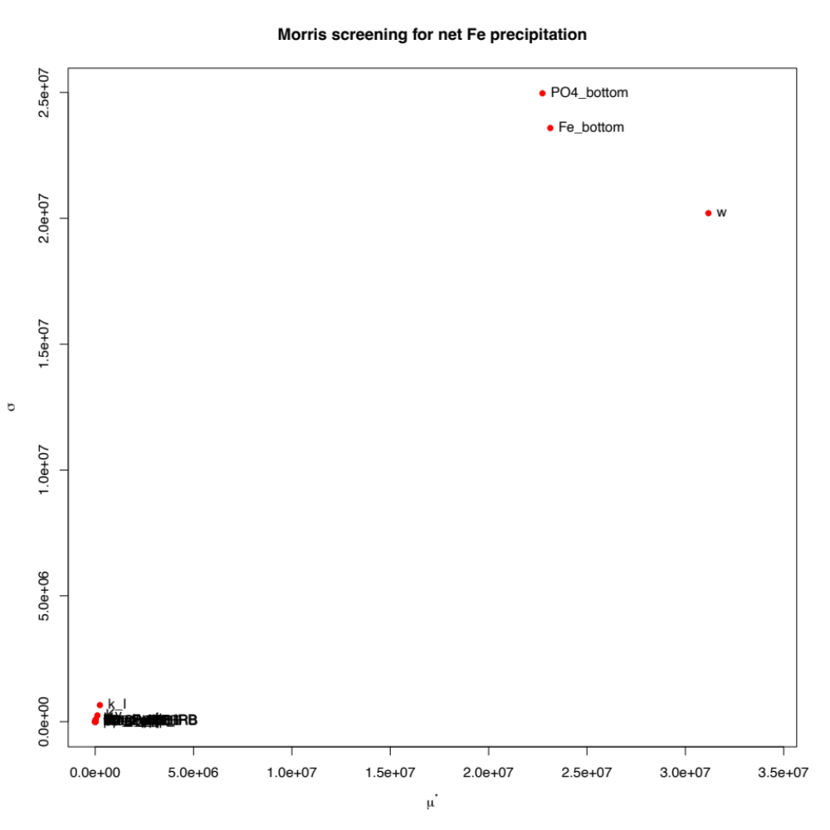
Supplementary Figure 1(n). Net annual Fe precipitation.
Supplementary Figure 1. Morris screening results of 14 model outputs. All 29 model parameters are tested, as listed in Supplementary Table 3. The x-axis μ* indicates the overall influence of the input parameter on the output, while σ indicates the nonlinear and/or interaction effects of the input parameter. Larger the μ* and σ are, more sensitive the output is with respect to the input parameter. A detailed description of Morris screening sensitivity analysis can be found in the Method section.

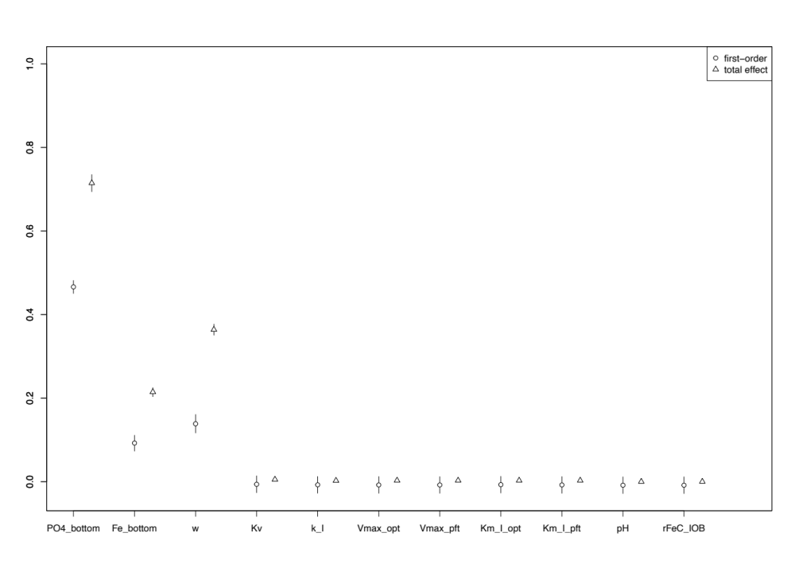
Supplementary Figure 2(a). Total productivity of oxygenic phototrophs
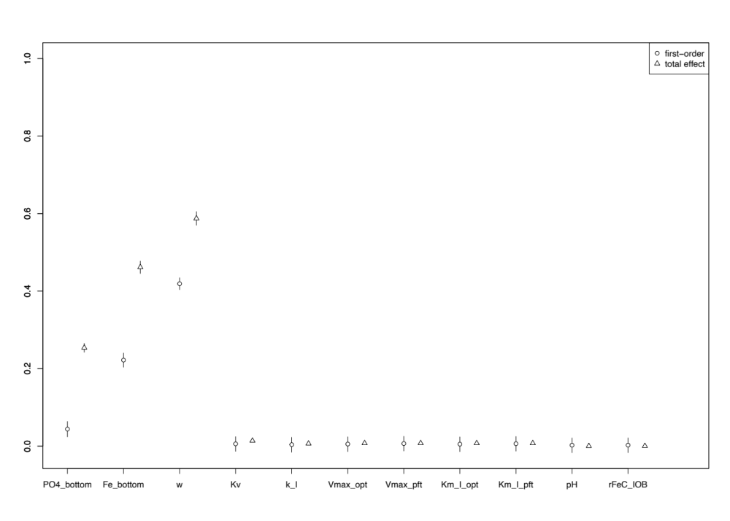
Supplementary Figure 2(b). Total productivity of photoferrotrophs
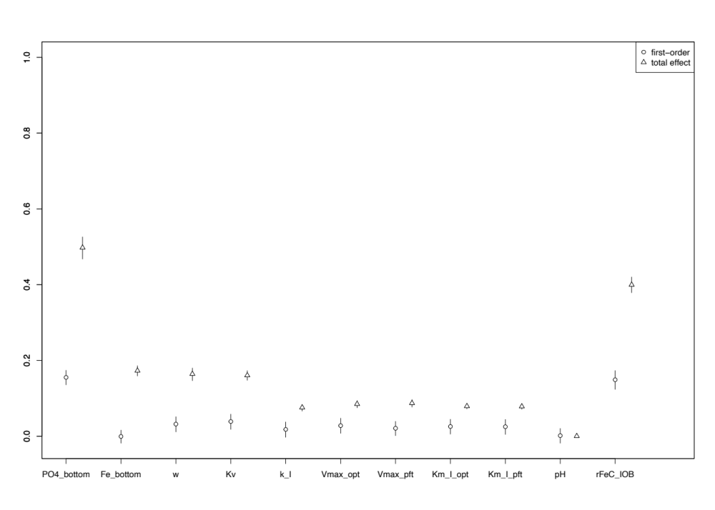
Supplementary Figure 2(c). Total productivity of microaerophilic IOB
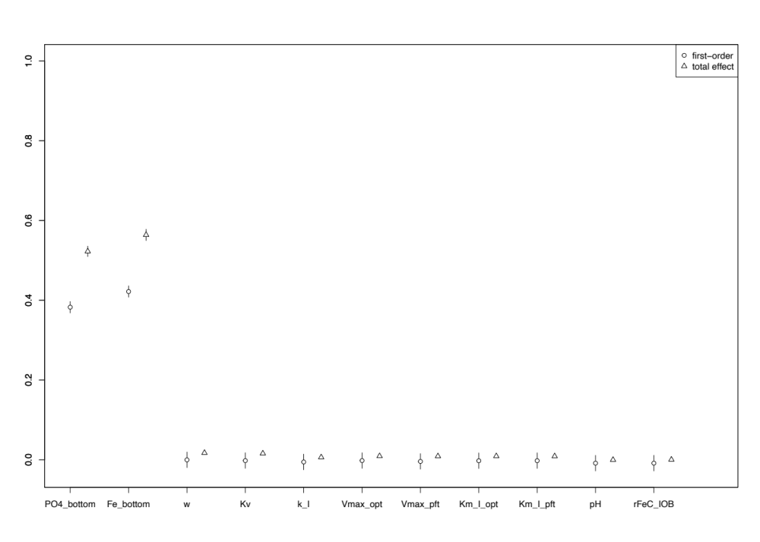
Supplementary Figure 2(d). Primary productivity fraction by oxygenic phototrophs
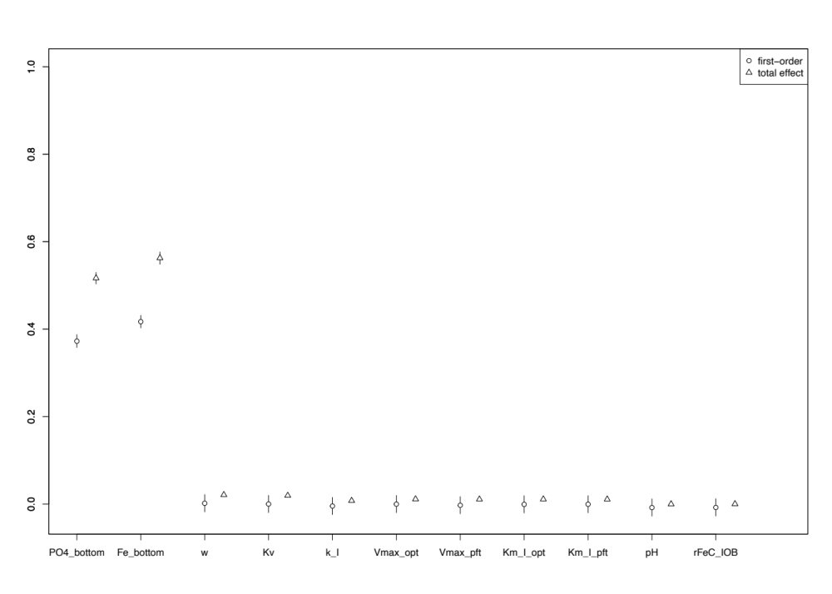
Supplementary Figure 2(e). Primary productivity fraction by photoferrotrophs
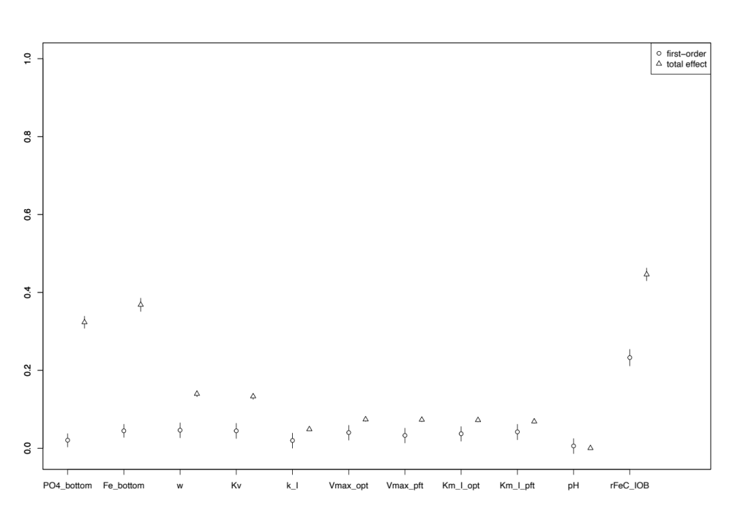
Supplementary Figure 2(f). Primary productivity fraction by microaerophilic IOB
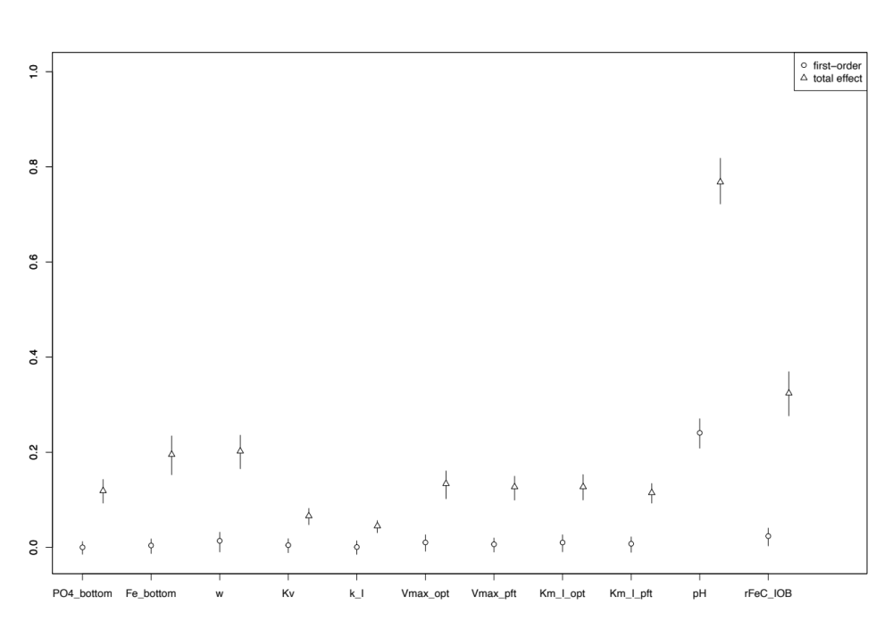
Supplementary Figure 2(g). Total Fe(II) oxidation via abiotic reaction with oxygen
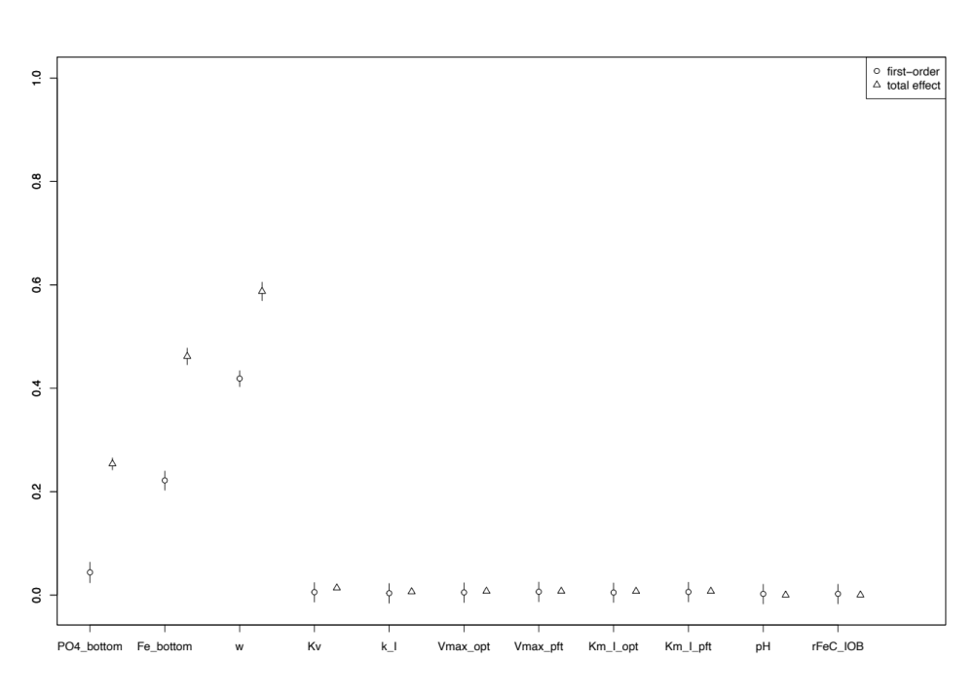
Supplementary Figure 2(h). Total Fe(II) oxidation by photoferrotrophs
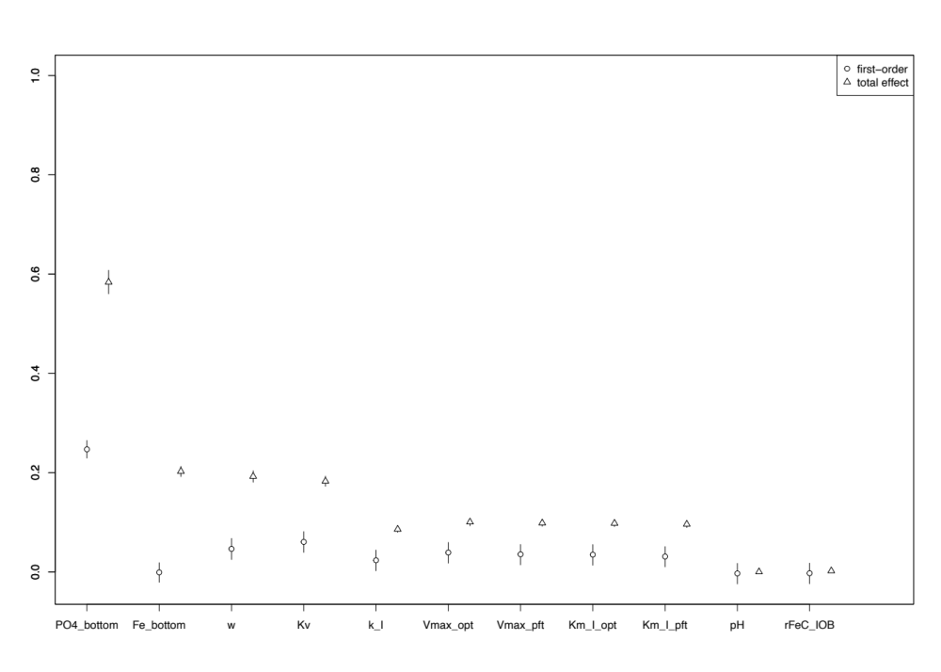
Supplementary Figure 2(i). Total Fe(II) oxidation by microaerophilic IOB
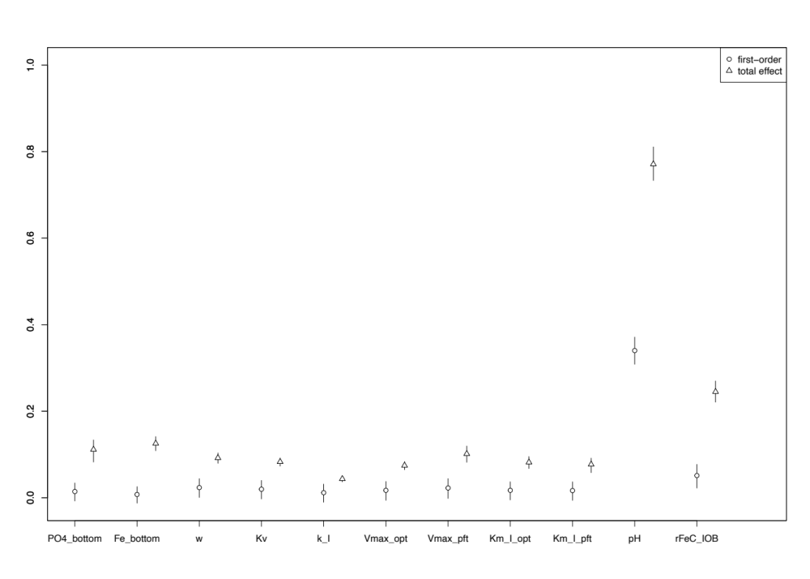
Supplementary Figure 2(j). Fe(II) oxidation fraction via abiotic reactions with oxygen
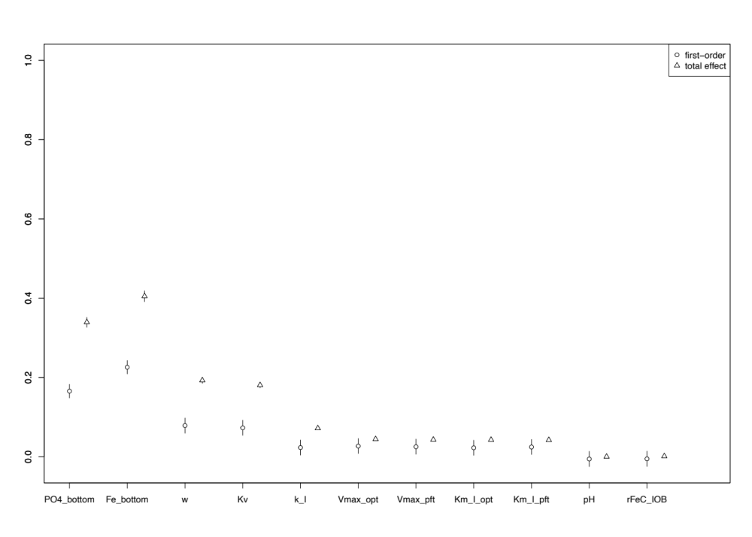
Supplementary Figure 2(k). Fe(II) oxidation fraction by microaerophilic IOB
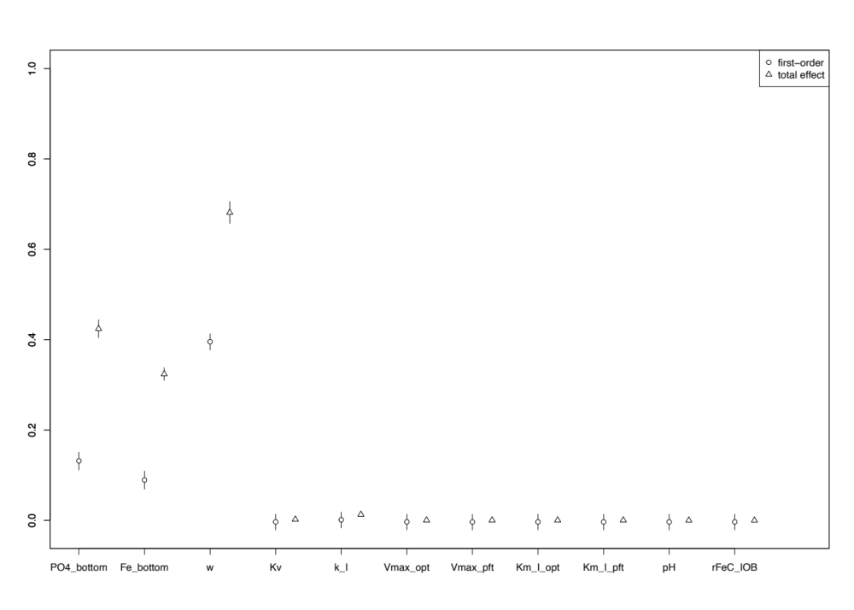
Supplementary Figure 2(l). Total iron reduction
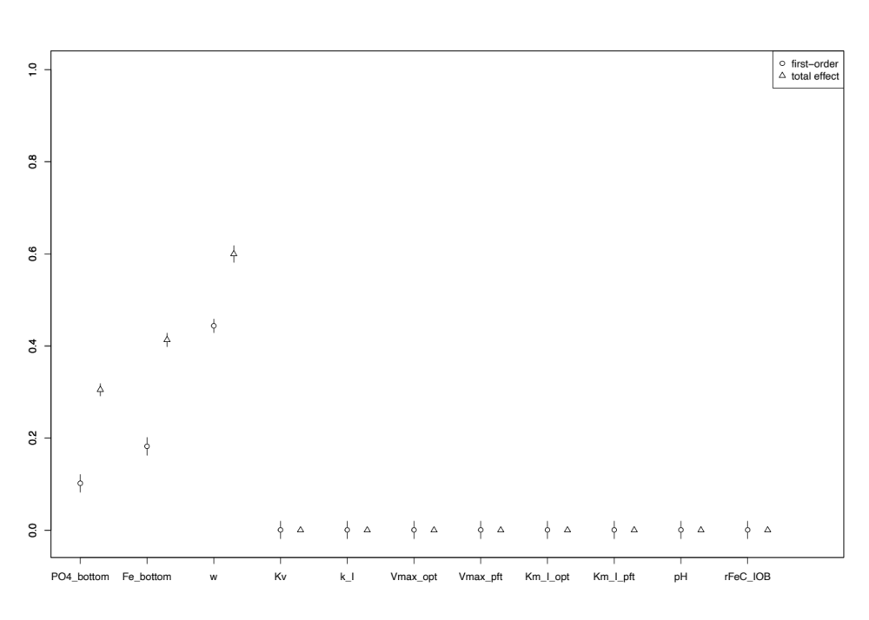
Supplementary Figure 2(m). Net annual Fe precipitation
Supplementary Figure 2. Sobol’ indices of the remaining 13 outputs of interest. Higher the index value, higher the fraction of the output variance due to the given input parameter or the combination. A detailed description of Sobol’ sensitivity analysis can be found in the Method section.

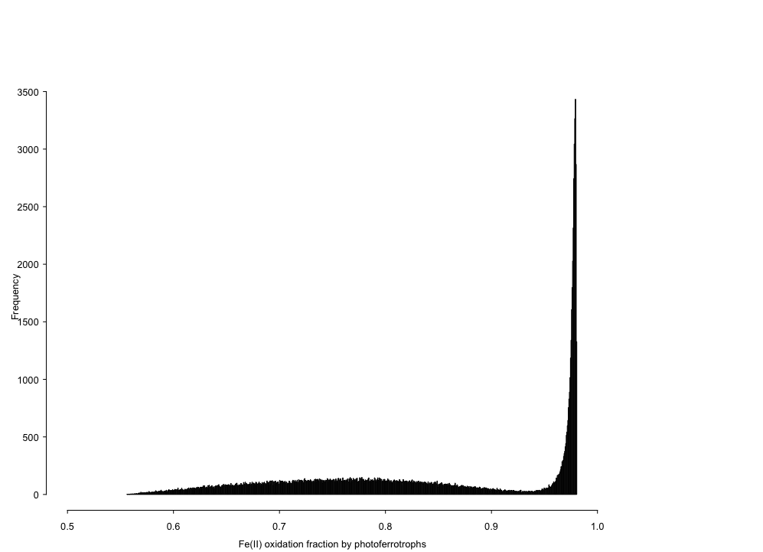
Supplementary Figure 3. Frequency histogram of the uncertainty of the Fe(II) oxidation fraction by photoferrotrophs with respect to deepwater phosphate and Fe(II) concentration (same dataset as Figure 1(b)). A Monte Carlo sample size of 100,000 is drawn from the parameter uncertainty ranges, and model output, i.e., Fe(II) oxidation fraction by photoferrotrophs, is then calculated.

Supplementary Figure 4(a). Uncertainty of net annual Fe precipitation with respect to the uncertainties of seawater upwelling speed, deepwater Fe(II) and phosphate concentrations. A Monte Carlo sample size of 100,000 is drawn from the parameter uncertainty ranges, and model output, i.e., net annual Fe precipitation, is then calculated. The uncertainty of net annual Fe precipitation is presented in three graphs, with each showing the effects of two parameters.
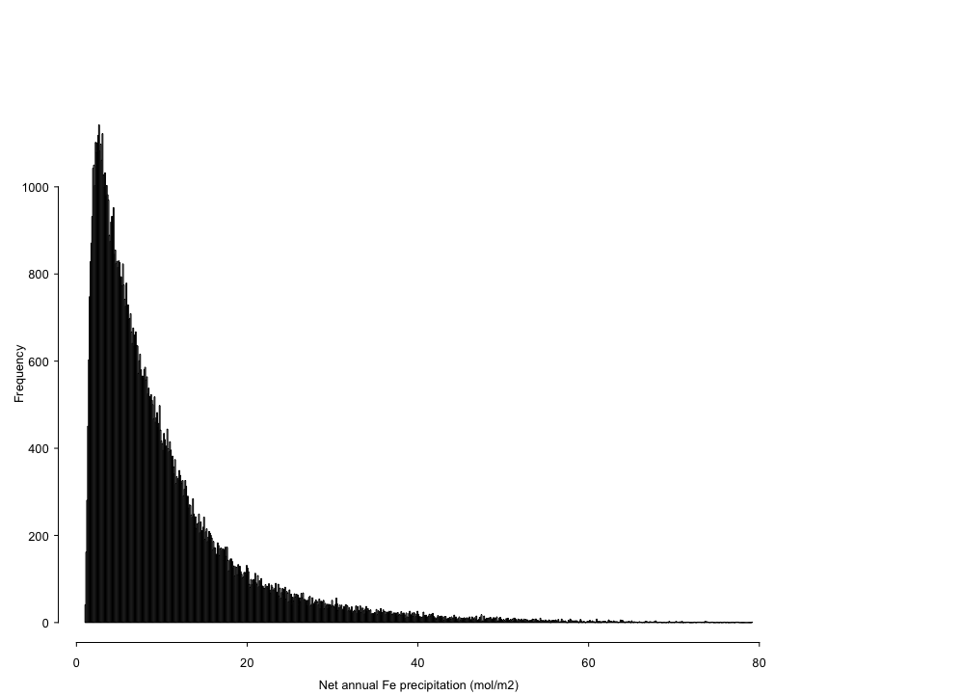
Supplementary Figure 4(b). Frequency histogram of the uncertainty of net annual Fe precipitation.
Supplementary Figure 4. Uncertainty propagation of net annual Fe precipitation

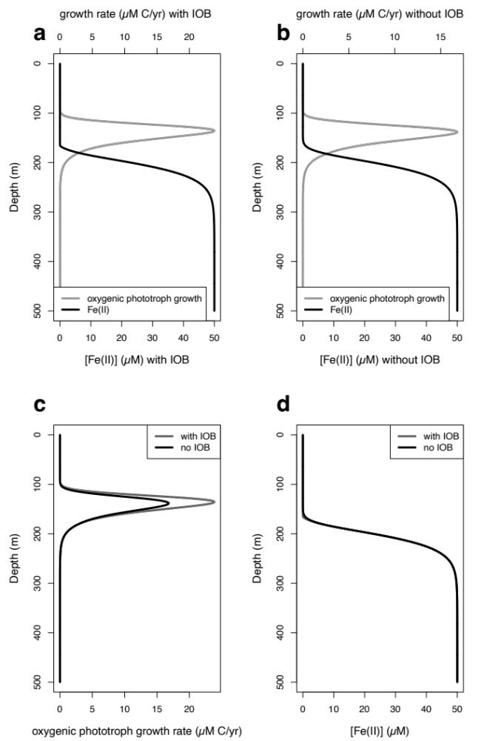
Supplementary Figure 5. Oxygenic phototroph productivity difference between the scenarios when microaerophilic IOB is present and absent. a baseline simulation result of oxygenic phototroph productivity and Fe(II) profile. b no microaerophilic IOB scenario oxygenic phototroph productivity and Fe(II) profile. c oxygenic phototroph productivity difference between the baseline scenario and the no IOB scenario. d Fe(II) profile difference between the baseline scenario and the no IOB scenario.

References:

1. Thompson, K.J., et al., Photoferrotrophy, deposition of banded iron formations, and methane production in Archean oceans. Science advances, 2019. 5(11): p. eaav2869.
2. Tosca, N.J., S. Guggenheim, and P.K. Pufahl, An authigenic origin for Precambrian greenalite: Implications for iron formation and the chemistry of ancient seawater. Bulletin, 2016. 128(3-4): p. 511-530.
3. van de Velde, S.J., et al., Iron and sulfur cycling in the cGENIE. muffin Earth system model (v0. 9.21). Geoscientific Model Development, 2021. 14(5): p. 2713-2745.
4. Jones, C., et al., Iron oxides, divalent cations, silica, and the early earth phosphorus crisis. Geology, 2015. 43(2): p. 135-138.
5. Halevy, I. and A. Bachan, The geologic history of seawater pH. Science, 2017. 355(6329): p. 1069-1071.
6. Krissansen-Totton, J., G.N. Arney, and D.C. Catling, Constraining the climate and ocean pH of the early Earth with a geological carbon cycle model. Proceedings of the National Academy of Sciences, 2018. 115(16): p. 4105-4110.
7. Jiang, C.Z. and N.J. Tosca, Fe (II)-carbonate precipitation kinetics and the chemistry of anoxic ferruginous seawater. Earth and Planetary Science Letters, 2019. 506: p. 231-242.
8. Holland, H.D., The Chemical Evolution of the Atmosphere and Oceans. Vol. 2. 1984: Princeton University Press.
9. Lyons, T.W., C.T. Reinhard, and N.J. Planavsky, The rise of oxygen in Earth’s early ocean and atmosphere. Nature, 2014. 506(7488): p. 307-315.
10. Simmons, H.L., et al., Tidally driven mixing in a numerical model of the ocean general circulation. Ocean Modelling, 2004. 6(3-4): p. 245-263.
11. Liang, X., M. Spall, and C. Wunsch, Global ocean vertical velocity from a dynamically consistent ocean state estimate. Journal of Geophysical Research: Oceans, 2017. 122(10): p. 8208-8224.
12. Valenti, D., et al., How diffusivity, thermocline and incident light intensity modulate the dynamics of deep chlorophyll maximum in Tyrrhenian sea. PLoS One, 2015. 10(1): p. e0115468.
13. Kim, G.E., M.-A. Pradal, and A. Gnanadesikan, Quantifying the biological impact of surface ocean light attenuation by colored detrital matter in an ESM using a new optical parameterization. Biogeosciences, 2015. 12(16): p. 5119-5132.
14. Denaro, G., et al., Dynamics of two picophytoplankton groups in mediterranean sea: Analysis of the deep chlorophyll maximum by a stochastic advection-reaction-diffusion model. PLoS One, 2013. 8(6): p. e66765.
15. Ozaki, K., et al., Anoxygenic photosynthesis and the delayed oxygenation of Earth’s atmosphere. Nature communications, 2019. 10(1): p. 1-10.
16. Makita, H., Iron-oxidizing bacteria in marine environments: recent progresses and future directions. World Journal of Microbiology and Biotechnology, 2018. 34(8): p. 1-13.
17. Manske, A.K., et al., Physiology and phylogeny of green sulfur bacteria forming a monospecific phototrophic assemblage at a depth of 100 meters in the Black Sea. Applied and environmental microbiology, 2005. 71(12): p. 8049-8060.
18. Eggerichs, T., et al., Interdependencies between biotic and abiotic ferrous iron oxidation and influence of pH, oxygen and ferric iron deposits. Geomicrobiology Journal, 2014. 31(6): p. 461-472.
19. Bonneville, S., P. Van Cappellen, and T. Behrends, Microbial reduction of iron (III) oxyhydroxides: effects of mineral solubility and availability. Chemical Geology, 2004. 212(3-4): p. 255-268.
20. Sobolev, D. and E.E. Roden, Characterization of a neutrophilic, chemolithoautotrophic Fe (II)-oxidizing β-proteobacterium from freshwater wetland sediments. Geomicrobiology Journal, 2004. 21(1): p. 1-10.
21. Tamura, H., K. Goto, and M. Nagayama, The effect of ferric hydroxide on the oxygenation of ferrous ions in neutral solutions. Corrosion science, 1976. 16(4): p. 197-207.

