The effects of paroxetine-induced transient apoptosis and brain remodeling on social behavior in developing zebrafish
Tomomi Sato et al.

Additional information

Supplementary information

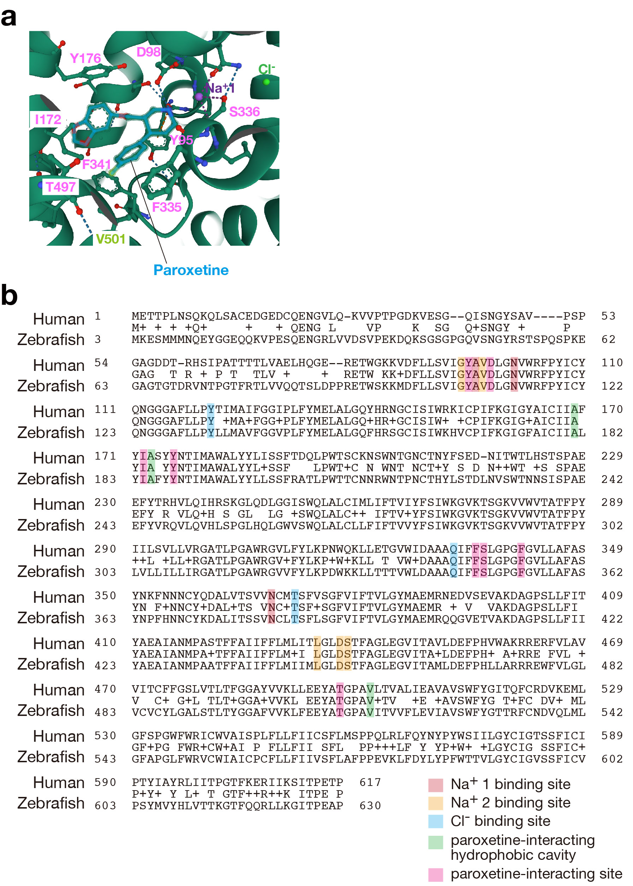
Supplementary Figure S1. Comparison of amino acid sequences of SERT between human and zebrafish. a X-ray structure of the ts3 human SERT complexed with paroxetine at the central site (516X, RCSB Protein Data Bank). Amino acids interacting with paroxetine (light blue), indicated in pink. An amino acid forming hydrophobic cavity, indicated in green. b Alignments of amino acid sequences of human and zebrafish SERT (P31645 and NP001035061). Amino acids interacting with paroxetine are completely identical between human and zebrafish.

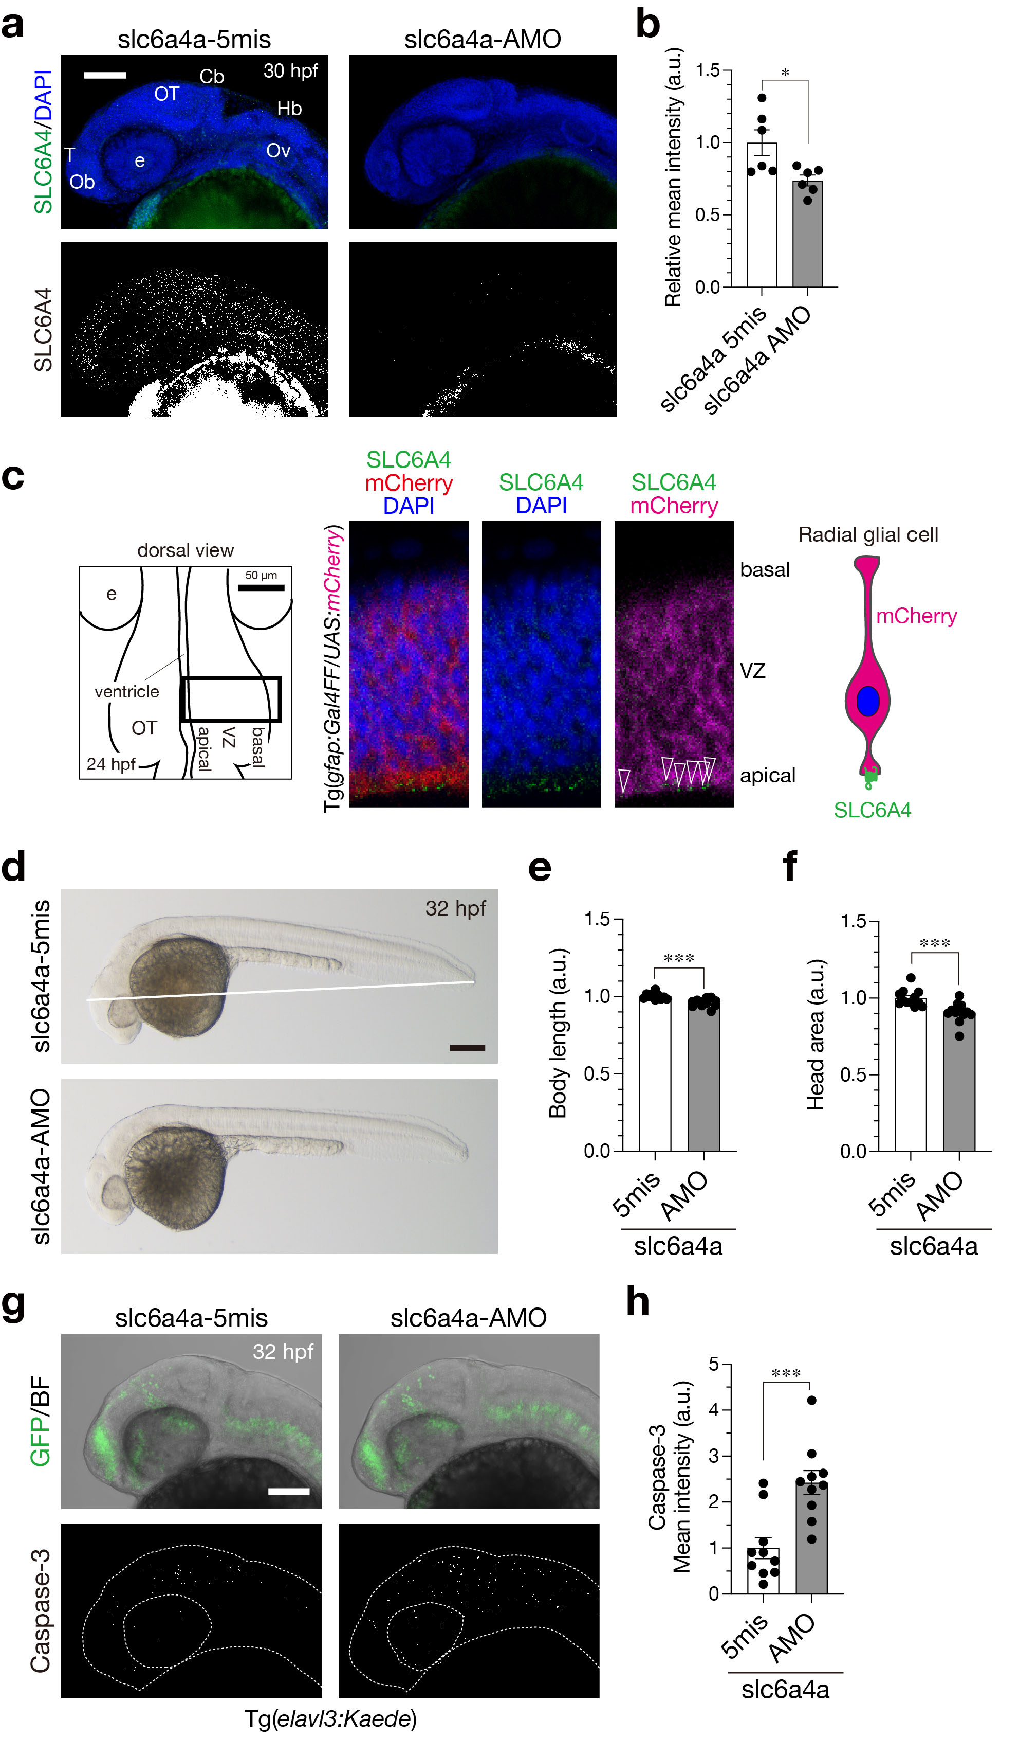
Supplementary Figure S2. Distribution and knockdown of zebrafish SLC6A4a. a Immunostaining with anti-SERT antibody for 30-hpf embryos injected with slc6a4a antisense MO (AMO) and the control (5mis). b Quantification of the immunofluorescent signals. c SLC6A4 (SERT) proteins in the apical surface of the ventricular zone in the brain (green, open arrowheads). Left, a scheme of the embryo immunostained for SLC6A4. Bold rectangle, the region shown in the right images. Right, a scheme of SLC6A4 localization in an RFP-expressing radial glial cell. d Lateral views of 32-hpf embryos injected with antisense slc6a4a-AMO and the control slc6a4a-5mis. White line, head-tail body length. e, f Quantification of the body length (e) and the head area (f) of the injected embryos. g Lateral views of 32-hpf Tg(elavl3:Kaede) embryos injected with MOs (top) and those embryos immunostained for active Caspase-3 (bottom). h Quantification of the intensity of active Caspase-3 signals in the brain of the injected embryos. Scale bars: 200 µm (d); 100 µm (g). Data are presented as mean ± SEM. *p < 0.05, ***p < 0.001, Mann-Whitney U test.

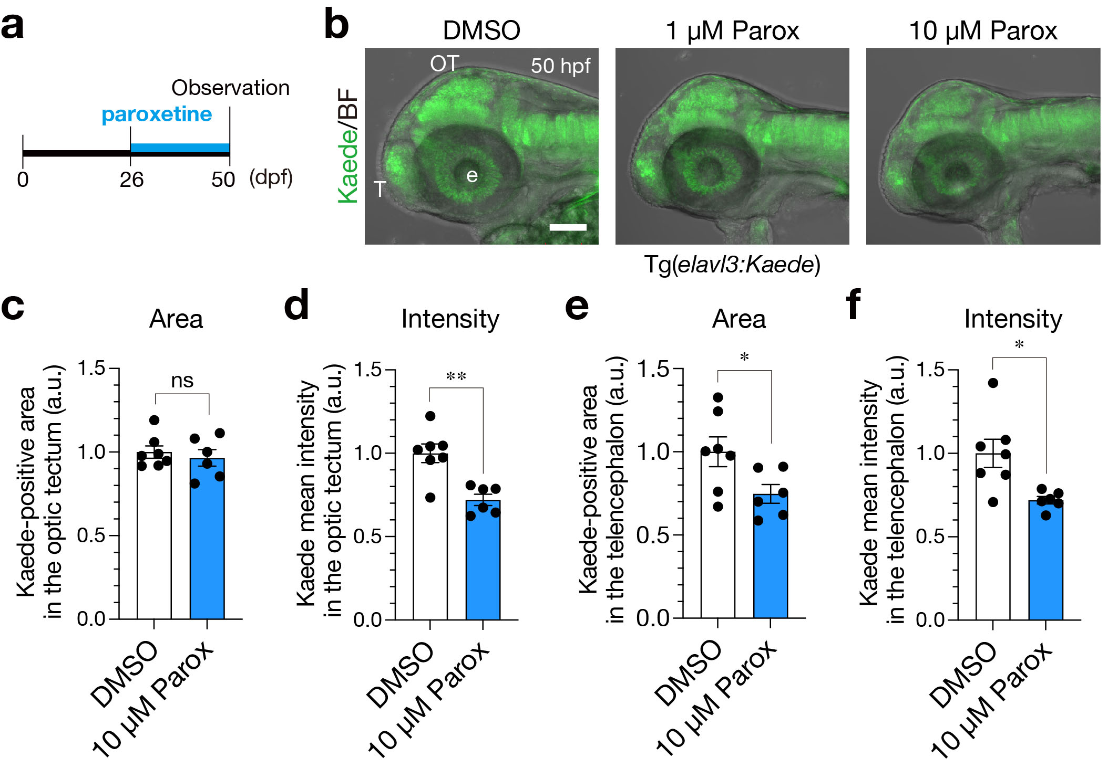
Supplementary Figure S3. Effects of early paroxetine on neurogenesis at 50 hpf. a A schematic diagram of the treatment with paroxetine. b Lateral views of 50-hpf Tg(elavl3:Kaede) embryos treated with 1 µM, 10 µM paroxetine and the control DMSO. c–f Quantification of Kaede-positive area (c, d) and the intensity (d, f) in the optic tectum (c, d) and the telencephalon (d, f) of 10 µM paroxetine-treated embryos. Parox, paroxetine. e, eye; OT, optic tectum; T, telencephlon. Scale bar, 100 µm. Data are presented as mean ± SEM. *p < 0.05, **p < 0.01, Mann-Whitney U test.

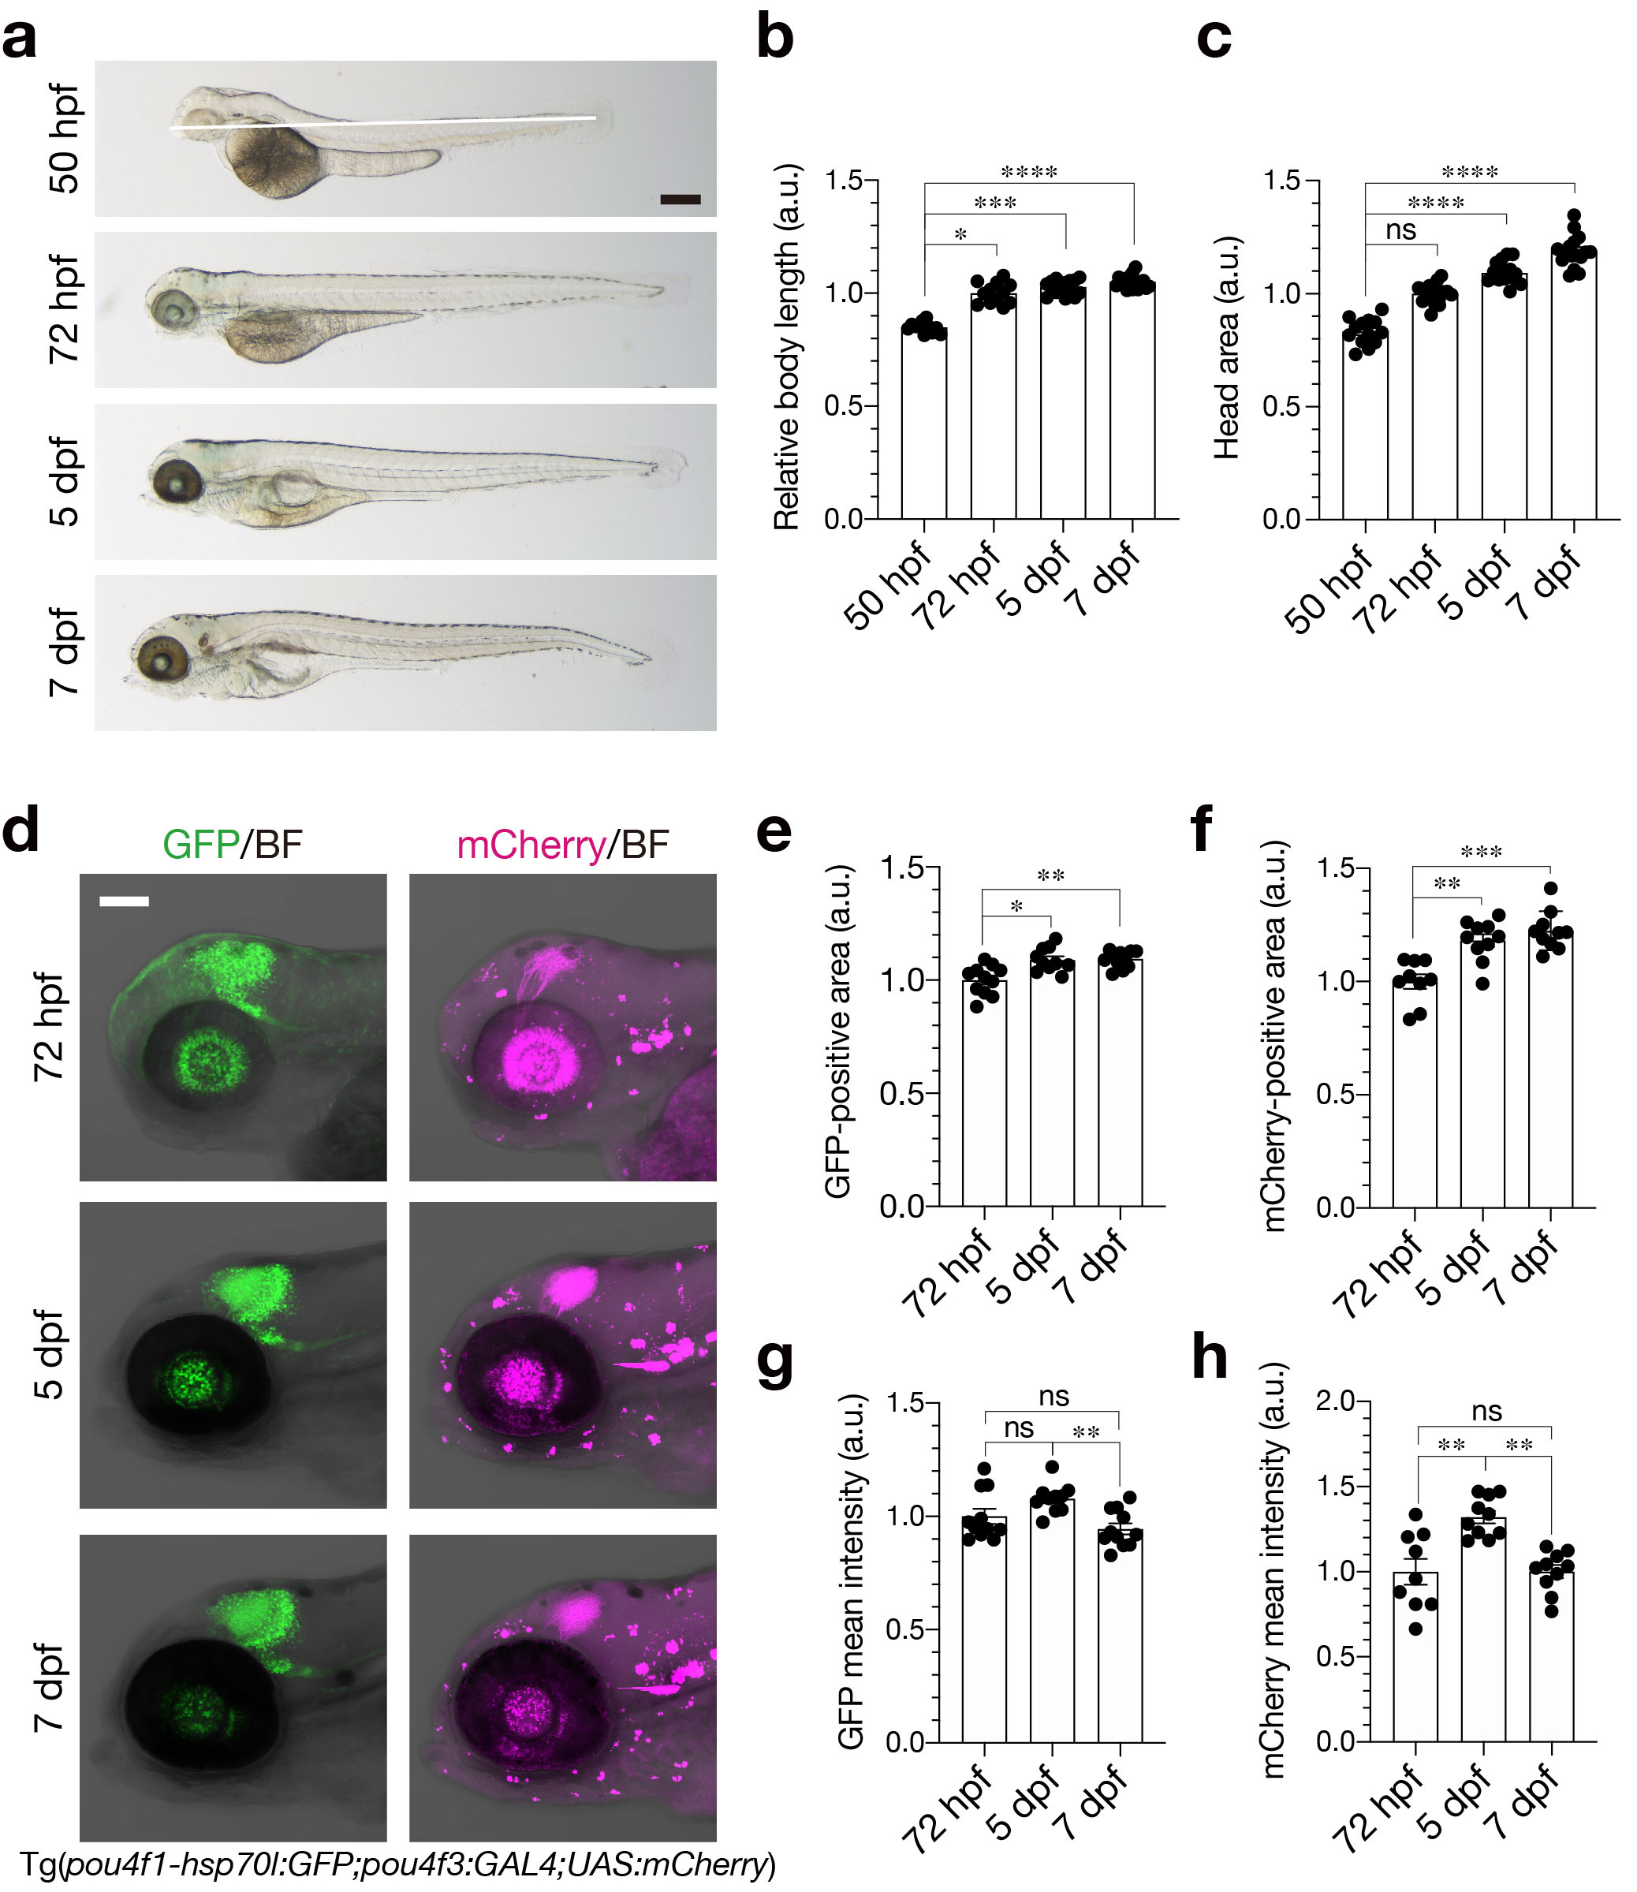
Supplementary Figure S4. Development of morphology and the retinotectal projection in wild-type embryos. a Lateral views of wild-type embryos at 50 hpf, 72 hpf, 5 dpf, and 7 dpf. White line, head-tail body length. b, c Quantification of the body length (b) and the head area (c) of wild-type embryos. d Lateral views of wild-type Tg(pou4f1-hsp70l:GFP;pau4f3:GAL4;UAS:mCherry) embryos at 72 hpf, 5 dpf, 7 dpf. GFP (green) expressed in tectal neurons and retinal axons. mCherry (red) expressed in retinal axons. e, f Quantification of GFP-positive (e) and mCherry-positive (f) areas in the optic tectum. g, h Quantification of the intensity of GFP (g) and mCherry (h) in the optic tectum. Scale bars: 200 µm (a); 100 µm (d). Data are presented as mean ± SEM. *p < 0.05, **p < 0.01, ***p < 0.001, ****p < 0.0001, ns, not significant. Kruskal-Wallis with Dunn’s multiple comparisons tests.

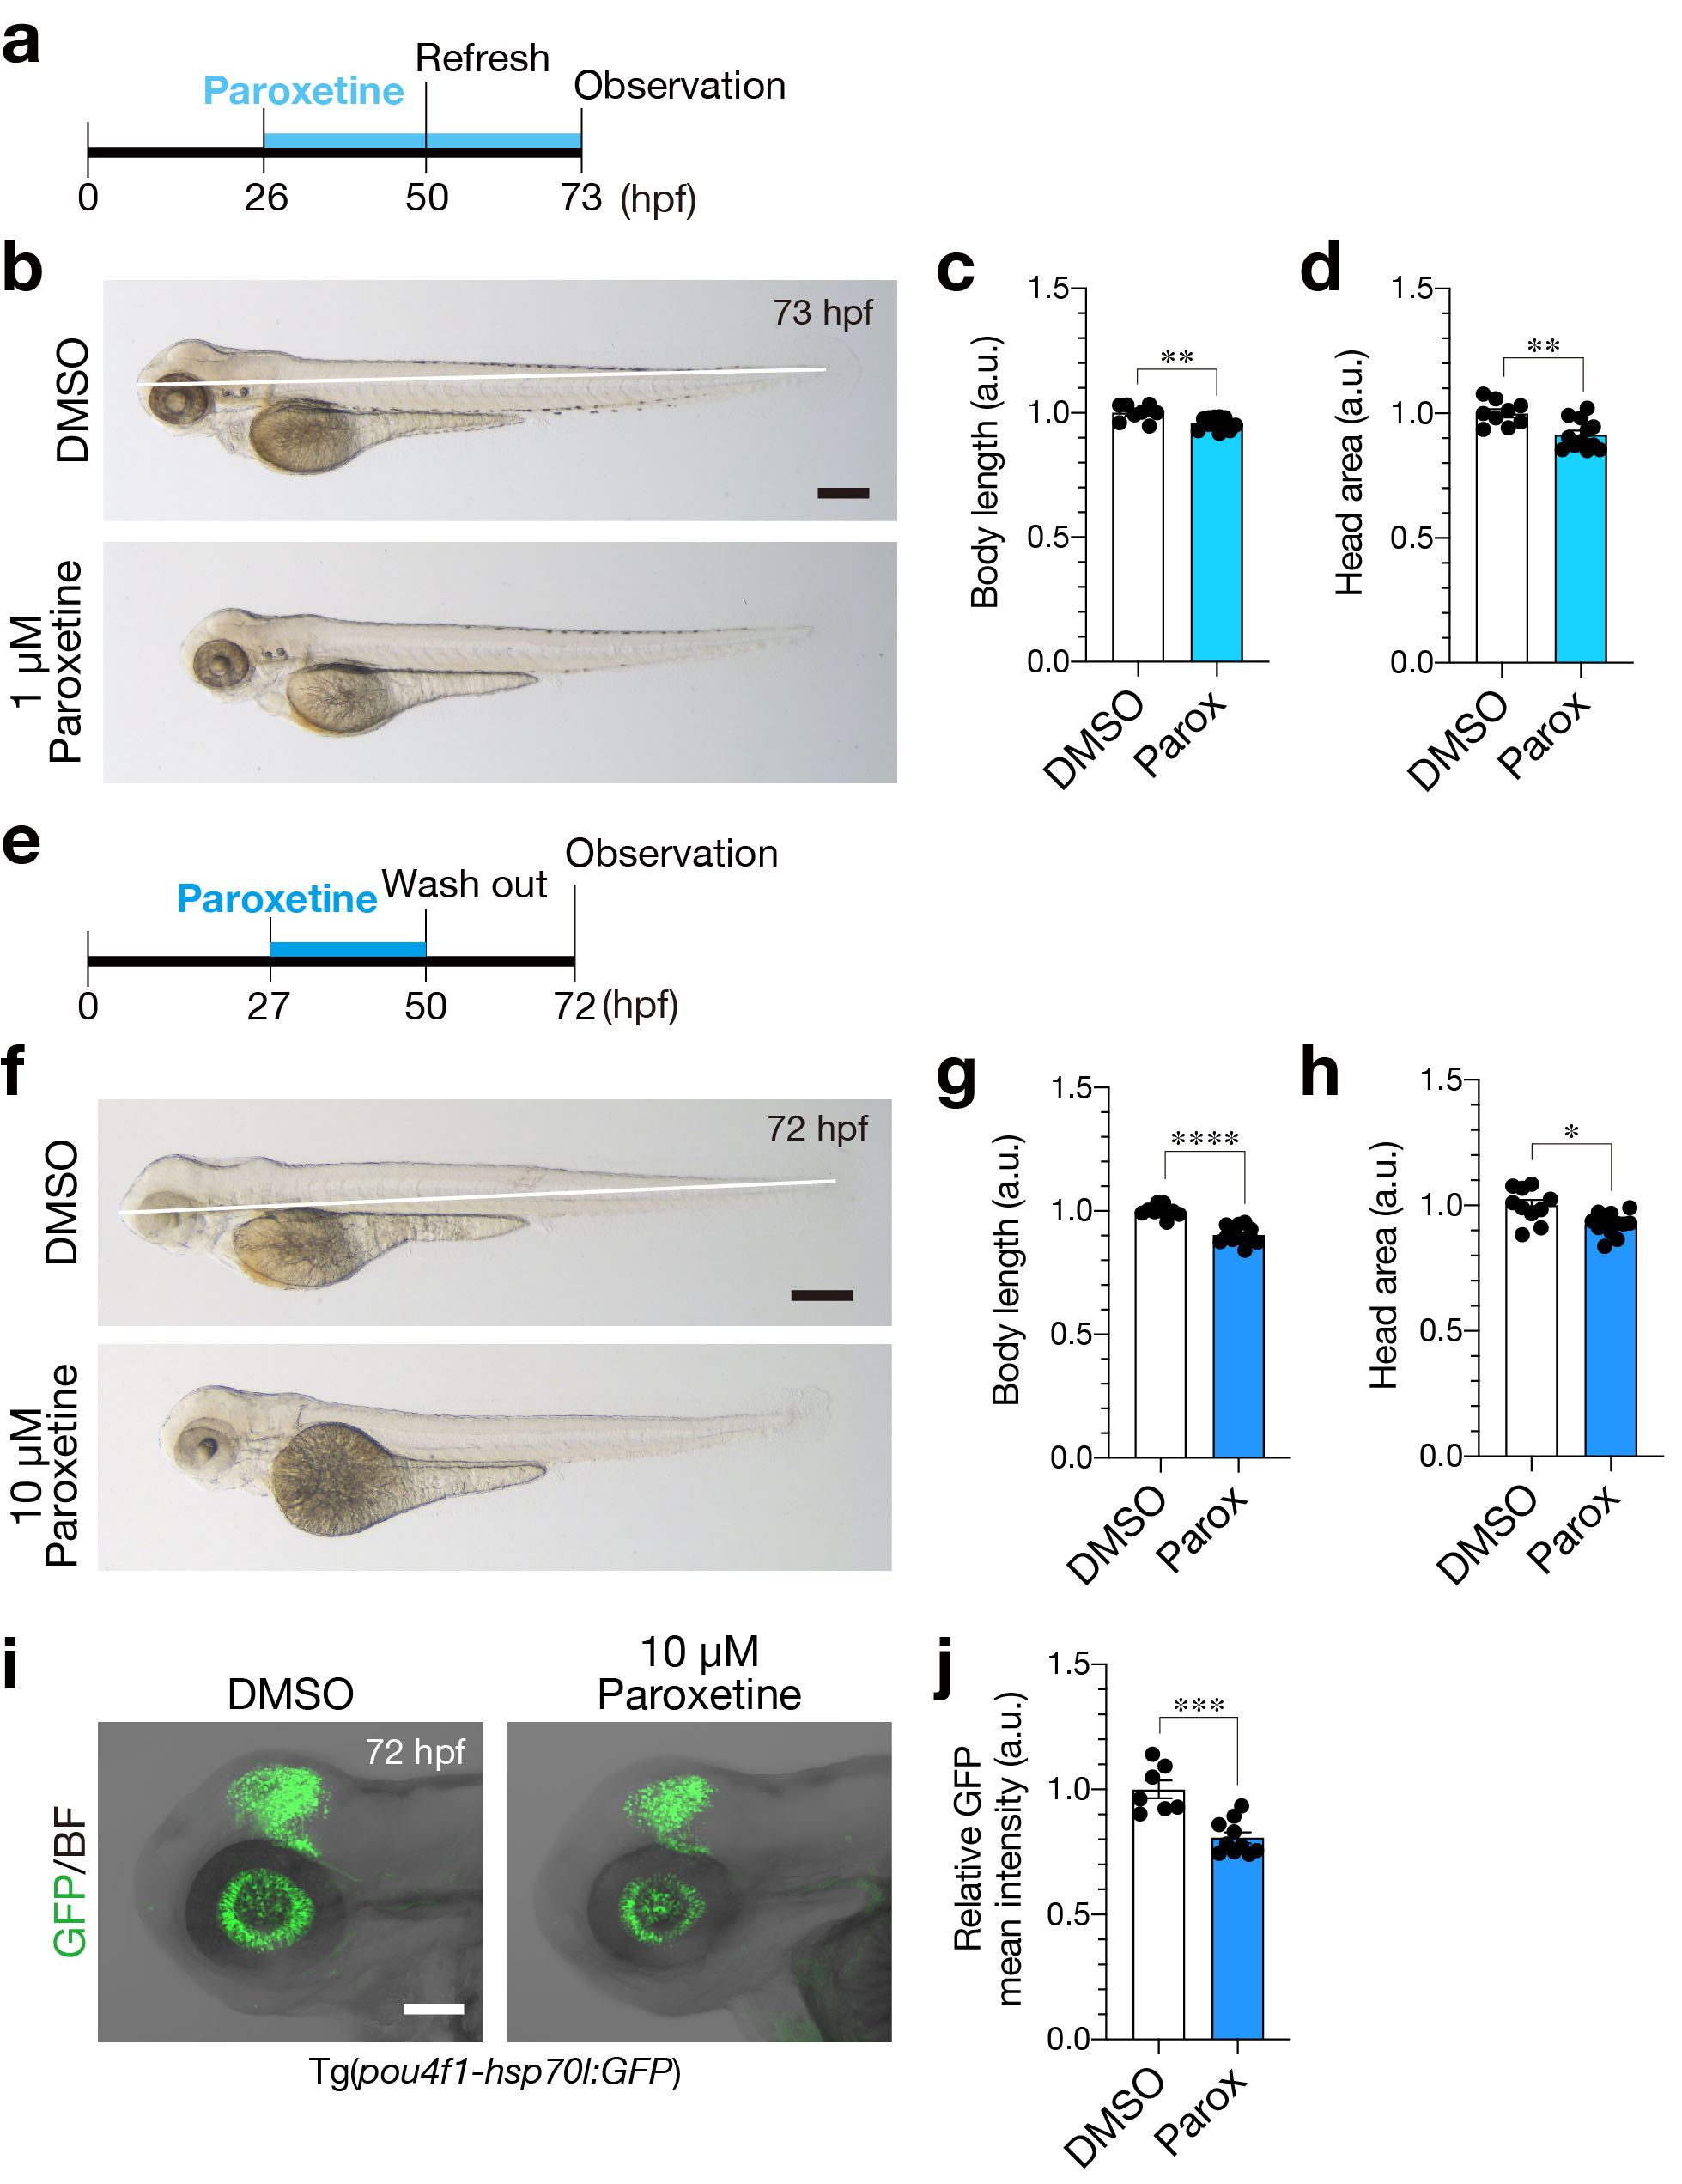
Supplementary Figure S5. Effects of early paroxetine on embryogenesis and neurogenesis at 3 dpf. a A schematic diagram of treatment with 1 µM paroxetine. b Lateral views of 73-hpf embryos treated with paroxetine and the control DMSO. c, d Quantification of the body length (c) and the head area (d) of the treated embryos. e A schematic diagram of treatment with 10 µM paroxetine. f Lateral views of 72-hpf embryos treated with paroxetine and the control DMSO. g, h Quantification of the body length (g) and the head area (h) of the treated embryos. i Lateral views of 72-hpf Tg(pou4f1-hsp70l:GFP) embryos treated with 10 µM paroxetine and the control DMSO. j Quantification of GFP intensity in the optic tectum of the treated embryos. White lines, head-tail body length. Parox, paroxetine. Scale bars: 200 µm (b, f); 100 µm (i). Data are presented as mean ± SEM. *p < 0.05, **p < 0.01, ***p < 0.001, ****p < 0.0001, Mann-Whitney U test.

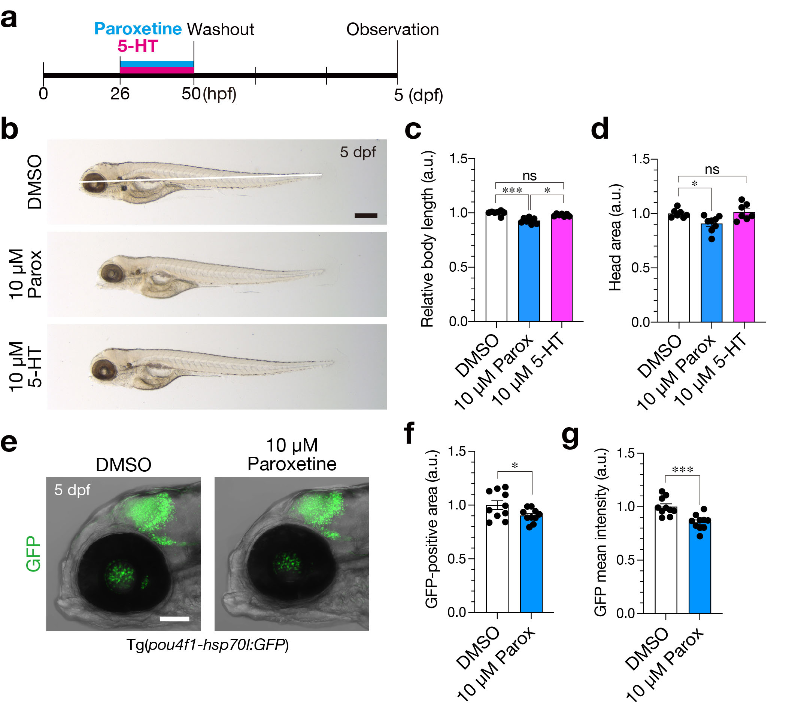
Supplementary Figure S6. Growth restriction and suppressed neurogenesis in early transient paroxetine-treated larvae at 5 dpf. a A schematic diagram of treatment with 10 µM paroxetine and 5-HT. b Lateral views of 5-dpf larvae treated with paroxetine, 5-HT and the control DMSO. White line, head-tail body length. c, d Quantification of the body length (c) and the head area (d) of the treated larvae. e Lateral views of 5-dpf Tg(pou4f1-hsp70l:GFP) larvae treated with 10 µM paroxetine and the control DMSO. f, g Quantification of GFP-positive area (e) and the intensity (f) in the optic tectum of the treated larvae. Parox, paroxetine. Scale bars: 200 µm (b); 100 µm (e). Data are mean ± SEM. *p < 0.05, ***p < 0.001, ns, not significant. Kruskal-Wallis with Dunn’s multiple comparisons tests (c, d), Mann-Whitney U test (f, g).

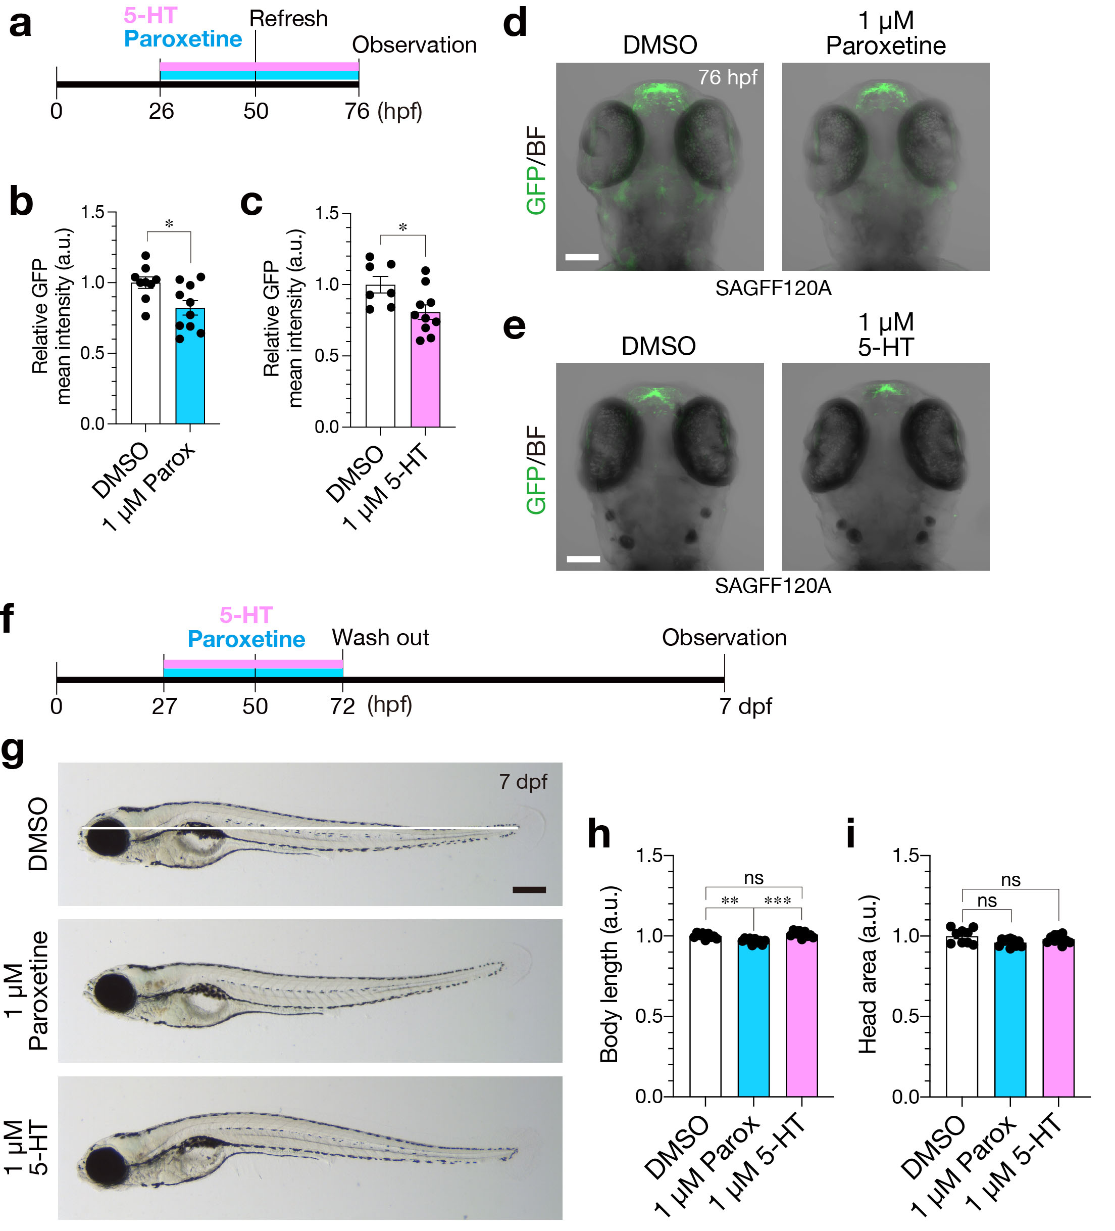
Supplementary Figure S7. Suppressed neurogenesis in the dorsal telencephalon and restored morphology at 7 dpf of paroxetine and 5-HT-treated larvae. a A schematic diagram of treatment with 1 µM paroxetine. b, c Quantification of GFP intensity in the dorsal telencephalon of the paroxetine-treated larvae (b), and 5-HT-treated larvae (c). d, e Dorsal views of 76-hpf SAGFF120A;UAS:GFP larvae treated with paroxetine, and the control DMSO (d), 5-HT and the control (e). f A schematic diagram of treatment with 1 µM paroxetine and 5-HT. g Lateral views of 7-dpf larvae treated with paroxetine, 5-HT and the control DMSO. White line, head-tail body length. h, i Quantification of the body length (h) and the head area (i) of the treated larvae. Parox, paroxetine. Scale bars: 100 µm (b); 200 µm (e). Data are mean ± SEM. *p < 0.05, **p < 0.01, ***p < 0.001, ns, not significant. Mann-Whitney U test (b, c), Kruskal-Wallis with Dunn’s multiple comparisons tests (h, i).

Supplementary Video 1 DMSO-treated fish in a no sibling trial.

Supplementary Video 2 DMSO-treated fish in a sibling trial.

Supplementary Video 3 Paroxetine-treated fish in a no sibling trial.

Supplementary Video 4 Paroxetine-treated fish in a sibling trial.

Supplementary Video 5 5-HT-treated fish in a no sibling trial.

Supplementary Video 6 5-HT-treated fish in a sibling trial.

