Supporting Information
Discovery of a novel SHP2 allosteric inhibitor using virtual screening, FMO calculation and molecular dynamic simulation

Zhen Yuan^{1§}, Manzhan Zhang^{1§}, Longfeng Chang^{1§}, Xingyu Chen, Shanshan Ruan, Shanshan Shi, Yiqing Zhang, Lili Zhu¹*, Honglin Li^{1,2,3}*, Shiliang Li^{1,2}*

¹Shanghai Key Laboratory of New Drug Design, State Key Laboratory of Bioreactor Engineering, School of Pharmacy, East China University of Science & Technology, Shanghai, China.
²Innovation Center for AI and Drug Discovery, East China Normal University, Shanghai 200062, China
³Lingang Laboratory, Shanghai 200031, China

§Authors contributed equally to this work.
* Corresponding author.
E-mail address:, zhulfl@ecust.edu.cn (Lili Zhu), hlli@ecust.edu.cn (Honglin Li), slli403@163.com (Shiliang Li).

Table S1. Building a dataset for testing the performance of FMO calculation, MM/PBSA and MM/GBSA.
ID | Structure | IC₅₀(μM) | ID | Structure | IC₅₀(μM)
F1 | 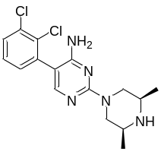 | 12 | F2 | 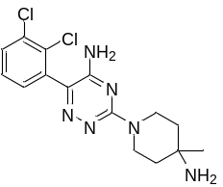 | 0.3
F3 | 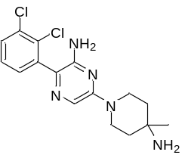 | 0.07 | F4 | 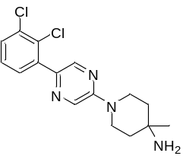 | 5.7
F5 | 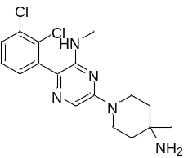 | 22 | F6 | 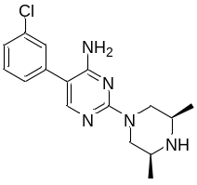 | 99
F7 | 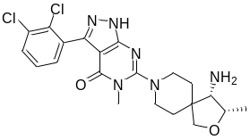 | 0.05 | F8 | 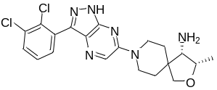 | 0.006
F9 | 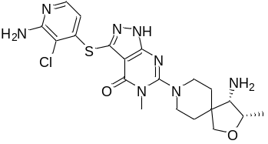 | 0.027 | F10 | 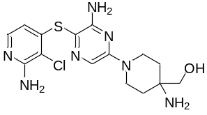 | 0.315
F11 | 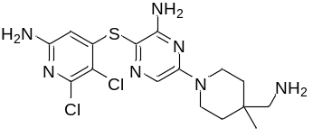 | 0.0177 | F12 | 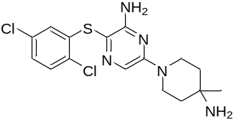 | 1.082
F13 | 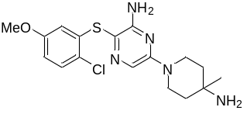 | 13.666 | F14 | 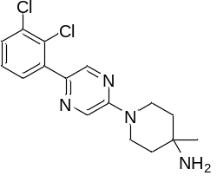 | 5.7
F15 | 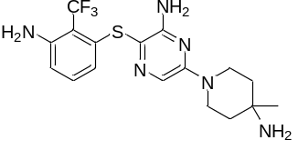 | 0.046 | F16 | 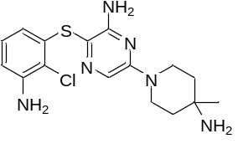 | 0.062
F17 | 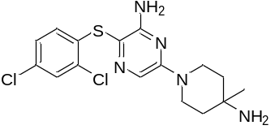 | 0.21 | F18 | 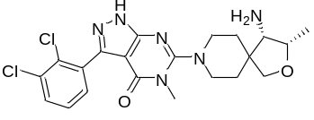 | 0.028
F19 | 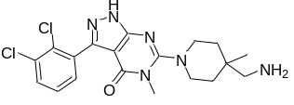 | 0.034 | F20 | 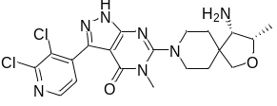 | 0.057
F21 | 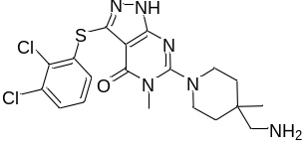 | 0.008 | F22 | 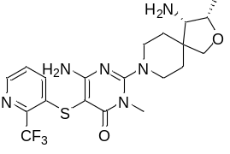 | 0.053
F23 | 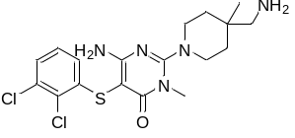 | 0.021 | F24 | 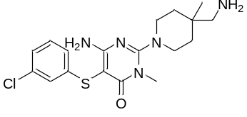 | 2.214
F25 | 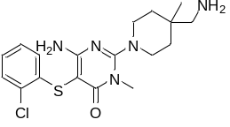 | 0.286 | F26 | 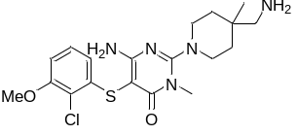 | 0.047
F27 | 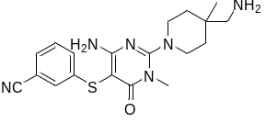 | 5.633 | F28 | 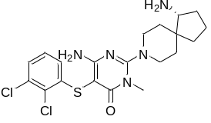 | 0.039
F29 | 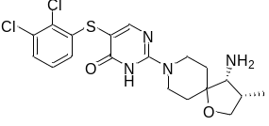 | 0.009 | F30 | 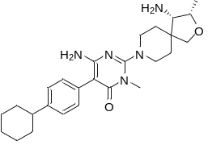 | 0.073
F31 | 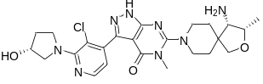 | 0.084 | F32 | 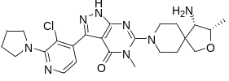 | 0.012
F33 | 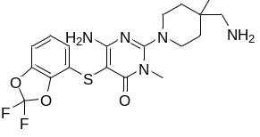 | 0.152 | F34 | 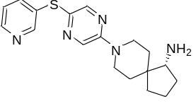 | 11.3
F35 | 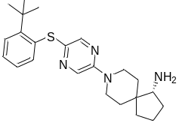 | 1.46 | F36 | 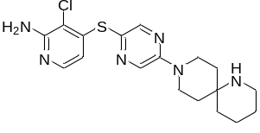 | 0.43
F37 | 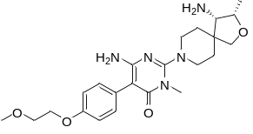 | 0.169 | F38 | 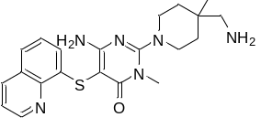 | 0.279
F39 | 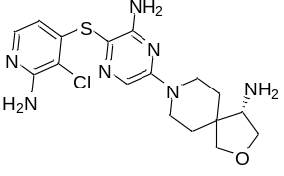 | 0.007 | F40 | 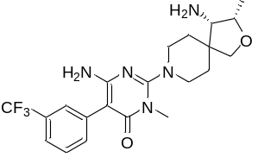 | 1.69
F41 | 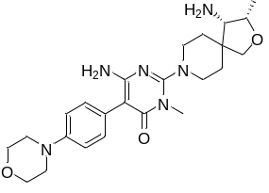 | 2.11 | F42 | 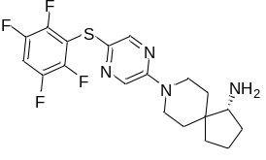 | 2.51
F43 | 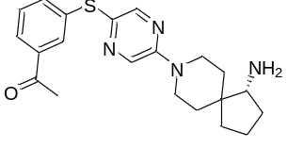 | 0.138 | F44 | 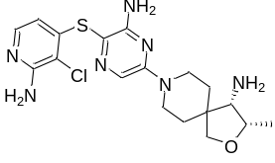 | 0.011
F45 | 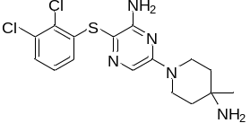 | 0.029 | F46 | 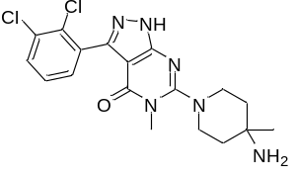 | 0.067
F47 | 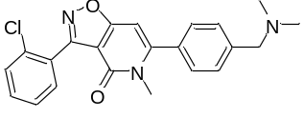 | 60 | F48 | 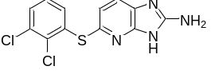 | 47
F49 | 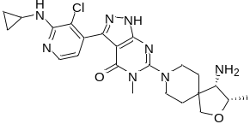 | 0.036 | F50 | 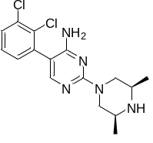 | 12
F51 | 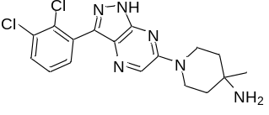 | 0.015

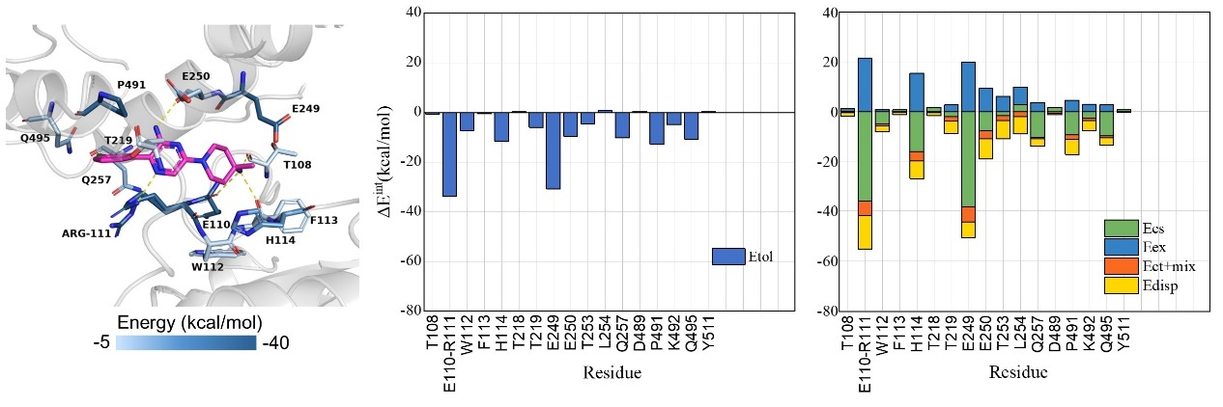
Figure S1. The binding mode of SHP099 and SHP2 protein (PDB: 5EHR) are drawn on left graph. The key residues and ligand are shown in sticks. Hydrogen bonds are depicted as dotted yellow lines. The pair interaction energies (PIE) of the compound SHP099 and the surrounding residues are drawn on middle graph, and the pair interaction energies decomposition analysis (PIEDA) for these residues are drawn on right graph. The electrostatic, exchange-repulsion, charge transfer, and dispersion terms are represented in green, blue, orange, and yellow, respectively.

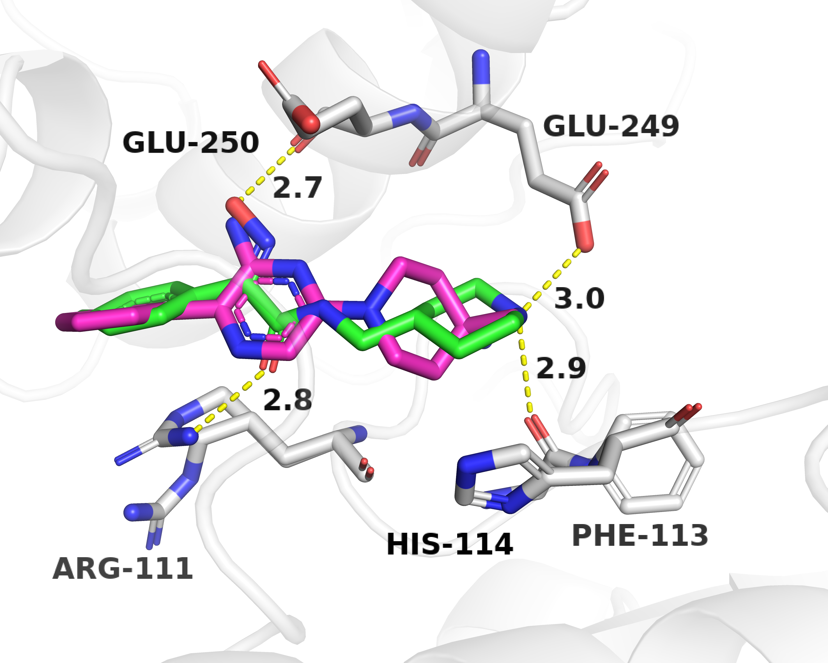
Figure S2. The binding mode alignment of 7188-0011 and SHP099. The key residues are shown in grey sticks. 7188-0011 and SHP099 are displayed in green sticks and red sticks, respectively. Hydrogen bonds are depicted as dotted yellow lines.

Table S2. PIEDA analysis for ligands (SHP099 and 7188-0011) and the surrounding residues with FMO method.
 | Residues ª | ΔE_{tol} ^{b} | ΔE_{es} | ΔE_{ex} | ΔE_{ct+mix} | ΔE_{disp}
SHP099 | T108 | -0.652 | 0.237 | 0.915 | -0.35 | -1.454
SHP099 | E110-R111 | -33.834 | -35.971 | 21.516 | -5.803 | -13.575
SHP099 | W112 | -7.348 | -4.885 | 0.843 | -0.897 | -2.408
SHP099 | F113 | -0.544 | 0.672 | 0.032 | -0.3 | -0.948
SHP099 | H114 | -11.575 | -15.992 | 15.379 | -3.839 | -7.124
SHP099 | T218 | 0.28 | 1.536 | 0.28 | -0.395 | -1.141
SHP099 | T219 | -6.031 | -2.02 | 2.731 | -1.71 | -5.031
SHP099 | E249 | -30.754 | -38.325 | 20.035 | -6.074 | -6.389
SHP099 | E250 | -9.652 | -7.74 | 9.406 | -3.128 | -8.189
SHP099 | T253 | -4.693 | -1.661 | 6.135 | -1.94 | -7.227
SHP099 | L254 | 0.901 | 2.822 | 7.079 | -1.967 | -7.034
SHP099 | Q257 | -10.297 | -10.374 | 3.594 | -0.461 | -3.056
SHP099 | D489 | 0.391 | 1.638 | 0.054 | -0.539 | -0.762
SHP099 | P491 | -12.691 | -9.239 | 4.536 | -1.877 | -6.11
SHP099 | K492 | -4.949 | -2.556 | 2.888 | -1.026 | -4.255
SHP099 | Q495 | -10.69 | -9.829 | 2.737 | -0.644 | -2.954
SHP099 | Y511 | 0.401 | 0.666 | 0.001 | -0.02 | -0.246
SHP099 | Total | -141.737
7188-0011 | Thr108 | -1.341 | -0.377 | 0.265 | -0.246 | -0.983
7188-0011 | S109 | 3.662 | 3.841 | -0.001 | -0.007 | -0.171
7188-0011 | R111-E110 | -44.29 | -39.382 | 15.945 | -6.184 | -14.669
7188-0011 | F113 | -3.547 | -3.058 | 0.001 | -0.064 | -0.426
7188-0011 | H114 | 1.075 | 2.763 | 6.47 | -1.591 | -6.567
7188-0011 | T218 | -6.849 | -5.318 | 0.946 | -0.745 | -1.732
7188-0011 | T219 | -5.307 | -2.19 | 3.148 | -1.45 | -4.815
7188-0011 | E249 | -16.701 | -22.389 | 15.976 | -4.597 | -5.69
7188-0011 | E250 | -7.052 | -4.669 | 2.556 | -1.504 | -3.434
7188-0011 | F251 | -9.871 | -9.626 | 4.348 | -2.078 | -2.515
7188-0011 | T253 | -2.928 | -0.35 | 5.274 | -1.734 | -6.118
7188-0011 | L254 | -1.048 | 2.871 | 2.968 | -1.561 | -5.327
7188-0011 | Q257 | -3.134 | -2.099 | 0.237 | -0.28 | -0.993
7188-0011 | D489 | 1.505 | 1.825 | 0.003 | -0.081 | -0.242
7188-0011 | P491 | -7.071 | -3.627 | 3.346 | -1.686 | -5.104
7188-0011 | K492 | -3.862 | -1.822 | 0.307 | -0.473 | -1.874
7188-0011 | Q495 | -2.936 | -2.054 | 0.053 | -0.201 | -0.734
7188-0011 | Y511 | 1.574 | 2.037 | 0.004 | -0.156 | -0.311
 | Total | -108.121
ª Residues indicates residues in the 4.5Å range around the ligand. ^{b}ΔE_{tol} is represented as the total pair interaction energies, which was decomposed into the electrostatic (ΔE_{es}), exchange-repulsion (ΔE_{ex}), charge transfer (ΔE_{ct+mix}), and dispersion terms (ΔE_{disp}). All calculated values are in kcal/mol.

Table S3. Results of Dock-FMO virtual screening and biochemical assay.
Compounds |  |  | Dock-FMO virtual screening protocol |  | In vitro biological activityª
ID | CAS | Structure | Docking score  (Glide SP)/(kcal/mol) | ΔE_{int}  (FMO) /(kcal/mol) | Inhibition rate (%) for SHP2^{WT} at 50 μM | SHP2^{WT} IC₅₀ (μM) | SHP2^{PTP} IC₅₀ (μM)
6623-1943 | 1093730-85-8 | 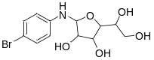 | -8.828 | -121.301 | 5.6 | - | -
7188-0011 | 892228-51-2 | 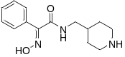 | -7.518 | -108.121 | 52.7 | 54.31 ± 0.67 | >100
S823-4326 | 2096008-34-1 | 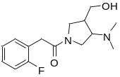 | -8.252 | -169.123 | 3.36 | - | -
S635-0105 | 1775394-69-8 | 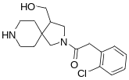 | -8.242 | -172.619 | -4.7 | - | -
S836-7125 | 2096104-09-3 | 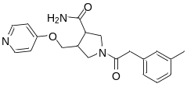 | -8.291 | -148.084 | 0.34 | - | -
5720-0003 | 690689-19-1 | 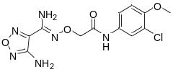 | -7.632 | -116.148 | 10.6 | - | -
G490-0681 | 932363-16-1 | 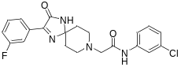 | -7.903 | -129.574 | -1.5 | - | -
Y021-2085 | 932280-17-6 | 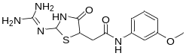 | -7.800 | -106.569 | 2.1 | - | -
Y042-2116 | 1676107-72-4 | 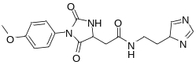 | -9.149 | -128.156 | 13.8 | - | -
Y041-7883 | 1630921-11-7 | 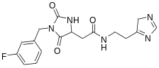 | -8.232 | -109.369 | -0.09 | - | -
8013-2952 | 85230-89-3 | 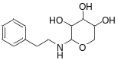 | -8.274 | -116.15 | -1.2 | - | -
FF20-1444 | 1400636-05-6 | 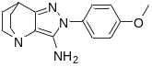 | -7.517 | -103.156 | -6.1 | - | -
8020-2570 | 1092305-89-9 | 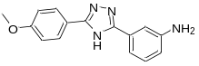 | -7.835 | -86.219 | -36.9 | - | -
3253-5003 | 306952-57-8 | 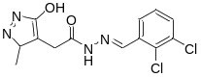 | -8.379 | -107.103 | -3.9 | - | -
D585-0174 | 1030105-83-9 | 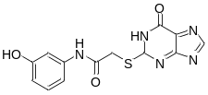 | -7.671 | -116.033 | 4.1 | - | -
8388-0735 | 1009665-00-2 | 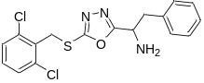 | -8.891 | -93.221 | -0.8 | - | -
2798-1431 | 447444-78-2 | 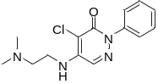 | -9.261 | -117.751 | 11.1 | - | -
D665-1401 | 931376-03-3 | 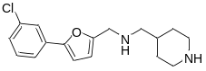 | -8.255 | -229.095 | 4.8 | - | -
3010-1404 | 106522-85-4 | 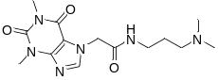 | -8.523 | -190.613 | 13.3 | - | -
S720-2261 | 2488124-94-1 | 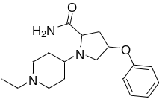 | -8.378 | -278.465 | -12.7 | - | -
S056-0504 | 1341016-78-1 | 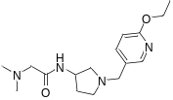 | -8.400 | -232.466 | -3.9 | - | -
S695-2043 | 2095999-96-3 | 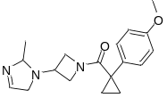 | -7.828 | -132.039 | -2.0 | - | -
E535-6542 | 1015900-40-9 | 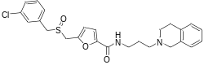 | -8.361 | -144.877 | -17.8 | - | -
Y020-1890 | 1009599-65-8 | 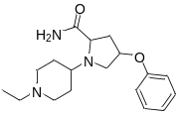 | -7.628 | -136.536 | 4.4 | - | -
8008-4228 | 330838-83-0 | 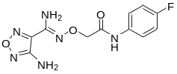 | -8.020 | -118.171 | 1.1 | - | -

The ¹H-NMR and MS spectra of the purchase xx compounds
¹H-NMR of 2798-1431
¹H-NMR of 3010-1404
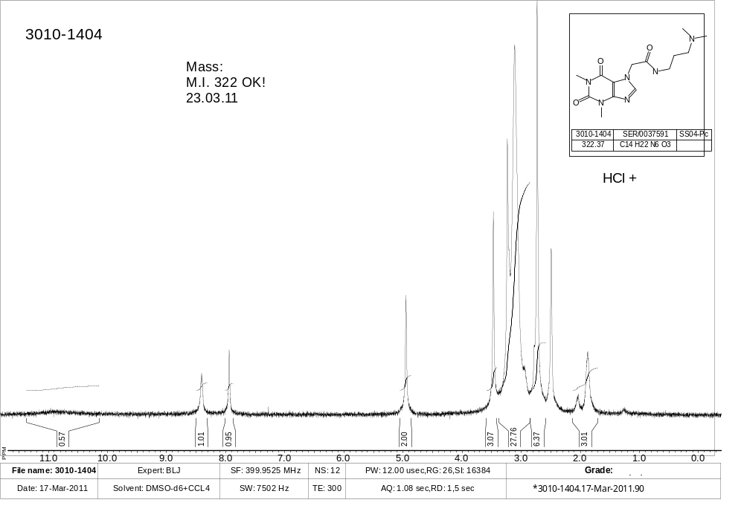
¹H-NMR of 3253-5003
¹H-NMR of 5720-0003
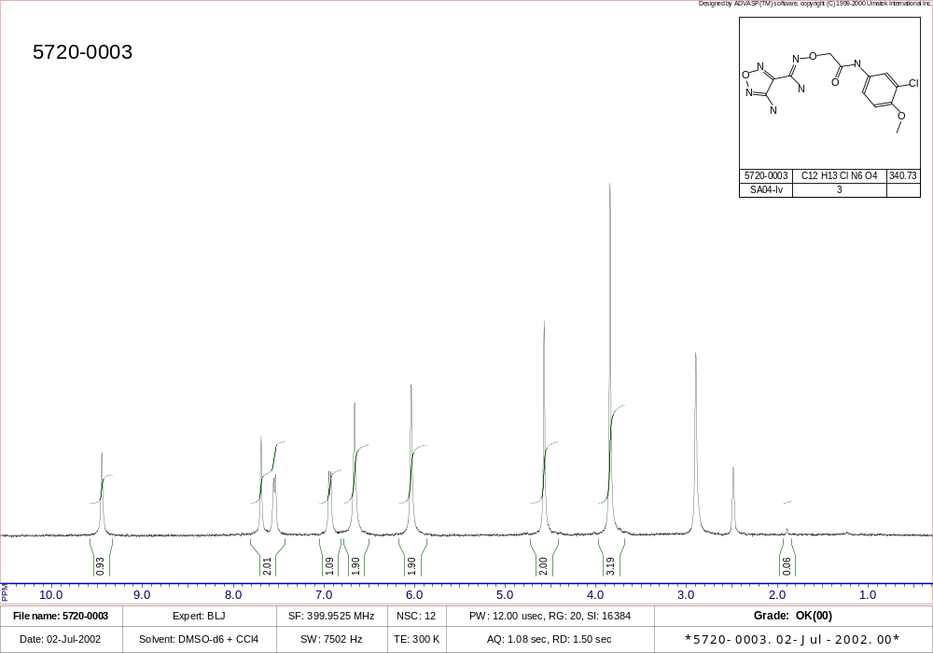
¹H-NMR of 6623-1943
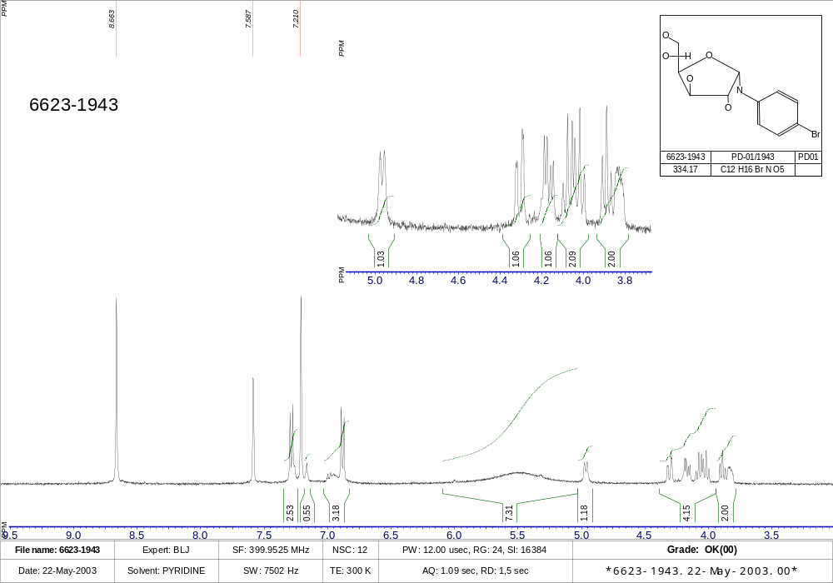
MS of 7188-0011
¹H-NMR of 8008-4228
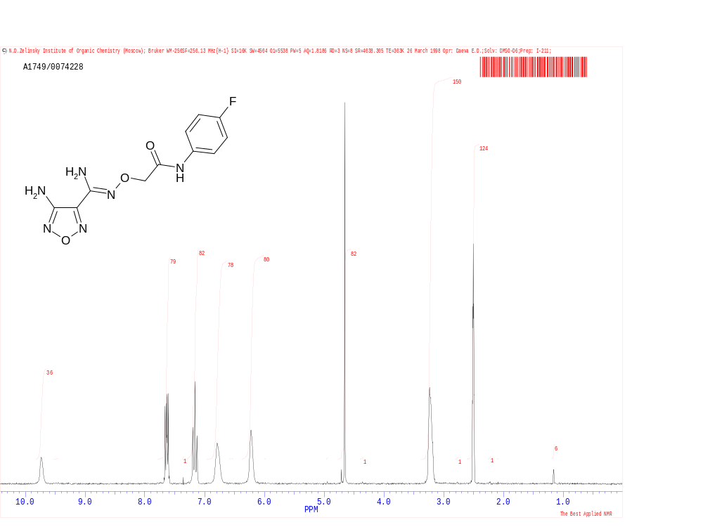
¹H-NMR of 8013-2952
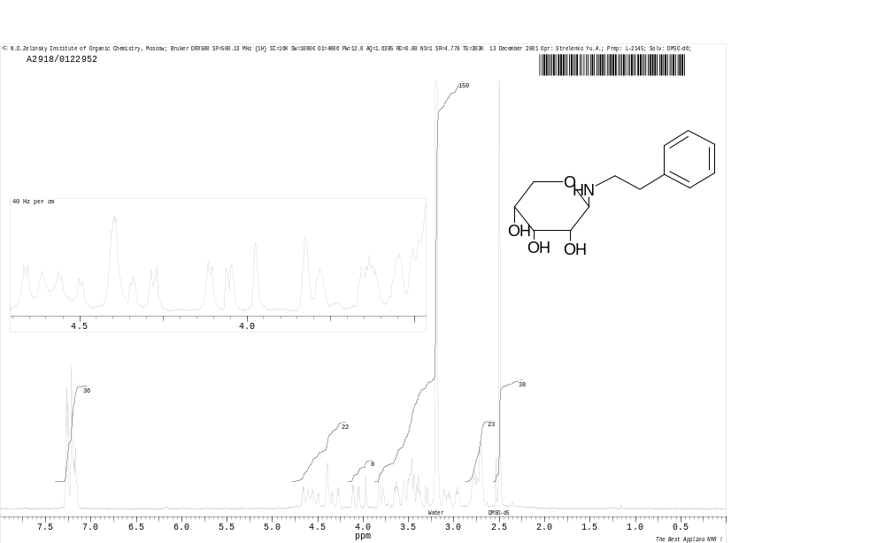
¹H-NMR of 8020-2570
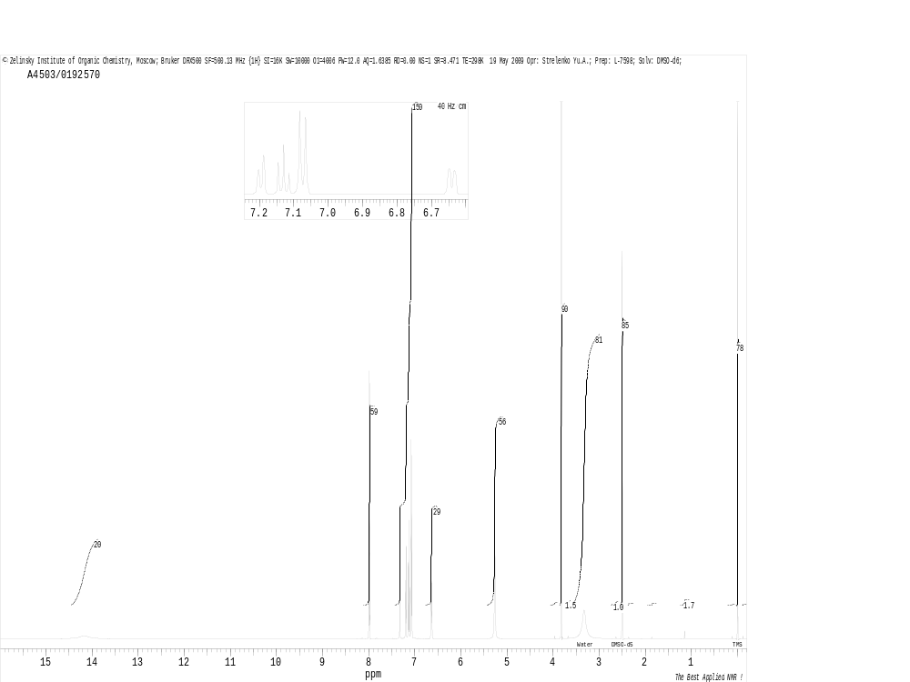
¹H-NMR of 8388-0735
¹H-NMR of D585-0174
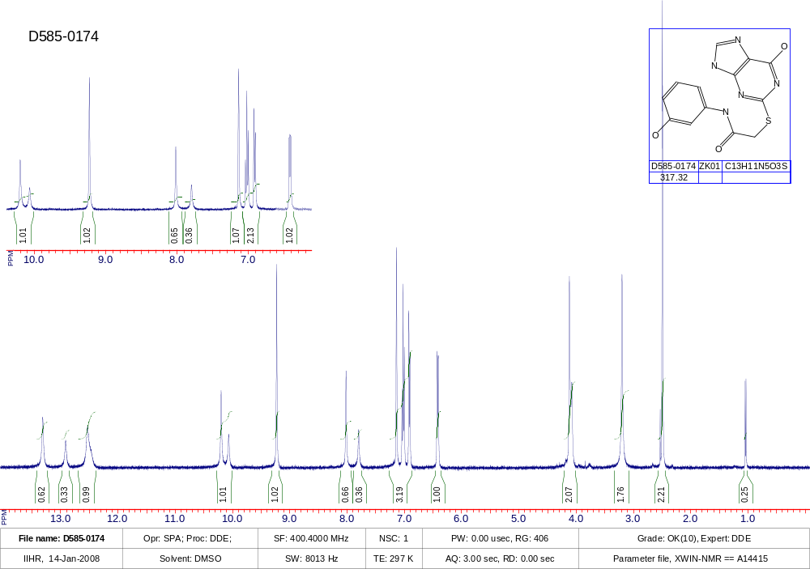
¹H-NMR of D665-1401
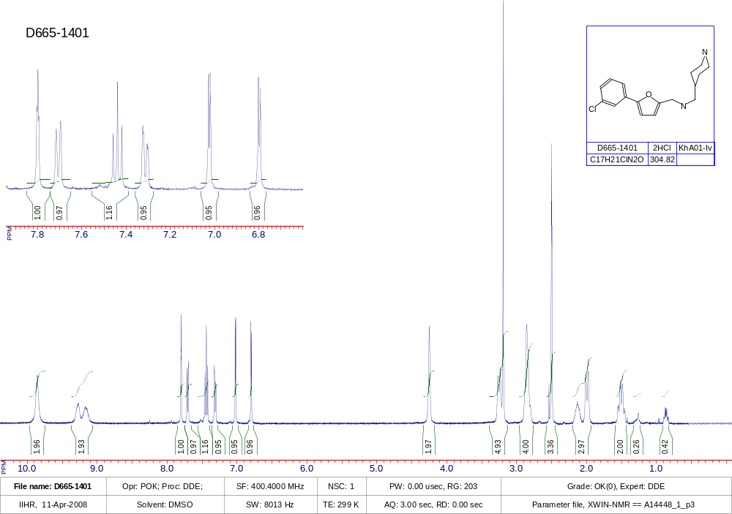
MS of E535-6542
¹H-NMR of FF20-1444
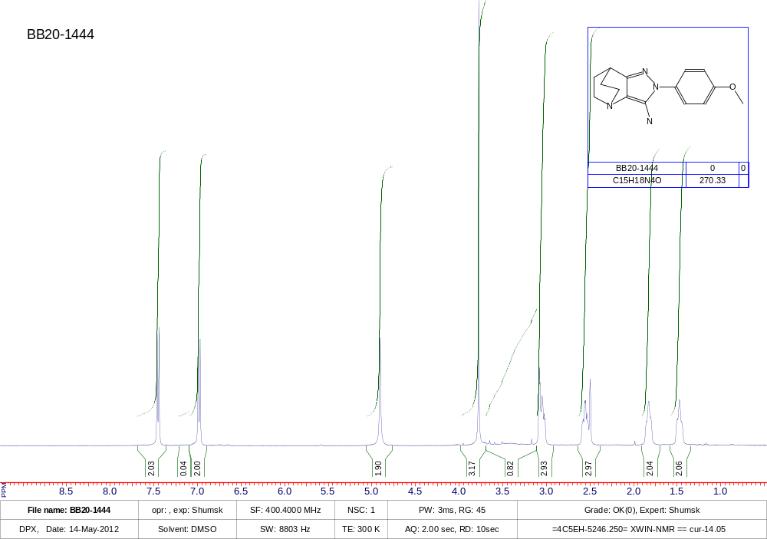
MS of G490-0681
MS of S056-0504
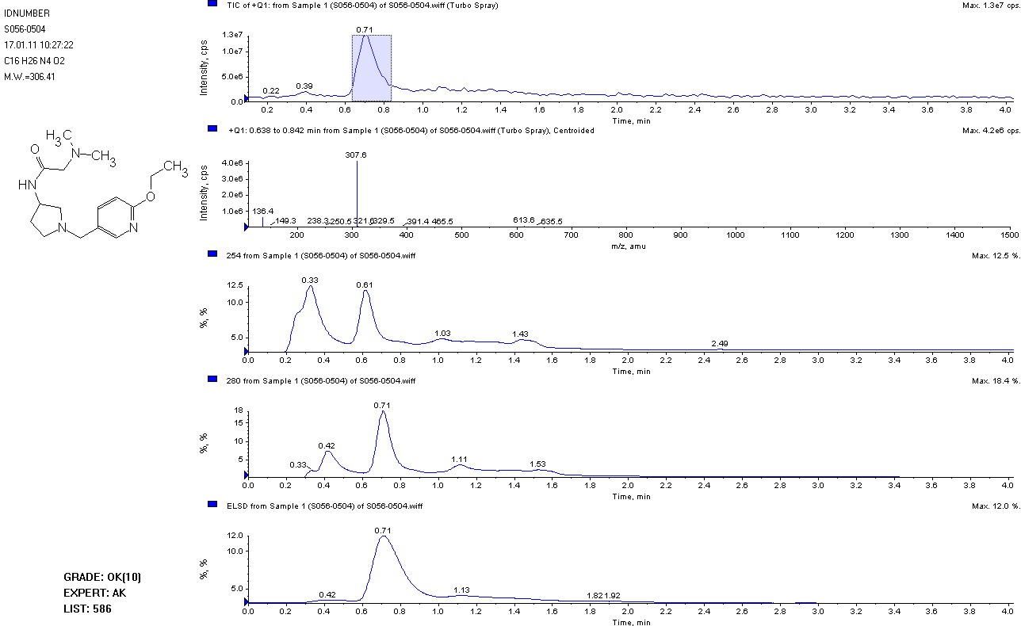
S635-0105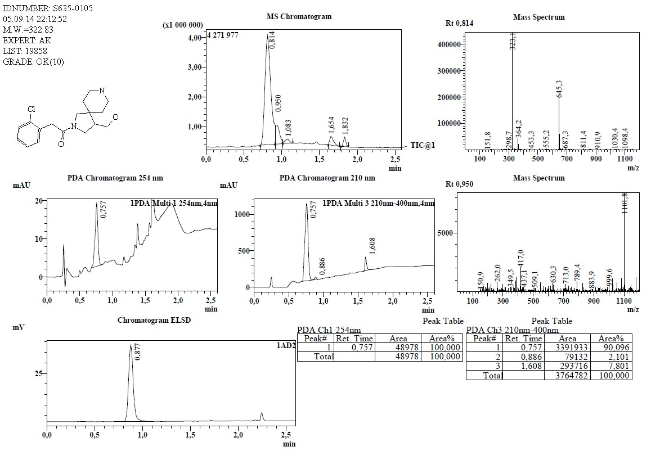
¹H-NMR of S695-2043
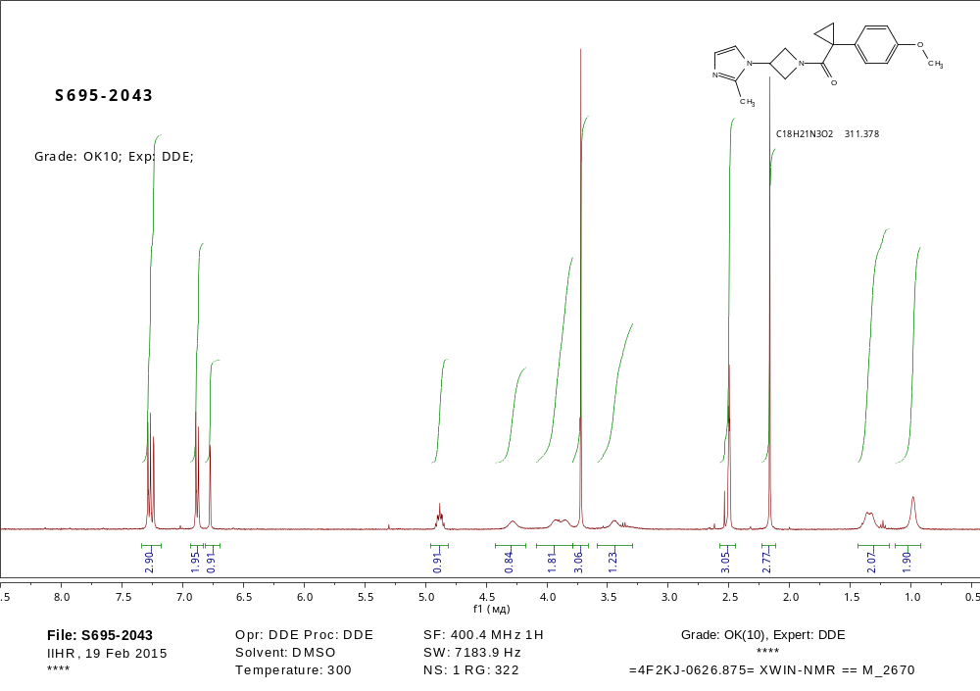
S720-2261
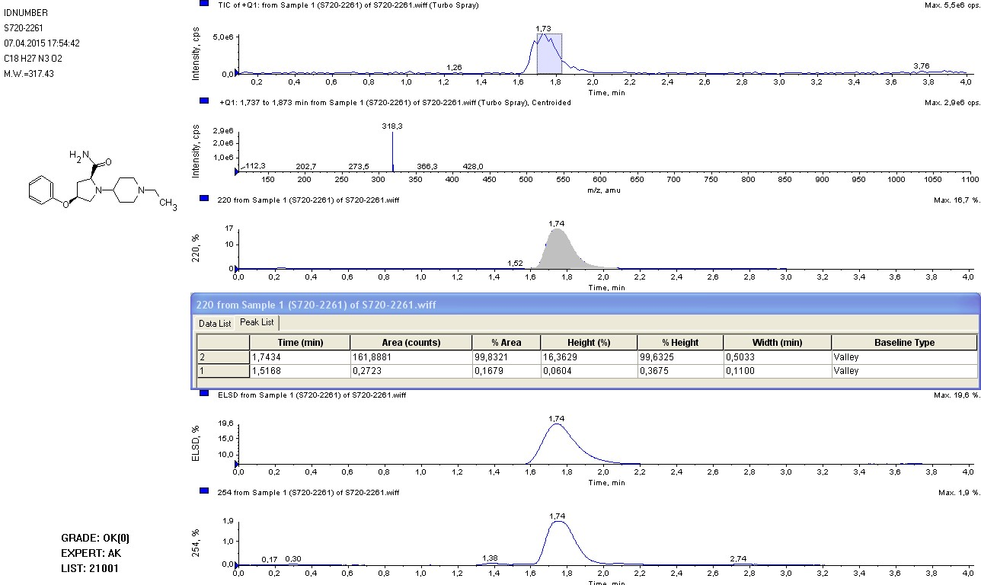
S823-4326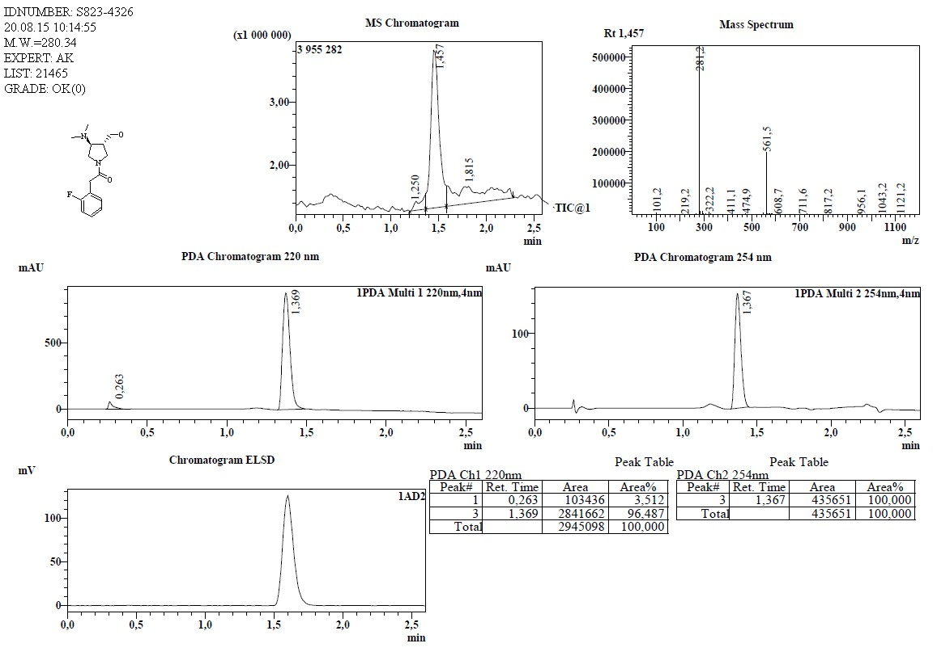
S836-7125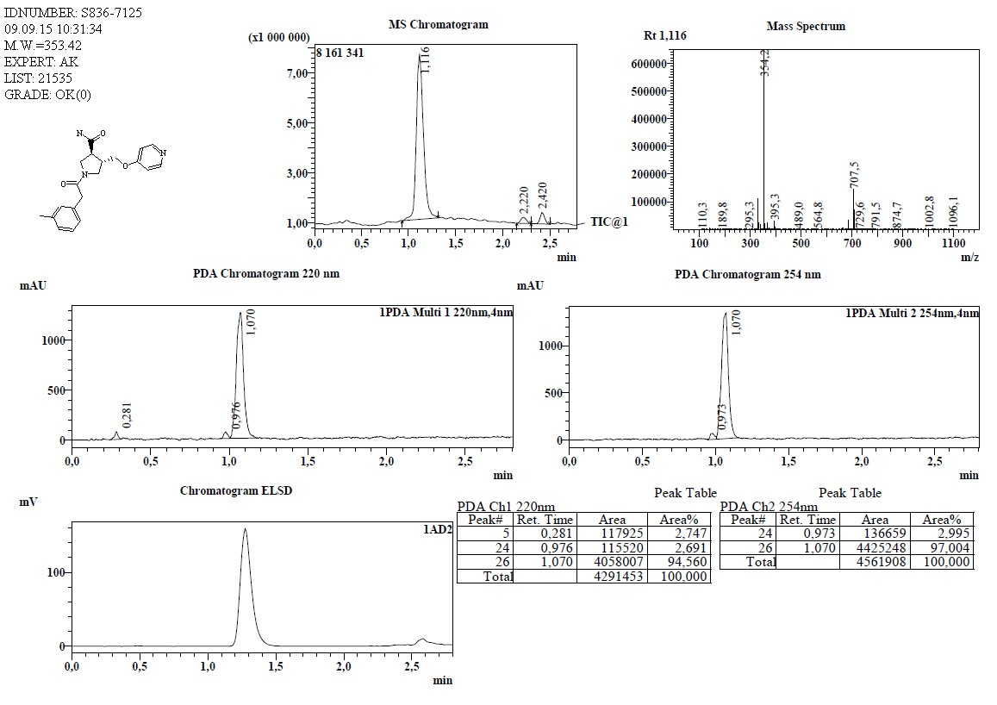
Y020-1890
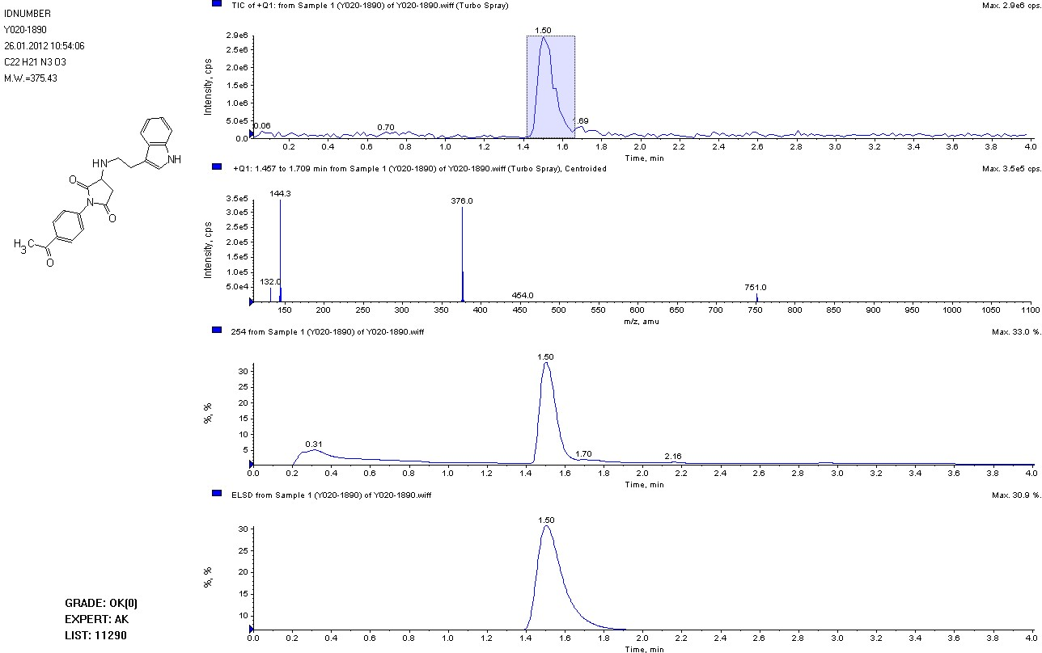
Y021-2085
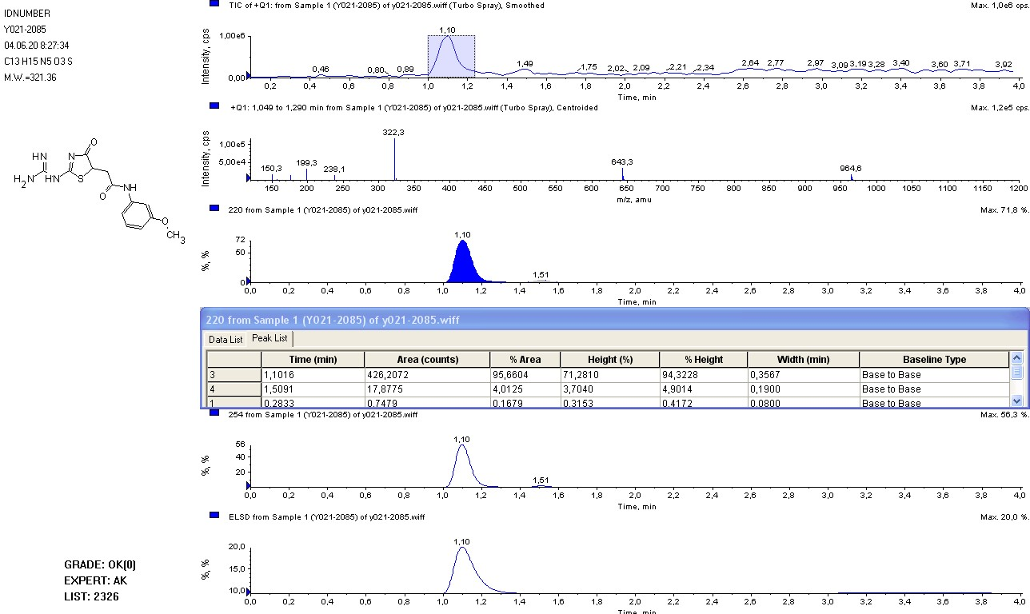
Y041-7883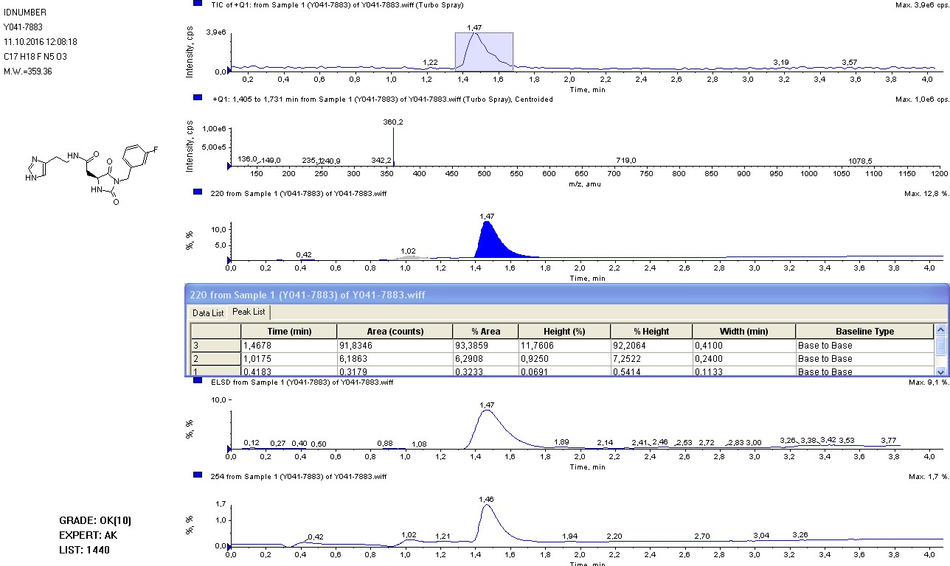
Y042-2116