Supplementary Fig. 1 Study schema: patients’ enrollment and immunohistochemistry.

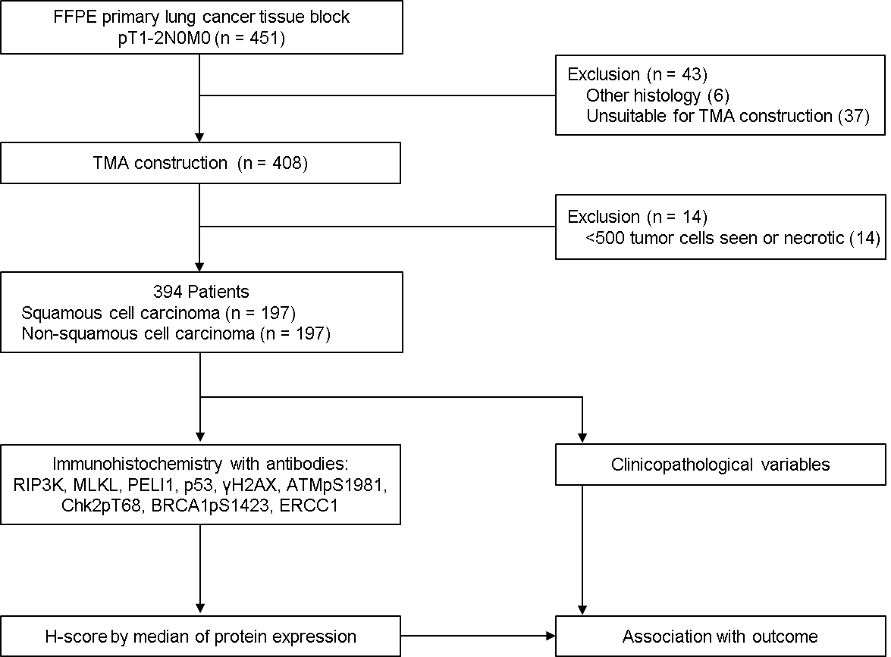
FFPE: formalin-fixed paraffin-embedded; TMA: tissue microarray.

Supplementary Fig. 2 Images for immunohistochemistry in proteins involved in necroptosis and DNA damage response. Expression of the proteins was classified into low and high by using a criterion of median value of all mean H-scores (H & E, x 200).

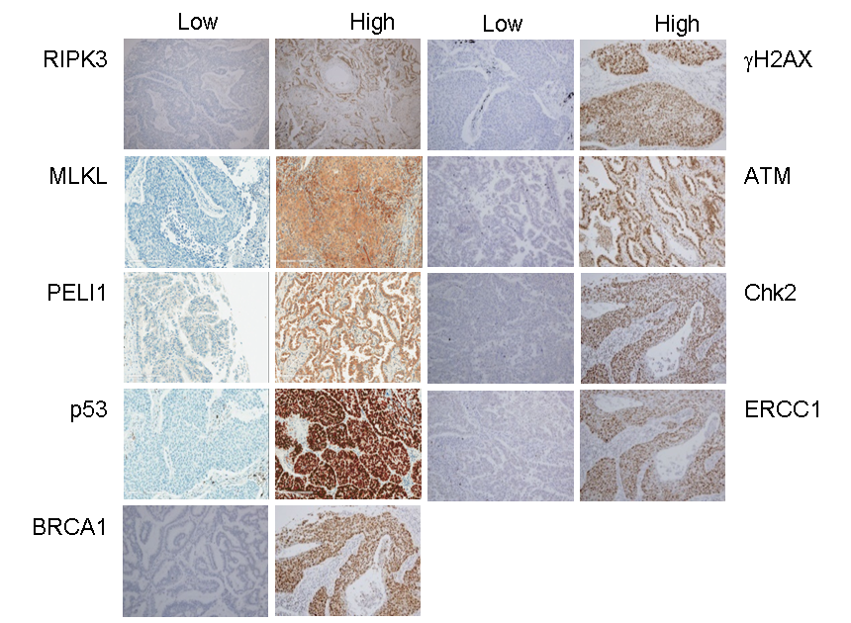

Supplementary Table 1 Information on antibodies for proteins involved in necroptosis and DNA damage response.

Antibody | Clonality | Dilution | Source
RIPK3 | rabbit polyclonal | 1:300 | Abcam ab72106
MLKL (EPR17514) | rabbit monoclonal | 1:40 | Abcam ab184718
PELI1 (F-7) | mouse monoclonal | 1:20 | Santa Cruz sc-271065
p53 (DO-7) | mouse monoclonal | 1:1000 | Dako M7001
ATMpS1981 (7C10D8) | mouse monoclonal | 1:600 | Rockland 200-301-500
γH2AXpS139 (JBW301) | mouse monoclonal | 1:100 | Millipore 05-636
Chk2pT68 | rabbit polyclonal | 1:30 | Cell Signaling 2661s
BRCA1pS1423 | rabbit polyclonal | 1:100 | Abcam ab47325
ERCC1 (8F1) | mouse monoclonal | 1:100 | GeneTex GTX22356

Supplementary Table 2 Survival of the patients with stage I NSCLC by clinicopathological variables.

 |  |  | HR (95% CI)ª | P
Age |  |  | 1.036 (1.017—1.056) | < 0.001
Gender | Men |  | 1 | 0.061
 | Women |  | 0.696 (0.476—1.017)
Smoking habit | Never |  | 1 | 0.586
 | Ever |  | 1.107 (0.767—1.598)
ECOG performance status | 0—1 |  | 1 | 0.576
 | 2 or more |  | 0.752 (0.278—2.039)
CCIS | 0 |  | 1 | 0.100
 | 1 |  | 1.167 (0.800—1.702)
 | 2 or more |  | 1.803 (1.052—3.092)
Histology | SCC |  | 1 | 0.671
 | Non-SCC |  | 1.070 (0.784—1.460)
Tumor size, cm |  |  | 1.124 (1.034—1.222) | 0.006
T stage | 1 |  | 1 | < 0.001
 | 2 |  | 1.865 (1.315—2.647)
Lymphatic invasion | No |  | 1 | 0.306
 | Yes |  | 0.826 (0.572—1.191)
Vascular invasion | No |  | 1 | 0.153
 | Yes |  | 0.771 (0.540—1.101)
Type of surgery | Lobectomy |  | 1 | 0.493
 | Bilobectomy |  | 0.854 (0.472—1.543)
 | Pneumonectomy |  | 1.298 (0.783—2.153)
Adjuvant chemotherapy | No |  | 1 | 0.694
 | Yes |  | 0.912 (0.576—1.444)
ª Hazard ratio and 95% confidence interval by Cox regression test. ECOG, Eastern Cooperative Oncology Group; CCIS, Charlson comorbidity index score; NA, not applicable; SCC, squamous cell carcinoma.

Supplementary Table 3 Proteins involved in necroptosis and DNA damage response and survival of patients with stage I NSCLC according to histology: Simple Cox model.

 |  | Total |  |  | SCC |  |  | Non-SCC
 |  | HR (95% CI)ª | P |  | HR (95% CI)ª | P |  | HR (95% CI)ª | P
RIPK3 | low v high | 1.306 (0.955—1.787) | 0.094 |  | 1.773 (1.137—2.765) | 0.011 |  | 0.920 (0.591—1.431) | 0.710
MLKL | low v high | 0.937 (0.686—1.279) | 0.681 |  | 1.170 (0.740—1.849) | 0.503 |  | 0.771 (0.491—1.210) | 0.258
PELI1 | low v high | 1.217 (0.891—1.662) | 0.217 |  | 1.768 (1.100—2.843) | 0.019 |  | 0.853 (0.544—1.338) | 0.489
p53 | low v high | 0.738 (0.540—1.010) | 0.057 |  | 0.556 (0.346—0.896) | 0.016 |  | 0.927 (0.595—1.445) | 0.738
BRCA1 | low v high | 1.358 (0.988—1.868) | 0.060 |  | 1.648 (1.051—2.583) | 0.029 |  | 1.099 (0.697—1.731) | 0.685
γH2AX | low v high | 1.347 (0.975—1.861) | 0.071 |  | 1.561 (0.994—2.453) | 0.053 |  | 1.116 (0.698—1.783) | 0.647
ATM | low v high | 1.328 (0.963—1.831) | 0.084 |  | 1.299 (0.828—2.039) | 0.256 |  | 1.315 (0.828—2.089) | 0.246
Chk2 | low v high | 1.117 (0.805—1.549) | 0.508 |  | 1.248 (0.801—1.947) | 0.328 |  | 0.922 (0.556—1.530) | 0.753
ERCC1 | low v high | 1.114 (0.810—1.533) | 0.508 |  | 1.223 (0.783—1.910) | 0.377 |  | 0.952 (0.594—1.525) | 0.837
Expression of the proteins was classified into low and high by using a criterion of median value of all mean H-scores. ª Hazard ratio and 95% confidence interval by Cox regression test. SCC, squamous cell carcinoma.

Supplementary Table 4 Combined effects of proteins on survival of the patients with stage I SCC.
 |  |  | n | aHR (95% CI) | P | q-value*
RIPK3/p53 | High/Low |  | 41 | 1 | 0.001 | 0.005
 | Low/Low |  | 42 | 3.981 (1.238—12.797)
 | High/High |  | 65 | 4.123 (1.476—11.520)
 | Low/High |  | 47 | 8.394 (2.856—24.677)
RIPK3/BRCA1 | High/High |  | 70 | 1 | 0.029 | 0.048
 | High/Low |  | 37 | 1.947 (0.857—4.421)
 | Low/High |  | 24 | 2.597 (0.855—7.887)
 | Low/Low |  | 65 | 3.115 (1.465—6.623)
RIPK3/PELI1 | High/High |  | 61 | 1 | 0.048 | 0.060
 | High/Low |  | 45 | 1.635 (0.712—3.755)
 | Low/High |  | 18 | 2.105 (0.642—6.906)
 | Low/Low |  | 71 | 2.927 (1.368—6.262)
PELI1/p53 | High/Low |  | 30 | 1 | 0.007 | 0.018
 | Low/Low |  | 53 | 3.474 (1.049 to 11.507)
 | High/High |  | 49 | 4.393 (1.370 to 14.089)
 | Low/High |  | 63 | 6.760 (2.173 to 21.024)
PELI1/BRCA1 | High/High |  | 50 | 1 | 0.052 | 0.052
 | High/Low |  | 29 | 1.938 (0.720 to 5.219)
 | Low/High |  | 43 | 1.902 (0.704 to 5.135)
 | Low/Low |  | 73 | 3.285 (1.376 to 7.845)
Expression of the proteins was classified into low and high by using a criterion of median value of all mean H-scores. aHR, hazard ratio adjusted with age, gender, smoking habit, Eastern Cooperative Oncology Group performance status, Charlson comorbidity index score, tumor size, T stage, lymphatic or vascular invasion, type of surgery, and adjuvant chemotherapy. *FDR corrected p values after adjustment for multiple comparisons. SCC, squamous cell carcinoma.

