Supplementary Figures
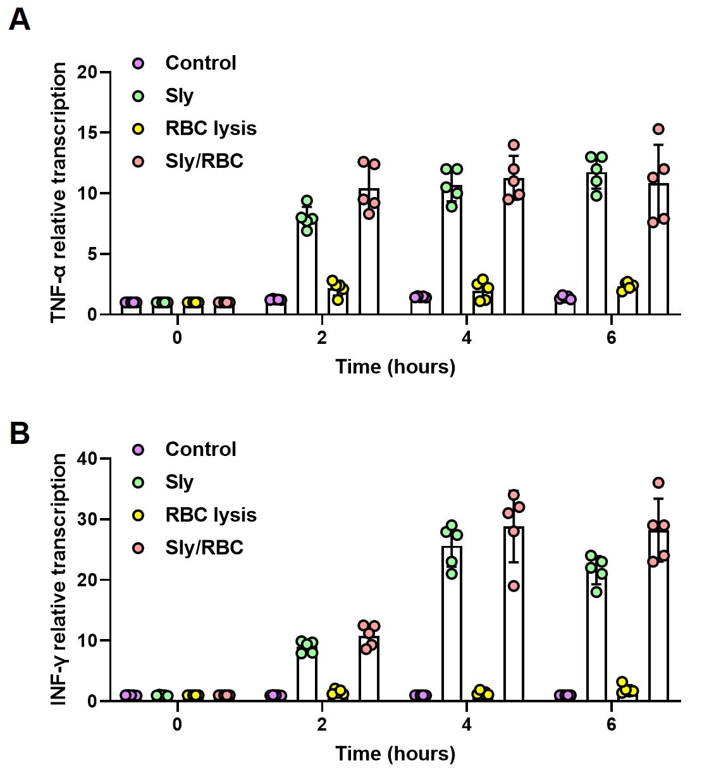
Fig S1. The Effect of Sly Hemolytic Products on TNFα and IFN-γ in Brain Microvascular Endothelial Cells
Sly promotes the expression of TNF-α(A) and IFN-γ(B) in hCMEC/D3, but the hemolytic products do not affect the expression of both.

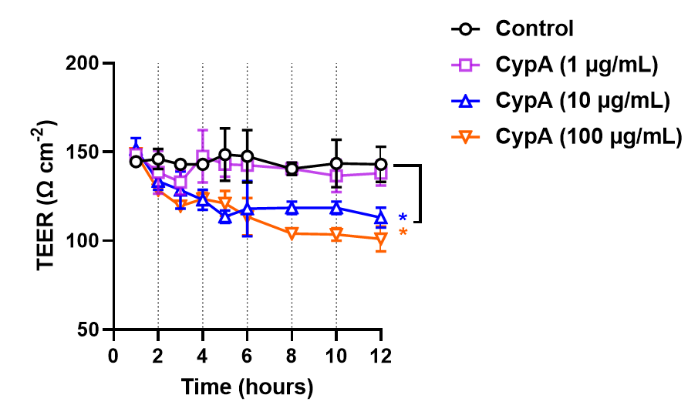
Fig S2. CypA Can Increase the Permeability of the BBB Model
TEER method to detect changes in BBB permeability.

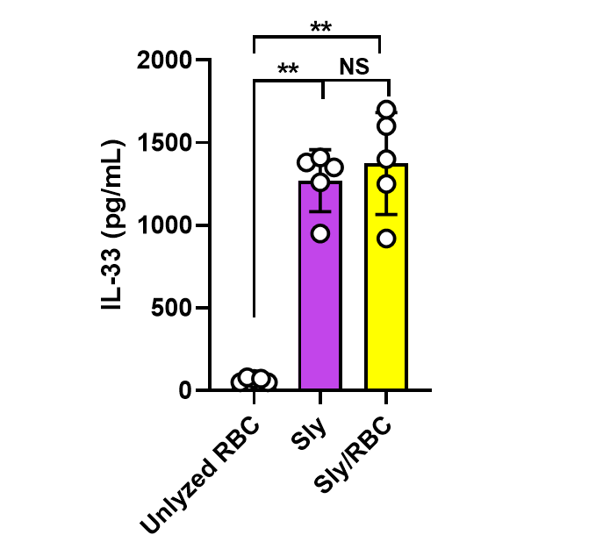
Fig S3. Sly Can Increase the Expression of IL-33 in Brain Microvascular Endothelial Cells.

Orignal Blots
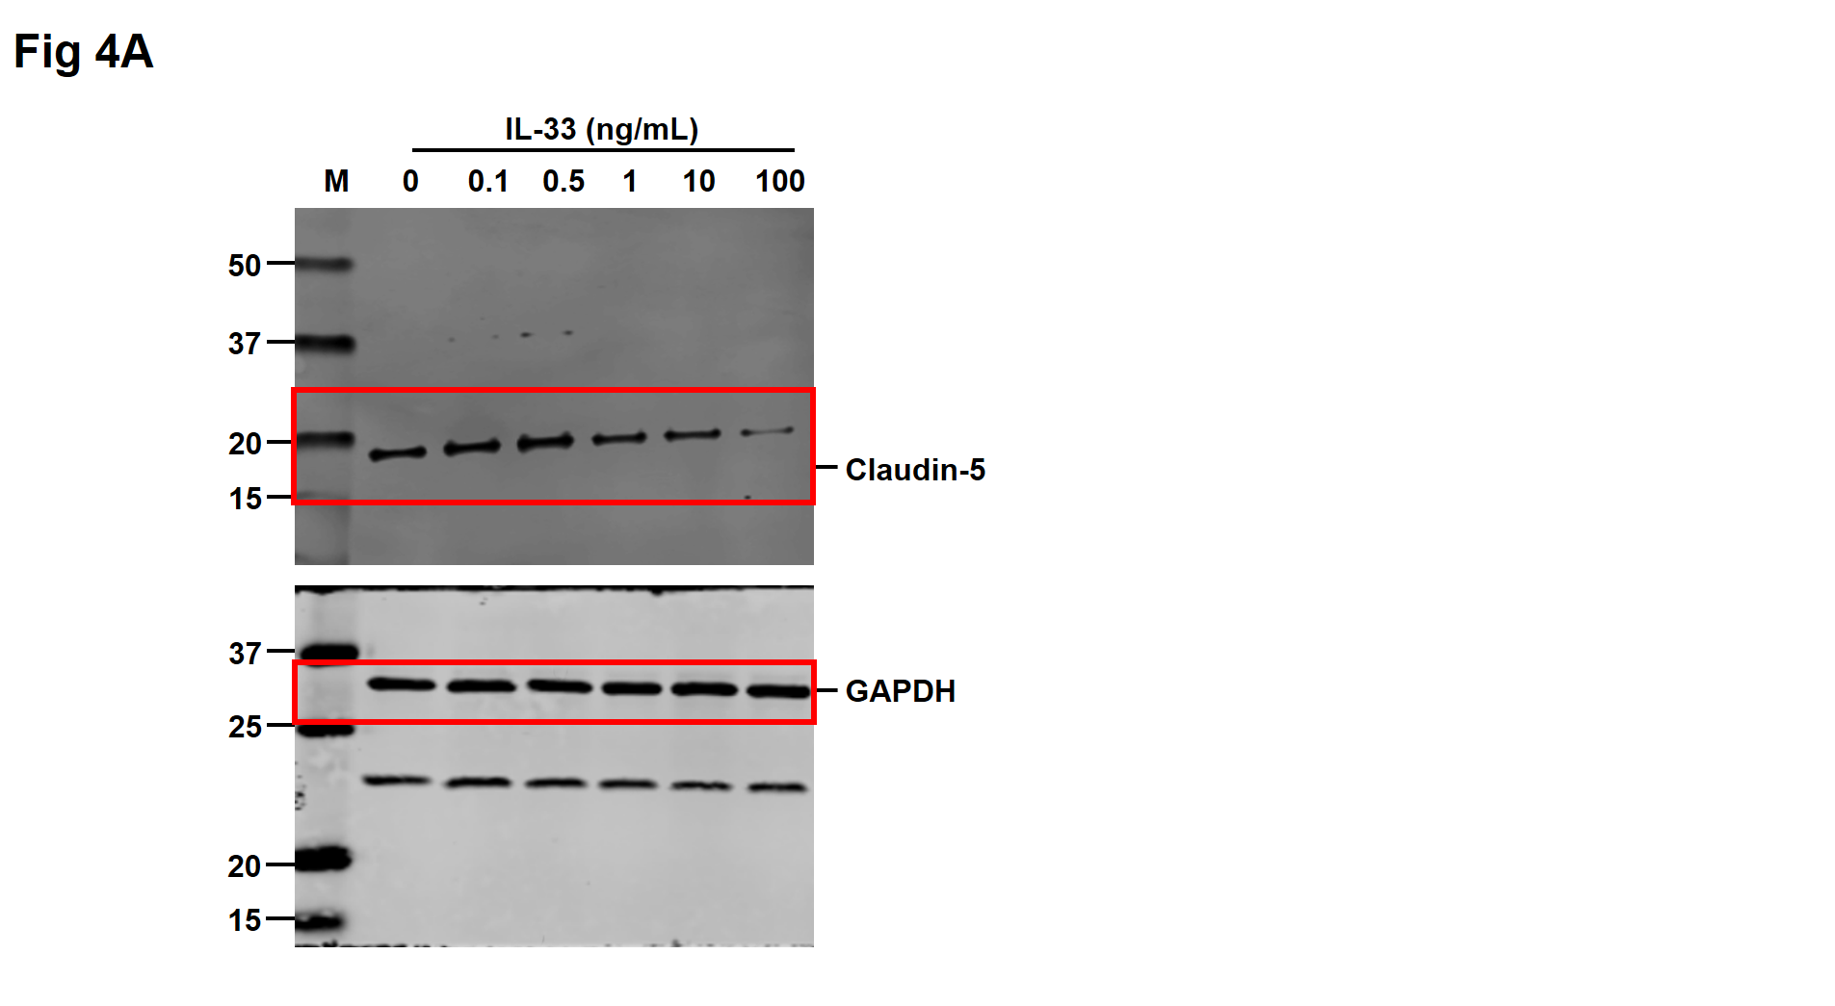
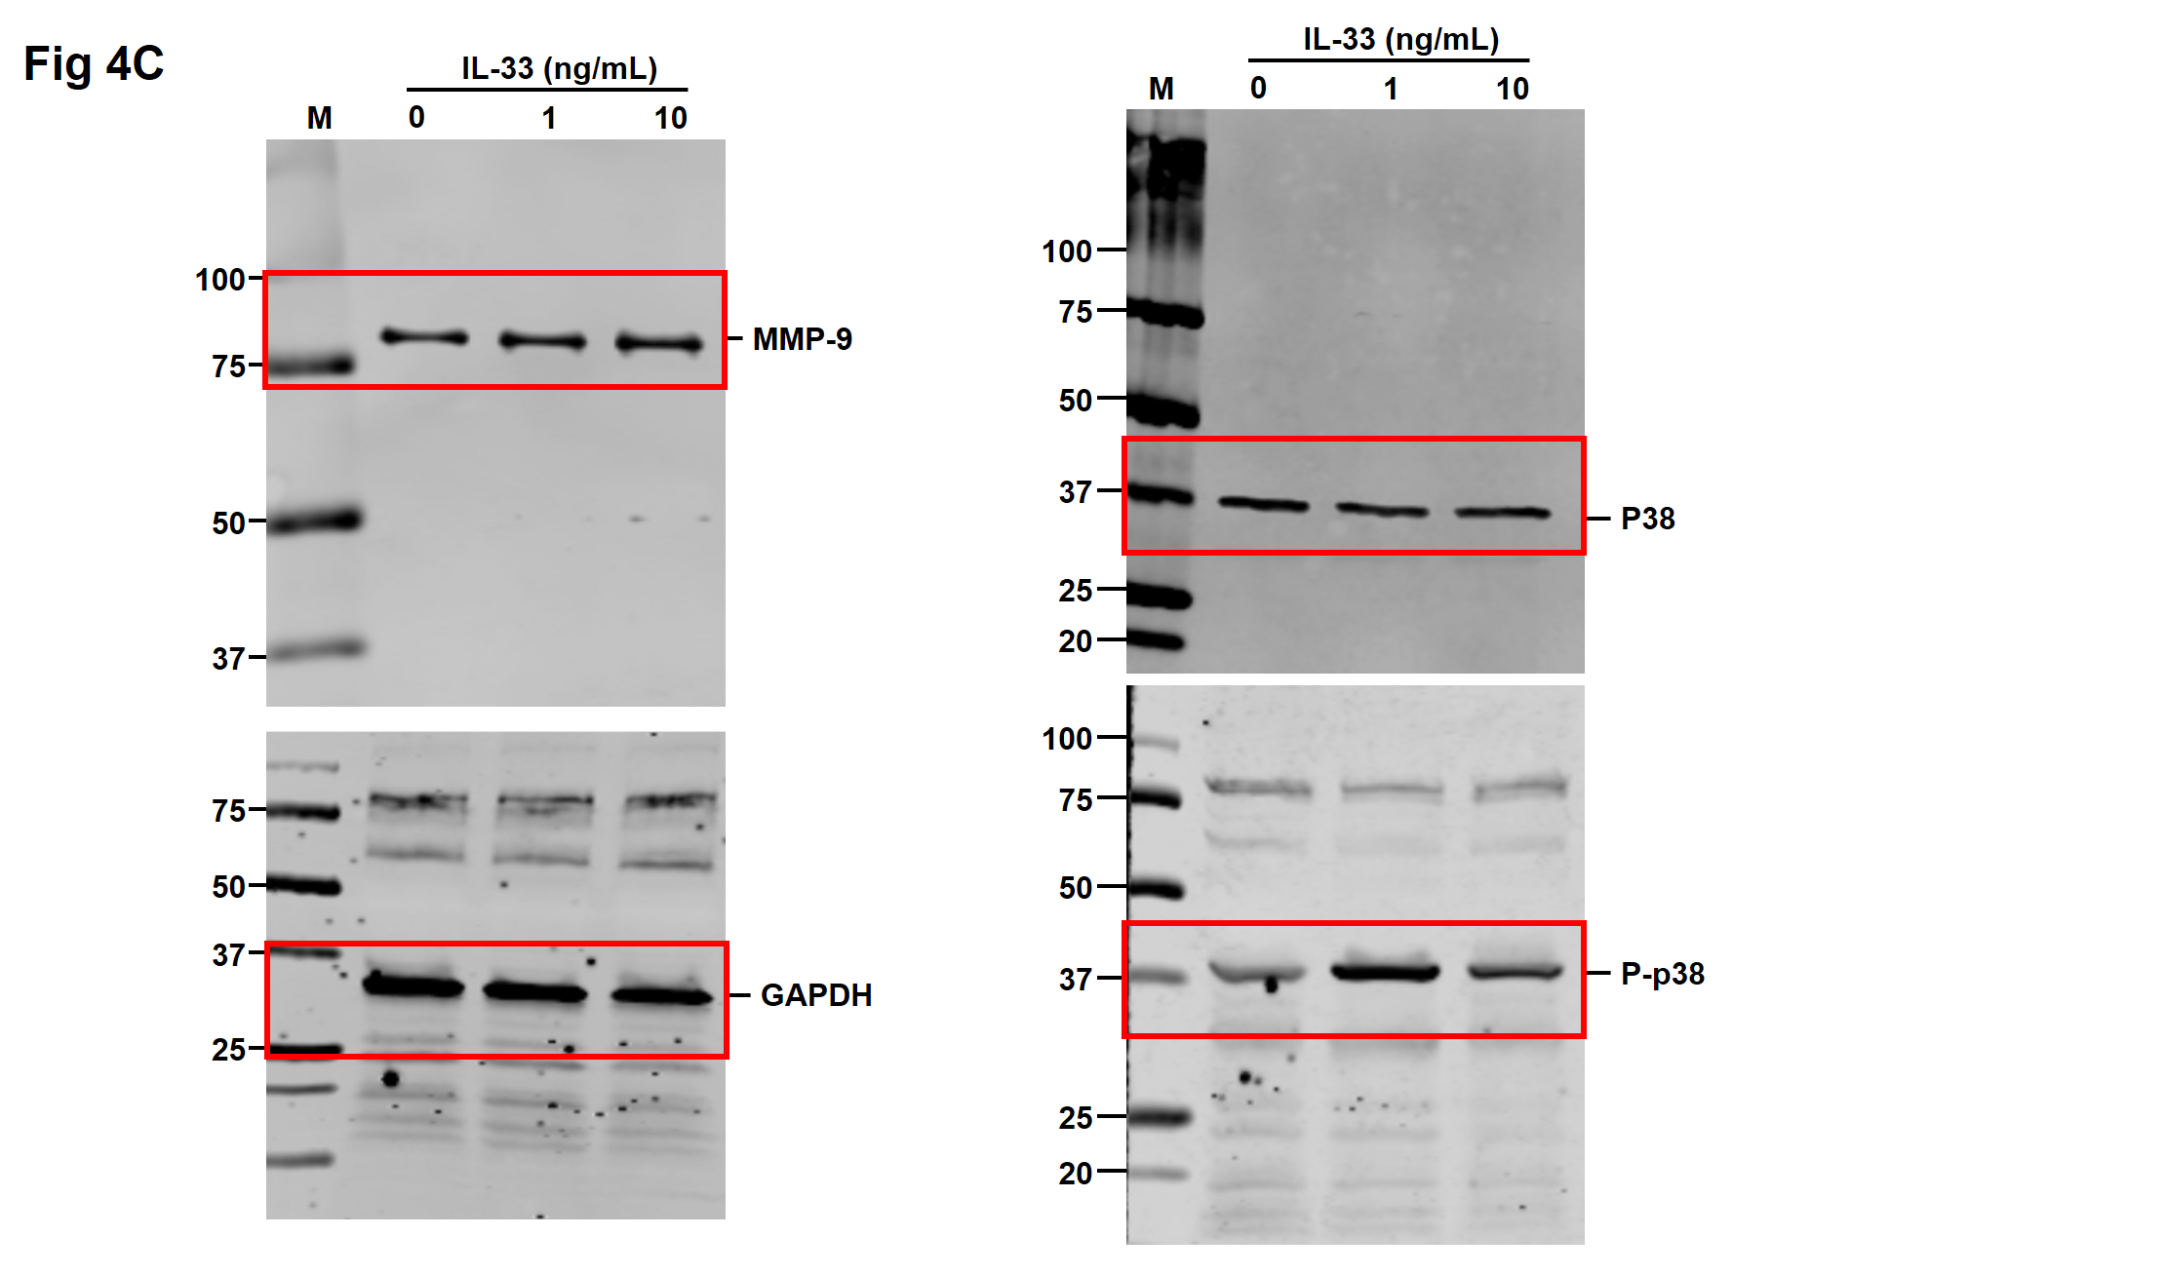
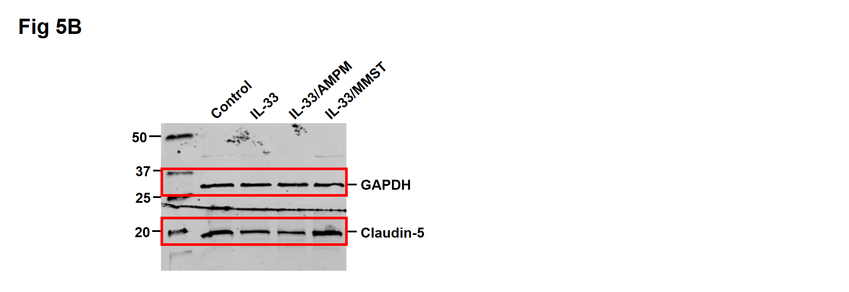

Supplementary Tables
Tab S1. The primers for RT-PCR
Gene | Sequence
il6 | forward TCAGAACGAATTGACAAACA
il6 | reverse TTGAATCCAGATTGGAAGC
il8 | forward ATGACTTCCAAGCTGGCCGTGGCT
il8 | reverse TCTCAGCCCTCTTCAAAAACTTCTC
ifnγ | forward TCAGCTCTGCATCGTTTTGG
ifnγ | reverse GTTCCATTATCCGCTACATCTGAA
tnfα | forward GGTGATCGGTCCCAACAAGGA
tnfα | reverse CACGCTGGCTCAGCCACTC
gapdh | forward ACCACAGTATGCCATCAC
gapdh | reverse TCCACCACCCTGTTGCTGTA

