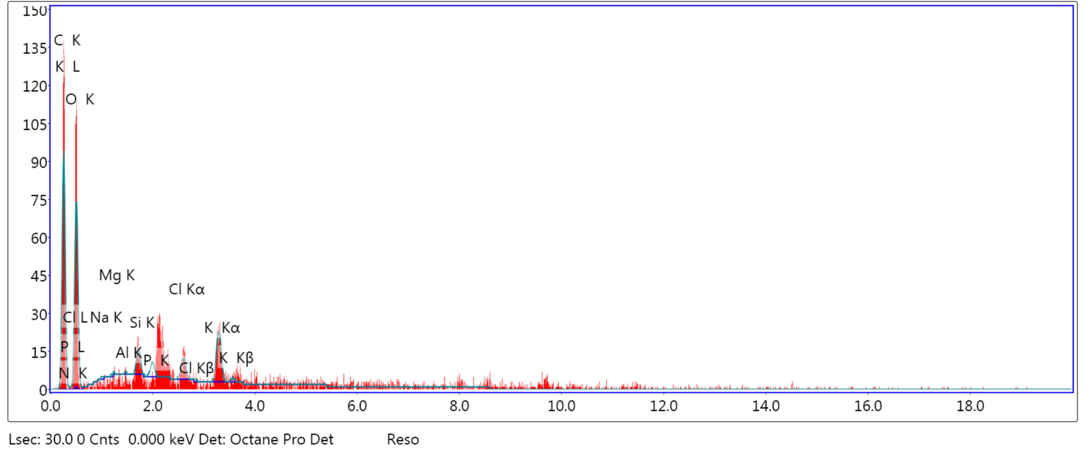
A
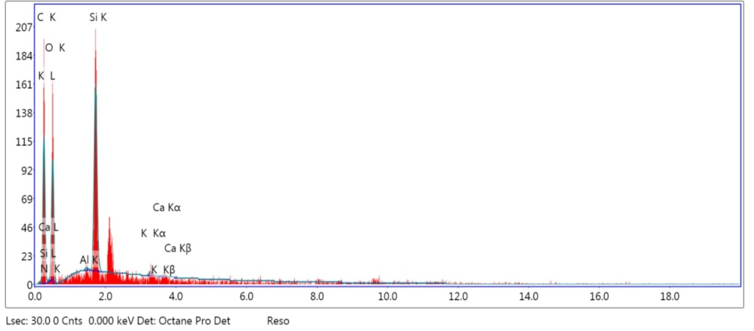
B
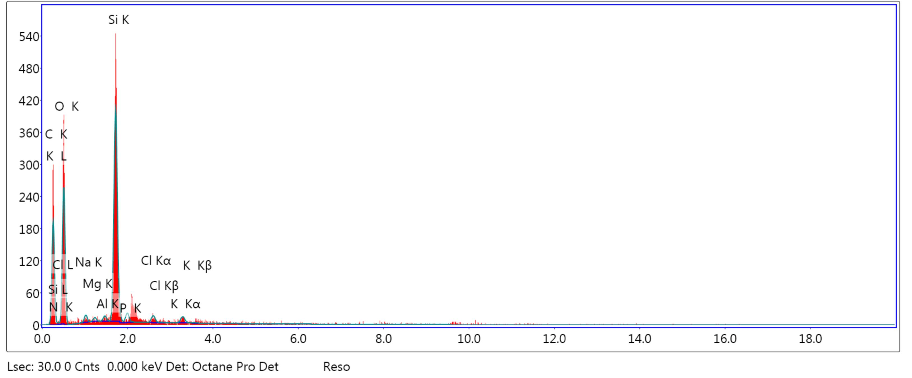
C

Fig. Supplementary data EDXA of sugar cane (raw materials) (A) Dry leaves of sugar cane, (B) Green leaves of sugar cane and (C) Tops

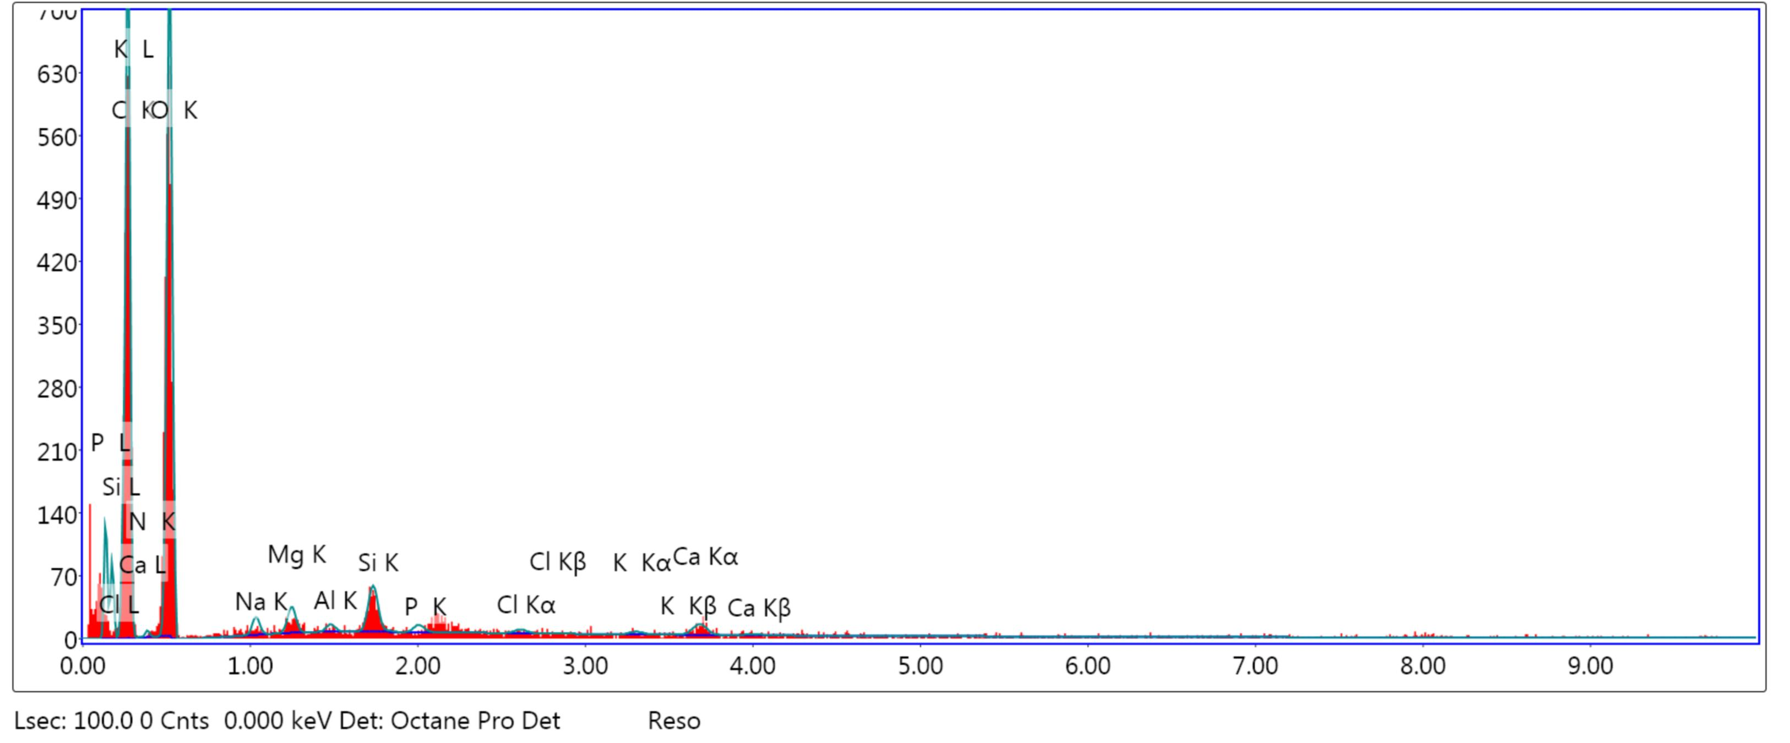
A
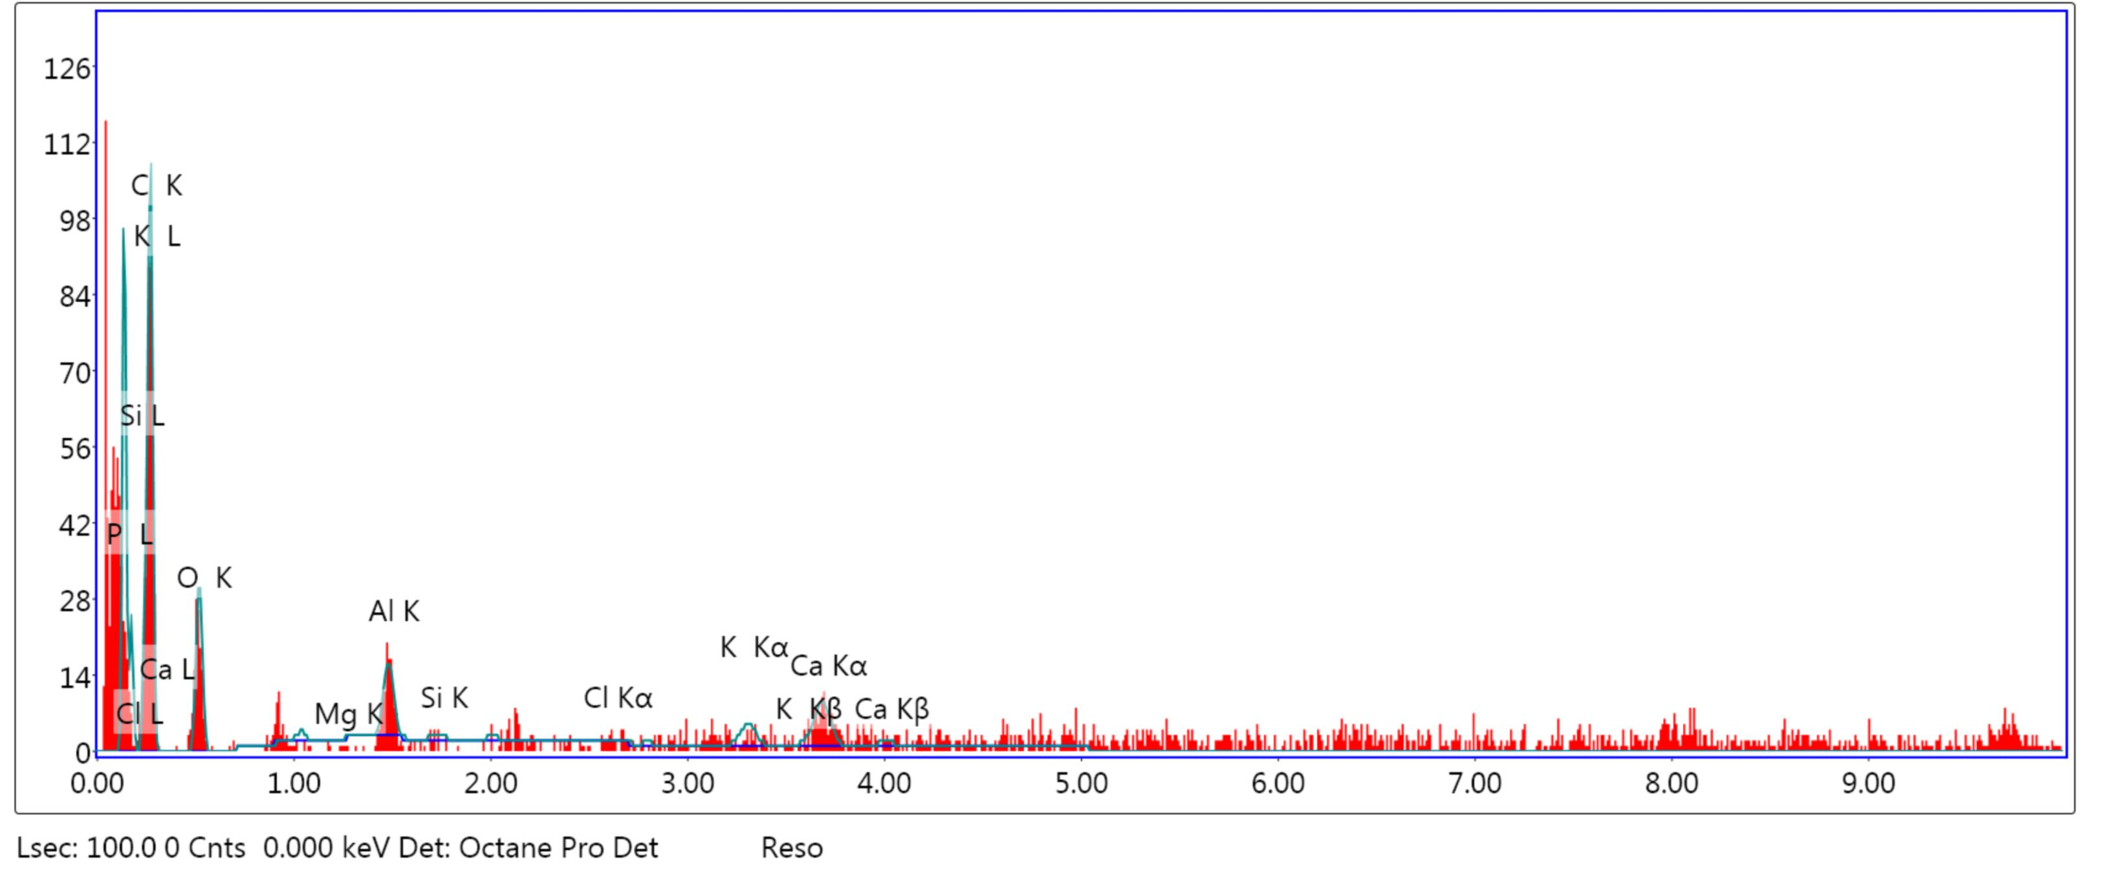
B
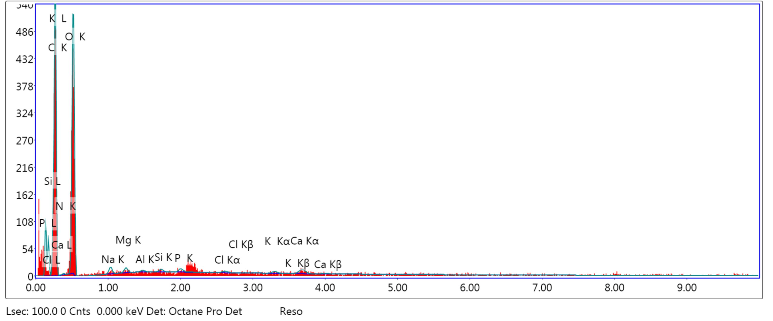
C

Fig. Supplementary data EDXA of sugar cane Cellulose (A) Dry leaves of sugar cane, (B) Green leaves of sugar cane and (C) Tops after NaOH pretreatment

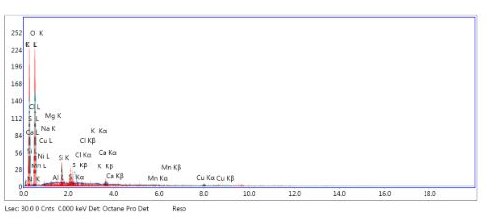
A
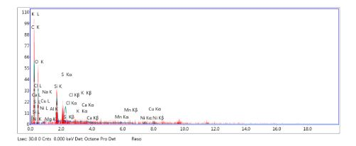
B
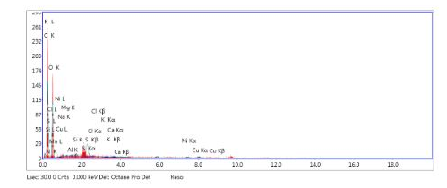
C

Fig. Supplementary data EDXA of sugar cane (A) Dry leaves, (B) Green leaves and (C) Tops after H2O2 pretreatment

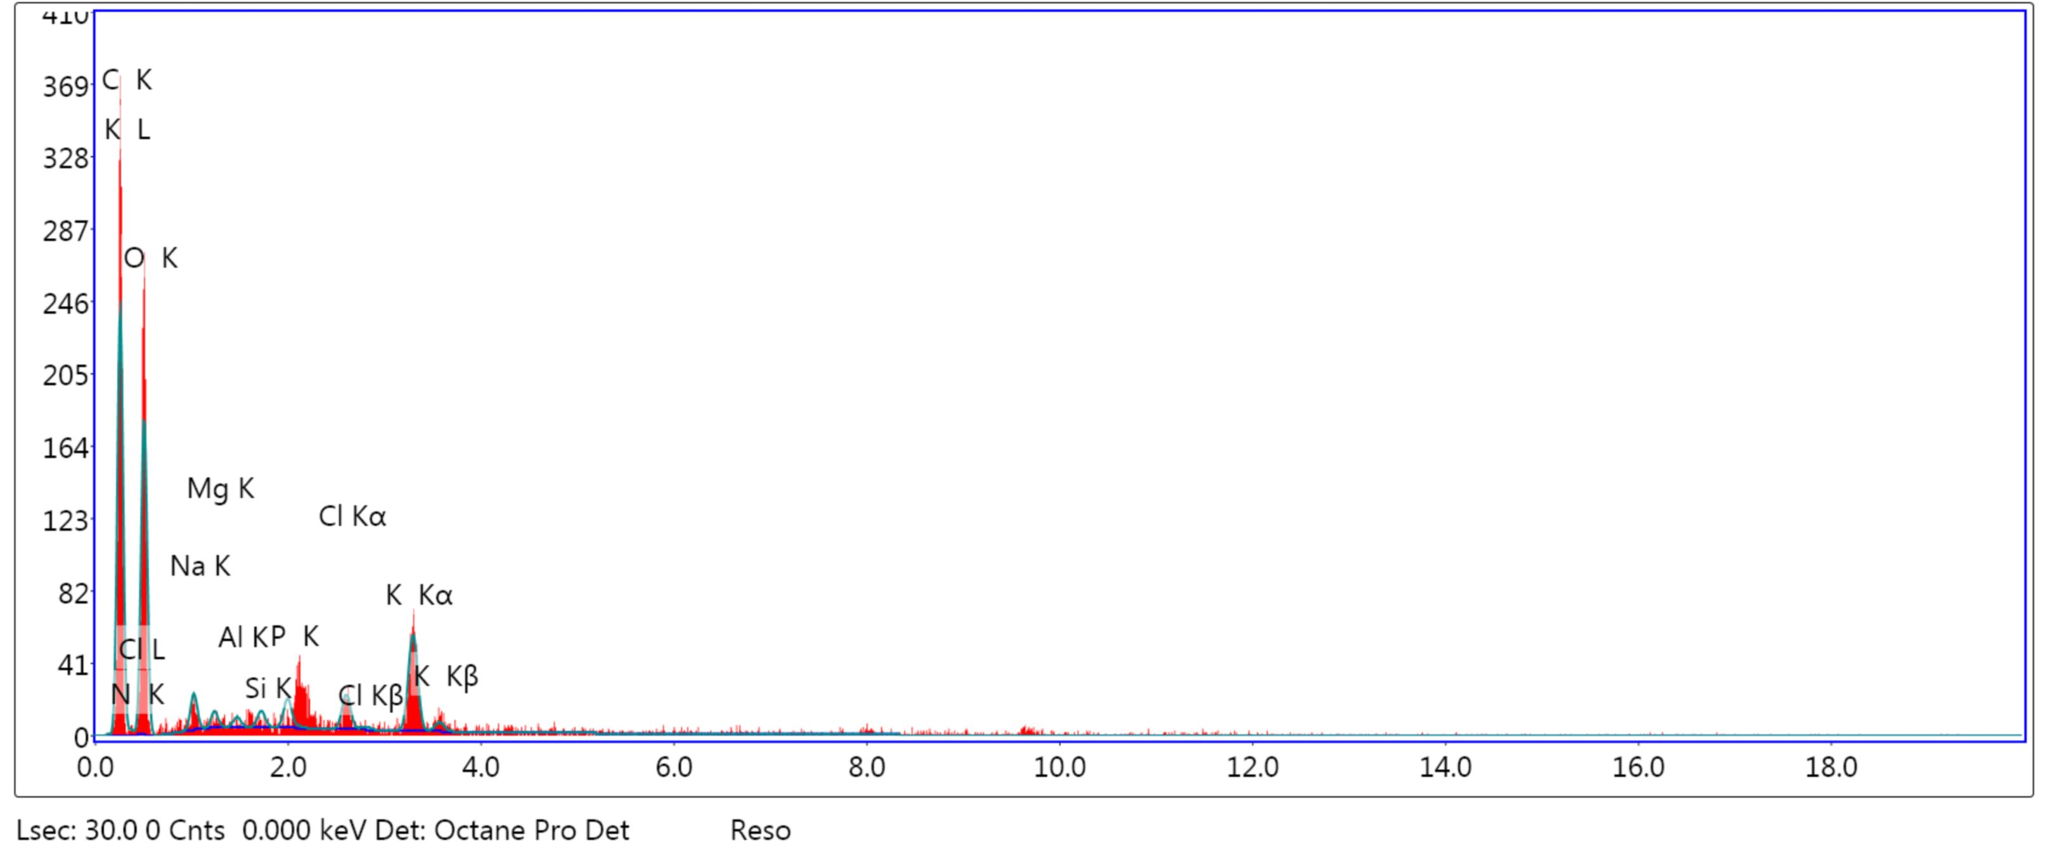
A
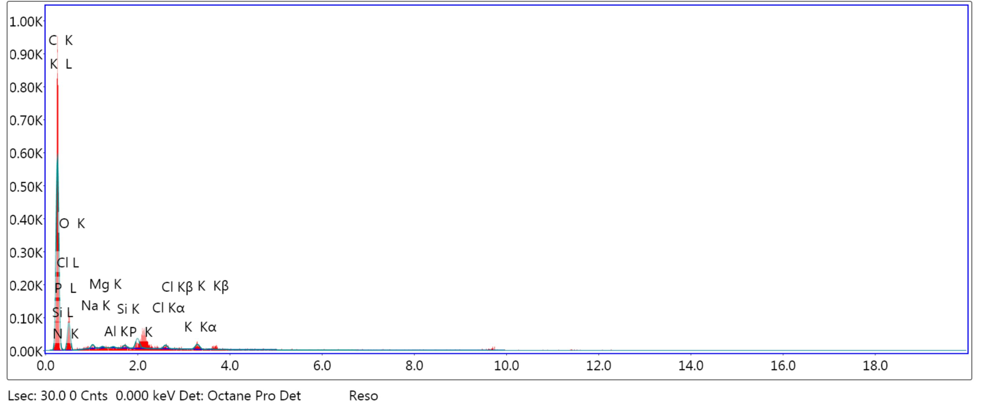
B

Fig. Supplementary data EDXA of (A) Jatropha shell and (B) Jatropha deoiled seed cake raw materials

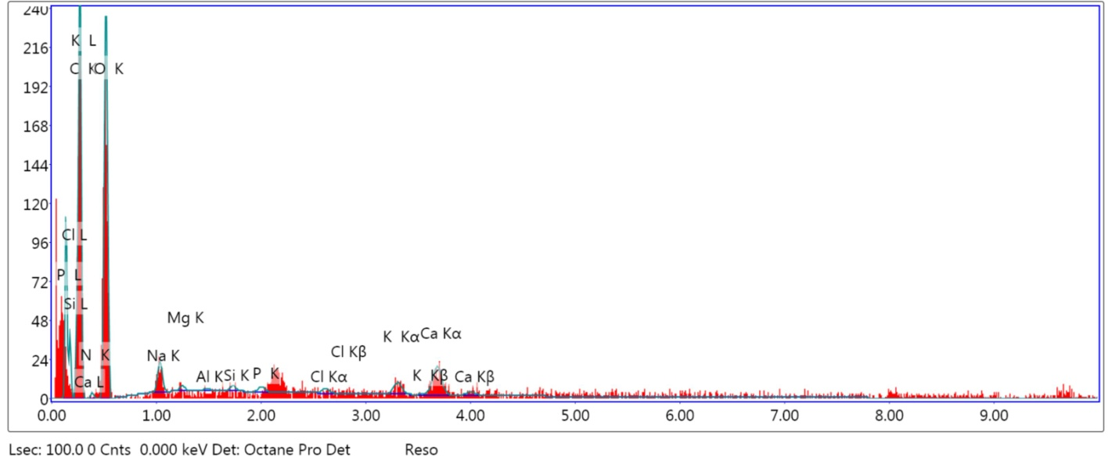
A
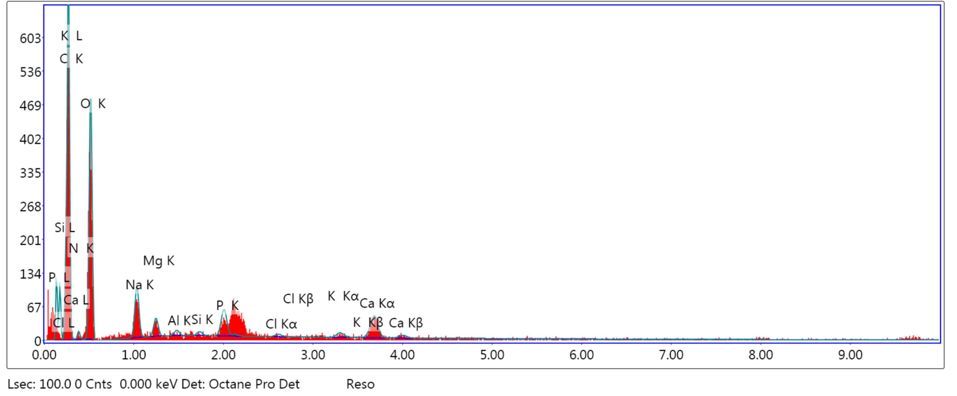
B

Fig. Supplementary data EDXA of jatropha Cellulose (A) Jatropha Shell and (B) Jatropha deoiled seed cakes after NaOH treatment

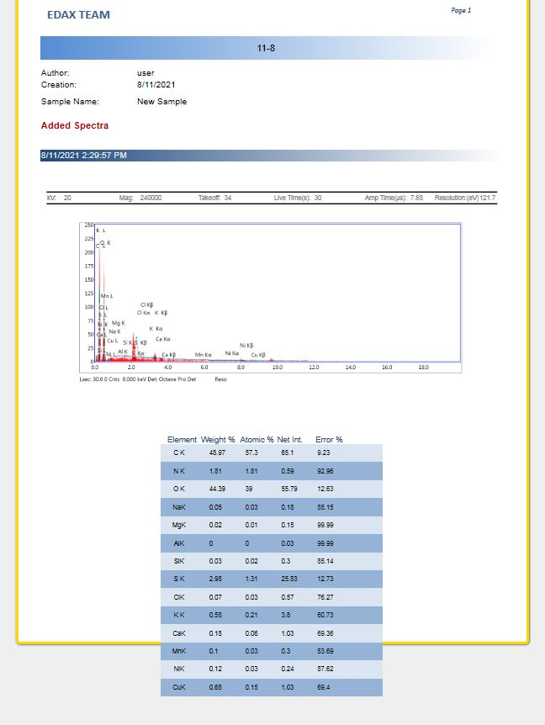
A
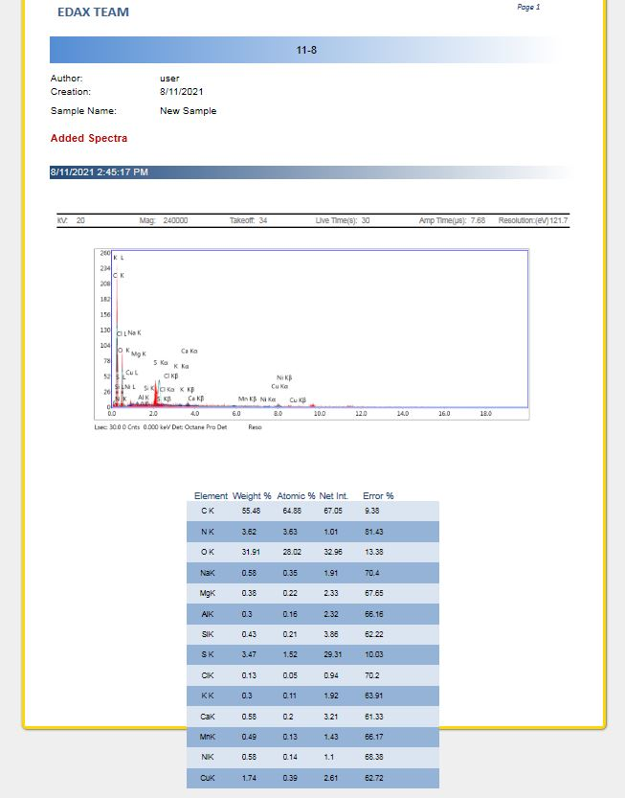
B

Fig. Supplementary data EDXA of jatropha (A) Shell and (B) Jatropha deoiled seed cakes after H₂O₂ treatment

