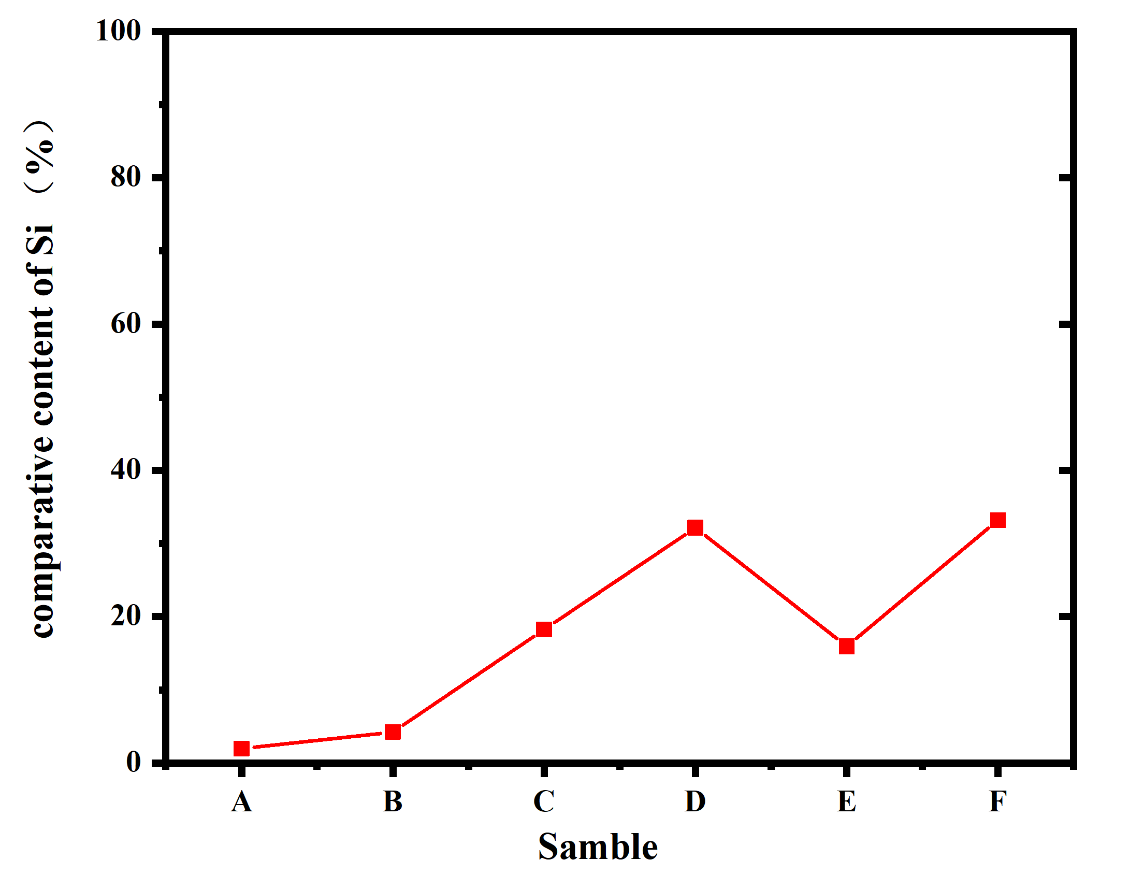
Fig. 1 Relative content of silicon obtained from ICP analysis

The relative content of silicon in the A-F region of the waste graphite infusion cylinder is shown in the Fig. 1, wherein the relative content of silicon in the D region is the highest, and the D region is located in the middle of the infusion cylinder from the perspective of position, so it is assumed that a large amount of silicon-containing substances are accumulated here compared with other regions. Compared with the relative content of SiC in each region, it is found that the variation trend of the relative content of SiC and Si in D region is consistent,and we predicted that the reaction in D region is the most violent and the amount of SiC is the most.

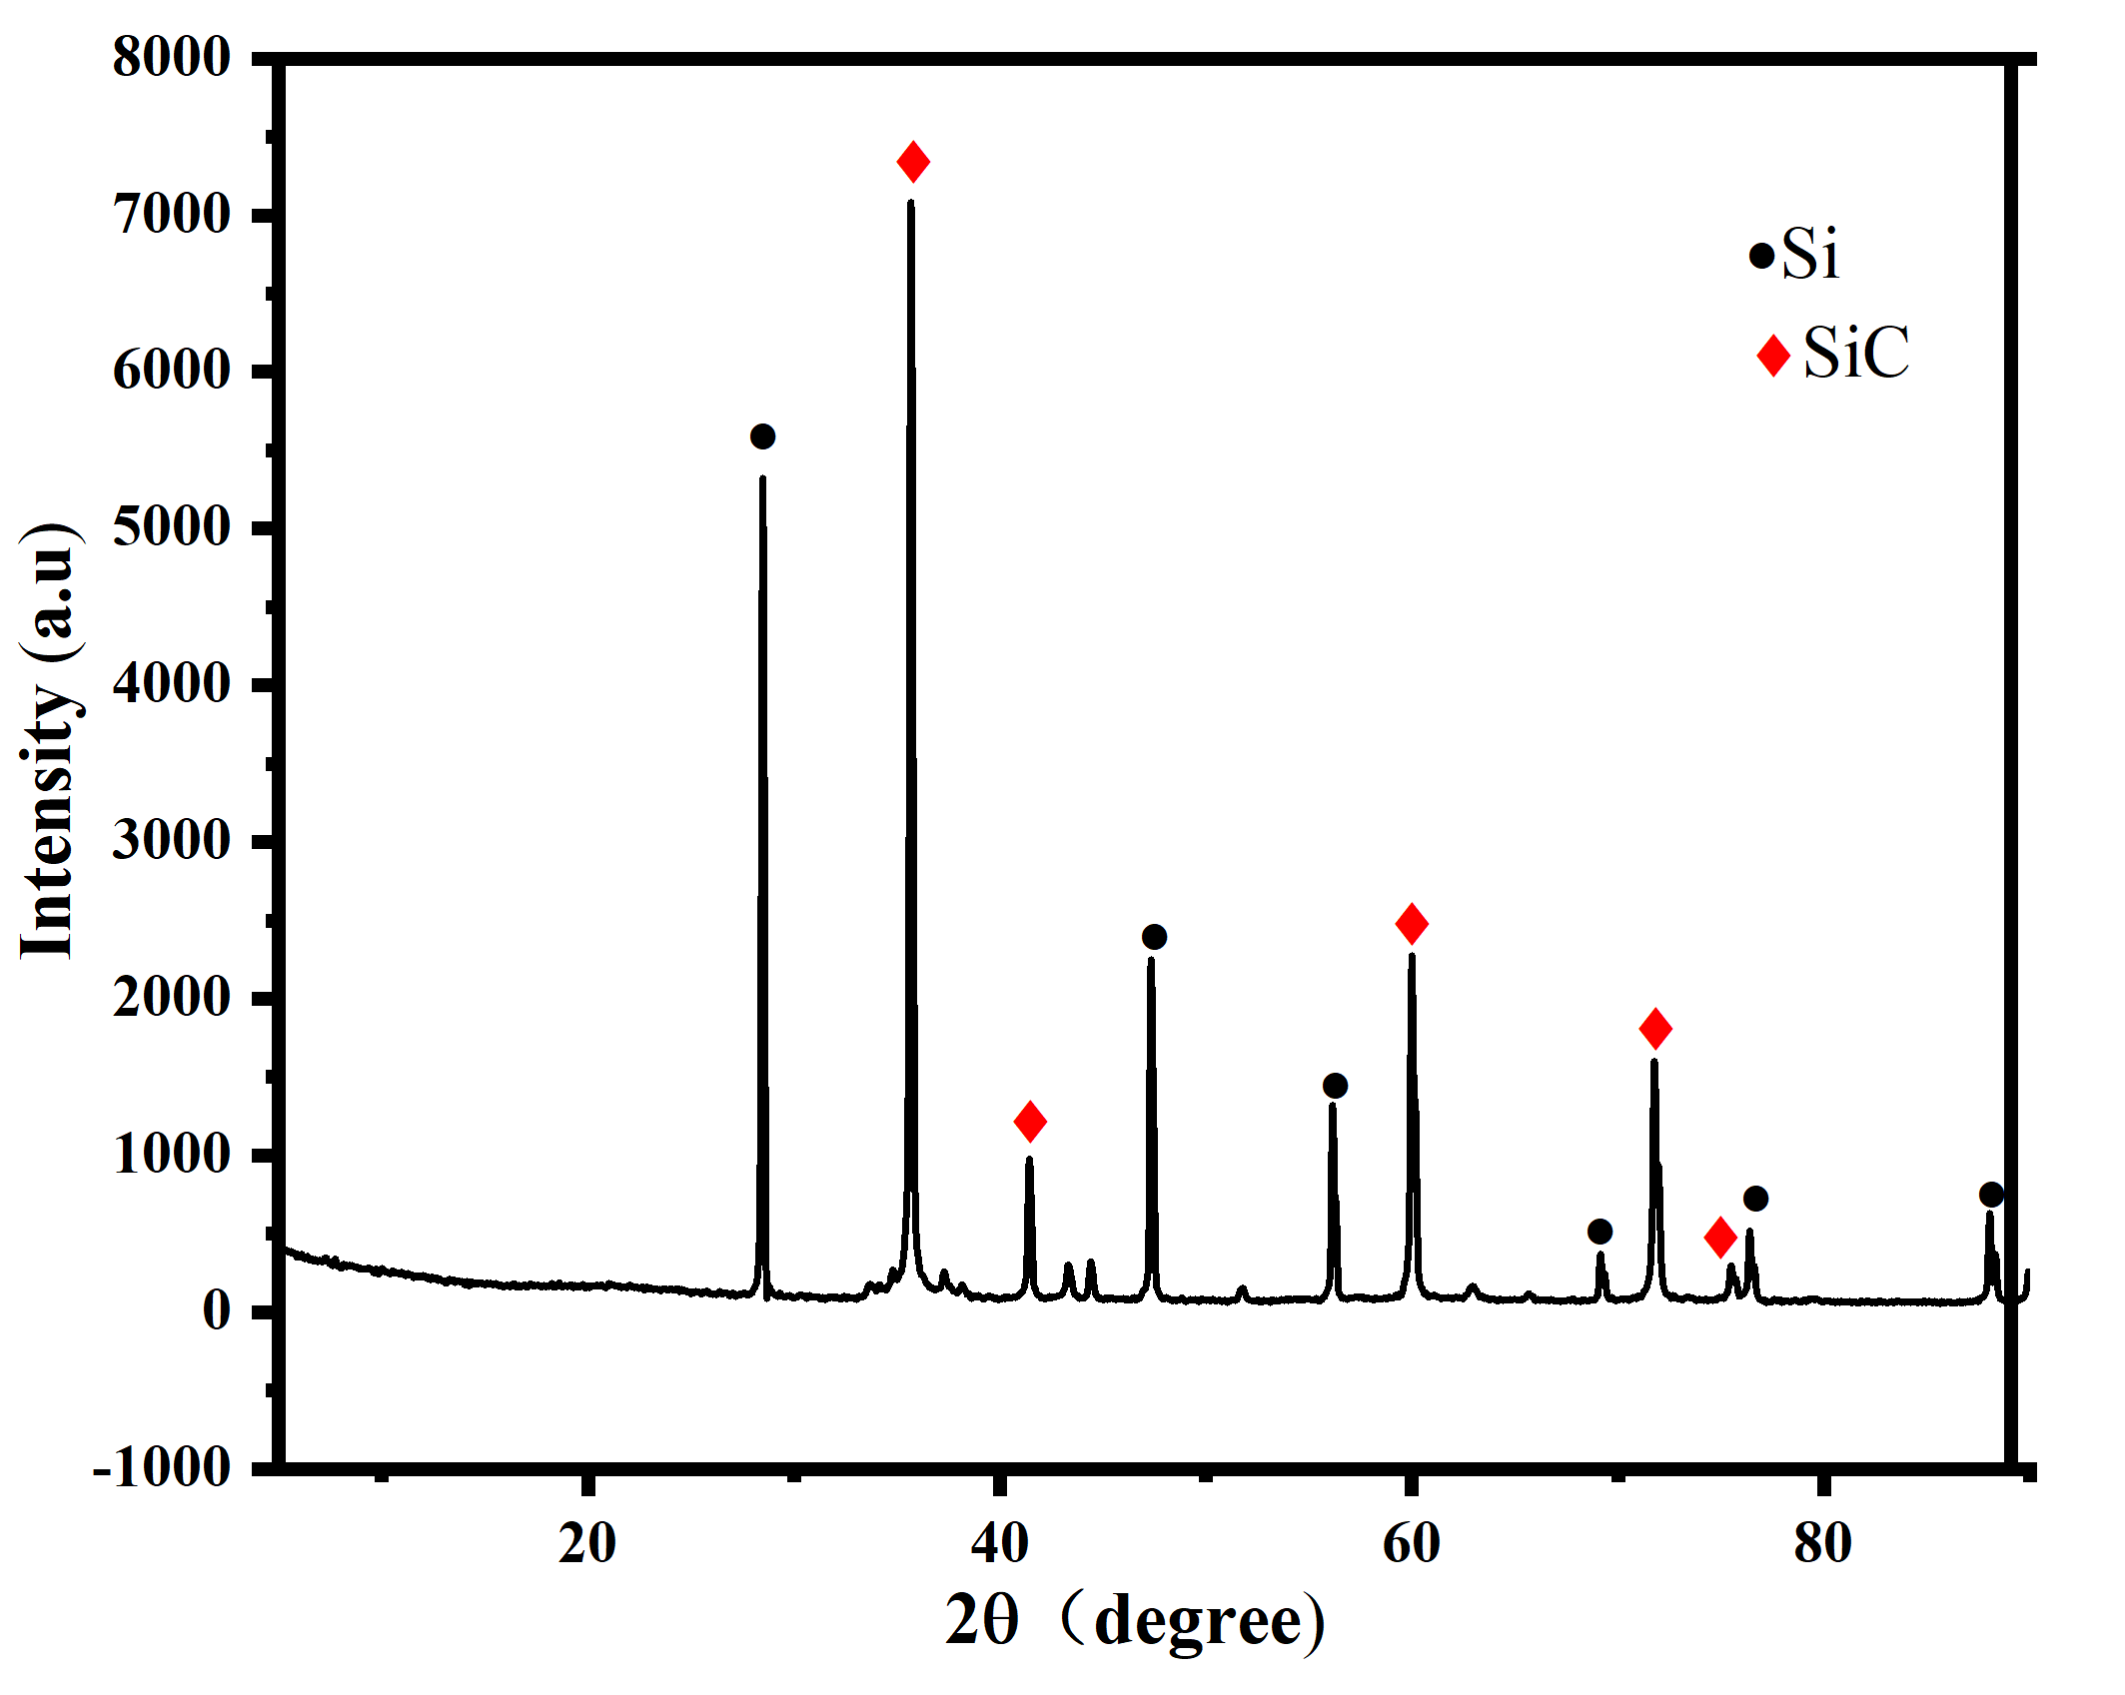
Fig. 2 XRD analysis of ash
Six regional waste graphite infusion cylinder samples were selected for fixed carbon detection, and the physical phase of the ash was detected, and the XRD results of the obtained ash are shown in Fig. 2, from which it can be seen that the main phases of the ash are Si and SiC, which is in line with the main phases of the waste graphite dinfusion cylinder as C, Si, and SiC, indicating that in the process of the reaction, the SiC is indeed generated, and the SiC has penetrated into the graphite of the infusion cylinder to a certain extent.

