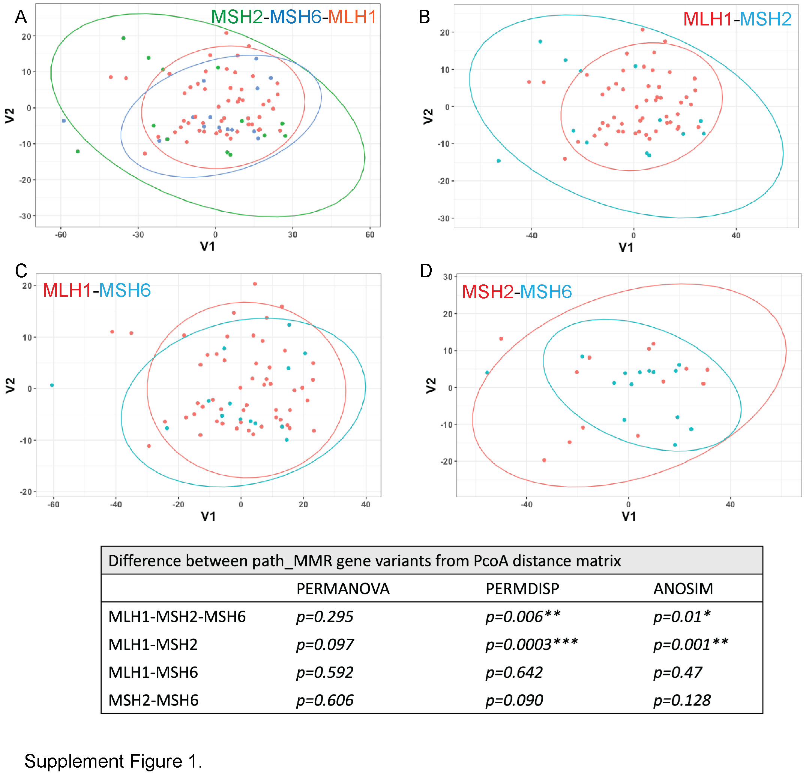
Supplement Figure1. Principal coordinate analysis (PCoA) of the Euclidean distances calculated from 171 circulating metabolome values. The difference between path_MMR variant carriers; MLH1, MSH2 and MSH6 was tested for significance using PERMANOVA on the PCoA distance matrices. Beta-dispersion test was used to test if the variance of cohorts was significantly different or not. ANOSIM test was used to test if there is more similarity within the cohorts than between cohorts A) compare all cohorts and B-D) each cohort paired. The table shows p-values for PERMANOVA, PERMDISP and ANOSIM analysis.

