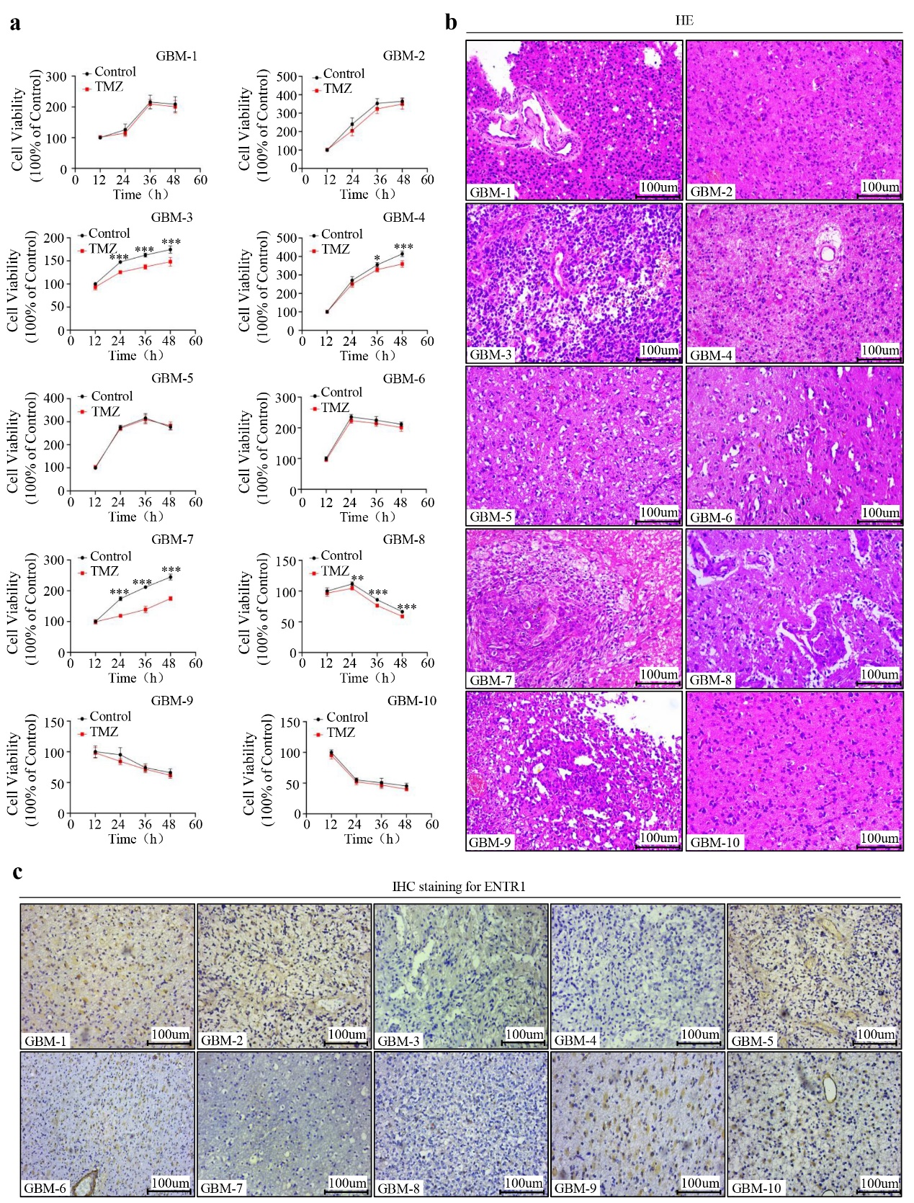
Supplemental Fig. 1 Effect of ENTR1 expression in human primary GBM cells. (a) Primary GBM cells were harvested and cultured in vitro, subsequently treated with TMZ (200μM) for 12-48h, and then subjected the cells to CCK-8 assay at indicated time points to measure the different of cell viability. (b) Representative images of HE staining of 10 human primary GBM cell samples. (c) Representative images of IHC staining showed that the expression of ENTR1 was high in majority of TMZ-resistant human primary GBM cell samples. *p < 0.05, **p < 0.01, ***p < 0.001 vs. Control group.

