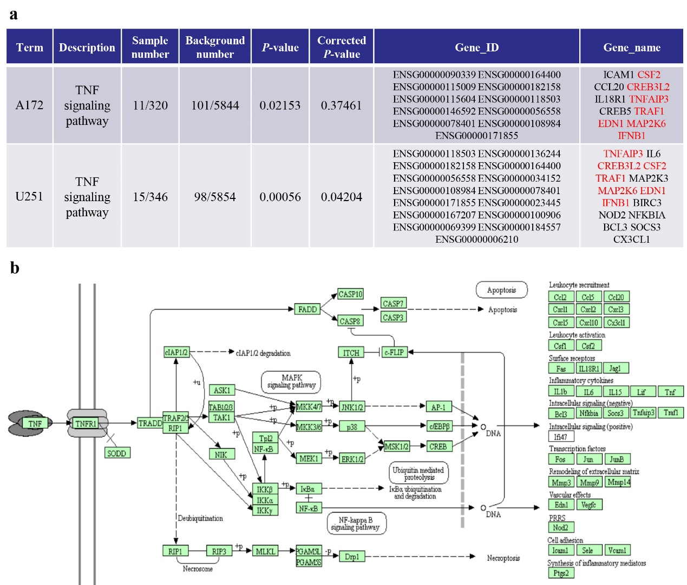
Supplemental Fig. 3 The gene expression profile of TNF signaling pathway induced by ENTR1 overexpression. (a) The details of TNF signaling pathway altering in the regulation of ENTR1. (b) Schematic representation of TNF signaling pathway in KEGG pathway database.

