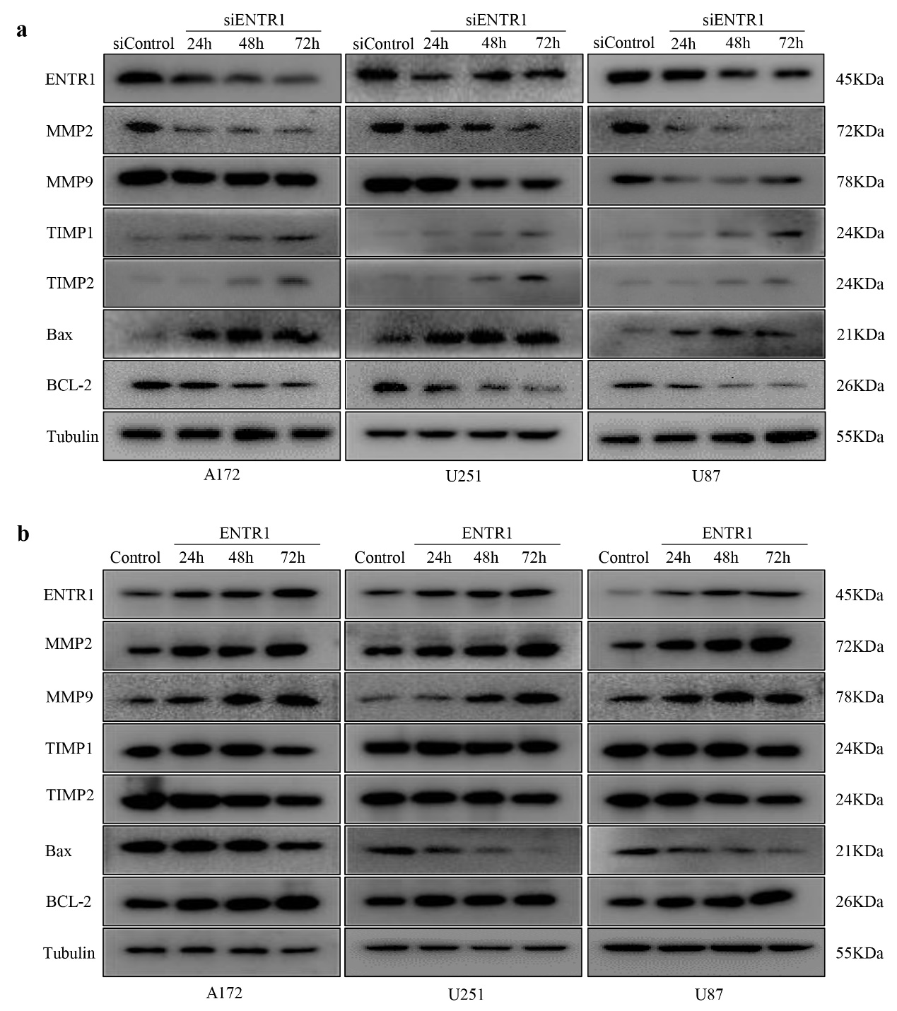
Supplemental Fig. 2 The effect of ENTR1 on invasion- and apoptosis-related biomarkers. (a) Cells were transfected with siControl or siENTR1 for 24-72h. Western blot assay was used to detect the expression level of ENTR1-related indicated proteins. (b) Cells were infected with plasmid ENTR1 or plasmid Control for 24-72h. Western blot assay was used to detect the expression level of ENTR1-related indicated proteins.

