Supplementary Information

First-in-human Study of a ^{99m}Tc-Labeled Single-Domain Antibody for SPECT/CT Assessment of HER2 Expression in Breast Cancer

Lingzhou Zhao^{1§}, Changcun Liu^{1§}, Yan Xing¹, Jin He², Jim O’Doherty³, Wenhua Huang⁴ and Jinhua Zhao¹*

¹ Department of Nuclear Medicine, Shanghai General Hospital, Shanghai Jiao Tong University School of Medicine, Shanghai, China
² Department of Pathology, Shanghai General Hospital, Shanghai Jiao Tong University School of Medicine, Shanghai, China
³ Siemens Healthineers, Malvern, Pennsylvania, USA
⁴ Nanomab Technology Limited, Shanghai, China
__________________________________________________________________________________
* Corresponding author: zhaojinhua1963@126.com (J. Zhao), Fax: 0086-21-37798352, Tel:0086-21-37798352.
§ These authors equally contributed to this work.

Methods
NM-02 production and formulation
The NM-02 nanobody was produced according to good-manufacturing-practice standards. The sequence of NM-02 with a C-terminal hexahistidine tail was subcloned into the pE7 expression vector and produced in Escherichia coli BLR (DE3). Then, the expressed NM-02 was purified from periplasmic extracts by cation exchange chromatography on SP Sepharose (Denver, CO, USA) and buffer-exchanged to phosphate-buffered saline (PBS) with gel filtration on Superdex 75 resin (Denver, CO, USA). The produced NM-02 nanobodies were aseptically dispensed into septum-sealed sterile glass vials at a concentration of 2.0 mg/mL in 100 μL PBS (pH = 7.4) and stored at -80 ºC.

Preparation of the [^{99m}Tc(OH₂)₃(CO)₃]⁺ complex
All reagents used in radiolabeling, including preparation of the [^{99m}Tc(OH₂)₃(CO)₃]⁺ complex and ^{99m}Tc-NM-02, were in accordance with GMP standards. ^{99m}Tc-pertechnetate (Na^{99m}TcO₄) solution, purchased from Shanghai GMS Pharmaceutical Co., Ltd (Shanghai, China), was obtained from a ⁹⁹Mo/^{99m}Tc generator. The [^{99m}Tc(OH₂)₃(CO)₃]⁺ complex was manufactured using a tricarbonyl kit containing 4.5 mg Na₂[H₃BCO₂], 2.85 mg Na₂B₄O₇·10H₂O, 7.15 mg Na₂CO₃, and 8.5 mg Na₂C₄H₄O₆·2H₂O in a small glass vial under argon. One milliliter of Na^{99m}TcO⁴ solution (3330–5032 MBq) was added to the vial, and the vial was incubated in a boiling water bath for 30 minutes. Subsequently, the vial was removed from the water bath and cooled to room temperature. After adjusting its pH to 7.0-7.5 by addition of 180 μL HCl (1.0 M), the radiochemical purity (RCP) of the [^{99m}Tc(OH₂)₃(CO)₃]⁺ complex was analyzed by instant thin-layer chromatography (ITLC) using silica gel 60 F254 TLC plates (Merck, Darmstadt, Germany) and ITLC-SG glass microfiber chromatography paper (Agilent, Folsom, CA, USA). The [^{99m}Tc(OH₂)₃(CO)₃]⁺ complex showed a broad peak with an average retention factor (R_{f}) of 0.4-0.5 in the TLC plate using 1% HCl in methanol as the mobile phase, whereas ^{99m}TcO⁴⁻ had an R_{f} of 1. The R_{f} values of colloidal ^{99m}Tc and the [^{99m}Tc(OH₂)₃(CO)₃]⁺ complex were 0 and 1, respectively, in the ITLC-SG paper using citrate buffer (pH 5.4) as the mobile phase. The RCP was calculated as the ^{99m}Tc radioactivity associated with the [^{99m}Tc(OH₂)₃(CO)₃]⁺ complex as a percentage of the total ^{99m}Tc radioactivity on the paper. Only [^{99m}Tc(OH₂)₃(CO)₃]⁺ complex with a high RCP (>95%) was used for subsequent NM-02 radiolabeling.

Radiolabeling of NM-02
For NM-02 radiolabeling, 400 μL of the formed [^{99m}Tc(OH₂)₃(CO)₃]⁺ complex, corresponding to 977-1539 MBq, was immediately mixed with 200 μg of NM-02 in 100 μL PBS. The mixture was incubated at 50 °C in a water bath for 1 h to prepare ^{99m}Tc-NM-02. Its RCP was assessed by ITLC, with an R_{f} of 0 in TLC-SG paper using citrate buffer (pH 5.4) as the mobile phase; unreacted [^{99m}Tc(OH₂)₃(CO)₃]⁺ complex and ^{99m}TcO⁴⁻ both had R_{f} values of 1 under the same conditions. Then, 1.5 mL saline was added to the vial to bring the total volume to 2.0 mL. Other quality control items, including visual check and pH and endotoxin testing, were performed. Only ^{99m}Tc-NM-02 with an RCP >95%, pH = 7.0-7.5, and endotoxin levels <15 EU/mL with a colorless, clear appearance was used in this study. The RCP was calculated as the ^{99m}Tc radioactivity associated with ^{99m}Tc-NM-02 as a percentage of the total ^{99m}Tc radioactivity on the paper. Because the RCP was >95%, ^{99m}Tc-NM-02 could be directly used for further studies. For patient injection, the mixture was diluted to 2 mL using sterile saline, and 1.0 mL of the final solution was withdrawn aseptically into a 2.0-mL syringe, corresponding to 406–510 MBq ^{99m}Tc-NM-02 containing 100 μg NM-02.

Patient selection
Adult women who met the inclusion criteria were invited to participate in this study. The inclusion criteria were as follows: pathologically confirmed breast cancer; agreed to participate in this study and signed the informed consent form; AST, ALT, BUN, and Cr no more than twice the normal value; and no currently active infectious diseases, such as hepatitis A infection, hepatitis B infection, HIV infection, and tuberculosis. The exclusion criteria were as follows: male; pregnant or breastfeeding; uncertain or untested human epidermal growth factor receptor 2 (HER2) expression level; pacemakers; known abnormal liver, kidney, or thyroid function; serious active infection; recent myocardial infarction or other cardiogenic events requiring hospitalization; and unlikelihood of cooperating with the requirements of this clinical study after evaluation by the investigator. Patients with severe allergic reactions, persistent allergic reactions, willingness to quit the clinical study, and unlikelihood of continuing this clinical study after evaluation by the investigator were also excluded.
SPECT/CT acquisition protocol and quantitative analysis
The speed of bed motion for whole-body SPECT imaging was set at 10 cm/min, with a total scan time of about 20 minutes. Local SPECT/CT imaging was performed over 360° in 60 steps per full rotation, with a 20-s acquisition per step. Low-dose CT was used for attenuation correction and localization during tomographic acquisitions, with scan parameters as follows: 120 kV, 180 mA, 512 × 512 matrix, 3.75-mm thickness, and a large field of view. All SPECT scans were performed using low-energy high-resolution collimators in a 20% energy window centered around 140 keV with a 256 × 1024 matrix for whole-body SPECT imaging and a 128 × 128 matrix for local SPECT imaging. SPECT/CT images were reconstructed using the Xeleris Functional Imaging Workstation (Denver, CO, USA).
The Q.Metrix software package was used to perform quantitative measurements of SPECT data. Acquisition information was input into the software, including patient height and weight, tracer activities in the full and empty syringes, administration time, scan time, and camera sensitivity. The volumes of interest were chosen by thresholding methods, with an NM threshold of 0.4 on SPECT images. The maximum standardized uptake value could be automatically calculated in the system.

Radiation dosimetry calculations
For radiation dosimetry calculations, three patients underwent whole-body SPECT imaging at five time points, including 10 min, 1 h, 2 h, 3 h, and 24 h after injection, with a calibration source of 37 MBq above the head of each patient. OLINDA/EXM dose calculation software 1.1 was used to calculate dosimetry.

Safety assessment
For safety assessment, all patients underwent measurement of vital signs and clinical laboratory testing. Vital signs, including blood pressure, heart rate, respiration rate, and body temperature, were recorded during the screening period, before injection, and then every 1 h up to 4 h after injection and the first 48 h after the SPECT/CT scan. Clinical laboratory testing was performed before and 48 h after injection. The testing included standard hematologic and comprehensive metabolic panels, including red blood cells, hemoglobin, white blood cells, neutrophils, lymphocytes, platelets, creatinine, monocytes, eosinophils, basophils, blood urea nitrogen, calcium, sodium, potassium, lactate dehydrogenase, alanine transaminase, aspartate aminotransferase, alkaline phosphatase, total serum bilirubin, and serum albumin. Additional phone interviews were performed 1 week after the SPECT/CT scan for patients to record their subjective adverse experiences.

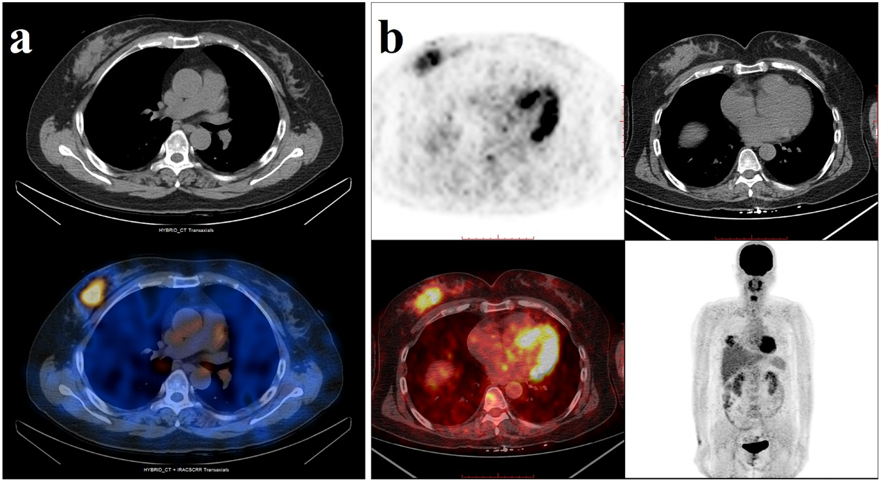
Fig. S1. Images of Patient BR001 at 1 h after injection of ^{99m}Tc-NM-02 (a) and ¹⁸F-FDG (b), respectively.

Fig. S2. SPECT/CT images of Patient BR005 at 1 and 2 h after injection.

