Predicting Monoclonal Antibody Binding Sequences from a Sparse Sampling of All Possible Sequences

Supplementary Material

Pritha Bisarad^{1,2,5,7,+}, Laimonas Kelbauskas^{3,+}, Akanksha Singh^{1,2,6,+}, Alexander T. Taguchi⁴, Neal W. Woodbury^{1,2,3,*}

¹School of Molecular Sciences, Arizona State University, Tempe, Arizona, United States of America, ²Center for Innovations in Medicine, Biodesign Institute, Arizona State University, Tempe, Arizona, United States of America, ³Center for Molecular Design and Biomimetics, Biodesign Institute, Arizona State University, Tempe, Arizona, United States of America, ⁴iBio Inc., San Diego, California, United States of America, ⁵Pediatric Movement Disorders Program, Division of Pediatric Neurology, Barrow Neurological Institute, Phoenix Children’s Hospital, Phoenix, Arizona, United States of America , ⁶Prellis Biologics Inc., Berkeley, California, United States of America, ⁷Department of Child Health, University of Arizona College of Medicine-Phoenix, Phoenix, Arizona, United States of America

⁺contributed equally
*corresponding author

Data Quality. Fig. S1 shows the Pearson correlation coefficient between the mAb’s log₁₀ binding values at each concentration and every other mAb’s log₁₀ binding values at each concentration. The four replicates of each mAb and each concentration were averaged prior to calculating the correlation coefficient. The data is organized from the lowest concentration (0.125 nM) to the highest concentration (8 nM) for each mAb. As one moves along the diagonal, one can see that the replicates are generally very similar in each case, the different concentrations are generally less similar, and different mAbs are quite dissimilar from each other. No data was excluded from the analysis.
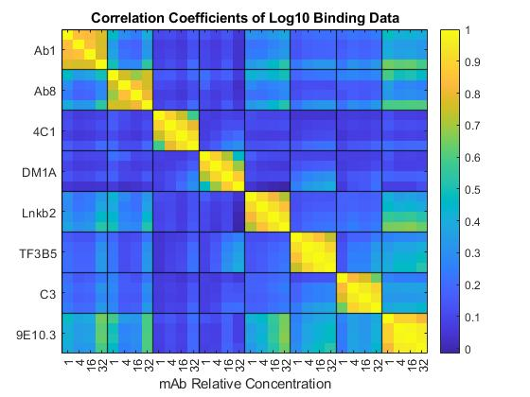
Figure S1. Pearson correlation coefficients between the linear binding values of array data after averaging replicates. For each monoclonal antibody, there are four concentrations (in increasing order, 0.125 nM, 0.5 nM, 2.0 nM, 8.0 nM).

Distributions. Fig. S2 shows the distributions of each of the datasets (each mAb at each concentration). Note that both the frequency scale (y-axis) and the binding value (x-axis) are log₁₀; binding is given in log₁₀ fluorescence counts. The background binding of the labeled secondary antibody to the arrays is ~800 counts. There is considerable variation in the number of high binding value sequences on these arrays, with both Ab1 and Ab8 having very few sequences that bind with values above 3,000 counts (~3.5 on the log scale) and TF3B5 having hundreds of sequences with values that saturate the detector at 65,536 counts at the highest concentration (4.82 on a log₁₀ scale). The binding values of the mAbs to their cognate sequences are not shown, but with the exception of 4C1, the signal from the cognate sequence is saturating even at 0.125 nM for those mAbs that had a cognate sequence synthesized on the array (see below).
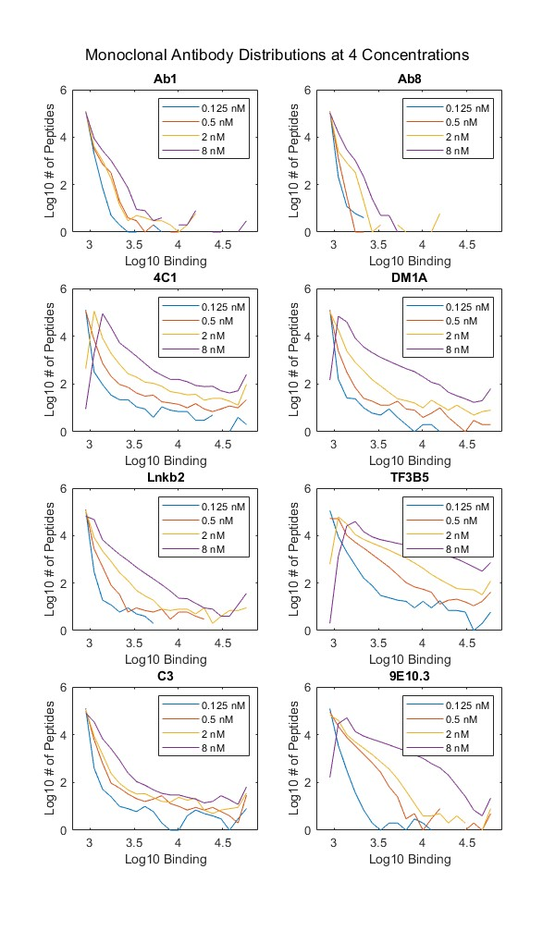
Figure S2. Log₁₀ binding distributions of each monoclonal antibody at four concentrations.

The distributions give an immediate indication of the specificity of each mAb. Since the binding data is from peptides sampling, nearly randomly, all of the 16 amino acid sequence space (16¹⁰ = 10¹² sequences) without regard for any specific biological relevance, this platform gives a simple empirical comparison of specificity in an unbiased dataset. The specificity of mAbs means that the vast majority of the binding is near the background level and in the case of Ab8, there is almost no binding more than a few times the background level. As can be seen in Fig. S1, the correlation between binding of different mAbs is generally low, presumably due to very different interactions and sequence requirements. Thus, what one learns about binding of one mAb is unlikely to be useful in characterizing the binding of another. For this reason they were modeled separately. In addition, optimal methods for extracting sequence-binding information are likely to differ between mAbs as seen in the main text.

Linearity with concentration. In order to take into account the fact that at higher concentrations we see detector saturation for some peptide binding, the points that saturated at one concentration are assumed to increase linearly with concentration at higher concentration. Fig. S3 justifies that assumption looking at the overall linearity of binding as a function of concentration for each of the mAbs. In each case, the average binding of all peptides that do not saturate at any concentration is plotted, showing that there is a linear dependence of binding on concentration at least within the dynamic range of the detector. Thus the assay itself is very linear with concentration.
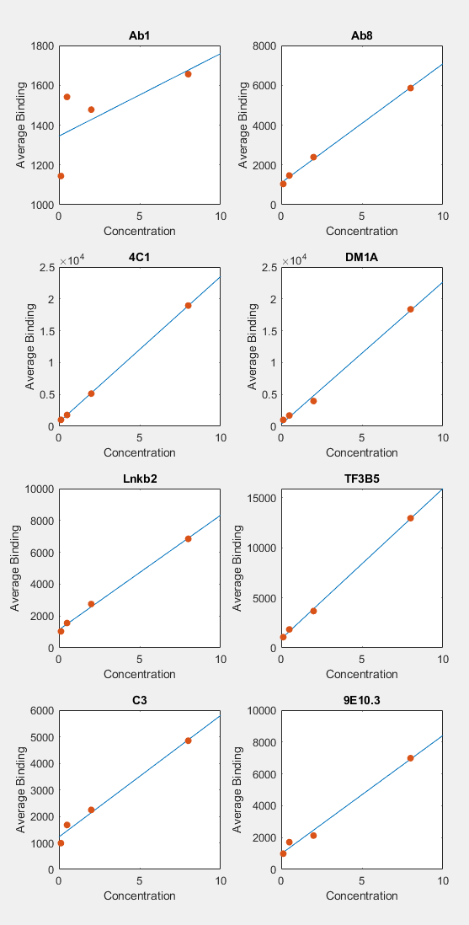
Figure S3. The average binding of mAbs to peptides on the array vs. concentration for all peptides that do not saturate at any concentration.

Cross validation study of binding prediction. Figure S5 shows a 10-fold cross validation study of sequence-specific binding prediction models for each mAb as a density scatter plot¹. Here the log₁₀ sequence-specific binding of the predicted value is plotted against the log₁₀ measured sequence-specific binding value (sequence-specific binding refers to binding in which the composition-based binding was removed, as described in the main text). As described in the main text, saturating points were extrapolated based on concentration, which is why there are higher sequence specific values here than in Fig. S4 which is based on original measured values. 90% of the peptide-binding pairs (randomly selected) were used to train the model in each case and 10% were used as the test set. This was done for all ten possible 90:10 combinations so that all peptides were ultimately included in the test set. Figure S5 plots all of the predicted test binding values against the measured values. It also shows, as a red dot, the predicted and measured value of each mAb cognate sequence when that value is present on the array. Note that the predicted value of the cognate is generally lower than the measured value, particularly in cases like Ab1 and Ab8 where there are very few peptides that bind strongly. However, even though the value predicted for the cognate is generally lower than its measured value, its rank remains high among the ~126,000 points plotted. Note also that the cognate prediction is being compared to sequences of many lengths (the array peptides range from 5 to 11 residues), rather than only to sequences of the same length. In general, ranking works better if the predictions are to a set of peptides of the same length. That length need not be exactly the length of the cognate sequence as long as it contains the cognate sequence, but both the model, and the data, tend to give higher binding for longer peptides. Thus, when looking, for example, at binding to a protein, one would want to tile the protein sequence as even length pieces for an accurate comparison of different regions of the protein.
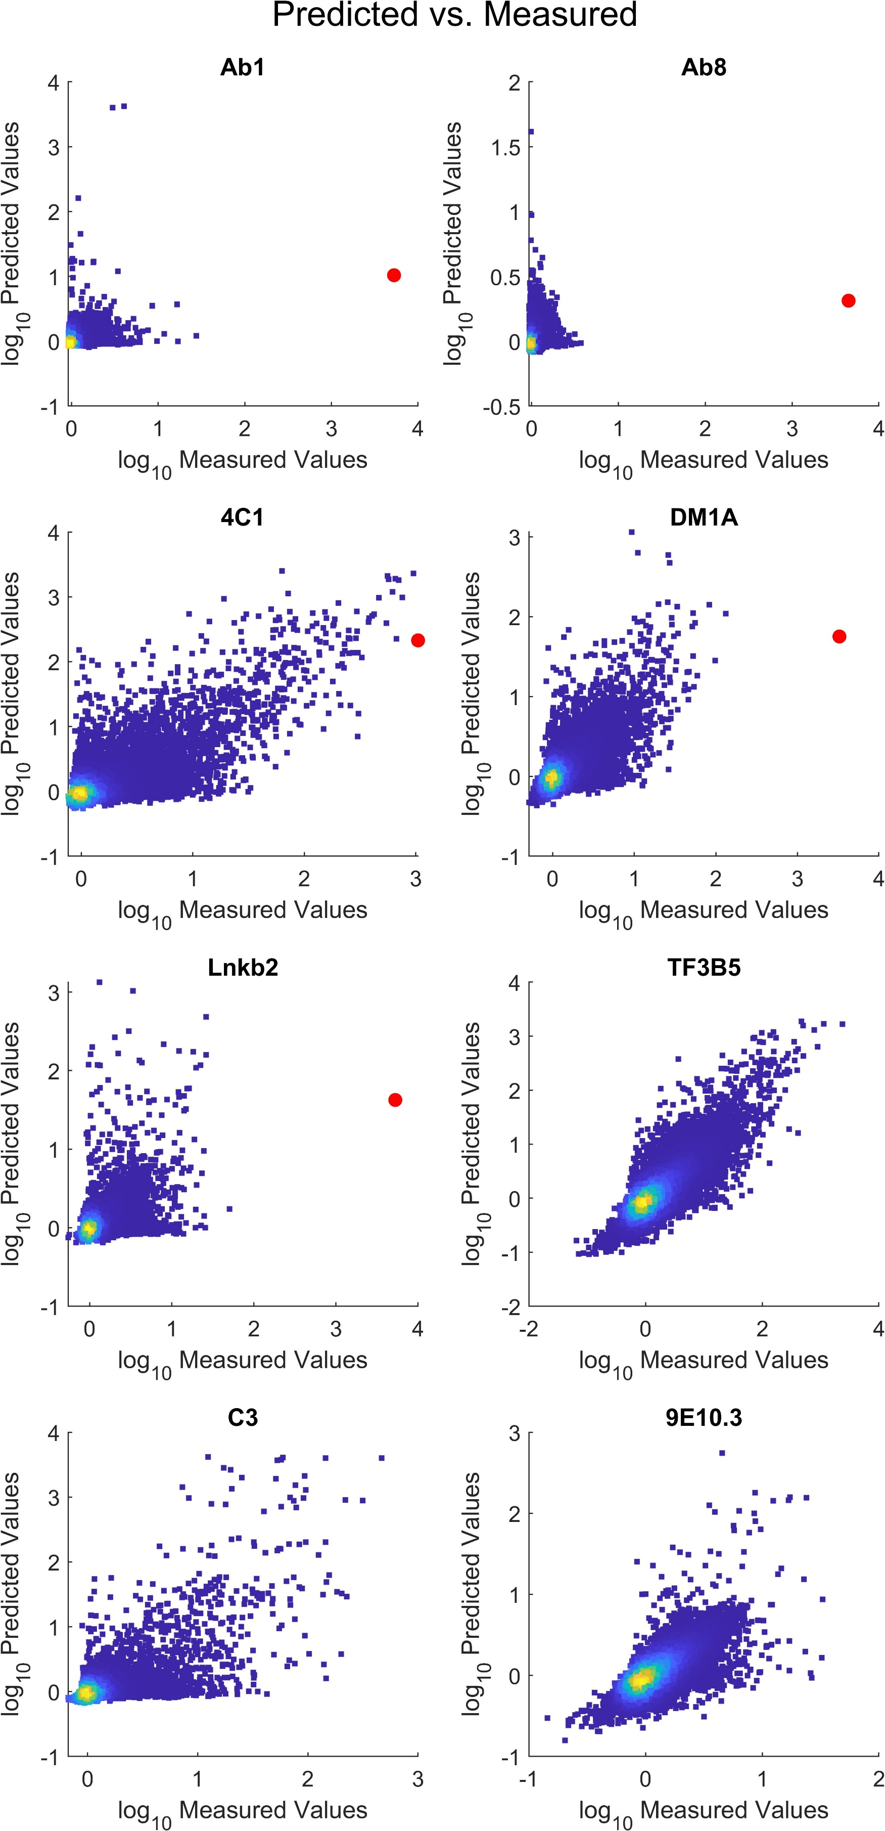
Figure S4. Density scatter plot of log₁₀ predicted values of the sequence dependent binding vs. the log₁₀ sequence dependent binding determined from the values measured on the array. Red dots are the cognate sequences.
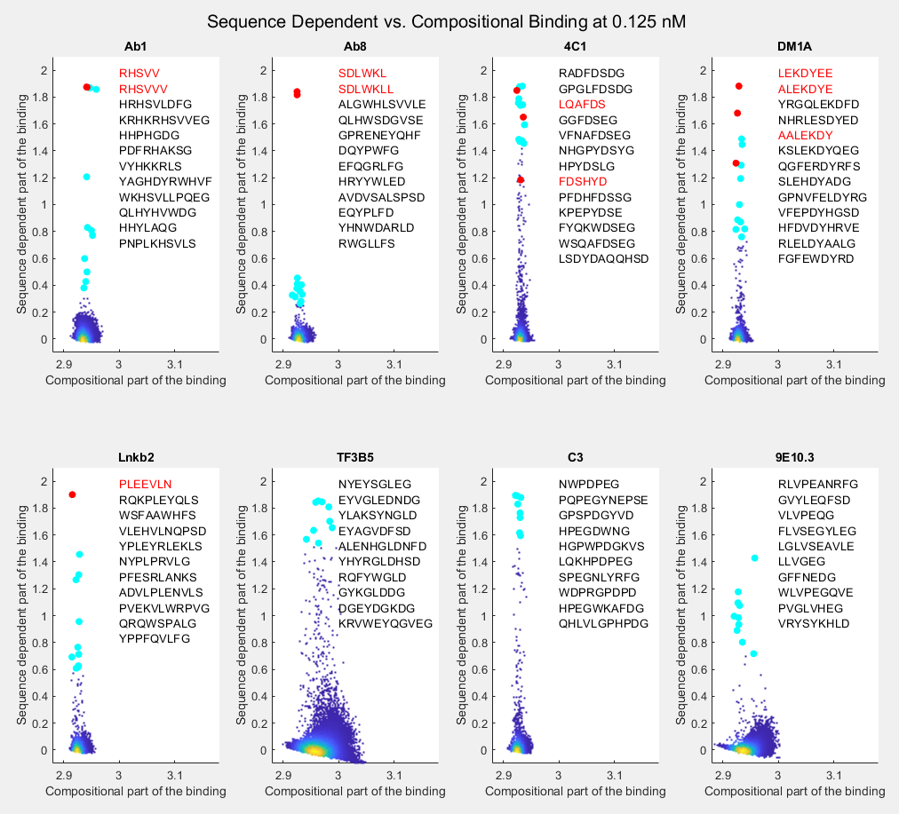
Figure S5. Sequence-dependent binding vs. compositional binding for each of the mAbs at 0.125 nM concentration. Each sequence is plotted as a scatter plot. Also plotted for reference are the cognate sequences that are present on the array (Red). The top ten non-cognate sequences from the array are shown in light blue. Both the cognate epitope sequences and the top 10 array sequences are listed for each mAb.
Compositionally Dependent Binding. Fig. S4 shows scatter plots of sequence-dependent binding (y-axis) vs. compositional binding (x-axis) determined as described in Methods of the main text. Basically, a set of coefficients relating the number of each amino acid in the peptide to the binding of that amino acid is determined in a linear fit (there is also a bias term). The amount of binding that can be described this way is subtracted from the total binding (subtraction is performed after taking the log₁₀). In every case but 4C1, when the cognate epitope sequence in present on the array (shown as red points) it represents the strongest sequence-specific binding (the cognate epitope sequences for TF3B5, C3 and 9E10.3 were not present on the array). Most of the mAbs have a very narrow range of composition-dependent binding. In other words, the only term in the linear fit that was really significant was the bias term describing the background binding. Only a small fraction of the binding distribution (0.05 on the log₁₀ scale) could be explained by composition alone. The two exceptions to this rule are TF3B5 and 9E10.3, both of which show a distribution of compositional log₁₀ binding values >0.1. Even for these two mAbs, however, compositional binding is still modest compared to sequence specific log₁₀ binding of 1.5-2. The overall amount of sequence specific binding among the array peptides varies greatly between mAbs. Ab1 and Ab8 have the least number of sequence-specific binding sequences. Ab8 in particular is devoid of any sequences that bind with sequence-specific binding values above 0.5, while Ab1 has only 6 such sequences. In all other mAbs, at least the top 10 sequence-specific binding sequence values (light blue points) are higher than 0.5. TF3B5 is at the opposite end of the spectrum, having about 100 sequences that show substantial sequence specific binding, including a number that saturate the detector (~1.9 on the y-axis). Other mAbs are between these extremes. 4C1 is the one case where none of the sequences synthesized on the array to represent its cognate epitope sequence are the highest binding sequences. This suggests that at least in the context of binding to a linear sequence attached to an array surface, this mAb is less specific than the other mAbs; there are apparently multiple different sequences that bind this mAb about as strongly as the cognate epitope sequence.

Also shown in Fig. S4 are the ten highest binding sequences on the array (in black type) as well as the sequences of the cognate epitope representations considered (in red). As seen in Fig. 1 of the main text, in every case but Ab8, at least several of the top ten sequences are clearly related to the cognate epitope sequence. In the case of Ab8, the relationship is more difficult to discern, though one can see a similarity in the particular amino acids used. The general similarity of some of the stronger sequence-dependent binding sequences to the corresponding cognate epitope suggests that sequence-specific information is indeed available on the array. 4C1 is again an interesting example. 8 of the top ten sequences contain FDS or YDS. It is clear that a rather simple motif is all that is required to achieve high binding with this mAb, consistent with its apparently promiscuous sequence dependence. It is important to remember that in this work, the epitopes are taken out of their folded protein environment. This may well decrease the binding value and specificity. However, the fact remains that quite a large number of different linear sequences do bind, even if the mAb may ultimately bind more strongly and specifically to the antigen, and that level of binding is going to increase the general off-target binding of 4C1 or of other mAbs that show substantial amounts of sequence-dependent binding.

Ranking based on binding. Table S1 is similar to Table 2 of the main text except that the ranking in this case was based directly on binding of the concentration of mAb, choosing the concentration for each peptide considered that gives the highest rank. What one sees is that for the Baseline model, some mAbs such as TF3B5, DM1A an 9E10.3 show their cognate sequences at much high rank than using the slope of the dose dependence. However, once shifting is introduced, the two approaches become much more similar in predicting that the cognate sequence is among the top sequences. This appears to be because the baseline model gives variable results for the different concentrations, all of which are very close to the background level. This tends to make the dose response slope very similar for all peptides.
Table S1: Ranks out of 1,000,000 based on concentration maximum
mAb | Baseline¹ | + Weighting¹ | + Shifting¹ | + Composition¹
Ab1 | 75,000 ± 20,000 | 1,300 ± 100 | 7.8 ± 1.3 | 5.0 ± 1.0
Ab8 | 680,000 ± 90,000 | 720,000 ± 40,000 | 14 ± 0.5 | 7.8 ± 1.5
4C1 | 1,900 ± 200 | 2,100 ± 200 | 150 ± 10 | 220 ± 20
DM1A | 1.2 ± 0.2 | 30 ± 5 | 2.8 ± 0.8 | 1.6 ± 0.2
Lnkb2 | 22,000 ± 10,000 | 60 ± 20 | 1.6 ± 0.4 | 1.4 ± 0.2
TF3B5 | 2.0 ± 0.4 | 1.0 ± 0.0 | 1.4 ± 0.4 | 1.4 ± 0.2
C3 | 2,200 ± 600 | 330 ± 40 | 43 ± 3 | 35 ± 4
9E10.3 | 1,700 ± 400 | 170 ± 20 | 130 ± 7 | 50 ± 5
¹See Table 2 for description of models
``````````````````````````````````````````````````````````````````````````````````````````````````````````````````````````````````````````````````````````````````````````````````````````````````````````````````````````````````````````````````````

Top Random Sequences Predicted
The top ten ranked random sequences, based on slope, for each of the mAbs is given in Table S2. Note that the mAb cognate sequences are included as reference at the top.
Table S2: Top 10 ranked random sequences based on slope for each mAb
Ab1 | Ab8 | 4C1 | DM1A | Lnkb2 | TF3B5 | C3 | 9E10.3
RHSVVV¹ | SDLWKLL | LQAFDS | LEKDYEE | PLEEVLN | EYLGLD | LPNPEGR | KLVSEE
WRHSLL | LKSGGGK | EYDSFG | HSFERDY | PLEQYLR | EYVGLD | WPSPEGY | RLVPEQ
RHSVVQ | LKSQGGK | GFDSRG | NNFEKDY | PLEGVLG | QYHGLD | FSRPDPE | WLVPEY
RHSVVR | SDLLKLL | PYDSYG | FERDYWA | PLFAVLH | GYSGLD | WGFPWPE | WLVPEP
HRHVVV | LKSLLYK | GYDSHW | NNFEQDY | PLELALS | GYSGLD | PNPEGYE | WLVSEH
HRHSAV | EPPWSGY | GWDSHG | FEWDFEH | VLQRVLR | AEYSGL | FRNPWPD | RLVSEQ
RRHSVH | EPPKKYY | PWDSNG | WPLERDY | PLHKVLH | PYNGLD | RHNPWPE | LLVAEV
VRHSVV | PPPWKFY | PWDSQG | FERDYRV | PLEEPLR | HYDGLD | WDPDPEG | LLVAEN
HRHSSH | KKSDLAK | RAPWDS | DFERDFP | PLESPLH | SEYHGL | RWPPWPD | WLVPEK
LRHSVP | EDLGKLY | LEPYDS | HFEHDYW | PLEARLA | PEYAGL | SFQPWPE | WLVSEQ
RRSSVV | LKWDLQK | HYDSYG | RFDRDYE | RPLEKQL | EYNGLS | APNPDGW | WLVSEL
¹This row contains the cognate sequences used in the ranking for comparison.

Mutation Substitution Matrices. Figure S6 is similar to Figure 2 in the main text, showing the predicted slopes of each single mutant of each of the mAbs. Figure 2 showed only four of these and compared the predicted and measured results. Here all eight predictions are shown (no measured values). For details, see the main text.
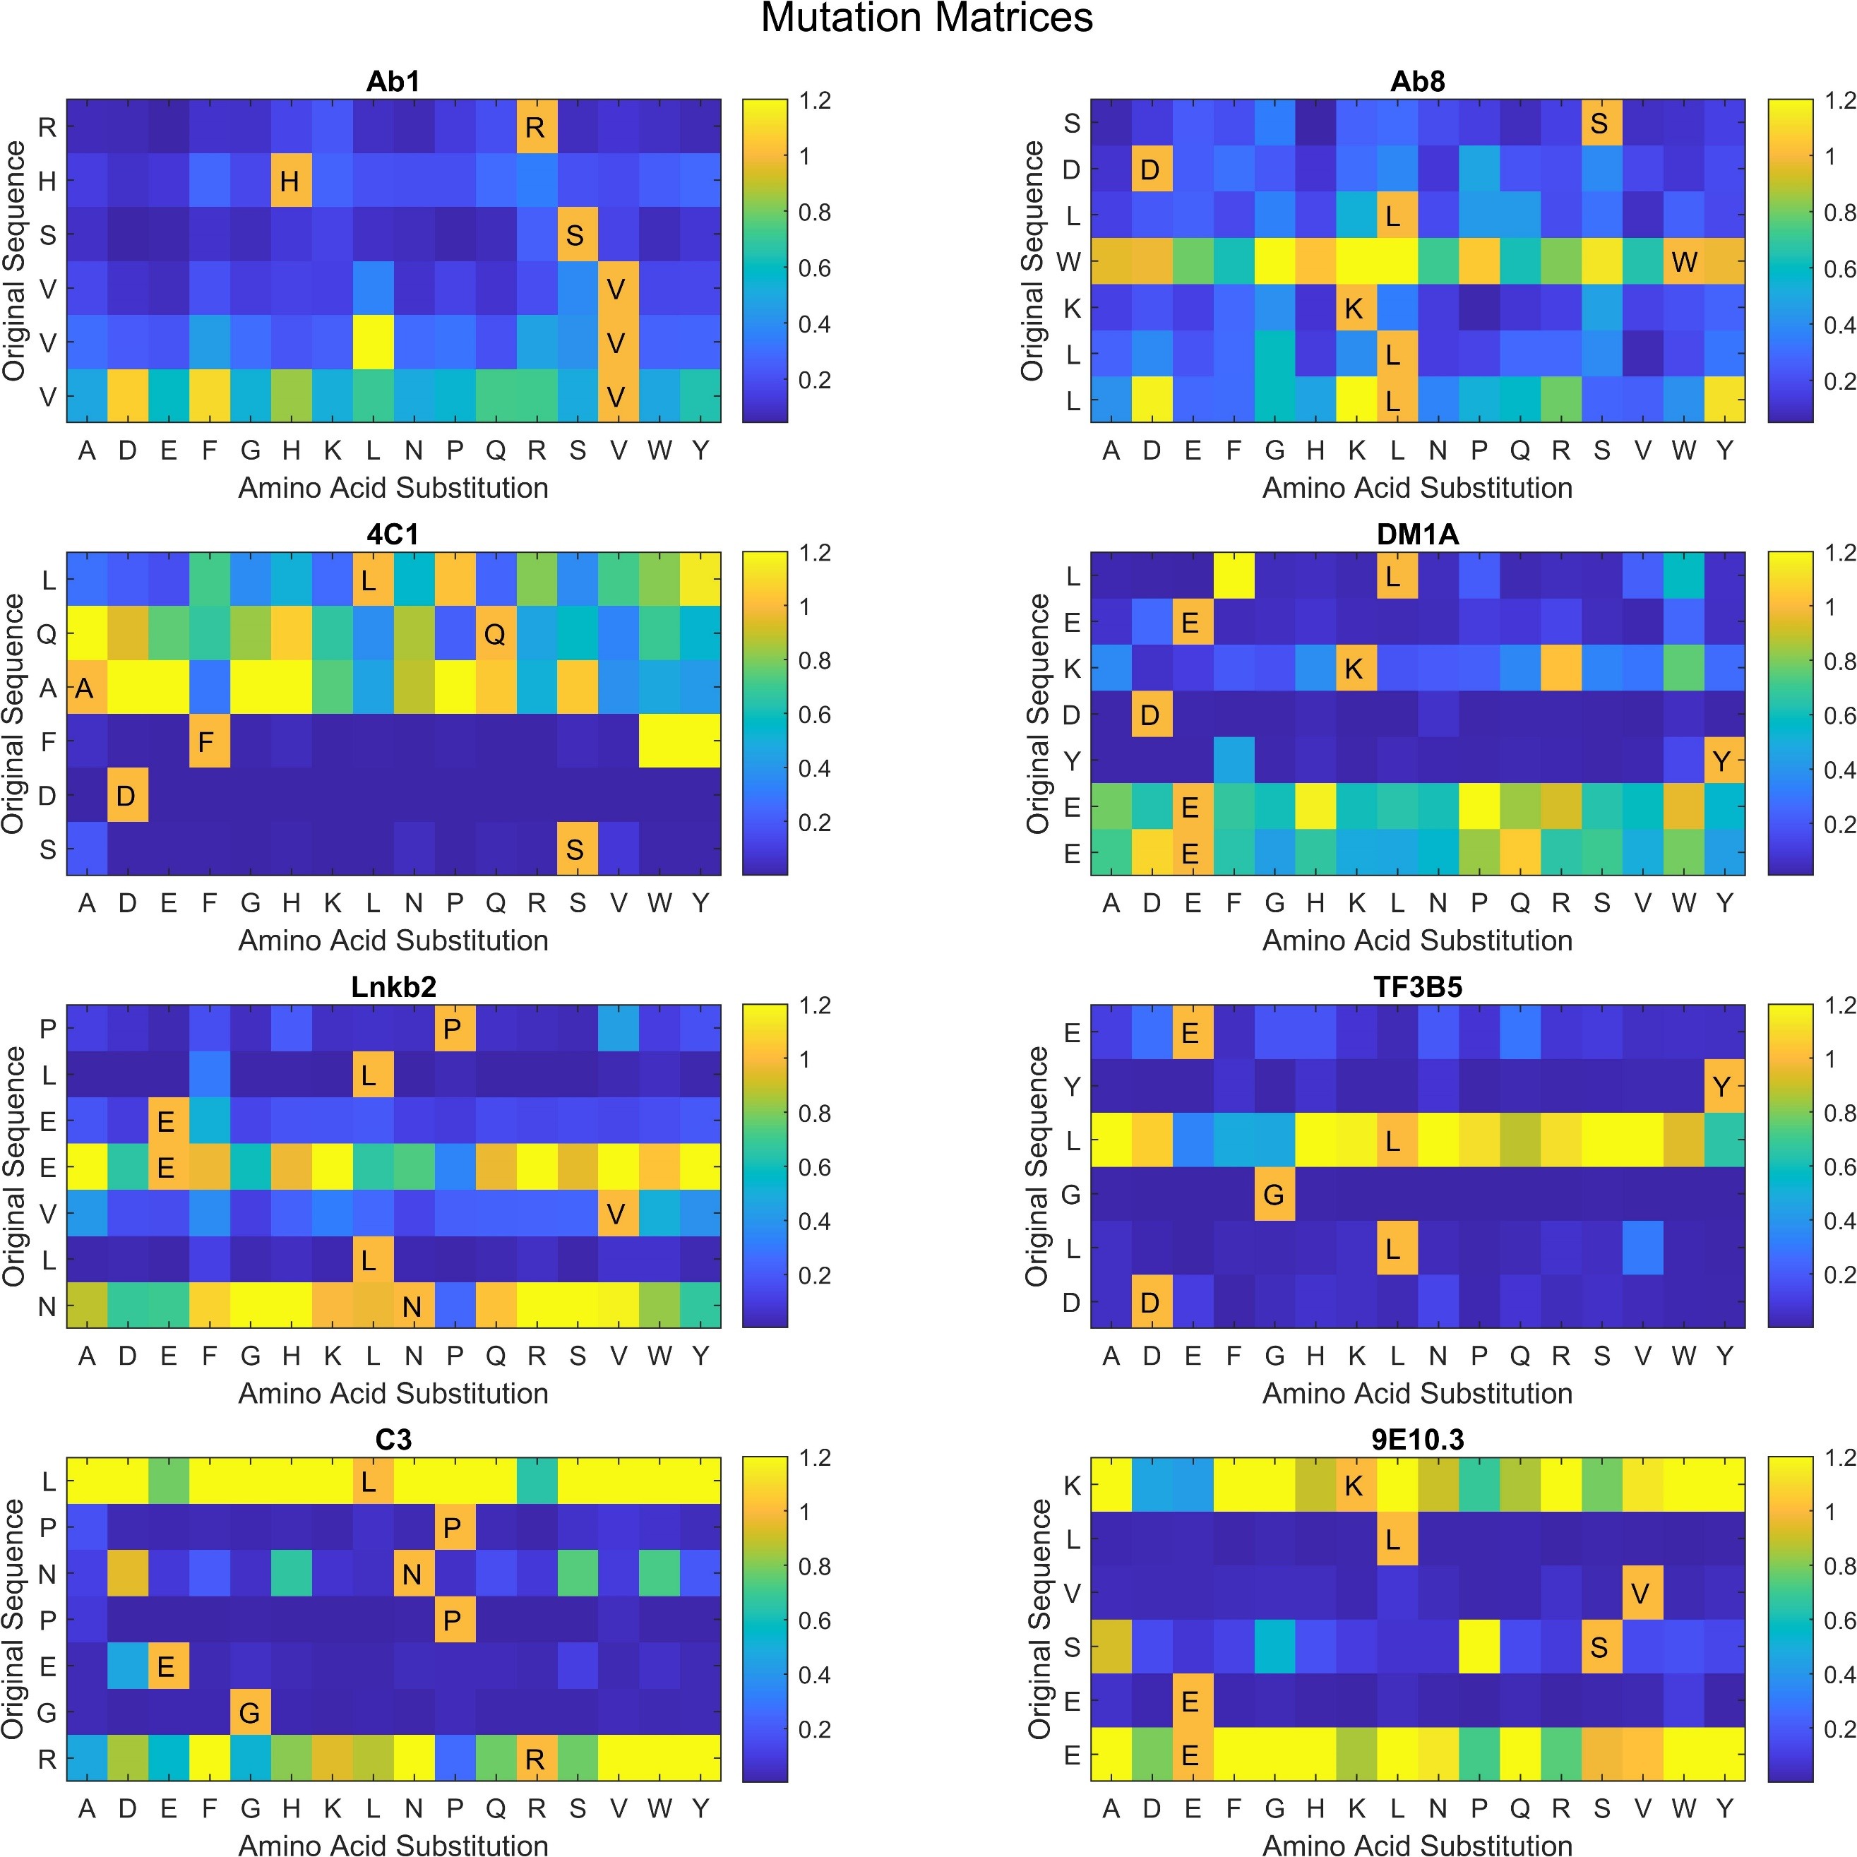
Figure S6. Mutation matrix for each of the mAb cognate sequences. The y-axis is the cognate sequence and the x-axis is the amino acid used for substitution. The color is proportional to the slope predicted by the neural network (see color bar). In each case, the values were normalized to the predicted slope of the cognate sequence. Note that any sequence with a value of 1.1 times the slope of the cognate sequence is yellow. This allowed better resolution of values less than 1.

Data and Algorithm Availability
Dataset. The averaged data for all 8 mAbs is available on Figshare. The data is in an excel spreadsheet, ‘Averaged_Array_Data.xlsx’. Column 1 contains the sequence corresponding to that row of data. Column 2 is either 0 or 1, with 1 meaning that the sequence and data in that row is for a mAb cognate sequence purposely included on the array. These sequences are removed by the algorithm prior to neural network training. The remaining 32 columns are the data for each mAb at each concentration (each value is the average of 4 measurements). The top row contains the name of the mAb and the second row contains the concentration. The subsequent values are the average measured binding values. Note that there are more values here than were used in the analysis because all sequences over 11 residues in length were excluded in the analysis. The values given are binding values in counts. The detector saturated at 65536 counts.

Algorithm. The Matlab script is available upon request as a single file (‘mAb_sequence_binding_relationship.m’) containing all the functions at the end. At the top of the script there are a series of values that can be varied:
Table S3: User defined variables in the Matlab Script
Variable | Options (Default) | Description
current_mAb | Ab1, Ab8, 4C1, DM1A, Lnkb2, TF3B5, C3, 9E10.3 | The name of the mAb to analyze
Data_file | (Averaged_Array_Data.xlsx) | The name of the data file
num_rep | User defined (12) | The number of neural network models averaged
numrand | User defined (1000000) | The number of random sequences predicted
num_layers | User defined (2) | The number of hidden layers
num_nodes | User defined (250) | The number of nodes/layer
miniBatchSize | User defined (1000) | The number of sequences analyzed per mini batch
MaxEpochs | User defined (20) | The number of training Epochs
InitialLearnRate | User defined (0.002) | Learning rate during training
LearnRateDropFactor | User defined (0.9) | Rate at which the learning rate drops during training
shift | User defined (5) | The number of different registers of each sequence in the input vector used during training. 0 means no register shifting
weight_high_binders | true/false (true) | Determines if weighting of high binding values is used
maxdensity | User defined (300) | If weighting used, this is the number of sequences per bin after copying
maxcopy | User defined (100) | If weighting used, this is the maximum number of any one sequence
conc2compare | 0.125, 0.5, 2, 8 (8) | If weighting used, this is the concentration used to set the number of copies of high biding sequences
EndMarkers | true/false (true) | Determines if end markers are used
adjust_saturated_points | true/false (true) | Determines if saturated points are extrapolated based on concentration
Composition_fit | true/false (true) | Determines if compositional binding is subtracted from the data before training the model
ExcludeLong | true/false (true) | Determines if the longest sequences are excluded from the training
maxlen | 8-13 (11) shorter than 8 would remove too much data | If longest sequences are excluded, this is the maximum length used

The script is set up to run as long as the data file is in the same directory as the script. Note that this script was developed under Matlab release 2022a, though it should work on a range of release versions.
Literature Cited
1 Eilers, P. H. C. & Goeman, J. J. Enhancing scatterplots with smoothed densities. Bioinformatics 20, 623-628, doi:10.1093/bioinformatics/btg454 (2004).

