Supplementary Information

Avalanche tuning in bionic MoS₂/WS₂ transistor for high-frequency visual behavior beyond human retina

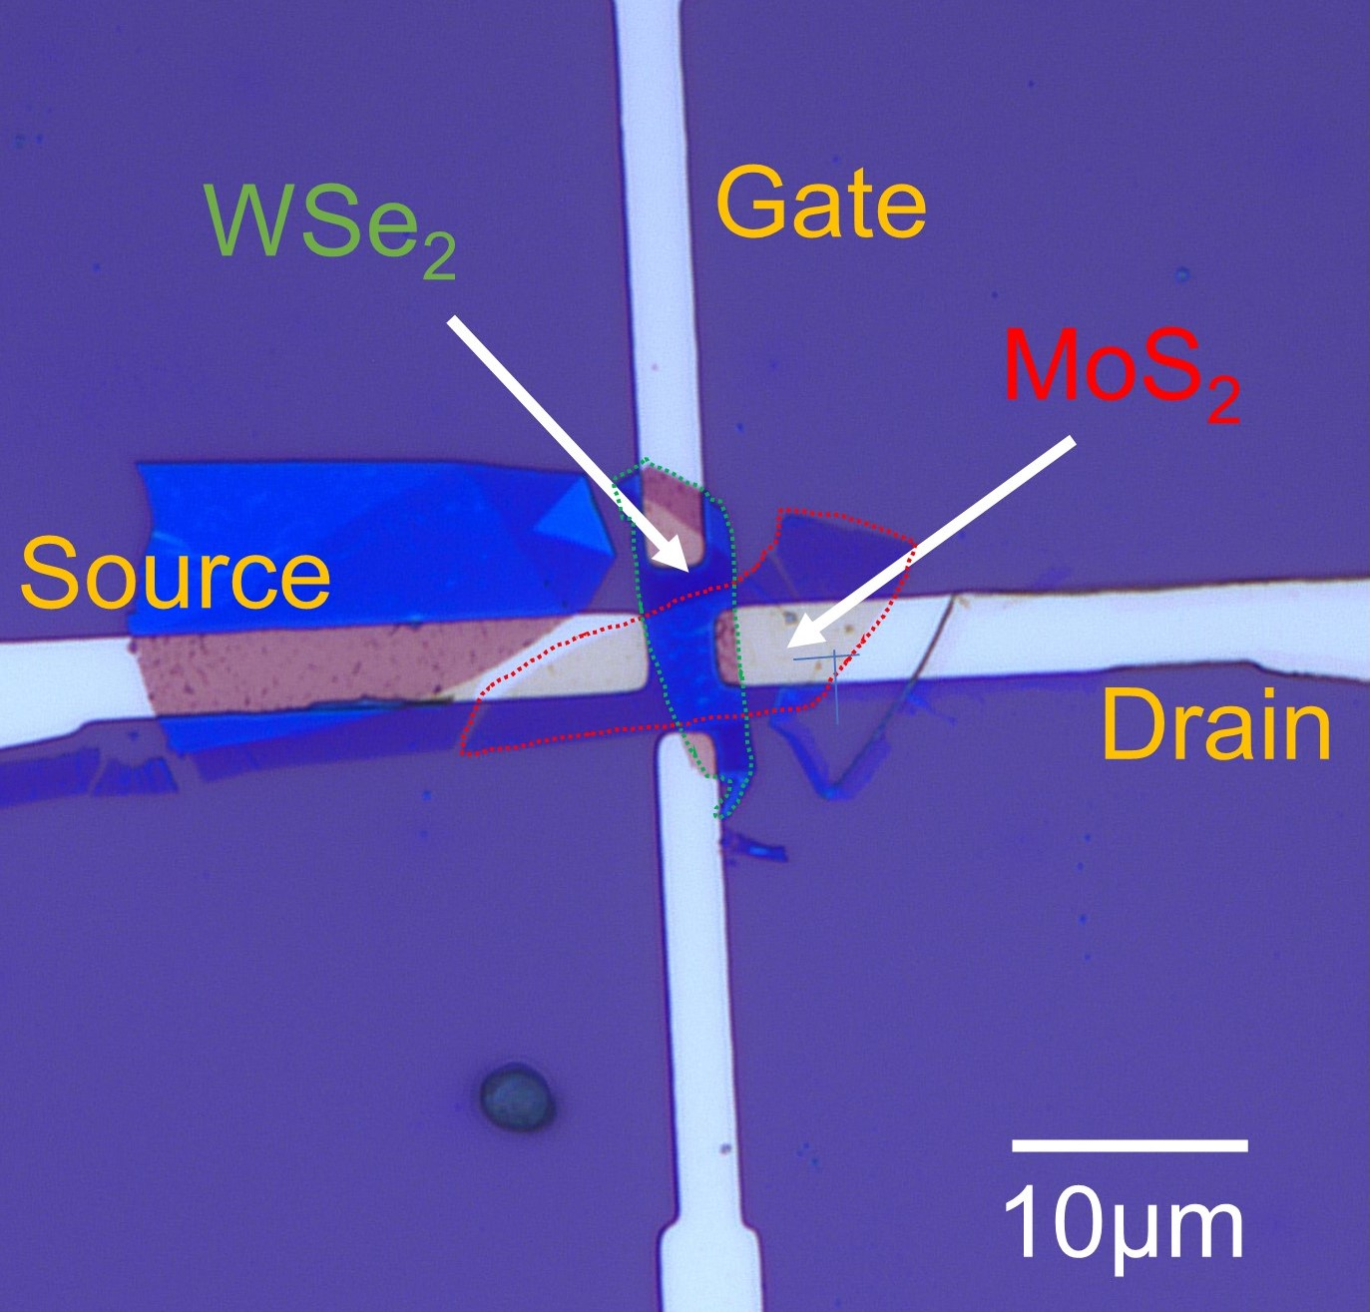
Figure 1. Optical microscopy images of the device structure and electrical connections for the junction filed effect transistor (JFET) consisting of an ultrathin MoS₂ transport channel and top WSe₂ gate.

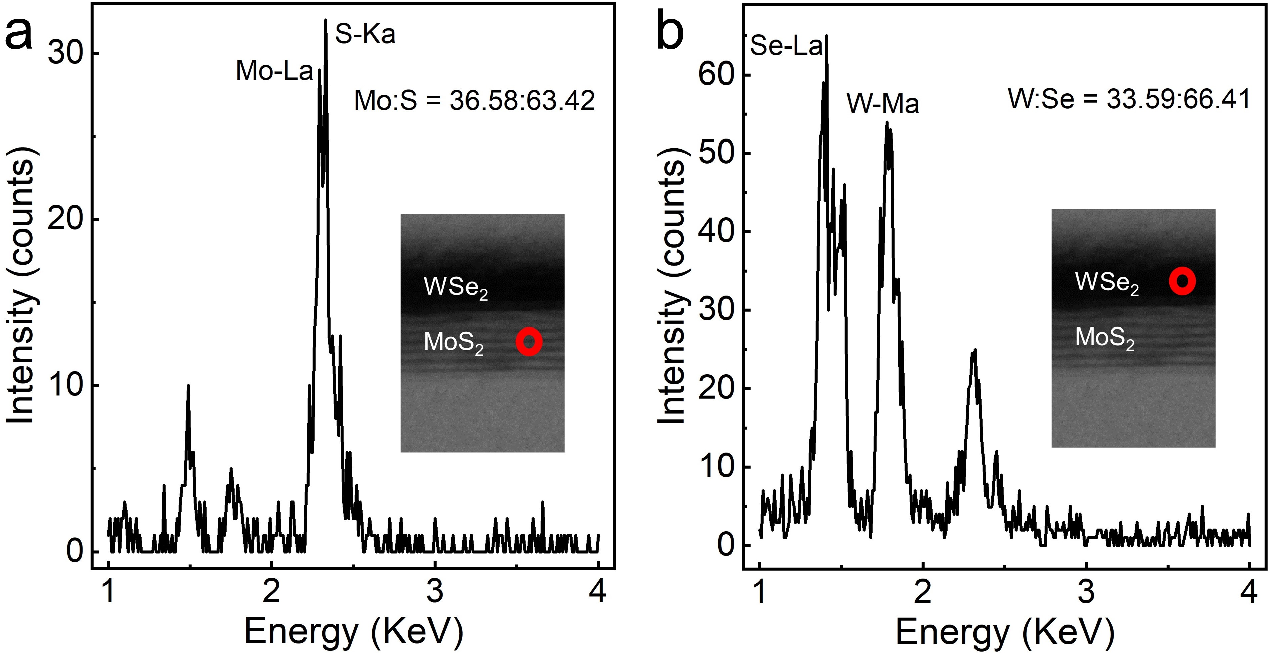
Figure 2. EDX analysis of cross sectional MoS₂/WSe₂ interface, corresponding to (a) MoS₂ and (b) WSe₂, respectively.

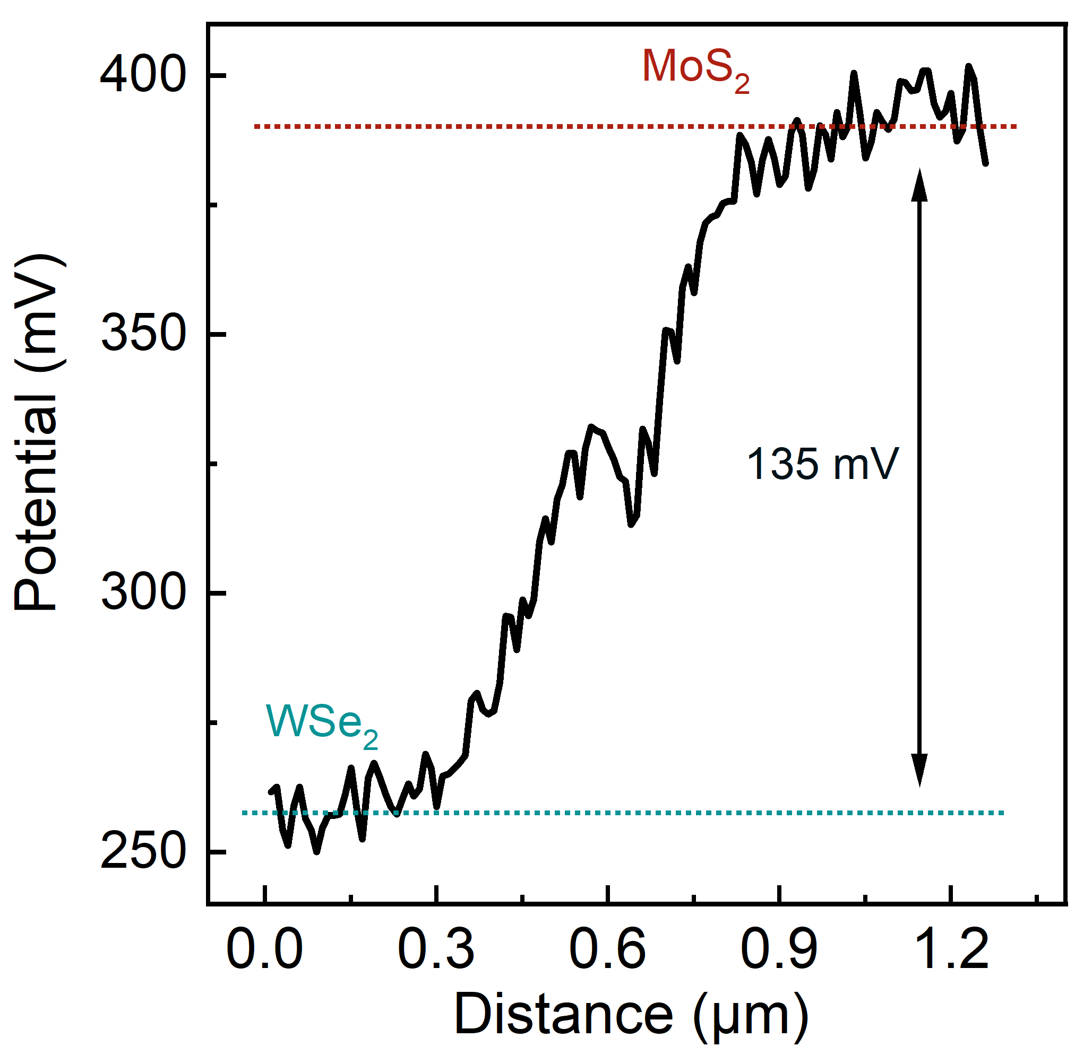
Figure 3. In situ surface potential difference (SPD) plot of the measured MoS₂/WSe₂ interface.

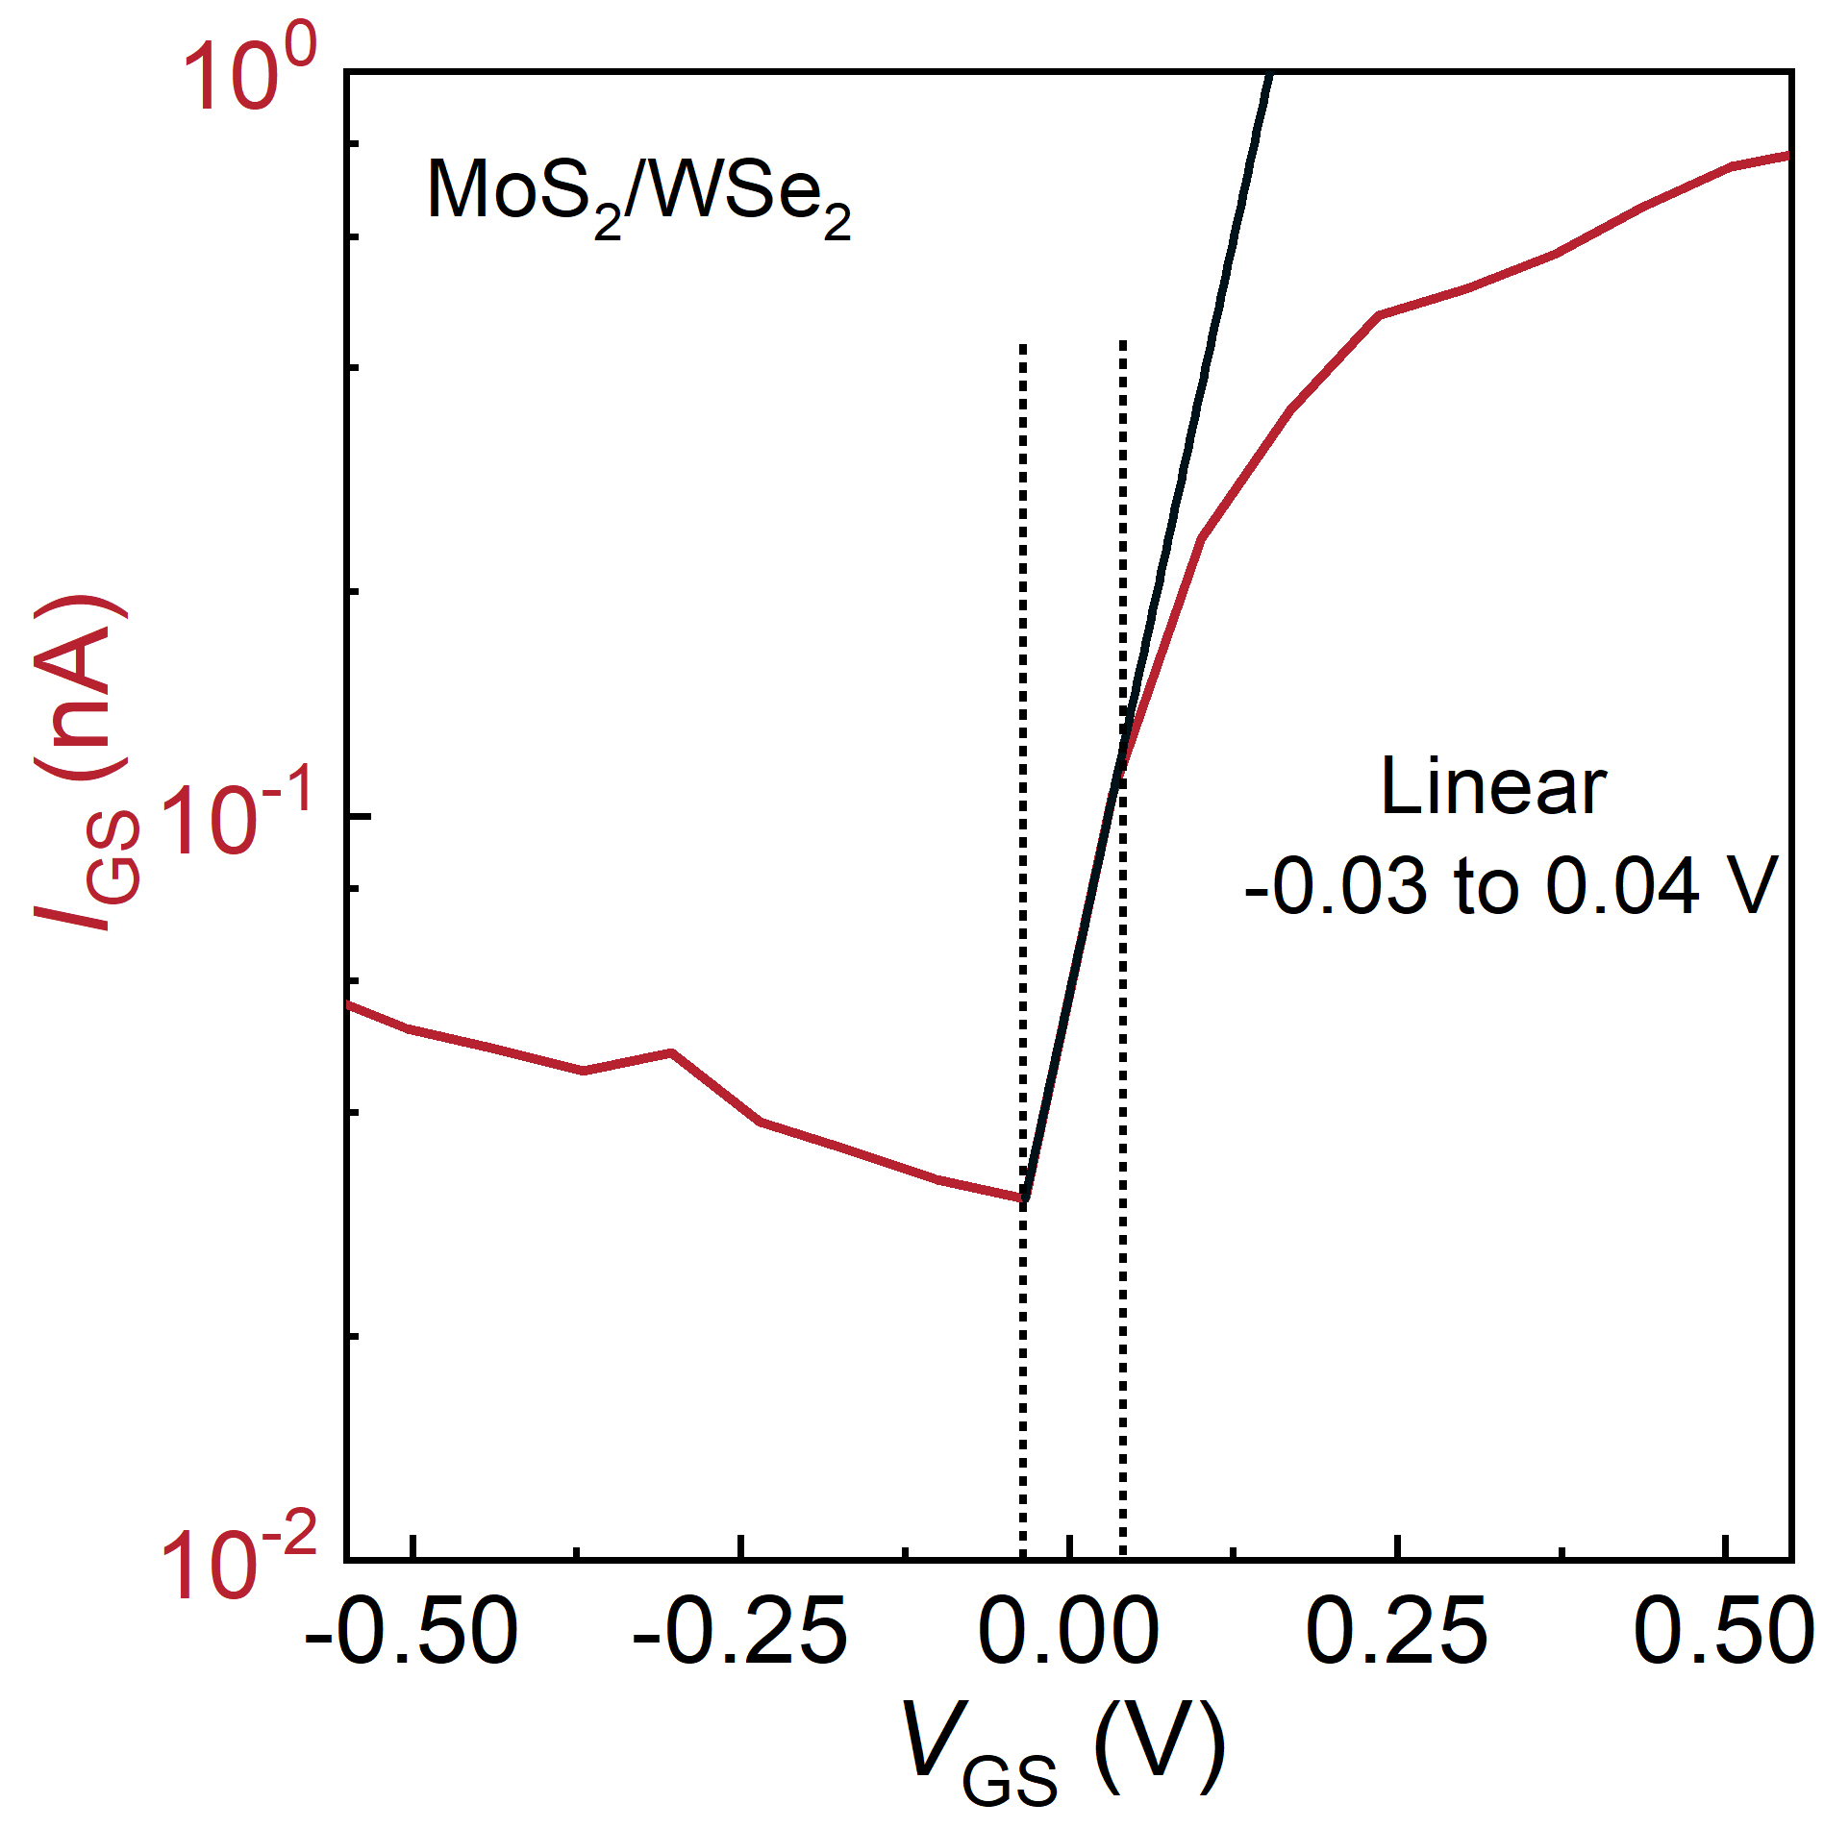
Figure 4. The linear part of the I-V curve. The ideal factor (n) is calculated using the formula: $\text{n=}\frac{\text{q}}{{\text{k}}_{\text{b}}\text{T}}\frac{\text{dV}}{\text{dlnI}}$, where q, k_{b} and T are elementary charge, Boltzmann constant and Kelvin temperature.

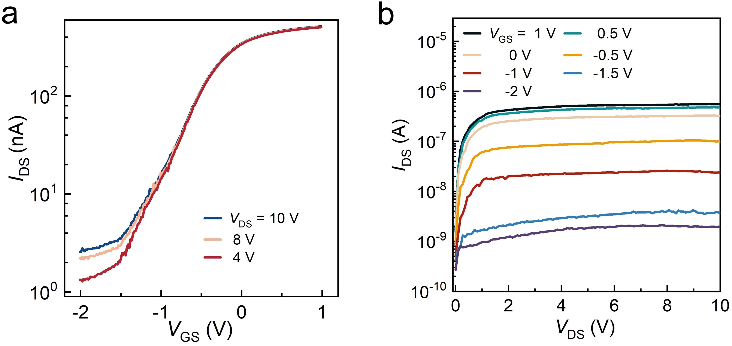
Figure 5. Transfer (a) and output (b) characteristics of the device acting JFET. The transfer curves at V_{DS} at 4, 8 and 10 V are nearly overlapped, showing the device enters the saturation region from 4 to 10 V, which is consistent with output curve.

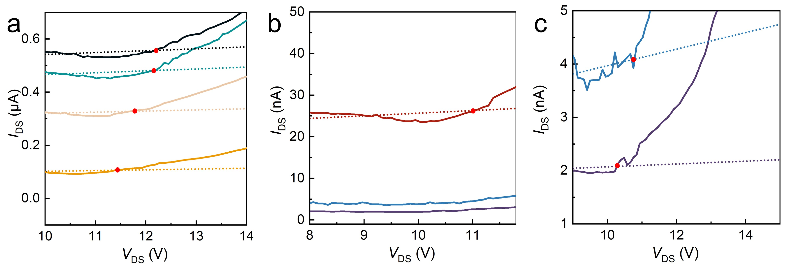
Figure 6. The definition of the V_{EB} at different gate voltage (V_{GS}). The V_{EB} is the intersection of the extension of the linear region of the saturation current and the I_{DS}.

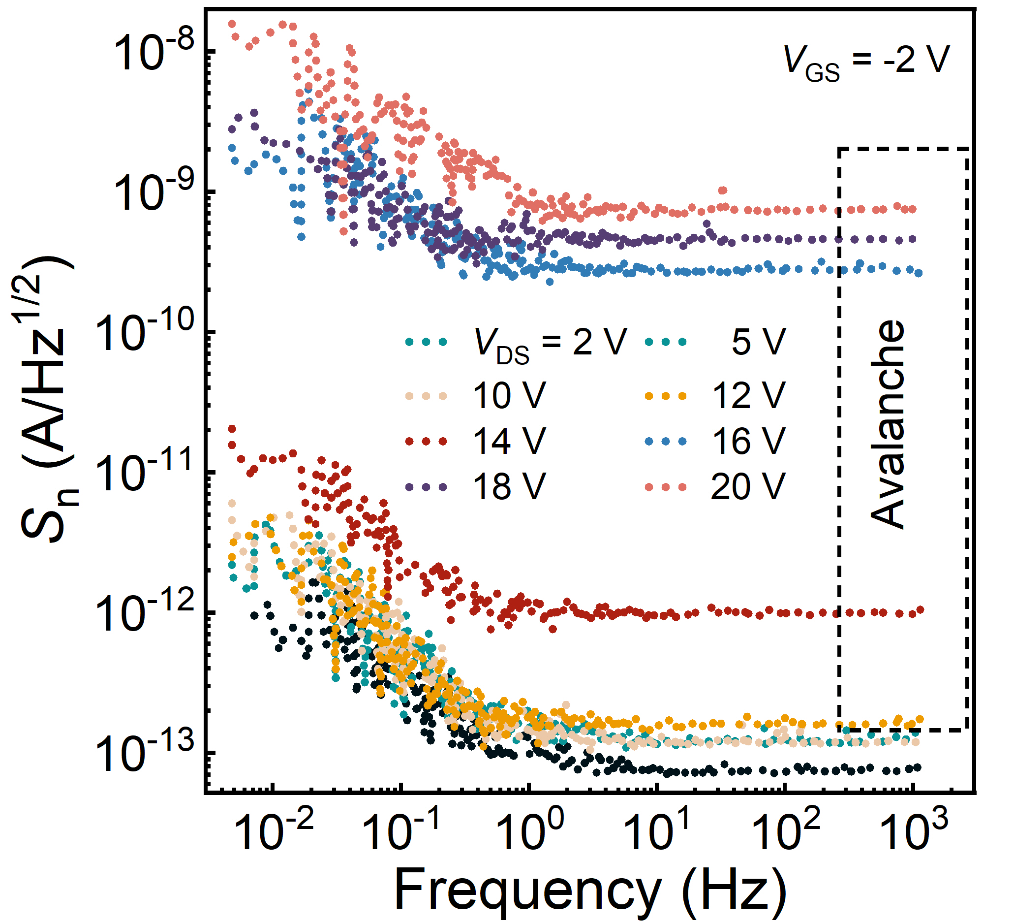
Figure 7. Noise spectral density (S_{n}) of the device at different V_{DS} by the Fourier transformation of dark current traces.

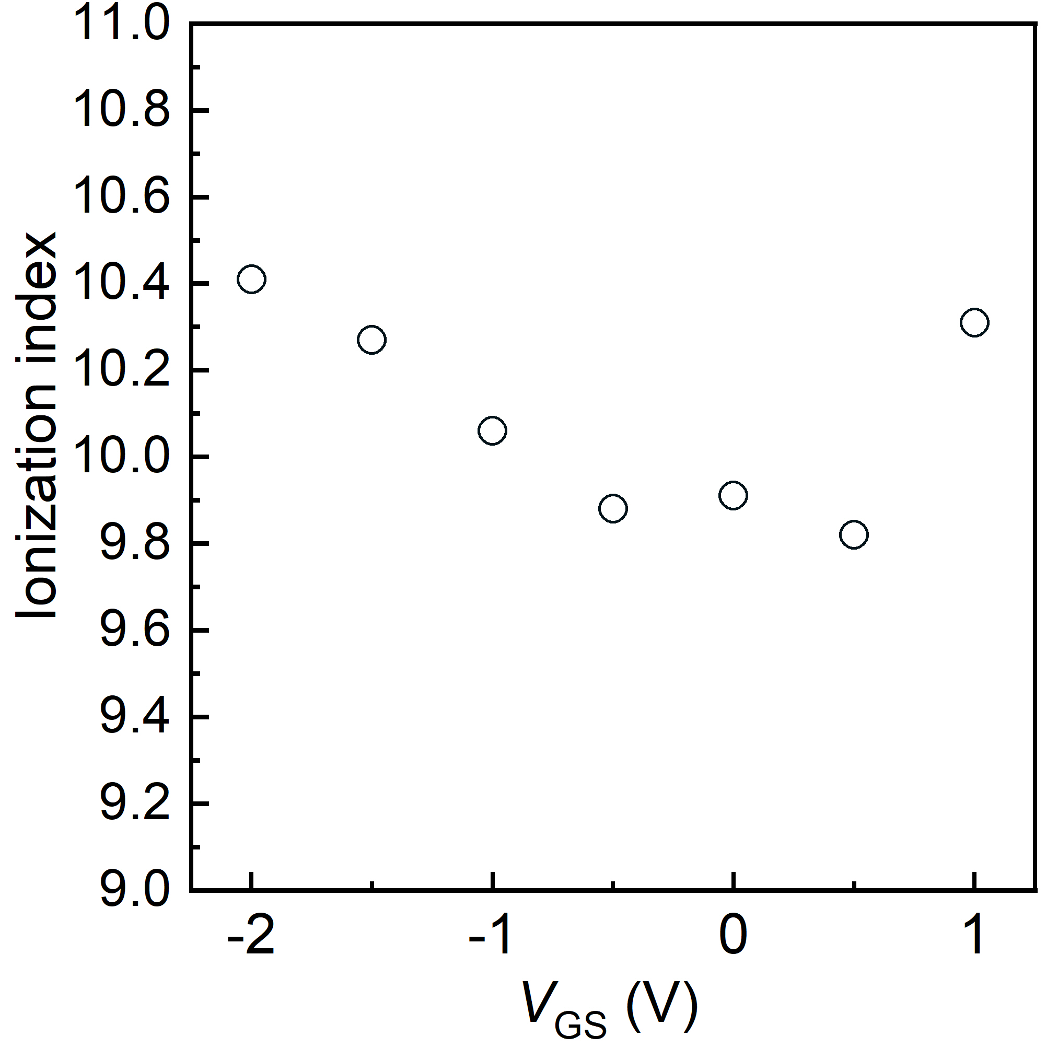
Figure 8. The ionization index at different V_{GS}.

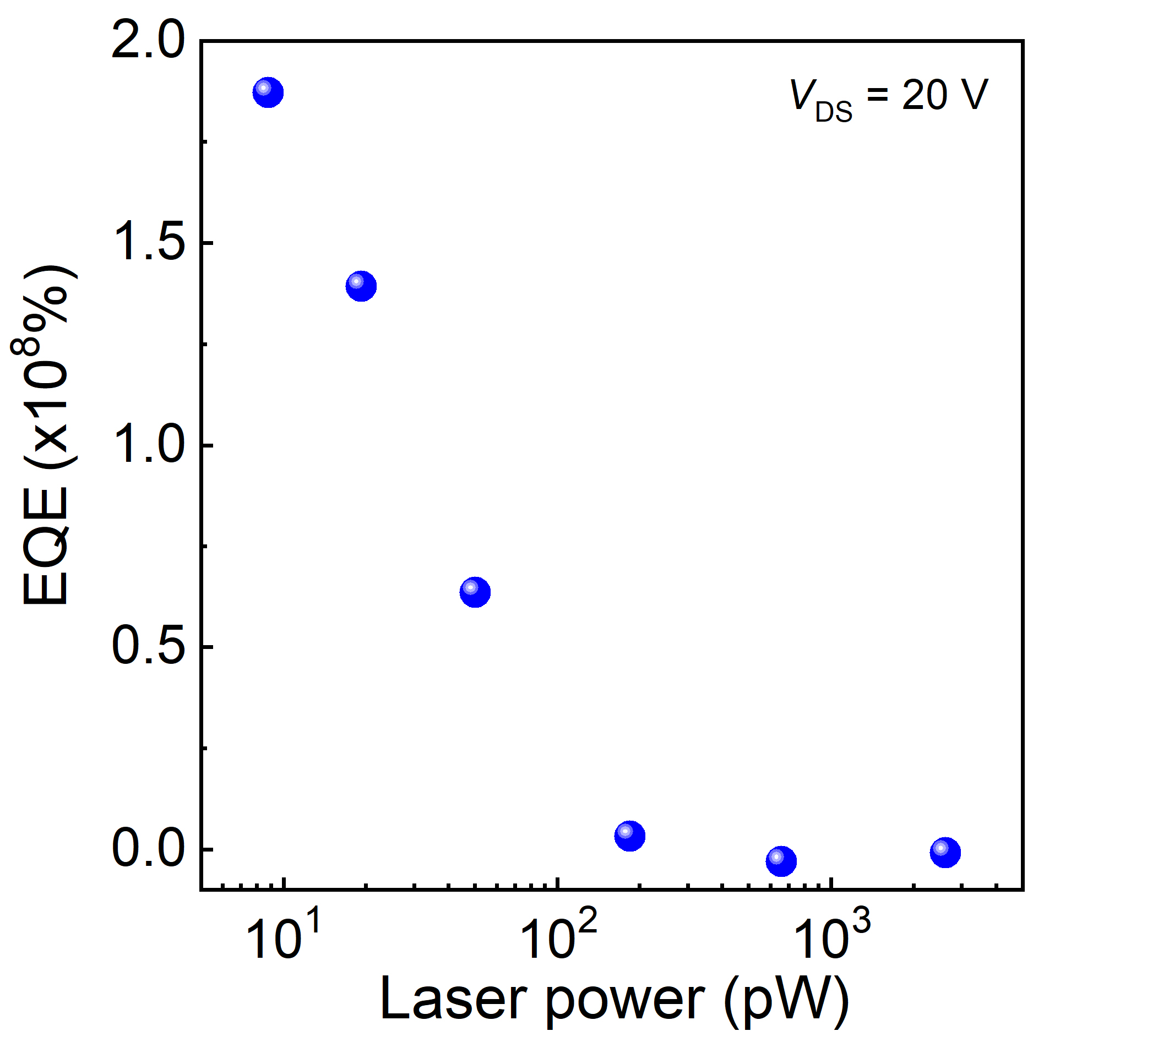
Figure 9. Avalanche external quantum efficiency (EQE) at V_{DS} = 20 V as function of light power.

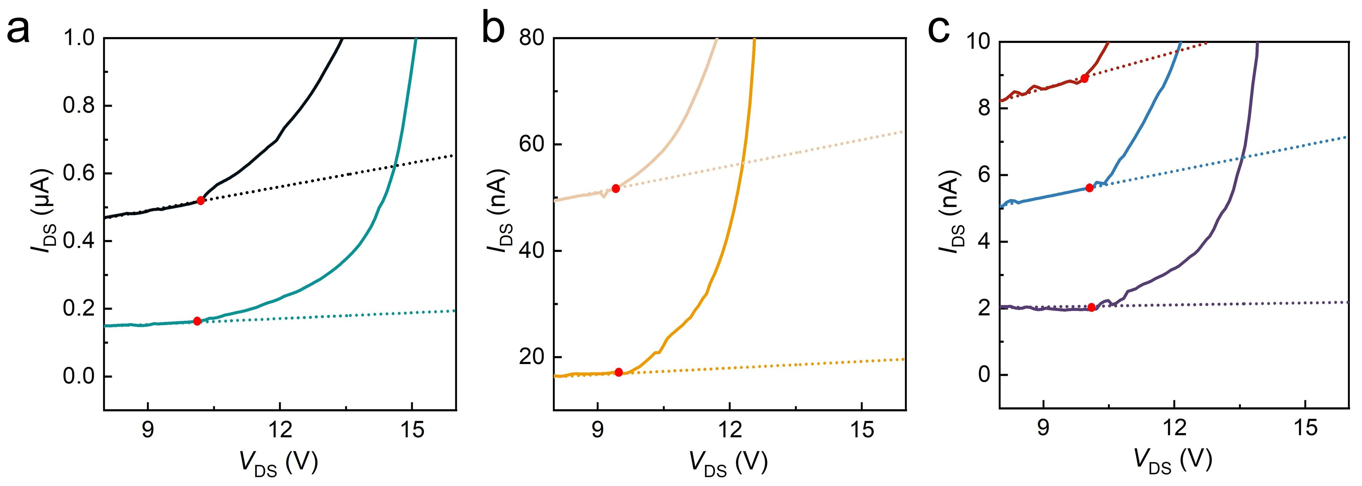
Figure 10. The definition of the V_{EB} under different fixed laser power. The V_{EB} is the intersection of the extension of the linear region of the saturation current and the I_{DS}.

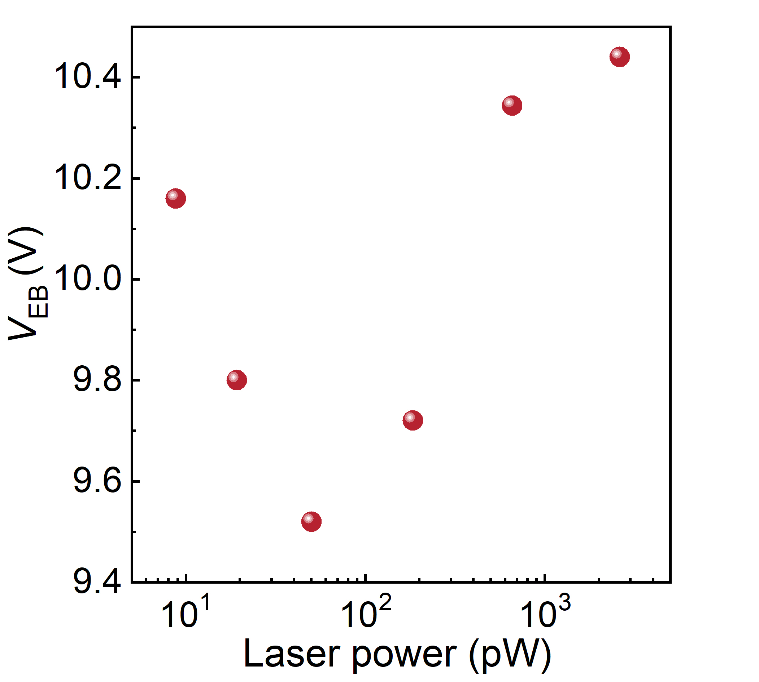
Figure 11. The V_{EB} as function of laser power.

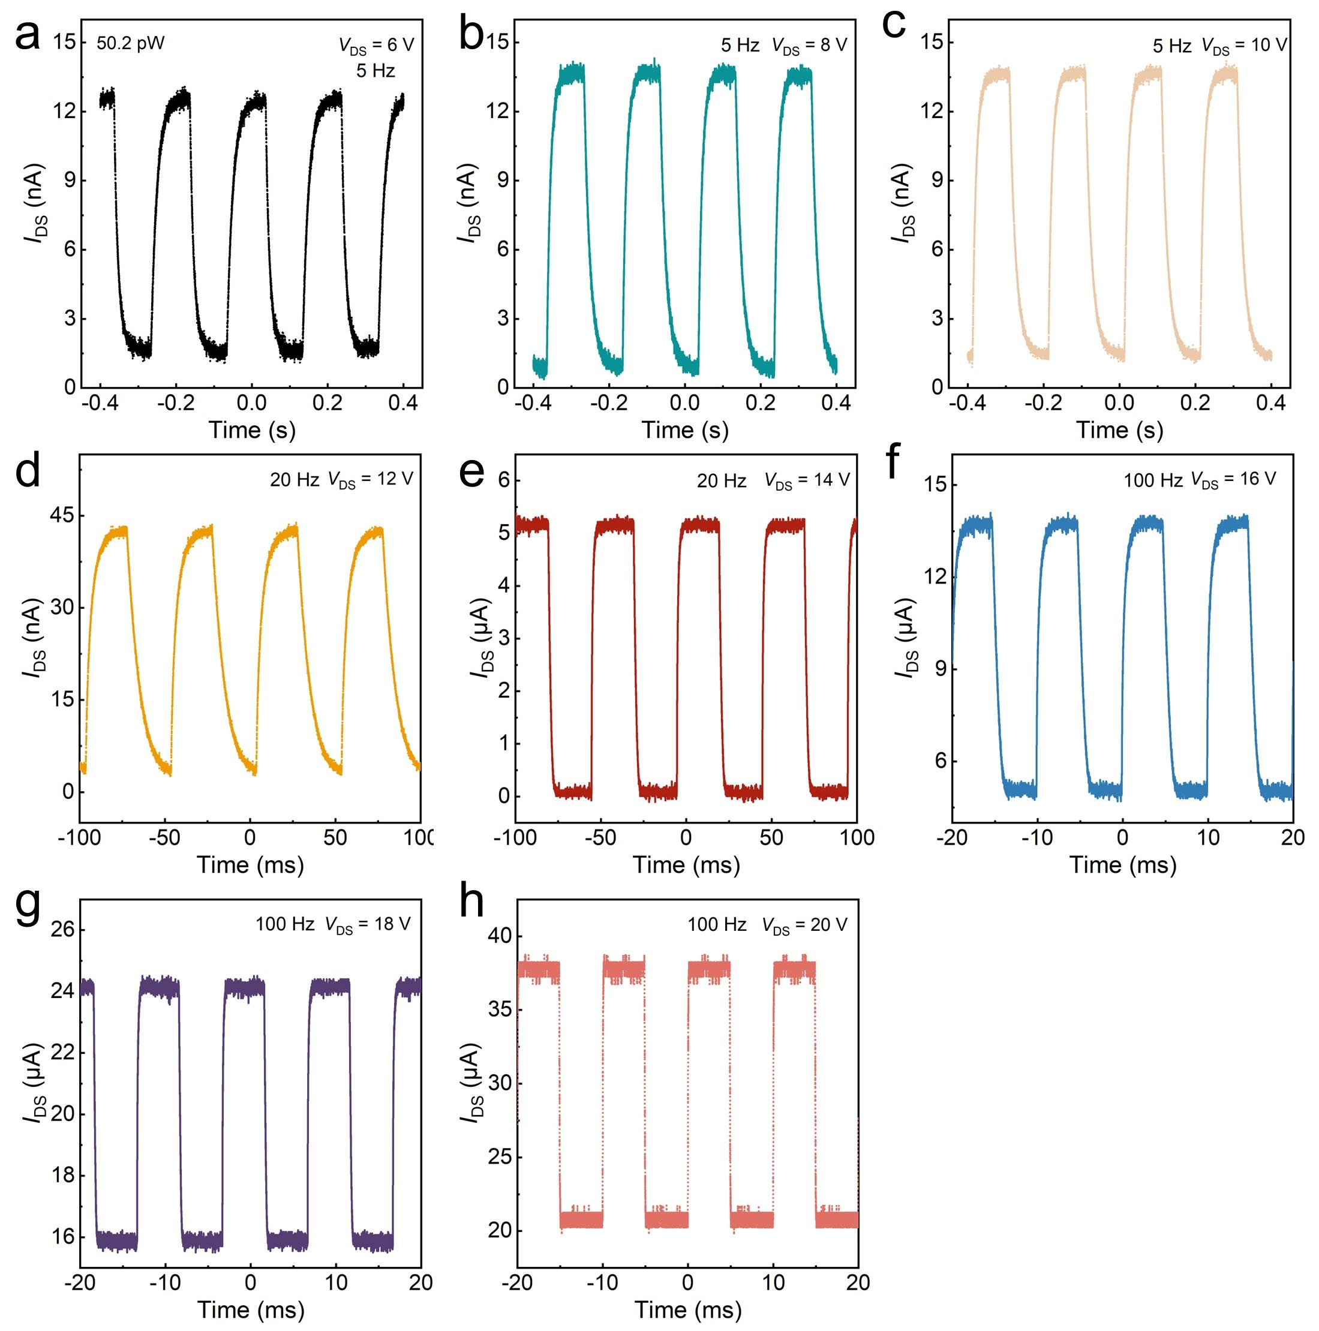
Figure 12. Photo-response of the device at different V_{DS} under light power of 50.2 pW.

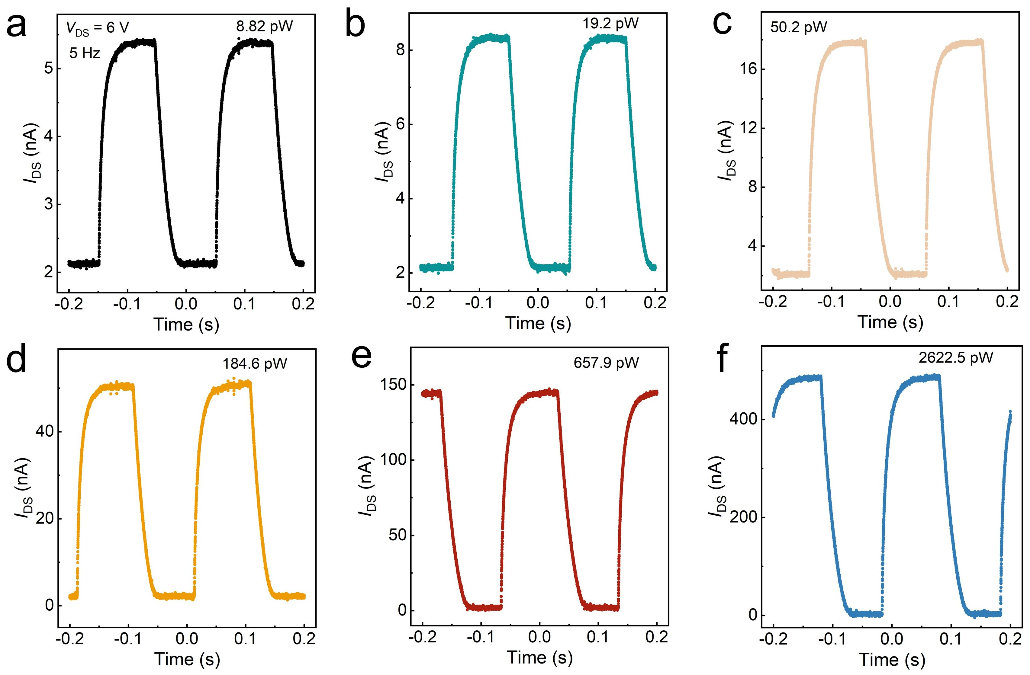
Figure 13. Photo-response at V_{DS} = 6 V under different fixed light power.

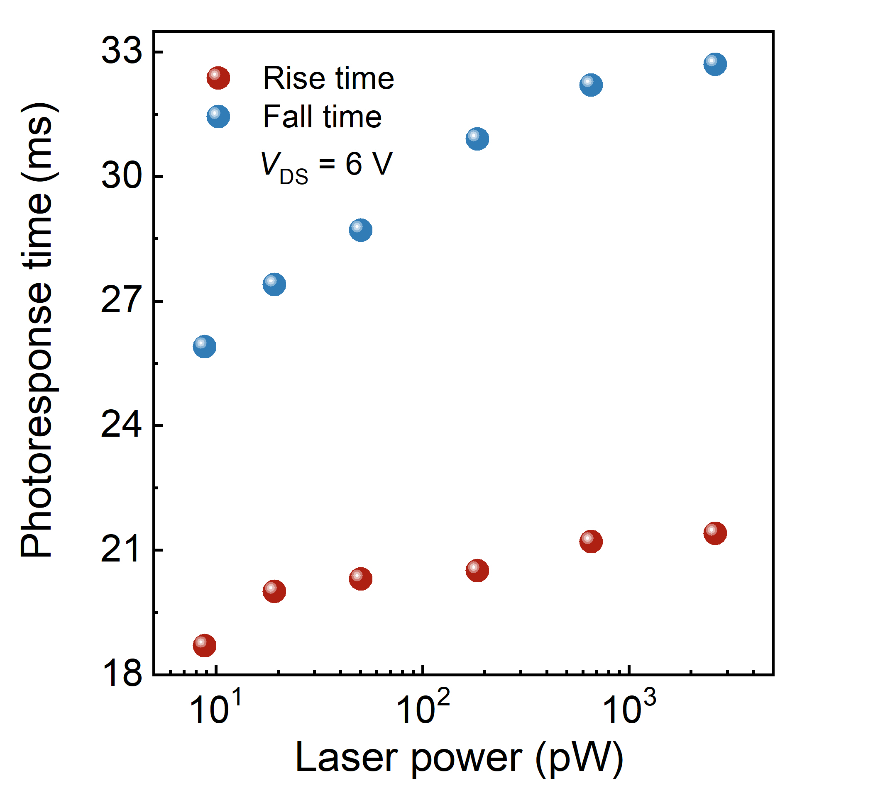
Figure 14. Photo-response as function of light power at V_{DS} = 6 V.

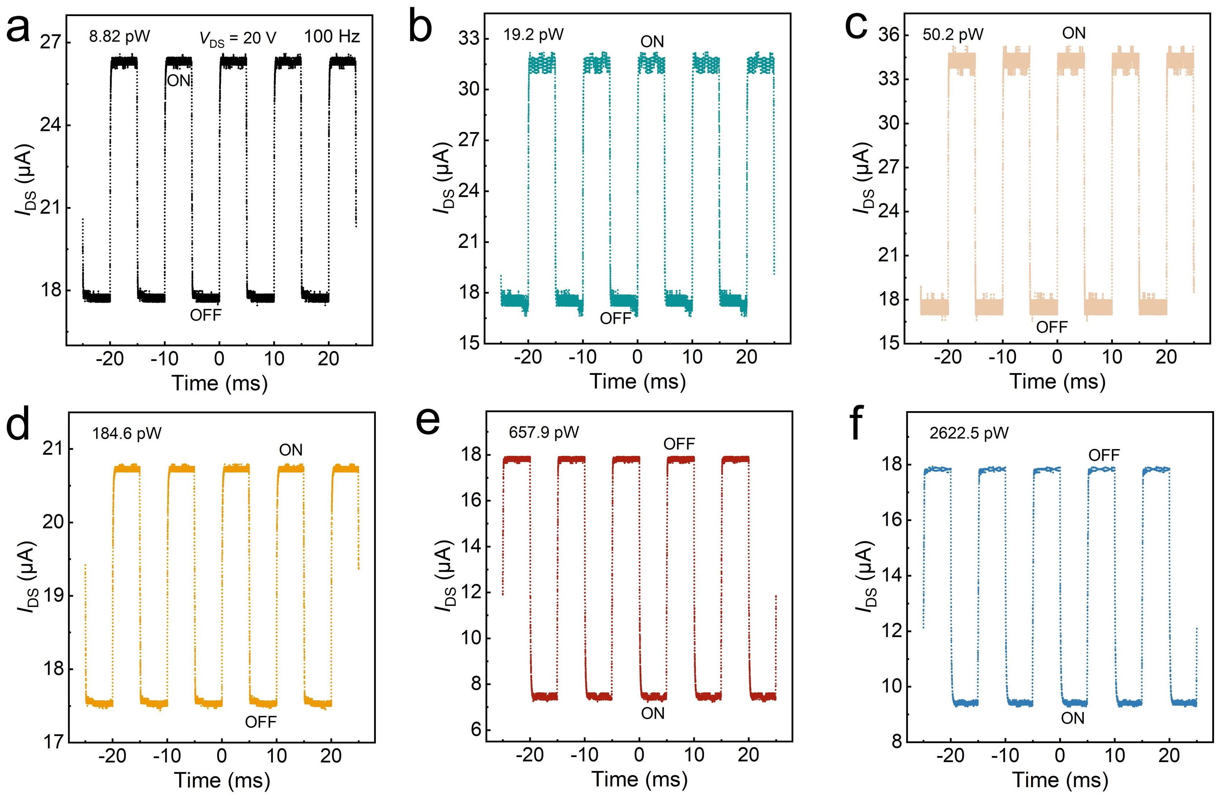
Figure 15. Photo-response at V_{DS} = 20 V under different fixed light power.

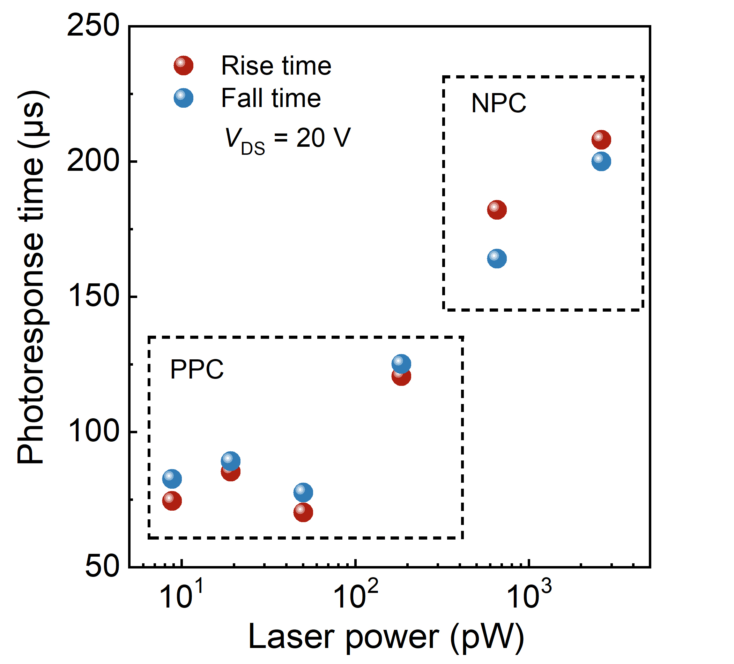
Figure 16. Photo-response as function of light power at V_{DS} = 20 V, showing the PPC and NPC effect at weak and strong laser illumination, respectively.

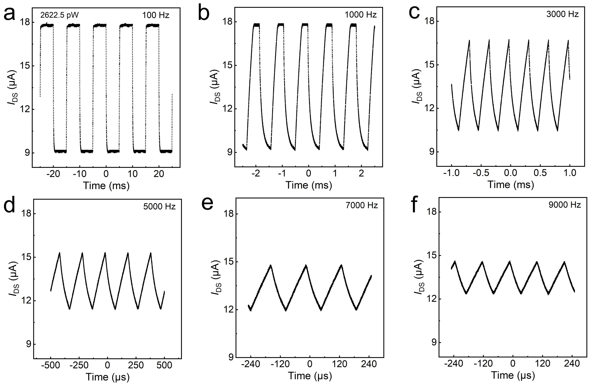
Figure 17. Photo-response with different frequency at V_{DS} = 20 V and laser power of 2622.5 pW.

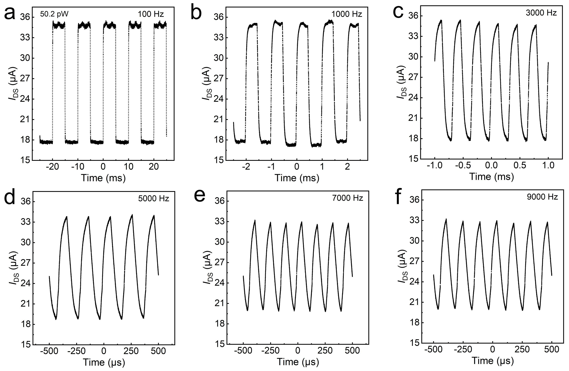
Figure 18. Photo-response with different frequency at V_{DS} = 20 V and laser power of 50.2 pW..

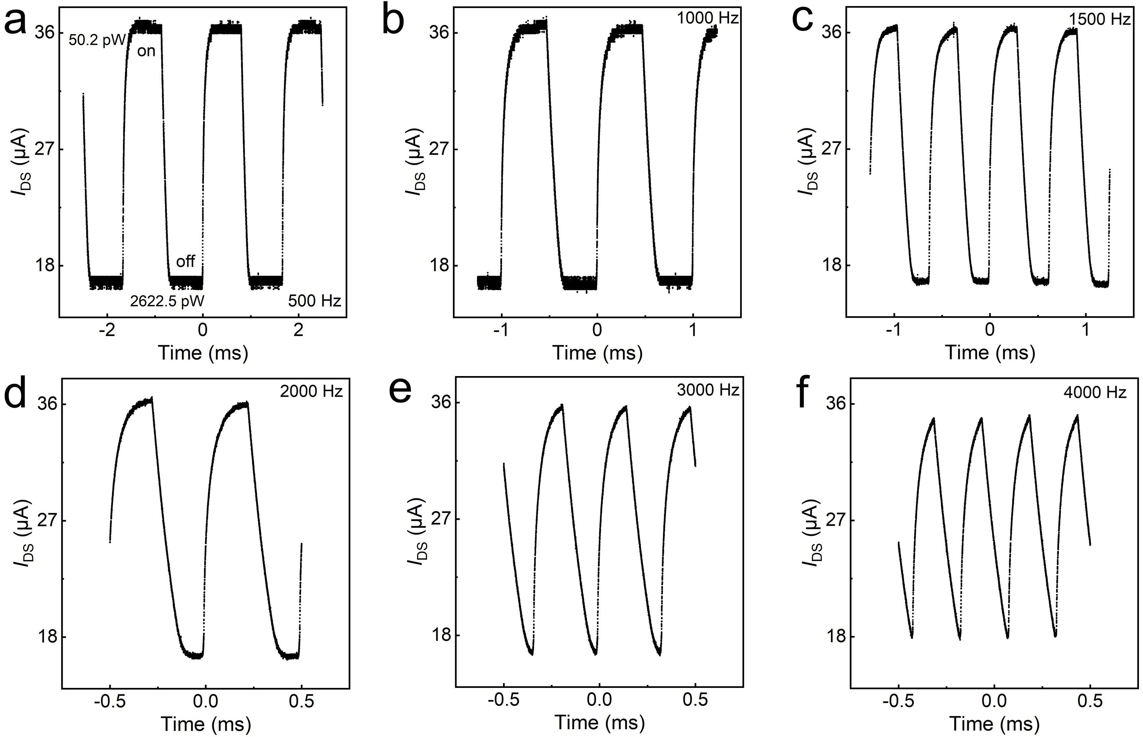
Figure 19. Time-varying current by switching laser power between 50.2 and 2622.5 pW with different frequency at V_{DS} = 20 V.

