Disentangling microbial syntrophic mechanisms for hexavalent chromium reduction in autotrophic biosystems
Baogang Zhang¹, Jun Liu^{1,2}*, Yizhi Sheng²*, Jiaxin Shi¹, Hailiang Dong^{1,2}*

ª State Key Laboratory of Biogeology and Environmental Geology, China University of Geosciences, Beijing 100083, China
^{b} Department of Geology and Environmental Earth Science, Miami University, Oxford, OH 45056, USA

*Corresponding author
Jun Liu, liujun2009sysu@gmail.com;
Yizhi Sheng, shengy5@miamioh.edu;
Hailiang Dong, dongh@cugb.edu.cn.

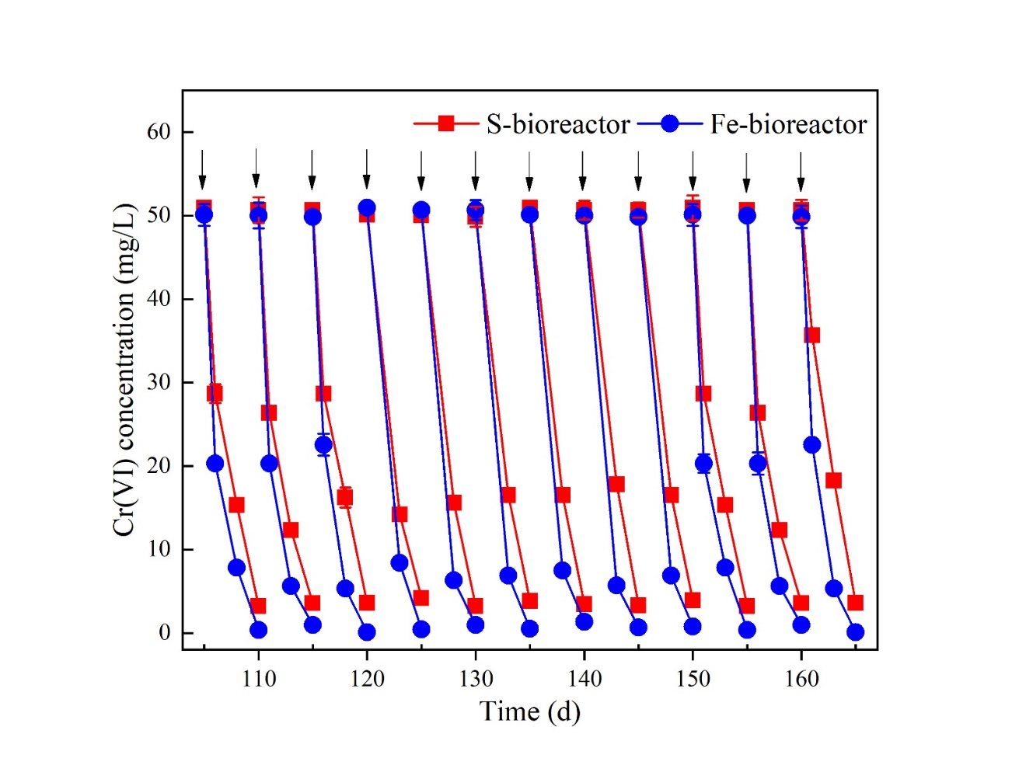
Figure S1 Time-course operations of Cr(VI) reduction in S- and Fe- bioreactors. Multiple cycles of Cr(VI) measurements were conducted.

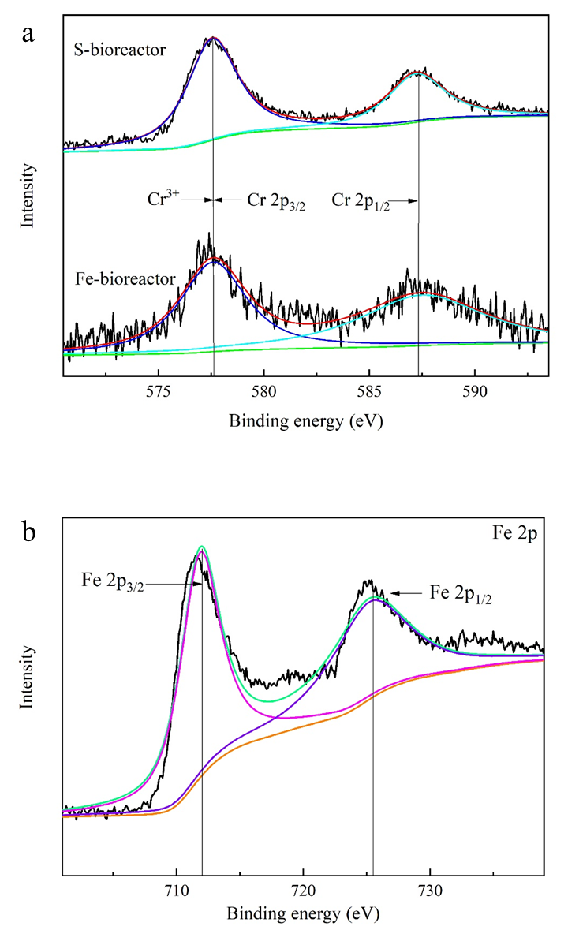
Figure S2 XPS spectra of Cr 2p for the generated precipitates in S- and Fe- bioreactors (a), and Fe 2p XPS spectra for precipitates in the Fe-bioreactor (b). In panel a, the dark blue and light blue curves represent the peaks of Cr2p3/2 and Cr2p1/2, respectively, and the green curve is the baseline. In panel b, the pink and purple curves represent the peaks of Fe2p3/2 and Fe2p1/2, respectively, and the orange curve is the baseline. All curves were fitted by XPS Peak Fit software.

