Table 1 Molecular structures and SMILES strings of some diselenides and standard drugs (Miltefosine and Pentamidine)
Comp. ID | Molecular Structures | SMILES
1 | 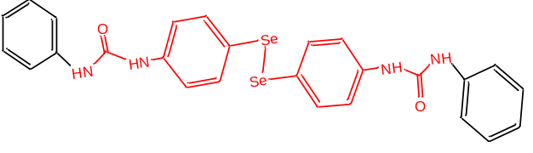 | O=C(NC1=CC=CC=C1)NC1=CC=C([Se][Se]C2=CC=C(NC(=O)NC3=CC=CC=C3)C=C2)C=C1
2 | 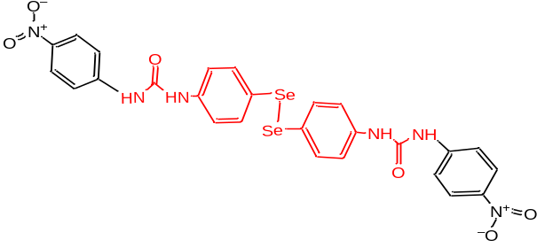 | [O-][N+](=O)C1=CC=C(NC(=O)NC2=CC=C([Se][Se]C3=CC=C(NC(=O)NC4=CC=C(C=C4)[N+]([O-])=O)C=C3)C=C2)C=C1
3 | 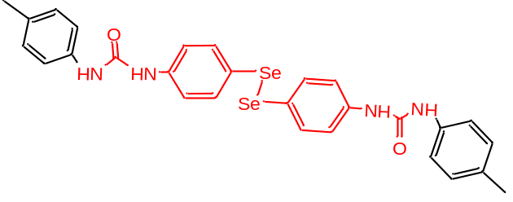 | CC1=CC=C(NC(=O)NC2=CC=C([Se][Se]C3=CC=C(NC(=O)NC4=CC=C(C)C=C4)C=C3)C=C2)C=C1
4 | 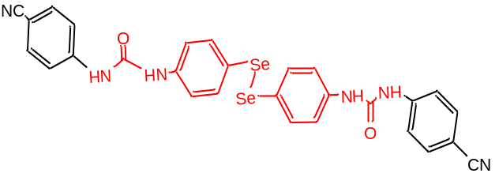 | O=C(NC1=CC=C([Se][Se]C2=CC=C(NC(=O)NC3=CC=C(C=C3)C#N)C=C2)C=C1)NC1=CC=C(C=C1)C#N
5 | 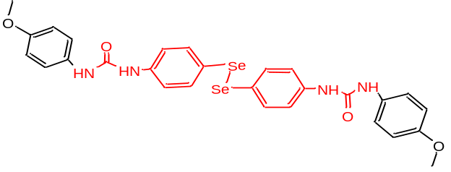 | COC1=CC=C(NC(=O)NC2=CC=C([Se][Se]C3=CC=C(NC(=O)NC4=CC=C(OC)C=C4)C=C3)C=C2)C=C1
6 | 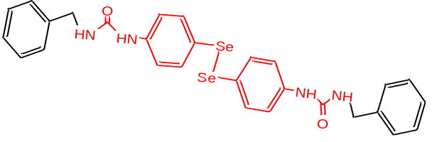 | O=C(NCC1=CC=CC=C1)NC1=CC=C([Se][Se]C2=CC=C(NC(=O)NCC3=CC=CC=C3)C=C2)C=C1
7 | 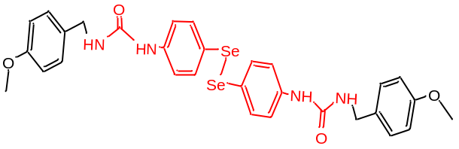 | COC1=CC=C(CNC(=O)NC2=CC=C([Se][Se]C3=CC=C(NC(=O)NCC4=CC=C(OC)C=C4)C=C3)C=C2)C=C1
8 | 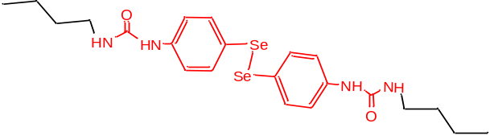 | CCCCNC(=O)NC1=CC=C([Se][Se]C2=CC=C(NC(=O)NCCCC)C=C2)C=C1
9 | 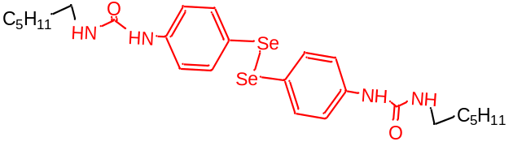 | CCCCCCNC(=O)NC1=CC=C([Se][Se]C2=CC=C(NC(=O)NCCCCCC)C=C2)C=C1
10 | 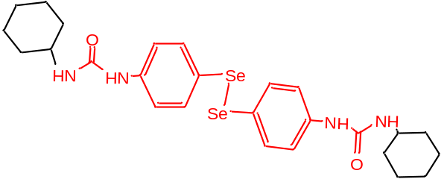 | O=C(NC1CCCCC1)NC1=CC=C([Se][Se]C2=CC=C(NC(=O)NC3CCCCC3)C=C2)C=C1
11 | 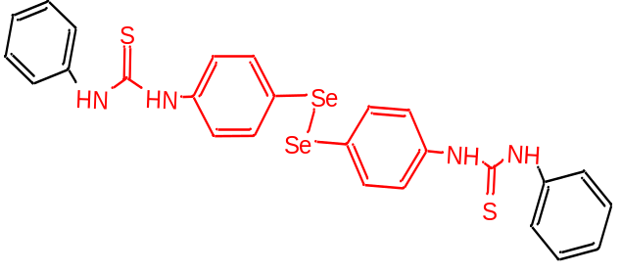 | S=C(NC1=CC=CC=C1)NC1=CC=C([Se][Se]C2=CC=C(NC(=S)NC3=CC=CC=C3)C=C2)C=C1
12 | 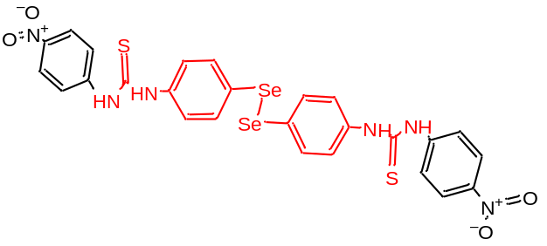 | [O-][N+](=O)C1=CC=C(NC(=S)NC2=CC=C([Se][Se]C3=CC=C(NC(=S)NC4=CC=C(C=C4)[N+]([O-])=O)C=C3)C=C2)C=C1
13 | 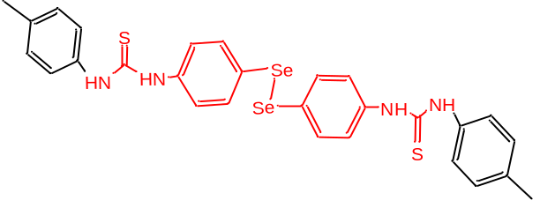 | CC1=CC=C(NC(=S)NC2=CC=C([Se][Se]C3=CC=C(NC(=S)NC4=CC=C(C)C=C4)C=C3)C=C2)C=C1
14 | 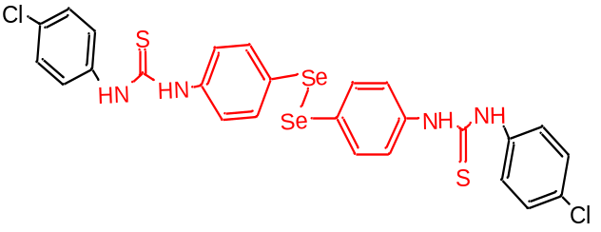 | ClC1=CC=C(NC(=S)NC2=CC=C([Se][Se]C3=CC=C(NC(=S)NC4=CC=C(Cl)C=C4)C=C3)C=C2)C=C1
15 | 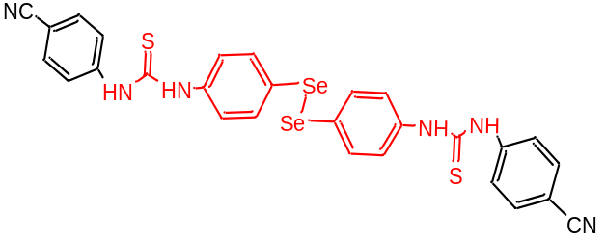 | S=C(NC1=CC=C([Se][Se]C2=CC=C(NC(=S)NC3=CC=C(C=C3)C#N)C=C2)C=C1)NC1=CC=C(C=C1)C#N
16 | 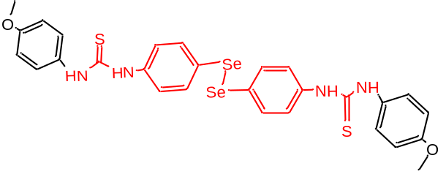 | COC1=CC=C(NC(=S)NC2=CC=C([Se][Se]C3=CC=C(NC(=S)NC4=CC=C(OC)C=C4)C=C3)C=C2)C=C1
17 | 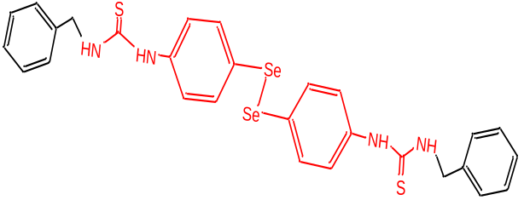 | S=C(NCC1=CC=CC=C1)NC1=CC=C([Se][Se]C2=CC=C(NC(=S)NCC3=CC=CC=C3)C=C2)C=C1
18 | 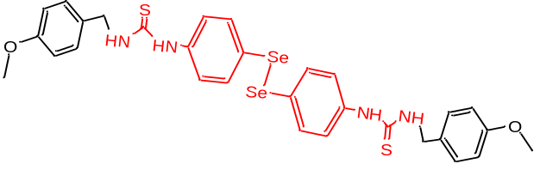 | COC1=CC=C(CNC(=S)NC2=CC=C([Se][Se]C3=CC=C(NC(=S)NCC4=CC=C(OC)C=C4)C=C3)C=C2)C=C1
19 | 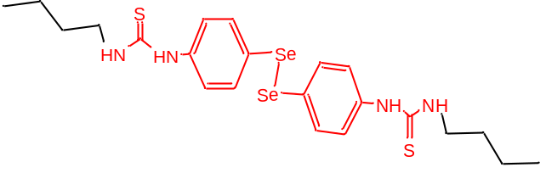 | CCCCNC(=S)NC1=CC=C([Se][Se]C2=CC=C(NC(=S)NCCCC)C=C2)C=C1
20 | 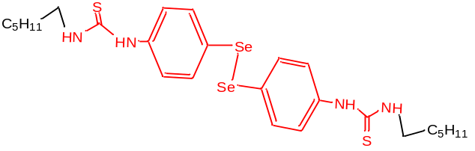 | CCCCCCNC(=S)NC1=CC=C([Se][Se]C2=CC=C(NC(=S)NCCCCCC)C=C2)C=C1
21 | 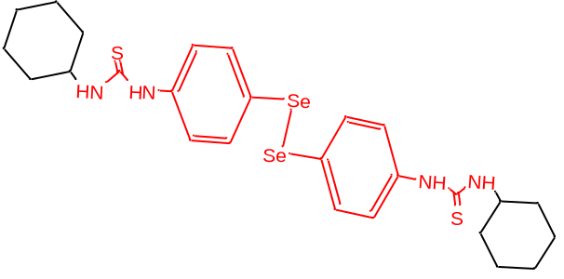 | S=C(NC1CCCCC1)NC1=CC=C([Se][Se]C2=CC=C(NC(=S)NC3CCCCC3)C=C2)C=C1
22 | 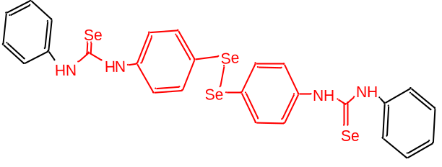 | [Se]=C(NC1=CC=CC=C1)NC1=CC=C([Se][Se]C2=CC=C(NC(=[Se])NC3=CC=CC=C3)C=C2)C=C1
23 | 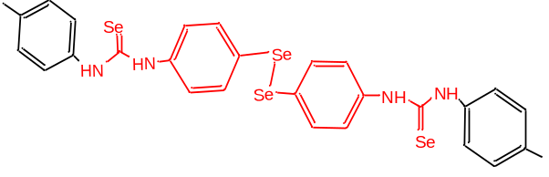 | CC1=CC=C(NC(=[Se])NC2=CC=C([Se][Se]C3=CC=C(NC(=[Se])NC4=CC=C(C)C=C4)C=C3)C=C2)C=C1
24 | 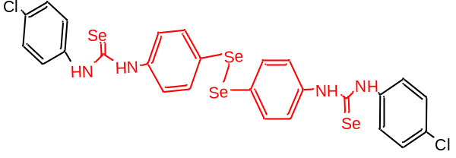 | ClC1=CC=C(NC(=[Se])NC2=CC=C([Se][Se]C3=CC=C(NC(=[Se])NC4=CC=C(Cl)C=C4)C=C3)C=C2)C=C1
25 | 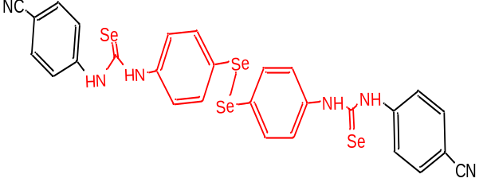 | [Se]=C(NC1=CC=C([Se][Se]C2=CC=C(NC(=[Se])NC3=CC=C(C=C3)C#N)C=C2)C=C1)NC1=CC=C(C=C1)C#N
26 | 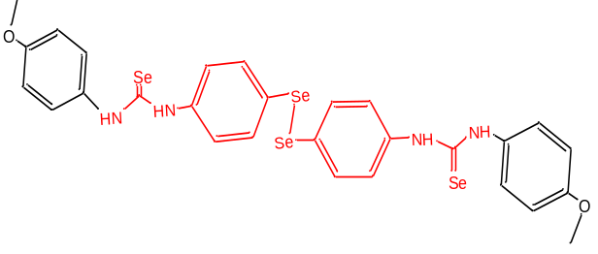 | COC1=CC=C(NC(=[Se])NC2=CC=C([Se][Se]C3=CC=C(NC(=[Se])NC4=CC=C(OC)C=C4)C=C3)C=C2)C=C1
27 | 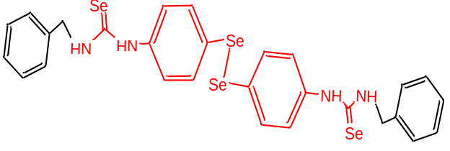 | [Se]=C(NCC1=CC=CC=C1)NC1=CC=C([Se][Se]C2=CC=C(NC(=[Se])NCC3=CC=CC=C3)C=C2)C=C1
28 | 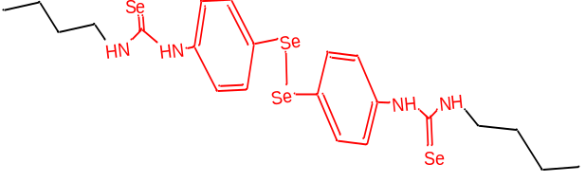 | CCCCNC(=[Se])NC1=CC=C([Se][Se]C2=CC=C(NC(=[Se])NCCCC)C=C2)C=C1
29 | 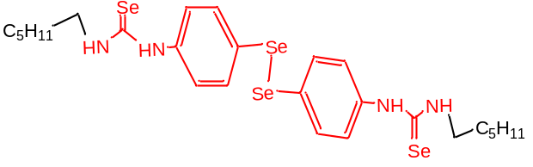 | CCCCCCNC(=[Se])NC1=CC=C([Se][Se]C2=CC=C(NC(=[Se])NCCCCCC)C=C2)C=C1
30 | 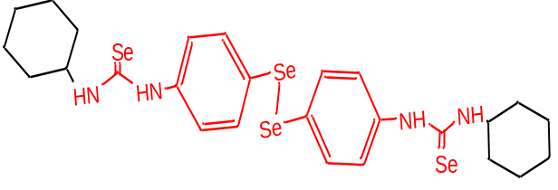 | [Se]=C(NC1CCCCC1)NC1=CC=C([Se][Se]C2=CC=C(NC(=[Se])NC3CCCCC3)C=C2)C=C1
Milt | 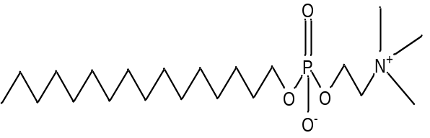 | CCCCCCCCCCCCCCCCOP([O-])(=O)OCC[N+](C)(C)C
Pent | 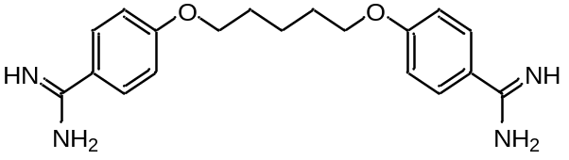 | NC(=N)C1=CC=C(OCCCCCOC2=CC=C(C=C2)C(N)=N)C=C1
Key: Milt – Miltefosine, Pent - Pentamidine

