Supplementary Online Content
Supplemental Figure 1: Association of comorbidities with severe pneumonia mortality.
Supplemental Figure 2: Association of complications with severe pneumonia mortality.
Supplemental Figure 3: Association of patient Clinical manifestations with severe pneumonia mortality.
Supplemental Figure 4: Association of laboratory results with severe pneumonia mortality.
Supplemental Figure 5: Association of long-term prognosis outcomes with severe pneumonia mortality.

Supplemental Figure 1: Association of comorbidities with severe pneumonia mortality.

A Chronic obstructive pulmonary disease
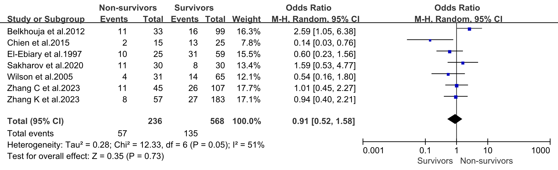
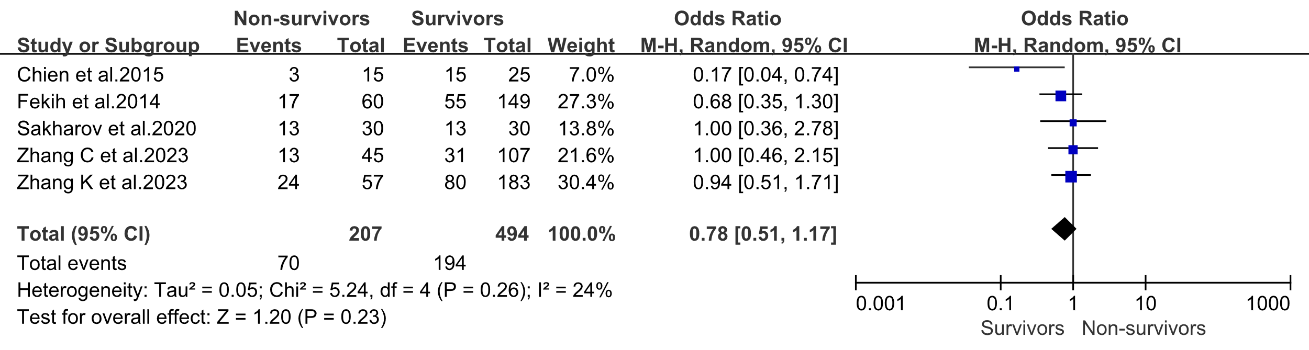
B Hypertension
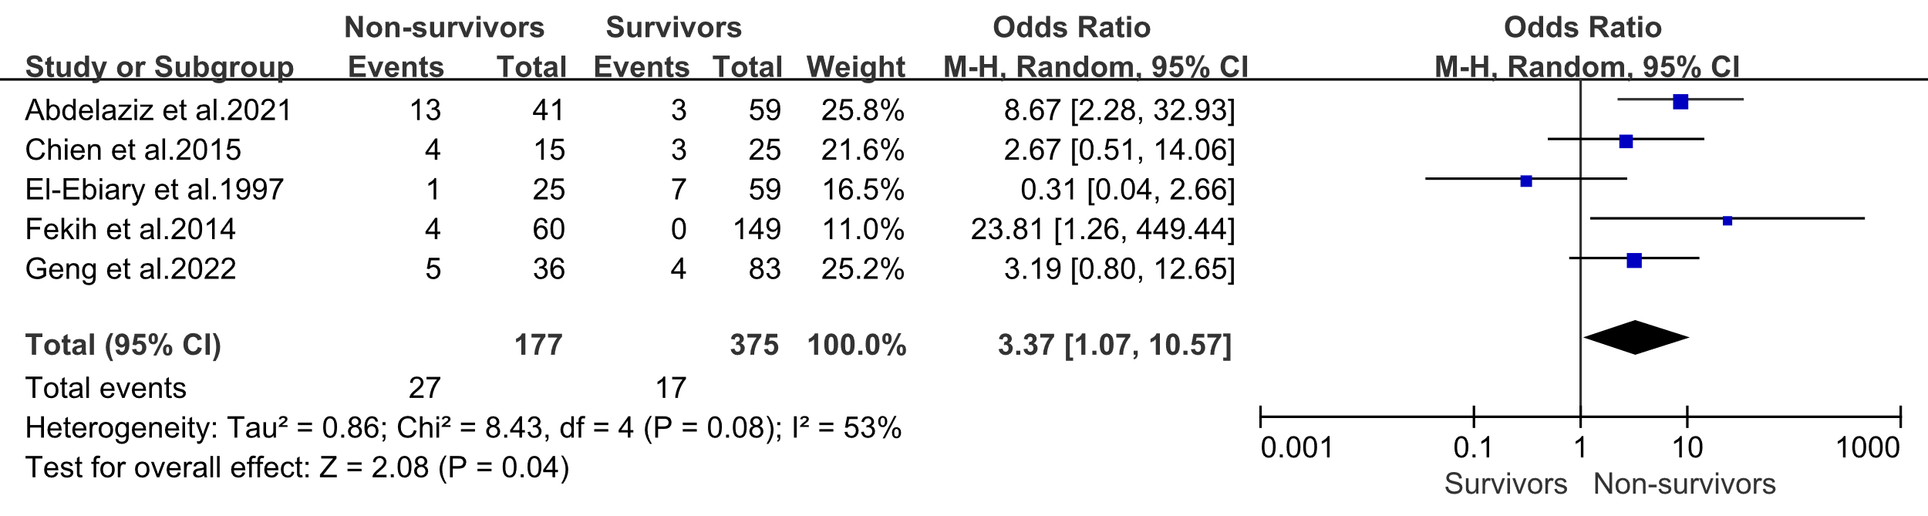
C Neoplasm
D Diabetes mellitus
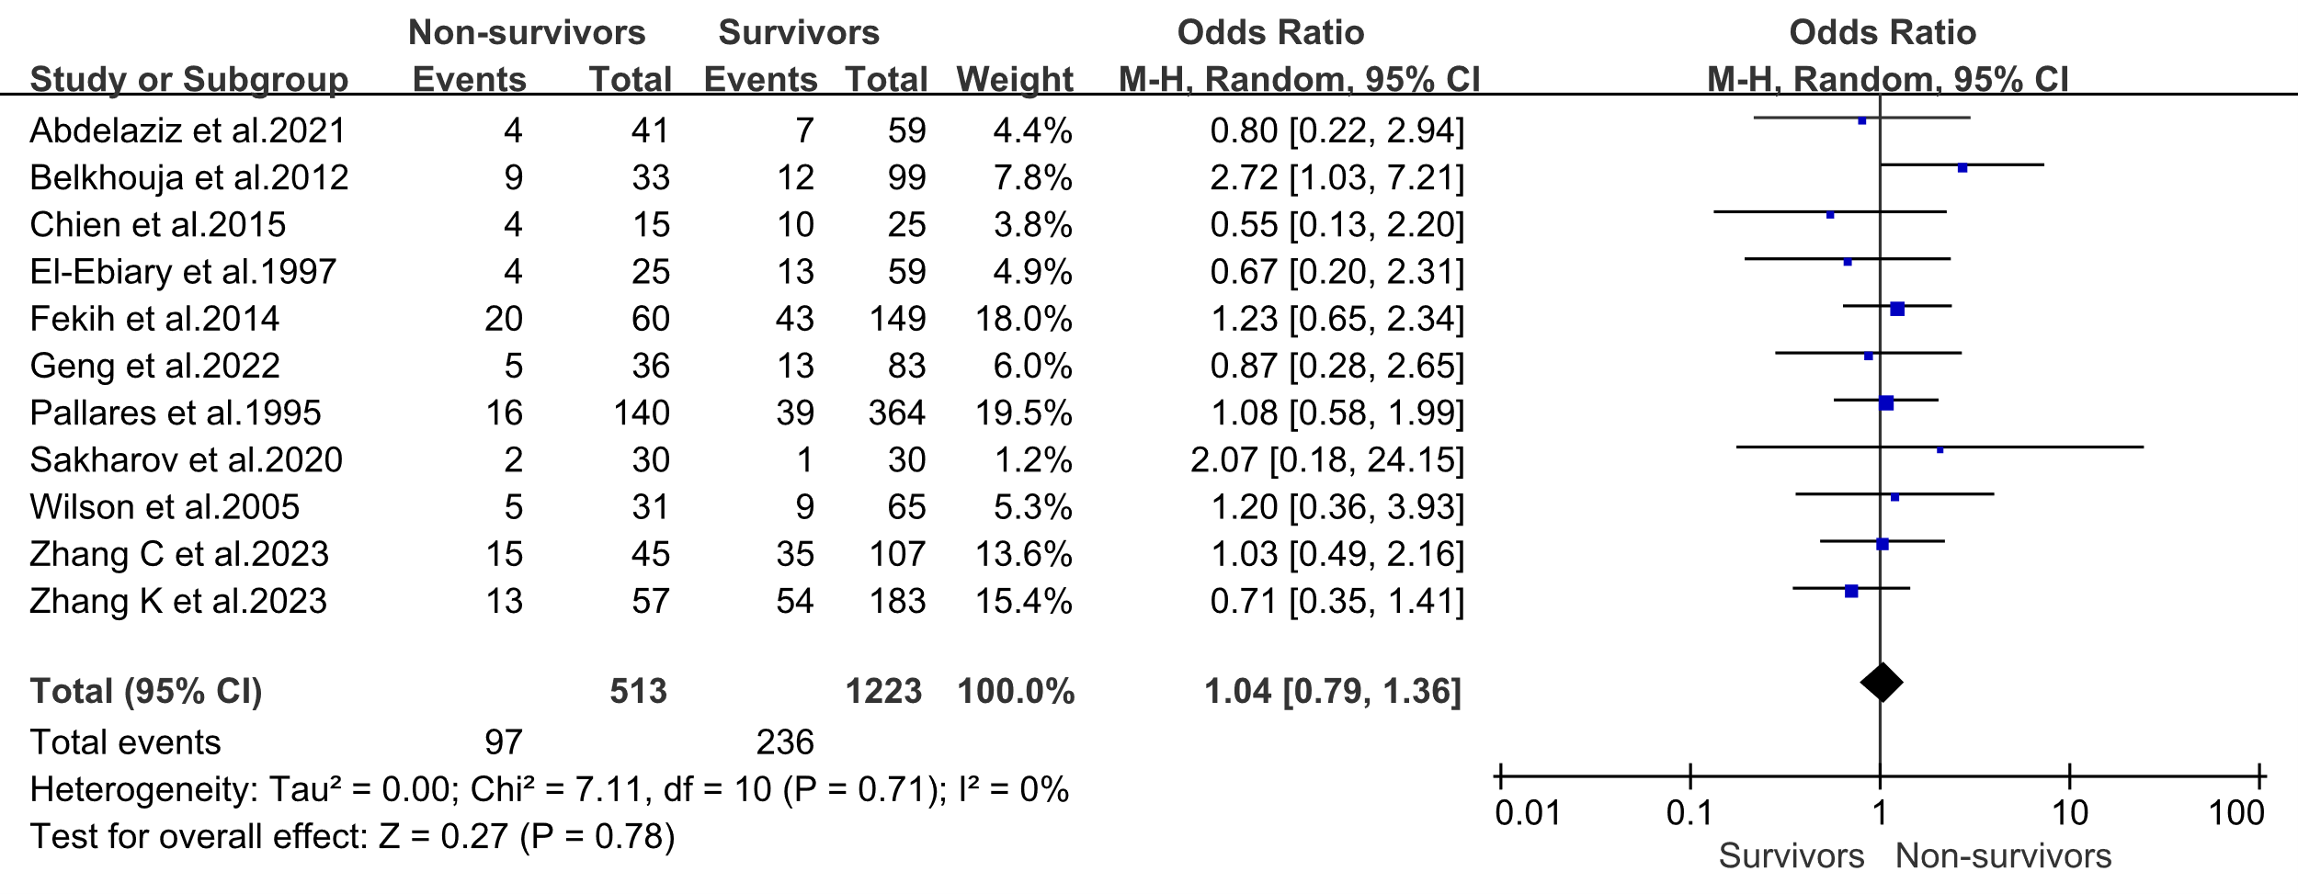

Supplemental Figure 2: Association of complications with severe pneumonia mortality.

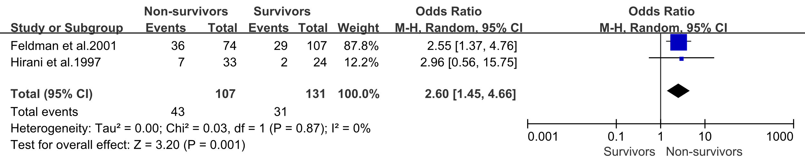
A Diastolic hypotension
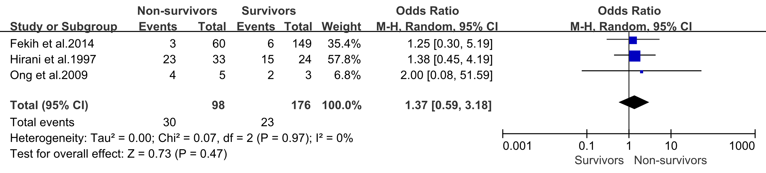
B Respiratory failure
C Acute confusion
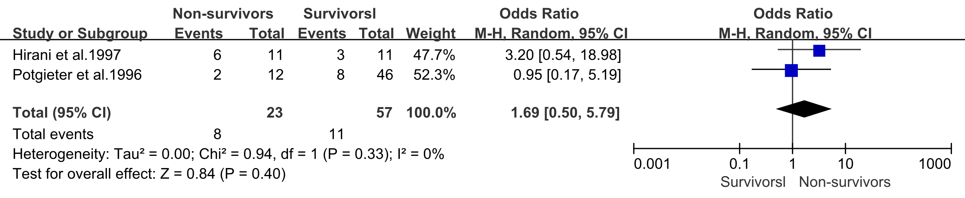
D Pleural effusion
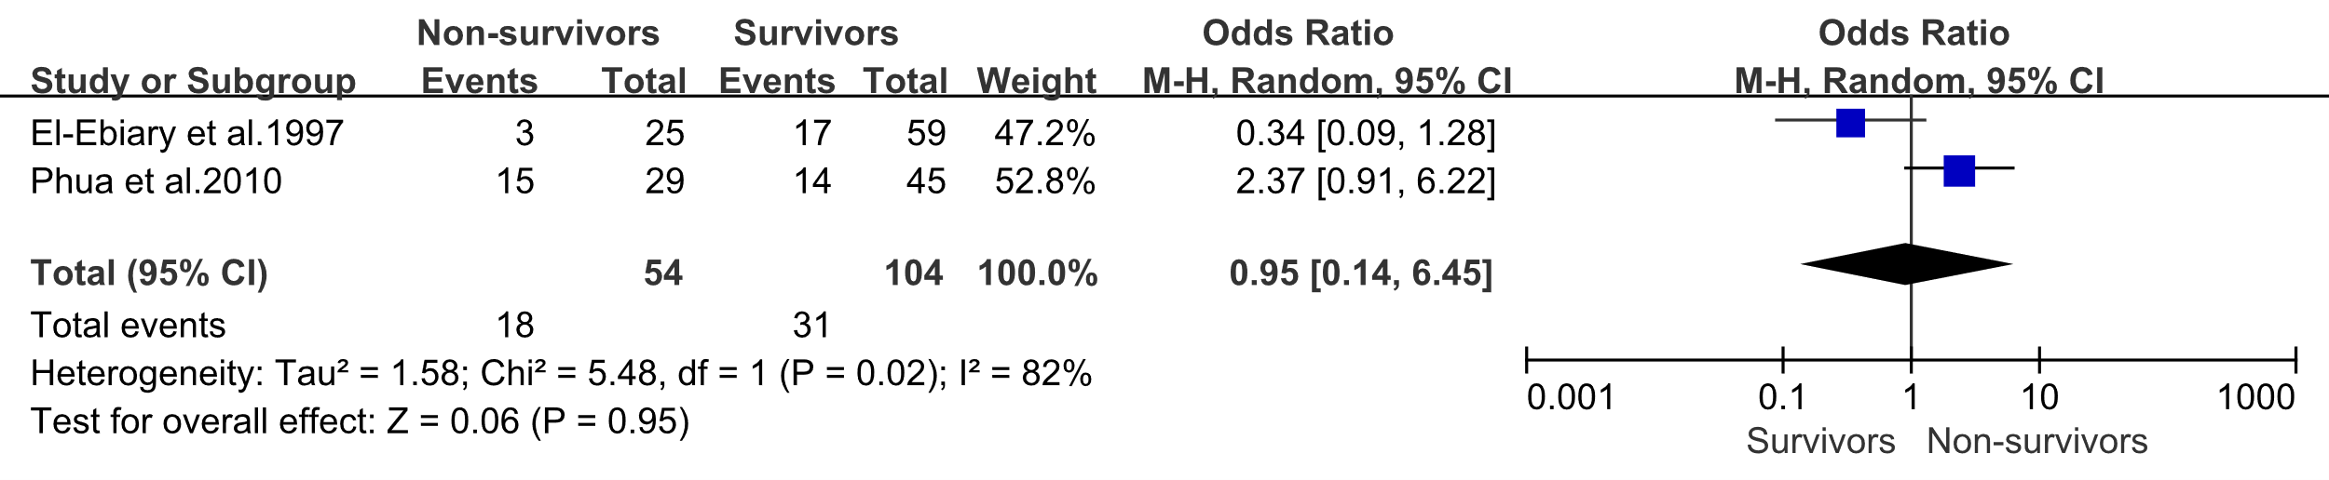
E Acute lung injury/Acute respiratory distress syndrome
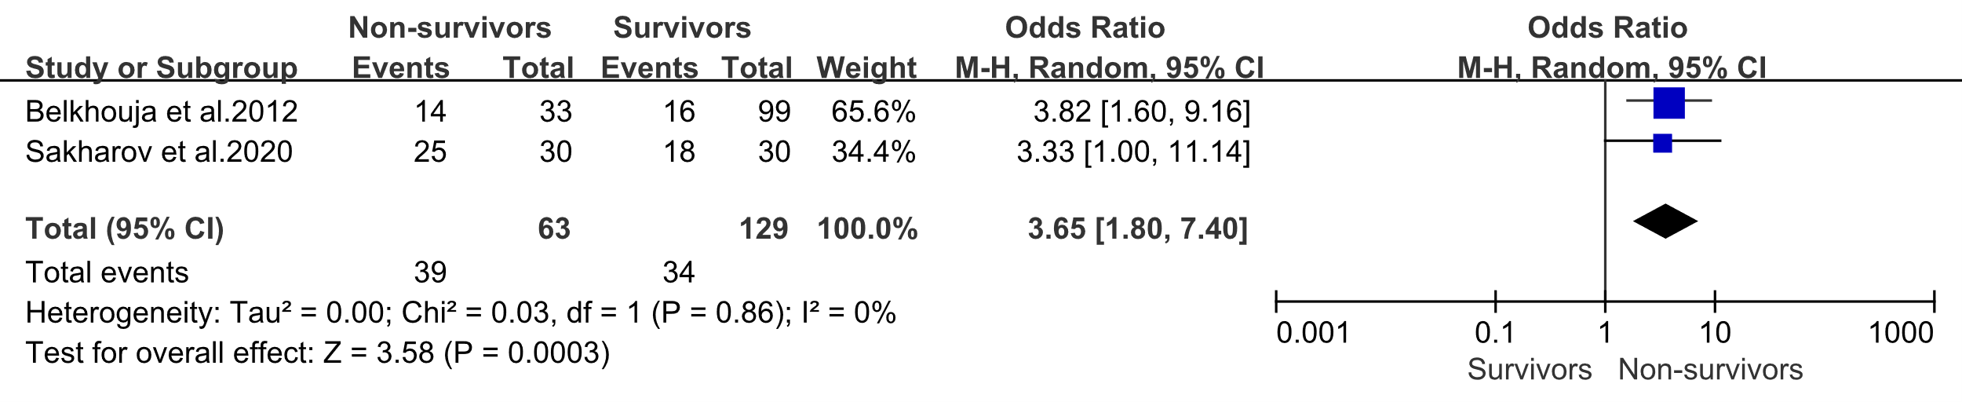

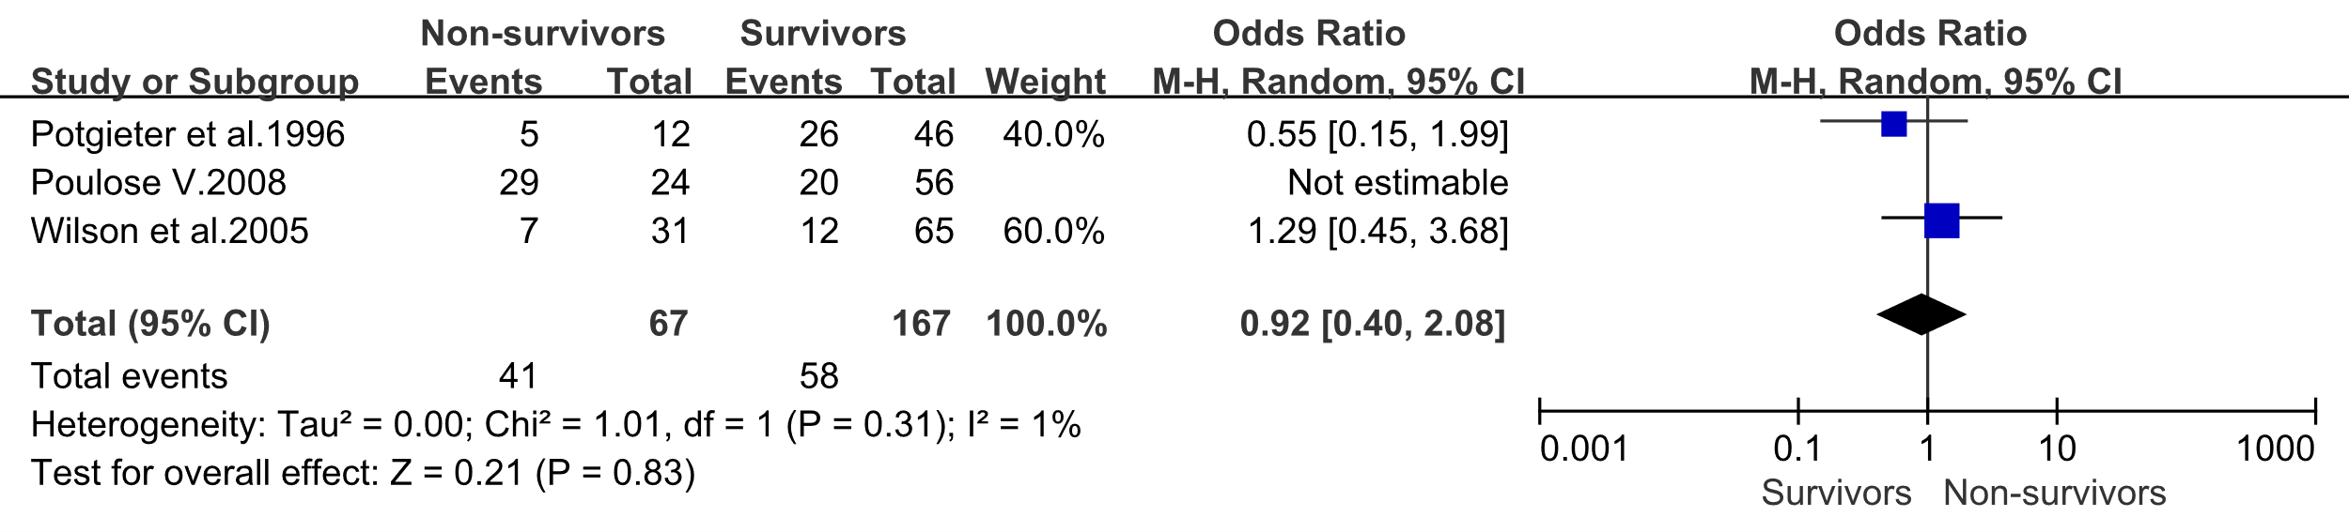
F Bacteraemia
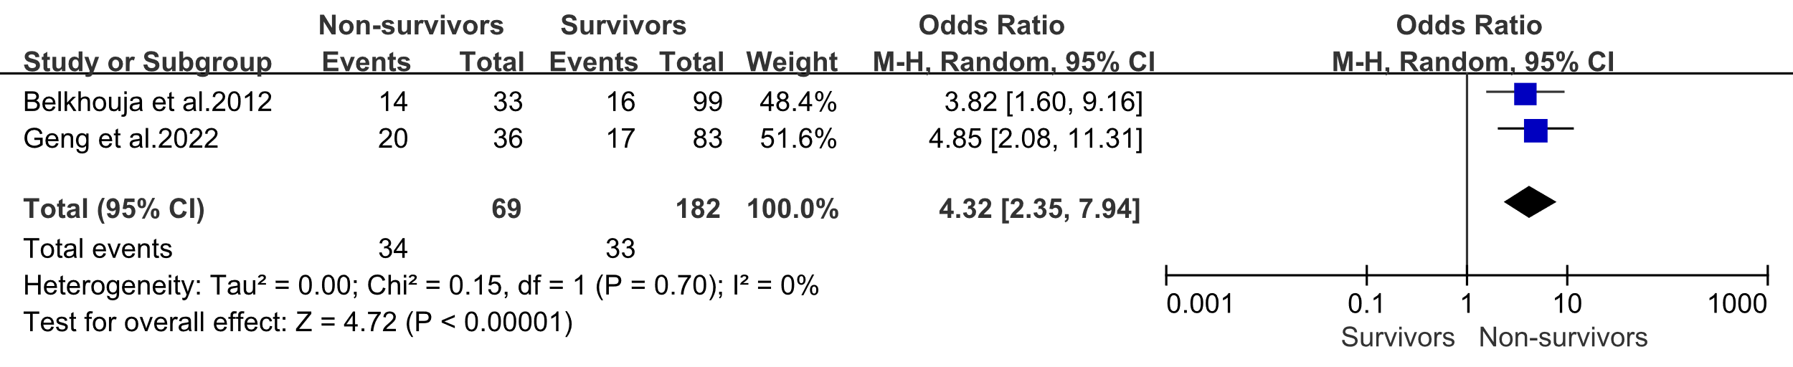
G Multiple organ failure
H Acute kidney injury
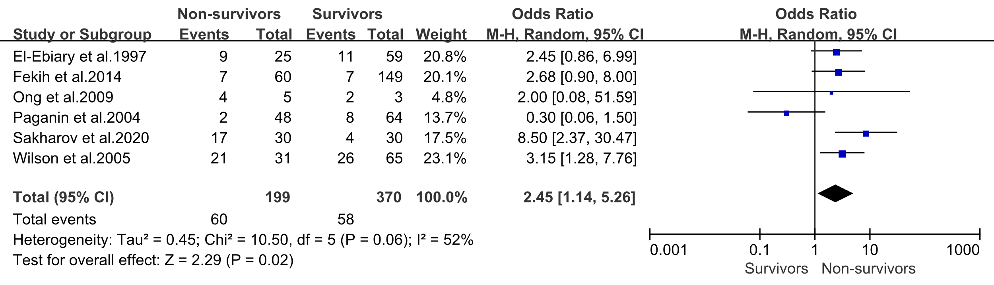
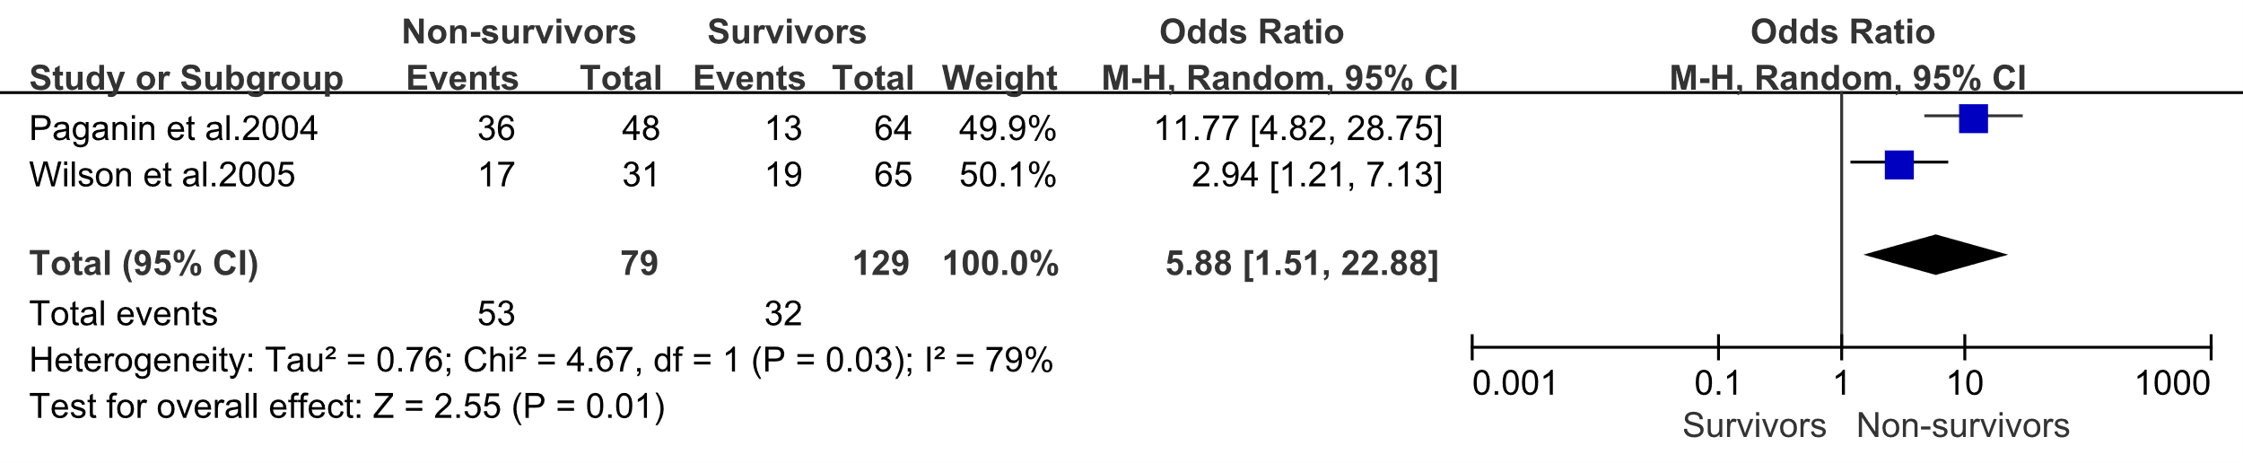
I Metabolic acidosis

Supplemental Figure 3: Association of patient Clinical manifestations with severe pneumonia mortality.

A Respiratory rate
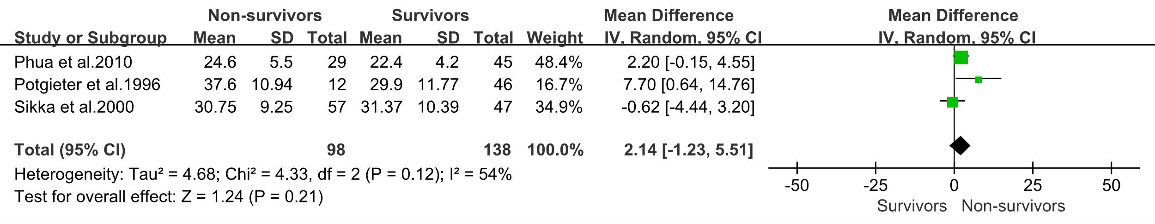
B Heart rate
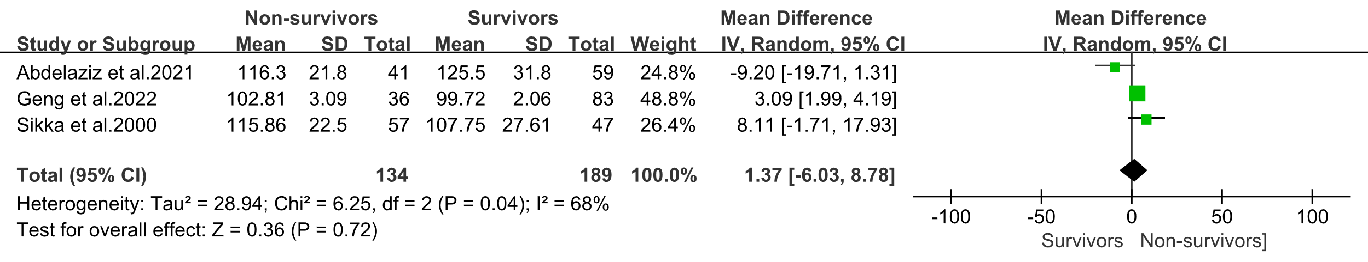
C Body temperature
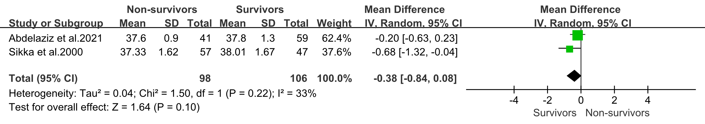
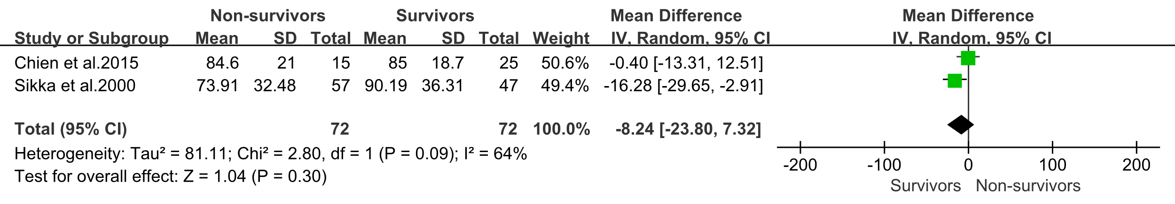
D Mean arterial pressure
E Urine output
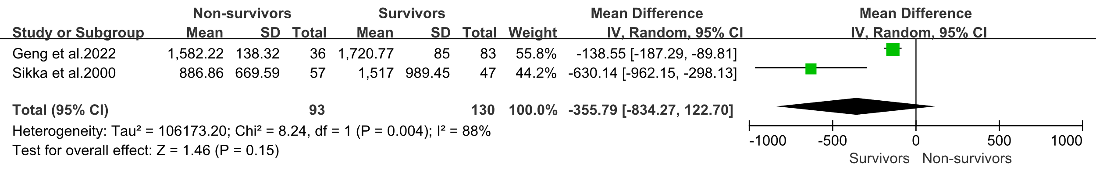

Supplemental Figure 4: Association of laboratory results with severe pneumonia mortality.

A White blood cell count
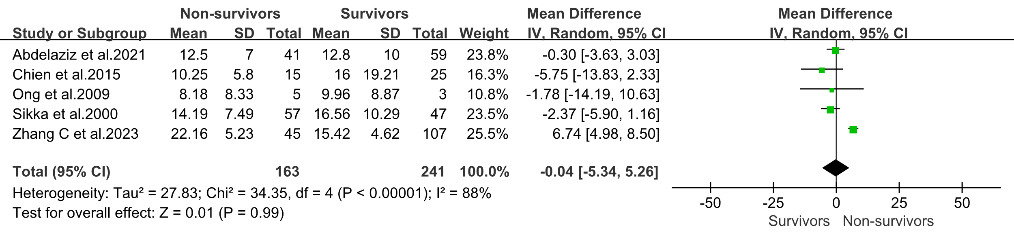
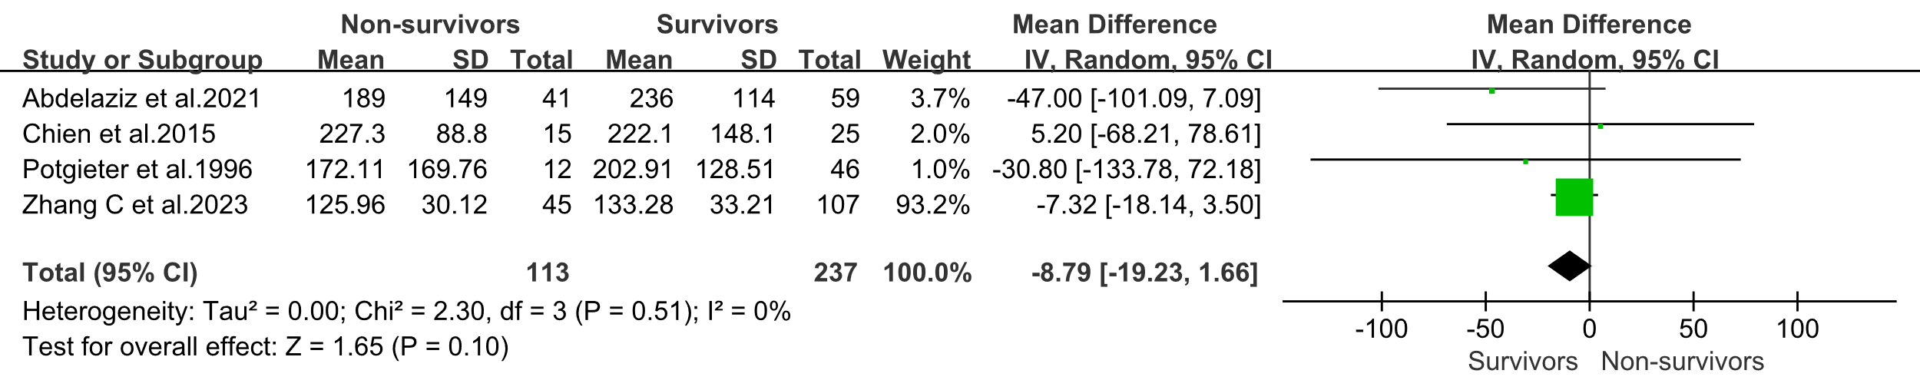
B Platelet count
C C-reactive protein
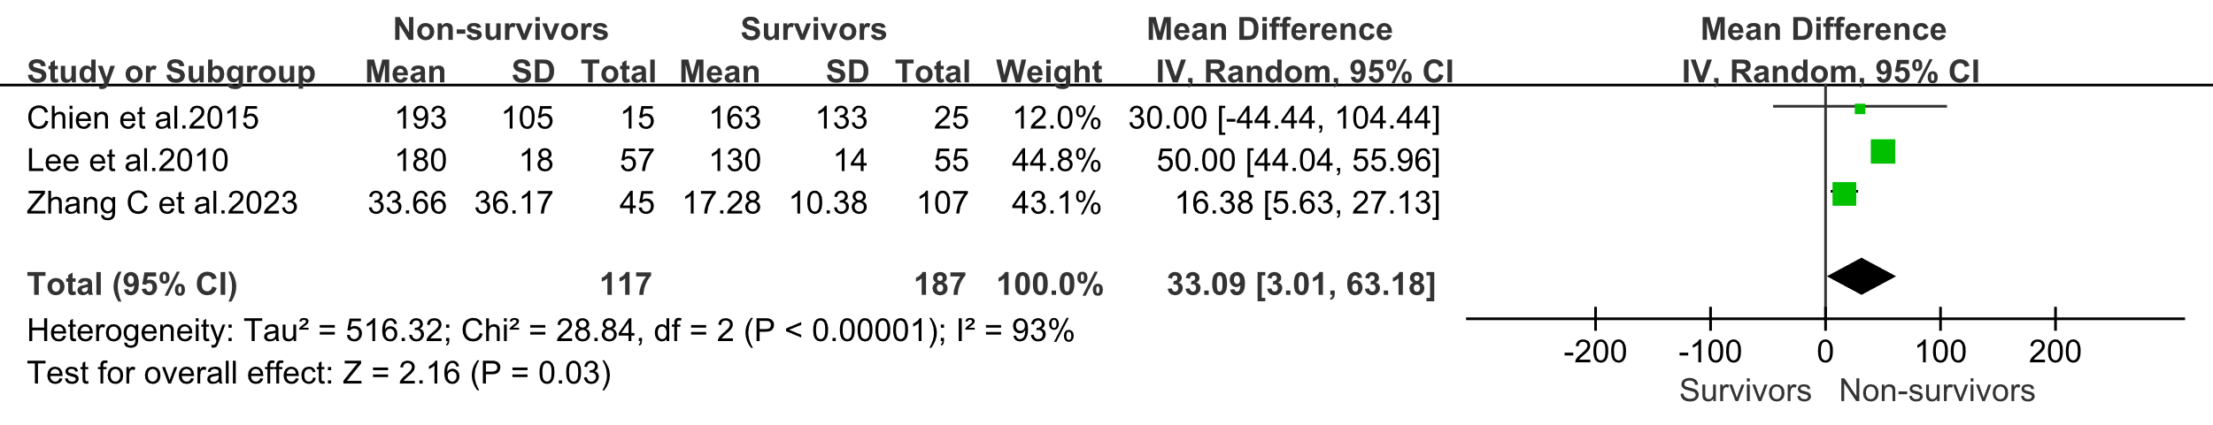
D Hemoglobin
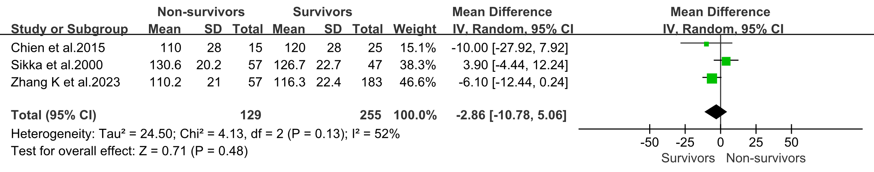
E Albumin
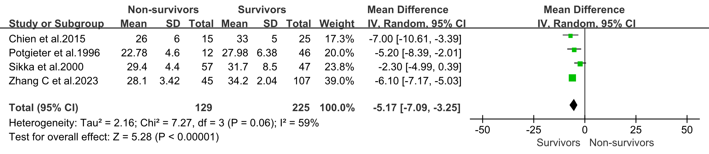
F Glutamic oxaioacetic transaminase
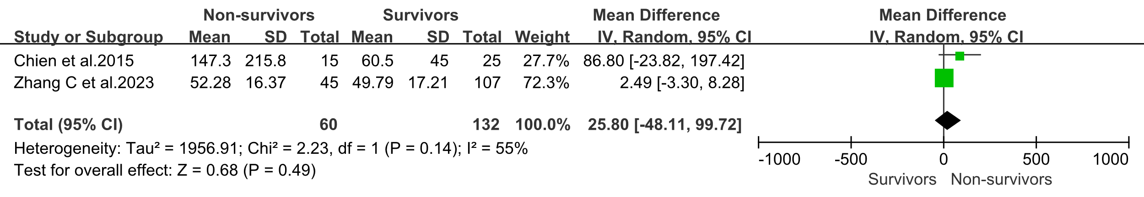

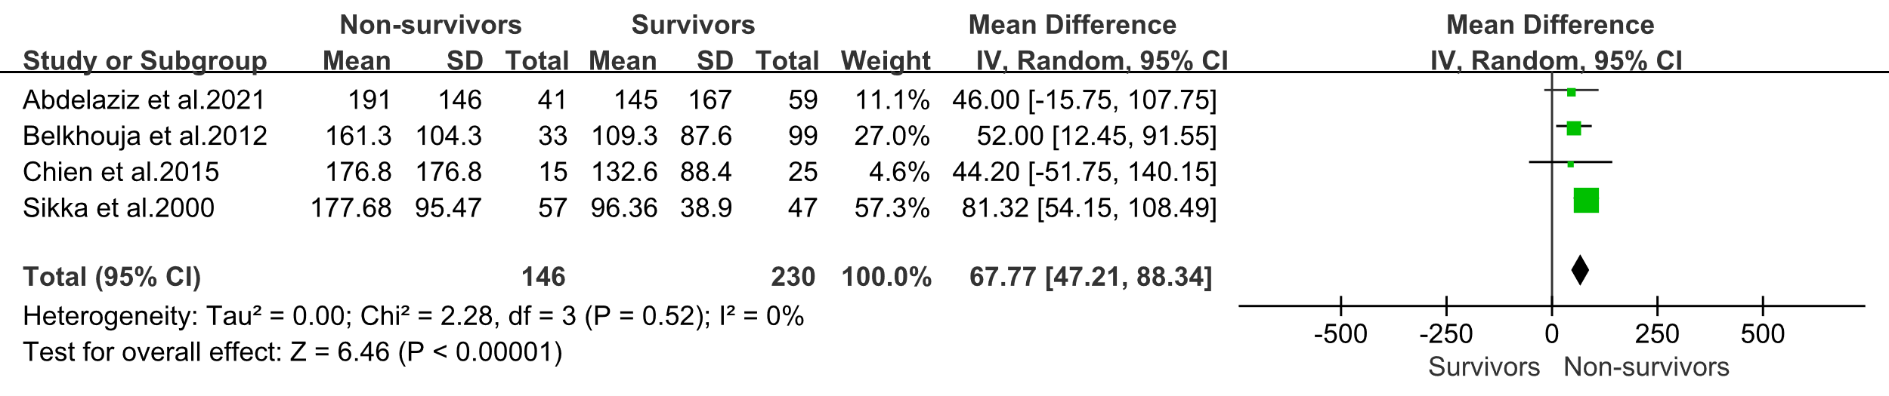
G Serum creatinine
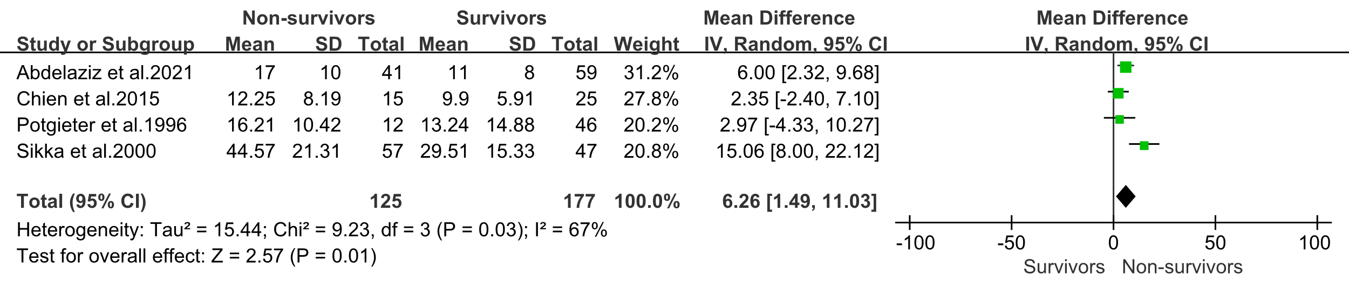
H Blood urea nitrogen
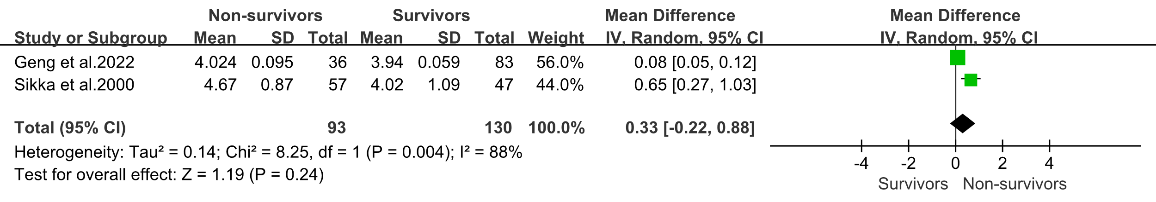
I Potassium
J PaO₂/FiO₂
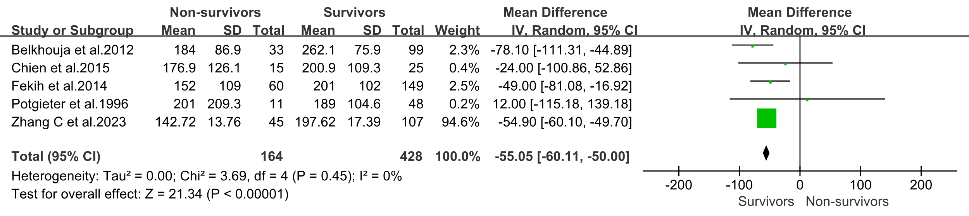
K Arterial blood PH
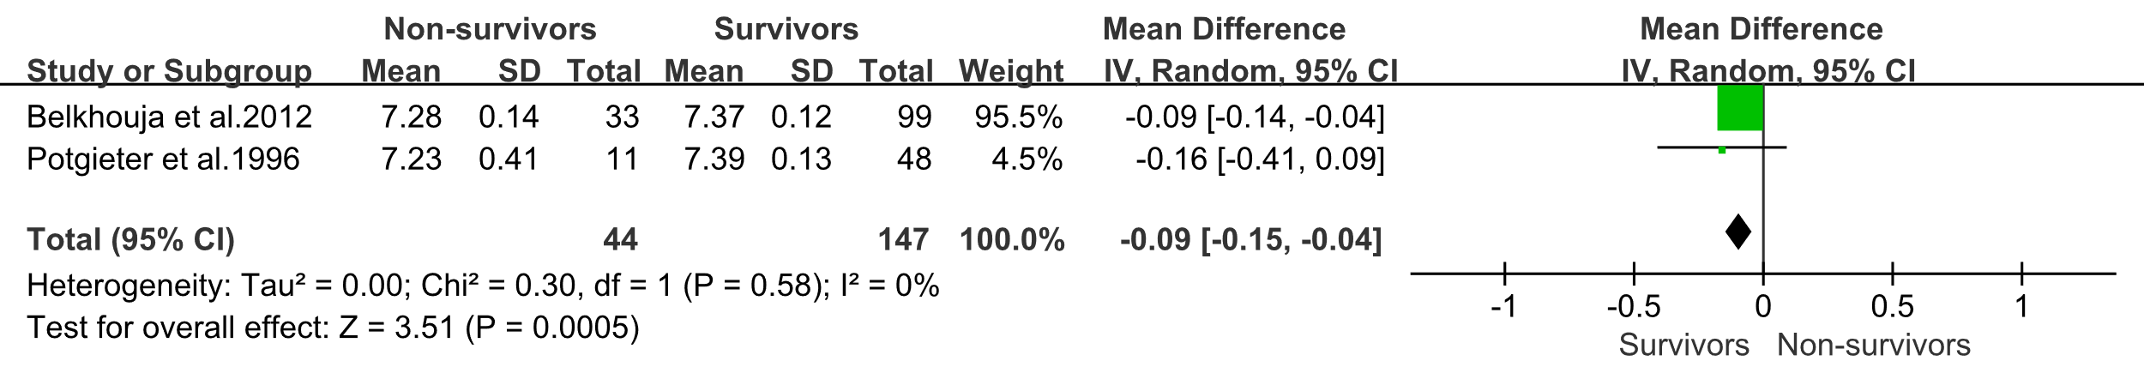

L Leukopenia
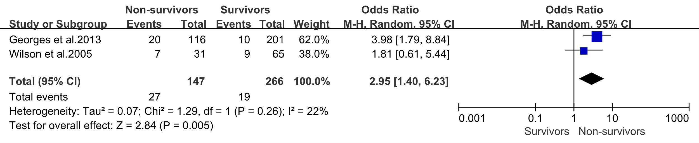
M Multilobar or bilateral involvement
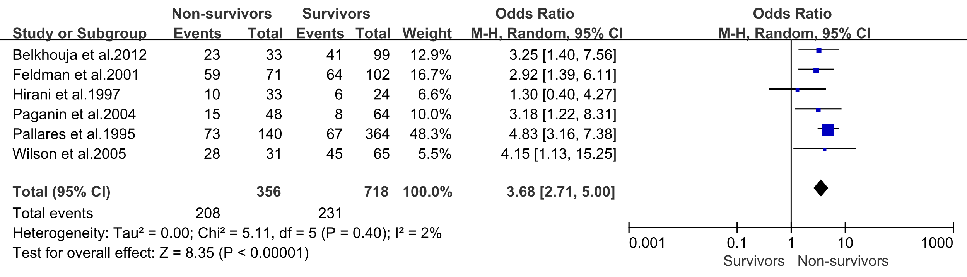
N Bacterial mixed infection
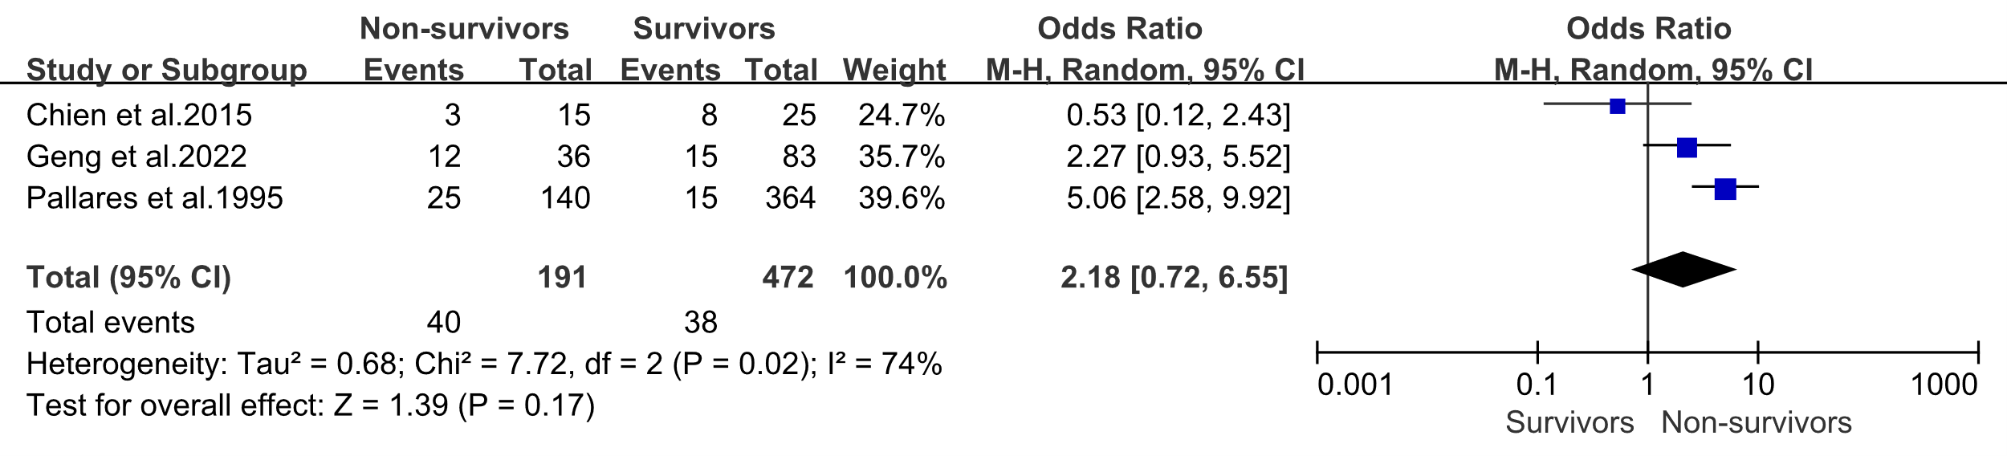
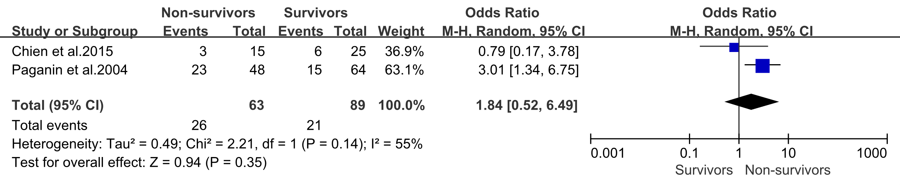
O Positive blood culture
P Sputum cont culture growth
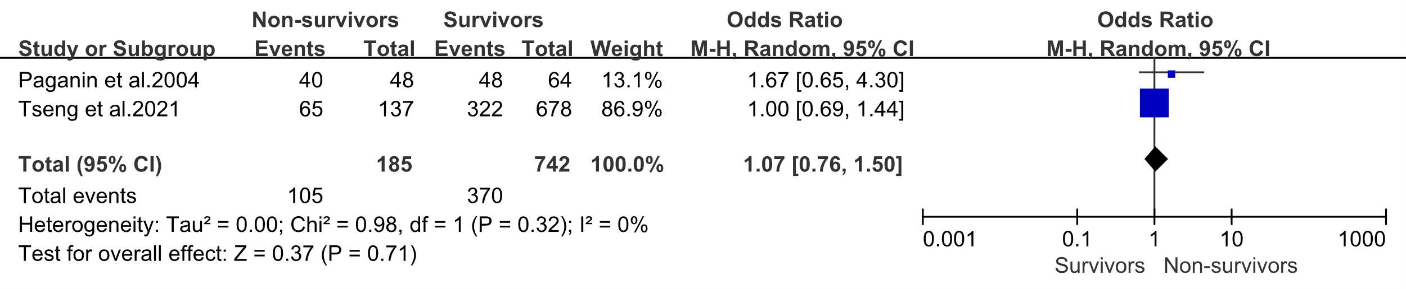

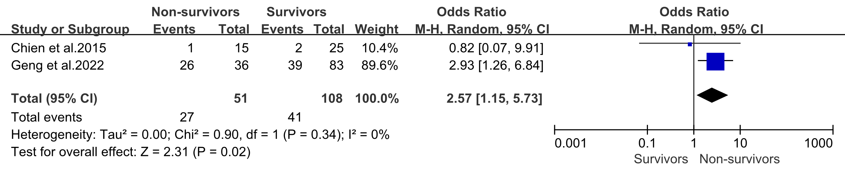
Q Gram-negative microorganism
R Gram-positive microorganism
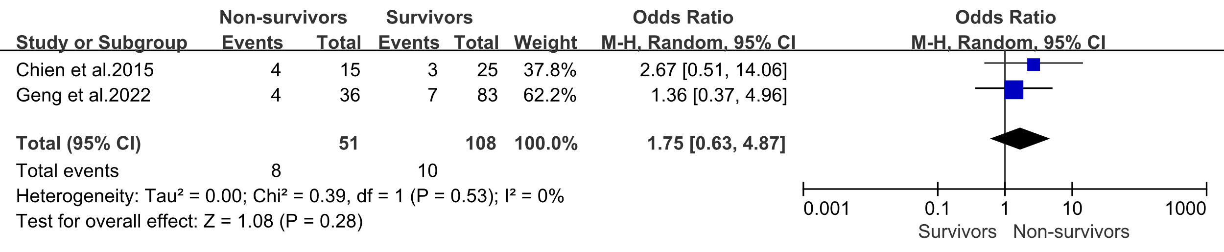
S Sodium<136 mEq/L
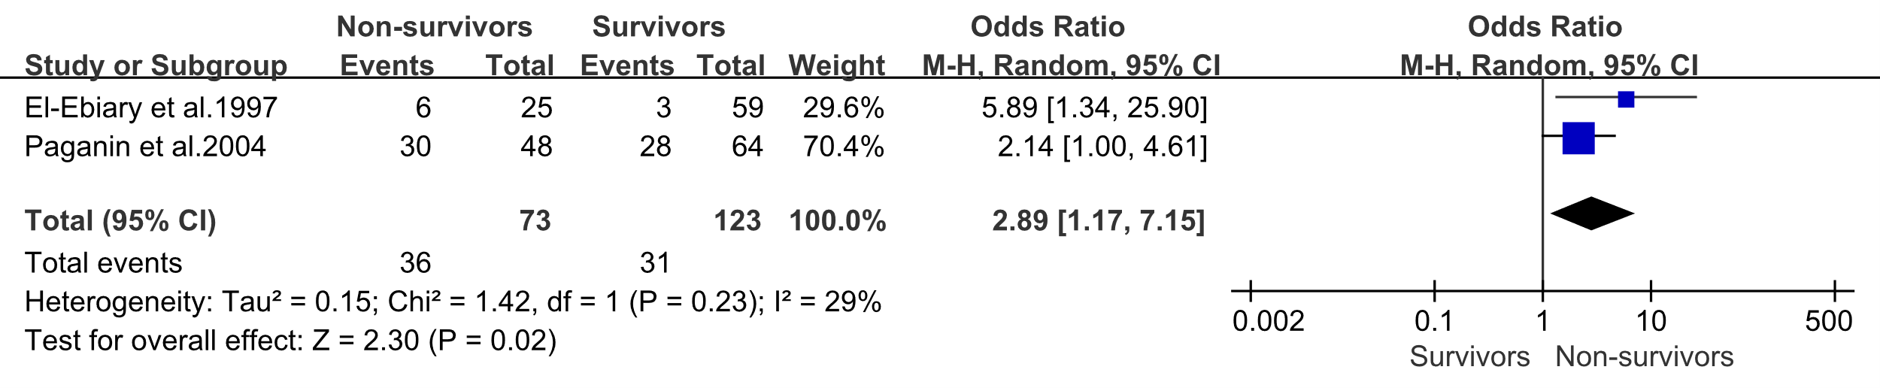

Supplemental Figure 5: Association of long-term prognosis outcomes with severe pneumonia mortality.

A Length of hospital stay
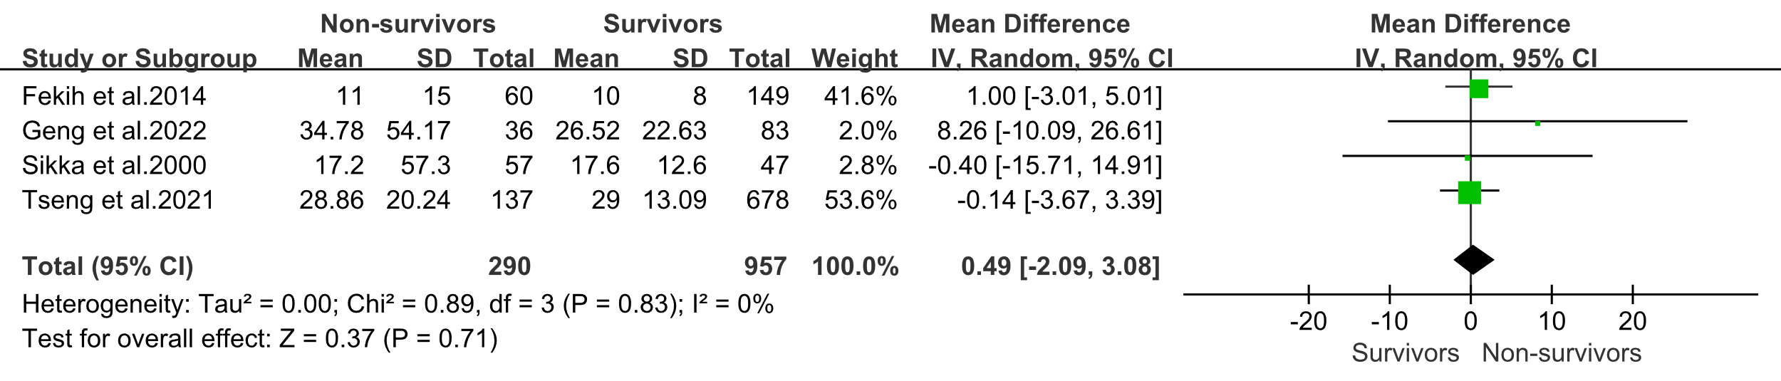
B Length of ICU stay
